Nurturing Process – Waterfall Deliverables – Part -2
Dinesh Kulkarni
Waterfall Model Documents

Document 6- Please prepare a use case diagram, activity diagram and a use case specification document.
1. Use case Name
2. Use case Description
3. Actors Primary Actors Secondary actors
4. Basic Flow
5. ALTERNATE FLOW
6. Exceptional flows
7. Pre- Conditions
8. post-conditions
9. Assumptions
10. Constraints
11. Dependencies
12. Inputs and Outputs
13. Business Rules
14.Miscellaneous Information

Answer
Use Case diagram for CTS Waterfall project
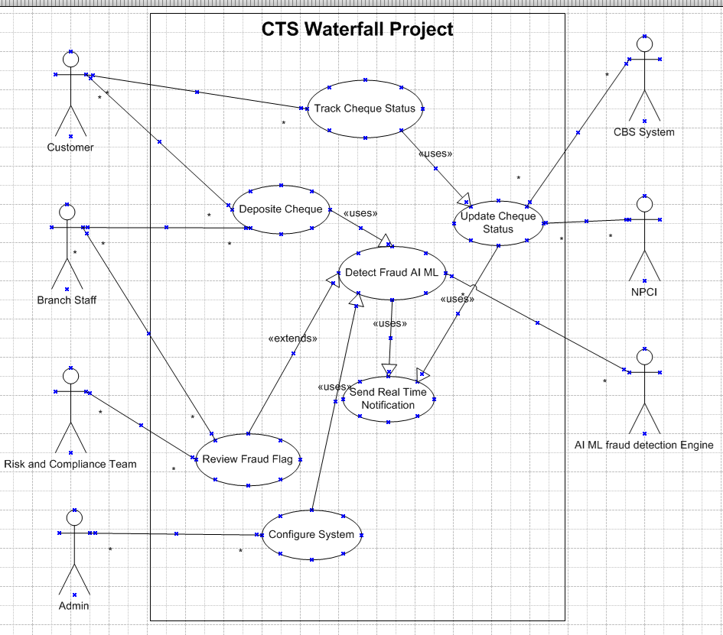

Activity Diagram for CTS Waterfall project
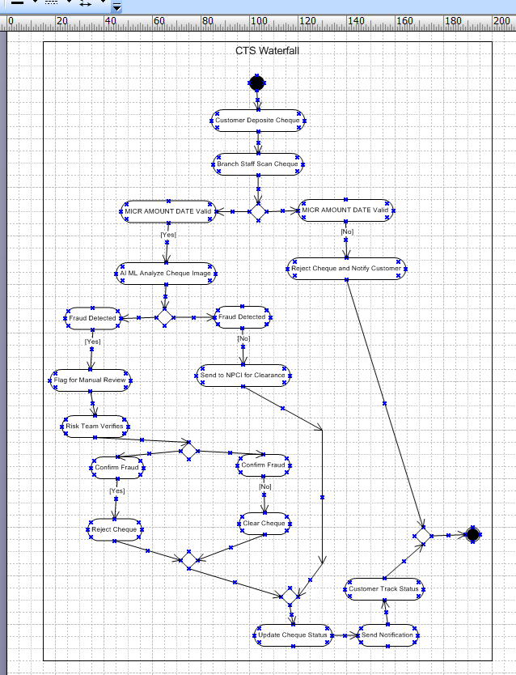

Use Case Specification Document
1. Use Case Name
Detect Fraudulent Cheque
2. Use Case Description
The system uses AI/ML models to analyze scanned cheque images for tampering, signature forgery, or altered amounts. If fraud is suspected, the cheque is flagged for manual review by the Risk & Compliance Team.
3. Actors
- Primary Actors:
  - Customer
  - Branch Staff (Uploads cheque images)
  - Risk & Compliance Team (Manual review)
  - Admin
- Secondary Actors:
  - Core Banking System (CBS) (Provides customer signature data)
  - NPCI System (Update cheque Status)
  - AI/ML Fraud Detection Engine (Automated analysis)
4. Basic Flow
- Cheque image and metadata (MICR, amount, date) are uploaded to the CTS.
- AI/ML model performs the following checks:
  - Signature Mismatch: Compares with stored customer signatures.
  - Tampering: Detects erasures, font inconsistencies, or altered fields.
  - Amount/Date Alterations: Validates against numerical patterns.
- If no fraud is detected, the cheque proceeds to clearance via CBS/NPCI.
- System updates the cheque status as Cleared and triggers a real-time notification.
5. Alternate Flow
- A1: False Positive (AI Flags Valid Cheque)
  - Risk Team manually reviews the flagged cheque.
  - Overrides the AI decision if the cheque is valid.
  - Cheque proceeds to clearance.
6. Exceptional Flows
- E1: Poor Image Quality
  - System rejects the scan and requests a resubmission from the branch.
- E2: AI Model Failure
  - System falls back to manual verification by the Risk Team.
- E3: Network Downtime
  - Cheque processing is paused until connectivity is restored.
7. Pre-Conditions
- Cheque image and metadata are successfully uploaded.
- AI/ML model is trained and operational.
- Customer signature records are available in CBS.

8. Post-Conditions
- Cheque is either cleared, rejected, or flagged for review.
- Fraudulent transactions are logged in the audit trail.
- Customer receives a status notification (SMS/email).
9. Assumptions
- AI model accuracy is ≥90%.
- Historical fraud data is available for model training.
- Branch staff follows scanning protocols.
10. Constraints
- Must comply with RBI’s 1-hour fraud escalation rule.
- AI processing time ≤5 seconds per cheque.
- False positives must not exceed 5% of detections.
11. Dependencies
- Integration with CBS for signature data.
- Access to NPCI APIs for clearance.
- Availability of the AI/ML engine.
12. Inputs and Outputs
- Inputs:
  - Cheque image (front/back).
  - MICR code, amount, date.
  - Customer account details.
- Outputs:
  - Fraud score (0–100%).
  - Status update ("Cleared", "Flagged", "Rejected").
  - Audit log entry.
13. Business Rules
- BR1: All flagged cheques must be reviewed within 1 hour.
- BR2: Fraudulent cheques are reported to RBI within 24 hours.
- BR3: Customers must be notified of status changes in real time.
14. Miscellaneous Information
- Training Data: 50,000+ cheque images used for AI training.
- Regulatory: Logs must be archived for 7 years (RBI mandate).
- Performance Metrics:
  - Target fraud detection rate: ≥95%.
  - Max false positive rate: ≤5%.

Document 7- Screens and pages
Please follow the following steps to create the mock-ups
1. Kindly use balsamic or Axure. ------------------------------------------We use AXURE
2. Always start with a home page of an application.
3. Take a feature and follow it to the end

1.CTS HOME PAGE
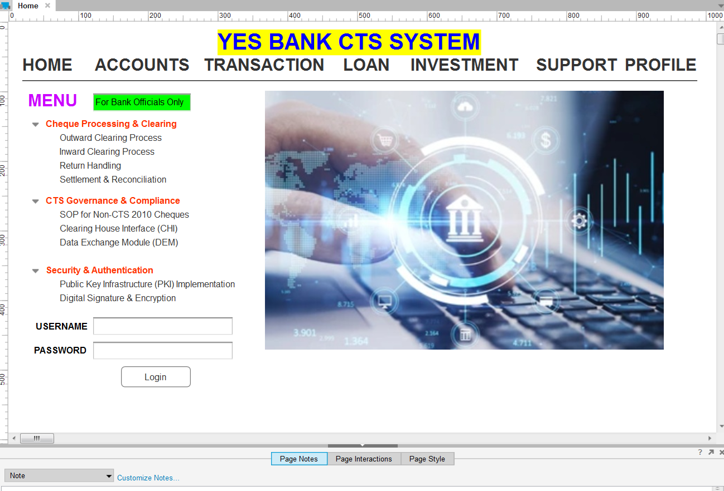

2.CHEQUE SCANNING
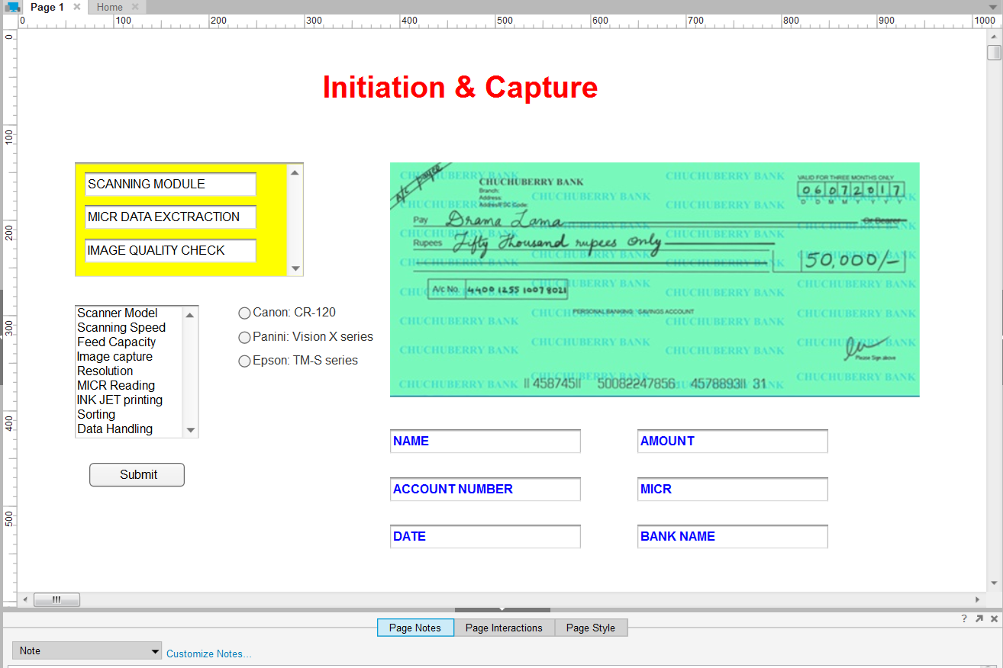
3.DATA ENTRY AND VALIDATIONS
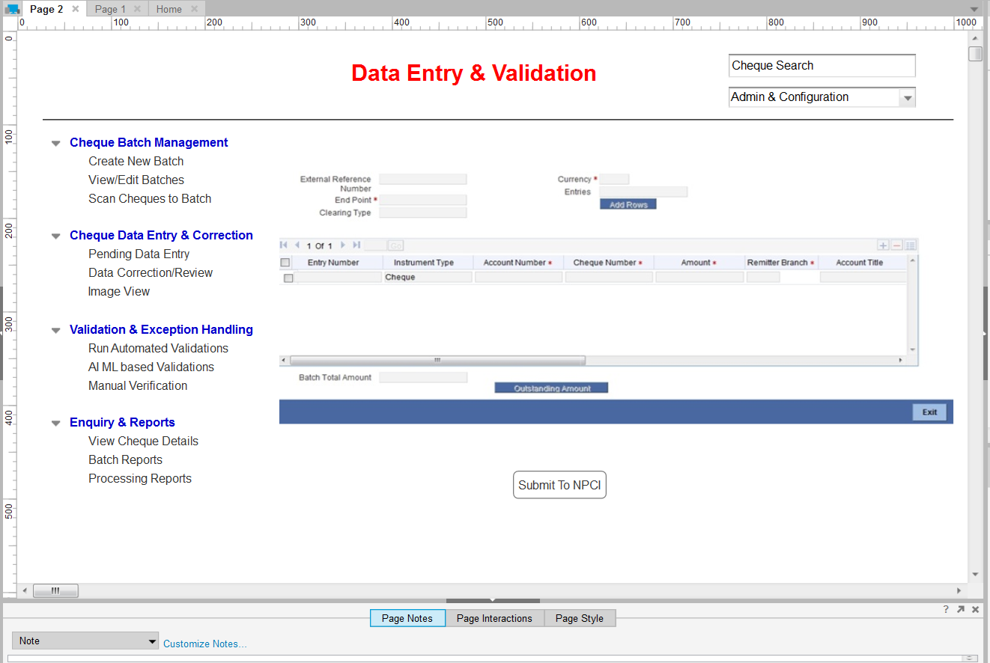
4.NPCI PROCESSING
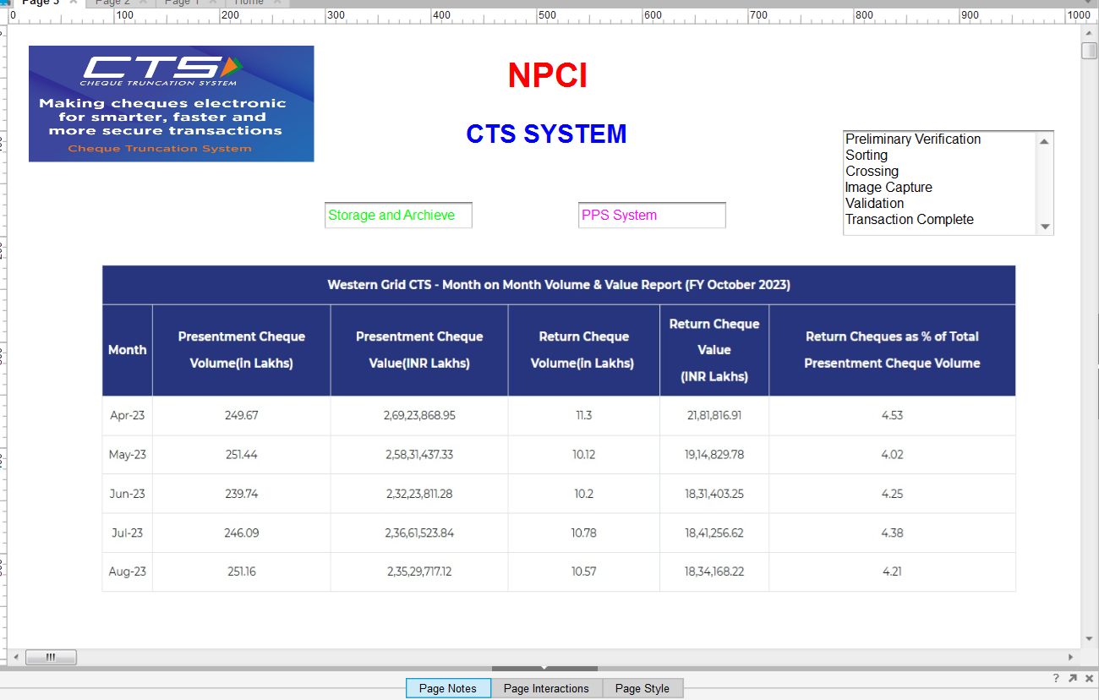
5. SIGNATURE VERIFICATION AND SETTLEMENT
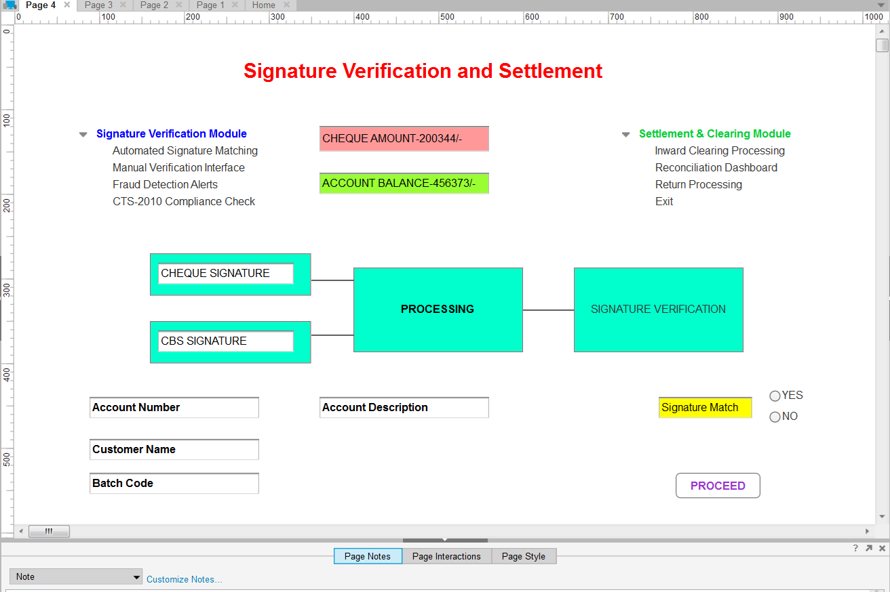

Document 8- Tools-Visio and Axure
Write a paragraph on your experience using Visio and Axure for the project.
Visio and Axure are essential tools for structuring and designing a Cheque Truncation System (CTS) project effectively. Visio is widely used for system modelling, allowing you to create Use Case diagrams to define user interactions and Activity diagrams to map transaction workflows. Its ability to visualize processes with swimlanes and structured layouts ensures clarity in cheque processing, clearing, and settlement operations. Axure, on the other hand, is ideal for UI design and prototyping, enabling interactive screens for cheque verification, settlement processing, and fund transfer interfaces. With its drag-and-drop functionality and real-time interactions, Axure helps create realistic user experiences that stakeholders can test before implementation. Combining these tools ensures a seamless transition from conceptual system design to functional UI development, making CTS implementation efficient and user-friendly.
Visio for Use Case & Activity Diagrams
- Use Case Diagrams: Helps visualize interactions between users (actors) and the system, defining functionalities like cheque processing, clearing, and settlement.
- Activity Diagrams: Represents the workflow of CTS transactions, including cheque scanning, validation, clearing, and return processing.
- Advantages:
  - Provides structured UML diagrams for system analysis.
  - Supports swimlanes for role-based workflows.
  - Ideal for process mapping and compliance tracking.
Axure for UI & Screens
- UI Mock-ups: Helps design interactive screens for cheque processing, verification, and settlement.
- Prototyping: Allows dynamic interactions like button clicks, form validations, and navigation flows.
- Advantages:
  - Supports drag-and-drop UI components for quick design.
  - Enables interactive prototypes without coding.
  - Useful for stakeholder presentations and usability testing.
Both tools complement each other visio ensures structured system design, while Axure brings UI concepts to life.

Document 9 – BA Experience Summary
1. Requirement Gathering Phase
- Used the MoSCoW prioritization technique (Must, Should, Could, Won’t) to classify and organize requirements.
- Faced client unavailability, so proactively coordinated with alternate contacts to gather essential information quickly.
- Validated captured requirements using the FURPS model (Functionality, Usability, Reliability, Performance, Supportability).
- Identified and eliminated duplicate/redundant requirements to ensure clarity and precision.
- Used prototyping to help clients visualize the system and refine unclear or abstract requirements.

2. Requirement Analysis Phase
- Created UML diagrams such as use case, class, and sequence diagrams for visual representation.
- Used Activity Diagrams to define and validate the business process flow.
- Shared diagrams with stakeholders and team members. Adjusted diagrams as per suggestions to reach consensus.
- Authored both the BRS (Business Requirement Specification) and SRS (Software Requirement Specification) documents.

3. Design Phase
- Generated test cases from use case diagrams to ensure comprehensive coverage.
- Maintained regular communication with clients to finalize design and solution documents.
- Wrote both positive and negative test cases to capture edge-case behaviours.
- Ensured no test case is skipped, knowing its future impact on development and testing accuracy.
- Created test data for various testing scenarios.
- Maintained and updated the Requirement Traceability Matrix (RTM) to ensure alignment of requirements and deliverables.

4. Development Phase
- Conducted and facilitated JAD (Joint Application Development) sessions for solution finalization.
- Acted as a bridge between tech and business by clarifying queries during development.
- Handled team conflicts during JAD sessions by initiating one-on-one discussions, promoting a healthy and collaborative environment.
- Used reference diagrams to help developers understand business logic and develop units accordingly.
- Organized regular meetings with the technical team and client despite challenges like team member availability; ensured session recordings and follow-ups with absent members.

5. Testing Phase
- Prepared test cases directly based on approved use cases.
- Performed high-level testing to verify end-to-end process flows and core business logic.
- Coordinated with the client to obtain test data and align on validation parameters.
- Ensured the RTM was updated post-testing to map each requirement with test outcomes.
- Obtained UAT signoff from the client post validation.
- Conducted UAT preparation sessions with the client and relevant stakeholders.

6. Deployment Phase
- Submitted the final RTM to the client and included it in the Project Closure Document.
- Coordinated and shared end-user manuals for customer onboarding and internal use.
- Planned and conducted training sessions for end users and client-side support staff.
- Ensured 100% attendance in training sessions by actively tracking and following up with all participants.

