Document 6- Please prepare a use case diagram, activity diagram and a use case specification document.
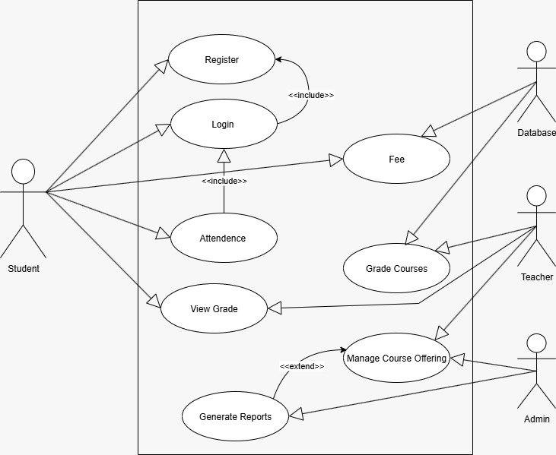
Answer 6: Use case diagram

For Student:
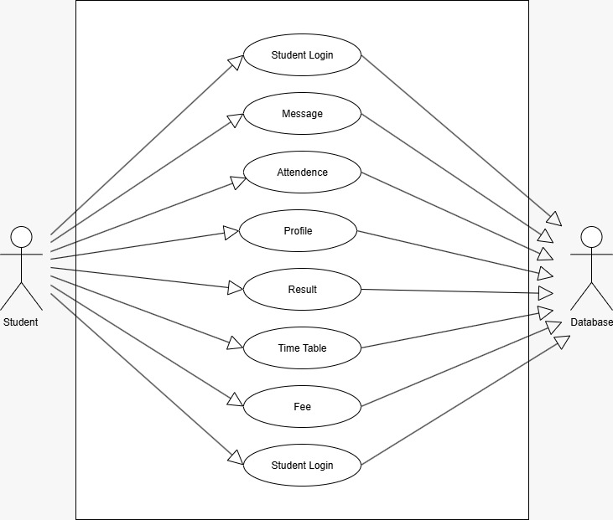
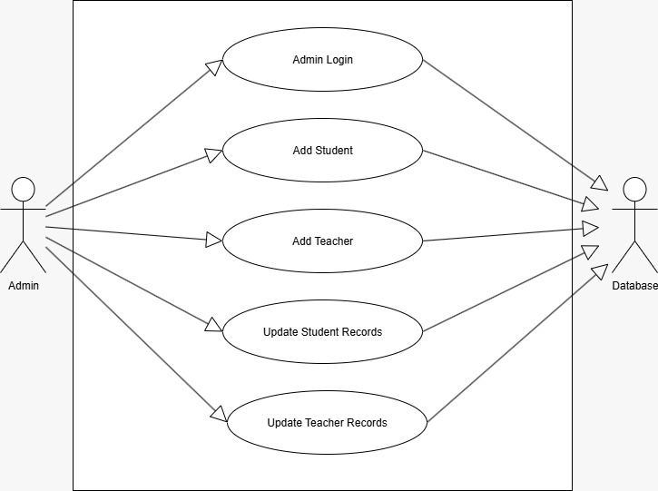
For Administrator:
Use case specification:
Use Case ID | UC001
Use Case Name | Student Registration
Created by | Campuslink Ltd. | Last Updated by | 18-July-2025
Date Created | 18-July-2025 | Last Revision Date | 18-July-2025
Actor | Student, Admin
Description | This use case allows students to register in the system by providing personal and academic details
Pre-condition | Student must have valid admission information and documents.
Post-condition | Success: Student registration is completed successfully and data is stored.  Failure: System shows error and student is not registered.
Basic Flow | - Student opens registration form.  - Enters personal and academic details.  - Uploads required documents.  - Clicks submit.  - Admin verifies and approves.
Alternative Flow | Admin enters student data manually.
Exceptions | Missing or invalid data triggers validation errors
Frequency of Use | High (during admission period)
Assumptions | Student has all required details and documents.

Use Case ID | UC002
Use Case Name | Mark Attendance
Created by | Campuslink Ltd. | Last Updated by | 18-July-2025
Date Created | 18-July-2025 | Last Revision Date | 18-July-2025
Actor | Faculty, Student
Description | Faculty marks student attendance in the system for each class.
Pre-condition | Faculty must be Logged in with valid credentials
Post-condition | Success: Attendance is saved in the database.  Failure: Attendance not recorded due to system or input error.
Basic Flow | - Faculty selects subject and class.  - Marks students as present/absent.  - Submits attendance
Alternative Flow | Admin marks attendance for faculty during emergency
Exceptions | System crash or connectivity issues.
Frequency of Use | Daily
Assumptions | Internet connectivity is available.

Use Case ID | UC003
Use Case Name | View Results
Created by | Campuslink Ltd. | Last Updated by | 18-July-2025
Date Created | 18-July-2025 | Last Revision Date | 18-July-2025
Actor | Student, Faculty
Description | Students and faculty can view academic results from the portal.
Pre-condition | Marks must be uploaded in the system
Post-condition | Success: Results are visible on screen.  Failure: Error in fetching or displaying results
Basic Flow | - Student logs in.  - Navigates to Results section.b  - Selects semester/subject.  - Views results.
Alternative Flow | Faculty views class performance through dashboard
Exceptions | Data not available or system error
Frequency of Use | Periodic (after exams)
Assumptions | Results are already entered into the system.

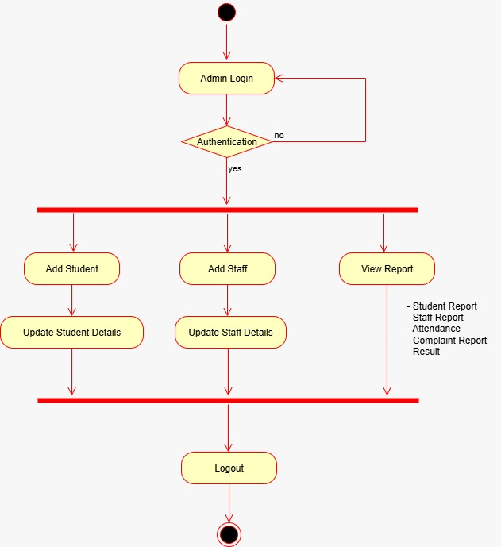
Activity diagram:
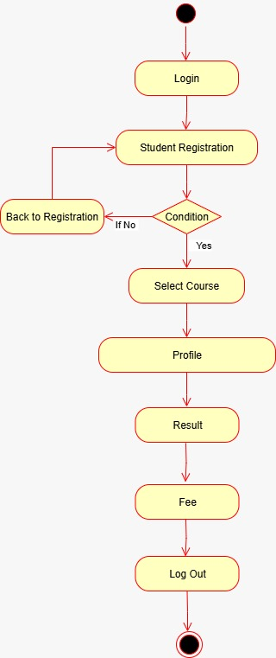
Document 7- Screens and pages
Answer 7:
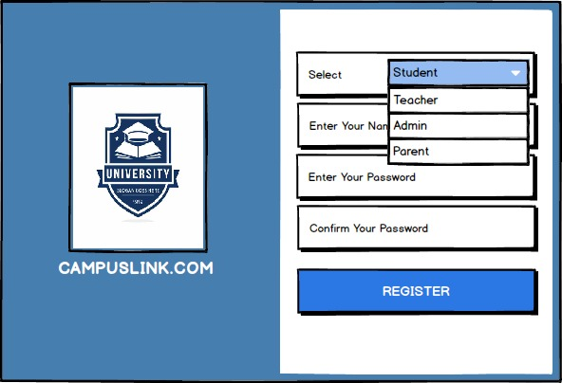
Registration page:

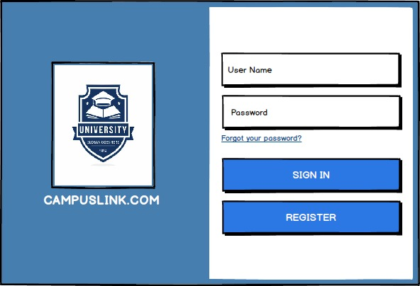
Login page:

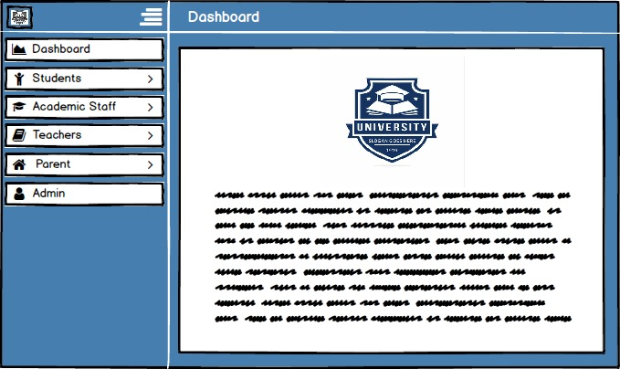
Dashboard:

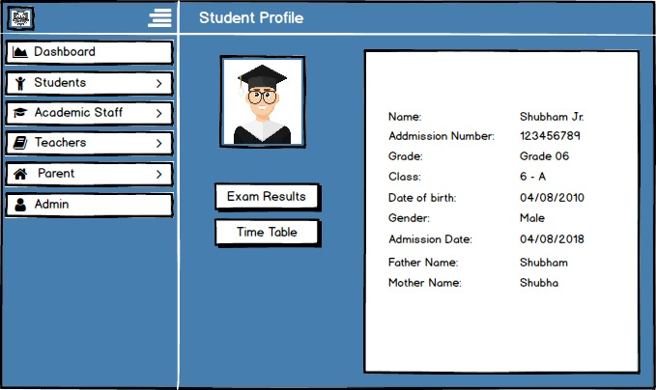
Student profile page:

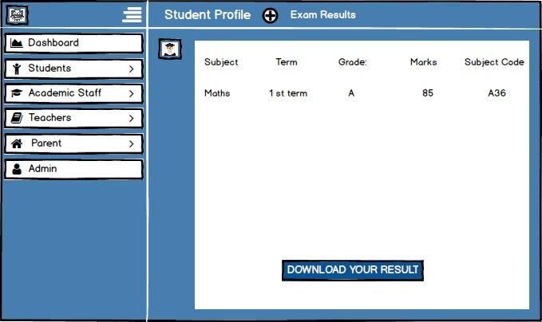
Results page:

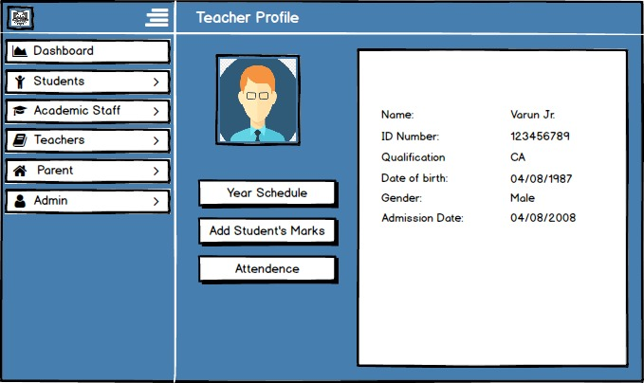
Teacher profile page:

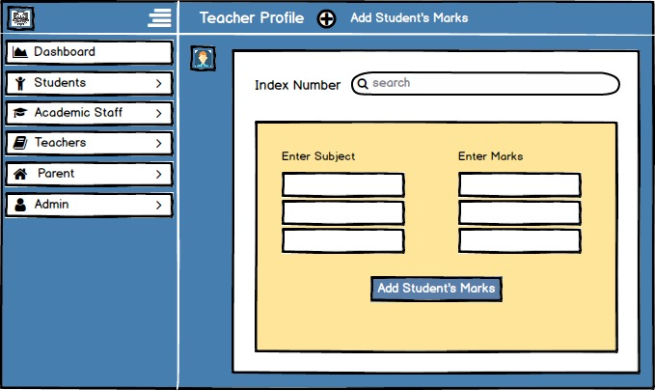
Students marks Update Page:

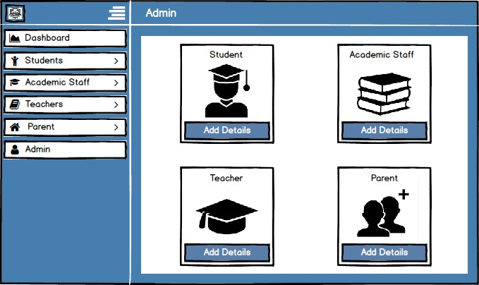
Admin Page:

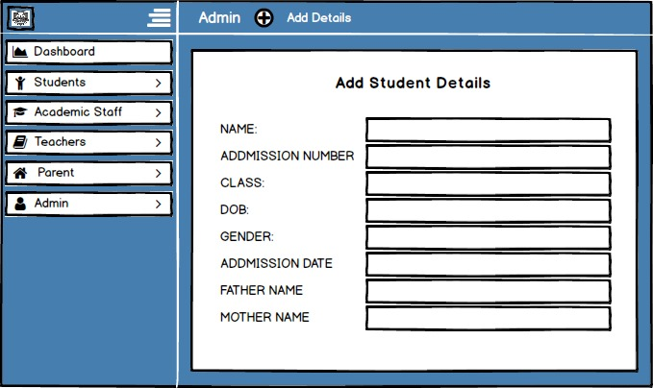
Students detail update page:

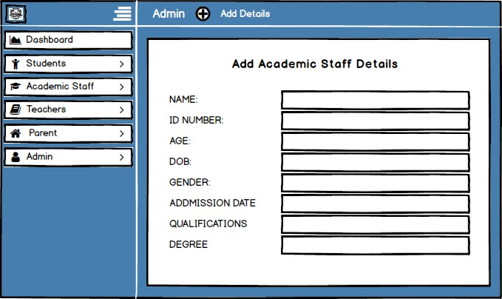
Administrative staff update page:

Document 8- Tools-Visio and Axure/Balasmiq
Answer 8:
For the Student Management Application project, I used Microsoft Visio, Balsamiq, and Axure RP to support the system design and documentation process. Visio was used to create professional diagrams such as the use case diagram, activity diagram, and business process models, which helped clearly represent the functional flow and interactions within the system. Balsamiq was helpful during the initial design phase for creating quick, low-fidelity wireframes to visualize basic layout ideas and get early feedback from stakeholders. After finalizing the structure, I used Axure RP to develop high-fidelity, interactive prototypes that simulated real system behavior, helping users understand how the final application would work. Using these tools together improved communication, ensured design clarity, and made the overall project planning and execution more efficient.

Document 9- BA experience
Answer 9:
My experience as BA in the following phases for the Student Management Application project:
- Requirement Gathering:
- For gathering requirements, I used the MoSCoW technique to prioritize features like online registration, attendance, fees tracking, and result viewing.
- Since stakeholders (faculty/admin) were occasionally unavailable, I identified alternate contacts from the institution to ensure timely inputs.
- I validated all collected requirements using the FURPS model, checking for functionality, usability, performance, reliability, and supportability.
- During this phase, I came across many duplicate and conflicting requirements, especially between admin and faculty expectations, which I resolved through discussion.
- I used prototyping with Axure and Balsamiq to present early wireframes. This helped stakeholders give more specific and refined requirements.

- Requirement Analysis:
- I created detailed UML diagrams like use case diagrams, activity diagrams, and AS-IS/TO-BE models using Visio to visually describe how the system would function.
- The activity diagram clearly mapped the step-by-step processes like student registration and fee tracking.
- I communicated all diagrams and requirement documents with the team and incorporated feedback from both technical and non-technical members.
- Prepared essential documents like the BRS (Business Requirement Specification) and SRS (Software Requirement Specification).

- Design:
- Based on use case diagrams, I prepared test cases covering student registration, attendance tracking, result viewing, grievance submission, and fee management
- Shared all design documents and solution overviews with the stakeholders for approval.
- Developed both positive and negative test cases to ensure robustness.
- Regularly updated the Requirement Traceability Matrix (RTM) to ensure all requirements were covered in the design and testing phase.
- Assisted the QA team by preparing test data relevant to student workflows.

- Development:
- Conducted and managed JAD (Joint Application Development) sessions to ensure the tech team understood all use cases clearly.
- Clarified queries from developers during coding, especially related to system workflows and rules (like attendance cutoff logic or late fee calculation).
- Addressed conflicts or confusion among team members by conducting one-on-one discussions to ensure team alignment and smooth progress.
- Provided all diagrams and documents as reference materials for developers during coding.
- Coordinated with both technical and institutional stakeholders for feedback and weekly reviews.

- Testing:
- Derived test cases directly from use cases to ensure complete coverage of student-side and admin-side functionalities.
- Performed high-level testing and helped identify bugs and flow mismatches.
- Worked closely with the client to get UAT (User Acceptance Testing) readiness by preparing them with sample scenarios and walkthroughs.
- Took sign-off on RTM and test results before final rollout.
- Ensured all fixes were tested and retested before UAT.

- Deployment:
- Forwarded the final RTM and closure documents to the institution for records.
- Coordinated with the tech team to prepare user manuals for students, faculty, and admin users.
- Organized training sessions and live demo meetings to ensure all users understood the application usage.
- Ensured all important staff members attended the final handover and training sessions.

