Online Agriculture Products Store
Question 1 – Write Agile Manifesto – 8 Marks
Ans: Agile
Agile is lightweight and can be applied in situations that demand quicker delivery. Documentation is not necessary in Agile. Customer retention is enhanced due to the absence of documentation. Agile lacks support for scalability and extensibility.
Twelve principles of Agile Software
1. Deliver value to the customer through early and ongoing software releases.
2. Embrace changing requirements, even if they arise late in the development process. Agile methodologies leverage change to provide a competitive edge for the customer.
3. Release functional software regularly, ranging from a few weeks to a couple of months, with a preference for shorter intervals.
4. Business stakeholders and developers should collaborate daily throughout the duration of the project.
5. Organize projects around motivated individuals. Provide them with the necessary environment and support, and trust them to accomplish their tasks.
6. The most effective way to share information within a development team is through face-to-face communication.
7. The primary indicator of progress is working software.
8. Agile methodologies encourage sustainable development. Sponsors, developers, and users should be able to maintain a consistent pace indefinitely.
9. Continuous focus on technical excellence and sound design improves agility.
10. Simplicity, or the art of maximizing the amount of work not performed, is crucial.
11. The best architectures, requirements, and designs arise from self-organizing teams.
12. At regular intervals, the team assesses how to enhance its effectiveness and then adjusts its practices accordingly.

Question 2 – User Stories- Acceptance Criteria-BV-CP – 40 Marks
USER STORIES AND THEIR ACCEPTANCE CRITERIA

Story 1
- Issue Type: Story
- Summary: Delivery Boy Registration
- Description:
As a Delivery Boy
I want to register in Scrum Foods
So that I can deliver customer orders
- Acceptance Criteria:
  - Registration screen with fields: Name, Password, Nation ID, Mobile No, Email, Address, Phone Number
  - Click on Register button
  - Show success notification
- Business Value (BV): 500
- Complexity Points (CP): 2
- Priority: Highest
- Labels: registration, delivery boy

Story 2
- Issue Type: Story
- Summary: Customer Login Functionality
- Description:
As a Customer
I want to log in to Scrum Foods
So that I can place food orders
- Acceptance Criteria:
  - Login screen with username and password fields
  - Forgot password link available
  - Redirect to dashboard after login
- BV: 400
- CP: 2
- Priority: High
- Labels: login, customer

Story 3
- Issue Type: Story
- Summary: Add Restaurant Details
- Description:
As a Restaurant Admin
I want to add restaurant information
So that customers can view my menu
- Acceptance Criteria:
  - Form includes Name, Address, Contact, Cuisine Type, Timings
  - Upload menu file
  - Show confirmation
- BV: 450
- CP: 3
- Priority: High
- Labels: restaurant, admin

Story 4
- Issue Type: Story
- Summary: Browse and Order Food
- Description:
As a Customer
I want to browse restaurants and food items
So that I can place orders online
- Acceptance Criteria:
  - Restaurant list with filter options
  - Menu items with "Add to Cart"
  - Checkout and order confirmation
- BV: 600
- CP: 3
- Priority: Highest
- Labels: order, food

Story 5
- Issue Type: Story
- Summary: Make Online Payment
- Description:
As a Customer
I want to make a secure payment
So that I can confirm my food order
- Acceptance Criteria:
  - Multiple payment methods (Card, UPI, Wallet)
  - Secure payment gateway
  - Show success/failure message
- BV: 550
- CP: 3
- Priority: High
- Labels: payment

Story 6
- Issue Type: Story
- Summary: Real-Time Order Tracking
- Description:
As a Customer
I want to track my food delivery
So that I know when it will arrive
- Acceptance Criteria:
  - Real-time map view
  - Delivery status updates
  - Contact delivery boy button
- BV: 500
- CP: 3
- Priority: Medium
- Labels: tracking, delivery

Story 7
- Issue Type: Story
- Summary: Submit Customer Feedback
- Description:
As a Customer
I want to provide feedback
So that I can share my service experience
- Acceptance Criteria:
  - 1–5 star rating and comment box
  - Submit button
  - Feedback stored in system
- BV: 300
- CP: 2
- Priority: Medium
- Labels: feedback

Story 8
- Issue Type: Story
- Summary: Admin View Orders Dashboard
- Description:
As an Admin
I want to view all orders
So that I can manage delivery flow
- Acceptance Criteria:
  - Filter by date, status, customer
  - Update order status
  - Export data option
- BV: 400
- CP: 3
- Priority: High
- Labels: admin, dashboard

Story 9
- Issue Type: Story
- Summary: Delivery Boy View Assigned Orders
- Description:
As a Delivery Boy
I want to see my orders
So that I can deliver them on time
- Acceptance Criteria:
  - Show active and past orders
  - Map with delivery route
  - Status update button
- BV: 450
- CP: 3
- Priority: High
- Labels: delivery, orders

User Story 1 – Delivery Boy Registration
Field | Details
Summary | Delivery Boy Registration
As a | Delivery Boy
I want to | Register in Scrum Foods
So that | I can deliver customer orders
Acceptance Criteria | Registration screen with fields: Name, Password, Nation ID, Mobile No, Email, Address, Phone Number; Register button; Show success notification
BV | 500
CP | 2
Priority | Highest
Labels | registration, delivery boy

User Story 2 – Customer Login Functionality
Field | Details
Summary | Customer Login Functionality
As a | Customer
I want to | Log in to Scrum Foods
So that | I can place food orders
Acceptance Criteria | Login screen with username & password; Forgot password link; Redirect to dashboard
BV | 400
CP | 2
Priority | High
Labels | login, customer

User Story 3 – Add Restaurant Details
Field | Details
Summary | Add Restaurant Details
As a | Restaurant Admin
I want to | Add restaurant information
So that | Customers can view my menu
Acceptance Criteria | Form with Name, Address, Contact, Cuisine Type, Timings; Upload menu; Confirmation shown
BV | 450
CP | 3
Priority | High
Labels | restaurant, admin

User Story 4 – Browse and Order Food
Field | Details
Summary | Browse and Order Food
As a | Customer
I want to | Browse restaurants and food items
So that | I can place orders online
Acceptance Criteria | Restaurant list with filters; Menu with "Add to Cart"; Checkout; Order confirmation
BV | 600
CP | 3
Priority | Highest
Labels | order, food

User Story 5 – Make Online Payment
Field | Details
Summary | Make Online Payment
As a | Customer
I want to | Make a secure payment
So that | I can confirm my food order
Acceptance Criteria | Payment via Card/UPI/Wallet; Secure gateway; Show success/failure message
BV | 550
CP | 3
Priority | High
Labels | payment

User Story 6 – Real-Time Order Tracking
Field | Details
Summary | Real-Time Order Tracking
As a | Customer
I want to | Track my food delivery
So that | I know when it will arrive
Acceptance Criteria | Real-time map; Delivery status updates; Contact delivery boy button
BV | 500
CP | 3
Priority | Medium
Labels | tracking, delivery

User Story 7 – Submit Customer Feedback
Field | Details
Summary | Submit Customer Feedback
As a | Customer
I want to | Provide feedback
So that | I can share my service experience
Acceptance Criteria | 1–5 star rating; Comment box; Submit button; Store feedback
BV | 300
CP | 2
Priority | Medium
Labels | feedback

User Story 8 – Admin View Orders Dashboard
Field | Details
Summary | Admin View Orders Dashboard
As a | Admin
I want to | View all orders
So that | I can manage delivery flow
Acceptance Criteria | Filter by date, status, customer; Update order status; Export option
BV | 400
CP | 3
Priority | High
Labels | admin, dashboard

User Story 9 – Delivery Boy View Assigned Orders
Field | Details
Summary | Delivery Boy View Assigned Orders
As a | Delivery Boy
I want to | See my orders
So that | I can deliver them on time
Acceptance Criteria | Show active/past orders; Map with route; Status update button
BV | 450
CP | 3
Priority | High
Labels | delivery, orders

Question 3– What is epic? Write 2 epics – 5 Marks
Ans : An Epic in Agile refers to a substantial piece of work that can be divided into smaller tasks known as User Stories. Epics represent high-level features or requirements that provide considerable value to the user. Due to their size, they are generally not feasible to finish within a single sprint and are often distributed over several sprints. Epics help in managing large, complex functionalities.
• They offer a broad overview prior to exploring detailed stories.
• Epics are frequently aligned directly with features or modules within a product.
Epic 1: User Registration and Authentication
Epic Name: Account Creation and Secure Login
Epic Description:
As a new user of the Scrum Foods app, I want to register myself and securely log in, so that I can personalize my experience and access all features of the food delivery system.
Acceptance Criteria:
- Users must be able to register using mobile number, email, or social logins.
- Users must receive OTP/email confirmation for verification.
- Passwords must be securely encrypted.
- Users must be able to log in with valid credentials.
- Invalid login attempts should show error messages.
- A ‘Forgot Password’ option should be available.
Related User Stories:
- As a user, I want to register with my email/mobile and password.
- As a user, I want to receive a confirmation message after registering.
- As a user, I want to log in with my credentials.
- As a user, I want to reset my password via email or OTP.
Epic 2: Order Placement and Checkout
Epic Name: Place and Pay for Food Orders
Epic Description:
As a customer, I want to browse the menu, select items, place an order, and pay online, so that I can quickly get my desired food delivered to my location.
Acceptance Criteria:
- Users should be able to browse restaurants and menus.
- Users must be able to add/remove items from the cart.
- The total price and taxes should be calculated correctly.
- Users must choose delivery address and time slot.
- Users should be able to pay via credit card, debit card, UPI, wallet, or cash on delivery.
- Users should receive order confirmation and invoice.
Related User Stories:
- As a user, I want to search and filter restaurants by cuisine or rating.
- As a user, I want to add items to my cart with quantity adjustments.
- As a user, I want to choose my preferred payment option.
- As a user, I want to receive a confirmation after placing my orders.
Question 4 –What is the difference between BV and CP – 2 Marks
1. BV - BV refers to business value, which is assigned by the client based on the significance of the task. Business Value indicates how crucial this feature (user story) is to the business. This is assessed using Scrum Currency Notes, which include denominations of Rs 1000, Rs 500, Rs 100, Rs 50, Rs 20, and Rs 10.
2. CP - CP, also known as Story Points (SP), represents the effort required by Scrum Developers to implement this feature (user story) utilizing technology. The effort encompasses the time needed to address complexity and write the code. CP is estimated by the Scrum Developers through the use of Poker cards, which feature values of “?”, 1, 2, 3, 5, 8, 13, 20, 40, 100, and BIG.
Question 5 –Explain about Sprint– 5 Marks Ans :
Sprints are defined as time-boxed iterations within a continuous project development cycle—these are short, repeatable phases that typically span from one to four weeks. They are fundamental to Agile and Scrum methodologies, which decompose large, complex product development projects into smaller, more manageable components.
Sprint Backlog
• A Sprint is a time-constrained iteration in Agile, usually lasting between 1 and 4 weeks.
• It enables teams to construct and deliver small, functional segments of the product.
• Each Sprint incorporates Scrums (daily stand-up meetings) to assess progress and identify any obstacles.
• Sprint Duration: 2 weeks
• Scrum Duration: 1 day

Sprint Backlog Example:
PBI | TASKS | WIP | DONE
Registration | 3 | 2 | 1
Login | 2 | 2 | 0
Add Restaurants | 3 | 3 | 0
Order Food | 3 | 3 | 0
Make Payment | 3 | 3 | 0
Track Delivery | 3 | 3 | 0
Customer Feedback | 2 | 2 | 0
1. Sprint and Scrum Duration and Value
Term | Description | Duration | Your Value
Sprint | A time-boxed iteration | 2 Weeks | Your Sprint Value: 2 Weeks
Scrum | Daily team meeting within a Sprint | 1 Day | Your Scrum Value: 1 Day

Question 6 – Explain Product backlog and sprint back log– 5 Marks
Product Backlog - The product backlog is a compilation of all tasks and user stories necessary for the completion of the entire project. However, it is more than just a basic task list. A well-structured product backlog dissects each item into a sequence of steps that assist the development team.
Sprint backlog : A portion of the product backlog chosen for a specific sprint. It consists of tasks that can be finished within that sprint and does not change throughout the sprint.
Question 7 – What is impediments log? write 2 impediments – 5 Marks
Ans : Impediments : In the context of Scrum, these are referred to as "blockers" that hinder the Scrum Team from finishing their tasks, which subsequently affects their velocity. Any factor that obstructs the team from performing their duties is deemed an impediment. Impediments are essentially hurdles or obstacles, and they are documented in Impediment Logs. These "blockers" inhibit the Scrum Team from accomplishing their work and must be recorded in the impediment logs. Every challenge encountered by the team will be noted in the impediments log.

Question 8 – Explain Velocity of the Team – 1 Marks

Ans : Team velocity is defined as a "metric that quantifies the volume of work a team can accomplish within a single sprint and serves as a crucial indicator in Scrum." Upon finishing a sprint, you will sum the points for all user stories that are fully completed and, over time, calculate the average number of points you achieve per sprint.
Velocity – How many Complexity Points is covered in this sprint. Velocity of team is 8

Question 9 – Draw Sprint Burn Charts n Product Burn Down Charts– 3 Marks
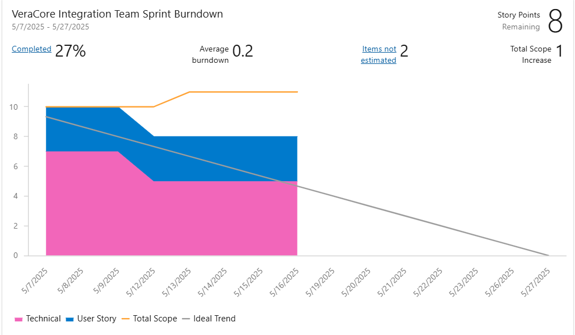

Sprint Burndown Chart. This chart illustrates your team's advancement towards achieving the sprint goal throughout the 2-week duration. The blue line indicates the actual work accomplished, while the green dashed line represents the ideal pace of progress.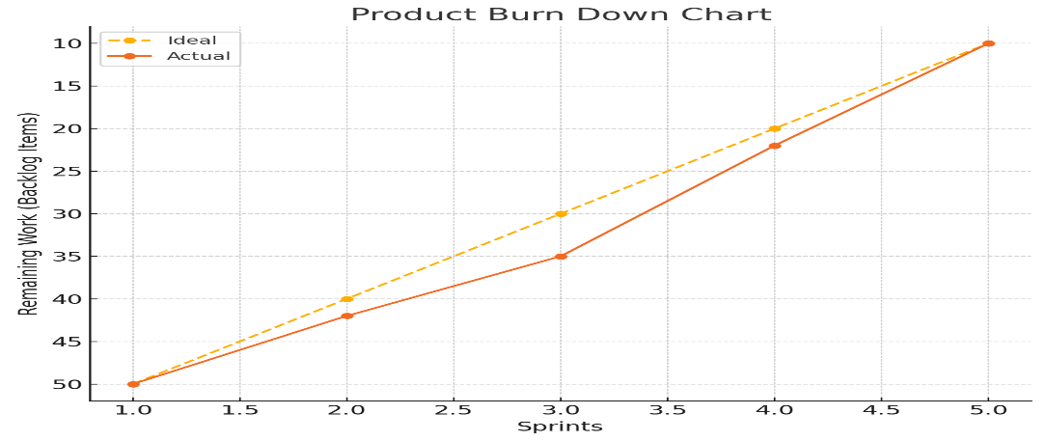

Question 10 – Explain about Product Grooming – 2 Marks
Ans -Product Grooming / Product Refinement
Product Grooming refers to the session where the project's or product's vision or objectives are discussed, along with identifying the target audience and the market segment the product aims to serve. It involves understanding the needs and solutions that the product must provide, as well as the benefits that clients will receive.
Additionally, it is essential to identify the EPICs from the product backlog. Product grooming is a process that involves planning the project and comprehending the requirements. Therefore, product grooming encompasses the refinement needed to grasp what stakeholders require, the reasons behind those requirements, and the value that needs to be added.

Question 11 – Explain the roles of Scrum Master and Product Owner – 3 Marks
• The Scrum Master is responsible for implementing Scrum as outlined in the Scrum Guide. They achieve this by assisting everyone in grasping Scrum theory and practice, both within the Scrum Team and across the organization.
• The Product Owner is responsible for maximizing the value of the product that results from the efforts of the Scrum Team. The Product Owner is an individual, not a committee.
• Scrum Master - The daily responsibilities of a Scrum Master involve servant leadership, which includes performance planning, coaching, fostering self-organization, eliminating obstacles, resolving conflicts, and supporting the team.
• Product Owner - The primary duty of the Product Owner is to ensure customer satisfaction, which they accomplish by prioritizing customer requirements and maintaining transparency between the development team and stakeholders.
The product owner guarantees stakeholder satisfaction by ensuring product success, and building a product which meets business requirements.
Both the Product Owner and the Scrum Master are essential members of a Scrum project team, as they foster an ideal relationship with the development team and work diligently to produce the best outcomes.

Question 12 – Explain all Meetings Conducted in Scrum Project – 8 Marks
Ans : There are five types of scrum meetings held during the scrum process which are as follows.
- Sprint Planning Meeting
- Daily Scrum Meeting
- Sprint Review Meeting
- Sprint Retrospective Meeting
- Backlog Refinement Meeting

● Sprint Planning Meeting :
This meeting starts with the Product Owner. During this session, the PO articulates their vision and outlines how the team should approach this phase of the project. Team members then determine the volume of work they can accomplish within the sprint. Additionally, this is when tasks are transferred from the Product Backlog to the Sprint Backlog. This phase necessitates extensive planning and may require several hours for the team to finalize the Sprint.

Daily Scrum Meeting :
Following the planning meeting, we transition into the daily scrum meetings. Each day, for 15 minutes, the team convenes to discuss any challenges or updates regarding their tasks. Although brief, this meeting is a crucial component of the scrum framework. It aims to ensure that all team members remain aligned and focused..
Daily Stand-up Meeting
At the conclusion of each Scrum, Scrum Developers will engage in a Scrum meeting. During this meeting, they are required to respond to three questions: a. What task did you work on during this Scrum? b. What task will you tackle in the next Scrum? c. Are there any challenges or impediments? When do you expect to complete the user story?

Sprint Review Meeting:
This meeting serves to present a live demonstration of the completed work. The Product Owner, Scrum Master, and stakeholders are present to evaluate the product and recommend changes or enhancements. They will review the Velocity – the number of CP covered in this sprint, as well as the Sprint Burn Down Chart.

Sprint Retrospective Meeting:
This meeting is conducted to encourage the team to reflect on their progress. Team members discuss their organizational concerns and teamwork openly. It is essential that the dialogue remains friendly, non-judgmental, and impartial. This review session is crucial for team building and development, and it plays a significant role in future Scrum projects.

Backlog Refinement Meeting:
Finally, we have the backlog refinement meeting. In this session, team members concentrate on the quality and skill involved in the work during the sprints. This meeting is vital for business owners to engage with the development team and assess the quality of the final product. It involves significant reflection on the team backlogs.

Question 13 – Explain Sprint Size and Scrum Size– 2 Marks
Ans :
Sprint Size: The entire idea of a sprint is to pinpoint user stories that the scrum team will focus on and finish within a designated sprint duration. This is commonly referred to as the sprint length. Sprints can last a maximum of 1, 2, 3, or 4 weeks. Any duration exceeding 4 weeks does not align with agile scrum project management.
Scrum Size : Scrum Team size can 8 to 10 people.
Product Owner
Scrum Master
Developers 8

Question 14 – Explain DOR and DOD – 2 Marks

Ans. Definition of Ready (DOR): refers to an agreement between the product owner and the team to establish a guideline known as the "Definition of Ready". This guideline ensures that the items prioritized at the top of the backlog are adequately prepared to be included in a sprint, allowing the development team to confidently commit to and complete them by the end of the sprint. The concept of the "Definition of Ready" is not explicitly outlined in the Scrum Guide, unlike user stories and their associated Acceptance Criteria.
Definition of Done (DOD): The Definition of Done is organized as a checklist of criteria, each designed to validate a user story or Product Backlog Item (PBI). This checklist ensures that the Development Team has a shared understanding of the quality standards they aim to achieve. It is utilized to verify the completeness of each Product Backlog Item or User Story.

Question 15 – Explain Prioritization Techniques and MVP – 3 Marks Ans.
ANS:
The prioritization of requirements is a crucial element in all software development methodologies, but it holds particular significance in Agile software development. When discussing the activities of a Product Owner in Scrum, such as "Ordering items in the Product Backlog to best achieve mission and objectives", "Demonstrating what the Scrum Team will focus on next", and "Enhancing the quality of the work performed by Developers", we are essentially referring to workload prioritization. Consequently, we tackle the prioritization challenge on two levels:
Product level: Evaluate which elements of the product might contribute more to the project's major aims.
Tasks level: Specify which work items must be completed and in what sequence during the software product development cycle.
Types of Agile Prioritisation Techniques.
MoSCoW Agile Prioritization Techniques The MoSCoW analysis is a prioritization method for business analysts, as recommended in the IIBA BABOK and originating from the DSDM (Dynamic Systems Development Method) software development approach. This technique suggests that a set of requirements or user stories should be classified into four distinct categories:
M: Must. This indicates a requirement that is essential for the final solution to be considered successful.
S: Should. This signifies a high-priority element that should be included in the solution if possible. While this is often a critical requirement, it can be fulfilled in alternative ways if absolutely necessary.
C: Could. This refers to a requirement that is desirable but not essential. It will be included if time and resources permit.
W: Would. This denotes a request that stakeholders have agreed will not be implemented in the current release but will be considered in the future.
Once the requirements are categorized into these four groups, they are prioritized within each category.
Priority Poker - Priority poker is a straightforward design game aimed at ranking items based on their significance. The name 'priority poker' is derived from its resemblance to poker arrangement, a method commonly used in Agile development projects to assess the costs of user stories.
Before initiating the game, the moderator gathers all individuals who should participate in the prioritization process, including stakeholders, product managers, strategists, programmers, domain experts, and occasionally consumers.
Cost of Delay - This Agile prioritization technique is a method that helps you assess the potential financial loss if specific features are not available. In essence, you are aligning yourself with those who are addressing urgent issues. Consequently, it becomes a proactive effort to ensure that there are no situations that result in financial losses.
MVP (Minimum Viable Product), the Foundation of the Agile Methodology. An MVP is a concept from agile scrum that denotes a product with just enough features to meet the needs of early adopters and, more importantly, provide them with something to offer feedback on to influence the product's future.

Question 16 – Difference between Business Analyst n Product Owner – 3 Marks
Product Owner - The Business Analysts create a vision for the product by considering their domain and industry experience along with market demands. Their responsibility is to guarantee that the product aligns with market and stakeholder requirements; they perform market analysis and subsequently conduct an enterprise SWOT analysis to formulate the product vision.
- Market Analysis
- Analysis of market need/demand
- Availability of similar products in the market
- Underserved customer needs
- Potential trends in synergy with current offerings.
- Enterprise Analysis
- SWOT analysis
Business Analyst: serve as the catalysts for change, adept problem solvers, inquisitive questioners, and facilitators, acting as a link between users/stakeholders and the Agile team. They challenge assumptions and requirements, evaluate needs, identify gaps, and collaborate closely with stakeholders/SMEs to elaborate on the requirements, features, user stories, and to comprehend and elicit the necessary requirements.
They work closely with the Product Owners to manage the user stories and epics.
- Requirements modeling and elicitation
- Data flow diagrams
- Business rules
- Dependency mapping
- Smooth execution of the sprints
- Requirements clarification to the team
Critical Responsibilities for Business Analysts
- Managing User Stories
- Prioritizing the user stories
- Clearing the impediments if any
- Detailing the Requirements as per the Stakeholders’ Needs and Expectations
- Requirements elicitation
- Business rules
- Modeling

Question 17 – Prepare a sample Resume of 3yrs exp Product Owner
Answer:
Name: Kanika Jagtap
Phone: +91-6265587734
Email: kanikaj@gmail.com
Location: Pune, India
LinkedIn: linkedin.com/in/kanika7516

Professional Summary
Certified Product Owner with 3 years of experience in Agile environments, skilled at managing product backlogs, defining user stories, and collaborating with cross-functional teams to deliver customer-centric products. Adept in Scrum practices, stakeholder management, and driving continuous improvement.

Skills
- Agile/Scrum Methodology
- Product Backlog Management
- User Story Writing & Prioritization
- Sprint Planning & Execution
- Stakeholder Communication
- JIRA, Confluence, Trello
- MVP Definition
- Product Road mapping
- Wireframing (Balsamiq, Figma)

Certifications
- Certified Scrum Product Owner (CSPO) – Scrum Alliance
- Agile Business Analyst – COEPD (2024)

Professional Experience
Product Owner
Scrum Foods Pvt. Ltd., Hyderabad
Mar 2022 – Present
- Owned and managed the product backlog for a food delivery application.
- Defined Epics, User Stories, and Acceptance Criteria aligned with business goals.
- Collaborated with UI/UX teams for feature designs and wireframes.
- Prioritized backlog using MoSCoW and Kano models for MVP planning.
- Facilitated daily scrums, sprint planning, reviews, and retrospectives.
- Worked with QA to define test cases and UAT scenarios.
- Increased delivery efficiency by 25% through effective backlog grooming.
Associate Product Owner
AgriMart Solutions, Bengaluru
Feb 2021 – Feb 2022
- Supported the senior PO in managing the online agriculture store platform.
- Conducted requirement elicitation sessions with stakeholders and end-users.
- Maintained sprint burndown charts and participated in all Scrum ceremonies.
- Translated business requirements into functional and non-functional requirements.
- Monitored development progress and removed impediments with the Scrum Master.

Education
B.Tech – Information Technology
Osmania University, Hyderabad – 2020

