Question 1– Audits
4 Quarterly Audits are planned Q1, Q2, Q3, Q4 for this Project What is your knowledge on how these Audits will happen for a BA?
An audit in the context of a Business Analyst refers to a structured review process that evaluates the effectiveness, accuracy, and compliance of business analysis activities within a project or organization. These audits ensure that the BA's work aligns with industry standards, stakeholder expectations, and project objectives.

Quarter 1-Audit Report
Requirement Gathering Phase
- BRD Template
- Elicitation result reports
- Duplicate requirements report.
- Grouping of functionalities / Features
- Client signoff

Quarter 2 -Audit Report
Requirement Analysis Phase

- UML diagrams
- Business to functional requirements mapping.
- Client signoff documents
- RTM document version control

Quarter 3 - Audit Report
Design Phase

- Utilization of tools
- Documented evidence on client communication
- Stakeholder MOM
Quarter 4 - Audit Report
Development & Testing
- JAD session report
- End user manual preparation document.
- BA and developer MOM.
- Test case summary.
- Training report to end user.
- Lessons learnt document.
- Email communication.

Question 2 – BA Approach Strategy
Business Analyst Approach Strategy
As a Business Analyst, ensuring a structured approach to project execution is crucial for successful delivery. Here’s a detailed strategy outlining the steps, methodologies, and techniques to be followed before kicking off the project.
1. Elicitation Techniques
Elicitation is the process of gathering requirements from stakeholders. The most effective techniques for this project include:
Interviews: Conduct direct discussions with stakeholders to understand the project vision and business needs.
Workshops: Organize sessions with the technical team to ensure alignment on feasibility.
Document Analysis: Study existing business models, policies, or any reference materials related to online agricultural platforms.
Prototyping: Create wireframes and mock-ups to validate requirements.
Observation: Understand how farmers procure products traditionally to identify pain points.

2. Stakeholder Analysis
Identifying stakeholders and their influence on the project is critical:
Primary Stakeholders: Mr. Henry, Peter, Kevin, Ben (representing farmers).
Project Team: Developers, Testers, DB Admin, Network Admin.
Financial & Decision Makers: Committee Members (Mr. Henry, Mr. Pandu, Mr. Dooku).

RACI Matrix (Responsibility Assignment)
A RACI (Responsible, Accountable, Consulted, Informed) model ensures clarity in roles:
Responsible–BA, Project Manager, Developers.
Accountable – Delivery Head (Mr. Karthik).
Consulted– Stakeholders, Subject Matter Experts.
informed – Committee, Clients.

3. Documentation to Prepare
Business Requirement Document (BRD) – Captures high-level business needs.
Functional Requirement Document (FRD) – Defines system functionalities.
Use Case Diagrams & Activity Diagrams – Visually represent system interactions.
User Stories Describe how different users will interact with the application.
Process Flow & Data Flow Diagrams – Outline workflows and data movement.
Traceability Matrix – Ensures requirements align with deliverables.
4. Approval and Sign-off Process
To ensure smooth execution, approvals must be obtained at different phases:
BRD Sign-off: The client reviews requirements for completeness before development begins.
FRD Approval: Validate technical feasibility.
Wireframe & Prototype Approval: Ensure the usability of the application.
UAT Client Acceptance: Final client validation before deployment.
How to Secure Approvals?
Formal client meetings.
Email confirmation and recorded agreements.
Digital signatures on approved documents.

5. Communication Strategy
Effective communication ensures transparency and progress tracking:
Tools: Microsoft Teams, Slack, Email.
Meeting Cadence: Weekly updates, sprint reviews, stakeholder meetings.
Reports: Status updates, risk logs, impact analysis.
Escalation Path: Defined workflow for conflict resolution.
6. Managing Change Requests
Change is inevitable. A well-defined process is required:
Identify & Document Change – Capture proposed alterations.
Analyse Impact – Assess cost, timeline, and scope.
Secure Approval – Ensure client validation.
Implement & Track – Update project plans accordingly.

7. Project Tracking & Status Updates
Keep stakeholders informed through:
Dashboards & Reports – Real-time updates via tracking tools.
Sprint Demos – Showcase incremental progress.
Feedback Mechanism – Stakeholders contribute to refinements.

8. UAT & Project Sign-off
Final validation ensures all requirements meet client expectations:
Conduct User Acceptance Testing (UAT) – Validate application with farmers.
Document Client Project Acceptance Form – Obtain formal approval.
Handover & Training – Ensure users understand system functionality.
Question 3 – 3-Tier Architecture
3-Tier Architecture is a client-server architecture divided into Presentation, Business Logic, and Data Access layers. It enhances scalability, maintainability, and separation of concerns.
1. Presentation Layer – User Interface (e.g., website or mobile app)
2. Business Logic Layer – Application logic (e.g., Java code validating transactions)
3. Data Layer – Database (e.g., MySQL storing product details)
This structure allows each layer to be developed, updated, and scaled independently.
Question 4 – BA Approach Strategy for Framing Questions
Framing questions effectively involves techniques like 5W1H, SMART goals, RACI analysis, and using visual models to extract clear requirements.
1. 5W1H – What, Why, Who, When, Where, How
2. SMART – Specific, Measurable, Achievable, Relevant, Time-bound
3. RACI Matri – Define roles clearly
4. Use Case Specs – Understand stakeholder interaction with system
5. Activity Diagrams and Models – Visualize processes before questioning
6. Mockups /Page Design – Helps stakeholders visualize end result.
Question 5 – Elicitation Techniques
Elicitation techniques are methods used by BAs to gather information from stakeholders. Examples include Interviews, Brainstorming, Document Analysis, and Prototyping
The techniques I’m aware of are:
B – Brainstorming
D – Document Analysis
R – Reverse Engineering
F – Focus Groups
O – Observation
W – Workshops
J – JAD (Joint Application Development)
I – Interview
P – Prototyping
Q – Questionnaire
U – Use Case Modelling
Question 6 – This project Elicitation Techniques
Selecting appropriate elicitation techniques depends on stakeholder availability, project complexity, and required clarity.
For this project, the following techniques are suitable:
- Prototyping: To visualize UI for farmers and manufacturers.
- Use Case Specs: To define system interactions.
- Document Analysis: To understand existing systems or forms.
- Brainstorming: To generate ideas with stakeholders like Peter, Kevin, and Ben.
Question 7 – 10 Business Requirements
Business Requirements are high-level needs that define what the system must do to deliver value to stakeholders
BR001 – Farmers should be able to search for available products in fertilizers, seeds, pesticides.
BR002 – Manufacturers should be able to upload and display their products in the application
BR003 – Users should register/login with email and password
BR004 – Users can Browse product categories.
BR005 – Payment methods should include UPI, Card, COD
BR006 – User should get email confirmation on orders
BR007 – User should Track the order
BR008 – Admin Should manage product categories.
BR009 – User can add wish list / Buy later
BR010 – Application should support both web and mobile platforms.
Question 8 –Assumptions
Assumptions are conditions believed to be true without proof during the planning phase
1. Internet connectivity is available in remote areas.
2. All users can access smartphones or computers.
3. Manufacturers will regularly update product inventory.
4. Farmers are familiar with digital payments.
5. Delivery services are available in remote areas.

Question 9 – This project Requirements Priority
Requirements Priority refers to the ranking or classification of project requirements based on their importance, urgency, or business value. Prioritizing requirements helps teams focus on delivering the most critical functionalities first, especially when resources, time, or budget are limited.

BR001 – Farmers should be able to search for available products in fertilizers, seeds, pesticides. – Priority
BR002 – Manufacturers should be able to upload and display their products in the application
BR003 – Users should register/login with email and password
BR004 – Users can Browse product categories.
BR005 – Payment methods should include UPI, Card, COD
BR006 – User should get email confirmation on orders
BR007 – User should Track the order
BR008 – Admin Should manage product categories.
BR009 – User can add wish list / Buy later
BR010 – Application should support both web and mobile platforms.

Question 10 – Use Case Diagram
A use case diagram is a visual representation in UML (Unified Modeling Language) that depicts the interaction between a system and its users (or actors) to achieve specific goals. It outlines the system's functionality from a user's perspective without detailing the internal workings of the system. Essentially, it shows "who" (actors) can "do what" (use cases) within a system.
Key Components of a Use Case Diagram:
- System:
Represented by a rectangle, it defines the boundaries of the system being modeled.
- Actors:
External entities (users, other systems, hardware) that interact with the system. They are depicted as stick figures.
- Use Cases:
Actions or tasks that actors can perform within the system. They are represented by ovals.
- Relationships:
Show how actors and use cases interact, including associations (simple interaction), includes (one use case uses another), extends (one use case extends another), and generalizations (inheritance).

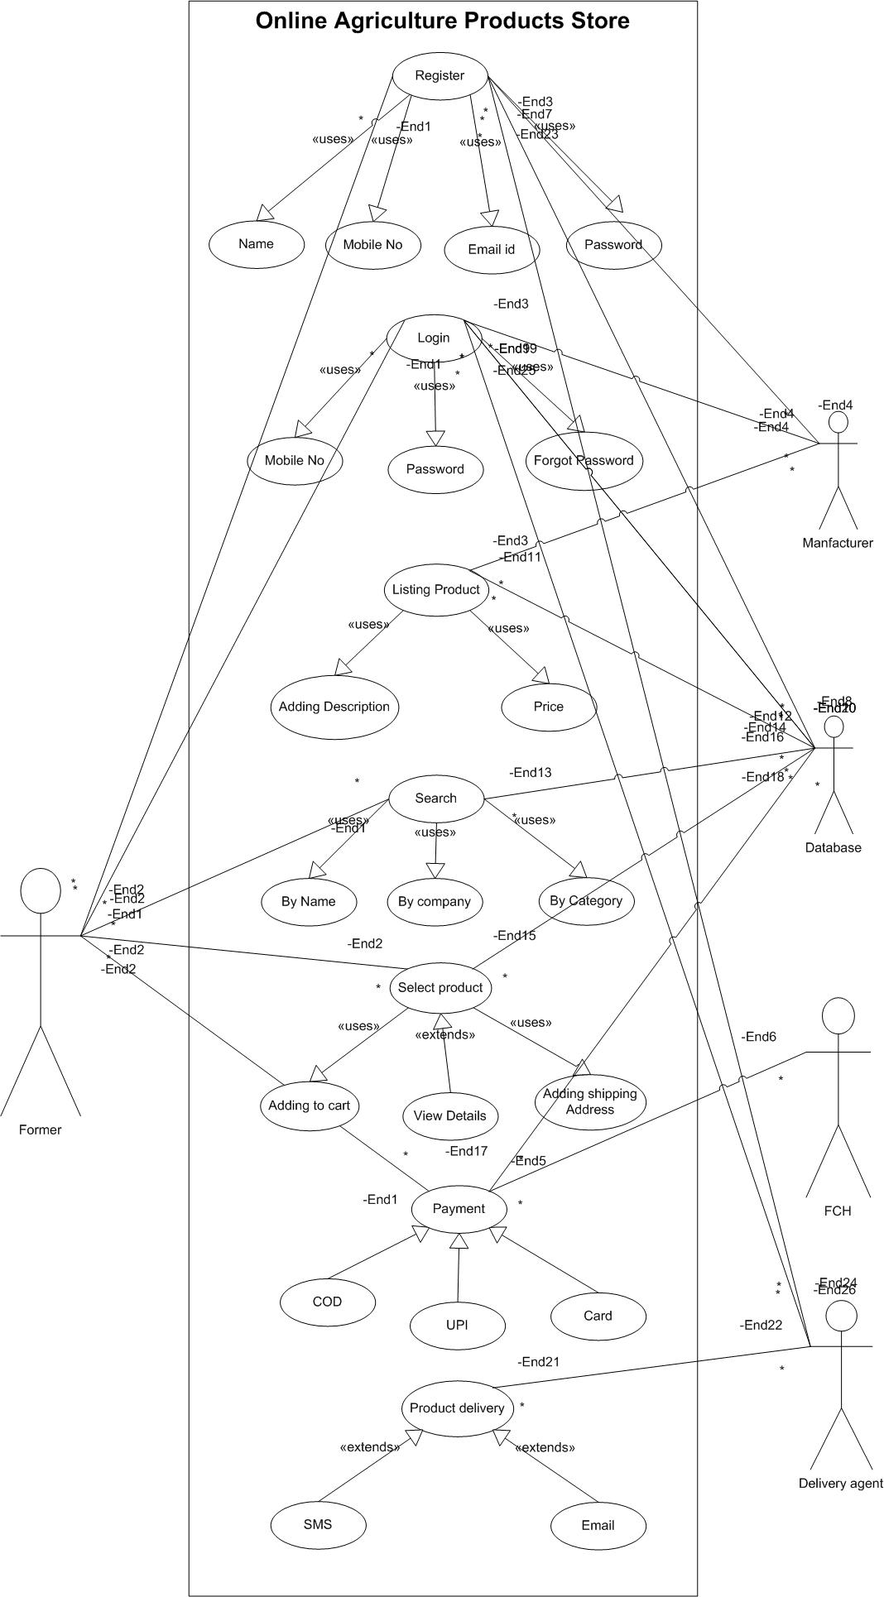
Question 11 – (minimum 5) Use Case Specs
A Use Case Specification Document describes a use case in detail, including its flow of events, conditions, actors, and business rules, forming a foundational part of functional requirements in system analysis.
Use Case Spec
Use Case | Registration
Description | Name, Mobile number, Mail ID, Password
Actors | Former, Manufacturer
Pre-Conditions | Active internet, Browser comptable
Post-Conditions | Home page of actor should be displayed
Basic Flow | Registration completed  Login using Your ID and password
Alternate Flow | ID already Registerd  Enter correct mail ID  Password should match Business Rules
Exceptional Flow | Continue without Registration  Login With OTP
Assumptions | Users have basic computer knowledge, English  Valid Email ID and Mobile Number
Constraints | User name cannot be name  Password not be a mobile number OR number series
Dependencies | Active Mail and Mobile number to verify
Input | Name  Mail ID  Phone number
Output | A valid Account
Business Rules | User name cannot be name  Password – 1 Cap,1small, 1num, 1special character  Valid Mail and Number

Use Case | Login
Description | Username Password
Actors | Former, Manufacturer
Pre-Conditions | Active internet, Browser comptable
Post-Conditions | Home page of actor should be displayed
Basic Flow | Username and Password are correct
Alternate Flow | Password wrong  Username wrong  Both wrong
Exceptional Flow | Forgot Password  Forgot Username
Assumptions | Users have basic computer knowledge, English
Constraints | User name cannot be name
Dependencies | User should exist / Registration process
Input | Username and Password
Output | Error Code / Status flag
Business Rules | Username - valid and unique Email ID  Password – 1 Cap,1small, 1num, 1special character

Use Case | Iisting Product
Description | Adding products and details about the prodcut  Pricing
Actors | Manufacturer
Pre-Conditions | Active internet,Database
Post-Conditions | Displaying listed products on the page available to buy
Basic Flow | Adding product Image  detailed description  Pricing
Alternate Flow | Image uploading error  Remaining stock / quantity of product
Exceptional Flow | Image size  Price INR
Assumptions | Stock of the products
Constraints | Description should not be empty  Liste product stock should not zero/remove the product with no stock
Dependencies | Manufacturer should register first to listing the product  Stock of the product
Input | Listing the product
Output | Able to buy the product
Business Rules | Dscription of the product  How to use the product(quantity related)  Expire date  Quality of product

Use Case | Search
Description | Serch the product by name/ Manufacturer
Actors | Former
Pre-Conditions | Internet connectivity  Browser comptable  English
Post-Conditions | Search result  Product descripton price and Quantity
Basic Flow | Shows Search results
Alternate Flow | The searched product is not available
Exceptional Flow | Shows similar product
Assumptions | Listed product stock maintenance  Live Updating about product stocks and description
Constraints | Language issue  Serching wrong product name
Dependencies | Database
Input | Searching the product name
Output | Displaying the products
Business Rules | Product must show if the product is good quality and in stock

Use Case | Buying product
Description | User can buy the product by adding items to cart
Actors | Former
Pre-Conditions | Login  Serching product  Adding to the cart
Post-Conditions | Adding items to the cart  Delivery location  Payment page
Basic Flow | Added to cart  Proceed to payment  Payment confirmation
Alternate Flow | Item not available for the location  Payment server issue
Exceptional Flow | The stock is not available  Payment issue from bank side
Assumptions | Users has basic computer knowldge  Maintaing quality and fast delivery  Product delivering each and ever location
Constraints | Address filling by user  Delivery issue  Select suitable product
Dependencies | Registration/Login  Data base  Stock  Delivery partners  Payment Gateway
Input | Adding required products to cart  Filling Delivery Address  Selecting Payment mode  Completing paymet
Output | Order completed page  Tracking order  Delivery the order
Business Rules | Maintaing the stocks  Listing Quality Product  Fast Delivery
Question 12 – (minimum 5) Activity Diagrams
An Activity Diagram is a type of UML (Unified Modeling Language) diagram used to model the workflow or activities of a system or business process. It visually represents the sequence of actions and the flow of control from one activity to another.

