CAPSTONE PREP 1 PART 2
PROJECT ON AGRICULTURAL ONLINE PRODUCTS STORE
QUESTION NO .1
AUDITS: QUATERLY AUDITS ARE PLANNED Q1, Q2, Q3, Q4 FOR THIS PROJECT. WHAT IS YOUR KNOWLEDGE ON HOW THESE AUDITS WILL HAPPEN FOE A BA?

ANSWER: QUARTER 1 REQUIREMENT GATHERING PHASE.

STAGE | QUARTER 1 AUDIT REPORT  (REQUIREMEMENT GATHERING PHASE)
COMPLETED | 10 WEEKS (WEEK 1 TO WEEK 10)
CHECK LIST | BRD Template
CHECK LIST | Elicitation results report
CHECK LIST | Duplicate Requirements report
CHECK LIST | Grouping of functionalities /features, client sign off
CHECK LIST | Email communications -To, CC, BCC

In this beginning stage of the project the quarterly audits are done based on the phases.
The first stage of the project is Requirement Gathering, in this phase we usually prepare various types of reports and mention in how many weeks or days the first phase is happening. We also have checklist where certain reports and results are obtained like BRD, Elicitation results, Emails.

QUARTER 2 REQUIREMENT ANALYSIS PHASE.

STAGE | QUARTER 2 AUDIT REPORT  (REQUIREMENT ANALYSIS PHASE)
COMPLETED | WEEK (16 TO 24 )7 WEEKS
CHECK LIST | UML Diagrams
CHECK LIST | Business to functional Requirements mappings.
CHECK LIST | Client sign off documents.
CHECK LIST | RTM Document version control.
CHECK LIST | Email communications -To, CC, BCC.

The second stage is Requirement Analysis phase where the requirements which are collected are analyzed using various diagrams like UML, RTM Documents and the communications through E-mails.

QUARTER -3 DESIGN PHASE.

STAGE | QUARTER 3 AUDIT REPORT  DESIGNING PHASE
COMPLETED  CHECKLIST | WEEK (24 TO 37) 7 WEEKS.
COMPLETED  CHECKLIST | Utilization of tools.
COMPLETED  CHECKLIST | Documented evidence on client communications.
COMPLETED  CHECKLIST | Stakeholders MOM
COMPLETED  CHECKLIST | Email Communications. -To, CC, BCC.

The third stage is Designing Phase where the time taken is 7 weeks.

And the usage of tools and stakeholder’s meeting’s and MOM are done in Designing phase.

QUARTER 4 AUDIT REPORTS.

STAGE | QUARTER 4 AUDIT REPORT  DEVELOPMENT PHASE.
COMPLETED | WEEK (40 TO 60 )20 WEEKS
CHECKLIST | JAD Sessions report.
CHECKLIST | End user manual preparation report.
CHECKLIST | Business Analyst and Developer MOM.
CHECKLIST | Email Communications – TO, CC, BCC.

In this Audit report stage, there are 20 weeks to run this Development phase.

There are few sessions like JAD and preparing of MOM of developers and business analyst.

user manual report is also done in this phase.

QUARTER 5 -AUDIT REPORTS.

STAGE | QUARTER 5 AUDIT REPORT.  TESTING
COMPLETED  CHECKLIST | WEEK (58 TO WEEK 78 )20 WEEKS.  TEST CASE SUMARY  TRAINING REPORTS TO END USERS.  LESSONS LEARNT DOCUMENTS.  EMAIL COMMUNICATIONS -TO, CC, BCC.

In this testing phase the business analyst and testers are involved. Here test
case summary and

reports to end users and Email communications are done. If they are any
errors again, they are sent to bug fix.

Question 2-
BA approach strategy
Before the project is going to kickstart, the committee asked MR. Karthik to submit BA approach
strategy?
Answer –
We have many Elicitation Techniques to apply used to gather requirements. Some of
them are Brain storming, Document Analysis, Workshops, Focus Groups,
Observations etc.

How to do Stake Holder Analysis in RCM: Stake Holder Analysis can be done by
using RACI Matrix involves in identifying stakeholders& defining their roles and
responsibilities within a project.

What Documents to write:
BRD, FRD, Use Case documentation, Test Case Document.

What process to follow to sign off on the document:
Sign off to be taken on SRS as this is the primary and important document.
Sign off can be taken by using E-Mail confirmation from client.

How to take approvals from the client:
Establishing a formal meeting with the clients to keep them informed and get
continuous feedbacks.

What Communications channels to establish and Implement:
Regular meetings, Bi weekly sprint reviews, monthly stakeholder update

How to handle change Requests:
Change request form, Do impact analysis, Approval process, Documentation.

How to update the progress of the project to the stake holders:
Weekly status reports, Monthly Review Meetings are done to update the progress of
the project.

How to take sign off on the UAT client project:
Acceptance Form: UAT preparation, conduct UAT, Fix Issues, Acceptance Form,
Final Review Meetings, Obtain Sign Off.

Question -3 Three tier Architecture and Explain it?

Answer- 3 Tier Architecture.

- Application Layer.

- Business Logic Layer.

- Database Layer.

- Application Layer -The top most layer of the architecture is also known as

“Presentation Layer “. It handles user interface IT components such as

Screens, Pages.

Example – E- Commerce Websites.

- Business Logic Layer- Middle layer of Architecture acts as an intermediary

between the presentation layer and the data storage layer. This layer contains

the core logic of the application.

Example – Printer, Payment Gateways.

- Database Layer -Bottom most layer of the architecture responsible for storing

and retrieving data.

Example – My SQL, Oracle database.

QUESTION 4 – Approach strategy for framing questions –

Answer – 1) The 5WH Frame work is a useful tool for gathering information and

understanding a situation by answering the questions about who, what, when, where

why and how?

2- The SMART technique can help in creating questions

(Specific, Measurable, Attainable, Relevant, Time Bound)

3- RACI charts help to define and clarify roles and responsibilities within a team by

outlining who is responsible, consulted, informative for each task.

4- UML is a standardized way of diagramming and modelling software system to aid

in design, development, communication between team members.

QUESTION 5 – What are the Elicitation Techniques?

Answer – Elicitation Techniques- These are the techniques used to gather the
information which are used in IT Companies to engage with the stake holders.
As a business analyst the elicitation techniques I’m aware of:

- Brain Storming – Brain Storming can be done either Individually or in groups

The ideas collected can be reviewed and analyzed. It can come up with very

innovative ideas & requirements.

- Document Analysis – Document Analysis could be a lot of information and

easy to transfer to a new system requirements document. It can have

documentation about your current system which can provide some of the

inputs for the new system requirements.

- Reverse Engineering – Where the Software for an existing system has little

or outdated documentation and it is necessary to understand what the

system does actually. It can extract implemented requirements from the

software code. (Solution to Problem). They are two general categories of

Reverse Engineering.

- Black Box Reverse Engineering.

- White Box Reverse Engineering.

Black box Reverse Engineering – The product is studied without examining its
internal structure.
White box Reverse Engineering -The Inner workings of the system/product
are studied.
- Focus Groups – A focus group is a means to elicit if the ideas and

attitudes about a specific product, service or opportunity in an interactive

group environment. The participants share their impressions, needs and

guided. There are pros /cons that should be considered when using:

Homogeneous VS Heterogeneous.

Homogeneous – Individuals with similar characteristics

Heterogeneous – Individuals with diverse back grounds, perspectives.

- Observation -Observing users or even doing part of their job can provide

information of existing processes inputs and outputs.

There are two basic approach for observation Techniques:

1)Active

2)Passive

Active: In this approach, the BA observes the current process and take notes

He /She may dialog with the worker. He /She asks the questions right away.

Passive: In this approach, the BA observes the SME working through the

business routine but does not ask the questions directly.

- Workshops: Workshops on compromise 6-10 or more users working together

to identify requirements. They are faster than the group interviews for

obtaining requirements, particularly for common or system wide requirements.

Process: 1) Prepare for the requirements workshop
2)Run the requirements tool.
3) Post Requirements workshop wrap up done by Facilitator.

- JAD (Joint Application Development): Define sessions, Defining the purpos

Scope and Objectives of the JAD sessions selecting the JAD Team, invite and

obtain commitments to attend the sessions from the appropriate stake holders

and scheduling the sessions. It is important to obtain management

commitment to support the process and identify the appropriate stake holders.

- Interviews: An interview is a systematic approach to elicit information from a

person or group of people in an informal or formal setting by talking to the

person, asking relevant questions and documenting the responses. Interviews

can be of 2 types – Structured, Unstructured.

Structed Interview – Questions are already planned or Framed.

Unstructured Interview- Questions Which are not planned and asking them to the client.

- Prototyping: Capturing the requirements from the clients using the logos

colures etc.

- Questionnaire: Questionnaires can be useful for obtaining limited systems

requirements detail from users /stake holders, who have a minor input or

geographically remote. The design of the Questionnaire are of 2 types -
Offline and web based.

- Use Case specs: A Use Case Specification is a detailed textual description of

how a user or actor interacts with the systems to achieve a specific goal.

Question 6 – Which Elicitation Techniques can be used in this project?

Answer – The Elicitation Techniques used in this project are:
- Interviews

- Workshops

- Prototyping.

- Interviews: Farmers, suppliers, and stake holders have unique

needs. (Delivering time lines, Payments).

Example- Knowing about the farmers what challenges they face when selling.
- Workshops – Brings Multiple stakeholders together like (Farmers, IT

Teams, CSR Board).

- Prototyping -Many farmers don’t understand technical documents

but can easily give feedback on a visual prototype of online stores.

Identifying Business Requirements including stake holders’ requirements -

- Providing an online platform for farmers to directly sell

agricultural products to consumers and retailers.

- Eliminate middle people to ensure farmers fair prices.

- Enable market reach for farmers in remote places.

- Ensuring secure payment gateways.

Stake holder Requirements

- MR. Henry (CSR Project Sponsor)
- Ensuring project aligns with CSR goals.
  - Cost effective solution within 2 CR budget.
- Completion within 18 months timeline.

- Mr. Pandu (Farmer Representative)
                - Easy Onboarding for farmers with minimal technical skills.
                - Local language support for product listings.
                - Transparent pricing systems without hidden charges.
                - Timely Payment for farmers.

- Peter (Project Manager)
                - Clear project scope and miles stones.
                - Risk Mitigation strategies.
                - Smooth Execution with defined roles. (RACI Matrix)
4) Kevin (Technical Lead /Developers)
            - Availability of trained JAVA resources.
            - Proper requirement clarity to avoid rework
            - Stable Infrastructures.
5) Ben (Tester / QA Lead)
              - Well documented test cases.
              - Availability of UAT testers.
              - Proper test Environment set up before Deployment.
6) End Users -
              - Easy Browsage of products.
              - Secure Checkout and Payment Process.
Customer Support Channel.

Question 7 -10 Business Requirements –Identify at least 10 Business
Requirements.

- Online Market place creation: Developing a secure online store for farmers

to sell products directly.

- Farmer Onboarding and Registration: Providing simple registration with

KYC verifications.

- Product Catalog and Management: Enables farmers to upload products

details (Name, price, Quantity,)

- Secure Payment Gateways Integration: Supports UPI, Cards, Net

Banking’s and ensure farmers to receive pay outs within a period.

- Order and Inventory Management: Automate order tracking, Stock

Availability and updates for farmers and customers.

- Logistics and Delivery Integration: Partners with logistics providers for

delivering tracking’s and integrations into the platform.
- Multi Language Support -Ensuring accessibility on mobile devices and

availability of local languages options.

- Customer Support and Feedback System- Providing a support channel for

farmers and buyers to resolve queries.

- Data Security and Compliances: Ensuring Compliances with data privacy

Regulations, Secures storage of farmer.
- Analytics and Reporting: Generating reports on sales farmer earnings, and

CSR impact for stake holders.

Question 8 – Assumptions

Assumptions- The statement which is to be true for planning and decision making

- All user has fundamental familiarity with smart phone or web

access.

- Reliable payment channels and logistics are accessible in rural
locations.

- All compliance and digital transactions permissions are
managed.

- Users can receive SMS/Email notifications.

- Adequate end user support is available.

Question -9 This Project Requirements Priority.

The project Requirement Priority is done by using MOSCOW and FURPS
Technique.

MOSCOW -It is a prioritization technique used in business and software

development to reach a common understanding between the stake holders on the

importance they place on the delivery of each requirement is known as MOSCOW –

Must, Should, Could, Would Technique.

FURPS – It is an Acronym representing a model for classifying software quality

attributes. FURPS- Functionality, Usability, Reliability, Performance, Supportability

Give Priority 1 to 10 numbers (1 Being Low Priority -10 Being Priority
these Requirements after discussions with the stake holders.

Requirement  ID | Requirement Name | Description | Priority
BR 001 | search products | Find /Browse the products | 9
BR 002 | Upload Inventory | Manufacturer post items. | 8
BR 003 | User Auth | Login/Registration | 10
BR 004 | Wishlist | Add to Wishlist | 6
BR 005 | Payments | Multiple online/COD options. | 9
BR 006 | Notifications | SMS/Email Alerts | 8
BR 007 | Order Tracking | Shipment tracking Info | 7
BR 008 | Security | Data/Payment safety | 10
BR 009 | Responsive UI | Mobile device compatibility | 7
BR 10 | Local Language | Multilingual Support | 6

Question 10 – Draw a Use Case Diagram.

Use Case Diagram- A Use Case Diagram is a Visual Representation of the

interactions between users (Actors) and a system. It is a high-level Diagram. It

shows the external Interface work. It is used to describe the functionality of the

system in a horizontal way

Use Case Diagram has 4 elements –

1-Actors

2- System

3-Use Cases

4- The Lines that represents the relationships.

Below is the Use Case Diagram which contains all the actors primary and secondary actors

and the use cases including extend and include relationships of online agricultural store .
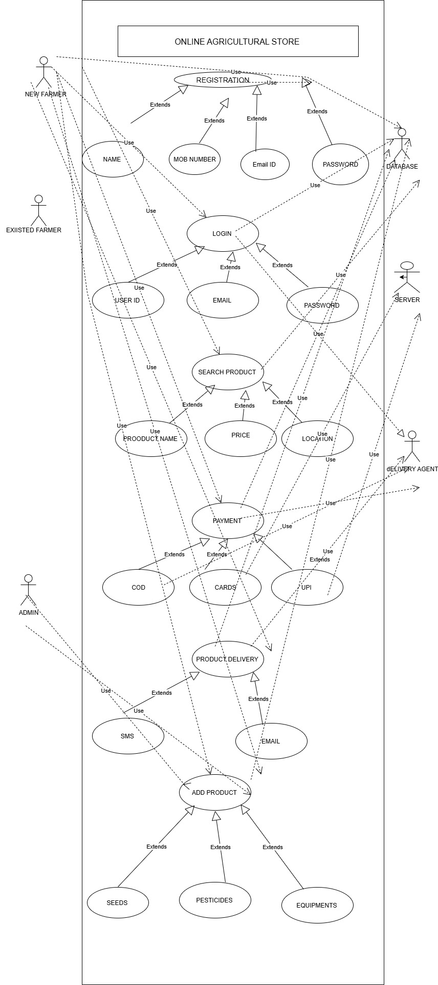Question 11- Prepare Use Case Specs for all Use Cases.

Use Case Specification – A use Case Specification generally a detailed textual

description of how a user interacts with the system to achieve a specific goal.
A Use Case Specification Generally Consists of:

- Actors

- Pre-Conditions

- Post Conditions

- Alternative Flows.

- Exceptions

- Use case

Use Case 1: Upload Products

Use Case | Uploading the products.
Actors | Farmers
Pre-Conditions | Order confirmed and assigned.
Post -Conditions | Status Updated
Basic Flow | Delivery partner’s logs in  Views assigned deliveries  Delivery to customer
Alternative Flow | Delivery Rescheduled or Delayed
Exceptions | Wrong Address  Customer Unavailable  Logistics issue Like Vehicles Breakdown
Use Case 2 Farmer Browses the Product.

Use Case | Farmers Browses the product
Actors | Farmers
Pre -conditions | Farmer has Access to the application with internet connectivity.
Post conditions | Farmer identifies required products for purchase.
Main Flow | Farmer logs into the system  Navigators products categories  Views product details and prices  Filters or searches for required products.
Exceptions | Slow internet, product loading failure

Use Case 3- Place Order

Use Case | Place Order
Actors | Customer
Pre -Conditions | Customer logged in; products exist in cart.
Post -Conditions | Order created and saved.
Basic Flows | Customer adds products to cart  Goes to check out  Confirms order details
Alternative Flows | Customer cancels the order
Exceptions | Out of stock products -Error Message

Use Case 4 -Make Payment

Use Case | Make Payment
Actors | Customer, payment methods.
Pre -Conditions | Customer has items in cart and proceeds to check out.
Post- Conditions | Payment processed; order finalized
Basic Flow | Customer selects the payment method.  Redirect to payment gateway  Payment authorized
Alternative flow | Customer switches to payment method
Exceptions | Payment Cancelled or declined.  Network Failure during the transactions.

Use Case 5 -Deliver the Products

Actors | Delivery partner
Pre- conditions | Order Confirmed and assigned
Post -conditions | Status updated
Basic Flow | Delivery partner logs in  Views assigned deliveries  Updates Delivery Status
Alternative Flow | Delivery Rescheduled
Exceptions | Wrong Address  Customer Unavailable  Logistics Issues

Questions- 12 Activity Diagrams

Definition:

Activity Diagram – It is the flow of the control and advanced version of flow chart. It

defines the workflow from one activity to another. It includes different states and

notations like actions, final, join, fork, merge swim lanes and control flow.

Below are the five activity diagrams

- . Login of the customer

2. Browsing the products

3. Adding the products to the cart

4. Payment of the user

5. Delivery of the product

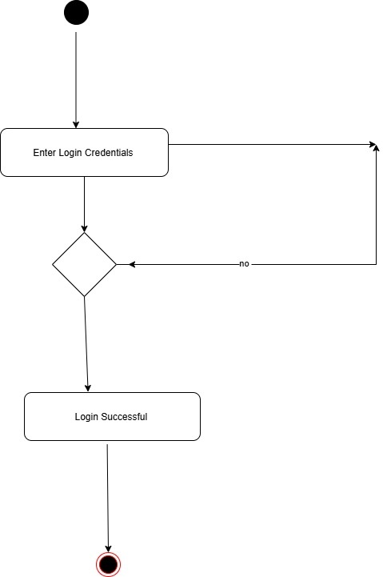

User Registration of the customer

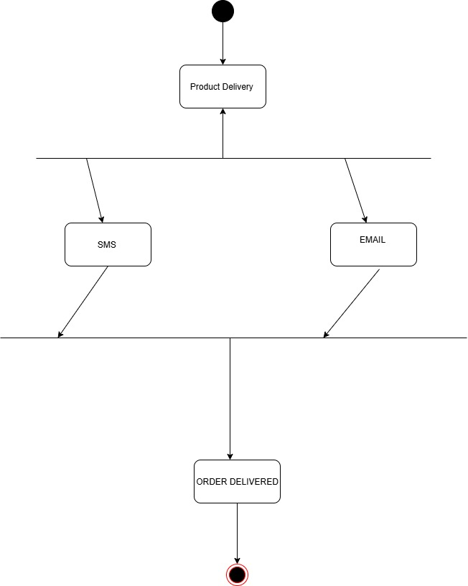

Delivering the product

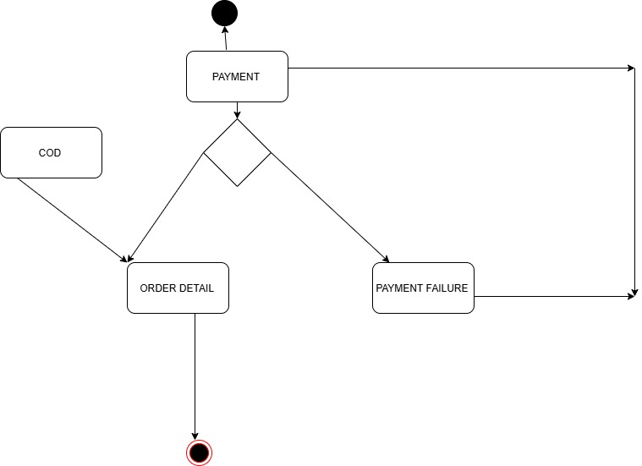

Payment Details Of the customer

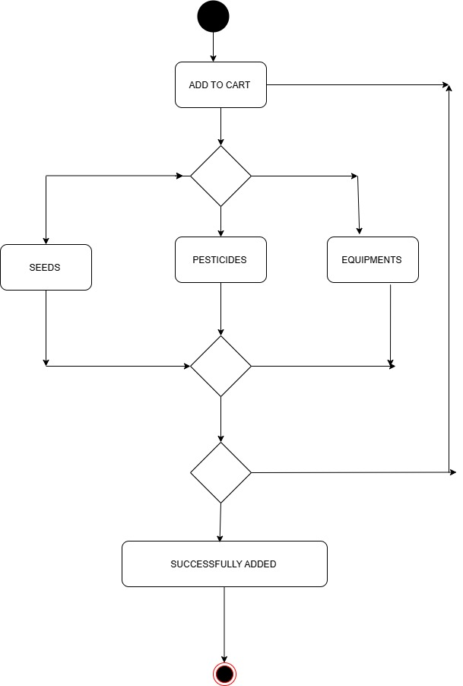
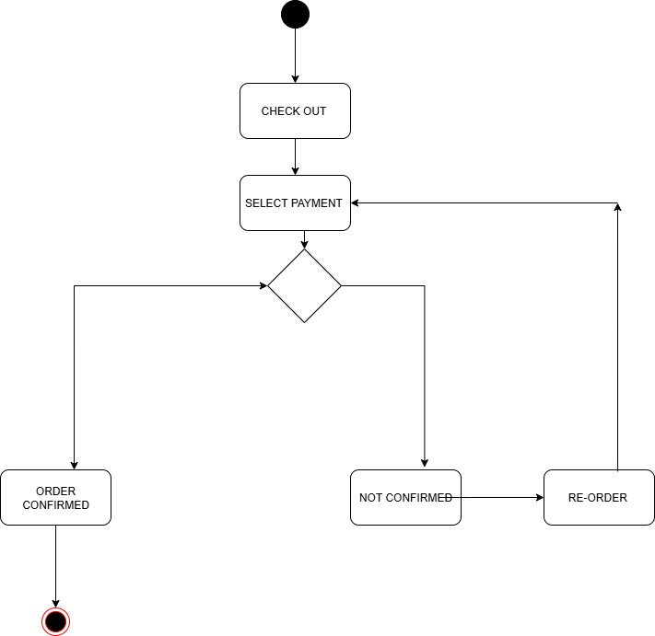

Check out of the customer

