Waterfall Model Documents
Waterfall Project - 2

Document 6- Please prepare a use case diagram, activity diagram and a use case specification document.

Use case Diagram of E-Commerce Online Shopping

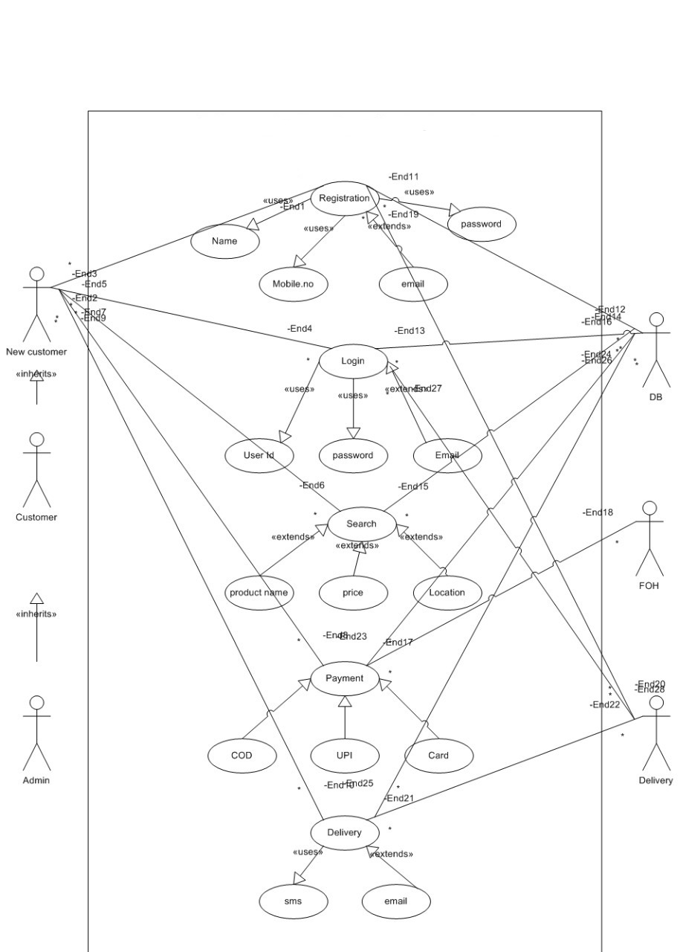
Activity Diagrams

Login

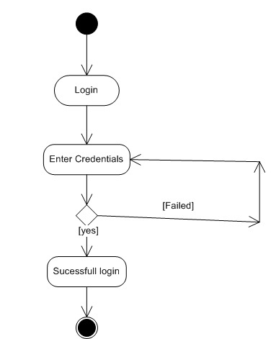

Product Search

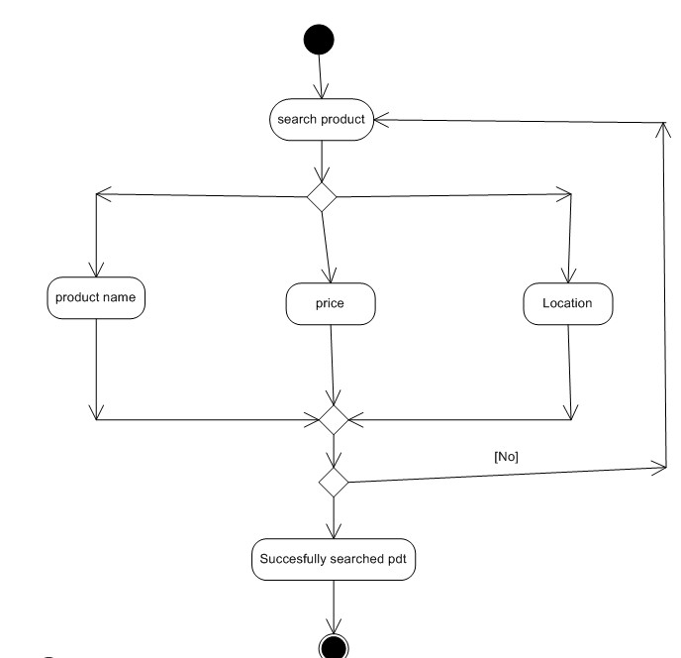

Product Return
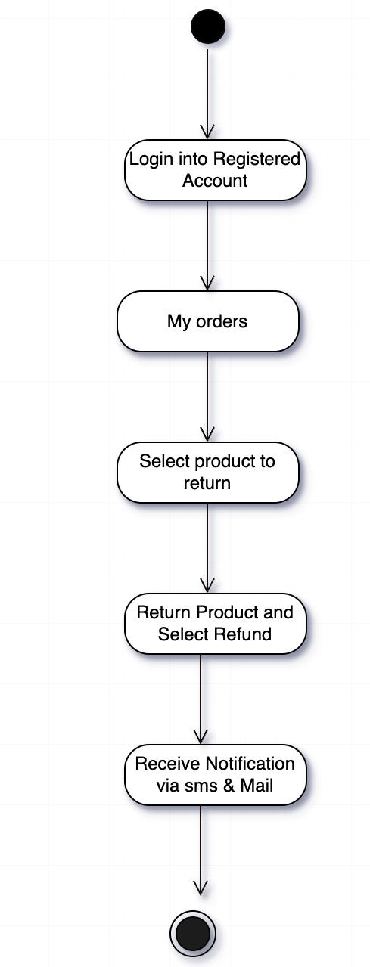

Payment Process
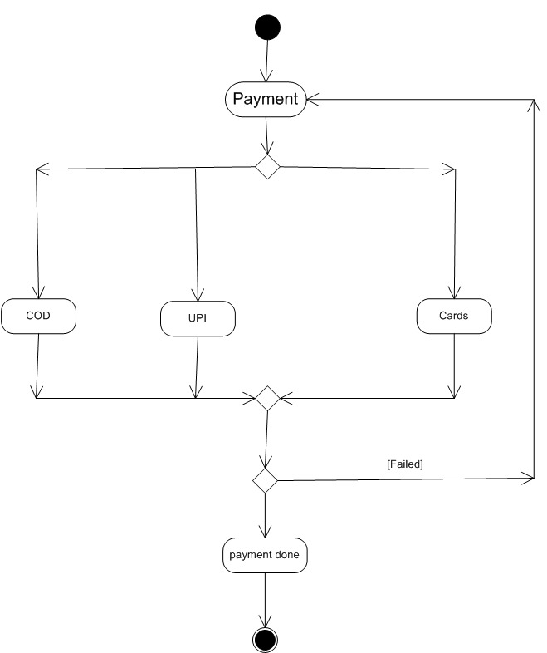

Order Delivery
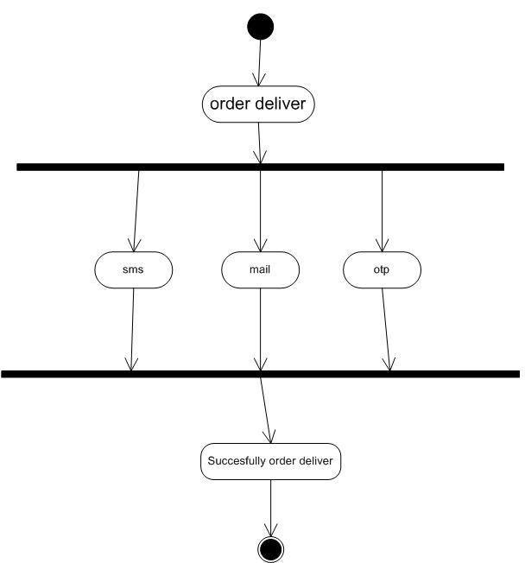

Use Case Specifications

1. Use case Name: User Registration
2. Use case Description:
Allows new customers to register on the e-commerce platform by providing essential details such as name, mobile number, email, and password.
3. Actors:
- Primary: New Customer
- Secondary: Database (DB)
4. Basic Flow:
- User navigates to the registration page.
- Enters name, mobile number, email, and password.
- Submits the registration form.
- System validates the details and creates new user record.
- User receives confirmation.
5. Alternate Flow:
- If the email is already registered, the system prompts user to recover password or login.
6. Exceptional Flows:
- Internet connectivity is lost before submission: error message displayed.
- Invalid email or password format: system prompts correction.
7. Pre-Conditions:
- User is not registered on the platform.
- Registration page is accessible.
8. Post-Conditions:
- User account is created.
- User can proceed to login.
9. Assumptions:
- All mandatory fields are provided by user.
10. Constraints:
- Unique email per user.
11. Dependencies:
- Email service for confirmation.
- Database for storage.
12. Inputs and Outputs:
- Inputs: Name, mobile number, email, password
- Outputs: Confirmation message, user record in database
13. Business Rules:
- Password must meet security criteria (min 8 chars, etc).
14. Miscellaneous Information:
- Registration may trigger welcome email/SMS.

2. Use Case: User Login

2. Use case Description:
Allows registered users to authenticate themselves using their credentials and access their account.
3. Actors:
- Primary: Customer
- Secondary: Database (DB)
4. Basic Flow:
- User navigates to the login page.
- Enters registered email/mobile and password.
- System verifies credentials.
- If valid, user is logged in.
5. Alternate Flow:
- User selects "Forgot Password" to reset credentials.
6. Exceptional Flows:
- Incorrect credentials: error message.
- Account locked due to multiple failed attempts.
7. Pre-Conditions:
- User is already registered.
- Login page is accessible.
8. Post-Conditions:
- User gains access to their account.
9. Assumptions:
- User provides correct credentials.

10. Constraints:
- Maximum login attempts before lockout.
11. Dependencies:
- Database for credential verification.
12. Inputs and Outputs:
- Inputs: Email/mobile, password
- Outputs: Access to user account, error message
13. Business Rules:
- Session timeout after inactivity.
14. Miscellaneous Information:
- Login may trigger two-factor authentication.

3. Use Case: Product Search

2. Use case Description:
Enables users to search for products based on name, price, and location filters.
3. Actors:
- Primary: Customer
- Secondary: DB, FOH (Front-of-House) System
4. Basic Flow:
- User enters search criteria (product name, price, location).
- System displays matching products.
- User reviews product details.
5. Alternate Flow:
- User applies additional filters (price range, rating).
6. Exceptional Flows:
- No products found: display "No results" message.
7. Pre-Conditions:
- User is logged in or as guest.
- Product database is available.
8. Post-Conditions:
- Display of product results.

9. Assumptions:
- Search terms match product data.
10. Constraints:
- Only searchable on available product attributes.
11. Dependencies:
- DB for product info.
- FOH for display.
12. Inputs and Outputs:
- Inputs: Search criteria
- Outputs: Product list/results
13. Business Rules:
- Only active products shown.
14. Miscellaneous Information:
- Search history may be stored for recommendations.

4. Use Case: Payment Processing

2. Use case Description:
Processes customer payments using various methods (COD, UPI, Card).
3. Actors:
- Primary: Customer
- Secondary: DB, Payment Gateway
4. Basic Flow:
- User selects payment method.
- Enters required payment info.
- System validates and processes payment.
- Payment confirmation provided.
5. Alternate Flow:
- User switches payment method before completion.
6. Exceptional Flows:
- Payment failure: display error, allow retry.
7. Pre-Conditions:
- Cart contains items.
- User is ready to checkout.
8. Post-Conditions:
- Order placed if payment successful.
9. Assumptions:
- Payment gateway is available.
10. Constraints:
- Only supported payment methods allowed.
11. Dependencies:
- External payment gateways.
- Database updates.
12. Inputs and Outputs:
- Inputs: Payment details, amount
- Outputs: Payment confirmation/failure message
13. Business Rules:
- Payment must be confirmed before order is created.
14. Miscellaneous Information:
- May require OTP or authentication for online payments.

5. Use Case: Order Delivery Notification

2. Use case Description:
Notifies customers of order status via SMS and/or email upon dispatch and delivery.
3. Actors:
- Primary: Delivery
- Secondary: Customer, DB
4. Basic Flow:
- Delivery team updates order status to "Dispatched".
- System sends SMS/email to customer.
- Upon delivery, another notification is sent.
5. Alternate Flow:
- Only email or SMS sent, based on customer preference.
6. Exceptional Flows:
- Notification service is down: queued notification.

7. Pre-Conditions:
- Order is ready for delivery.
- Customer communication details are valid.
8. Post-Conditions:
- Customer receives notifications.
9. Assumptions:
- Delivery status updates are timely.
10. Constraints:
- Maximum number of notifications per order.
11. Dependencies:
- SMS/email gateway.
- Delivery updates from system.
12. Inputs and Outputs:
- Inputs: Delivery status
- Outputs: SMS/email to customer
13. Business Rules:
- Notifications must contain order details.
14. Miscellaneous Information:
- Delivery notifications may include tracking links.

Document 7- Screens and pages

Login Page

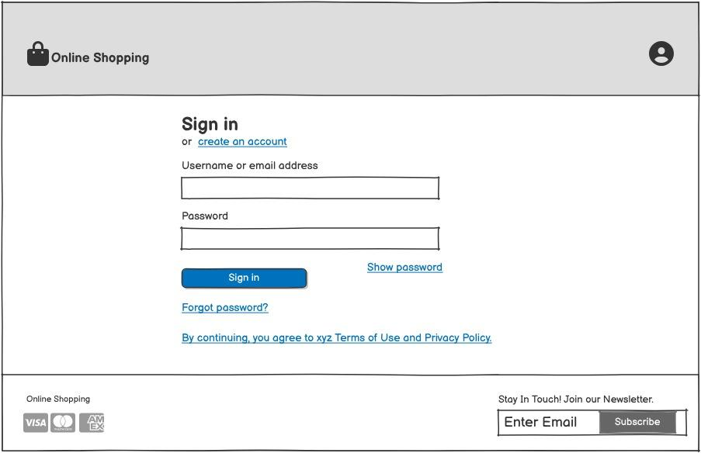

Main Page
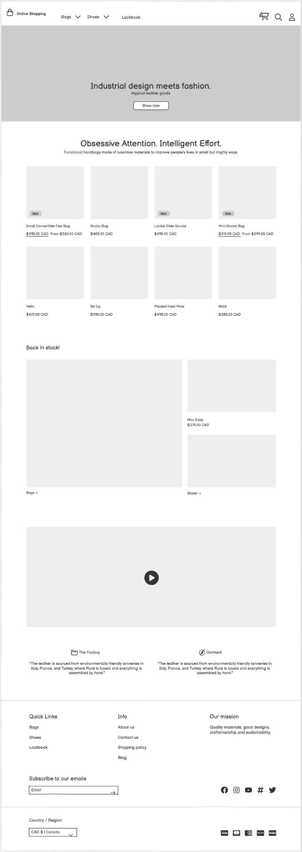
Product Page
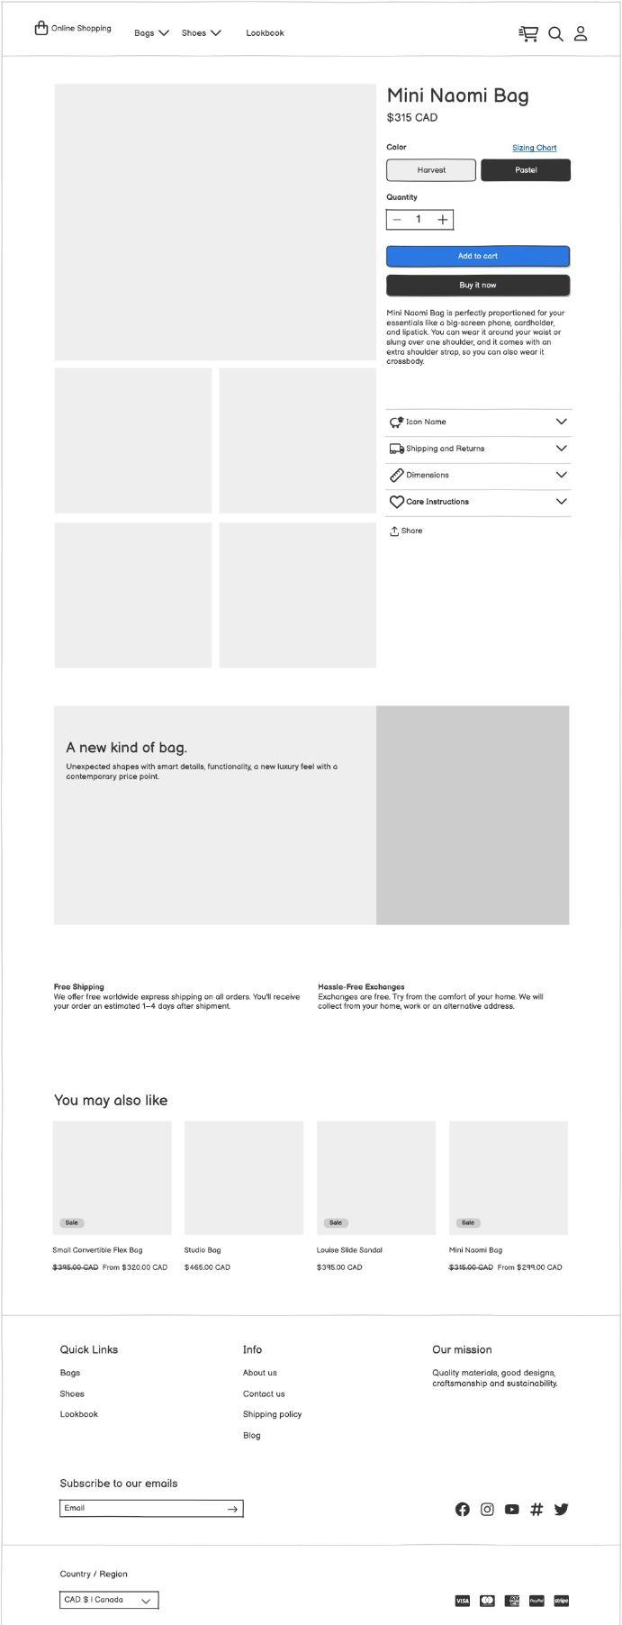
Product Page - Add to cart page
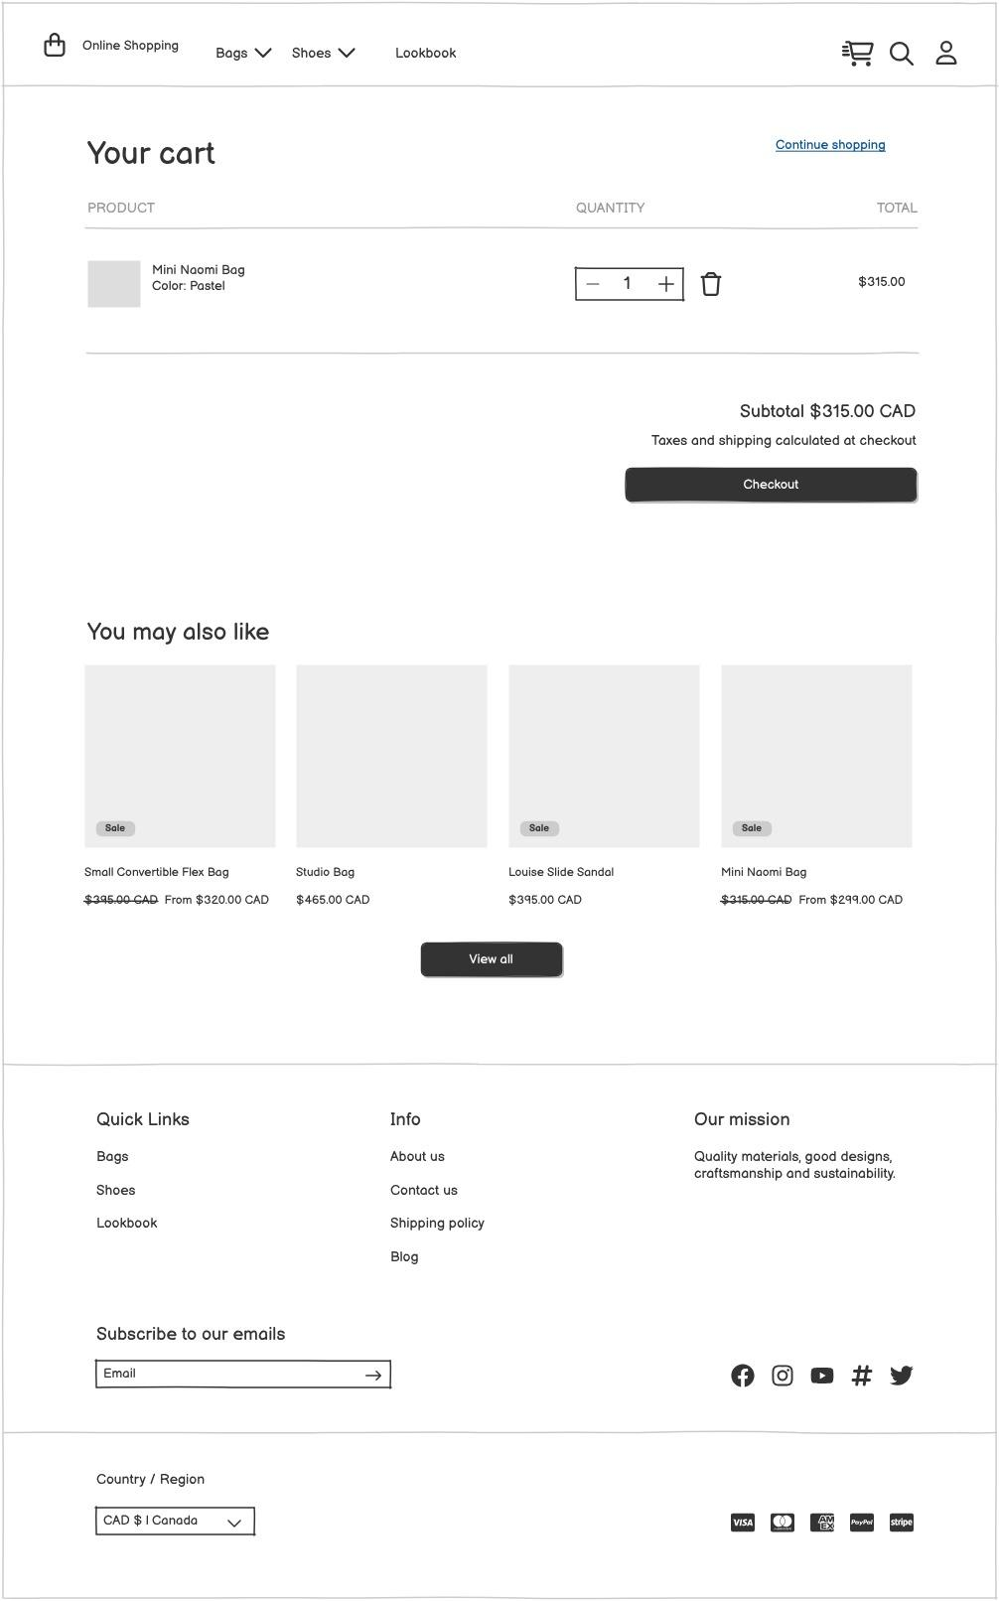

Document 8- Tools-Visio and Axure

In this project, I had the opportunity to use both Microsoft Visio, Balsamiq and Axure for
creating diagrams and interactive prototypes, which were essential for visualizing and
refining theE-Commerce Online Shopping platform. Visio was particularly
useful for creating structured diagrams, such as use case and activity diagrams, which
helped in illustrating the various interactions between actors and system components. Its
intuitive interface and extensive library of shapes made it easy to create professional-
looking diagrams, which facilitated clear communication with stakeholders.

Using Balsamiq for creating wireframes has been an intuitive and efficient experience.
Balsamiq’s user-friendly interface and simple drag-and-drop functionality allowed me to
quickly prototype various screens and visualize the application flow in a clear, structured
way. Its pre-built UI components and hand-drawn style made it easy to create mockups that
are straightforward and visually accessible, which was especially helpful for communicating
ideas to non-technical stakeholders. The tool’s focus on low-fidelity design helped keep the
focus on layout and functionality without getting bogged down by visual details, which
streamlined the feedback process. Overall, Balsamiq proved to be a powerful asset for
creating early-stage prototypes, enabling iterative design, and aligning team understanding.

On the other hand, Axure was invaluable for building interactive mock-ups and wireframes
of the user interface. With Axure, I was able to create a high-fidelity prototype that
simulated the user flow, from the home page to the job application process, which allowed
stakeholders to experience the application’s functionality firsthand. Axure’s dynamic panel
and conditional logic features were instrumental in creating realistic and functional
prototypes, enhancing stakeholder understanding and feedback. Together, Visio and Axure
provided a comprehensive toolkit for both conceptualizing and validating design ideas,
ultimately contributing to a smoother development process.

Document 9- BA experience

My experience as BA in following phases:

1. Requirement Gathering:

- In this phase, I applied the MoSCoW prioritization technique to categorize requirements based on necessity (Must Have, Should Have, Could Have, and Won’t Have), which streamlined the gathering process and aligned priorities with the project goals.

- Since the client was occasionally unavailable, I proactively identified and engaged alternative points of contact on the client’s side, ensuring no critical information was delayed and requirements were gathered efficiently.

2. Requirement Analysis:

- I created UML diagrams, including use case and activity diagrams, to provide a visual
representation of the requirements, making complex processes easier to understand for both the technical team and stakeholders. Using these diagrams, I prepared comprehensive Business Requirements Specifications (BRS) and System Requirements Specifications (SRS) documents.

- Communicating these diagrams to the team was sometimes challenging as feedback led to modifications. As a BA, I listened carefully to team input and incorporated valuable suggestions, ensuring that requirements were accurately and collaboratively defined.

3. Design:

- I derived test cases from the use case diagrams, ensuring complete test coverage, and included both positive and negative test cases to anticipate and handle potential Issues.

- Throughout this phase, I maintained open communication with the client regarding design and solution documents, seeking timely feedback to avoid Misunderstandings.

- Preparing test data and updating the Requirements Traceability Matrix (RTM) was crucial for tracking requirements, which ensured that all were met during the development and testing phases.

4. Development:

- Organized Joint Application Development (JAD) sessions to clarify requirements and align team understanding, which accelerated development and reduced the likelihood of misinterpretations.

- I was available to clarify any questions from the technical team, referring to diagrams and use cases for accurate coding guidance.

- Handling differences in opinion during JAD sessions was essential. I mediated discussions, engaging one-on-one with team members to ensure a supportive, collaborative environment.

- Frequent meetings with both the technical team and the client kept the project on track, and when some team members missed sessions, I provided recorded sessions and followed up with one-on-one discussions to keep everyone informed.

5. Testing:

- Test cases were prepared based on use cases, ensuring comprehensive testing that covered all potential scenarios.

- I conducted high-level testing and coordinated with the client to obtain necessary test data, enabling realistic test scenarios.

- Regular updates to the RTM helped track requirement fulfilment and maintained a clear link between requirements and their testing status.

- After high-level testing, I worked with the client to prepare for User Acceptance Testing (UAT), coordinating feedback and obtaining formal sign-off.

6. Deployment:

- During deployment, I provided the RTM to the client as part of the project closure documentation, demonstrating that all requirements were met.

- Coordinated the preparation and distribution of end-user manuals and organized training sessions for end-users, ensuring that all relevant stakeholders attended and understood the system.

- I validated requirements using the FURPS (Functionality, Usability, Reliability, Performance, and Supportability) technique, which helped ensure that each requirement met both functional and non-functional criteria.

- Prototyping was used to refine requirements further and eliminate redundancies, enhancing the clarity and specificity of the final requirements.

This comprehensive experience has equipped me with practical skills in BA methodologies,
effective communication, and collaborative problem-solving, ensuring project success
through every phase from requirements gathering to deployment.

