CAPSTONE PREP 3 PART 1 PROJECT
Question -1 A customer can make a payment either by Card or by

Wallet or by Cash or by Net banking.

- Draw a Use Case Diagram

Use case Diagram – Use Case Diagram is a high-level diagram. It is designed by

the BA at the requirement gathering phase where it shows the functionality of

the product. A Use Case Diagram is a Visual Representation of the

interactions between users (Actors) and a system.

It shows the external Interface work. It is used to describe the functionality of the

system in a horizontal way

Use Case Diagram has 4 elements –

1-Actors

2- System

3-Use Cases

4- The Lines that represents the relationships.

Use Case Diagram

- Derive Boundary Classes, Controller classes, Entity Classes.

Boundary Classes – These are used to handle interactions between the
systems and the external actors like users, other systems, or devices. They
handle input and output, acting as the first point of contact for any interaction.
This is basically called as view. This represents the presentation of the
application. The view class refers to the model. The view is not dependent on
the application logic. View class is the data required by the query. View class is
represented as boundary Class.
Example- Payment Option Boundary
Card Payment Boundary

Controller Classes- These acts as an intermediary between Boundary and
Entity Classes. Whenever the user sends request for something then it always
goes through the controller. The controller is responsible for inspecting the
requests from view and passes it to the model. In GUI the views and the
controllers often work very closely together.
Controller Classes are responsible for Managing Workflows, Coordinating
Interactions, Enforcing Business Rules.
Example- Payment Initiated Controller
Card Payment Controller

Entity Classes- It represents the core data and business logic of the application
It is a blue print for the type of the object in the system which defines
- Attributes

- Relationships

- Operations

This represents Database tables in DB. All model classes are represented

by Entity Classes

Example- 1) Customer

2) Payment

3-

Place these classes on a three tier Architecture.

Application Layer – This layer comes under Screens, pages, Validation on

pages, Company specific logic, Functionality.

This classes fits for Payment method Selection Boundary.

Card Payment Boundary.

Business Logic Layer – All Re-usable components, frequently changing

components, Governing body Rules and Regulations, Compliances.

This Classes fits for Payment Controller and Wallet Controller.

Data Layer -Database Components connecting to data base.

This Classes fits for Customer, Payment

4- Explain Domain Model for Customer making payment through Net Banking?
Domain Model – A data model is a conceptual representation that defines
the structure, relationships and behaviours of Entities within a specific
problem domain.
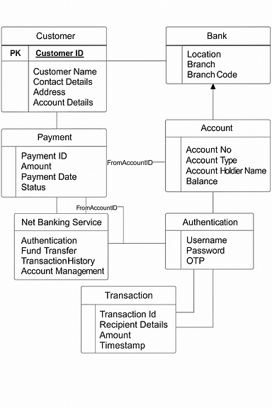

The detailed UML-style Entity Relationship Diagram (ERD) for the Net
Banking System —
labelled entities, attributes, and relationships. It includes:

- Customer: ID, name, contact, address

- Bank: name, location, branch code

- Account: account number, type, holder name, balance

- Payment: ID, amount, date, status

- Transaction: ID, recipient, amount, timestamp

- Authentication: username, password, OTP

- Net Banking Services: fund transfer, account management, transaction history

5 - Draw a sequence diagram for payment done by Customer Net
Banking
Sequence Diagram – A sequence diagram is a type of interaction
diagram used in software Engineering and system design to illustrate how
process will operate with each other and in which order they will be. The
sequence diagram will be discussed and will be formed by the classes that
are discovered from MVC and will be mapped on 3 tier Architecture.
Lifeline – Lifeline indicates the life of a class.
Camel Casing – Entire first word will be in lower case and subsequent
words first letter should be in upper case. There will be no gap between
the words.
Return Message- This will always flow towards the controller, this is just
a message not a method.
Focus of control- It shows the life of the method.

Sequence Diagram
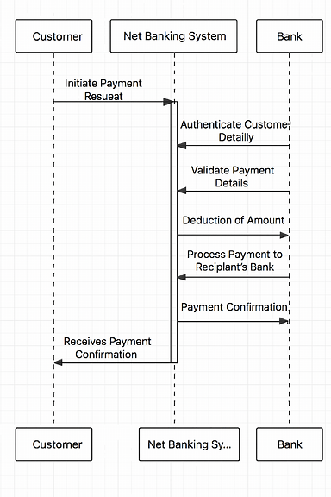

6- Explain Conceptual Model for this Case

Conceptual Model – It is a high-level representation of a system that helps in
understanding, visualizing, communicating the essential aspects of the domain.
It provides a clear and simplified view of the domain, making it easier to
understand. The key Elements for this case are –
Entities –Customer, Product, Owner and Payment.
Attributes-Customer ID, Name Email, phone number
Relationships- Customer does the payment
Customer | Initiates a payment for an order
Payment | Represents a transaction linked to an order
Payment Method | Specifies the mode: Card, Wallet, Cash, Net Banking

A Customer can make one or more Payments
Each Payment is associated with one Payment Method
Payment Method is a generalization (superclass) with four specializations
(subclasses):
- Card Payment

- Wallet Payment

- Cash Payment

- Net Banking Payment

Question -7 What is MVC architecture? Explain MVC rules to derive

classes from use case diagram and guidelines to place classes in 3-tier

architecture
MVC – Model, View, Controller is an architectural pattern that separates
an application into three main logical components Model, View and
controller.
View- Represents the presentation layer of the application
Model – Represents the data and the business logic of the application.
Controller – Acts as an intermediary between Model and View.

MVC Rules –
- Combination of one actor and a use case results in One boundary class.

- Combination of Two actors and a use case results in Two boundary class.

- Combination of Three actors and a use case results in Three
Boundary class.
- Use case will result in controller Class

- Each actor will result in one entity class.

Guidelines to place identified in MVC Classes in 3 tier Architecture.

- Place all the Entity Classes in DB layer.

- Place primary Actor associated boundary class in Application Layer.

- Place controller class in application Layer.

- If governing body influences or Reusability is there with any of the

remaining boundary classes, place them in business logic layer or

else in Application Layer.

Question -8 Explain BA contributions in project (Waterfall Model
– all Stages)
BA Contributions-
- Gathering the requirements through Elicitation Techniques

- Document the requirements through standards like
standards IEEE, CMMI
IEEE- Institute of Electric and Electronic Engineers
CMMI- Capability Maturity Model Integration
- Model the requirements by UML

- Communicate the requirements to the technical team

- Designing them by tracking them (RTM)

- Developing them by handling CR (Change Requests)

- Testing which facilitates UAT

Stage | Resources | Aircrafts and Resources
Requirements Gathering | BA, PM | BRD
Requirements Analysis | BA, PM  Tech Team -Sol Arch, DB Arch | FS /FRS /SSD/SRS/RTM
Design | Tech Team -Sol Arch, DB Arch, GUI Designer | Solution Document
Development – Coding | Programmers  Developers | CDD Applications
Testing | Testers | Test Documents  Applications with less errors

Unit, component, system, system Integration, AT
Configuration Management -PM
Deployment and Implementation – Release Engineers

Question – 9

What is conflict management? Explain using Thomas – Kilmann technique
Conflict Management – Conflict Management is the process of resolving
conflicts or disagreements between individuals or groups in a constructive
manner.
These are the results of Changes which improves the communication of
personal and professional growth.
5 Options of conflict Management –
- Competing
- Avoiding
- Accommodating
- Compromising
- Manage Conflicts
Conflicts require high level of energy for resolution.

Managing conflicts is all about maintaining the relations.

Habits are limiting factors in managing the conflicts.

Before Engaging in conflicts, think about expected Outcomes.
5 steps to conflict management –
- Identify the conflict

- Discuss the details
- Agree with the root problem

- Check for every possible solution for the conflict Negotiable

- Solutions to avoid future conflicts

Technique -Thomas Kilmann conflict Resolution graph
Assertiveness
High

Collaborating
Compete
Compromise

Low Avoid Accommodate

Low Co -operation High

X Axis – Co -operation, Y axis – Assertiveness
Thomas Kilmann Technique -It is widely used for a tool assessing conflicts resolution styles and guiding individuals for selecting appropriate strategies to manage conflicts.

Question -10 List down the reasons for project failure – 6 Marks

- Poor Planning

- Unclear Objectives and Requirements

- In adequate Risk Management

- Poor Communication

- Scope Creep

- Lack of stakeholder Engagement

- Resources Constraints

- Technical Challenges

Question -11 List the Challenges faced in projects for BA

The challenges faced in BA project are –

1-Unclear and changing Requirements

2-Managing stakeholder Expectations

3-Scope Creep and Scope Management

4-Time and Resource Constraints

5-Quality Assurance and Testing

6-Documentation and Knowledge Management

7-Technology Constraint’s and complexity

Question – 12 Write about Document Naming Standards

A document numbering standard is a systematic approach to assign unique

identifiers to various documents created and used throughout the development

process. All Documents are named using some standards

like [project ID] [Document Type] V [X]D [Y]. Ext

Example- Suppose we have a project with the ID “PROJ123” and we are

working on the Requirements Specification Document.

Project ID- PROJ123

Document Type- REQ

Version -1.0

Date- 2025-09-21

The document Identifier could be PROJ123-REQ-1.0-2025-09-21

Question- 13 What are the Do’s and Don’ts of a Business analyst

Do’s | Don’ts
- Consult an SME for the doubt Clarifications in Requirements  - Go to the client with a plain mind and listen carefully and completely until the client is done, and then you can ask the queries  - Try to extract Maximum leads to the solution from the client himself  - Concentrate on the Important Requirements  - Question the Existence of the Existence /Question Everything | - Never say NO to the client  - There is no word called BY DEFAULT  - Never Imagine in the terms of GUI  - Don’t interrupt the client when he is giving you the problem.  - Never try to give the solution to the client straight away with your experiences and Assumptions

Question -14 Write the difference between packages and sub-systems

Package – Collection of components which are not re-useable in nature

Application Development companies works on Packages

• Purpose: Encapsulation, modularity, and reusability.
• Used in: Programming languages (Java, Python), UML diagrams, and
system architecture.

Sub System- Collection of components which are re-useable in nature

Product Development companies works on Sub -System

• Purpose: Divide the system into coherent, independently manageable units.

• Used in: UML component diagrams, system architecture, and enterprise

Application.

Each subsystem may contain multiple packages and classes.

Question-15 What is camel-casing and explain where it will be used.

Camel Casing- Camel Casing is a naming convention used in Computer

Programming.

It is used for naming variables, functions, identifiers.

Example-

Camel Case: case Case Example

In Camel Casing, the first words start with the Lower Caser Letter and each

subsequent word begins with an upper-case letter.

- Improves readability of variable and function names.

- Avoids spaces and underscores, which can be problematic in some

languages.

- Common in many programming languages and frameworks.

Question- 16 Illustrate Development server and what are the accesses does

business analyst has?

Development Server – A development Server is dedicated Environment or

server that is used during the software development process.

It provides a platform for developers and testers to build, test and debug the

applications before they are deployed to a production Environment.

As a BA, we have only limited access only

BA uses this -

- Requirement Validation: Ensures features match business needs.

- Bug Reporting: Uses logs and UI to identify issues.

- Data Analysis: Verifies data flow and structure for documentation.

- Stakeholder Demos: Prepares walkthroughs using dev environment.

- Documentation: Captures screenshots, flows, and system behaviour.

Question -17 What is Data Mapping

Data Mapping – It is the process of matching fields from one data source to

another. It’s essential in systems integration, data migration, ETL (Extract,

Transform, Load) processes, and API communication.

BA role in Data Mapping -

- Gather source and target field definitions.

- Define transformation rules with stakeholders.

- Document mappings for developers and testers.

- Validate mappings during UAT and integration testing.

It defines how data in one format or structure (source) corresponds to data in
another (target). This ensures that data flows correctly between systems,
databases, or modules.

Question -18 What is API. Explain how you would use API integration in the
case of your application Date format is dd-mm-yyyy and it is accepting some
data from Other Application from US whose Date Format is mm-dd-yyyy?
API – Application Programming Interface, is a set of rules and tools that allows
Different Software applications to communicate with each Other.
It defines the methods and data formats the applications can use to request
and exchange the information.
BA role in this Integration -
- Define and document the expected formats.

- Collaborate with developers to ensure transformation logic is implemented.

- Validate during UAT that dates appear correctly in UI and reports.

- Update stakeholders and training materials to reflect format handling.
Scenario:
- Your Application: Accepts dates in dd-mm-yyyy format.

- US-based Source Application: Sends dates in mm-dd-yyyy format via API.

- Identify the Date Fields

Apply Transformation Logic
Integrate in API Layer

Document the Mapping
Validate with Unit Test

