Document 6: Use Case Diagram, Activity Diagram & Use Case Specification

Use Case Specification – is a document that provides detailed description of a Specific Use case , a scenario of how user interacts with the system to achieve a specific goal.

Use Case Name:
Order Punching System

Types Of Use Case
Primary {Essential Use Case} - The main Goal User want to accomplish using the system
Secondary [Supporting Use Case]- Supporting the primary use case but are not goal on their own

Relationship
Association – Connection Between a actor and a Use case
Include – Reusable common Functionality across multiple use cases
Exclude – Optional Or conditional Functionality
Generalization – Specialization of a use case for different scenario

1. Use Case Description:
This use case describes the process by which an Employee raises a request for Order Purchasing System Automation project at Ultratech Cement. The request is submitted through the UTCL portal, validated by the system, and forwarded to the Project Manager for approval. Once approved, it proceeds to the Admin for implementation.

2. Actors:
Primary Actor:
  - Employee – Initiates the automation request
  - Project Manager – Reviews and approves/rejects the request
  - Admin – Implements approved automation in the system
Secondary Actor -
  - Backend /Server– Performs validation and routing

3. Basic Flow (Main Success Scenario):
- Logs into the order portal using valid credentials.
- Navigates to the "Place Order" screen.
- Selects product, quantity, delivery location, and expected date.
- Validates the entered data (e.g., product code, quantity format).
- Fetches real-time stock availability from SAP.
- Checks dealer's credit status via SAP.
- If stock & credit are valid, auto-approves the order.
- Generates order confirmation and order number.
- Sends order confirmation to dealer via SMS and email.
- Syncs order data with SAP for invoice and dispatch.
- Views order status in the dashboard (e.g., "Confirmed").
- Processes the order for delivery and updates dispatch status.
- Notifies dealer of dispatch and estimated delivery date.
- Can track order until final delivery is completed.

4. Alternate Flow(s):
- 4A: Invalid Login Credentials
- Attempts to log in with incorrect credentials.
- 4B: Invalid Input or Missing Fields
  - Leaves quantity blank or enters an invalid format.

5. Exception Flows:
- 5A: Session Timeout
  - Leaves session idle for a long time.
- 5B: Duplicate Order Submission
  - Detects duplicate order based on product, dealer ID, and time window.
  - Submits same order twice accidentally.
- 5C: API Failure (SAP Down)
  - Tries to call SAP for stock or credit check.
- 5D: Unauthorized Access Attempt
- Verifies user role and denies access

6. Pre-Conditions:
- Dealer is registered in the system and has valid login credentials.
- Dealer is assigned an active region and delivery location.
- Dealer has a valid and active credit limit available in SAP
- Dealer has accepted terms and conditions (if mandatory)

7. Post-Conditions:
- The order is stored in the system with a unique Order ID
- The order status is set to either “Confirmed” or “Pending Approval”.
- The order data is synced with SAP for invoicing and dispatch planning.
- The dealer can view the order in their Order History and Dashboard.
- The order becomes available for processing by the dispatch/logistics team

8. Assumptions:
- Project Manager and Admin are available and have appropriate permissions.
- The system is online and operational.
- All dealers have access to smartphones or computers with a stable internet connection.
- SAP systems are accessible and stable during API integrations and go-live.
- Project stakeholders will be available for timely reviews, sign-offs, and approvals.

9. Constraints:
- Request form fields must not exceed predefined character limits.
- Only specific file types (e.g., .docx, .pdf, .png) can be attached.
- Requests must be submitted within working hours for same-day review.

10. Dependencies:
- Availability of SAP APIs for stock, credit, and invoice integration.
- Timely approval of functional requirements by stakeholders.
- Approval workflows must be configured.
- Timely training materials and user manuals for dealers

11. Inputs and Outputs:
- Inputs:
  - Dealer login credentials
  - Sales manager or admin approval (if needed)
  - Product stock levels by location
- Outputs:
  - Order confirmation with unique Order ID
  - Real-time order status updates (Confirmed, Dispatched, Delivered)
  - Approval requests and decisions

12. Business Rules:
- Only registered and active dealers can place orders.
- Minimum and maximum order quantity limits must be respected per product
- Orders can only be auto-approved if credit limit is available and product is in stock.
- Orders exceeding credit limits or with stock shortage will be marked as "Pending Approval."
- Real-time stock and credit data must be retrieved from SAP before confirming an order.
- All actions (place, approve, cancel, dispatch) must be logged with timestamp and user ID.
- Invoices must be generated automatically in SAP once order is confirmed.

13. Miscellaneous Information:
- Dealers, Sales Managers, Admin Team, Dispatch Team.
- . Internal server/cloud environment compliant with Ultratech's IT policy
- User manuals, quick start guides, and regional workshops for dealers.

USE CASE DIAGRAM -

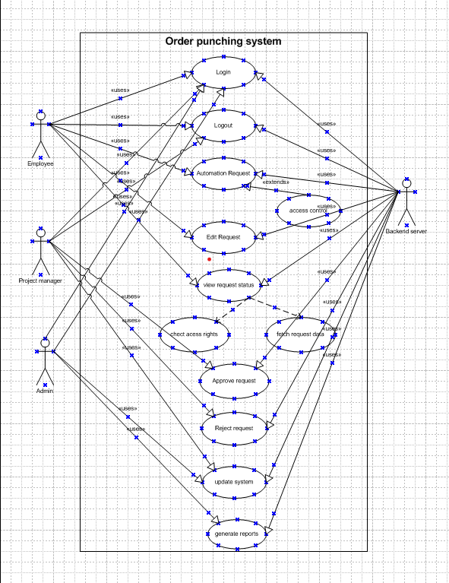

Activity Diagram -
Diagram 1-

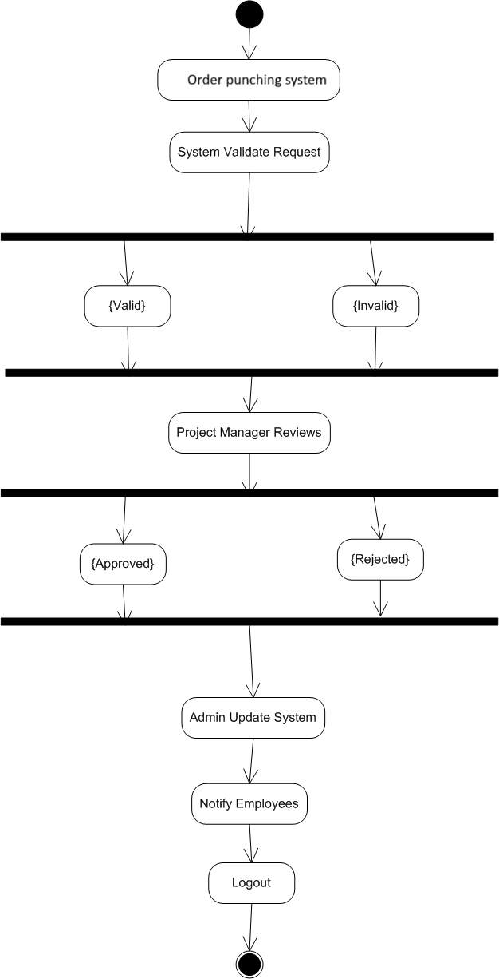 Diagram 2 -
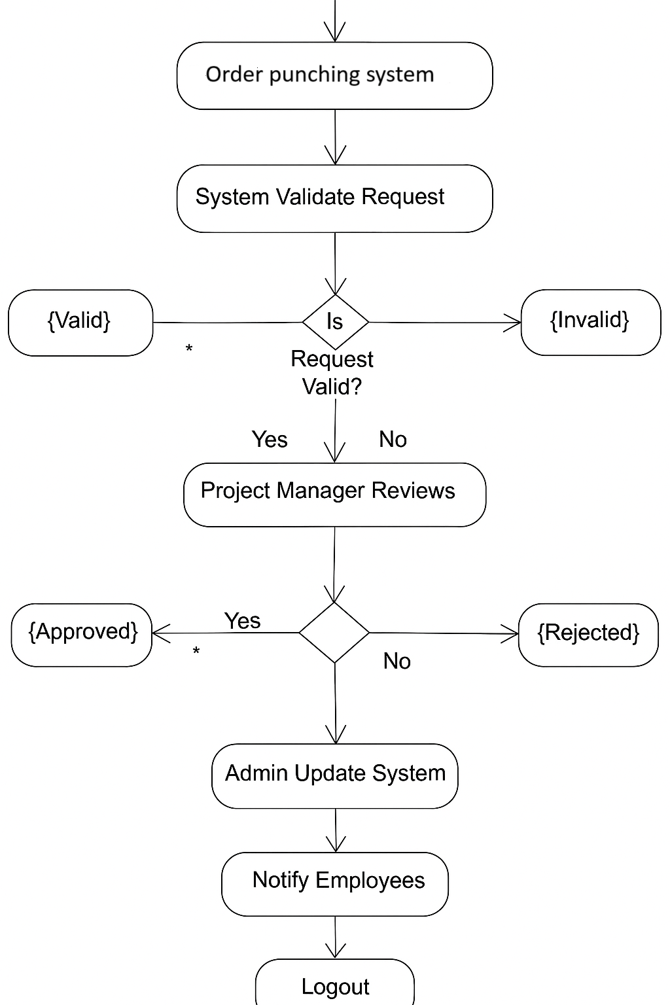

Document 7: Screens and Pages (Balsamiq Mockups)

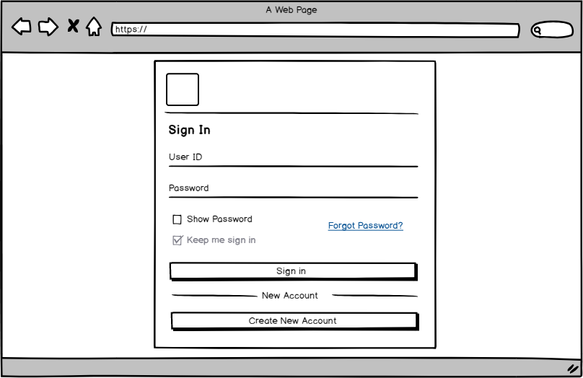

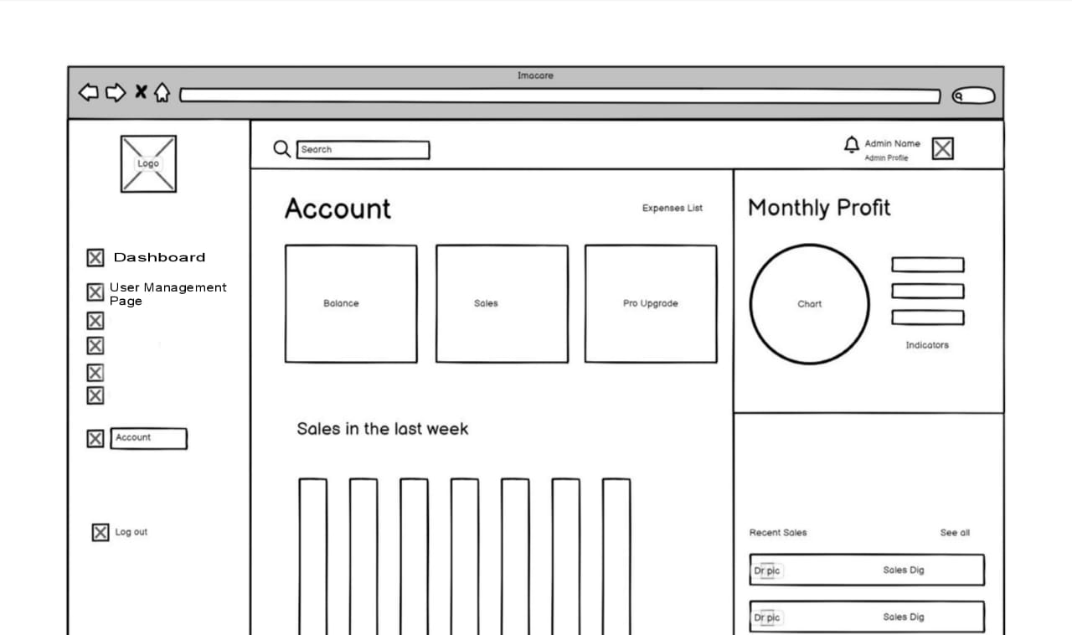1. Home Page
- Logo
- Navigation bar (Home | Login | Help)
- Brief description: “Welcome to UTCL.”

2. Login Page
- Fields: Username, Password
- Button: Login
- Link: Forgot Password

3. Admin Dashboard
- Tabs: Dashboard | User Management | Reports | Audit Log | Logout
- Widgets: Active Users, Roles Summary, Quick Links

4. User Management Page
- Table with:
  - User ID
  - Username
  - Role
  - Status
  - Action [Edit | Deactivate]
- Search Bar
- Button: Add New User

5. Edit User Role Page
- Form with:
  - User ID (read-only)
  - Username (read-only)
  - Current Role (dropdown to change)
  - Permissions (checkboxes)
- Buttons: Save | Cancel

6. Confirmation Page
- Message: “User role updated successfully.”
- Button: Back to User Management

7. Logout Page
- Message: “You have been logged out.”
- Link: Login again

Document 8: Tools – Visio and Axure
My Experience:
In Ultratech cement ltd, order punching system Project, I used Microsoft Visio extensively to create UML diagrams including use case and activity diagrams. It helped communicate the functional flow clearly to stakeholders.
Axure was used to design interactive prototypes for key modules such as the enhancement request form and admin approval panel. This was useful during review sessions and for validation with clients, ensuring that visual workflows aligned with business expectations.
Both tools contributed greatly to reducing ambiguity and achieving consensus during the design phase.

Document 9: My BA Experience in order punching system Project

1. Requirement Gathering:
- Employed MoSCoW technique to prioritize the enhancement features.
- Due to partial client availability, I coordinated with SMEs for clarifications.
- Validated requirements using FURPS (Functionality, Usability, Reliability, Performance, Supportability).
- Used prototyping (Axure) to elicit feedback from users.
- Duplicates and non-value-adding requests were filtered out for efficiency.

2. Requirement Analysis:
- Created Use Case Diagrams and Activity Diagrams for various upgradation flows.
- Conducted collaborative review sessions with cross-functional teams.
- Maintained and updated BRS and SRS documents.
- Reiterated requirement changes via version control documents.

3. Design:
- Converted use cases into positive and negative test scenarios.
- Held review sessions with the client to finalize UI/UX.
- Prepared Test Data for UAT phase.
- Maintained RTM to ensure traceability of all business and functional requirements.

4. Development:
- Conducted JAD sessions for developer handoffs.
- Acted as a liaison to resolve tech queries during coding.
- Ensured cohesive team communication by addressing interpersonal issues tactfully.
- Conducted frequent sync-ups with dev and client teams; handled absences with follow-ups and recordings.

5. Testing:
- Designed test cases aligned with use cases.
- Assisted in preparing the client for UAT by providing test data and execution plans.
- Ensured comprehensive coverage through RTM checks.
- Acquired formal UAT Sign-off from the client.

6. Deployment:
- Coordinated handover of the RTM with project closure documentation.
- Assisted in creating End User Manuals and Training Materials.
- Scheduled and monitored training sessions.
- Confirmed attendance and ensured all end users were equipped to use the new enhancements.

