Document 6- Please prepare a use case diagram, activity diagram and a use case specification document. Use case Diagram : 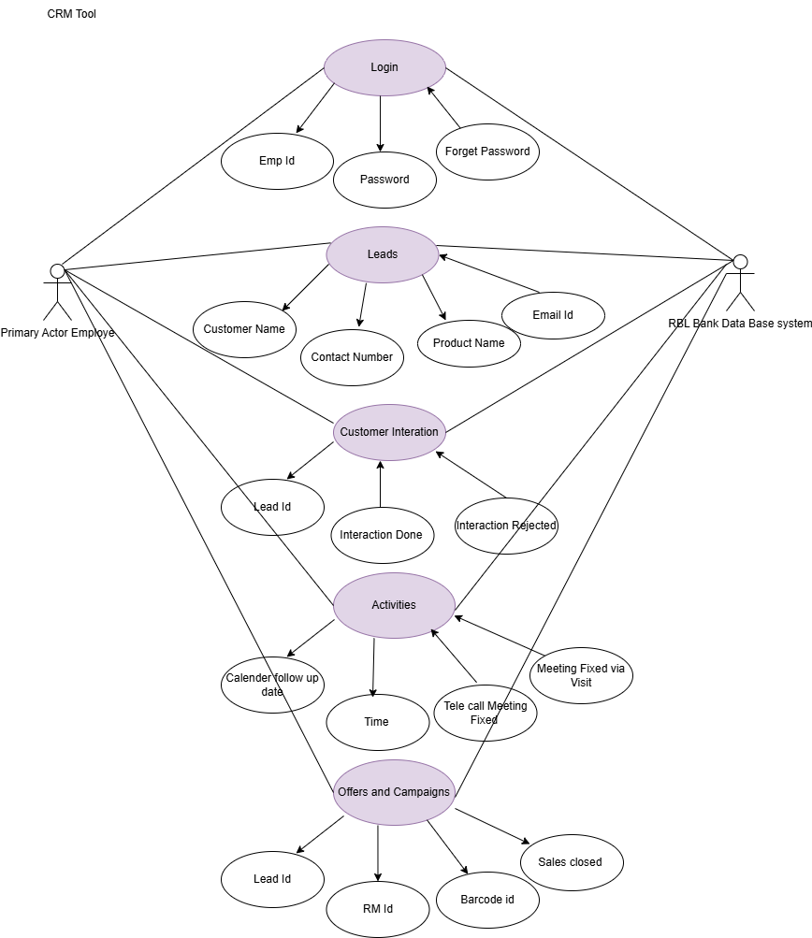

Activity diagram:
- Login page
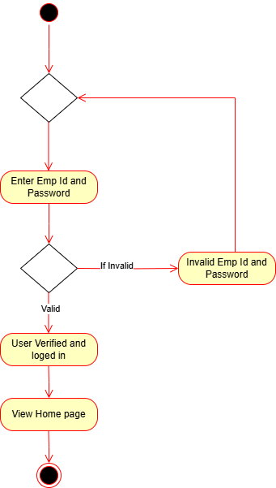

2.Leads
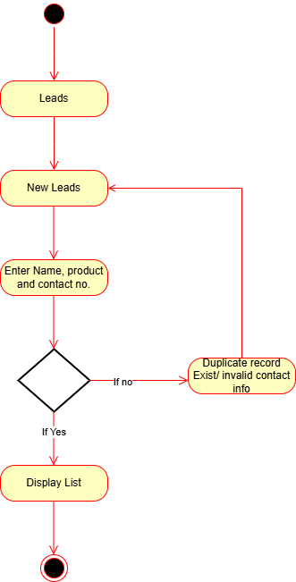

3.Customer Interaction
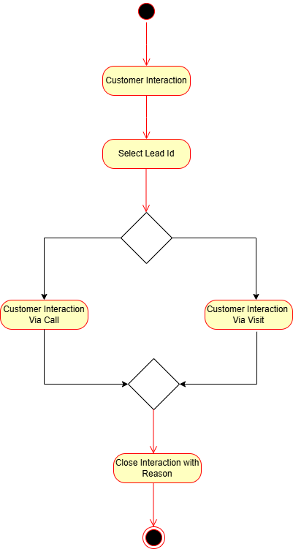

4. Activities
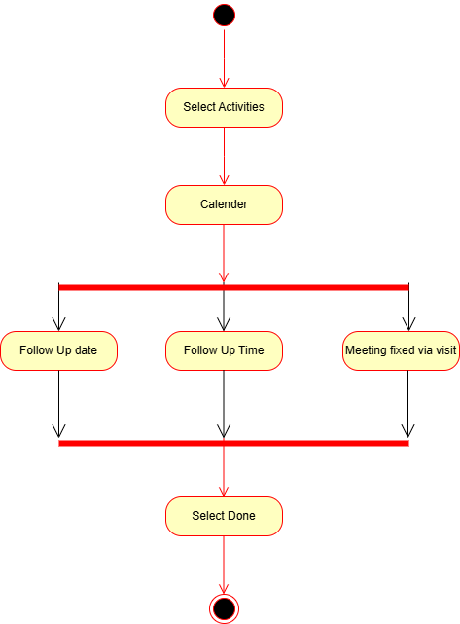

5.Offers and Campaigns

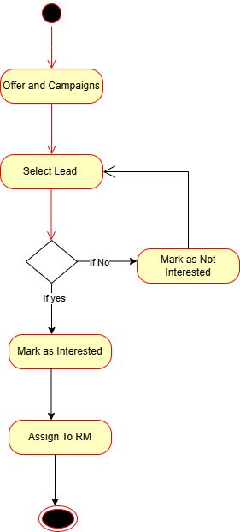

Usecase Specifications Documents
Use Case ID: UC001
Use Case Name: User Login to CRM Tool
Created By: [Mr. Janes ]
Date Created: 20/01/2025
Primary Actor: RBL Bank Employee
Description:
The employee logs into the RBL Bank CRM tool using a valid employee ID and password to gain access to CRM features such as leads, interactions, and campaigns.

Preconditions:
1.The employee has a valid CRM account (Employee ID and password).
2.The CRM system is online and accessible.

Postconditions:
1.The employee is successfully logged into the system.
2.The system maintains the user session until logout or timeout.
3.The employee is redirected to the CRM homepage/dashboard.

Main Flow:
1.The employee opens the CRM login interface.
2.The system prompts the employee to enter their Employee ID and Password.
3.The employee enters the credentials and submits the form.
4.The system validates the entered credentials against stored data in the RBL Bank database.
5.If credentials are valid:
6.The user is verified.
7.The employee is logged in successfully.
8.The CRM homepage is displayed.

Alternative Flow(s):
1.Invalid Credentials:
2.If the entered Employee ID or password is incorrect:
3.The system displays an error message: "Invalid Employee ID or Password".
4.The user is prompted to retry login.

Exceptions:
1.Multiple Invalid Attempts:
2.After multiple invalid attempts, the system may lock the account temporarily or trigger additional authentication (e.g., OTP or security questions).
System Downtime:
If the authentication server or CRM backend is down, login is not possible, and an error message is displayed.

Frequency of Use: Very High
(CRM is accessed daily by bank employees for customer management)

Assumptions:
1.Employees are trained and aware of their login credentials.
2.The CRM login interface is secured with SSL and follows secure authentication protocols.
3.Internet connectivity is available.
4.Optional: Multi-factor authentication (if implemented) is set up.

Use Case ID: UC002
Use Case Name: Manage Leads
Created By: [Mrs. Janes]
Date Created: 02/02/2025
Primary Actor: RBL Bank Employee
Description:
This use case allows RBL Bank employees to create and manage new customer leads by entering key details such as customer name, product of interest, and contact information. The system validates and stores this data for future interaction and campaign activities.

Preconditions:
The employee is successfully logged into the CRM system.
The CRM system is connected to the RBL Bank central database.
The employee has the required authorization to create leads.

Postconditions:
A new lead is successfully created and stored in the CRM system.
The lead is visible in the list of active leads.
The lead can now be used for follow-ups and interactions.

Main Flow:
The employee selects the Leads module from the dashboard.
The employee clicks on New Leads.
The system displays a form to enter:
Customer Name
Product Name (e.g., loan, credit card)
Contact Number
The employee submits the form.
The system checks for:
Duplicate records based on contact number or other identifiers.
Valid contact format.
If the data is valid and unique:
The lead is created successfully.
The system displays the list of leads including the newly created entry.

Alternative Flow(s):
1.Invalid or Duplicate Lead Entry:
If the contact number is already associated with an existing lead or the data format is incorrect:
The system displays an error: "Duplicate record exists / Invalid contact info".
The user is redirected back to the lead entry form to correct the input.

Exceptions:
System/database error:
If the CRM is unable to connect to the lead database, the operation fails and an error message is displayed.
Missing Required Fields:
The system prevents submission and prompts the employee to fill all mandatory fields.

Frequency of Use: High
(RBL employees regularly add new leads during customer acquisition processes.)

Assumptions:
1.Employees are aware of the data format requirements.
2.The CRM system includes backend logic for duplicate checks.
3.Network and database connectivity are active and stable.
4.Employee has sufficient access rights to add leads.

3.Customer Interaction

Use Case ID: UC003
Use Case Name: Customer Interaction
Created By: [Mr. Janes]
Date Created: 20/01/2025
Primary Actor: RBL Bank Employee

Description:
The employee initiates a customer interaction through the CRM tool by selecting a lead ID. The interaction can be conducted via call or visit. After completing the interaction, the employee closes it by providing a reason.

Preconditions:
The employee is logged into the CRM system.
A valid Lead ID exists in the CRM database.
The CRM system is online and accessible.

Postconditions:
Customer interaction is recorded (via call or visit).
The interaction is closed with a valid reason.
System logs the interaction for future reference.

Main Flow:
The employee selects the "Customer Interaction" feature in the CRM.
The system prompts the employee to select a Lead ID.
The employee selects the desired Lead ID from the available list.
The system prompts the employee to choose the mode of interaction (Call or Visit).
The employee conducts the interaction accordingly.
After interaction, the system prompts the employee to close the interaction.
The employee provides a valid reason and closes the interaction.
The system logs and confirms the closure of the interaction.

Alternative Flow(s):
1. Invalid or Missing Lead ID:
If the selected Lead ID is invalid or missing:
The system displays an error message: "Invalid or Missing Lead ID."
The user is prompted to select a valid Lead ID.
2. Change in Interaction Mode:
If the employee wants to switch from call to visit (or vice versa) before interaction completion:
The system allows switching and continues the process from the selected mode.

Exceptions:
1. No Action Taken:
If the employee attempts to close the interaction without recording any action:
The system displays a message: "Please complete the interaction before closing."
2. System Downtime:
If the CRM is temporarily inaccessible during interaction logging:
The system displays an error and prompts retry once connectivity is restored.

Frequency of Use: High
(Customer interactions are a core CRM function and used multiple times daily by employees)

Assumptions:
Employees are trained to handle both call and visit interactions.
Interaction options and closure reasons are predefined in the CRM system.
CRM interface for interaction is user-friendly and accessible.
Internet connectivity is stable during interaction.

4.Activities
Use Case ID: UC004
Use Case Name: Schedule Customer Activities
Created By: [Mr. Janes]
Date Created: 27/02/2025
Primary Actor: RBL Bank Employee

Description:
This use case describes how an RBL Bank employee schedules follow-up activities with a customer through the CRM system. Activities can include setting a follow-up date, follow-up time, or fixing a meeting via visit. The process concludes when the employee marks the activity as completed using the “Done” action.

Preconditions:
1.The employee is logged into the CRM system.
2.The customer lead or interaction record is already present.
3.The CRM calendar feature is available and functional.

Postconditions:
1.A follow-up activity or meeting is scheduled and stored.
2.The activity is marked as completed by the employee.
3.The system updates the customer’s interaction timeline.

Main Flow:
1.The employee navigates to the "Select Activities" section of the CRM.
2.The system displays the calendar interface.
3.The employee chooses from one or more activity options:
Set a Follow-Up Date
Set a Follow-Up Time
Fix a Meeting via Visit
The employee inputs/selects the relevant data for the activity.
The employee confirms by selecting Done.
The system stores the scheduled activity and confirms completion.

Alternative Flow(s):
1. Incomplete Activity Selection:
If the employee does not select all required fields (e.g., date without time):
The system displays an error message: “Please complete all required activity details.”
The user is prompted to enter missing information.
2. Rescheduling:
If the employee wants to change the date/time/meeting details before submitting:
The system allows editing and re-selection before confirming.

Exceptions:
1. Invalid Date/Time Format:
If an invalid or past date/time is selected:
The system shows an error message: “Invalid or past time/date not allowed.”
2. System Downtime:
If the calendar feature or CRM backend is offline:
Activity cannot be scheduled, and an error is shown.

Frequency of Use: Medium to High
(Used regularly when planning customer follow-ups or scheduling meetings)

Assumptions:
Calendar is integrated within the CRM interface.
Employees are trained to select appropriate follow-up or meeting options.
Activity data is stored in the CRM timeline/history.
System supports notifications/reminders based on scheduled activity.

5.Offers and Campaigns

Use Case ID: UC005
Use Case Name: Manage Offers and Campaigns
Created By: [Mr. Janes]
Date Created: 20/03/2025
Primary Actor: RBL Bank Employee
Description:
This use case outlines how an RBL Bank employee manages offers and campaigns through the CRM. The employee selects a lead, evaluates interest, and based on customer response, either marks them as interested (and assigns to RM) or not interested.

Preconditions:
The employee is logged into the CRM system.
Valid leads exist in the CRM database.
Active offers or campaigns are available.

Postconditions:
The lead is marked as interested or not interested.
Interested leads are assigned to a Relationship Manager (RM) for further follow-up.
Not interested leads are updated in the system and excluded from future follow-ups for this campaign.

Main Flow:
The employee navigates to the Offers and Campaigns section in the CRM.
The system displays the list of current offers and campaigns.
The employee selects a lead to approach.
The employee contacts the lead and assesses interest in the offer or campaign.
If the lead is interested:
The employee marks the lead as Interested.
The lead is Assigned to a Relationship Manager (RM) for further processing.
If the lead is not interested:
The employee marks the lead as Not Interested.
The lead is excluded from further outreach for this campaign.

Alternative Flow(s):
1. Lead Selection Cancelled:
If the employee decides not to proceed with a selected lead:
The system allows returning to the lead list without saving changes.
2. Incorrect Assignment:
If the lead is mistakenly marked as interested or not interested:
The system provides an option to update the lead status.

Exceptions:
1. No Campaigns Available:
If there are no active campaigns:
The system shows a message: “No active campaigns available at the moment.”
2. Assignment Error:
If assignment to RM fails due to system or data issue:
The system shows an error and logs the failure for retry.

Frequency of Use: Medium
(Campaigns and offers are run periodically; usage depends on campaign frequency)

Assumptions:
Campaign details and eligible leads are pre-configured in the CRM.
Employees are trained to handle lead conversations and interpret responses accurately.
CRM system supports automated RM assignment logic or manual selection.

Documents 7- Screens and Pages
1.Login Page
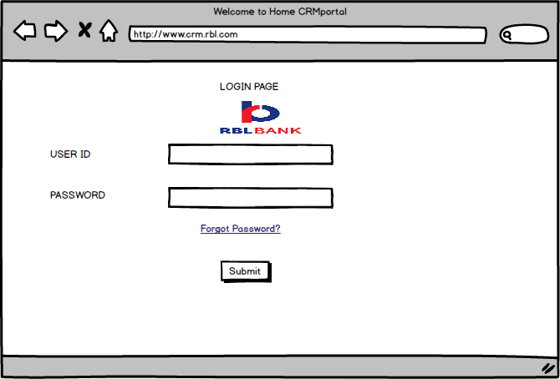

2. Home page

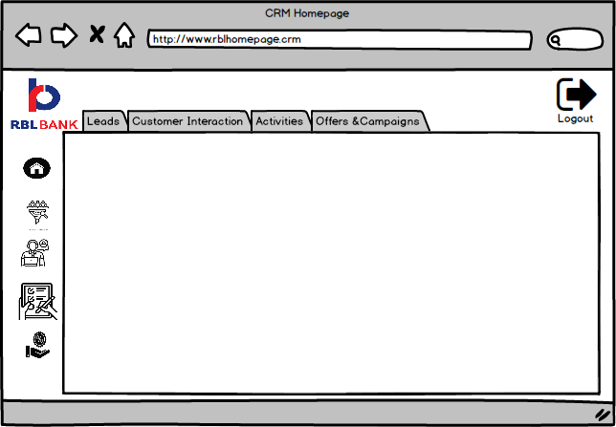

3.Manage Leads
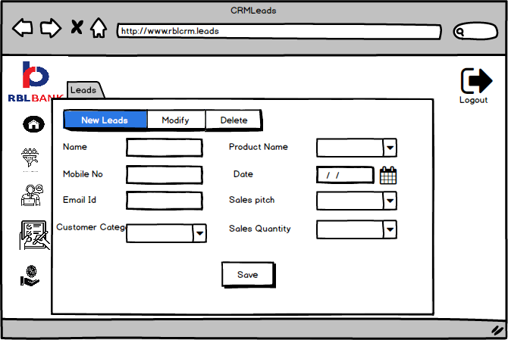
4.Customer Interactions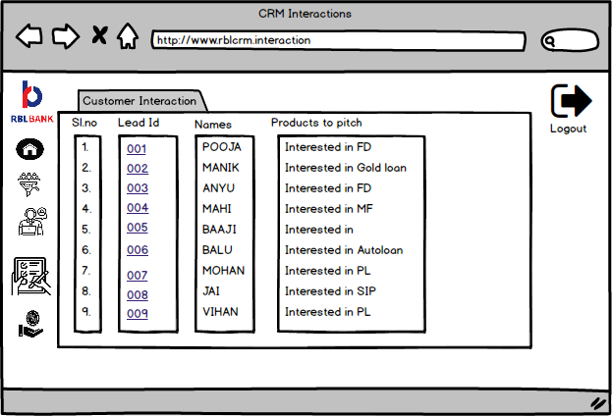
5. Interaction Details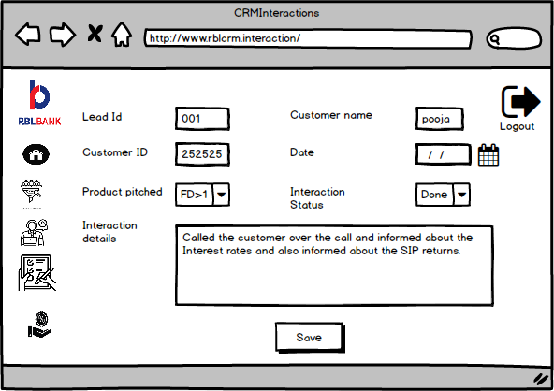

6.Activities

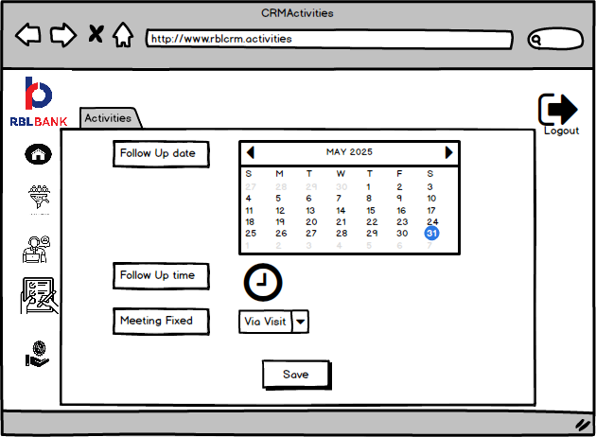

7.Offers and Campaigns
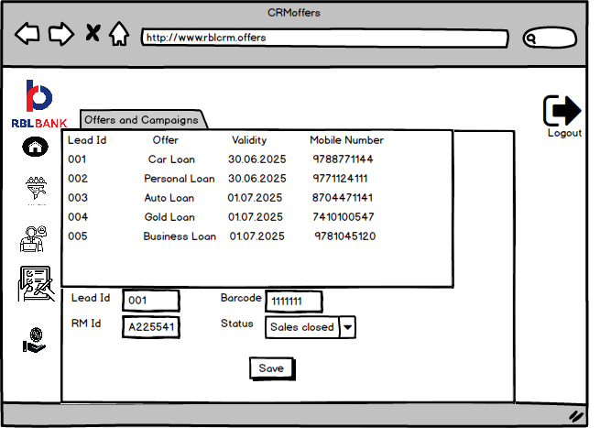

Document 8- Tools-Visio and Axure Write a paragraph on your experience using Visio and Axure for the project.
MS Visio is a powerful diagramming tool that allows users to create detailed charts, flowcharts, network diagrams, and organizational structures. It offers a variety of templates and shapes to visualize complex processes, making it useful for business, engineering, and IT professionals to communicate ideas and data clearly and efficiently. In Software Development it is Used to map out application architectures, UML diagrams, and wireframes.
Axure is a useful tool for creating interactive wireframes and prototypes without writing any code. It offers a simple drag-and-drop interface, allowing users to easily add elements like buttons, forms, images, menus, and shapes onto the screen. Users can also add interactive features such as pop-ups, sliders, and dynamic content that responds to user actions. One of its key features is the ability to add conditions and logic, so you can show how the system should behave in different situations. It also includes reusable components called “masters” to maintain consistency across screens. Axure allows for previewing prototypes in a browser and sharing them with others for feedback. While it has a bit of a learning curve, especially for more advanced options, it is a powerful tool for building and testing detailed user flows and system behavior before development begins.

Document 9- BA experience My experience as BA in following phases:
1. Requirement gathering
2. Requirement Analysis
3.Design
4. Development
5. Testing
6. Deployment

1.Requirement Gathering
- Requirement gathering is made from the stakeholders of RBL Bank Ltd using elicitation techniques like brainstorming ,focus groups, interview ,questionnaires. This helped in collecting a wide range of inputs from departments including sales, marketing, and customer support.
- I validate the requirements using FURPS technique.
- There are many requirements which are duplicated or repeated. We need to remove them immediately.
- Prototyping is used to give more specific requirements

2.Requirement Analysis
● I have to draw UML diagrams to visually describe the requirements
● Activity diagrams also used to describe the process flow
● Communicate the diagrams to team and if any changes or input given by the members to be made was made in the diagram. As a BA we need to consider the points and make modifications
● Prepare BRS and SRS

3. Design
● From the use case diagrams, we prepare test cases
● Communicate with client on design and solution documents
● Write negative test cases as well along with positive test cases.
● Prepare test data for testing
● Update RTM. This is just as we need to make sure that all the requirements are met

4. Development
● Organized JAD sessions
● Clarifying queries of tech team during coding
● There might be some team members who doesn't agree with the concept or who doesn’t cooperate during JAD sessions. As a BA i handle the situation gently and had one on one discussion with them. Explained how their actions are going to affect the project. Setup healthy environment within the team. ● Referred diagrams to code the Unit
● Conduct regular meetings with technical team and client which is challenging. Some team members might not be available for the meeting. Recording the session and providing that to missed one and having one to one discussion later with that missed person is all i need to do

5. Testing
● Prepare test cases from use cases
● Perform high level testing
● Test data is requested by BA from client
● Updated RTM
● Take signoff from client
● Prepare client for UAT

6. Deployment
● Forwarded RTM to client which should be attached to project closure document
● Coordinates to complete and share end user manuals
● Plans and organizes training sessions
● Make sure all the candidates attend the meeting

