Question 1 – Agile Manifesto – 8 marks
The primary purpose of the Agile Manifesto is to provide a foundation for developing software in a way that responds effectively to changing requirements and delivers value to customers. It aims to shift the focus from rigid processes and extensive documentation to individuals and interactions, working software, and customer collaboration.
The Agile Manifesto is a set of foundational principles for agile software development that emphasizes flexibility, collaboration, and customer satisfaction. It Outlines 4 core values and 12 principles guide agile practices.
4 Core Values of the Agile Manifesto:
- Individuals and Interactions over Processes and Tools: Focuses on the importance of effective communication and collaboration among team members.
- Working Software over Comprehensive Documentation: Prioritizes the delivery of functional software as the primary measure of progress.
- Customer Collaboration over Contract Negotiation: Encourages customers and stakeholders to have active involvement throughout the development process.
- Customer Collaboration over Contract Negotiation: Encourages customers and stakeholders to have active involvement throughout the development process.
12 Principles of Agile Manifesto:
- Customer Satisfaction through Early and Continuous Delivery: This principle concentrates on the importance of customer satisfaction by providing information to customers early on time and also with consistency throughout the development process.
- Welcome Changing Requirements, Even Late in Development: Agile processes tackle change for the customer's competitive advantage. Even late in development, changes in requirements are welcomed to ensure the delivered software meets the evolving requirements of the customer.
- Deliver Working Software Frequently: This principle encourages the regular release of functional software increments in short iterations. This enables faster feedback and adaptation to changing requirements.
- Deliver Working Software Frequently: This principle encourages the regular release of functional software increments in short iterations. This enables faster feedback and adaptation to changing requirements.
- Deliver Working Software Frequently: This principle encourages the regular release of functional software increments in short iterations. This enables faster feedback and adaptation to changing requirements.
- Deliver Working Software Frequently: This principle encourages the regular release of functional software increments in short iterations. This enables faster feedback and adaptation to changing requirements.
- Working Software is the Primary Measure of Progress: This principle emphasizes delivering functional and working software as the primary metric for project advancement. It encourages teams to prioritize the continuous delivery of valuable features, so it ensures that good progress is consistently achieved throughout the process. The primary goal is to provide customers with incremental value and also gather feedback early in the project life cycle.
- Working Software is the Primary Measure of Progress: This principle emphasizes delivering functional and working software as the primary metric for project advancement. It encourages teams to prioritize the continuous delivery of valuable features, so it ensures that good progress is consistently achieved throughout the process. The primary goal is to provide customers with incremental value and also gather feedback early in the project life cycle.
- Working Software is the Primary Measure of Progress: This principle emphasizes delivering functional and working software as the primary metric for project advancement. It encourages teams to prioritize the continuous delivery of valuable features, so it ensures that good progress is consistently achieved throughout the process. The primary goal is to provide customers with incremental value and also gather feedback early in the project life cycle.
- Working Software is the Primary Measure of Progress: This principle emphasizes delivering functional and working software as the primary metric for project advancement. It encourages teams to prioritize the continuous delivery of valuable features, so it ensures that good progress is consistently achieved throughout the process. The primary goal is to provide customers with incremental value and also gather feedback early in the project life cycle.
- Working Software is the Primary Measure of Progress: This principle emphasizes delivering functional and working software as the primary metric for project advancement. It encourages teams to prioritize the continuous delivery of valuable features, so it ensures that good progress is consistently achieved throughout the process. The primary goal is to provide customers with incremental value and also gather feedback early in the project life cycle.
- Working Software is the Primary Measure of Progress: This principle emphasizes delivering functional and working software as the primary metric for project advancement. It encourages teams to prioritize the continuous delivery of valuable features, so it ensures that good progress is consistently achieved throughout the process. The primary goal is to provide customers with incremental value and also gather feedback early in the project life cycle.

Question 2 – User Stories – Acceptance Criteria – BV – CP – 40 Marks
Write minimum 40 user stories and their acceptance criteria along with their BV and CP
User Story No: 1 | Tasks: 5 |  | Priority: High
As a user, I want to sign up easily using mobile or email, so I can start ordering food quickly.
BV: 90 |  | CP: 08
User can register using OTP for mobile or email, and login must be successful.

User Story No: 2 | Tasks: 4 |  | Priority: High
As a user, I want to search restaurants by name or cuisine, so I can find what I want easily.
BV: 85 |  | CP: 05
User can search by name, filter by cuisine, and get relevant results.

User Story No: 3 | Tasks: 6 |  | Priority: High
As a user, I want real-time order tracking, so I know where my food is.
BV: 95 |  | CP: 08
Order tracking shows map location, estimated time, and delivery updates.

User Story No: 4 | Tasks: 3 |  | Priority: High
As a user, I want to see ratings and reviews for each restaurant, so I can make informed choices.
BV: 70 |  | CP: 03
Reviews display with timestamps, ratings are averaged, and sorted.

User Story No: 5 | Tasks: 4 |  | Priority: Medium
As a user, I want to save my favourite restaurants, so I can reorder easily.
BV: 60 |  | CP: 04
"Favourite" button available, saved list accessible on profile.

User Story No: 6 | Tasks: 3 |  | Priority: High
As a user, I want to apply discount coupons during checkout, so I save money.
BV: 90 |  | CP: 05
Coupons can be applied, validated, and reflected in total amount.

User Story No: 7 | Tasks: 2 |  | Priority: Medium
As a user, I want to reorder from past orders, so I save time.
BV: 50 |  | CP: 02
Reorder button pulls the same items into cart.

User Story No: 8 | Tasks: 4 |  | Priority: High
As a user, I want to make payments through multiple methods, so I can choose my preference.
BV: 80 |  | CP: 06
Credit card, UPI, wallet, COD available and functional.

User Story No: 9 | Tasks: 2 |  | Priority: Medium
As a user, I want to set delivery instructions, so the rider knows my preferences.
BV: 45 |  | CP: 03
Notes field present and displayed to delivery rider.

User Story No: 10 | Tasks: 5 |  | Priority: High
As a user, I want to get 24/7 support, so I can solve my issues anytime.
BV: 85 |  | CP: 07
In-app chat, FAQs, and helpline number functional 24/7.

User Story No: 11 | Tasks: 2 |  | Priority: High
As a user, I want to schedule an order, so I get food when I want.
BV: 70 |  | CP: 04
Scheduled orders trigger notifications and timely deliveries.

User Story No: 12 | Tasks: 3 |  | Priority: Medium
As a user, I want to rate delivery experience separately, so feedback is detailed.
BV: 55 |  | CP: 03
Rating for delivery and food is collected independently.

User Story No: 13 | Tasks: 2 |  | Priority: Low
As a user, I want to see calorie information, so I can choose healthy options.
BV: 30 |  | CP: 02
Restaurants with nutrition info must display it.

User Story No: 14 | Tasks: 4 |  | Priority: High
As a user, I want to get updates via push notifications, so I don’t miss order info.
BV: 90 |  | CP: 04
Notifications are enabled and timely for order status.

User Story No: 15 | Tasks: 5 |  | Priority: Medium
As a user, I want to customize my meal (add/remove ingredients), so it suits my needs.
BV: 60 |  | CP: 06
Customization reflected in cart and visible to restaurant.

User Story No: 16 | Tasks: 3 |  | Priority: High
As a user, I want to contact the delivery agent, so I can coordinate better.
BV: 75 |  | CP: 04
Call/chat option becomes available once the order is picked.

User Story No: 17 | Tasks: 2 |  | Priority: Medium
As a user, I want to see estimated delivery time before ordering, so I can plan.
BV: 50 |  | CP: 03
ETA is displayed on restaurant listing and cart page.
User Story No: 18 | Tasks: 3 |  | Priority: Low
As a user, I want to gift an order to someone, so I can surprise them.
BV: 25 |  | CP: 03
Gift mode allows custom address and message.

User Story No: 19 | Tasks: 4 |  | Priority: Medium
As a user, I want to add tips for the delivery agent, so I can appreciate good service.
BV: 65 |  | CP: 04
Tip option at checkout and post-delivery available.

User Story No: 20 | Tasks: 2 |  | Priority: Medium
As a user, I want my app theme to switch to dark mode, so it's easier on my eyes.
BV: 65 |  | CP: 04
User can toggle light/dark mode from settings.

User Story No: 21 | Tasks: 4 |  | Priority: High
As a user, I want a simple and fast onboarding process, so I start quickly.
BV: 80 |  | CP: 05
Signup flow finishes in less than 2 minutes with intuitive steps.

User Story No: 22 | Tasks: 2 |  | Priority: Low
As a user, I want to change my language preference, so I use the app comfortably.
BV: 20 |  | CP: 02
Language switch works instantly across app.

User Story No: 23 | Tasks: 3 |  | Priority: Medium
As a user, I want to set dietary preferences (veg, vegan), so I get relevant results.
BV: 60 |  | CP: 04
Filter reflects on search and restaurant listings.

User Story No: 24 | Tasks: 3 |  | Priority: Medium
As a user, I want to track refunds, so I know when my money returns.
BV: 50 |  | CP: 03
Refund status updates are sent via app and email.

User Story No: 25 | Tasks: 2 |  | Priority: Medium
As a user, I want to cancel an order with reasons, so I explain my action.
BV: 45 |  | CP: 03
Cancel with dropdown list of reasons, policy alert.

User Story No: 26 | Tasks: 3 |  | Priority: High
As a user, I want food suggestions based on my taste, so I discover new favourites.
BV: 85 |  | CP: 05
Machine learning-based recommendations must be relevant.
User Story No: 27 | Tasks: 4 |  | Priority: High
As a user, I want to get loyalty points on every order, so I feel rewarded.
BV: 90 |  | CP: 07
Points tracked, usable for discounts, shown in wallet.

User Story No: 28 | Tasks: 3 |  | Priority: Medium
As a user, I want to see trending dishes in my city, so I try popular food.
BV: 55 |  | CP: 04
“Trending” section shows daily/weekly hits.

User Story No: 29 | Tasks: 4 |  | Priority: Medium
As a user, I want to set family member profiles, so I can order for them.
BV: 65 |  | CP: 06
Profiles stored with preferences and allergies.

User Story No: 30 | Tasks: 2 |  | Priority: Low
As a user, I want to share food photos in reviews, so others see real images.
BV: 25 |  | CP: 02
Image upload enabled during review.

User Story No: 31 | Tasks: 2 |  | Priority: Medium
As a user, I want to check restaurant hygiene ratings, so I order safely.
BV: 50 |  | CP: 03
Restaurants rated on cleanliness and compliance.

User Story No: 32 | Tasks: 3 |  | Priority: Medium
As a user, I want to pay using EMI or BNPL, so I manage my spending.
BV: 55 |  | CP: 04
EMI options show during checkout.

User Story No: 33 | Tasks: 2 |  | Priority: Low
As a user, I want a scratch card or spin wheel feature, so I enjoy rewards.
BV: 20 |  | CP: 02
Rewards unlocked after order, based on rules.

User Story No: 34 | Tasks: 3 |  | Priority: High
As a user, I want to set delivery to my current GPS location, so I save time.
BV: 70 |  | CP: 05
Auto-fetch of current address must work accurately.

User Story No: 35 | Tasks: 3 |  | Priority: Low
As a user, I want to refer a friend and get benefits, so I promote the app.
BV: 35 |  | CP: 03
Referral codes tracked, bonuses credited.
User Story No: 36 | Tasks: 4 |  | Priority: Medium
As a user, I want to see order milestones (accepted, cooked, out), so I stay informed.
BV: 50 |  | CP: 05
Timeline view updates in real-time.

User Story No: 37 | Tasks: 2 |  | Priority: Medium
As a user, I want to opt for eco-friendly packaging, so I support the environment.
BV: 45 |  | CP: 03
Toggle option at checkout reflects in order.

User Story No: 38 | Tasks: 3 |  | Priority: High
As a user, I want to see delivery boy ratings, so I know who is delivering.
BV: 75 |  | CP: 06
Rider profile with rating visible once assigned.

User Story No: 39 | Tasks: 2 |  | Priority: Medium
As a user, I want to request a call from support, so I can speak to someone.
BV: 50 |  | CP: 03
Call-back ticket raised with ETA for call.

User Story No: 40 | Tasks: 3 |  | Priority: High
As a user, I want to reorder group orders easily, so I save coordination time.
BV: 85 |  | CP: 07
Group orders saved and editable for reorders.

Question 3 – what is epic? Write 2 epics
An Epic is a large user story or a group of related user stories that together deliver a significant business value. Epics are often too big to be completed in a single iteration or sprint and are therefore broken down into smaller, manageable user stories during backlog refinement. They help in organizing and structuring the product backlog effectively and provide a high-level understanding of customer requirements.
Example Epics:
Epic 1: Seamless User Registration and Profile Management
User Story 1:  User sign-up using mobile number/email. | User Story 2:  Profile picture upload and edit. | User Story 3:  Set dietary preferences. | User Story 4:  Add and manage delivery addresses. | User Story 5:  Set language and dark mode preferences.

Epic 2: Fast and Reliable Food Ordering Experience
User Story 6:  Restaurant and dish search functionality. | User Story 7:  Real-time order tracking. | User Story 8:  Multiple payment options including wallets, UPI, and cards. | User Story 9:  Order scheduling and reorder features. | User Story 10:  Live customer support and delivery agent contact.

Question 4 – difference between BV and CP – 2 marks
Difference between BV and CP:
Business Value (BV) | Complexity Points (CP)
BV indicates how important a user story is to the business. | CP indicates the effort and complexity involved in developing a user story.
Estimated by the stakeholders or clients. | Estimated by the Scrum Developers.
Uses Scrum Currency Notes like ₹1000, ₹500, ₹100, etc., for estimation. | Uses Planning Poker cards like 1, 2, 3, 5, 8, etc., for estimation.
Focuses on business impact and customer priority. | Focuses on technical difficulty and time required for coding.
Differences in estimation are resolved through stakeholder discussion and agreement. | Differences in estimation are resolved through developer discussion and consensus.

Question 5 – Explain about Sprint – 5 Marks
What is Sprint?
- A Sprint is a time-boxed development cycle in Scrum (usually 1 to 4 weeks) where the Scrum Team delivers a potentially shippable product increment.
- All activities like planning, designing, coding, testing, and review are carried out within the sprint.
Sprint Duration:
- Standard Duration: 2 Weeks
- Sprint Value: 8 User Stories
Scrum Duration:
- Scrum is the daily 15-minute meeting to discuss progress, challenges, and plans.
- Standard Duration: 1 Day
- Scrum Value (Team Size): 6 Members (Including Product Owner, Scrum Master, and Developers)
Key Terms:
- PBI (Product Backlog Item)
  - A requirement, feature, or fix to be implemented.
- Task
  - A small unit of work derived from a PBI, done by one developer in one day.
- WIP (Work In Progress)
  - Tasks that are currently being worked on and are not yet complete.
Sprint Backlog Table:
PBI | Tasks | WIP | Done
User Login Feature | Create Login UI, Connect to DB | Connect to DB | Create Login UI
Search Restaurant by Name | Design Search Bar, Implement Logic | Implement Logic | Design Search Bar
Order Tracking | Design Map UI, Backend API |  | Design Map UI, API
Payment Gateway Integration | UI Integration, API Testing | UI Integration

Question 6 – Explain Product backlog and sprint back log – 5 Marks
Product Backlog:
- The Product Backlog is a dynamic and prioritized list of all the features, enhancements, bug fixes, technical tasks, and requirements needed in the product.
- It is maintained by the Product Owner and evolves as the product and market needs change.
- Each item in the Product Backlog is called a PBI (Product Backlog Item).
- Items are prioritized based on business value, user needs, and market demand.
- It serves as the single source of truth for all work required in the product.
Example PBIs:
- User login system
- Real-time order tracking
- Payment gateway integration
- 24/7 customer support chat
Sprint Backlog:
- The Sprint Backlog is a subset of the Product Backlog.
- It contains the PBIs selected for the current sprint, along with the tasks required to complete each item.
- It is created during the Sprint Planning Meeting by the Scrum Team.
- Sprint Backlog is updated daily and shows the current Work In Progress (WIP) and completed items.
- The Sprint Backlog is owned by the Development Team.
Product Backlog | Sprint Backlog
Maintained by Product Owner | Maintained by Development Team
Contains all items needed in the product | Contains only items selected for one sprint
Prioritized list of features | Task breakdown of selected PBIs
Dynamic and evolving | Fixed for the sprint once planning is done

Question 7 – What is impediments log? Write 2 impediments – 5 Marks
The Impediments Log is a document or list used to record all the challenges, blockers, and obstacles faced by the Scrum Team during a sprint. It helps the Scrum Master track and resolve issues that are affecting the team’s progress. The log is regularly reviewed during daily scrums and sprint retrospectives to ensure continuous improvement and productivity.
Impediment Number | Description of impediment | Impact | Resolution status
1 | API for payment gateway not provided by third-party vendor | Delay in integrating payment functionality | In Progress
2 | Developer system crashed during mid-sprint | Task reallocated to another team member | Resolved

Purpose of the Impediments Log:
- Ensures transparency in sprint progress
- Helps Scrum Master in tracking and solving blockers
- Improves team communication and accountability
- Supports faster decision making to keep the sprint on track

Question 8 – Explain Velocity of the Team – 1 Marks
Velocity is the measure of the total number of story points (or complexity points) completed by the Scrum Team in a single sprint. It helps in predicting how much work the team can handle in future sprints and is used for sprint planning and forecasting.
Example: If a team completes 30 story points in Sprint 1 and 32 in Sprint 2, their average velocity is 31 story points.

Question 9 – Draw Sprint Burn Charts n Product Burn Down Charts– 3 Marks
Burnup Chart:
1st Sprint:
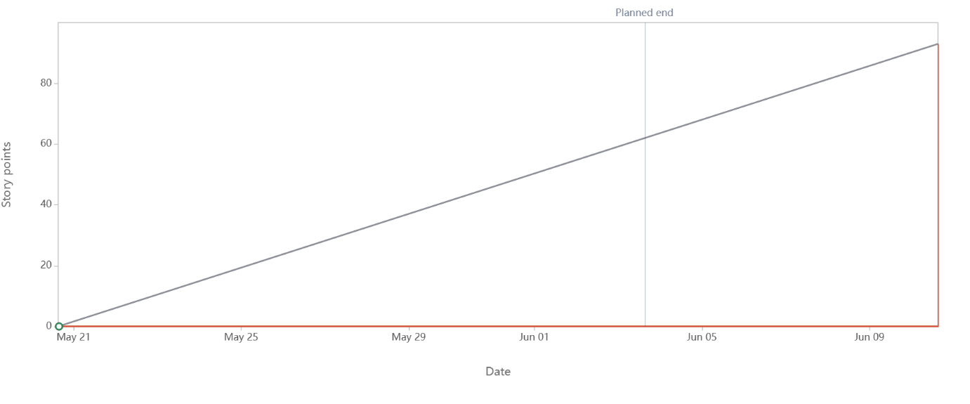
2nd Sprint:
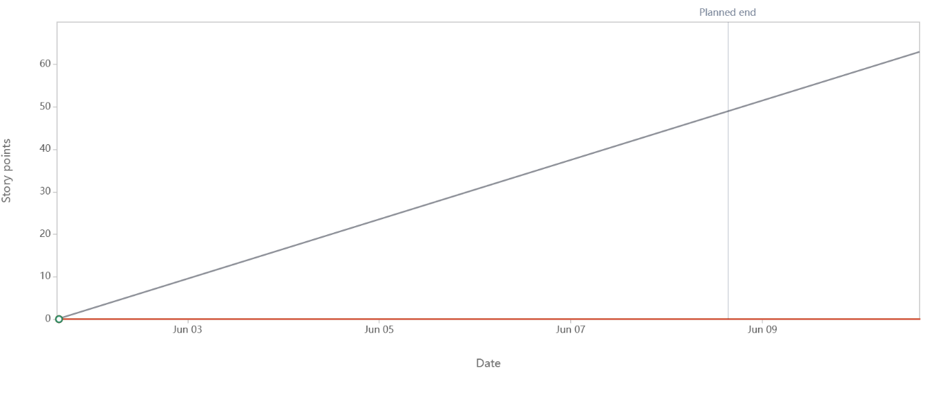

Product burn down chart:
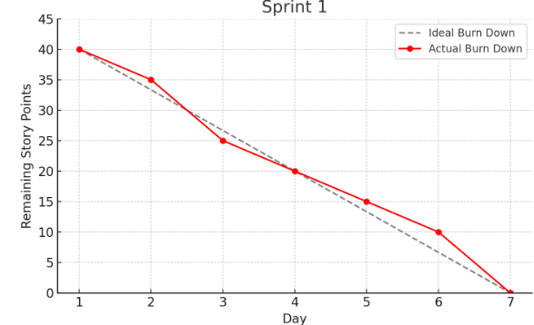

Question 10 – Explain about Product Grooming – 2 Marks
Product Grooming (also known as Backlog Refinement) is the process in Scrum where the Product Owner and the Scrum Team regularly review and update the Product Backlog. The goal is to ensure that backlog items are:
- Well-defined and clearly understood
- Properly prioritized based on business value
- Estimated in terms of effort (story points)
This activity helps the team prepare for Sprint Planning and ensures that the team always works on the most valuable and ready features.
Key Activities in Product Grooming:
- Breaking down large PBIs into smaller, manageable stories
- Clarifying requirements and acceptance criteria
- Re-estimating story points if needed
- Re-prioritizing backlog items based on business goals
Frequency: Usually done once or twice per sprint.

Question 11 – Explain the roles of Scrum Master and Product Owner – 3 Marks
Scrum Master:
- The Scrum Master is the servant-leader of the Scrum Team who ensures that the Scrum process is followed correctly and effectively.
- They help the team stay focused by removing blockers, organizing meetings, and facilitating communication within the team.
- They conduct important Scrum events like Daily Stand-ups, Sprint Planning, Sprint Reviews, and Sprint Retrospectives.
- Their role is to ensure continuous improvement by coaching the team on Agile best practices.
- Key responsibilities:
  - Facilitate Scrum ceremonies
  - Maintain the Impediment Log and remove blockers
  - Help the team become self-organizing
  - Shield the team from outside distractions
Product Owner (Role Played by Me):
In this SCRUM FOODS project, I acted as the Product Owner. I was responsible for maximizing the business value of the product by managing the Product Backlog and ensuring that the most valuable features are delivered first.
I interacted with stakeholders and customers to gather requirements and converted them into clear, prioritized user stories with proper acceptance criteria. I made sure the development team clearly understood what to build and why it mattered.
My Key Responsibilities as Product Owner:
- Created and maintained the Product Backlog
- Prioritized user stories based on Business Value (BV)
- Defined clear acceptance criteria for each feature
- Ensured the team understood the goals and customer needs

Question 12 – Explain all Meetings Conducted in Scrum Project – 8 Marks
Sprint Planning Meeting:
- When: At the beginning of every sprint
- Duration: Timeboxed to 4 hours for a 2-week sprint
- Participants: Product Owner, Scrum Master, Scrum Team
- Purpose:
  - Decide what work will be completed in the sprint
  - Define the Sprint Goal
  - The team pulls items from the Product Backlog into the Sprint Backlog
Daily Scrum (Stand-Up):
- When: Every working day of the sprint
- Duration: Timeboxed to 15 minutes
- Participants: Scrum Team (Scrum Master may facilitate)
- Purpose:
  - Team members share progress and blockers
  - Improve communication
  - Plan for the next 24 hours
- Each member answers:
  - What did I do yesterday?
  - What will I do today?
  - Are there any impediments?
Sprint Review Meeting:
- When: At the end of the sprint
- Duration: Timeboxed to 2 hours for a 2-week sprint
- Participants: Scrum Team + Stakeholders
- Purpose:
  - Demonstrate the product increment to stakeholders
  - Collect feedback for future development
  - Discuss what was completed and what wasn’t
Sprint Retrospective Meeting:
- When: Immediately after the Sprint Review
- Duration: Timeboxed to 1.5 hours for a 2-week sprint
- Participants: Scrum Team only
- Purpose:
  - Reflect on the sprint and identify what went well, what didn’t, and what can be improved
  - Promote continuous improvement
  - Scrum Master ensures that improvement actions are implemented in the next sprint
Product Backlog Grooming (Refinement):
- When: Mid-sprint (usually once or twice per sprint)
- Duration: 1 to 2 hours
- Participants: Product Owner, Scrum Master, Scrum Team
- Purpose:
  - Refine, clarify, and break down Product Backlog Items (PBIs)
  - Estimate and prioritize upcoming work
  - Prepare items for the next Sprint Planning

Question 13 – Explain Sprint Size and Scrum Size– 2 Marks
Sprint Size:
- A Sprint is a time-boxed period in Scrum during which a potentially shippable product increment is developed.
- The recommended Sprint Duration is 2 to 4 weeks, depending on the project needs.
- In this fixed time period, the team commits to complete selected Product Backlog Items (PBIs) and deliver working software.
Scrum Size (Team Size):
- The ideal Scrum Team size is 7 ± 2 members, meaning the team should have between 5 and 9 members.
- This includes:
  - 1 Product Owner
  - 1 Scrum Master
  - 5 to 7 Developers

Question 14 – Explain DOR and DOD – 2 Marks
Definition of Ready (DoR):
- Definition of Ready refers to a checklist or set of criteria that a Product Backlog Item (PBI) must meet before it can be picked up for a sprint.
- It ensures that the user story is well-defined, clear, and estimable by the development team.
Example DoR Checklist:
- User story is clearly written
- Acceptance criteria are defined
- Dependencies are resolved
- Story is estimated and prioritized
Definition of Done (DoD):
- Definition of Done is a shared understanding within the team of what it means for a task or user story to be considered complete.
- It includes development, testing, integration, documentation, and review.
Example DoD Checklist:
- Code is written and peer-reviewed
- Unit and functional tests are passed
- Code is merged into main branch
- Product Owner has accepted the story

Question 15 – Explain Prioritization Techniques and MVP – 3 Marks
1. Prioritization Techniques:
Prioritization techniques help the Product Owner and team decide which Product Backlog Items (PBIs) should be developed first based on business value, urgency, and customer needs.
Common Prioritization Techniques:
a. MoSCoW Technique:
- M – Must have
- S – Should have
- C – Could have
- W – Won’t have (this time)
Helps categorize features based on criticality.
b. Business Value (BV) Estimation:
- Stakeholders assign value (₹10 to ₹1000) using Scrum Currency Notes.
- Stories with higher BV are given priority.
c. WSJF (Weighted Shortest Job First):
- Priority = Business Value / Job Size (Complexity)
- Used in Scaled Agile Framework (SAFe) to maximize economic benefit.
2. MVP (Minimum Viable Product):
- An MVP is the smallest set of features that can be released to users to deliver value and gather early feedback.
- It helps in validating ideas quickly with minimum effort.
- MVP avoids over-engineering by focusing on what’s truly essential.

Question 16 – Difference between Business Analyst n Product Owner – 3 Marks
Focus:
- BA: Gathers and analyzes requirements
- PO: Manages product vision and backlog
Decision-Making:
- BA: Suggests solutions, no final authority
- PO: Has decision-making authority on product features
Backlog Ownership:
- BA: May assist in backlog refinement
- PO: Owns and prioritizes the Product Backlog
Stakeholder Role:
- BA: Acts as a bridge between stakeholders and developers
- PO: Represents stakeholders and customer interests
Documentation:
- BA: Prepares detailed requirement documents and user stories
- PO: Focuses on user stories with acceptance criteria and business value

Question 17 – Prepare a sample Resume of 3yrs exp Product Owner – 3 Marks
Name: Mr X
Mobile: +91-98765XXXXX
Email: MrX@gmail.com
Location: Chennai, Tamil Nadu, India
Career Objective
Product Owner with 3 years of experience in Agile Scrum projects. Skilled in backlog management, MVP planning, and sprint execution. Passionate about delivering high-value features through clear communication and stakeholder collaboration.
Professional Experience
Product Owner
TechNova Solutions Pvt. Ltd., Chennai
Feb 2021 – Present
- Led the development of SCRUM FOODS, a 24/7 food delivery app targeting all age groups.
- Managed 8 user stories per sprint, prioritized by Business Value (BV) using Scrum Currency.
- Created and maintained the Product Backlog, defining clear acceptance criteria.
- Defined and delivered the Minimum Viable Product (MVP) including login, restaurant search, order placement, and delivery tracking.
- Facilitated Sprint Planning, Daily Scrums, Reviews, and Retrospectives with a 6-member Scrum team.
- Collaborated with stakeholders to refine PBIs and resolve impediments.
Key Skills
- Product Backlog Management
- Sprint Planning & Execution
- Agile/Scrum Methodologies
- MVP Delivery
- Stakeholder Communication
- Tools: JIRA, Trello, Confluence
Education
- B.E. in Computer Science Engineering
Anna University, Chennai – 2020
Certifications
- Certified Scrum Product Owner (CSPO) – Scrum Alliance
- Agile Project Management – Coursera

