Question 1 – Functional Requirements - 15 Marks
Identify minimum 20 functional requirements
Req ID | Req Name | Req Description | Priority
FR0001 | Farmer Registration | Farmers should be able to register with the application using email and password. | 8
FR0002 | Farmer Login | Farmers should be able to log in using registered credentials. | 9
FR0003 | Manufacturer Registration | Product manufacturers should be able to register on the platform. | 8
FR0004 | Manufacturer Login | Manufacturers should be able to log in to upload/manage product listings. | 8
FR0005 | Browse Product Catalog | Farmers should be able to browse categorized product listings. | 9
FR0006 | Product Search | Farmers should be able to search products using keywords, categories, or filters. | 9
FR0007 | View Product Details | Farmers should be able to view product details like description, price, image, etc. | 8
FR0008 | Add to Cart | Farmers should be able to add products to the shopping cart. | 9
FR0009 | Add to Buy-Later List | Farmers should be able to save products for later purchase. | 7
FR0010 | Place Order | Farmers should be able to place an order for selected products. | 10
FR0011 | Order Confirmation Email | System should send confirmation email after successful order placement. | 9
FR0012 | Payment Gateway Integration | System should support COD, Credit/Debit Card, and UPI payments. | 10
FR0013 | Order Tracking | Farmers should be able to track the status and location of their orders. | 9
FR0014 | Manufacturer Product Upload | Manufacturers should be able to upload product info, price, stock, and image. | 8
FR0015 | Manage Products | Manufacturers should be able to edit/update or remove product listings. | 8
FR0016 | View Order History | Farmers should be able to view a list of their previous orders. | 7
FR0017 | Forgot Password | Users should be able to reset their password through a secure process. | 8
FR0018 | Logout Functionality | All users should be able to securely log out from the application. | 6
FR0019 | Admin Dashboard |  | 7
  Admin should be able to view/manage users, products, and orders.
FR0020 | Notification Alerts | System should notify users about order updates (e.g., dispatched, delivered). | 7

10 Non- functional requirements :

Req ID | Req Name | Req Description | Priority
NFR001 |  |  | 9
  Usability
  The application should have an intuitive and easy-to-use interface, suitable for rural users.
NFR002 | Performance |  | 8
  Pages (search, product listing, etc.) should load within 3 seconds under standard conditions.
NFR003 | Compatibility | The system should work across browsers (Chrome, Firefox, Edge) and devices (desktop/mobile). | 7
NFR004 | Security | User data and payment details should be encrypted and securely stored using HTTPS and AES. | 9
NFR005 |  | The application should have 99.5% uptime, ensuring constant access for users. | 8
  Availability
NFR006 |  |  | 7
  Scalability
  The system should be able to scale to handle increased users and product listings as needed.
NFR007 | Maintainability |  | 6
  The system should be built in a modular way to allow easy updates and issue resolution.
NFR008 | Localization Support |  | 7
  The application should support multiple regional languages to serve farmers from different areas.
NFR009 | Testability | The system should support automated and manual testing to ensure reliable delivery. | 8
NFR010 |  |  | 7
  Reliability
  System processes like order placement, payment, and notifications should be consistently accurate.

Question 2–Minimum 5 page designs - 15 Marks
Ans :
Home Page :

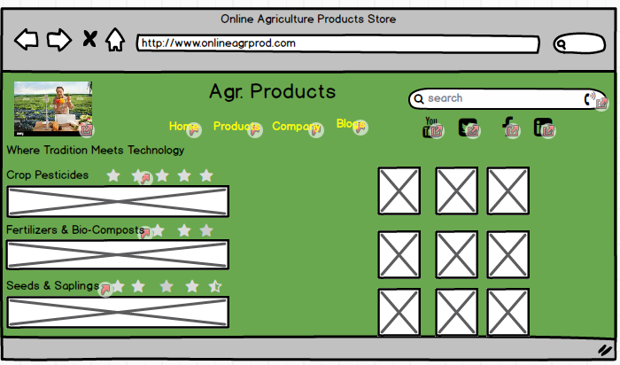

Search Page :
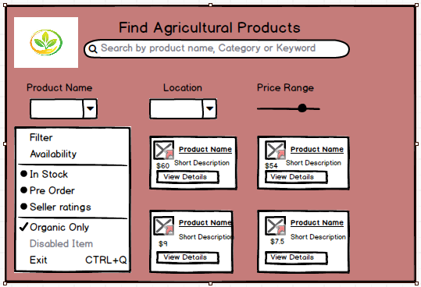

Payment Page :

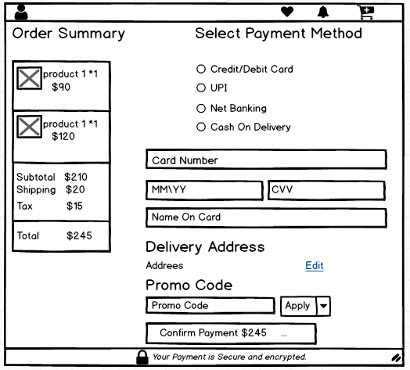

Order placing Page :
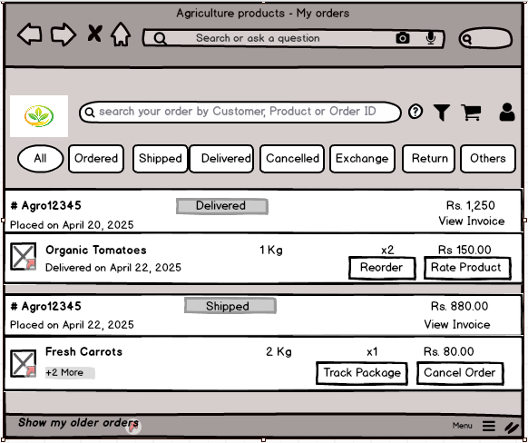

Order Tracking Page :
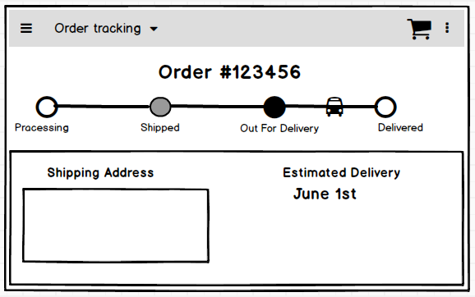

Question 3 – Tools (Balsamiq, MS Visio) - 15 Marks

1. Balsamiq
What is Balsamiq?
Balsamiq is a tool used to draw simple screen designs for websites or mobile apps. These drawings are called wireframes and they help you plan how each page of the app will look before building it.
Why use it?
- It helps to plan and show what the app will look like.
- We can quickly drag and drop buttons, text boxes, and other items to make sample pages.
- It looks like a hand-drawn sketch, so people focus on the layout, not on colors or fonts.
- Very useful for getting feedback from clients or developers early in the project.
Used in this project for:
- Designing screens like:
  - Home page
  - Product search page
  - Payment page
  - Order placing page
  - Order tracking page

2. Microsoft Visio
What is Visio?
Microsoft Visio is a tool used to make professional diagrams like flowcharts, ER diagrams, and process maps. It helps to visually explain how a system or process works.
Why use it?
- It has many ready-made shapes and connectors to make diagrams easy.
- Helps we show the connections between parts of a system clearly.
- Looks clean and professional – great for client presentations.
- Works well with other Microsoft Office tools like Word and Excel.
You can also use it for:
  - Use case diagrams
  - Workflow/process flow diagrams
Question 4 – RTM - 6 Marks
Req ID | Req Name | Req Description | Design | T1 (Unit Test) | T2 (Integration Test) | T3 (System Test) | T4 (Regression Test) | UAT (User Acceptance Test)
FR0001 | Farmer Registration | Farmers register with email/password | Complete | Complete | Complete | Complete | Complete | Incomplete
FR0002 | Farmer Login | Farmers log in using registered credentials | Complete | Complete | Complete | Complete | Complete | Incomplete
FR0005 | Browse Product Catalog | Farmers browse categorized product listings | Complete | Complete | Complete | Complete | Complete | Incomplete
FR0008 | Add to Cart | Farmers add products to shopping cart | Complete | Complete | Complete | Complete | Complete | Incomplete
FR0010 | Place Order | Farmers place an order for selected products | Complete | Complete | Complete | Complete | Complete | Incomplete
FR0012 | Payment Gateway Integration | Supports COD, Card, and UPI payments | Complete | Complete | Complete | Complete | Complete | Incomplete
FR0013 | Order Tracking | Farmers track status and location of orders | Complete | Incomplete | Incomplete | Incomplete | Incomplete | Incomplete
FR0017 | Forgot Password | Users reset password securely | Complete | Complete | Complete | Complete | Complete | Incomplete
NFR001 | Usability | Intuitive and easy-to-use interface | Complete | Complete | Complete | Complete | Complete | Incomplete
NFR004 | Security | Data and payments encrypted and securely stored | Complete | Complete | Complete | Complete | Complete | Incomplete

Question 5 – 10 Test Case Documents - 10 Marks
Ans :
Test Case ID | Test Case Name | Requirement ID | Description | Preconditions | Test Steps Summary | Expected Result | Status
TC_FR0001 | Farmer Registration | FR0001 | Verify farmer can register with email and password | User has internet access and registration page is available | 1. Open registration page2. Enter valid email & password3. Submit form | Farmer account created & confirmation message displayed | Incomplete
TC_FR0002 | Farmer Login | FR0002 | Verify farmer can log in with valid credentials | Farmer registered with valid email and password | 1. Open login page2. Enter registered email & password3. Click login | User logged in and redirected to dashboard | Incomplete
TC_FR0005 | Browse Product Catalog | FR0005 | Verify farmers can browse products by categories | User logged in | 1. Navigate to product catalog2. Select category3. View products | Products under selected category displayed | Incomplete
TC_FR0008 | Add to Cart | FR0008 | Verify farmers can add products to shopping cart | User logged in and browsing catalog | 1. Select product2. Click “Add to Cart” | Product added to cart successfully | Incomplete
TC_FR0010 | Place Order | FR0010 | Verify farmers can place order for selected products | Products added to cart | 1. Open cart2. Click “Place Order”3. Complete payment | Order placed successfully & confirmation displayed | Incomplete
TC_FR0012 | Payment Gateway Integration | FR0012 | Verify payment options COD, Card, UPI work correctly | Order ready to be paid | 1. Choose payment method2. Complete payment3. Verify success message | Payment processed & order confirmed | Incomplete
TC_FR0013 | Order Tracking | FR0013 | Verify farmers can track order status and location | Order has been placed | 1. Navigate to tracking page2. Enter order ID3. View status & location | Current status and location displayed correctly | Incomplete
TC_FR0017 | Forgot Password | FR0017 | Verify users can reset password securely | User has registered email | 1. Click “Forgot Password”2. Enter registered email3. Follow reset instructions | Password reset link sent and reset successful | Incomplete
TC_NFR001 | Usability | NFR001 | Verify interface is intuitive and easy to use for rural users | Application loaded | 1. Navigate through main features2. Check ease of use and clarity | Interface is clear, easy to navigate, no confusion | Incomplete
TC_NFR004 | Security | NFR004 | Verify data and payment encryption and secure storage | Application running, data input ready | 1. Enter sensitive data2. Check HTTPS transmission3. Verify encrypted storage | Data transmitted securely and stored encrypted | Incomplete

Question 6 – DB Design – 8 Marks
After the requirements are thoroughly explained to the entire project team by business analyst, the Database architects have decided to do the database design and also to represent the in-flow and out-flow of data. Draw database schema and ER diagram
Question 7 – Data Flow Diagram - 3 Marks
What is a data flow diagram? Draw a data flow diagram to represent the in-flow and out-flow of data when a Farmer is placing an order for the product
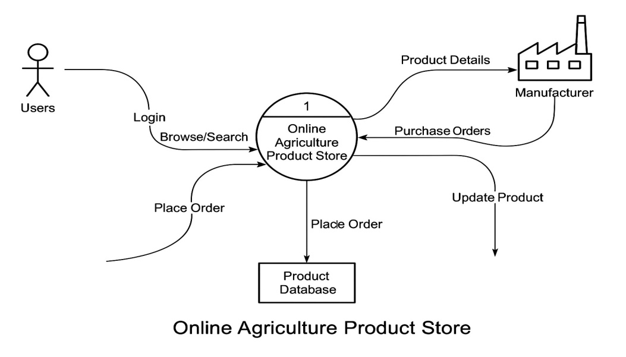

Question 8 – Change Request - 10 Marks
Due to change in the Government Taxation structure. We should change the Tax structure how do you handle change requests in a project?
Ans :
•When the government changes the tax rules, we write down the change request with all details.
•We check how this change will affect the project, like billing and payments.
•We talk with the project team, finance people, and others to understand the change.
•Then, we decide if the change should be done now or not.
•If yes, we update the project plan with new time and cost.
•We tell everyone in the project about the change and new plan.
•The developers change the system to add the new tax rules.
•Testers check the system to make sure everything works well and no problems happen.
•After testing, we release the updated system and watch for issues.
•Finally, we finish the change request and update all documents.
Question 9 – Change Request Vs an Enhancement - 5 Marks
As the project is in process, Ben and Kevin have contacted you. The reason is to inform you that they want the Farmers to sell their crop yields through this application i.e. Farmers should be able to add their crop yields or products and display to general public and should be able to sell them. They also want to introduce Auction system for their Crop yields. As a BA, what will be your response? Is this a change request or an enhancement???
Ans :
Ben and Kevin’s request to allow farmers to sell their crop yields through the application and to introduce an auction system is a change request rather than just an enhancement.
This is because it adds entirely new major features that were not part of the original project scope. Allowing farmers to list and sell their crops, plus adding an auction system, will require significant changes to the application’s design, development, and possibly its database and workflows.
As a Business Analyst, I would document this request formally, analyze its impact on time, cost, and resources, and present it to the project stakeholders for review and approval before proceeding.

Question 10 – Estimations - 6 Marks
Come up with estimations – How many Man-hours required
Ans:
Task | Time Needed (Man-hours)
Understanding what is needed | 16 hours
Designing screens and system | 24 hours
Writing the software code | 80 hours
Connecting parts and database | 24 hours
Testing to make sure it works | 32 hours
Putting the system live and helping users | 8 hours
Total Time Needed | 184 hours

Analysis:
- These hours are for a medium-sized team and medium difficulty work.
- Actual time may change depending on the team and tools used.
- It’s good to keep extra time (10-15%) for unexpected problems.
Question 11 – UAT – 6 Marks
Project has finally completed all the stages i.e., design, development, testing etc. Now, it is the role of a business analyst to contact the client for testing of the final product and have to successfully complete it. How are you going to handle this situation? And once it is done, what will be the process to close the project? Explain UAT Acceptance process
Ans:
When the project finishes designing, building, and testing, my job as a Business Analyst is to start User Acceptance Testing (UAT) with the client.
- Planning: First, I plan the UAT by deciding what needs to be tested and when.
- Designing: I prepare a simple UAT plan and share it with the client and testers.
- UAT Testers: I help the client’s users (testers) understand how to test the system.
- Testing: The testers check the system to see if everything works as expected.
- Bug Fixing: If they find problems, I tell the development team to fix them.
- Re-testing: After fixes, testers check again to make sure problems are gone.
- Sign Off: When the client is happy and everything works well, I get their official approval (sign off).

Question 12 – Project Closure Document - 6 Marks
Explain Project closure document
Ans:
A Project Closure Document is a formal report used at the end of a project to confirm that all work has been completed, and the project is officially finished.

Why it is important:
- It gives a clear summary of what was done.
- It helps close the project in an organized way.
- It makes sure that the client is satisfied.
- It records lessons learned for future projects.

What a Project Closure Document includes:
- Project Summary
Brief description of the project and its goals.
- Final Deliverables
A list of what was delivered (like software, reports, features).
- Client Acceptance
Confirmation that the client tested and approved the product.
- Issues and Resolutions
Any problems faced and how they were solved.
- Lessons Learned
–What went well and what can be improved in future projects.
- Budget and Time Summary
Final cost and duration compared to the original plan.
- Resource Release
Notes about releasing team members and other resources.
- Sign-Off
Signatures from the client and project manager to officially close the project.

