Nurturing Process - Capstone Project2 –Agile-Scrum V2D2 Aug2024
Question 1 – Write Agile Manifesto – 8 Marks
Agile Manifesto emphasizes four core values:
- Individuals and interactions over processes and tools
- Working software over comprehensive documentation
- Customer collaboration over contract negotiation
- Responding to change over following a plan
The 12 Principles behind the Agile Manifesto include:
- Satisfy the customer through early and continuous delivery of valuable software.
- Welcome changing requirements, even late in development. Agile processes harness change for the customer’s competitive advantage
- Deliver working software frequently, from a couple of weeks to a couple of months, with a preference to the shorter timescale.
- Business people and developers must work together daily throughout the project.
- Projects are built around motivated individuals. Give them the environment and support they need and trust them to get the job done.
- Face-to-face conversation is the best form of communication.
- Working software is the primary measure of progress.
- Agile process promote Sustainable development pace.
- Continuous attention to technical excellence.
- Simplicity—the art of maximizing the amount of work not done—is essential.
- Best architectures and designs emerge from self-organizing teams.
- Regular reflection and adaptation for effectiveness that tunes and adjusts its behavior accordingly.
Question 2 – Write minimum 40 User Stories with Acceptance Criteria, BV and CP – 40 Marks

Sprint 1 : HIGH PRIORITY STORIES

User story No : 1 | Task: 2 |  | Priority : Highest
AS A DELIVERY BOY
I WANT TO REGISTER
SO THAT I CAN DELIVER ORDERS
BV : 500 |  | CP : 02
Acceptance Criteria
Registration screen with fields (Name, Email, Phone, Password, ID Proof, etc.)
Submit
Success message

User story No : 2 |  | Task: 2 |  | Priority : Highest
AS A Restaurant Owner
I WANT TO View Orders
SO THAT I can fulfill them
BV : 500 |  |  | CP : 02
Acceptance Criteria
Table view of pending orders with item
Quantity
customer details

User story No : 3 | Task: 2 |  | Priority : Highest
AS A Customer
I WANT TO Add Address
SO THAT I receive food at the right location
BV : 500 |  | CP : 02
Acceptance Criteria
Text field with pin validation (within 5 km)

User story No : 4 | Task: 2 |  | Priority : Highest
AS A Customer
I WANT TO Select Payment Mode
SO THAT I can pay securely
BV : 500 |  | CP : 03
Acceptance Criteria
Radio buttons (COD, UPI, Card), Submit button

User story No : 5 | Task: 2 |  | Priority : Highest
AS AN Admin
I WANT TO Approve Restaurants
SO THAT valid ones are listed
BV : 500 |  | CP : 02
Acceptance Criteria
View list
Approve/Reject buttons
status updates

User story No : 6 | Task: 2 |  | Priority : Highest
AS A Customer
I WANT TO View Restaurant Menu
SO THAT I can choose items
BV : 500 |  | CP : 02
Acceptance Criteria
List view with images
Prices
categories
User story No : 7 | Task: 2 |  | Priority : Highest
AS A Delivery Boy
I WANT TO View Assigned Orders
SO THAT I can pick up
BV : 500 |  | CP : 02
Acceptance Criteria
List with order ID
customer address
status

User story No : 8 | Task: 2 |  | Priority : Highest
AS A Customer
I WANT TO Track Order
SO THAT I know ETA
BV : 500 |  | CP : 03
Acceptance Criteria
Real-time map
status updates (Picked, En Route, Delivered)

User story No : 9 | Task: 2 |  | Priority : Highest
AS A Regional Admin
I WANT TO Manage Delivery Boys
SO THAT I assign work effectively
BV : 500 |  | CP : 02
Acceptance Criteria
Add/edit/delete delivery boy info
region assignment

User story No : 10 | Task: 2 |  | Priority : Highest
AS A Customer
I WANT TO Cancel an Order
SO THAT I avoid wrong deliveries
BV : 500 |  | CP : 02
Acceptance Criteria
Cancel button visible until dispatched

SPRINT 2 – CUSTOMER FEATURES
User story No : 11 | Task: 2 |  | Priority : Highest
AS A Customer
I WANT TO Give Feedback
SO THAT I share my experience
BV : 200 |  | CP : 02
Acceptance Criteria
Rating stars
text comment
submit button

User story No : 12 | Task: 2 |  | Priority : Highest
AS A Customer
I WANT TO View My Order History
SO THAT I can reorder
BV : 300 |  | CP : 02
Acceptance Criteria
List with filters
reorder option

User story No : 13 | Task: 2 |  | Priority : Lowest
AS A Customer
I WANT TO Logout
SO THAT I end my session securely
BV : 100 |  | CP : 01
Acceptance Criteria
Logout button
redirect to login page

User story No : 14 | Task: 2 |  | Priority : Lowest
AS A Customer
I WANT TO View Delivery Boy Contact
SO THAT I follow up
BV : 50 |  | CP : 01
Acceptance Criteria
Show name
Photo
mobile number

User story No : 15 | Task: 2 |  | Priority : Highest
AS A Customer
I WANT TO Login
SO THAT I access my dashboard
BV : 300 |  | CP : 02
Acceptance Criteria
Email/password
Validation
success redirect

User story No : 16 | Task: 2 |  | Priority : Highest
AS A Customer
I WANT TO Register
SO THAT I can place orders
BV : 300 |  | CP : 02
Acceptance Criteria
Name
Email
Phone
Password
OTP verification

User story No : 17 | Task: 2 |  | Priority : Highest
AS A Customer
I WANT TO Chat with Regional Admin
SO THAT I can request refund
BV : 200 |  | CP : 02
Acceptance Criteria
Text box
order ID pre-filled
submit
issue ID generated

User story No : 18 | Task: 2 |  | Priority : Lowest
AS A Customer
I WANT TO View Offers
SO THAT I get discounts
BV : 100 |  | CP : 01
Acceptance Criteria
Display list of active offers
conditions

User story No : 19 | Task: 2 |  | Priority : Highest
AS A Customer
I WANT TO Filter Restaurants
SO THAT I find by cuisine/rating
BV : 200 |  | CP : 02
Acceptance Criteria
Dropdowns
multi-select filters
reset option

User story No : 20 | Task: 2 |  | Priority : Highest
AS A Customer
I WANT TO Add to Cart
SO THAT I can order multiple items
BV : 300 |  | CP : 02
Acceptance Criteria
Quantity selector
update/remove option

SPRINT 3 – RESTAURANT AND ADMIN FEATURES
User story No : 21 | Task: 2 |  | Priority : Highest
AS A Restaurant Owner
I WANT TO Add/Edit Menu
SO THAT customers view updated items
BV : 300 |  | CP : 02
Acceptance Criteria
Upload item name
Photo
Price
category

User story No : 22 | Task: 2 |  | Priority : Lowest
AS A Restaurant Owner
I WANT TO Set Time Slots
SO THAT customers know timings
BV : 100 |  | CP : 01
Acceptance Criteria
From/To fields
Save
confirmation

User story No : 23 | Task: 2 |  | Priority : Lowest
AS A Restaurant Owner
I WANT TO View Feedback
SO THAT I improve services
BV : 100 |  | CP : 01
Acceptance Criteria
Table with ratings
filter by date

User story No : 24 | Task: 2 |  | Priority : Highest
AS A Restaurant Owner
I WANT TO View Revenue Report
SO THAT I track earnings
BV : 200 |  | CP : 02
Acceptance Criteria
Date filter
summary in Excel

User story No : 25 | Task: 2 |  | Priority : Highest
AS A Delivery Boy
I WANT TO Update Delivery Status
SO THAT customer is notified
BV : 200 |  | CP : 02
Acceptance Criteria
Radio buttons (Picked up, Delivered)
submit

User story No : 26 | Task: 2 |  | Priority : Lowest
AS A Delivery Boy
I WANT TO Raise an Issue
SO THAT Admin is informed
BV : 100 |  | CP : 01
Acceptance Criteria
Text field
issue type dropdown
submit

User story No : 27 | Task: 2 |  | Priority : Lowest
AS A Delivery Boy
I WANT TO View Earnings Report
SO THAT I track my pay
BV : 100 |  | CP : 02
Acceptance Criteria
Date filters
download PDF

User story No : 28 | Task: 2 |  | Lowest
AS A Regional Admin
I WANT TO View Regional Revenue
SO THAT I track performance
BV : 100 |  | CP : 02
Acceptance Criteria
Table of restaurants
revenue column

User story No : 29 | Task: 2 |  | Priority : Highest
AS A Regional Admin
I WANT TO Generate Performance Report
SO THAT I share insights
BV : 200 |  | CP : 03
Acceptance Criteria
From/To date
download Excel

User story No : 30 | Task: 2 |  | Priority : Highest
AS AN Admin
I WANT TO View All Issues
SO THAT I can resolve them
BV : 200 |  | CP : 02
Acceptance Criteria
List with status filters (open, in-progress, closed)

SPRINT 4 – BUSINESS OWNER & REPORTING
User story No : 31 | Task: 2 |  | Priority : Highest
AS A Business Owner
I WANT TO View Global Revenue Report
SO THAT I assess ROI
BV : 300 |  | CP : 03
Acceptance Criteria
Filter by date
export options

User story No : 32 | Task: 2 |  | Priority : Highest
AS A Business Owner
I WANT TO Update Payments for Restaurants
SO THAT dues are cleared
BV : 200 |  | CP : 02
Acceptance Criteria
Payment screen
Confirmation
audit trail

User story No : 33 | Task: 2 |  | Priority : Highest
AS A Business Owner
I WANT TO View Platform Insights
SO THAT I make business decisions
BV : 300 |  | CP : 03
Acceptance Criteria
Pie charts
metrics (orders/day, top restaurants)

User story No : 34 | Task: 2 |  | Priority : Highest
AS A Business Owner
I WANT TO View Customer Retention Reports
SO THAT I measure loyalty
BV : 200 |  | CP : 02
Acceptance Criteria
Line graph
% return users

User story No : 35 | Task: 2 |  | Priority : Lowest
AS A Business Owner
I WANT TO Raise Strategic Requests
SO THAT development prioritizes features
BV : 100 |  | CP : 01
Acceptance Criteria
Submit form with impact description

User story No : 36 | Task: 2 |  | Priority : Highest
AS A Restaurant Owner
I WANT TO Receive Notifications for Orders
SO THAT I don’t miss orders
BV : 200 |  | CP : 02
Acceptance Criteria
Real-time alerts with sound

User story No : 37 | Task: 2 |  | Priority : Highest
AS A Delivery Boy
I WANT TO See Map View for Directions
SO THAT I reach faster
BV : 300 |  | CP : 03
Acceptance Criteria
Map integration with customer location

User story No : 38 | Task: 2 |  | Priority : Highest
AS AN Admin
I WANT TO Manage Refund Requests
SO THAT customer satisfaction is ensured
BV : 200 |  | CP : 02
Acceptance Criteria
View
Approve
comment on refund issues

User story No : 39 | Task: 2 |  | Priority : Lowest
AS A Regional Admin
I WANT TO Send Notices to Restaurants
SO THAT updates are shared
BV : 100 |  | CP : 01
Acceptance Criteria
Message box
recipient dropdown

User story No : 40 | Task: 2 |  | Priority : Lowest
AS A Customer
I WANT TO Apply Promo Code
SO THAT I get discounts
BV : 10 |  | CP : 01
Acceptance Criteria
Promo field
Validation
new total display

Question 3 – What is an Epic? Write 2 Epics with BV and CP – 5 Marks
Definition of Epic:
In Agile, an Epic is a large user story that cannot be completed in a single sprint. It represents a broad business requirement or a high-level functionality and is divided into smaller user stories (features or tasks) during backlog refinement or sprint planning.
Example Epics for Scrum Foods Application
Epic 1: Customer Food Ordering Journey
• Description: Enabling a seamless customer experience from login to order placement and tracking.
• Decomposed Into User Stories:
- Register/Login as customer
- View restaurants and menus
- Add items to cart
- Add delivery address
- Apply promo codes
- Select payment mode
- Track order
- Business Value (BV): ₹1000
- Complexity Points (CP): 13
Epic 2: Restaurant Management Dashboard
• Description: Providing restaurants with a centralized dashboard to manage orders, timings, menu, and revenue.
• Decomposed Into User Stories:
- Register/Login as restaurant
- View incoming orders
- Manage food menu (add/edit/delete)
- Set time slots
- View revenue and feedback
- Business Value (BV): ₹1000
- Complexity Points (CP): 13
Question 4 – What is the Difference Between BV and CP? – 2 Marks
Aspect | Business Value (BV) | Complexity Points (CP)
Definition | Importance of a feature from the business or customer perspective | Technical effort required to develop a feature
Decided By | Product Owner, Client, or Stakeholders | Scrum Development Team
Purpose | Helps prioritize user stories based on business impact | Helps estimate development effort and sprint capacity planning
Unit/Scale | Monetary value (e.g., ₹1000, ₹500) or relative priority | Story points (e.g., 1, 2, 3, 5, 8, etc.)
Example | A feature generating revenue may be valued at ₹1000 | A simple UI task might be 1 CP, complex logic might be 8 CP

Question 5 – Explain about Sprint – 5 Marks
What is a Sprint?
A Sprint is a time-boxed iteration in Agile Scrum, typically lasting 2 weeks, where a Scrum team works to deliver a usable and potentially shippable product increment. It is a core element of the Scrum framework.
Key Characteristics of a Sprint:
- Fixed Duration:
- In this project, Sprint duration is 2 weeks.
- Helps in maintaining consistent delivery cadence.
- Defined Goal:
- Each sprint starts with a Sprint Goal.
- The team selects User Stories from the Product Backlog based on priority and team capacity.
- Sprint Planning:
- At the beginning of each sprint, a Sprint Planning Meeting is conducted to:
- Select user stories (PBIs).
- Break them into tasks.
- Assign to developers.
- Set the sprint backlog.
- Daily Scrums (Scrum Meetings):
- 15-minute meetings held daily during the sprint.
- Developers answer:
- What did I do yesterday?
- What will I do today?
- Any impediments?
- Sprint Review:
- Conducted at the end of the sprint with all stakeholders.
- Demonstrates the product increment.
- Discusses velocity, burn down charts, and feedback.
- Sprint Retrospective:
- Only Scrum Developers participate.
- Discusses what went well, what didn’t, and lessons learned.
- Product Increment:
- A working product increment is produced from “Done” stories.
- Must be shippable, tested, and meet Definition of Done (DoD).
Question 6 – Explain Product Backlog and Sprint Backlog – 5 Marks
Product Backlog:
The Product Backlog is a master list of all features, enhancements, fixes, and requirements for the product. It is created and maintained by the Product Owner.

Key Characteristics:
- Contains User Stories, Epics, and Tasks.
- Items are prioritized by Business Value (BV).
- Continually refined and updated through Product Grooming.
- Represents the entire scope of the product to be developed.
Example from Scrum Foods:
- “As a customer, I want to add an address so that food can be delivered.”
- “As a delivery boy, I want to update delivery status so that customers get updates.”
Sprint Backlog:
The Sprint Backlog is a subset of the product backlog. It contains the User Stories selected during Sprint Planning for the current sprint.
Key Characteristics:
- Owned by the Scrum Development Team.
- Contains PBI (Product Backlog Items), broken down into Tasks.
- Tracked daily through Scrum Boards (To Do → WIP → Done).
- Sprint Backlog is locked during sprint (changes not allowed).
Example from Sprint 1:
- Sprint Goal: Enable core registration and ordering.
- Selected Stories: Registration (Customer, Delivery Boy), Add Address, View Menu, Place Order, etc.
Question 7 – What is Impediments Log? Write 2 Impediments – 5 Marks
What is an Impediments Log?
An Impediments Log is a tracking tool used in Agile Scrum to record all the obstacles, blockers, or challenges faced by the Scrum team during a sprint. These impediments prevent or slow down progress and must be resolved as quickly as possible, usually by the Scrum Master.
Purpose of Impediments Log:
- Ensures transparency of blockers.
- Helps the Scrum Master take quick action.
- Supports the Scrum value of inspection and adaptation.
- Improves velocity and productivity over time.
Example Format of an Impediment Log:
Impediment ID | Description | Raised By | Impact | Status
IMP-01 | API for restaurant menu is not returning data | Dev - Gowri | Cannot integrate menu screen | Open
IMP-02 | Delay in credentials from payment gateway | Dev - Rajesh | Payment feature is blocked | In Progress
2 Sample Impediments for Scrum Foods:
Impediment 1: API Failure for Real-Time Tracking
- Description: The real-time delivery tracking API is not returning updated coordinates.
- Impact: Delivery boy’s location cannot be shown to the customer; tracking feature is delayed.
- Status: Logged and assigned to backend team for fix.
Impediment 2: Restaurant Login Fails During Peak Time
- Description: Multiple restaurants report login failure during lunch hours due to load.
- Impact: Restaurants are unable to process orders during peak hours.
- Status: DevOps team analyzing logs and planning scaling solution.
Question 8 – Explain Velocity of the Team – 1 Mark
Definition of Velocity:
Velocity is a measurement of the total effort (Complexity Points or CPs) completed by a Scrum team in a single sprint. It indicates the team’s delivery capacity and helps in predicting timelines and planning future sprints.
How Velocity Works:
- Calculated at the end of each sprint.
- Only includes “Done” user stories (meeting the Definition of Done).
- Measured in Story Points (CP).
Example from Scrum Foods Project:
- Let’s say in Sprint 1, your team completes 10 user stories with the following CPs:
2, 2, 3, 2, 2, 1, 2, 3, 2, 1
➤ Total CP = 20
So, the team velocity = 20 CP per sprint
Importance:
- Helps in forecasting how many sprints are needed to complete the backlog.
- Provides insights into team performance and progress consistency.

Question 9 – Draw Sprint Burn Charts n Product Burn Down Charts– 3 Marks
Sprint Burn Down Chart
Sprint : Sprint 1|||| Estimation level : Work Item Count
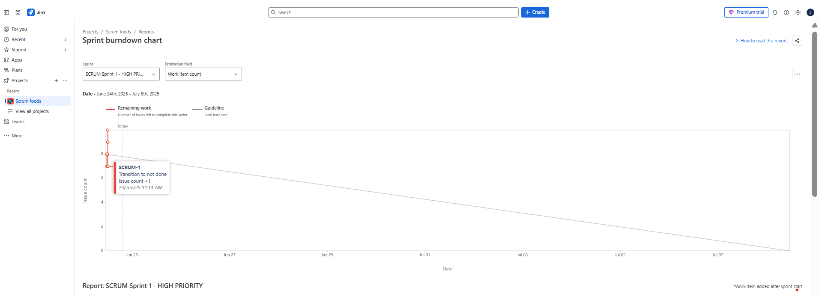
Sprint : Sprint 1|||| Estimation level : Story Points
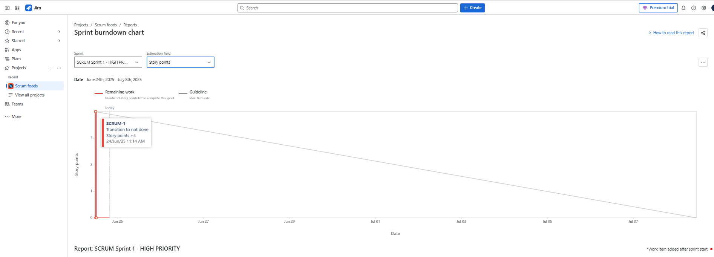
Sprint: Sprint 1|||| Estimation level: Time
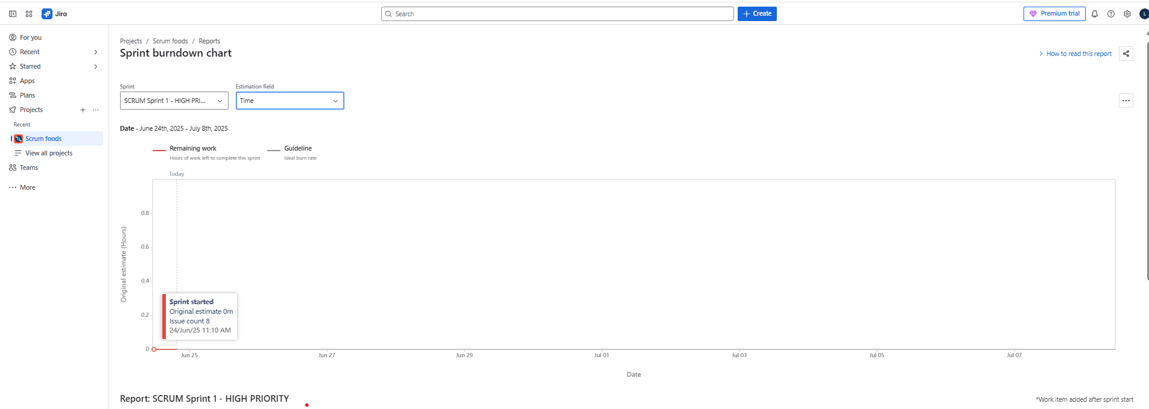
Sprint: Sprint 2|||| Estimation level: Story points
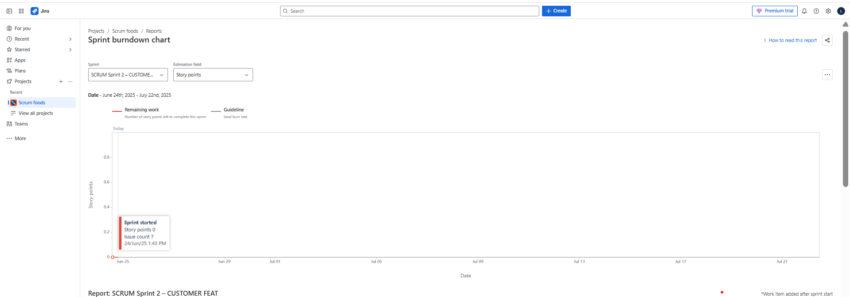
Sprint: Sprint 2|||| Estimation level: Work Item Count
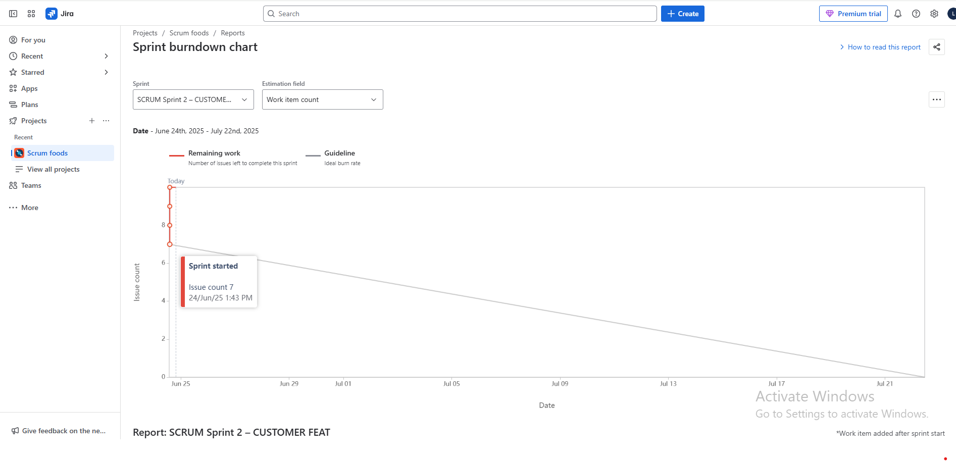
Sprint: Sprint 2|||| Estimation level: Time
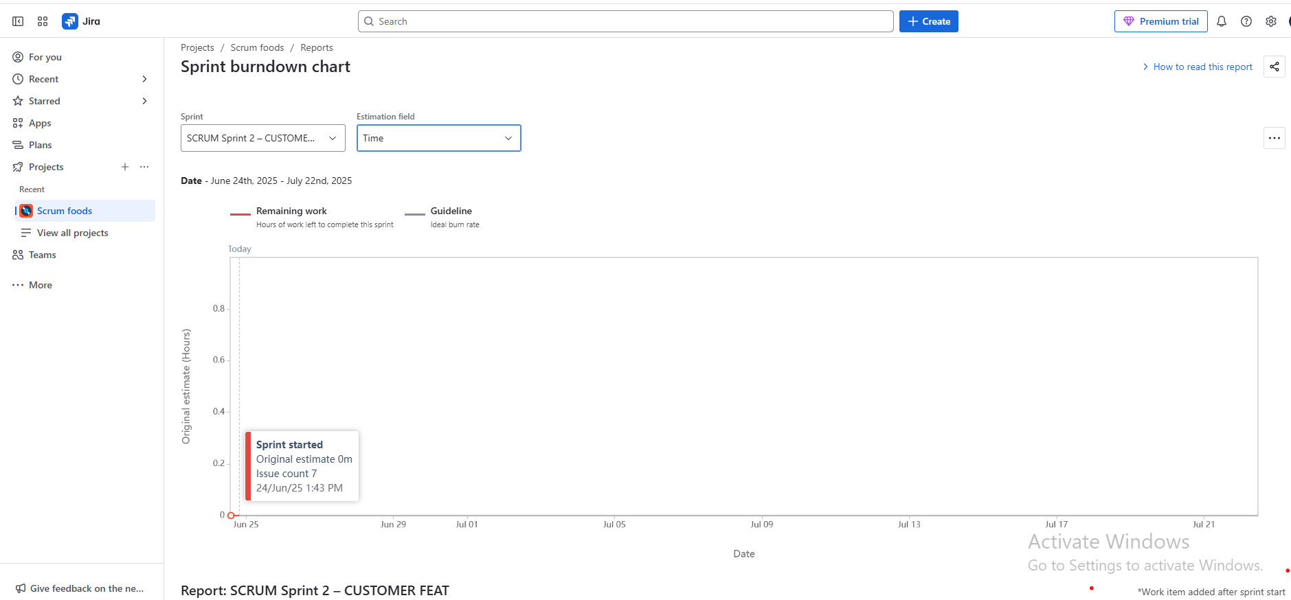
Sprint: Sprint 3 |||| Estimation level: Story Points
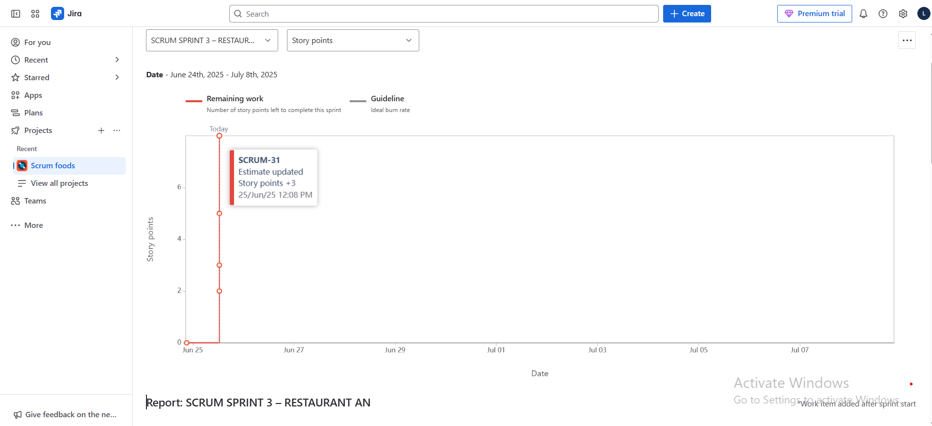
Sprint: Sprint 3 |||| Estimation level: Work Item Count
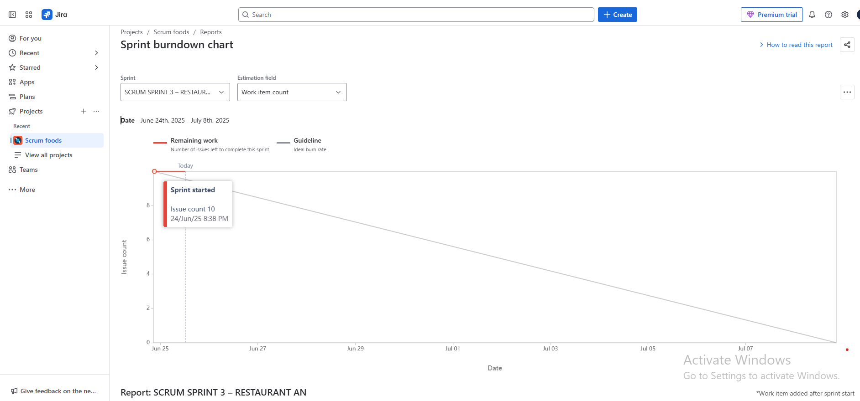
Sprint: Sprint 3 |||| Estimation level: Time
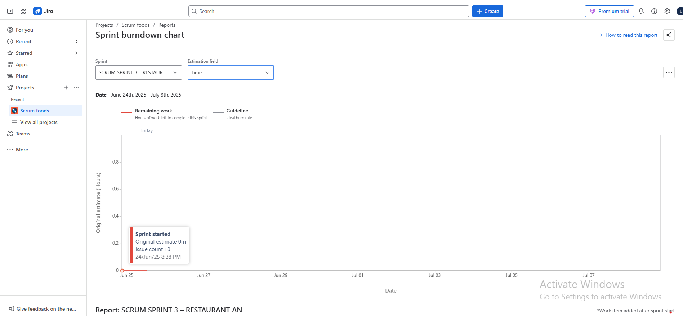
Sprint: Sprint 4 |||| Estimation level: Story Points
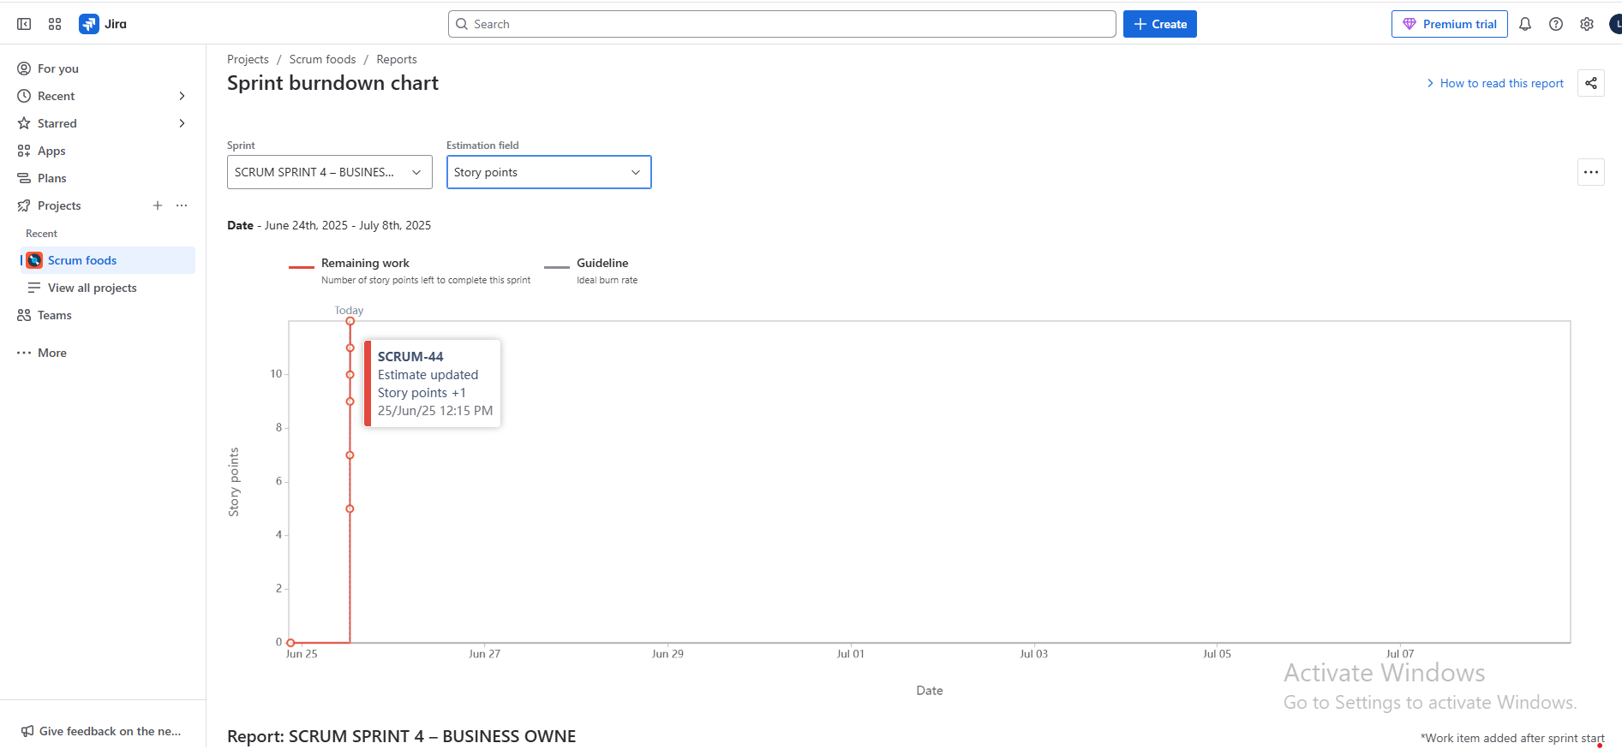
Sprint: Sprint 4 |||| Estimation level: Work Item Count
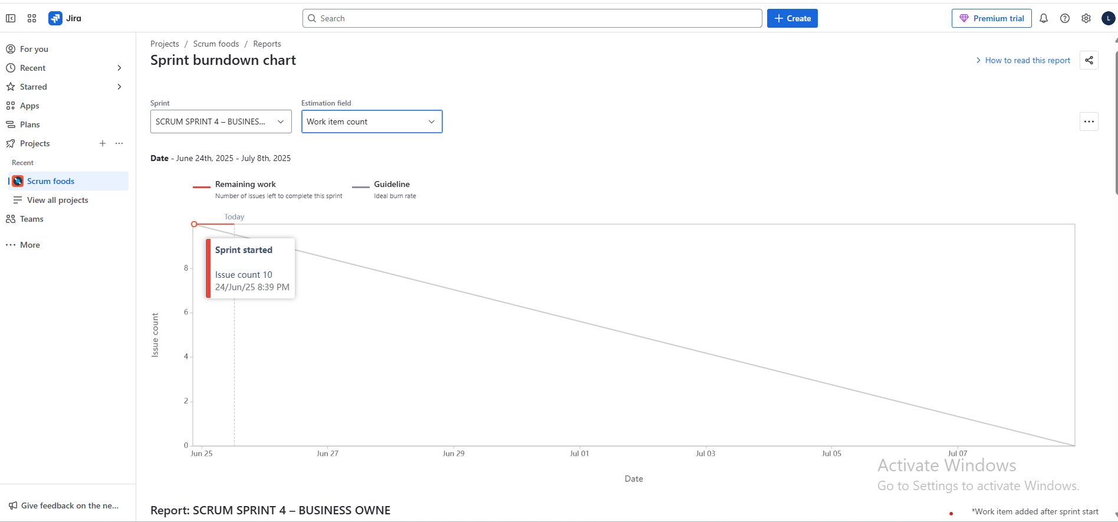
Sprint: Sprint 4 |||| Estimation level: Time
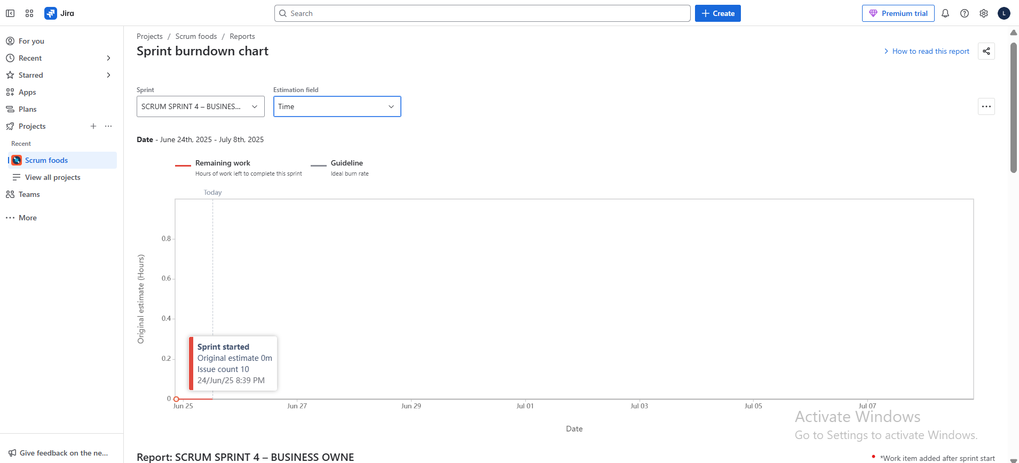
Product Backlog :
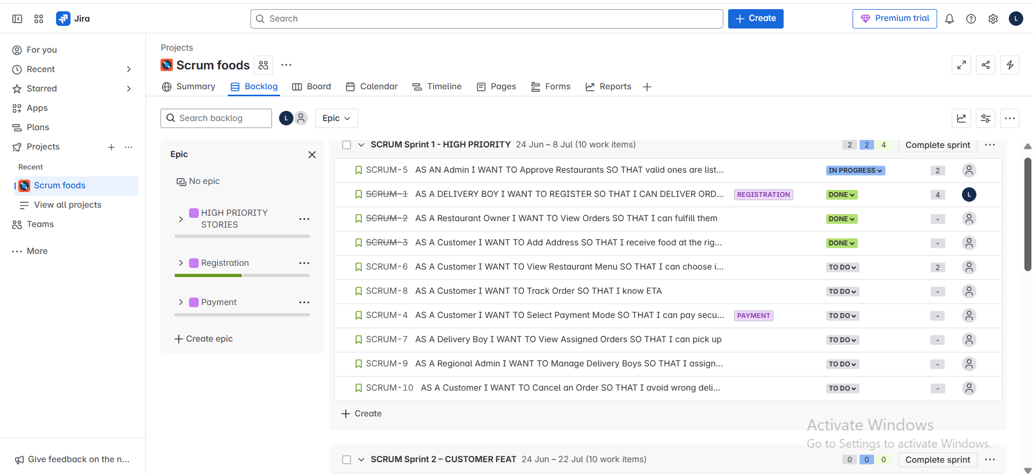
Product Backlog Board:
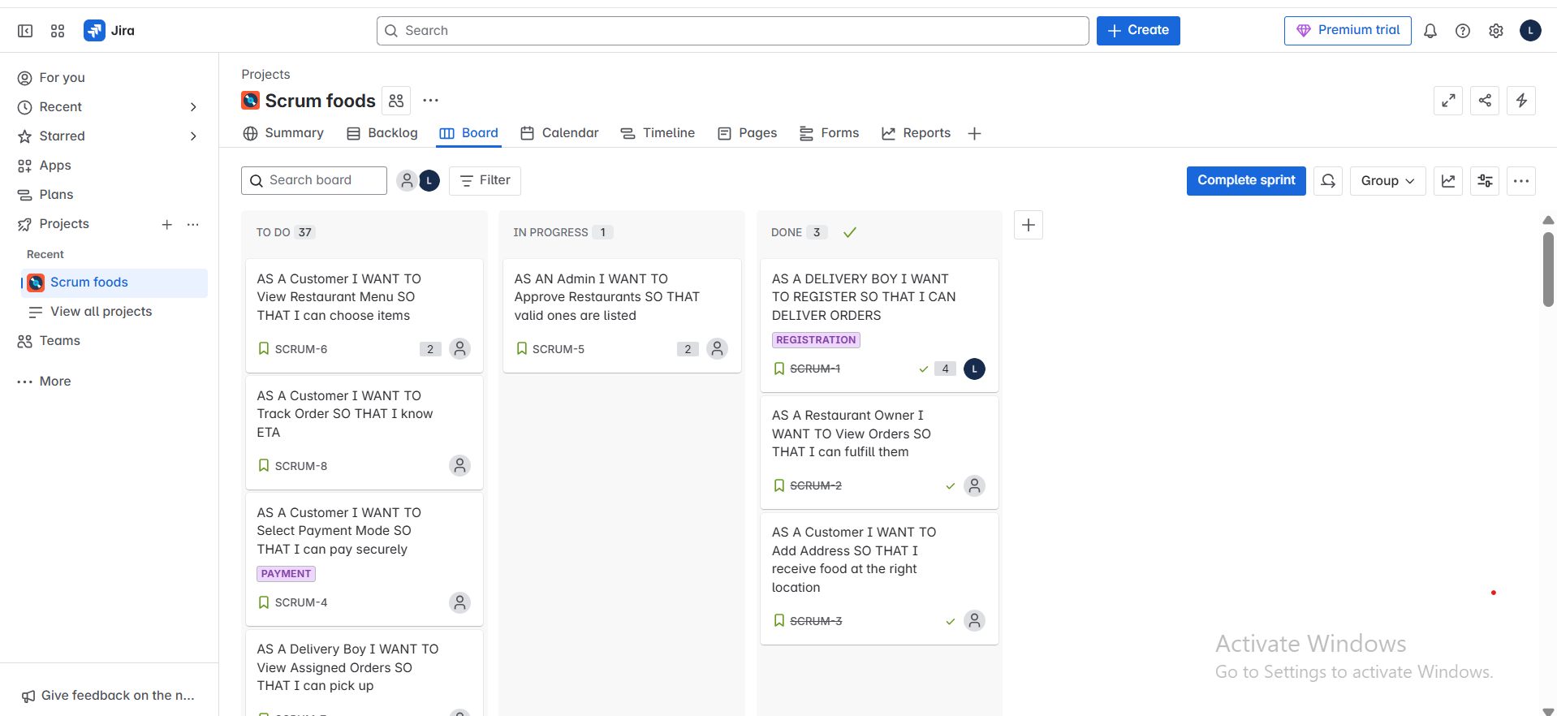
Question 10 – Explain Product Grooming – 2 Marks
Definition:
Product Grooming, also known as Backlog Refinement, is the ongoing process where the Product Owner and Scrum Team review and refine the Product Backlog to ensure items are:
- Clearly defined
- Well prioritized
- Sized (with CP – Complexity Points)
- Ready for upcoming sprints
Key Activities in Product Grooming:
- Add new user stories based on stakeholder feedback or new requirements.
- Break down Epics into smaller, manageable user stories.
- Update Acceptance Criteria to make stories clear and testable.
- Assign BV (Business Value) and CP (Complexity Points) to user stories.
- Re-prioritize items based on business needs or dependencies.
- Remove outdated or irrelevant items from the backlog.
Who Participates?
- Product Owner (leads the session)
- Scrum Master (facilitates if needed)
- Scrum Developers (help estimate and clarify complexity)
Importance:
- Ensures only “ready” user stories enter Sprint Planning.
- Reduces surprises and delays during sprint execution.
- Keeps the Product Backlog clean, prioritized, and actionable.
Question 11 – Explain the Roles of Scrum Master and Product Owner – 3 Marks
1. Scrum Master
The Scrum Master is responsible for facilitating the Scrum process and ensuring the team follows Agile principles.
Key Responsibilities:
- Conducts Scrum ceremonies (Daily Stand-up, Sprint Review, Retrospective).
- Removes impediments/blockers faced by the team.
- Acts as a coach and servant leader for the Scrum Team.
- Shields the team from external distractions.
- Encourages continuous improvement and team accountability.
- Supports the Product Owner in maintaining the Product Backlog.
Example (Scrum Foods):
If the delivery tracking API fails, the Scrum Master ensures it’s resolved quickly so the team can proceed.
2. Product Owner – The Value Maximizer
The Product Owner is responsible for maximizing the product’s value by managing the Product Backlog.
Key Responsibilities:
- Defines and prioritizes user stories based on business needs.
- Maintains a clear and refined Product Backlog.
- Acts as the bridge between stakeholders and the development team.
- Ensures stories have clear acceptance criteria and business value.
- Participates in Sprint Planning, Reviews, and backlog grooming sessions.
Example (Scrum Foods):
As the Product Owner, you decided to prioritize “Real-time Order Tracking” over “Promo Code Application” based on stakeholder input.
In simple Terms:
Role | Focus Area | Key Responsibility
Scrum Master | Process and team facilitation | Removes blockers, ensures Agile is followed
Product Owner | Product and business value | Manages backlog, defines priorities
Question 12 – Explain All Meetings Conducted in Scrum Project – 8 Marks
Scrum includes five key ceremonies (meetings) that ensure transparency, collaboration, and continuous improvement throughout the project lifecycle.
- Sprint Planning Meeting
- Purpose: To plan the work for the upcoming sprint.
- Attendees: Product Owner, Scrum Master, Scrum Developers
- Activities:
- Select high-priority Product Backlog Items (PBIs)
- Define Sprint Goal
- Break down PBIs into tasks
- Estimate CP and commit to the sprint backlog
Scrum Foods Example: 10 user stories (MVP) were selected for Sprint 1 including registration, payment, and menu features.
- Daily Scrum (Daily Stand-up)
- Purpose: A 15-minute meeting for team synchronization and planning for the next 24 hours.
- Each team member answers:
- What did I do yesterday?
- What will I do today?
- Any impediments?
- Attendees: Only Scrum Developers; Scrum Master facilitates.
Scrum Foods Example: Gowri updates: “Worked on address validation yesterday, today I’ll complete payment mode. Blocked due to missing payment gateway API.”
- Sprint Review Meeting
- Purpose: To demonstrate the product increment and collect stakeholder feedback.
- Attendees: Scrum Team, Product Owner, Scrum Master, Client, Stakeholders
- Activities:
- Showcase completed user stories
- Discuss Velocity
- Review Sprint Burndown Chart
- Collect suggestions for improvement
Scrum Foods Example: Stakeholders provided feedback on UI and requested addition of delivery boy picture in the tracking screen.
- Sprint Retrospective Meeting
- Purpose: A team-only meeting to reflect on the sprint and identify areas for improvement.
- Attendees: Only Scrum Developers (Scrum Master optional)
- Activities:
- Discuss what went well
- What didn’t go well
- Action items for next sprint
Scrum Foods Example: Lesson learned: Include API testing earlier to avoid integration delays.
- Product Backlog Grooming (Refinement) Meeting
- Purpose: To refine the product backlog and prepare it for upcoming sprints.
- Attendees:Product Owner, Scrum Master (optional), Scrum Developers
- Activities:
- Split Epics into stories
- Add acceptance criteria
- Estimate BV and CP
- Prioritize stories
Scrum Foods Example: The story “Customer Food Ordering” was broken into multiple smaller stories like “Add to Cart”, “Select Payment Mode”, etc.
In simple Terms:
Meeting | Purpose | Participants
Sprint Planning | Plan sprint goal, select stories | PO, SM, Developers
Daily Scrum | Sync on progress and blockers | Developers
Sprint Review | Show increment, get feedback | PO, SM, Developers, Client, Stakeholders
Sprint Retrospective | Inspect and improve team process | Developers only
Product Grooming | Refine backlog for future sprints | PO, Developers (SM optional)

Question 13 – Explain Sprint Size and Scrum Size – 2 Marks
Sprint Size: Sprint size refers to the duration of a Sprint cycle – the fixed period in which a set of user stories must be completed and a product increment is delivered.
• Standard Size: In most Agile teams, including this project, the sprint size is 2 weeks (10 working days).
• Purpose: Allows predictability and a regular rhythm for planning, development, and review.
• Example (Scrum Foods): Sprint 1 ran from Monday to the second Friday, during which 10 user stories (MVP) were implemented.
Scrum Size: Scrum size refers to the duration of the Daily Scrum (also called the Daily Stand-up meeting).
• Standard Size: 15 minutes per day
• Purpose: Helps the team stay aligned and informed of daily progress, blockers, and task transitions.
• Conducted by: Scrum Developers with optional facilitation by the Scrum Master.
In simple terms:
Term | Definition | Duration
Sprint Size | Total length of one development iteration | 2 weeks (10 working days)
Scrum Size | Duration of daily stand-up meeting | 15 minutes
Question 14 – Explain DOR and DOD – 2 Marks
1. Definition of Ready (DOR) : A user story is considered “Ready” when it is well-defined, understood, and actionable for development in a sprint.
- Ensures the team starts only well-prepared stories.
Key Criteria for DOR:
- Clear and complete User Story written.
- Acceptance Criteria are defined.
- Business Value (BV) and Complexity Points (CP) estimated.
- Dependencies are identified and resolved.
- Test cases or conditions are known.
Example (Scrum Foods): A story like “Customer selects payment mode” with defined UI fields, acceptance criteria, and CP=3 is Ready for development.
2. Definition of Done (DOD): A product backlog item is considered “Done” when it meets all agreed completion criteria by the team.
- Ensures the story is fully developed, tested, and potentially shippable.
Key Criteria for DOD:
- Code is written and unit tested.
- Peer reviewed and merged to main branch.
- Integrated and functional in the system.
- Tested against acceptance criteria.
- No major bugs; passes QA.
- Documented (if needed).
- Approved by Product Owner.
Example (Scrum Foods): A payment story is “Done” only when the user can select a payment mode, it integrates with the gateway, is tested, and shows success message.
Question 15 – Explain Prioritization Techniques and MVP – 3 Marks
1. Prioritization Techniques in Agile : Prioritization helps the Product Owner decide the order of features in the product backlog based on business value, risk, customer needs, and dependencies.
Popular Techniques:
a. MoSCoW Method
- Must Have – Critical features (e.g., Login, Payment)
- Should Have – Important but not critical
- Could Have – Nice to have
- Won’t Have (now) – Can be postponed
b. Value vs Effort Matrix
- Compares Business Value (BV) vs Complexity Points (CP)
- Helps in selecting high-value, low-effort stories first
c. Kano Model
- Categorizes features as:
- Basic Needs (must-haves)
- Performance Needs (more = better)
- Exciters/Delighters (bonus features)
d. WSJF (Weighted Shortest Job First)
- Formula: WSJF = BV / CP
- Selects stories that deliver the most value in the shortest time
2. MVP – Minimum Viable Product : A Minimum Viable Product (MVP) is the smallest version of the product that delivers enough core functionality to be usable by early customers and gather feedback.
Purpose:
- Launch fast
- Test market demand
- Reduce development risk
- Get real user feedback
In Scrum Foods Project: The MVP includes the following 10 stories:
  - Customer Registration & Login
  - View Restaurants
  - View Menu
  - Add to Cart
  - Add Delivery Address
  - Select Payment Mode
  - Place Order
  - Order Confirmation
  - Delivery Boy Assignment
  - Real-Time Order Tracking
These cover the end-to-end ordering flow, which is critical for market testing.
Question 16 – Difference Between Business Analyst and Product Owner – 3 Marks
While both roles contribute to successful product development, Business Analyst (BA) and Product Owner (PO) have distinct responsibilities, especially in Agile environments.
Comparison Table
Aspect | Business Analyst (BA) | Product Owner (PO)
Primary Focus | Requirements elicitation and documentation | Maximizing product value and backlog prioritization
Customer Interaction | Acts as a bridge between client and technical team | Direct interaction with stakeholders to understand needs
Backlog Ownership | May help manage and write user stories | Owns and maintains the Product Backlog
Decision-Making | Recommends based on analysis, but doesn’t make product decisions | Makes final calls on what to build and when
Sprint Participation | Supports Scrum team with clarification and artifacts | Active in sprint planning, grooming, reviews, and accepts work
Agile Role | Optional role in Agile teams (often advisory) | Mandatory role in Scrum framework
Documentation | Prepares BRDs, FSDs, user stories, process flows | Focuses on concise user stories and acceptance criteria
Example in Scrum Foods Project: From above we can take
- Gather food ordering trends.
- Document login process flows.
- Assist in preparing reports.
- As the Product Owner (in this capstone), you:
- Finalized and prioritized 40 user stories.
- Participated in backlog grooming and sprint planning.
- Approved completed features and maintained product vision.
Here it says :
- BA ensures requirements are clear and complete.
- PO ensures right features are prioritized and delivered.

Question 17 – Sample Resume of a 3-Year Experienced Product Owner – 3 Marks
SAMPLE RESUME – PRODUCT OWNER (3 YEARS EXPERIENCE)
Name : Surya Likhitha Lolabhattu
Email: suryalikhitha1311@gmail.com
Phone: +91-9704783815
LinkedIn: linkedin.com/in/Likhitha-lolabhattu
Location: Hyderabad, India
Professional Summary
Certified Product Owner with 3+ years of experience in Agile Scrum environments, delivering customer-centric digital solutions. Strong expertise in product backlog management, sprint planning, and user story creation. Proven ability to collaborate with cross-functional teams, prioritize product features based on business value, and drive timely product releases.
Key Skills
- Agile & Scrum Methodology
- User Story Writing
- Sprint Planning & Review
- Stakeholder Communication
- MVP Definition
- Jira
- Wireframing (Balsamiq, MS Visio)
- UAT & QA Collaboration
Certifications
- Agile Business Analyst – COEPD
Professional Experience
BA – APT IT Solutions April 2025 – Present | Hyderabad, India
Project: Online Agriculture Product Store
- Acted as Product Owner for a CSR initiative project with a budget of ₹2 Cr and 18-month duration.
- Defined Registration, Product Catalog, Cart, Payment, Order Tracking.
- Conducted Sprint Planning, Grooming, Retrospective, and Review meetings with an 8-member Scrum team.
- Coordinated with stakeholders to define MVP and delivered it in 3 sprints.
- Created wireframes and prototypes using Balsamiq and collaborated with QA for UAT.
Education
PGDM – Siva Sivani Institute of management | Hyderabad | 2019- 2021
Projects Handled
• Scrum Foods – Capstone Project (COEPD):
Defined product vision, created 40+ user stories, managed sprint execution, reviewed burndown charts, and handled client feedback loops.

