NURTURING PROCESS – CAPSTONE PROJECT – 2

Question 1 – write Agile Manifesto
4 Core Values

Individuals and Interactions over Processes and Tools:
It means ~ People communicating and collaborating effectively is more important
Instead of relying only on email chains team member walks over to a colleague (or jumps on a quick video call) to clarify a requirement and solve a problem immediately

Working Software over Comprehensive Documentation:
It means ~ Providing, valuable software to the customer frequently based on their requirement is the primary measure of progress.
Instead of spending month or two writing several specification document for a new login feature, the team builds a basic, secure login function in 2 weeks, releases it to a small group of users, and gathers feedback.

Customer Collaboration over Contract Negotiation:
It means ~ Building a strong, partnership with the customer and involving them throughout the process is more valuable.
Instead of pointing to a signed contract that says "Feature X must have login authentication without mobile OTP " when the customer now realizes it should have strong security level, which should have mobile OTP work better in the context.

Responding to Change over Following a Plan:
It means ~ In regard to changing requirements responding to customer query and adhering to their changes is more important than following the initial plan .
A 3-month project to build an e-commerce store mobile application, a major security concern is discovered by immediately adjusting their plan for the next sprint to prioritize implementing enhanced security measures.

12 Principles
Our highest priority is to satisfy the customer through early and continuous delivery of valuable software.
Ex- Releasing a basic function - "Add to Cart" feature , Instead of waiting 6 months for the entire checkout process.

Welcome changing requirements
Ex - A customer sees an prototype design in early stage and realizes a search filter is missing, thought of before is crucial. The team incorporates this new requirement into the next sprint backlog.
Deliver working software frequently
Ex- Shipping small usable functionality to the live application every 2 weeks (In a usual sprint)

Business People and cross discipline team must work togeather
Ex- Business analyst & developer / Business analyst & UI & UX team should work to-geather . This means cross functional

The most effective and efficient method of conveying information is face-face conversation
A team meeting or team huddle will be more effective to arrive better clarity instead of sending chain emails.
Working product is primary measure of progress:
Demonstrating a newly completed "payment processing" feature in a ecommerce mobile app is a better way to progress. to next step (Sprint)

Maintain the sustainable phase indefinitely
Planning realistic amounts of work per sprint (velocity) that the team can consistently achieve without burnout.

Continuous attention to technical excellence and good design enhances agility
Giving continuous attention to all the implementation , sprint releases etc for its enhancement or any correction will be the best approach.
Simplicity the art of maximizing the amount of work not done--is essential.
Building the simplest version of a feature that meets the core need first (e.g., basic search),

The best architectures, requirements, and designs emerge from self-organizing teams.
The entire team connect for a meeting on how to implement a new feature

Team reflects on how to become more effective
Retrospective meeting will significantly help the team on how to correct their mistakes , and to access what went wrong to improve their quality

Question 2 – User Stories- Acceptance Criteria-BV-CP
User Registration
As a new user I want to register via phone number or email, so that I can use this app for ordering my food.
Business Value – 8/10
Complexity Point – 5
- Accep Criteria – User can select between Email or Phone Number registration

Login Functionality
As a user I want to have my mobile with me or registered email id (user name)
And also password, So that I can Login to my profile to book my preferred order.
Business Value – 7/10
Complexity Point – 5
Accep Criteria : Both mobile and email id must be active to get the OTP for validation

Search for restaurant :
As a user , I try to navigate the search feature (Search Box) and I will try to search for the desired restaurant from where I would like to place my order . So that, the functionality will help me pull the desired menu from that restaurant

Business Value – 8/10
Complexity Point – 4
Accep Criteria : Given the search for the restaurant when there is list of rset are available, then restaurant must be available

Search for Menu :
As a registered user after identifying the restaurant, I should be able to view the list of menus from their cart. So that I can select my preferred menu.
Business Value – 6/10
Complexity Point – 6
Accep Criteria : Catalogue must be displayed & Desired Menu must be available

Add to Cart
As a customer I would like to add the selected menu into the cart. So that I can proceed for check out process to confirm my order. :
Business Value – 6/10
Complexity Point – 6
Accep Criteria : Pop-up number must be displayed after adding product to the chart

Proceed Checkout
As a customer , I should be able to see the menu item , price & Qty in the cart. So that I can able to proceed for check out process for payment.
Business Value – 6/10
Complexity Point – 6
Accep Criteria : Proceed to checkout option must be enable. Before that make sure you have selected the desired product what you need, along with the quantity & delivery address.

Delivery Address:
As a customer, I should be able to edit or confirm the delivery address of my item selected. So that I will get my menu to my registered address without any hassle.
Business Value – 7/10
Complexity Point – 7
Accep Criteria : Make sure you have the right delivery address & you have the option to add new address incase of placing order for anyother person.

Payment Process:
As a customer , I should be able to select the payment option to make payment . So that my order will be confirmed. (Credit Card / Net Banking/ COD)
Business Value – 9/10
Complexity Point – 11
Accep Criteria : Make sure you have a active debit card/credit card & if the payment is going to be done using net-banking , make sure you have active internet connection along with valid credentials to login.

Payment Authetication :
As a customer, I should have valid active mobile number which should be registered with the app.So that I can get the otp for payment authentication & also order confirmation.
Business Value – 9/10
Complexity Point – 10
Accep Criteria : Make sure your mobile network is active in order to get the OTP at the time of transaction

Delivery Boy to pick orders
As a delivery boy, I want to register my details with the app. So that based on notification I can pick the orders for delivery to the customer.
Business Value – 7/10
Complexity Point – 10
Accep Criteria : Pick Order button appears only if the partner’s status is Available.
Order status changes to "Picked" in real-time.

Admin
As a admin, I should have a control over the app with all the features and functionalities to ensure the safety. So that the app will be more trustable & reliable.
Business Value – 9/10
Complexity Point – 10
Accep Criteria : Ensure Payment gateway is highly secured

Order History
As a user , I should be able to view my order history . So that I can be aware of my previous order booked.

Business Value – 5/10
Complexity Point – 4
Accep Criteria : Orders must be sorted (1-10) per page
List down the orders by selecting the date range

Question 3– What is epic? Write 2 epics

An Epic is a large body of work that captures a strategic business goal. It’s too big to deliver in a single sprint and must be broken down into smaller Features and User Stories.
- Search for Menu
- Epic: Streamlined Payment Gateway

Question 4 –What is the difference between BV and CP
Business Value : The benefit or impact of the user story delivers to the business or customer. Product Owner will be deciding this . The severity depends from (1-10)
Example - Payment Related functionality & Order History

Complexity Point - The effort & difficulty risk, technical challenges, and uncertainty required to implement the story. Development team will be deciding this. This is based on Fibonacci series. (1,2,3,5,8,13) For instance "How hard is this to build (Any feature).

Question 5 –Explain about Sprint

Sprint Value – 20 User Stories
Scrum Value – 10 Member team size.
PBI | TASK | WIP | DONE

Question 6 – Explain Product backlog and sprint back log

Product Backlog - list of all desired features, fixes, and enhancements for the app.
Owned by: Product Owner . A dynamic, prioritized list of all desired features, fixes, and enhancements for the app. Owned by: Product Owner . It contains requirement / task & defects

Sprint Backlog – A Subset of the product Backlog selected for the sprint. It will go for (2-4) weeks broken into task. Owned by developers.
- What task did you work in this scrum?

  - Search by Cuisine Completed: Finalized acceptance criteria, User Stories, API contracts, and UI wireframes.

  - Handling Payment - Handling with payment module (CC/ GPAY/ COD ) option

- What task will you work on next scrum?

  - Search for Menu items (Need to work on listing the menus based on different category)

  - Delivery address - Need to work on adding New delivery address & also the option for editing existing address & also define auto address deduction.

- Any Challenges/impediments? When you will complete the user story?

Delay in payment processing
Restaurant API is not stable

Question 7 – What is impediments log? write 2 impediments

- Payment Gateway Integration Delay

- Action – Escalate this to the payment integration team PAYPAL
- Deadline – This should be resolved within 48-60 Hours

- Restaurant Menu API is not stable

- Inconsistent data causing confusion while booking orders .
Rates are not reflecting sometime.

- Action: Schedule call with API vendor to fix this.
- Deadline – This should be resolved within 4-5 Business Days

Question 8 – Explain Velocity of the Team

It refers to the measures of the amount of work a development team can complete during a sprint. They are responsible for estimating the effort required to complete each user story or backlog item.

Question 9 – Draw Sprint Burn Charts in Product Burn Down Charts

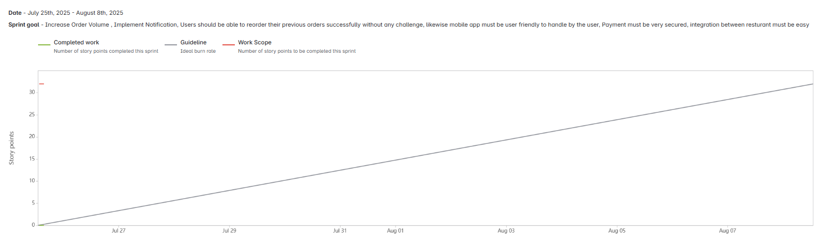

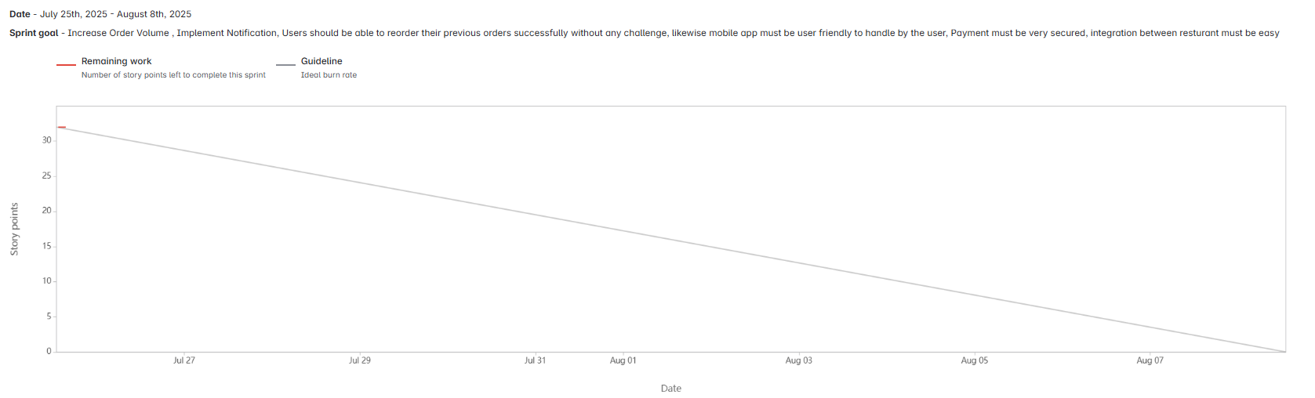

Question 10 – Explain about Product Grooming
Product Grooming also known as backlog grooming . Agile development that Involves preparing & refining items in the product backlog to ensure they are prioritized & ready for development.
Backlog Review
Prioritization
Acceptance Criteria

Question 11 – Explain the roles of Scrum Master and Product Owner

PRODUCT OWNER | - The PO is the voice of the customer and owns the product vision and refines the Product Backlog  - It ensures backlog items are clear, actionable and aligned with business goals.  - He collaborates with the stakeholder
SCRUM MASTER | - The SM is a servant-leader who removes roadblocks .  - Ensures Scrum events (Planning, Daily Scrum, Review, Retro) happen effectively and stay time-boxed.  - Teaches Scrum principles to the team

Question 13 – Explain Sprint Size and Scrum Size–

Sprint Planning | Max 8 hours for a 4-week Sprint
Daily Scrum | 15 minutes (time-boxed event).
Sprint Review | Max 4 hours for a 4-week Sprint.
Sprint Retrospective | Maximum it goes upto 3 hours .

Role | Count
Developers | 3–9
Scrum Master (SM) | 1
Product Owner (PO) | 1
Business Analyst (BA) | 1
Tester(s) | 1–2
UI/UX Designer | 1-2

Question 12 – Explain all Meetings Conducted in Scrum Project

Sprint Planning | Max 8 hours for a 4-week Sprint Plan what to deliver (Sprint Goal) and how to do it (Sprint Backlog). The attendees are Scrum Team / Developers
Daily Scrum | 15 minutes (time-boxed event). Sync daily progress, plan next 24 hours, identify blockers. "What did I do? What will I do? Any impediments? These are the 3 major criteria. The Attendees are Developers
Sprint Review | Max 4 hours for a 4-week Sprint. Sprint Review is to inspect the working product (the Increment) and adapt the Product Backlog based on feedback from stakeholders. The attendees are - Scrum Team & stakeholders (Users)
Sprint Retrospective | Maximum it goes upto 3 hours . This meeting deals with process improvement . What went well ? What can be done to improve ? and what is the action item. The attendees are - Scrum Team (Product Owner, Scrum Master, Developers).

Question 14 – Explain DOR and DOR

Definition of Done -
The DOD outlines the criteria that must be met for backlog item to be considered complete & potentially shippable . Item meets all specified acceptance criteria & functional requirement.
Definition of Ready –
The DOR outlines the criteria that a product backlog item (User story/ feature) should meet before it considered ready to be taken into sprint development. Ensures item is well defined & understood.

Question 15 – Explain Prioritization Techniques and MVP

As a BA, you facilitate this with the Product Owner and technical team.
Prioritization techniques are method used to determine the order in which task, feature items should be addressed.
MoSCow - Categorize items as: Must have, Should have, Could have, Won’t have.
Kano Model – Classify the features as Basic , Performance, Delighter based on customer satisfaction.
MVP - The smallest working product that delivers maximum output.
With the minimal input , we get maximum result .
MVP Features:
Browse nearby restaurants
See menu & prices
Place an order
Pay online or Cash on Delivery
Question 16 – Difference between Business Analyst n Product Owner

Product Owner - Maximize product value & Return of Investment / Owns the Product Backlog | Business Analyst - Bridges the gap between business & technical team
Defines & prioritizes items in the Product Backlog. | Helps write user stories, acceptance criteria, and clarifies doubts about the backlog.
Define user stories & product features | Understand the business needs, process and requirement
Manages the product backlog & maintains it | Creates documentation of business rules, workflows

Question 17 – Prepare a sample Resume of 3yrs exp Product Owner
DEEPAK K
Product Owner | Agile Delivery Specialist
dkrishnaxxxx@gmail.com | +91-9940070245 | dkrishnadeepak.linkedin.com

Summary
Product Owner with 3 years of experience driving value in Agile environments. Proven success in backlog prioritization, stakeholder alignment, and working on requirement gathering , documentation, centric digital products. Certified Scrum Product Owner (PSPO-1)

Skills
- Agile/Scrum: Sprint Planning, User Stories, Backlog Refinement, MVP Definition
- Prioritization: MoSCoW, Value vs. Effort
- Tools: Jira, Trello, POWER BI, SQL
- Leadership: Stakeholder Management, Cross-Functional Collaboration
- Analytics: KPI Tracking, User Feedback Analysis

Professional Experience
Product Owner | TATA ELXSI | Jan 2022 – Present
*Scrum team building a mobile app for TATA Motors EV Users (20K+ users)*
- Backlog Management: Owned 150+ item backlog; reduced scope creep by 40% Prioritization: Used RICE scoring to sequence features
- Release Leadership: Delivered 3 major updates ahead of schedule for EV Software features for the 4 wheeler owners
- Stakeholder Sync: Ran bi-weekly Sprint Reviews with business partner.
- Certifications
- Agile Business Analyst
- Certified Scrum Product Owner® PSPO1
- Prof Scrum Master PSM1

Education
B.Com (Bachelor of Commerce) | University of Madras | 2021

