Decode the case study
- Project idea – to build online store is to facilitate farmers to buy seeds, pesticides and fertilizers from anywhere.
- Current needs – New users are involved and application should be user friendly.
- Current problems – Procuring fertilizers, buying seed and lack of pesticides.

Question 1: Prepare Business Process Model
- Goal: To create an online platform where farmers can easily buy agricultural products like seeds, fertilizers and pesticides.
- Inputs: Product information, Orders, Payments and customer information.
- Resources: E-commerce platform, Delivery system, Inventory management, Marketing and advertising tools.
- Outputs: Inventory reports, Agricultural products, Customer feedback, Marketing analytics.
- Activities: Marketing and promotion, Order processing, Payment processing, Shipping, Customer service.
- Value: Accessibility, Quality, Transparency, Convenience, Cost savings.

Question 2: SWOT Analysis
- Strengths:
- High Quality Products
- User Friendly Platform
- Customer Loyalty
- Direct to Consumer Model
- Weakness:
- Technical challenges
- Inventory management
- Limited Product Variety
- Customer Acquisition cost
- Opportunities:
- Data Analytics
- Collaborations
- Market Expansion
- New Product Development
- Threats:
- Competition
- Climate Change
- Customer Preferences
- Data Security

Question 3: Feasibility Study
To conduct feasibility study for the online agriculture product store project in JAVA following points should be considered
- Hardware and Software Requirements:
- Server, Storage, Networking equipment and Development tools.
- Ensure that the infrastructure is scalable to handle the expected increase in data storage.
- Resources:
- Ensure that there are enough resources to meet the project requirements within timeframe.
- Availability of trained resources with expertise in JAVA, networking, database management and web development.

- Budget:
- Ensure that budget is feasible and project can be completed within allocated funds.
- Determine the budget required for the project, salaries of resources, hardware and software costs and other expenses such as marketing and administrative costs (rent, utilities, insurance and taxes).
- Time frame:
- Determine the time frame required for the project to be completed including development, testing and deployment phases.
- Ensure that time frame is realistic and achievable within the constraints of available resources and budget.

Question 4: GAP Analysis
- Current State:
- Farmers have to physically visit the shops to buy agricultural products such as fertilizers, seeds and pesticides.
- Farmers have to rely on the intermediaries for the procurement of these products, which results in higher prices and low-quality products.
- Farmers not being able to procure latest or effective products because of there is a lack of communication between farmers and manufacturers.
- Farmers often face difficulty in finding the right products according to their specific crop requirement.

- Desired State:
- Farmers will be able to order the required agricultural products online, saving their time and efforts.
- Farmers can buy products directly from the manufacturers at affordable prices.
- Through the online store, the manufacturers can communicate with farmers and provide them latest product and technologies.
- In online store farmers can easily search and filter products based on their specific requirements, crop types and other parameters which will help farmers to find right products easily.

Question 5: Risk Analysis
There are several risk factors that need to be considered during the project planning phase. These risk factors can be categorized into BA Risks and Project Risks. Please find the following risk factors that can be involved in this project.
- BA Risks:
- Product Quality:
Ensuring the quality of agricultural products from sourcing to delivery is crucial. A compromise in quality can lead to customer dissatisfaction.
- Supplier Reliability:
Unreliable suppliers can lead to delays and poor product quality. Dependency on suppliers for timely and quality delivery of products is a risk.
- Market Demand:
There is a risk in demand of online agricultural products because of market demand fluctuates, may be insufficient products or less demand leading to low revenue and sales.
- Pricing Strategy:
Incorrect pricing can result impacting business profitability and customer appeal.
- Customer Trust:
Customer may be hesitant to adopt online platforms for purchasing agricultural products due to issue of quality assurance and issue of trust compared to traditional methods.

- Project Risks:
- Technical Issues:
Technical issues or software bugs can disrupt the functionality of online platform.
- Payment Processing:
If there is a payment processing issue can result in financial losses, a poor customer experience and in failed transactions.
- Resources Risk:
Testing, deployment, insufficient staffing and budget constraints leads to project delays.
- Data Security:
Online platforms are unsafe potential financial losses, compromise of sensitive customer information and data breaches.
- Supply Chain Disruption:
Supply chain disruption from sourcing to inventory and transportation, can affect product availability and customer satisfaction
- Technology:
Unreliable or outdated technology infrastructure can cause slow performance and website downtime.

Question 6: Stakeholder Analysis [RACI Matrix]
RACI matrix is a useful tool for stake holder analysis which defines the roles and responsibilities of stakeholders in project.
RACI Matrix: Responsible, Accountable, Consulted and Informed
The stakeholders in this project and their roles in the RACI matrix are as follows:
Mr. Henry: Accountable- Mr. Henry is responsible for ensuring the success of the project and making final decisions.
Peter, Kelvin and Ben (Stakeholders and farmers)- Consulted- They provide requirements and feedback to the project team and consult with other stakeholders.
Mr. Pandu (Financial Head)- Responsible- Mr. Pandu is responsible for managing the project budget and ensuring financial compliance.
Mr. Dooku (Project Coordinator)- Consulted- Mr. Dooku consults with other stakeholders and provides the guidance and support to the project team.
Mr. Karthik (Delivery Head)- Responsible- Mr. Karthik is responsible for managing the project delivery and ensuring that project meets the client’s expectations.
Mr. Vandanam (Project Manager)- Responsible- Mr. Vandanam is responsible form managing the project team and ensuring that project is completed successfully.
Ms. Juhi, Mr. Teyson, Ms. Lucie, Mr. Tucker, Mr. Bravo (Java Developers)- Responsible- They are responsible for developing the d=software applications and delivering them on time.
Mr. Mike (Network Admin)- Responsible- Mr. Mike is responsible for setting up the network infrastructure required for the project.
John (DB Admin)- Responsible- He is responsible for managing the project database.
Mr. Jason and Ms. Alekya (Tester)- Responsible- They are responsible for testing the software applications and ensure that they are error free.

Question 7: Business Case Document
- Why is this project initiated?
- The purpose of this business case is development in Online Agriculture Products Store and facilitate remote area farmers to buy online agriculture products. The goal is to provide a platform for farmers to purchase necessary products without facing any difficulties in procuring fertilizers, seed and pesticides. The proposed solution is a application that allows manufacturers can communicate with farmers and provide them latest product and technologies.

- What are the current problems?
- Farmers have to physically visit the shops to buy agricultural products such as fertilizers, seeds and pesticides.
- Farmers have to rely on the intermediaries for the procurement of these products, which results in higher prices and low-quality products.
- Farmers not being able to procure latest or effective products because of there is a lack of communication between farmers and manufacturers.
- Farmers often face difficulty in finding the right products according to their specific crop requirement.
For these problems there is need for platform that can facilitate the purchase of these products for farmers.

- With this project, how many problems could be solved?
The online agriculture products store will be provide the following benefits:
- The application will save time and money for farmers, which can be utilized in farming activities
- Farmers will be able to purchase necessary products without facing difficulties in procuring fertilizers, seeds and pesticides.
- Companies manufacturing fertilizers, seeds and pesticides will have a platform to directly reach out to farmers.

- What are the risks?
- The application may not be user-friendly, leading to low adoption by farmers.
- Poor product quality and delivery issue causes dissatisfaction among customers.
- The application may face technical issues during development and deployment.

- What is the time frame and cost?
- The estimated budget for the project is 2 Crores INR. This includes the cost of development, testing, deployment and maintenance. The project is expected to be completed within 18 months.

Question 8: SDLC Methodologies
SDLC stands for Software Development Life Cycle. This methodologies includes Sequential, Iterative, Evolutionary and Agile.
- Sequential: This methodology follows a linear approach and moves through each phase of the SDLC in a set sequence. This method is best suited for this project with well-defined requirements low risk and predictable outcomes. However this approach may not be suitable for projects where there are evolving requirements or where changes need to be made during the development process.

- Iterative: The iterative methodology involves multiple iterations or cycles of the SDLC process. This methodology is used for projects where requirements are not well-defined or may evolve during the development process.

- Evolutionary: This methodology is best suited for projects where the requirements are not fully defined or may change frequently. In this approach, the initial product is not fully functional but evolves overtime through a series of iterations.

- Agile: The agile methodology is an iterative and incremental approach to software development that focuses on delivering working software in small increments or sprints. The agile approach emphasizes customer collaboration, continuous feedback and flexibility in response to changing and where there is a need for rapid delivery of working software.
It is essential to consider factors such as project requirements, project scope, team size, budget and timeline before choosing the methodology.

Question 9: Waterfall RUP Spiral and Scrum Models
V model and waterfall model are structured, sequential methodologies that require extensive planning and documentation. The V model, in particular places a strong emphasis on testing and verification throughout the development process.
On the basis of provided information, it seems like the project team may be more comfortable with the waterfall model due to its familiarity and structured approach. However, as a business analyst it is more important to consider the specific needs and requirements of the project in order to determine the most appropriate methodology.

Question 10: Waterfall Vs V-Model
Sr. No. | Waterfall Model | V Model
1 | The waterfall model is a relatively linear sequential design approach to develop software projects | The V model is a model in which the execution of the phases happens in a sequential manner in V shape.
2 | The waterfall model is a continuous process | The V model is a simultaneous model.
3 | In waterfall model, the total defects in the developed software are higher. | In V model, the total defects in the developed software are lower.
4 | In waterfall model, the defects are identified in the testing phase. | In V model, the defects are identified in the initial phase.
5 | It is used when requirements are fixed | If the requirements of the user are uncertain and keep changing then V model is the better alternative
6 | Testing activities are accomplished after the development activities are over. | Testing activities are start with the first stage itself.

Question 11: Justify your choice
As a business analyst my recommendation would be use the waterfall model for project. The waterfall model is a relatively linear sequential design approach where each phase of the software development process is completed before moving onto the next phase. This model is suitable for project with clear requirements, which is the case for the online agriculture product store project. The requirements for the project have been shared by the stakeholders and the project has clear objective of developing online platform for farmers to buy agriculture products.
On the other hand, the V model is an extension of the waterfall model and it is used for testing and verification. It is useful when the requirements are clear. However, its not an appropriate approach for software development projects as it does not provide a framework for design and development.
Hence, I recommend waterfall model for this project.

Question 12: Gantt Chart
Gantt chart is work breakdown structure
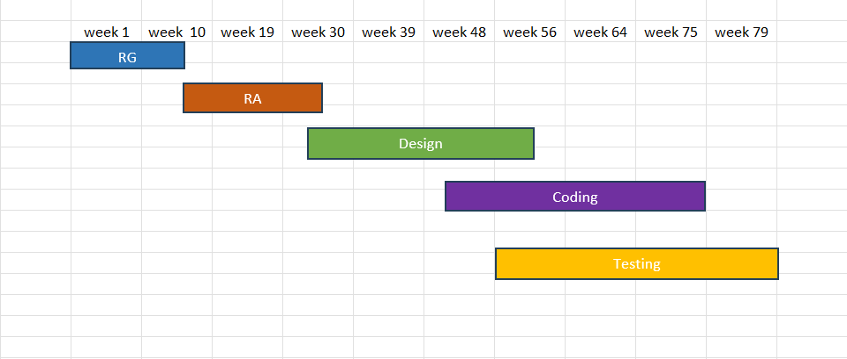

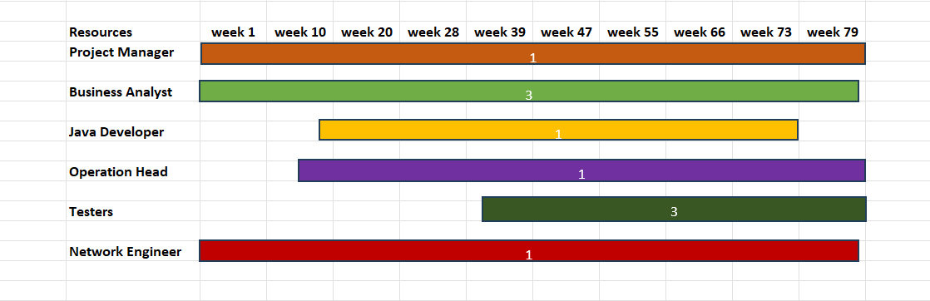

Question 13: Fixed Bid Vs Billing
Fixed Bid: The requirements are frozen at the start of the project and estimates are made based on those requirements. The resource estimation for the entire project is done beforehand. Based on the project requirement the number of resources required at each stage is decided. Cost can increase or decrease when change is introduced, each change would involve a plan realignment. The timelines for the development of the entire software are predefined and the development firm should adhere to it is contractually bound.
Billing: The requirements are defined at the beginning here. These requirements may increase while software development. The resource requirements vary based on the user stories and changes introduced. Budget may increase in case of complex feature intensive delivery and can reduce when changes are simple. Work is estimated based on the resources required to develop each user story. The combination of these deliverables can be used for budget estimation. The timelines for delivery are defined considering no dynamic changes in the requirements.

Question 14: Preparer Timesheets of a BA in various stages of SDLC
➢ Design Timesheet of a BA
S. No. | Tasks | Start Time | End Time | Duration in hrs
1 | Requirements Review | 10:00AM | 11:00AM | 1
2 | Stakeholder Consultation | 11:00AM | 1:00PM | 2
3 | User Interface Design | 2:00PM | 4:00PM | 2
4 | Data Model Design | 4:30PM | 5:30PM | 1
5 | System Architecture Design | 5:30PM | 7:30PM | 2

➢ Development Timesheet of a BA
S. No. | Tasks | Start Time | End Time | Duration in hrs
1 | Morning meetings with programmers and developers | 10:00AM | 11:00AM | 1
2 | Detailed analysis on the coding part of the software | 12:00PM | 1:00PM | 1
3 | Reporting to the development of the project to the client | 1:15PM | 2:15PM | 1
4 | Loe level design document is prepared by developers and studied | 3:00PM | 4:00PM | 1

➢ Testing Timesheet of a BA
S. No. | Tasks | Start Time | End Time | Duration in hrs
1 | Meeting with testers and responsible stakeholders | 10:00AM | 11:00AM | 1
2 | Comprehensive assessment of a software as per client needs | 12:00PM | 1:30PM | 1Hr 30Min
3 | Defects are analyzed and errors are minimized | 2:00PM | 3:30PM | 1Hr 30Min
4 | Test document is prepared | 4:00PM | 5:15PM | 1Hr 15Min

➢ UAT Timesheet of a BA
S. No. | Tasks | Start Time | End Time | Duration in hrs
1 | Morning meeting with the concerned team | 10:00AM | 11:30AM | 1Hr 30Min
2 | Genuine change requests are put under consideration | 11:45PM | 1:00PM | 1Hr 15Min
3 | Functionalities are added as per the given change request | 1:30PM | 3:30PM | 2
4 | Reporting the possible outcome to the PM | 4:00PM | 5:00PM | 1

➢ Deployment n Implementation Timesheet of a BA
S. No. | Tasks | Start Time | End Time | Duration in hrs
1 | Solution design | 10:00AM | 12:00PM | 2
2 | User interface design | 1:00PM | 3:00PM | 2
3 | Data mapping | 4:00PM | 6:00PM | 2
4 | Test planning | 10:00AM | 11:00AM | 1
5 | UAT | 11:30AM | 1:30PM | 2
6 | Training and documentation | 1:30PM | 3:30PM | 2
7 | Deployment | 4:00PM | 6:00PM | 2

