Question 1 – write Agile Manifesto – 8 Marks
Answer:
Four main Values-
- Individuals and interactions over processes and tools
- Working software over comprehensive documentation
- Customer collaboration over contract negotiation
- Responding to change over following a plan
Twelve Principles of Agile Software-
1. Satisfy the customer through early and continuous delivery of valuable software.
2. Welcome changing requirements, even late in development. Agile processes harness change
for the customer's competitive advantage.
3. Deliver working software frequently, from a couple of weeks to a couple of months, with a
preference to the shorter timescale.
4. Business people and developers must work together daily throughout the project.
5. Build projects around motivated individuals. Give them the environment and support they
need, and trust them to get the job done
6. The most efficient and effective method of conveying information to and within a
development team is face-to-face conversation.
7. Working software is the primary measure of progress.
8. Agile processes promote sustainable development. The sponsors, developers, and
users should be able to maintain a constant pace indefinitely.
9. Continuous attention to technical excellence and good design enhances agility.
10. Simplicity--the art of maximizing the amount of work not done--is essential.
11.The best architectures, requirements, and designs emerge from self-organizing
teams.
12.At regular intervals, the team reflects on how to become more effective, then tunes
and adjusts its behaviour accordingly

Question 2 – User Stories- Acceptance Criteria-BV-CP – 40 Marks

Answer:

1. Farmer Registration
User Story:
As a farmer, I want to register on the platform so that I can access and purchase agricultural products.
Business Value (BV): 1000
Complexity Points (CP): 100
Acceptance Criteria:
Farmers can register using their name, email, phone number, and address.
A unique farmer ID is generated upon successful registration.
Verification email or OTP is sent for account activation.
2. Manufacturer Registration
User Story:
As a manufacturer, I want to register so that I can list my products.
BV: 500
CP: 40
Acceptance Criteria:
Manufacturers can register using their company name, email, phone number, and business license details.
A unique manufacturer ID is generated.
Verification is required via admin approval.

3. User Login
User Story:
As a user, I want to log in using my credentials so that I can access my account.
BV: 500
CP: 40
Acceptance Criteria:
Users log in with their registered email and password.
Failed login attempts are limited to 5 before account lock.
Option to stay logged in for a specified period is available.

4. Reset Password
User Story:
As a user, I want to reset my password if I forget it.
BV: 50
CP: 3
Acceptance Criteria:
Users can reset their password via email by receiving a secure link.
The reset link is valid for a limited time (e.g., 24 hours).
Password must meet minimum security requirements (e.g., 8 characters, alphanumeric).

5. Browse Categorized Products
User Story:
As a farmer, I want to browse products categorized as fertilizers, seeds, and pesticides.
BV: 500
CP: 40
Acceptance Criteria:
Products are displayed under clearly labeled categories.
Farmers can browse category-specific product lists.
Pagination is enabled for large product catalogs.

6. Add Products to Catalog
User Story:
As a manufacturer, I want to add my products to the catalog with details like name, price, and availability.
BV: 100
CP: 5
Acceptance Criteria:
Manufacturers can add product name, description, price, quantity, and images.
A submission confirmation is displayed upon successful addition.
Admin approval is required before the product becomes visible to farmers.

7. Search for Products
User Story:
As a user, I want to search for products by name or category.
BV: 20
CP: 2
Acceptance Criteria:
A search bar is available on every page.
Search results display relevant products with names, prices, and images.
Search suggestions appear as users type in the search bar.
8. Add Products to Shopping Cart
User Story:
As a farmer, I want to add products to my shopping cart so that I can buy them later.
BV: 1000
CP: 100

Acceptance Criteria:
Farmers can add multiple products to the cart from the product page.
Items remain in the cart until they are purchased or removed.
A confirmation message appears after adding a product to the cart.

9. View Total Price
User Story:
As a farmer, I want to view the total price of items in my cart, including taxes and delivery charges.
BV: 500
CP: 40
Acceptance Criteria:
The total price is calculated dynamically based on the items in the cart.
Taxes and delivery charges are displayed separately.
Farmers are informed of any discounts or promotional offers applied.

10. Remove Items from Shopping Cart
User Story:
As a farmer, I want to remove items from my shopping cart.
BV: 20
CP: 2
Acceptance Criteria:
Farmers can remove individual items or clear the entire cart.
A confirmation prompt appears before removing items.
The cart updates dynamically after an item is removed.

11. Multiple Payment Options
User Story:
As a farmer, I want to pay using multiple options like Credit/Debit cards, UPI, and COD.
BV: 1000
CP: 100
Acceptance Criteria:
Payment methods include Credit/Debit cards, UPI, and COD.
Transactions are processed securely with an OTP or authentication.
A confirmation page displays transaction success or failure.

12. Payment Confirmation Email
User Story:
As a farmer, I want to receive a confirmation email after making a payment.
BV: 50
CP: 3
Acceptance Criteria:
The email includes order details, payment method, and transaction ID.
Emails are sent immediately after successful payment.
A customer support contact is included in the email for queries.

13. Order Tracking
User Story:
As a farmer, I want to track my order status.
BV: 500
CP: 40
Acceptance Criteria:
Farmers can view real-time status updates (e.g., Order Placed, Shipped, Delivered).
Tracking links are accessible from the user dashboard.
Notifications are sent for key order status updates.

14. Approve or Reject Product Submissions
User Story:
As an admin, I want to approve or reject manufacturer product submissions.
BV: 500
CP: 40
Acceptance Criteria:
Admins can view product submissions and approve/reject with a comment.
Approved products appear in the catalog.
Rejected submissions notify manufacturers with a reason.

15. Generate Sales Reports
User Story:
As an admin, I want to generate sales reports.
BV: 100
CP: 5
Acceptance Criteria:
Reports include total revenue, number of transactions, and top-selling products.
Reports are filterable by date range and category.
Admins can download reports in Excel or PDF format.

16. User-Friendly UI with Mobile Responsiveness
User Story:
As a user, I want a user-friendly UI with mobile responsiveness, so that I can easily use the platform on any device.
Business Value (BV): 1000
Complexity Points (CP): 100
Acceptance Criteria:
The UI adjusts dynamically to different screen sizes (mobile, tablet, desktop).
Buttons and text fields are optimized for touch input on mobile devices.
Navigation is intuitive and consistent across devices.

17. View Similar Product Recommendations
User Story:
As a farmer, I want to view similar product recommendations, so that I can explore more options related to my needs.
BV: 100
CP: 5
Acceptance Criteria:
Similar products are displayed below the product detail page.
Recommendations are based on category, price range, and user reviews.
Clicking on a recommended product redirects to its detail page.

18. Filter Products by Price and Rating
User Story:
As a farmer, I want an option to filter products by price and rating, so that I can find products that fit my preferences.
BV: 50
CP: 23
Acceptance Criteria:
Filters for price range and user ratings are available on the product listing page.
Selected filters update the product list dynamically without a page refresh.
Users can clear all filters with a single action.

19. Edit Product Details After Listing
User Story:
As a manufacturer, I want to edit my product details after listing, so that I can update incorrect or outdated information.
BV: 50
CP: 3
Acceptance Criteria:
Manufacturers can edit product name, price, description, and availability.
Changes must be approved by the admin before being reflected publicly.
A notification is sent to the manufacturer once the update is approved.

20. 24/7 Customer Support via Chat or Phone
User Story:
As a user, I want 24/7 customer support via chat or phone, so that I can get help anytime I face an issue.
BV: 1000
CP: 100
Acceptance Criteria:
Live chat is available on all pages of the platform.
Support contact number is displayed prominently in the footer.
Chat functionality provides automated responses for FAQs and connects to a representative if needed.

21. Save Products to a Wishlist
User Story:
As a farmer, I want to save products to a wishlist, so that I can revisit them later for purchase.
BV: 100
CP: 5
Acceptance Criteria:
Products can be added to a wishlist from the product detail page.
Wishlist is accessible from the user dashboard.
Wishlist items are retained even after logout.

22. View Analytics for Product Sales
User Story:
As a manufacturer, I want to view analytics for my product sales, so that I can track performance and trends.
BV: 50
CP: 20
Acceptance Criteria:
Analytics include total sales, revenue, and top-selling products.
Data is presented in charts and downloadable reports (Excel/PDF).
Filters for date range and product category are available.

23. Manage User Roles and Permissions
User Story:
As an admin, I want to manage user roles and permissions, so that I can control access to platform features.
BV: 1000
CP: 100
Acceptance Criteria:
Admin can assign roles (e.g., farmer, manufacturer, admin).
Permissions are predefined for each role and can be customized.
Changes in roles or permissions take immediate effect.

24. View FAQs for Common Queries
User Story:
As a user, I want to view FAQs for common queries, so that I can quickly resolve my issues without contacting support.
BV: 50
CP: 2
Acceptance Criteria:
FAQs are categorized (e.g., orders, payments, account).
Users can search within the FAQ section for keywords.
Each FAQ has a collapsible answer for easy navigation.

25. Download Order History
User Story:
As a farmer, I want to download my order history, so that I can maintain records of my purchases.
BV: 100
CP: 20
Acceptance Criteria:
Order history includes order ID, product name, quantity, price, and date.
Users can download the history in Excel or PDF format.
A filter for date range is available before downloading.

26. User Story: User Registration
As a farmer, I WANT to register on the platform,
SO THAT I can access and purchase agricultural products.
Acceptance Criteria:
The user should be able to fill out a registration form with fields such as Name, Email, Phone Number, and Address.
The system must validate mandatory fields and display error messages for invalid entries.
A confirmation email should be sent to the user after successful registration.
BV: 500
CP: 40

27. User Story: Product Search
As a farmer, I WANT to search for products by name or category,
SO THAT I can find the required agricultural products quickly.
Acceptance Criteria:
The user should be able to enter keywords in the search bar.
Search results should display products that match the entered keywords.
The user can filter search results by price, rating, and availability.
BV: 1000
CP: 100

28. User Story: Add to Cart
As a farmer, I WANT to add products to my shopping cart,
SO THAT I can review and purchase them later.
Acceptance Criteria:
Users should see an “Add to Cart” button for each product.
The cart should display the product name, quantity, price, and subtotal.
Users can increase or decrease product quantity in the cart.
BV: 500
CP 5

29. User Story: Order Tracking
As a farmer, I WANT to track my order status,
SO THAT I can know when my order will be delivered.
Acceptance Criteria:
Users should be able to view the status of their order (e.g., "Processing," "Shipped," "Out for Delivery").
A tracking ID should be generated and displayed.
Updates should be sent via email and SMS for every status change.
BV: 100
CP: 3

30. User Story: Manage Product Listings
As a manufacturer, I WANT to manage my product listings,
SO THAT I can update product details or remove outdated items.
Acceptance Criteria:
Manufacturers should be able to view a list of their products.
There should be options to edit product details such as name, price, and description.
Deleted products should no longer appear in the store for farmers.
BV: 50
CP: 2

31. User Story: Payment Options
As a farmer, I WANT to pay using multiple payment options,
SO THAT I can choose the method most convenient for me.
Acceptance Criteria:
Payment options should include Credit/Debit cards, UPI, and Cash on Delivery (COD).
The system should validate payment details before processing the transaction.
A payment receipt should be generated and sent to the user's email.
BV: 1000
CP: 100

32. User Story: Customer Support
As a user, I WANT 24/7 customer support via chat or phone,
SO THAT I can resolve my issues promptly.
Acceptance Criteria:
A live chat option should be available on the platform.
A toll-free phone number should be displayed prominently.
Automated responses should be available for FAQs during non-working hours.
BV: 500
CP: 40

33. User Story: Analytics Dashboard for Admin
As an admin, I WANT an analytics dashboard,
SO THAT I can view overall sales performance and user metrics.
Acceptance Criteria:
The dashboard should display total sales, most purchased products, and active users.
Filters should be available for date range and product categories.
Reports should be exportable in PDF and Excel formats.
BV: 1000
CP: 100

34. User Story: Reset Password
As a user, I WANT to reset my password,
SO THAT I can regain access to my account if I forget my credentials.
Acceptance Criteria:
A "Forgot Password" link should be available on the login page.
Users should receive a password reset email with a unique link.
The reset link should expire after 24 hours for security.
BV: 100
CP: 8

35. User Story: FAQs
As a user, I WANT to view FAQs,
SO THAT I can get answers to common queries without contacting support.
Acceptance Criteria:
FAQs should be categorized (e.g., Payments, Orders, Registration).
Users should be able to search FAQs by keywords.
Each FAQ should include a clear and concise answer.
BV: 500
CP: 40

Question 3– What is epic? Write 2 epics – 5 Marks

Answer:

1. Epic: User Account Management
Description: Provide users with the ability to register, manage, and securely access their accounts.
Associated User Stories:
As a farmer, I want to register on the platform so that I can access and purchase agricultural products.
As a manufacturer, I want to register so that I can list my products.
As a user, I want to log in using my credentials so that I can access my account.
As a user, I want to reset my password if I forget it.
As an admin, I want to manage user roles and permissions.

2. Epic: Product Catalog and Shopping
Description: Enable farmers to browse, search, and purchase products while allowing manufacturers to list and manage their offerings.
Associated User Stories:
As a farmer, I want to browse products categorized as fertilizers, seeds, and pesticides.
As a manufacturer, I want to add my products to the catalog with details like name, price, and availability.
As a user, I want to search for products by name or category.
As a farmer, I want to add products to my shopping cart so that I can buy them later.
As a farmer, I want to pay using multiple options like Credit/Debit cards, UPI, and COD.

Question 4 –What is the difference between BV and CP – 2 Marks

Answer:
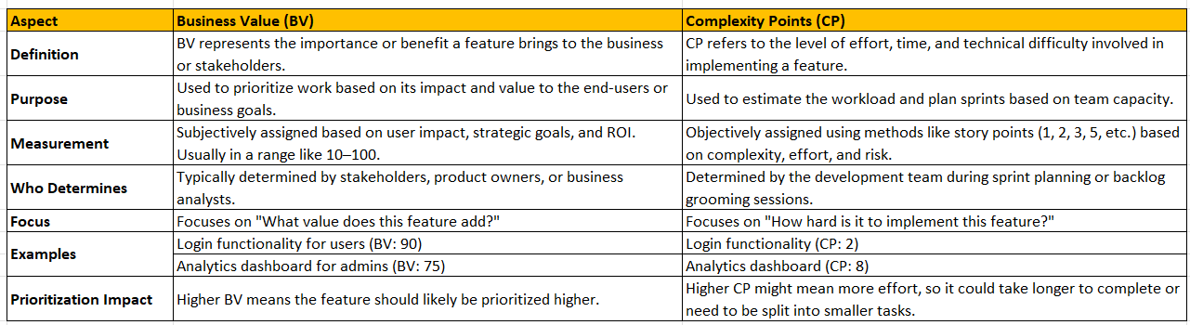

Question 5 –Explain about Sprint– 5 Marks

Answer:

A Sprint is a time-boxed iteration in Agile development during which a team works to complete a specific set of deliverables, typically chosen from the product backlog. It is the core building block of the Scrum framework, helping teams deliver small, incremental, and usable features of the product iteratively.

Key Characteristics of a Sprint:

Time-Boxed:
Sprints usually last 1–4 weeks. The duration is consistent throughout the project to ensure predictability.

Fixed Goals:
Once a Sprint begins, the goals and scope are locked. Changes to the scope are avoided until the next Sprint.
Deliverable Output:

The result of a Sprint is a potentially shippable product increment, which is reviewed by stakeholders.

Collaboration:
Sprints encourage close collaboration between cross-functional team members (developers, testers, BAs, etc.).
Inspection and Adaptation:

Each Sprint ends with a Sprint Review and Sprint Retrospective to inspect progress and adapt the process for improvement.

Sprint Lifecycle:

Sprint Planning:
The team decides what can be delivered during the Sprint and creates the Sprint Backlog.
Tasks are broken down into smaller chunks, and estimations are done.

Daily Standups (Scrum Meetings):
- A short, 15-minute meeting where the team discusses:
- What they completed yesterday.
- What they plan to do today.
- Any blockers or impediments.

Execution:
The team works on the selected backlog items, following Agile principles.
Progress is tracked using tools like burn-down charts or Kanban boards.

Sprint Review:
At the end of the Sprint, the completed work is demonstrated to stakeholders for feedback.

Sprint Retrospective:
The team reflects on the Sprint to identify successes and areas for improvement.

Benefits of Sprints:
Focused Work: Teams focus on a specific set of tasks within the fixed time-box.
Faster Feedback Loop: Regular reviews allow stakeholders to provide feedback, reducing rework.
Predictability: Fixed durations make planning and tracking easier.
Continuous Improvement: Retrospectives ensure the process evolves with lessons learned.

Example:
Duration: 2 weeks
Goal: Add user login and product search functionality.

Sprint Backlog:
Build login screen.
Validate user credentials.
Implement product search feature.
At the end of the Sprint, these features are reviewed, and feedback is collected for refinement in subsequent Sprints.

Question 6 – Explain Product backlog and sprint back log– 5 Marks
Answer:

The Product Backlog and Sprint Backlog are essential components of Agile frameworks like Scrum. While both are related to managing work, they serve different purposes and are used at different stages of the project.

- Product Backlog

Definition:
The Product Backlog is a prioritized list of all features, functionalities, requirements, and changes needed to deliver the final product. It represents the entire scope of work for the project.

Key Characteristics:

- Owned by the Product Owner: The Product Owner manages and prioritizes the Product Backlog.
- Dynamic: Items in the backlog can change as the product evolves and requirements are refined.
- Prioritized: The most critical and high-value items are placed at the top to be worked on first.

• Granularity:
- High-priority items are well-defined and ready to be worked on.
- Low-priority items are less detailed and can be refined later.

Components:
- User Stories (e.g., "As a user, I want to search for products so that I can find what I need.")

• Features
• Technical Enhancements
• Bug Fixes

Example:
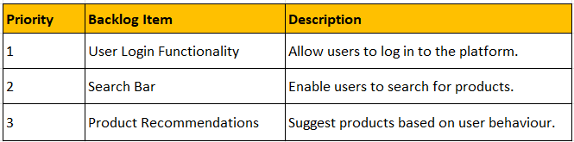

2. Sprint Backlog

Definition:
The Sprint Backlog is a subset of the Product Backlog that the team commits to completing during a specific Sprint. It represents the "To-Do" list for that Sprint.
Key Characteristics:
- Owned by the Development Team: The team selects items from the Product Backlog during Sprint Planning and commits to completing them.
- Fixed During Sprint: Once the Sprint starts, the Sprint Backlog should not change unless absolutely necessary.
- Detailed Tasks: The items in the Sprint Backlog are broken into smaller tasks for execution.

Components:
• Selected Product Backlog Items for the Sprint.
• Tasks necessary to complete those items.
• Sprint Goal that defines what the Sprint aims to achieve.

Example:
For a 2-week Sprint with a goal to implement a login system:
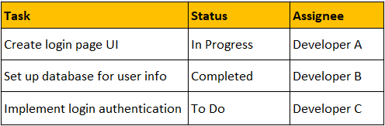

Question 7 – What is impediments log? write 2 impediments – 5 Marks

Answer:

What is an Impediments Log?

An Impediments Log is a tool used in Agile (especially in Scrum) to track and manage obstacles or issues that hinder the team's progress during a Sprint. These impediments can be anything that slows down, blocks, or reduces the productivity of the team.
The Scrum Master is typically responsible for identifying, logging, and resolving impediments, ensuring that the team can stay focused on delivering value.

Key Characteristics of an Impediments Log:
- Centralized Document: A single source for tracking all impediments for easy reference.
- Transparency: Keeps the team and stakeholders informed about issues and their status.
- Regular Updates: Reviewed during Daily Standups or Sprint meetings for updates on resolution progress.
- Prioritized: Impediments are prioritized based on their impact on the team's progress.

Sample Impediments Log with 2 examples:

Question 8 – Explain Velocity of the Team – 1 Marks.

Answer:

In Agile, Velocity is a metric used to measure the amount of work a team can complete during a Sprint, expressed in terms of completed story points (CP) or other effort units like hours or tasks. It helps teams predict how much work they can realistically accomplish in future Sprints and ensures proper Sprint planning.

How Many CPs Were Covered in This Sprint?

List Completed User Stories: For example:
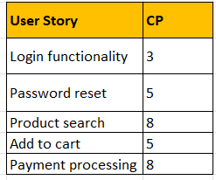

Sum of Completed CPs: Total CPs=3+5+8+5+8=29

Question 9 – Draw Sprint Burn Charts and Product Burn Down Charts– 3 Marks

Answer:

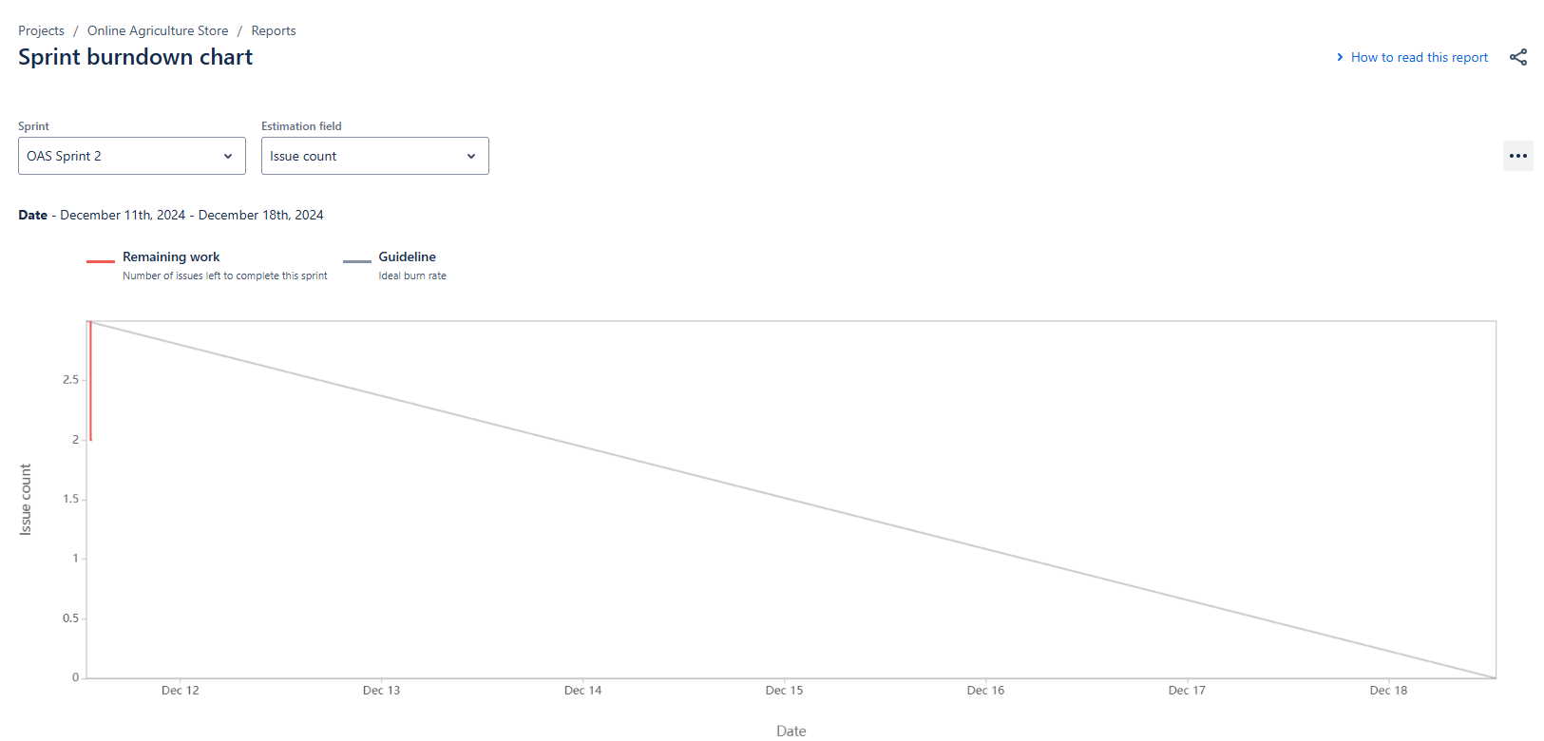

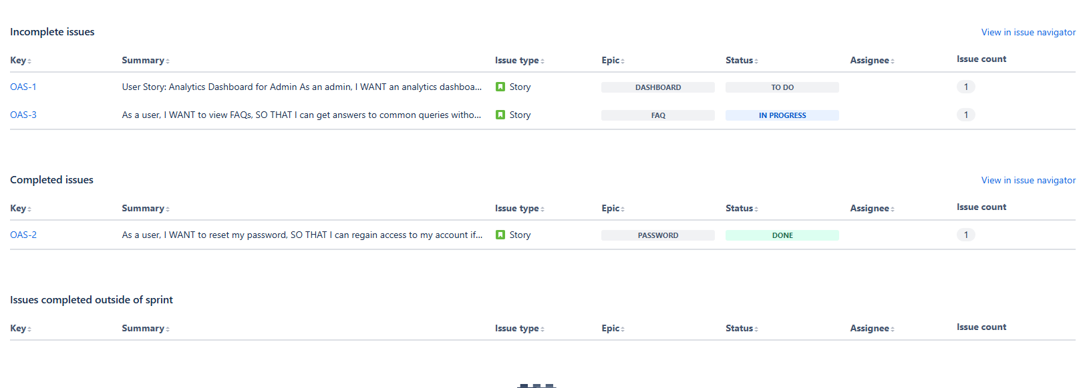

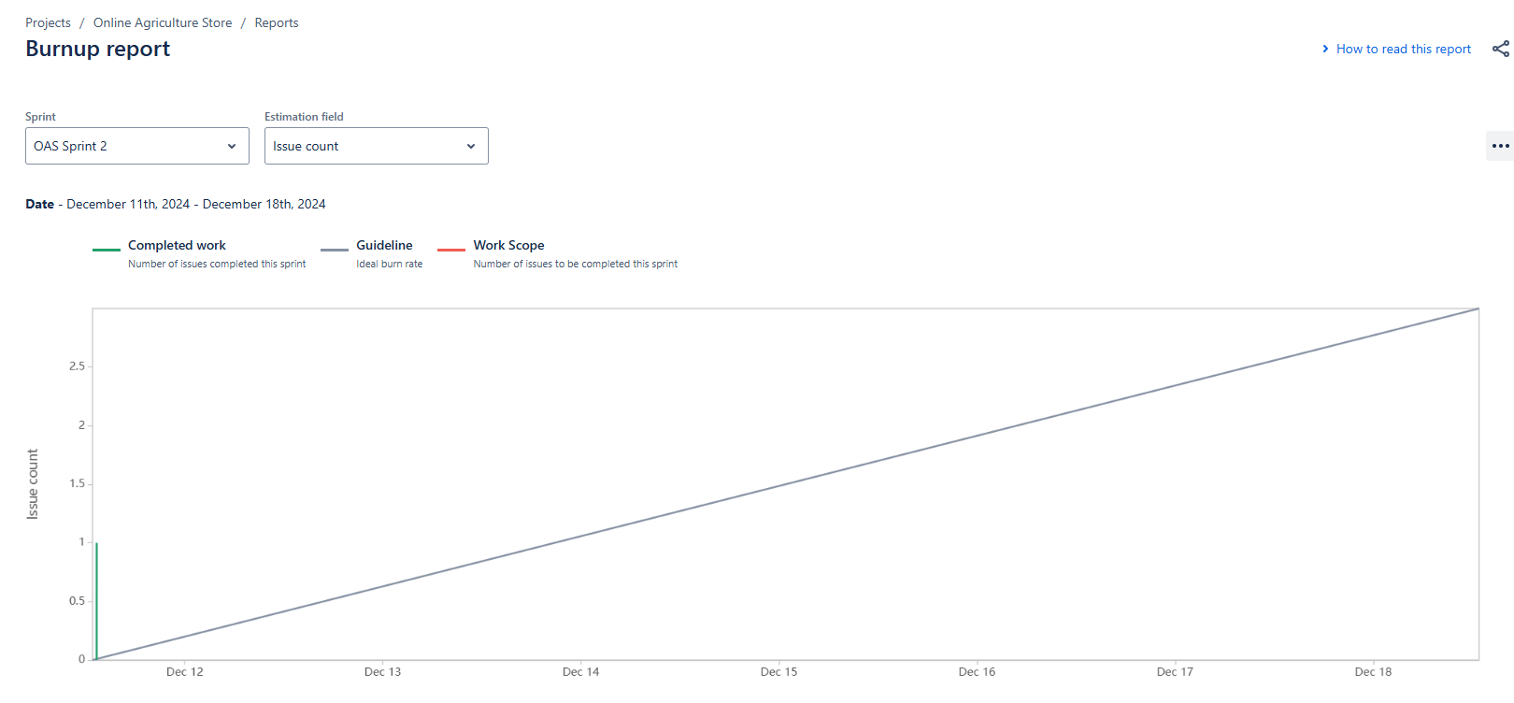

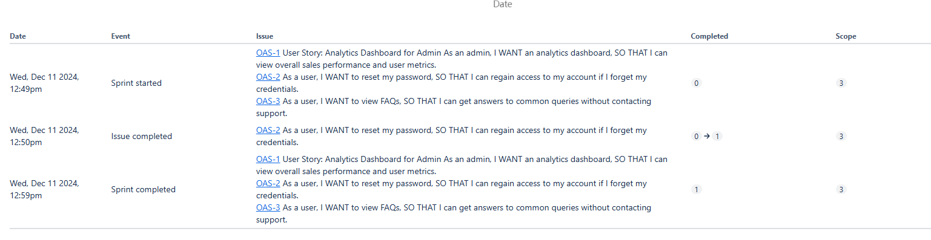

Question 10 – Explain about Product Grooming – 2 Marks
Answer:

Product Grooming (also called Backlog Refinement) is an Agile practice where the team reviews and updates the Product Backlog to ensure it remains well-organized, prioritized, and ready for future Sprints. This activity involves discussing, clarifying, and breaking down backlog items (User Stories or Epics) to make them actionable and detailed enough for the development team to work on.

Steps Involved in Product Grooming

Review Backlog Items:
Identify top-priority items and discuss their requirements.
Remove obsolete or irrelevant items.

Clarify Requirements:

Ensure backlog items are well-documented and understood by the team.
Add or update Acceptance Criteria for User Stories.

Prioritize Items:

Rearrange items based on business needs, dependencies, or stakeholder feedback.

Estimate Effort:

Use techniques like Planning Poker to assign story points or effort values to backlog items.

Break Down Large Items:

Decompose Epics or complex User Stories into smaller, manageable tasks.

Prepare Sprint-Ready Items:

Ensure that high-priority items meet the Definition of Ready (DoR), meaning they are clear, feasible, and actionable.

Question 11 – Explain the roles of Scrum Master Product Owner – 3 Marks

Answer:

1. Scrum Master

The Scrum Master is a servant leader responsible for ensuring the team follows Scrum principles and practices effectively. They act as a facilitator, coach, and protector of the team.

Responsibilities of the Scrum Master

Facilitating Scrum Events:

Organize and ensure productive Sprint Planning, Daily Stand-ups, Sprint Reviews, and Retrospectives.

Removing Impediments:

Identify and resolve blockers that hinder the team’s progress.

Coaching the Team:

Guide the team in understanding and adopting Scrum practices.
Foster a culture of continuous improvement.
Protecting the Team:

Shield the team from external distractions or unnecessary interruptions.

Ensuring Transparency:

Help maintain clear communication between the team, Product Owner, and stakeholders.
Promote the use of visible tools like burndown charts or Kanban boards.

Promoting Collaboration:

Encourage collaboration within the team and with external stakeholders.

2. Product Owner
The Product Owner (PO) is the key decision-maker regarding the product. They represent the business or customer needs and ensure the team delivers value aligned with business goals.

Responsibilities of the Product Owner

Managing the Product Backlog:

Create, prioritize, and refine the backlog to align with business objectives.
Ensure backlog items are well-defined and meet the Definition of Ready (DoR).

Setting Priorities:

Decide what work is most important and communicate this priority to the team.

Defining Vision:

Clearly articulate the product vision to the team and stakeholders.

Collaborating with Stakeholders:

Act as a bridge between the development team and stakeholders.
Gather and refine requirements from customers, users, and business representatives.

Acceptance of Deliverables:

Review and accept or reject the team’s deliverables based on acceptance criteria.

Maximizing Business Value:

Ensure the team delivers features and increments that provide the highest value.

Question 12 – Explain all Meetings Conducted in Scrum Project – 8 Marks

Answer:

1. Sprint Planning
Purpose: To define what will be delivered in the upcoming Sprint and how the team will accomplish the work.
When: At the start of each Sprint.
Duration: Time-boxed to a maximum of 8 hours for a 4-week Sprint (proportionally shorter for shorter Sprints).

Participants:
Scrum Master (facilitates)
Product Owner (presents prioritized backlog items)
Development Team (selects work and defines the plan)

Key Activities:
Discuss the Sprint Goal: Define the objective for the Sprint.
Select Backlog Items: The team pulls high-priority items from the Product Backlog.
Task Breakdown: Backlog items are broken into smaller tasks.
Effort Estimation: Estimate the time/effort required for each task.

2. Daily Scrum (Daily Stand-up)
Purpose: To inspect progress toward the Sprint Goal and plan the next 24 hours.
When: Held every day during the Sprint.
Duration: Time-boxed to 15 minutes.

Participants:
Development Team (main participants)
Scrum Master (facilitator)
Product Owner (optional observer)

Key Activities: Each team member answers three questions:
What did I do yesterday?
What will I do today?
Are there any impediments blocking my work?

3. Sprint Review
Purpose: To demonstrate the work completed during the Sprint and gather feedback from stakeholders.
When: At the end of the Sprint.
Duration: Time-boxed to 4 hours for a 4-week Sprint (proportionally shorter for shorter Sprints).

Participants:
Scrum Team (Scrum Master, Product Owner, Development Team)
Stakeholders (e.g., customers, users, business leaders)

Key Activities:
Product Demonstration: Showcase completed Product Backlog Items.
Feedback Gathering: Stakeholders provide feedback for future improvements.
Sprint Goal Evaluation: Assess whether the Sprint Goal was achieved.

4. Sprint Retrospective
Purpose: To reflect on the past Sprint and identify opportunities for improvement.
When: After the Sprint Review and before the next Sprint Planning.
Duration: Time-boxed to 3 hours for a 4-week Sprint

Participants:
Scrum Team (Scrum Master, Product Owner, Development Team)

Key Activities:
Review What Went Well: Identify successes.
Identify Challenges: Discuss what didn’t go well.
Action Plan: Create a plan to improve processes and resolve challenges in the next Sprint.

5. Backlog Refinement (Product Grooming)
Purpose: To review, clarify, and prioritize items in the Product Backlog.
When: Ongoing throughout the Sprint (often held mid-Sprint).
Duration: Usually 1-2 hours, not time-boxed but kept short and efficient.

Participants:
Product Owner (leads the discussion)
Development Team
Scrum Master (optional facilitator)

Key Activities:
Clarify requirements and refine backlog items.
Estimate effort or complexity for items.
Break down larger items (Epics) into smaller, actionable stories.

13. Explain Sprint Size and Scrum Size - 2 Marks

Answer:

1. Sprint Size
The Sprint Size refers to the duration of a Sprint, typically measured in weeks. It defines the time-box in which the team completes a defined set of work and delivers a usable product increment.

Key Aspects of Sprint Size
- Duration:
- Most commonly 1 to 4 weeks.
- The ideal duration depends on the project's complexity, the team's capabilities, and stakeholder needs.

Consistency:
Sprint sizes should remain constant throughout the project for predictability and reliable metrics like velocity.

Suitability:
Shorter Sprints (1-2 weeks):
- Suitable for fast-paced projects with rapidly changing requirements.
- Allow quicker feedback loops.

Longer Sprints (3-4 weeks):
- Suitable for projects with more stable requirements or complex deliverables.
- Provide more time for in-depth development.

Benefits of Choosing the Right Sprint Size
- Encourages focused work and manageable planning.
- Provides regular opportunities for feedback and adjustments.
- Balances progress visibility with development time.

2. Scrum Team Size
The Scrum Team Size refers to the number of members in the Scrum Team, which includes:

- Product Owner
- Scrum Master
- Development Team
The Development Team consists of cross-functional members such as developers, testers, database administrators, and designers.

Recommended Team Size
- 5 to 11 members (including the Product Owner and Scrum Master):
- Small enough to stay agile and promote effective collaboration.
- Large enough to complete the work within the Sprint.

Why the Team Size Matters
Small Teams (fewer than 5 members):

- Lack of diverse skills may create bottlenecks.
- Reduced productivity due to overload on individuals.

Large Teams (more than 11 members):
- Communication challenges and increased overhead.
- Difficulty in maintaining focus and alignment.

Question 14 – Explain DOR and DOD – 2 Marks
Answer:
What is DoR?
The Definition of Ready ensures that a user story or task is sufficiently prepared for the team to start working on it.
It defines the entry criteria that must be met before pulling an item into a Sprint.

Purpose:
Prevents wasted effort caused by unclear or incomplete requirements.
Ensures the team understands what is expected before work begins.

Example of DoR
For a user story like "As a farmer, I want to browse products so that I can choose what to buy," the DoR might include:

- Acceptance criteria written and reviewed.
- All designs or wireframes attached.
- Dependencies (like APIs) identified or resolved.
- Effort estimation completed by the team.
2. Definition of Done (DoD)
What is DoD?
The Definition of Done ensures that a user story, feature, or task is completed to the agreed standard.
It defines the exit criteria that must be met for work to be considered finished.
Purpose
Ensures the product increment is of high quality and potentially shippable.
Establishes a shared understanding among the team of "what done means."

Example of DoD
For the same user story, "As a farmer, I want to browse products so that I can choose what to buy," the DoD might include:

- Code is written, reviewed, and approved.
- Feature is tested (unit tests, integration tests, etc.).
- User interface aligns with design specifications.
- Deployed to staging for Product Owner approval.
- No known defects, and all acceptance criteria are met.

Question 15 – Explain Prioritization Techniques and MVP – 3 Marks
Answer:
Prioritization Techniques
Prioritization techniques are used to rank features, tasks, or user stories in order of importance. They help Product Owners and teams focus on delivering the most valuable items first.

1. MoSCoW Method
Stands for Must Have, Should Have, Could Have, and Won’t Have.
Must Have: Critical requirements that are essential for the product to function.
Should Have: High-priority items that are not critical but add significant value.
Could Have: Nice-to-have features that can be deferred if time or budget is limited.
Won’t Have: Features that will not be included in this release but may be considered in the future.

Example:
Must Have: User login functionality.
Should Have: Product filters for price and ratings.
Could Have: Advanced analytics for manufacturers.
Won’t Have: Multilingual support.
100 Dollars Test:
The 100 Dollars Test is a simple and effective prioritization technique used in product management to determine the relative importance of features, tasks, or requirements based on stakeholder input. It is particularly useful when there are multiple stakeholders with differing opinions about what should take priority.

How the 100 Dollars Test Works
Assign a Budget: Each participant is given an imaginary budget of 100 dollars (or points) to allocate.
List Features/Tasks: Provide the participants with a list of features, tasks, or user stories that need prioritization.
Allocate Dollars: Ask participants to allocate their 100 dollars across the features based on their perceived importance or value.
Stakeholders can allocate all 100 dollars to a single feature or distribute it among several features as they see fit.
Calculate Scores: Sum up the dollars assigned to each feature by all participants. Features with the highest total scores are given higher priority.
Prioritize the List: Rank the features in descending order based on their total scores.

Minimum Viable Product (MVP)
What is MVP?
Minimum Viable Product (MVP) is the smallest version of a product that can be released to users while delivering enough value to meet basic needs and provide feedback for improvement.
It is a core Agile concept used to validate ideas and reduce development risk.

Purpose of MVP:
Test market demand with minimal investment.
Collect user feedback to improve future iterations.
Quickly deliver value to users and stakeholders.

Question 16 – Difference between Business Analyst n Product Owner – 3 Marks
Answer:
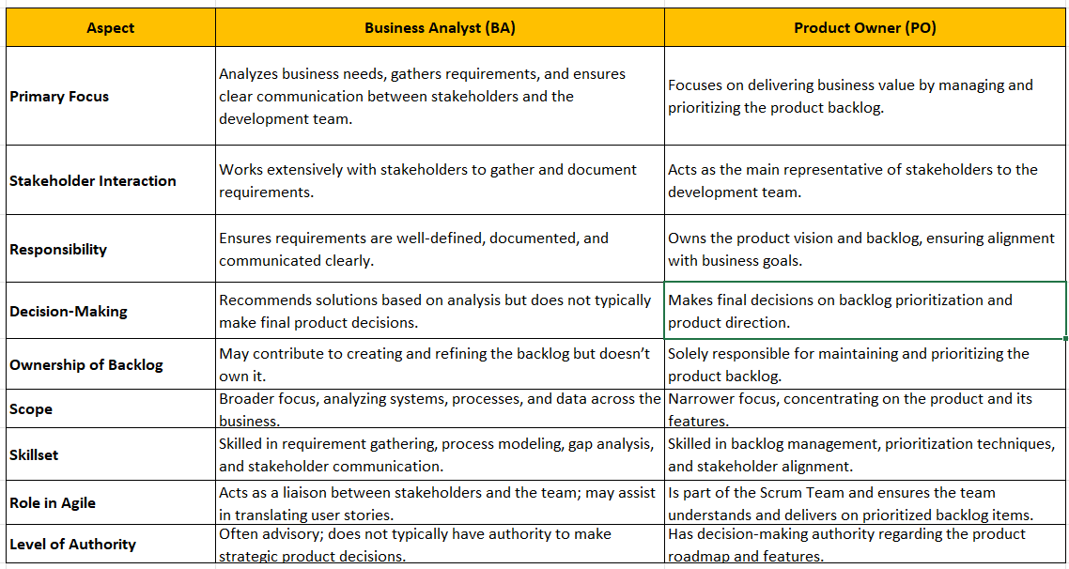

Question 17 – Prepare a sample Resume of 3yrs exp Product Owner – 3 Marks
Answer:
Arjun P Raut
Certified Product Owner | 3 Years of Experience in Agile Product Management
📞 Phone: 9975428391 | 📧 Email: arjun.ss2137@gmail.com | 📍 Location: Pune, Maharashtra

Summary
Results-driven Certified Product Owner with 3 years of experience in managing product backlogs, driving Agile Scrum processes, and delivering high-value products aligned with business goals. Expertise in stakeholder management, requirement prioritization, and maximizing ROI through data-driven decision-making. Adept at fostering collaboration between cross-functional teams to ensure seamless product delivery.

Core Competencies
- Agile & Scrum Methodologies
- Product Backlog Management
- User Story Writing & Grooming
- Stakeholder Engagement
- Roadmap Planning & Execution
- Data-Driven Decision-Making
- Prioritization Techniques (MoSCoW, 100 Dollar Test)
- Excellent Communication & Negotiation Skills

Certifications
- Certified Scrum Product Owner (CSPO) – [2023]
- Business Analysis Fundamentals – [2022]

Professional Experience
Product Owner
ABC Tech Solutions | November 2023 – Present
Pune, Maharashtra
- Owned and prioritized the product backlog for a web-based e-commerce platform, resulting in a 20% increase in user engagement over two quarters.
- Collaborated with stakeholders to define and refine the product vision, ensuring alignment with business goals.
- Led backlog grooming sessions and authored clear, concise user stories with acceptance criteria for developers.
- Successfully launched a mobile-responsive UI redesign that improved page load time by 15% and reduced bounce rates by 10%.
- Conducted Sprint Planning and facilitated Sprint Reviews to gather feedback and adjust backlog priorities.
- Monitored team velocity and ensured incremental value delivery by adhering to Definition of Done (DoD).
- Partnered with QA teams to ensure test cases covered all acceptance criteria, ensuring 99% defect-free product increments.
Associate Product Owner
XYZ Digital Inc. | September 2022 – October 2023
Pune, Maharashtra
- Collaborated with the Product Manager to implement new features for a customer relationship management (CRM) tool used by 10,000+ clients.
- Conducted user research and analysed feedback to identify high-impact opportunities, which increased customer retention by 15% within 6 months.
- Owned the requirements gathering process, turning business needs into actionable user stories and epics.
- Worked closely with the development team to deliver two major releases on time and within budget.
- Created roadmaps and release plans, ensuring alignment with the development team and stakeholders.
Business Analyst (Intern)
DEF Systems August 2021 – July 2022
Pune, Maharastra
- Assisted in requirement elicitation and documentation for a financial analytics dashboard project.
- Prepared wireframes and prototypes using tools like Balsamiq to communicate design ideas effectively.
- Supported the Product Owner during backlog grooming and sprint reviews.

Education
- Bachelor of Technology in Computer Science
Pune University, Pune, April 2020

Tools & Technologies
- Agile Tools: Jira, Trello, Azure DevOps
- Wireframing: Figma, Balsamiq, Adobe XD
- Analytics: Google Analytics, Tableau, Power BI
- Communication: Slack, MS Teams, Zoom

Soft Skills
- Analytical Thinking
- Strategic Planning
- Problem-Solving
- Team Collaboration
- Time Management

