Waterfall Project2 – Part -2/2 – 100 Marks - Pass 60 %

CR Barath Narayanan

Document 6- Please prepare a use case diagram, activity diagram and a use case specification document.
Use case diagram:
Login:
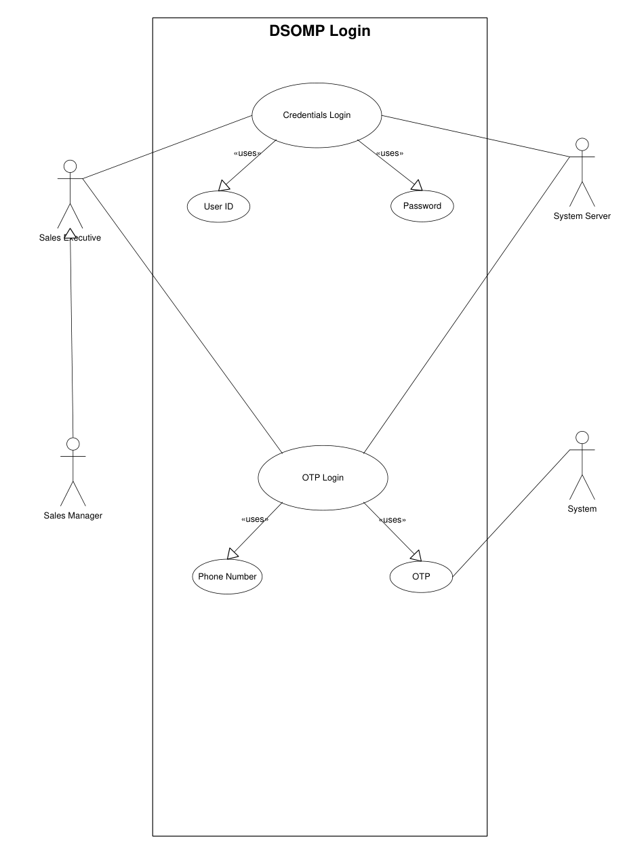

Meeting Logs:
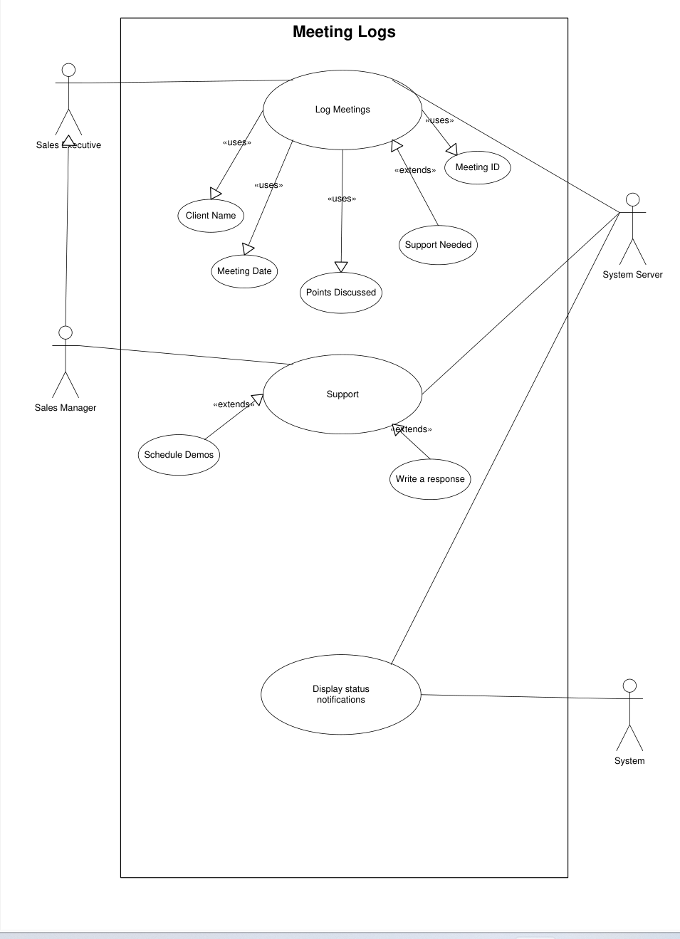

Generate Quotes:
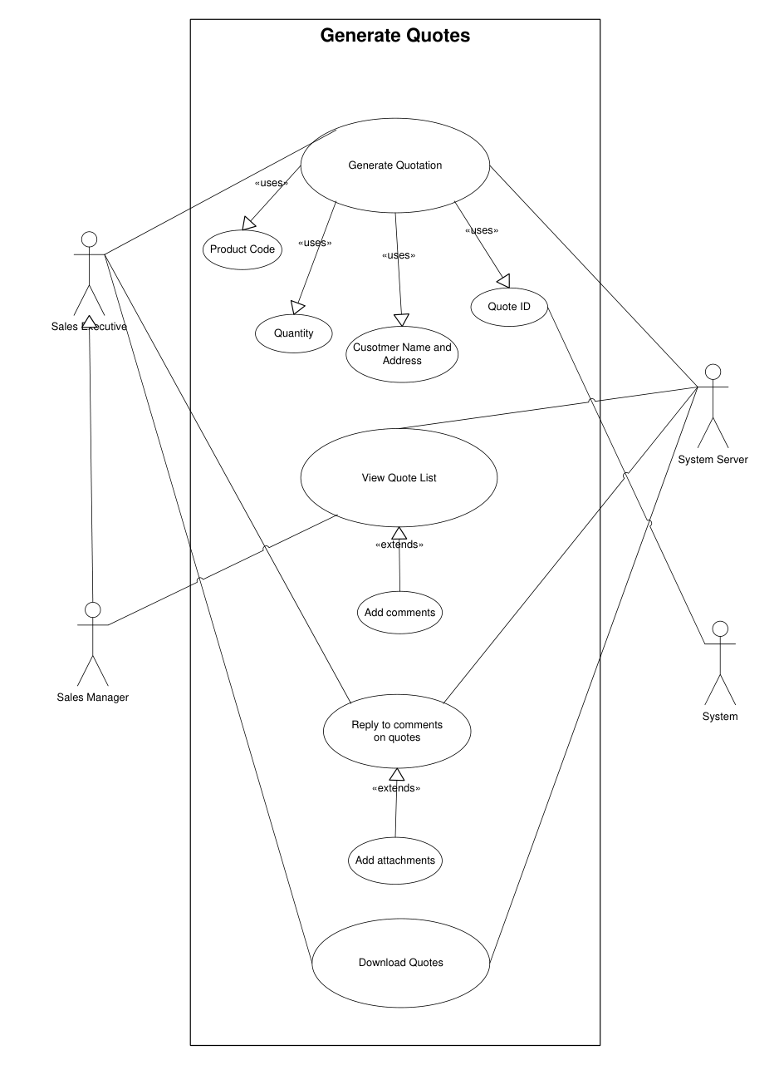

Leave Applications:
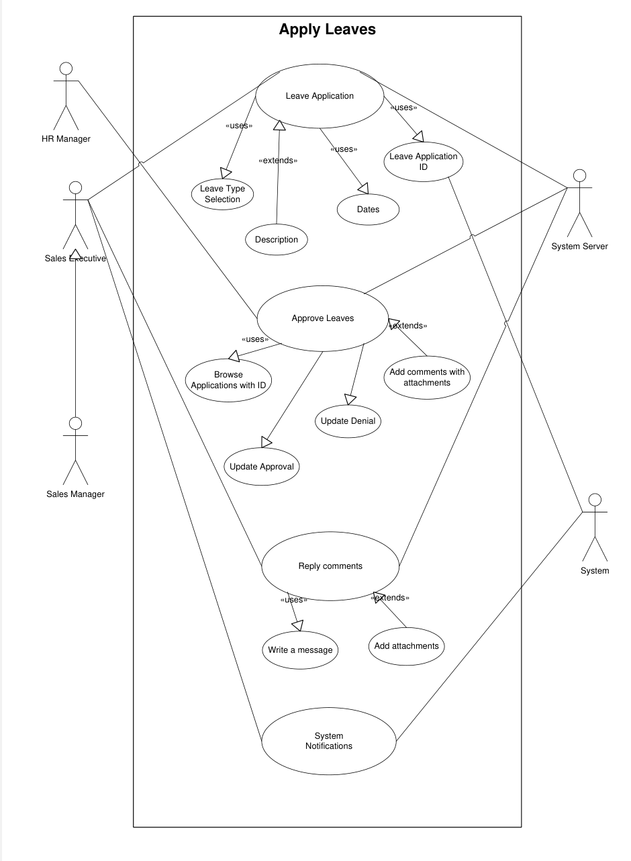

Expense Claims:
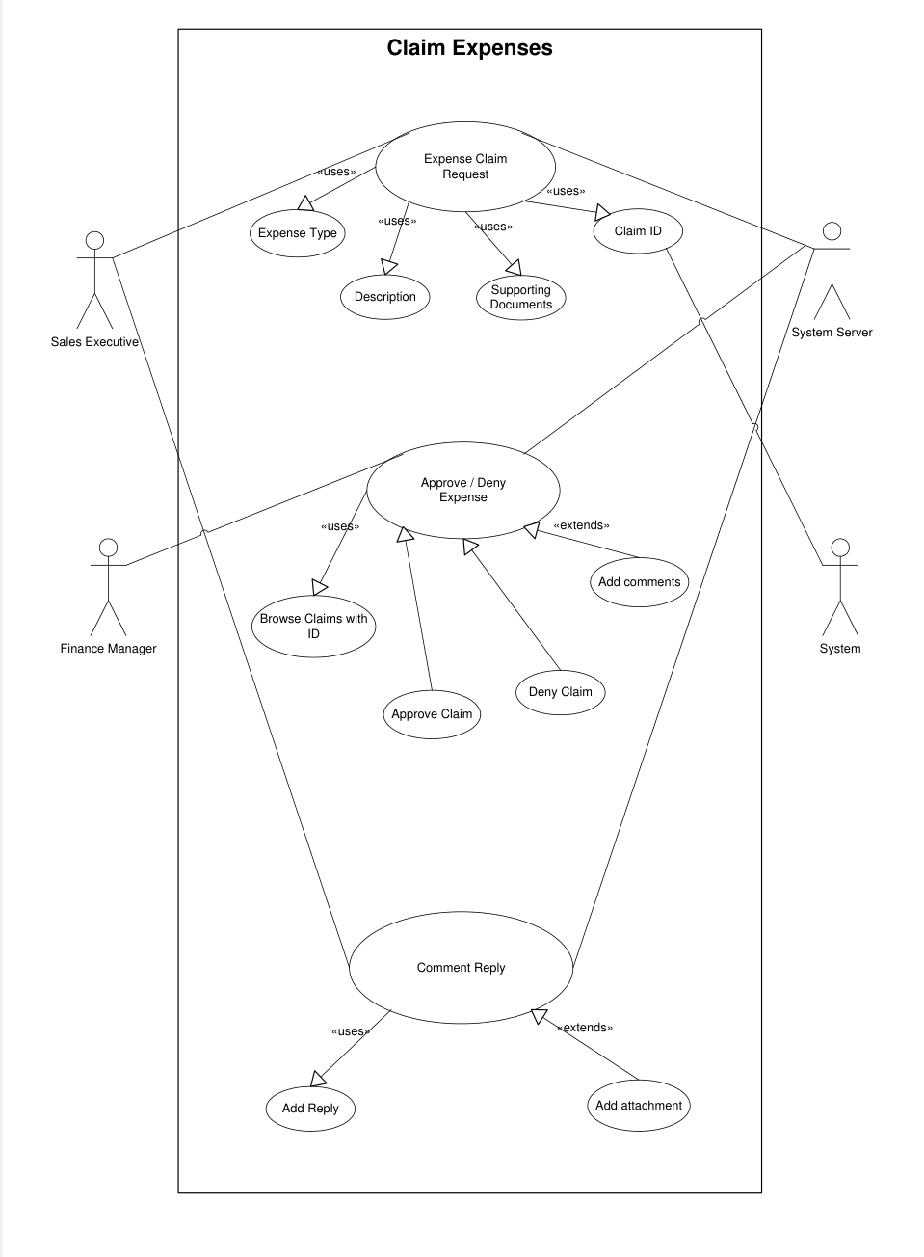

Activity diagram:
Login Page:
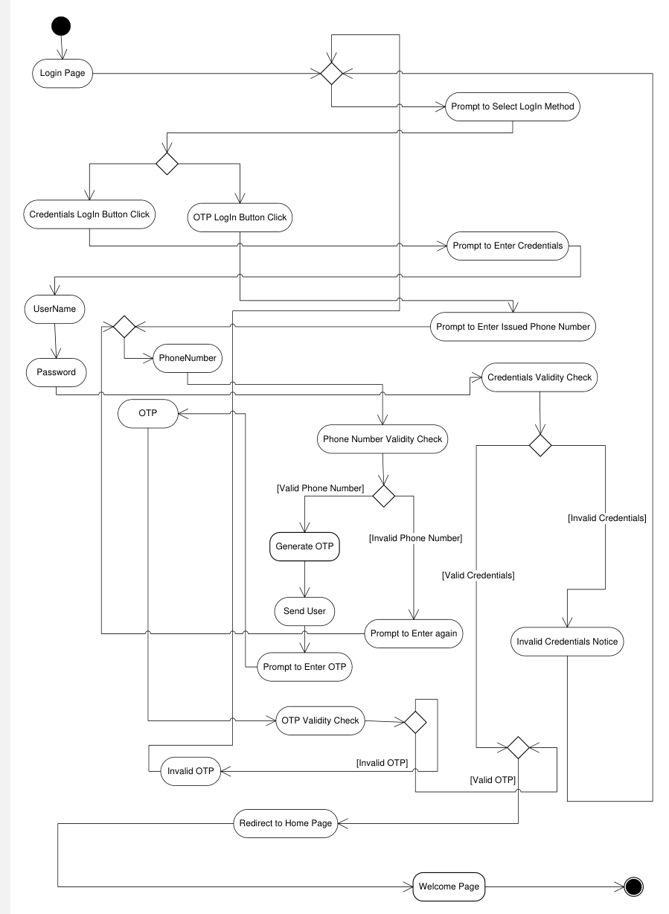

Log Meetings:
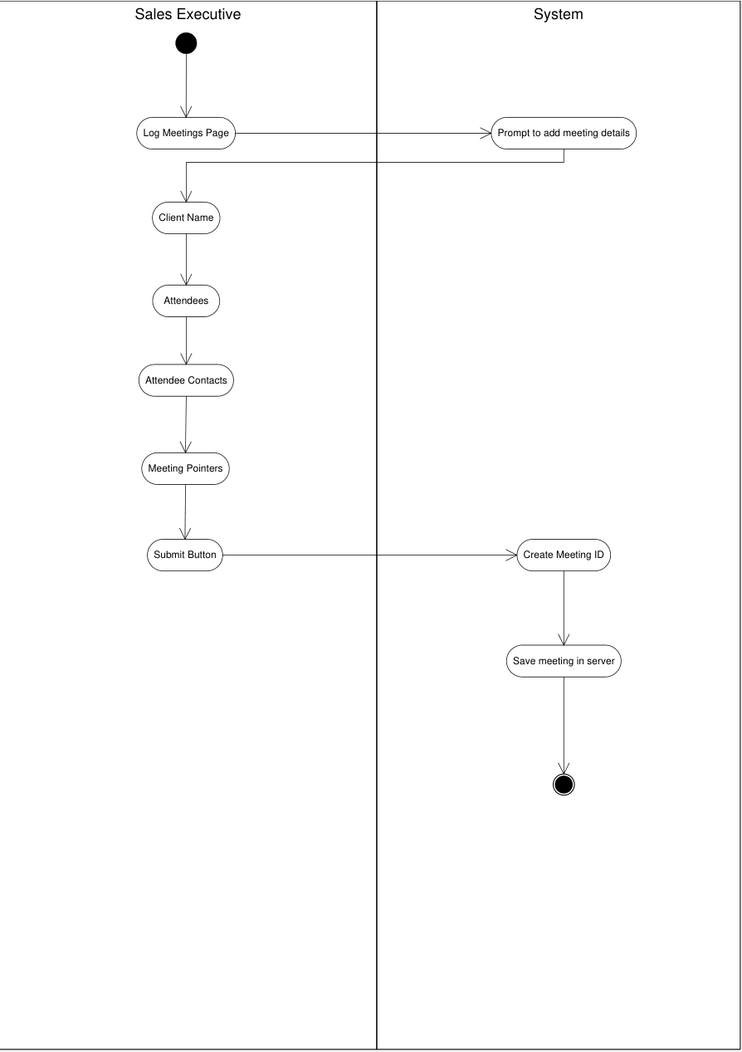

Claim Expenses:
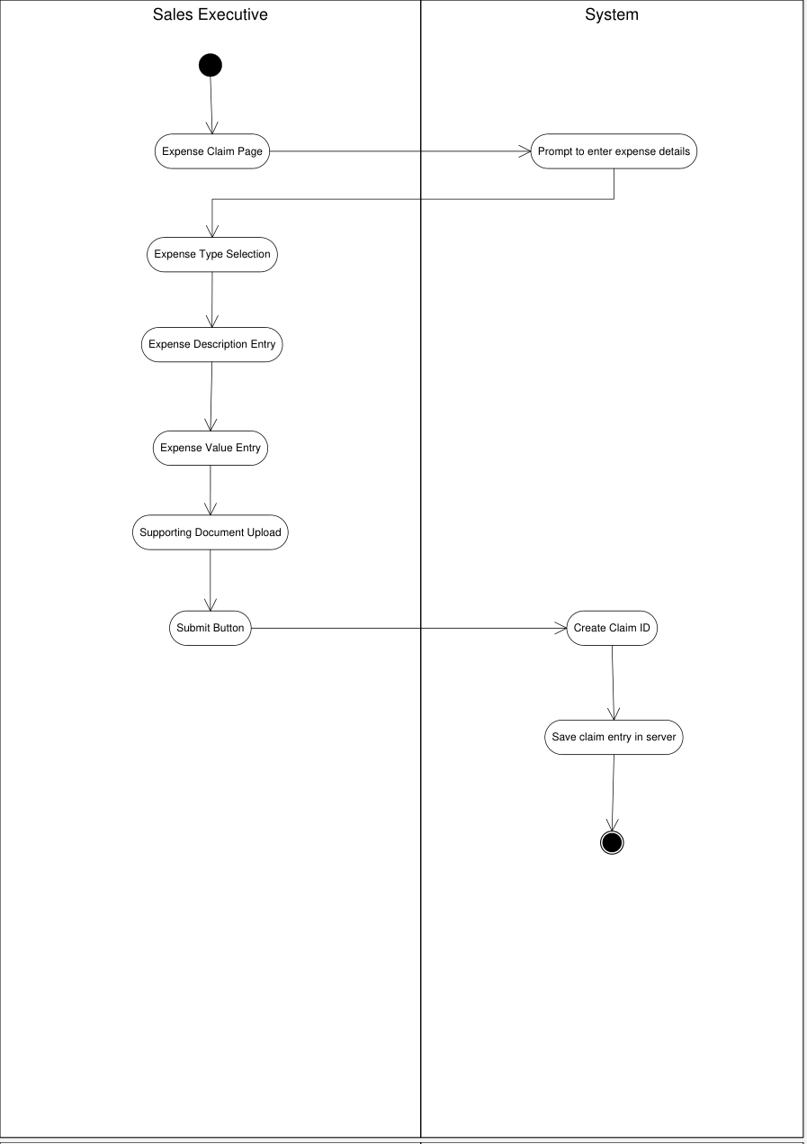

Leave Application:
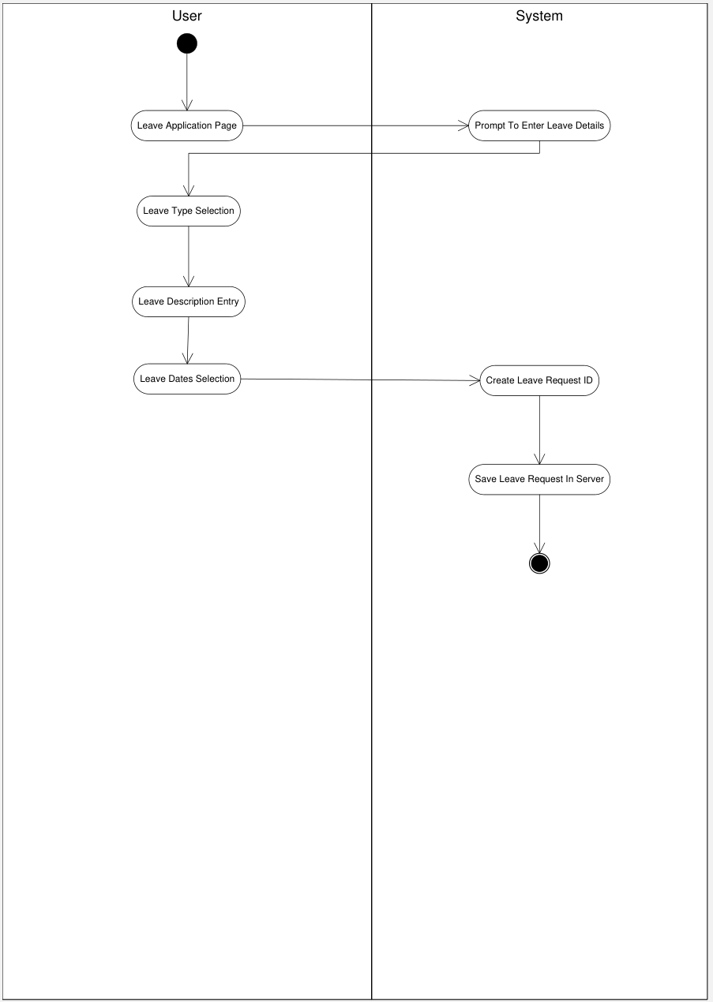

View Meeting Logs:
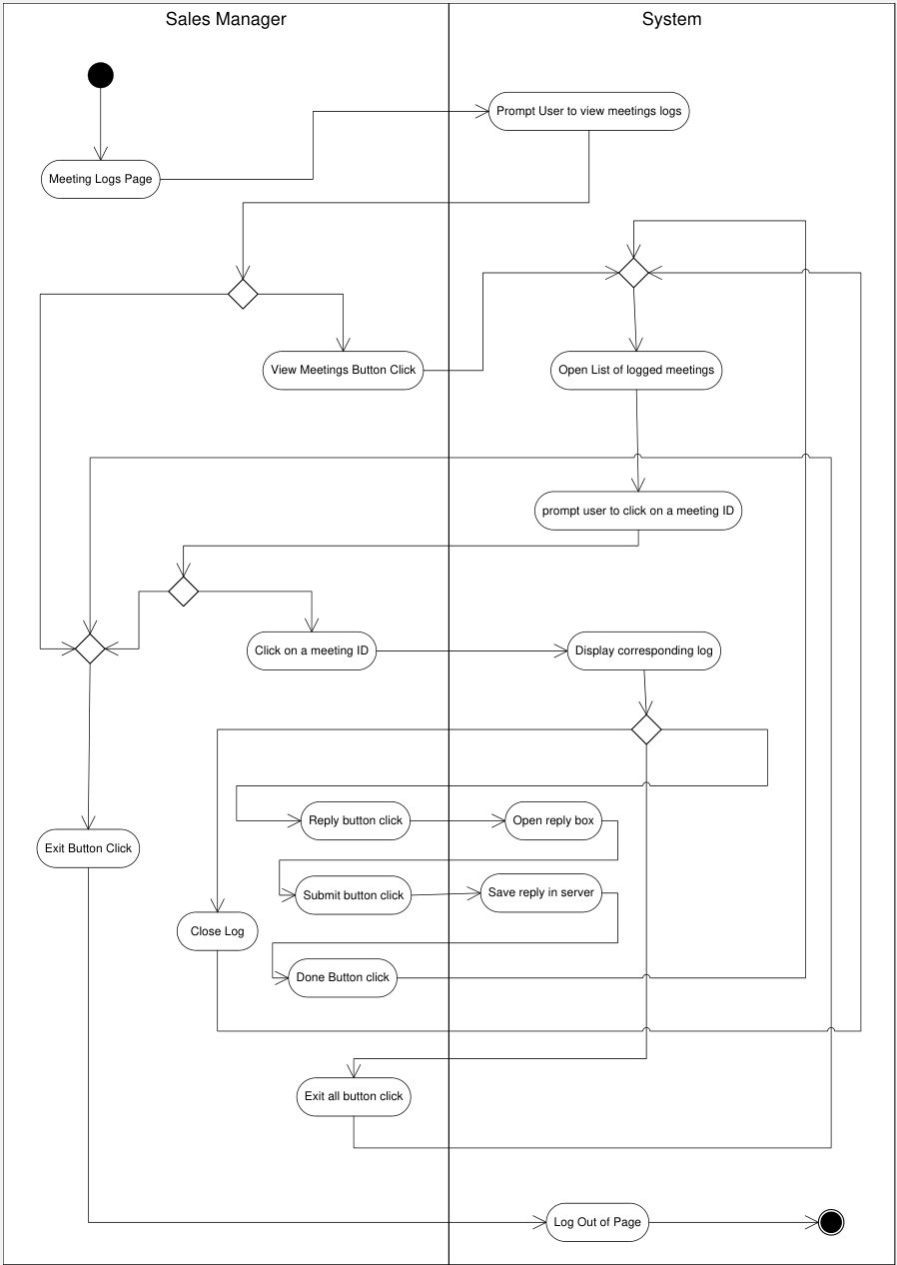

Leave Approvals:
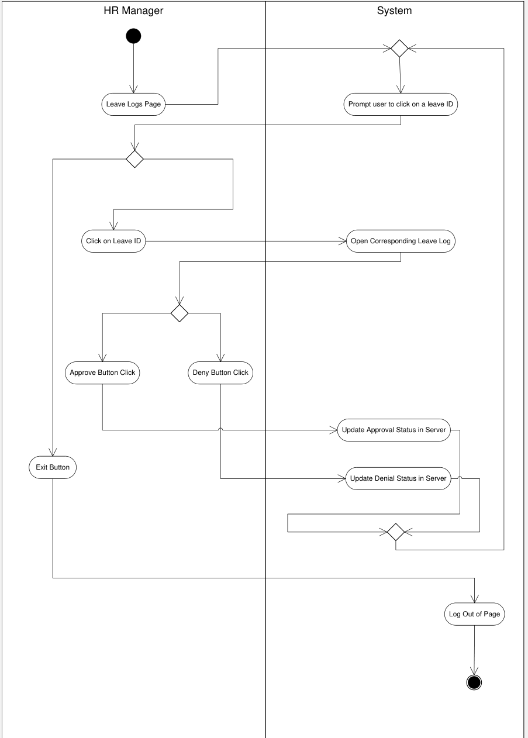

Expense Claim Approval:
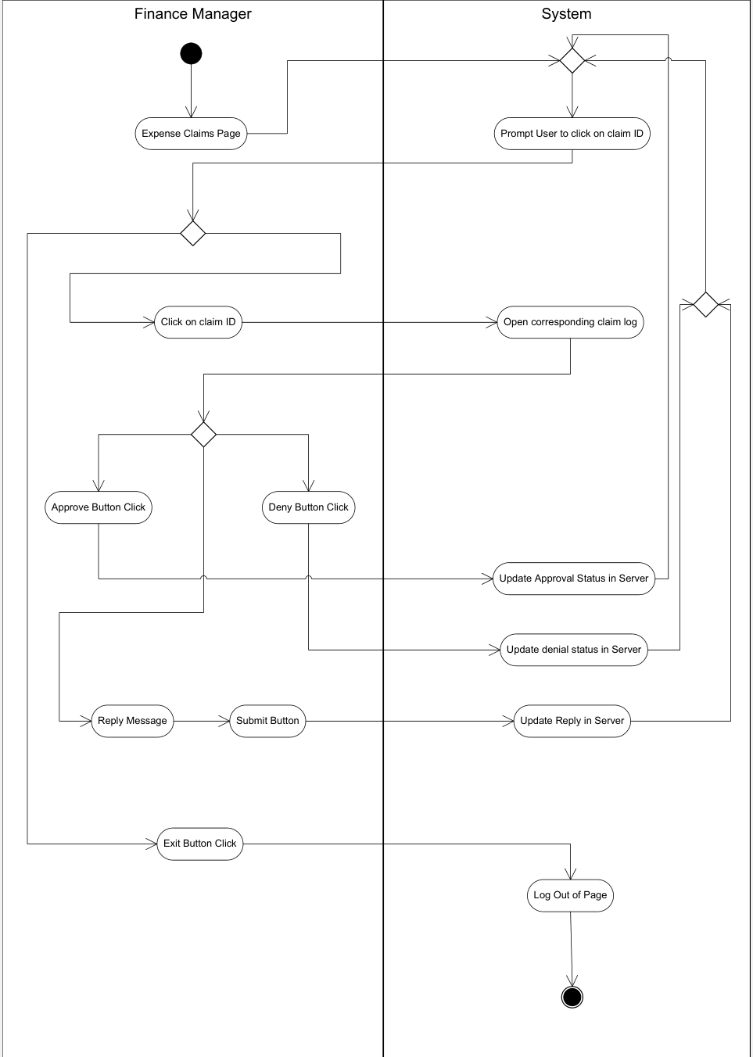

Use case specification documents:
SUBMIT EXPENSE REQUEST:
Use Case Name | Expense Request
Actor(s) | Primary Actor |  |  | Employee
 | Supporting Actor |  |  | System
Created By | Barath
Date Created | 20th July 2025
Last Updated | 20th July 2025
Use Case ID | UC-EXP-001
Priority | High
Status | Final
Use Case Description | This use case describes the process by which an employee submits a new expense request for reimbursement. The system captures the necessary details, including receipts and descriptions, and routes the request to the appropriate manager for approval.
Actors | Employee |  |  | The individual who submits an expense request for incurred costs.
Actors | System |  |  | The application used to enter, validate, store, and route expense request data.
Preconditions | The employee is logged into the system.
Preconditions | The expense was incurred and relevant receipts are available.
Preconditions | The expense falls within company policy.
Postconditions | The expense request is saved and marked “Pending Approval”.
Postconditions | A notification is sent to the appropriate manager.
Basic Flow | Step | Actor | Description
Basic Flow | 1 | Employee | Logs into the system and navigates to the “Expense Request” section.
Basic Flow | 2 | System | Displays the expense request form.
Basic Flow | 3 | Employee | Fills in details such as expense type, amount, date, description, and attaches receipts.
Basic Flow | 4 | System | Validates mandatory fields and file formats.
Basic Flow | 5 | Employee | Clicks “Submit”.
Basic Flow | 6 | System | Saves the request and updates its status to “Pending Approval”.
Basic Flow | 7 | System | Notifies the assigned manager of the new request.
Alternate Flow | Step | Actor | Description
Alternate Flow | 5A | Employee | Clicks “Save as Draft” instead of “Submit”.
Alternate Flow | 6A | System | Saves the request in draft mode.
Alternate Flow | 7A | System | Allows employee to return later to edit and submit.
Exception Flow | Step | Actor | Description
Exception Flow | E1 | System | If mandatory fields are missing, displays error message and prevents submission.
Exception Flow | E2 | System | If receipt file exceeds size limit or is in an invalid format, shows an error message.
Exception Flow | E3 | System | If there's a system error during submission, prompts user to retry later.
Business Rules | Expenses over a predefined limit require additional documentation.
Business Rules | Receipts must be uploaded in PDF, JPEG, or PNG format.
Business Rules | Duplicate expense entries are not allowed for the same date and category.
Business Rules | Certain expense types may require prior approval or additional fields (e.g., travel).
Assumptions | The user has been trained on how to use the expense module.
Assumptions | The employee has access to a scanner or camera to upload receipts.
Assumptions | Company policies and limits are already configured in the system.
Related Artifacts | BRS Document (Section: Expense Management)
Related Artifacts | SRS Document (Module: Expense Request Workflow)
Related Artifacts | Activity Diagram: Submit Expense Request
Related Artifacts | Sequence Diagram: Expense Request Submission Flow

APPROVE EXPENSE:
Use case name | Approve expenses
Actors | Primary Actor |  | Manager
Actors | Supporting Actor |  | System
Created By | Barath
Created Date | 20th July 2025
Last updated | 20th July 2025
Use Case ID | UC-EXP-002
Priority | High
Status | Final
Use Case Description | This use case describes the process by which a manager reviews and approves or rejects expense reports submitted by employees. Upon approval, the expense is routed for reimbursement processing. If rejected, the system notifies the employee with a reason.
Actors | Manager: |  | The person responsible for reviewing and approving submitted expense reports.
 | System: |  | The application that facilitates the submission, approval, rejection, and notification processes.
Preconditions | The manager is logged into the system.
 | The expense report has been submitted and is in a "Pending Approval" state.
Postconditions | The expense is either approved and forwarded for reimbursement, or rejected and sent back to the employee with comments.
Basic Flow | Step | Actor |  | Description
Basic Flow | 1 | Manager |  | Logs into the system and navigates to the expense approval dashboard.
Basic Flow | 2 | System |  | Displays a list of all pending expense reports.
Basic Flow | 3 | Manager |  | Selects a specific expense report for review.
Basic Flow | 4 | System |  | Displays the full details of the expense report including receipts.
Basic Flow | 5 | Manager |  | Reviews the report and clicks “Approve”.
Basic Flow | 6 | System |  | Updates the status of the expense to “Approved”.
Basic Flow | 7 | System |  | Notifies the employee of the approval and routes the report to the Finance team for processing.
Alternate Flow | Step | Actor |  | Description
Alternate Flow | 5A | Manager |  | Reviews the report and clicks “Reject”.
Alternate Flow | 6A | System |  | Prompts the manager to enter a reason for rejection.
Alternate Flow | 7A | Manager |  | Enters reason and confirms.
Alternate Flow | 8A | System |  | Updates status to “Rejected” and sends notification to employee with the reason.
Exception Flow | Step | Actor |  | Description
Exception Flow | E1 | System |  | If the expense report cannot be loaded (e.g., system error), an error message is shown.
Exception Flow | E2 | System |  | If the manager tries to approve without selecting a report, an alert prompts selection.
Business Rules | Only managers assigned to the employee can approve or reject their expense reports.
Business Rules | An expense report cannot be modified once approved.
Business Rules | The manager must provide a reason when rejecting an expense.
Assumptions | Managers have been assigned expense reports.
Assumptions | Users have appropriate permissions to perform their roles.
Related Artifacts | BRS Document (Section: Expense Management)
Related Artifacts | SRS Document (Module: Expense Approval Workflow)
Related Artifacts | Activity Diagram: Approve Expense
Related Artifacts | Sequence Diagram: Expense Approval Interaction

LOG MEETINGS:
Use Case Name | Log Meeting Details
Actor(s) | Primary Actor |  | Employee
Actor(s) | Supporting Actor |  | System
Created By | Barath
Date Created | 20th July 2025
Last Updated | 20th July 2025
Use Case ID | UC-ML-003
Priority | High
Status | Final
Use Case Description | This use case describes the process by which an employee records meeting-related information in the timesheet, including the date, duration, meeting subject, participants (if needed), and remarks. The data is saved and can be reviewed by project managers or HR for attendance and performance tracking.
Actors | Employee |  | The user who logs their daily meeting details in the timesheet.
Actors | System |  | The application used to enter, store, and retrieve timesheet data.
Preconditions | The employee is logged into the system.
Preconditions | The meeting has already occurred.
Preconditions | The timesheet module is accessible.
Postconditions | The meeting details are saved and reflected in the timesheet for that date.
Postconditions | The record is available for review or editing.
Basic Flow | Step | Actor |  | Description
Basic Flow | 1 | Employee |  | Logs into the system and navigates to the “Timesheet and meetings” module.
Basic Flow | 2 | System |  | Displays the timesheet interface with date-wise entry fields.
Basic Flow | 3 | Employee |  | Selects the appropriate date and time slot for the meeting.
Basic Flow | 4 | Employee |  | Enters meeting title/subject, duration, optional remarks, and other required details.
Basic Flow | 5 | System |  | Validates the entry (e.g., overlapping time, mandatory fields).
Basic Flow | 6 | Employee |  | Clicks “Save” or “Submit”.
Basic Flow | 7 | System |  | Stores the meeting log in the timesheet and displays confirmation.
Alternate Flow | Step | Actor |  | Description
Alternate Flow | 5A | Employee |  | Chooses to update an existing meeting record.
Alternate Flow | 6A | System |  | Loads the previous data.
Alternate Flow | 7A | Employee |  | Edits the fields and clicks “Update”.
Alternate Flow | 8A | System |  | Saves the updated meeting entry.
Exception Flow | Step | Actor |  | Description
Exception Flow | E1 | System |  | If required fields (meeting title or duration) are missing, displays error message.
Exception Flow | E2 | System |  | If the time slot overlaps with another entry, warns the employee and prevents submission.
Exception Flow | E3 | System |  | If there's a backend failure, prompts user to retry or contact support.
Business Rules | Employees must log meeting details on the same day or within 3 business days.
Business Rules | Time entries should not exceed 8 hours per day unless approved by the manager.
Business Rules | Meetings must be work-related; irrelevant entries may be flagged during audit.
Assumptions | The employee knows the meeting details and its purpose.
Assumptions | The system time zone is correctly set to ensure accurate timestamps.
Assumptions | Only authorized users have access to modify their own timesheet.
Related Artifacts | BRS: Timesheet Management Features
Related Artifacts | Activity Diagram: Log Meeting Details
Related Artifacts | Sequence Diagram: Save Timesheet Entry
Related Artifacts | UI Mockup: Timesheet and meetings Entry Form

QUOTE GENERATION:
Use Case Name | Generate Quotation
Actor(s) | Primary Actor |  | Sales Executive
 | Supporting Actor |  | System
Created By | Barath
Date Created | 20th July 2025
Last Updated | 20th July 2025
Use Case ID | UC-SALES-003
Priority | High
Status | Final
Use Case Description | This use case describes the process by which a Sales Executive generates a quotation for a client based on the requested products or services. The quotation includes product descriptions, pricing, taxes, terms, and validity. The system supports automatic calculations and document generation.
Actors | Sales Executive |  | Initiates the quotation generation process.
Actors | System |  | Facilitates form filling, calculates total cost, and generates the quotation document.
Preconditions | The Sales Executive is logged into the system.
Preconditions | Client details are available or created.
Preconditions | Product/service catalog is accessible.
Postconditions | The quotation is saved in the system.
Postconditions | A PDF version of the quotation is generated and optionally sent to the client.
Postconditions | The quotation is assigned a unique reference number.
Basic Flow | Step | Actor |  | Description
Basic Flow | 1 | Sales Executive |  | Logs in
Basic Flow | 2 | Sales Executive |  | Navigates to the “Generate Quotation” module.
Basic Flow | 3 | Sales Executive |  | Selects existing client or enters new client details.
Basic Flow | 4 | Sales Executive |  | Adds items from the catalog with quantity, price, and applicable tax.
Basic Flow | 5 | System |  | Automatically calculates totals, taxes, and discounts.
Basic Flow | 6 | Sales Executive |  | Adds payment terms, delivery details, and notes if needed.
Basic Flow | 7 | Sales Executive |  | Clicks “Generate Quotation”.
Basic Flow | 8 | System |  | Creates the quotation PDF with a unique number and stores it.
Basic Flow | 9 | Sales Executive |  | Reviews, prints, or emails the quotation to the client.
Alternate Flow | Step | Actor |  | Description
Alternate Flow | 6A | Sales Executive |  | Opens a previously generated quotation for the same client.
Alternate Flow | 7A | Sales Executive |  | Updates quantities, pricing, or terms.
Alternate Flow | 8A | System |  | Saves it as a revised quotation with version control.
Exception Flow | Step | Actor |  | Description
Exception Flow | E1 | System |  | Displays error if mandatory fields (client name, item list) are missing.
Exception Flow | E2 | System |  | If tax rules are outdated or missing, alerts the user.
Exception Flow | E3 | System |  | If server error occurs, prompts to retry or save as draft.
Business Rules | Each quotation must have a unique ID and timestamp.
Business Rules | Quotations must follow pricing rules set by the organization.
Business Rules | Validity period (e.g., 30 days) must be included.
Business Rules | Discounts above a threshold require managerial approval.
Assumptions | Product pricing and taxes are regularly updated in the system.
Assumptions | Sales Executives have access only to clients assigned to them.
Assumptions | All system-generated documents follow a predefined format.
Related Artifacts | BRS: Quotation & Proposal Management
Related Artifacts | Activity Diagram: Generate Quotation
Related Artifacts | Sequence Diagram: Quotation Generation and Approval (if applicable)
Related Artifacts | UI Mockup: Quotation Entry Screen and PDF Output

Document 7: Screens and Pages
Login Page
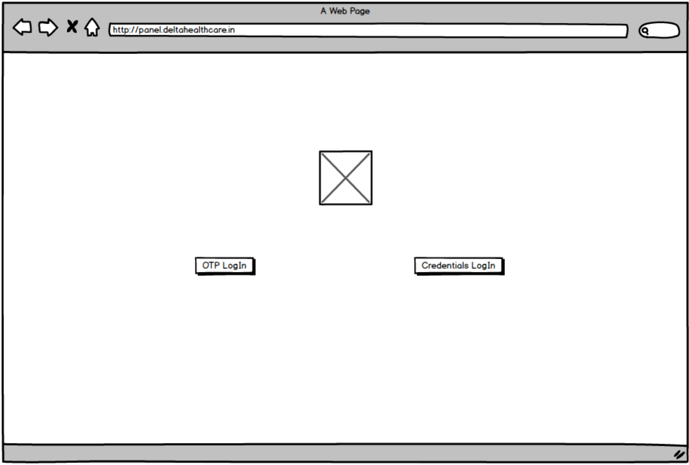

OTP Login:
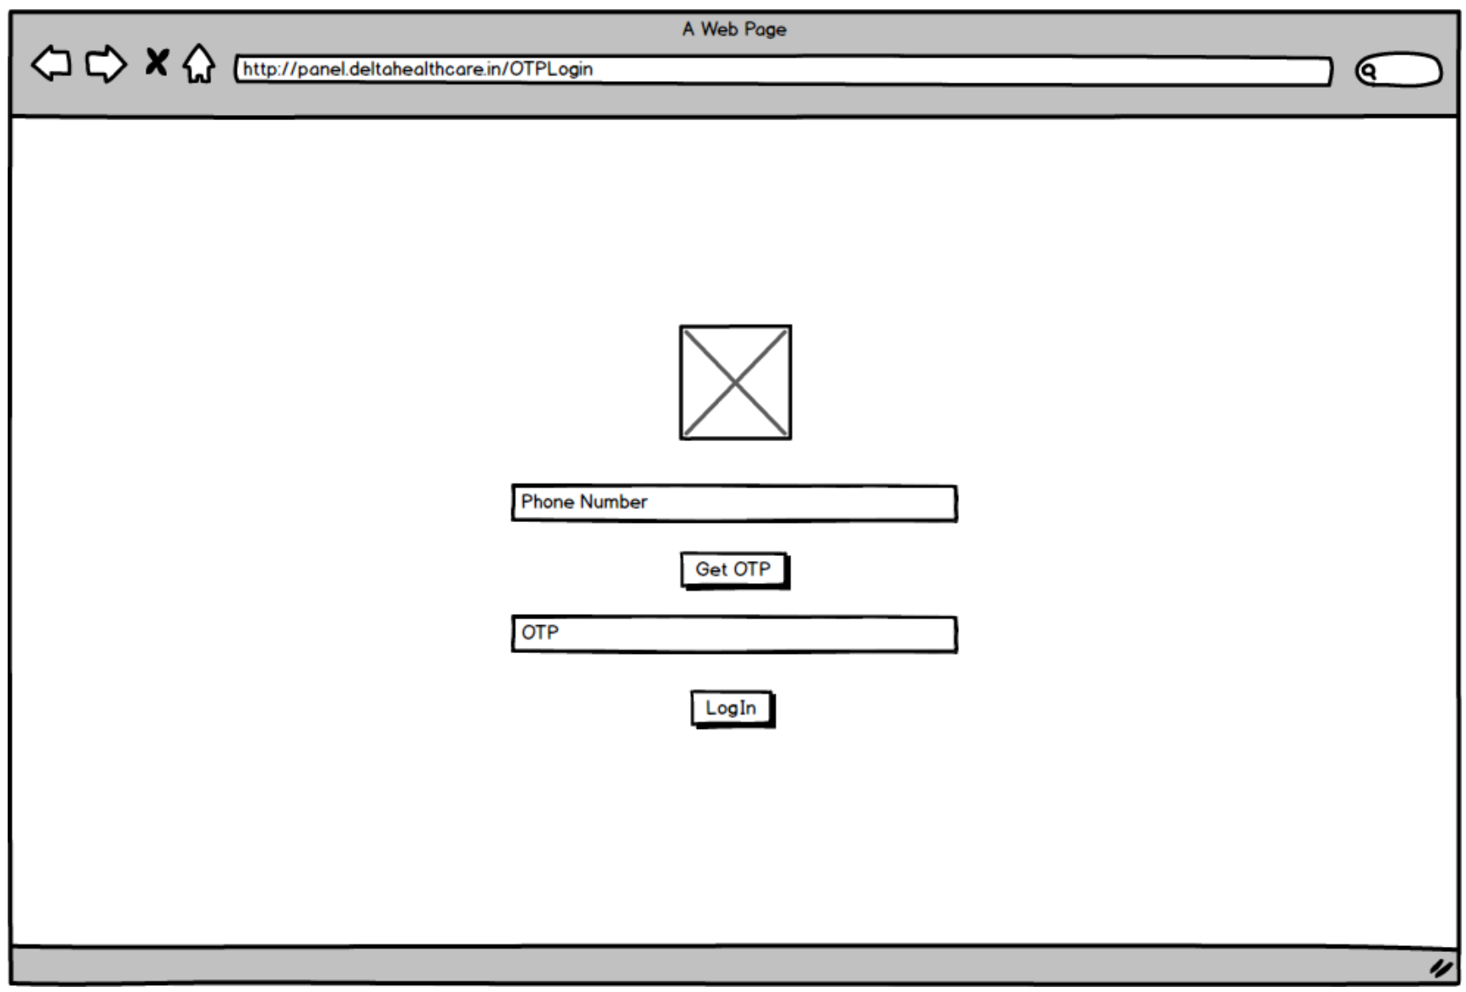
Credentials Login Page:
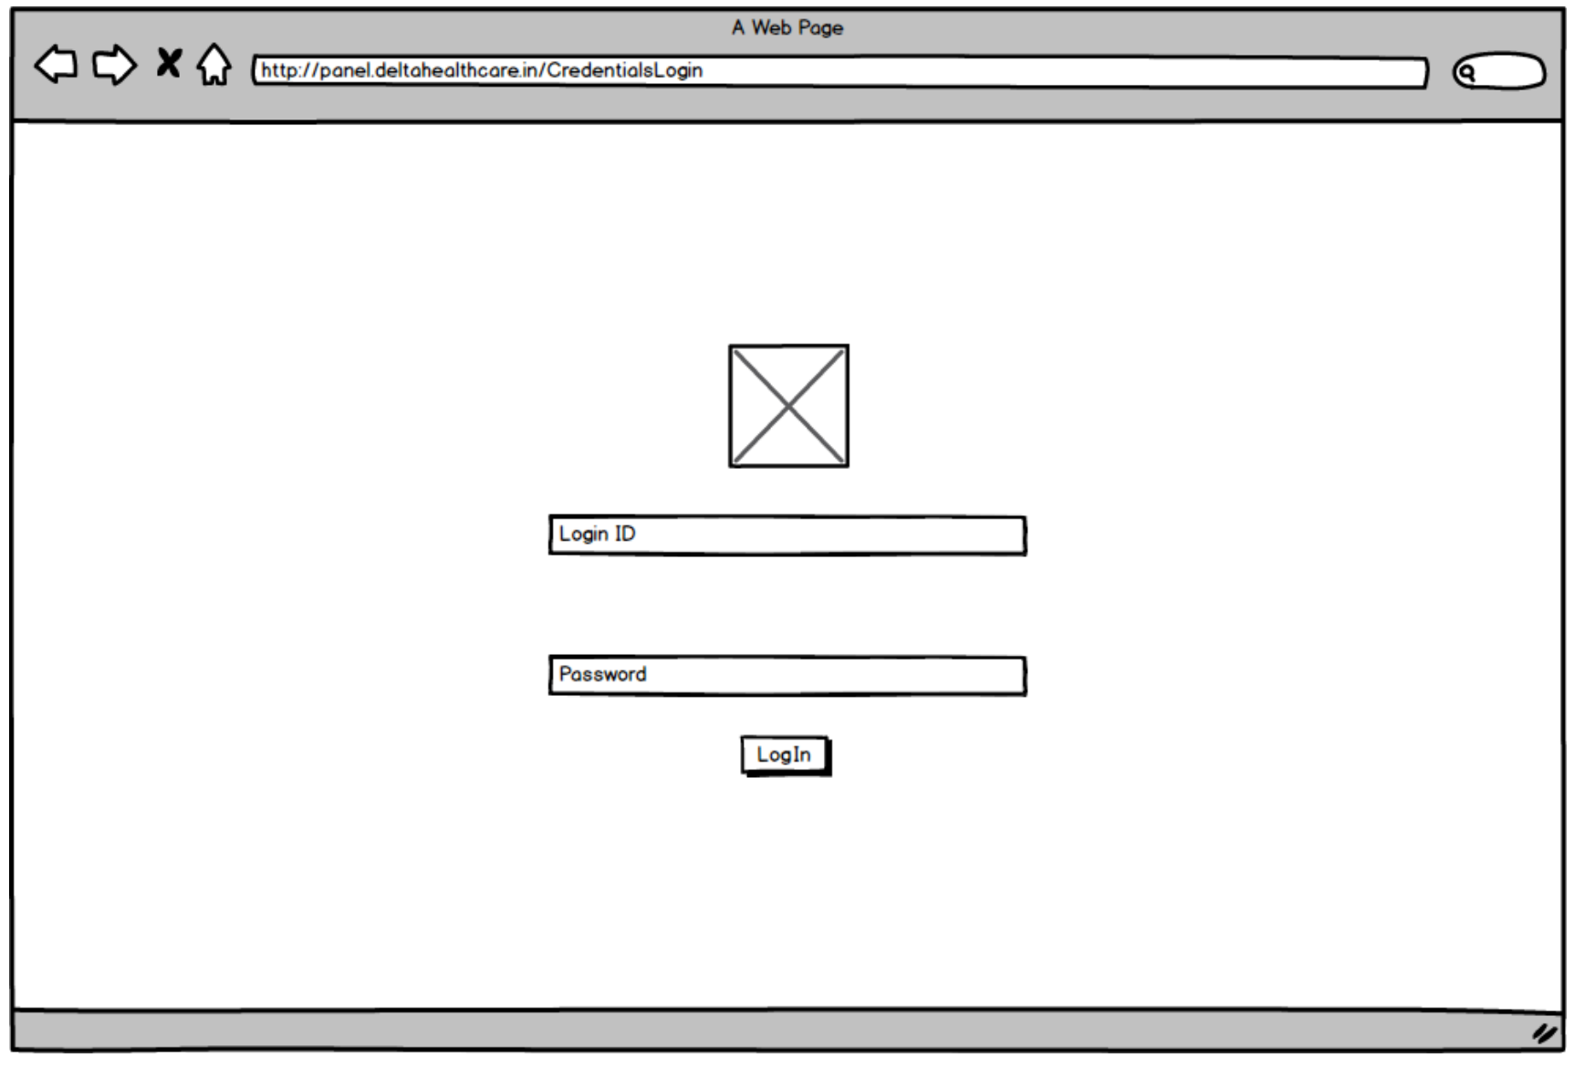

Meeting Logs:
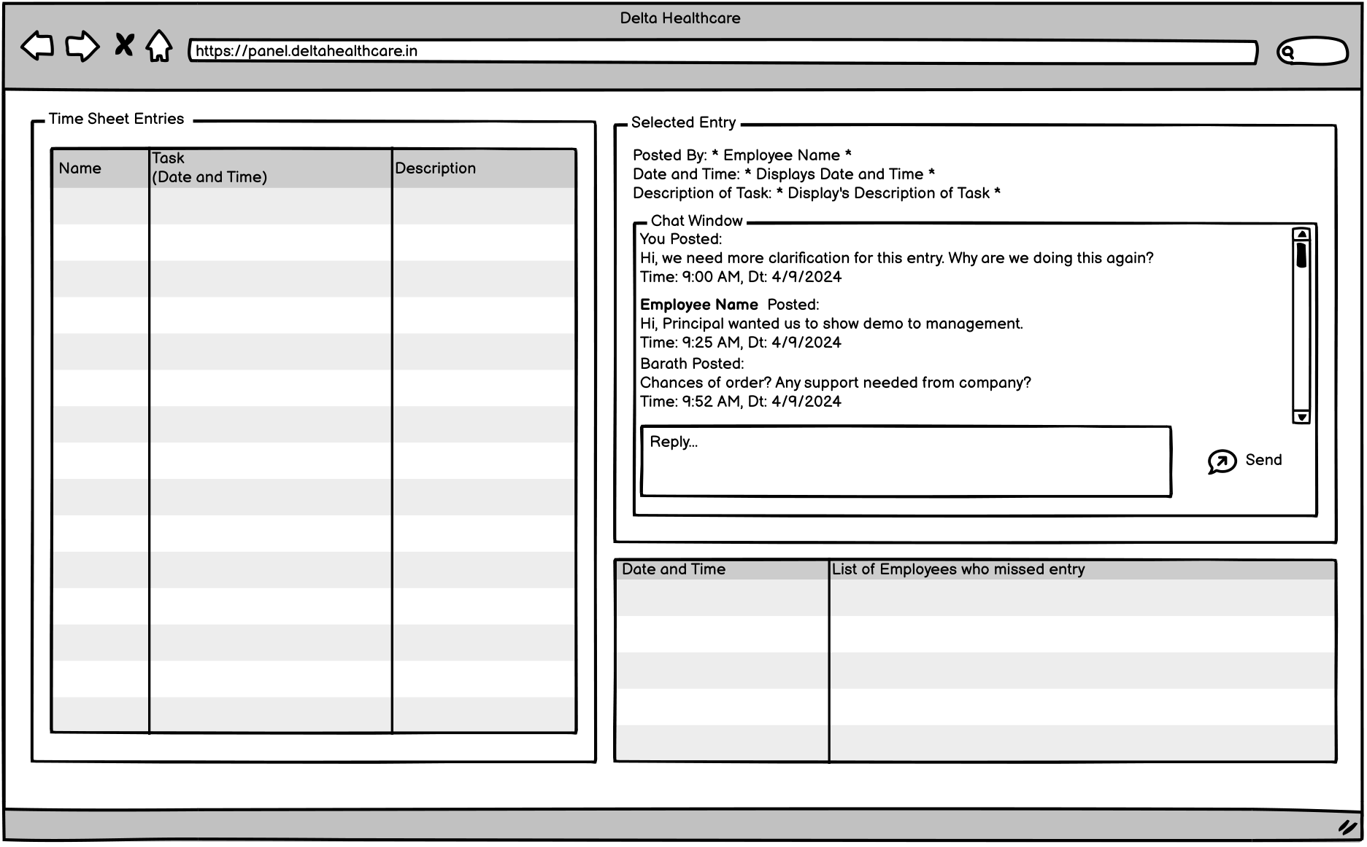

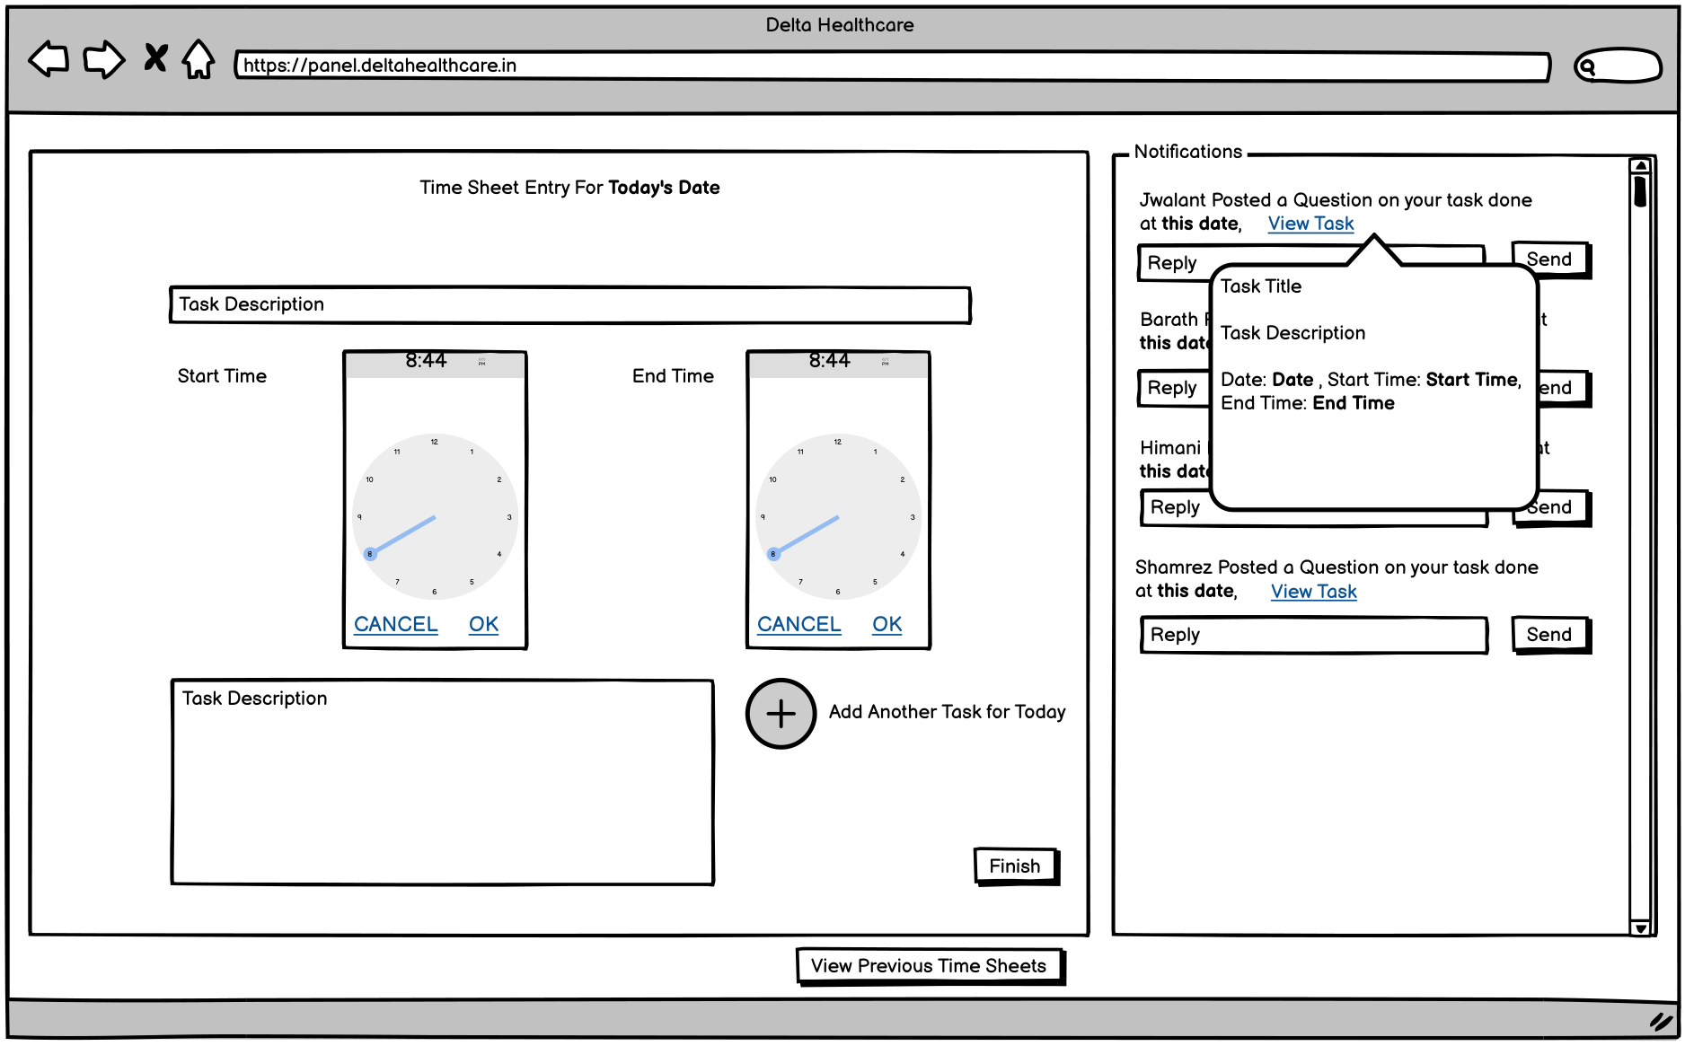

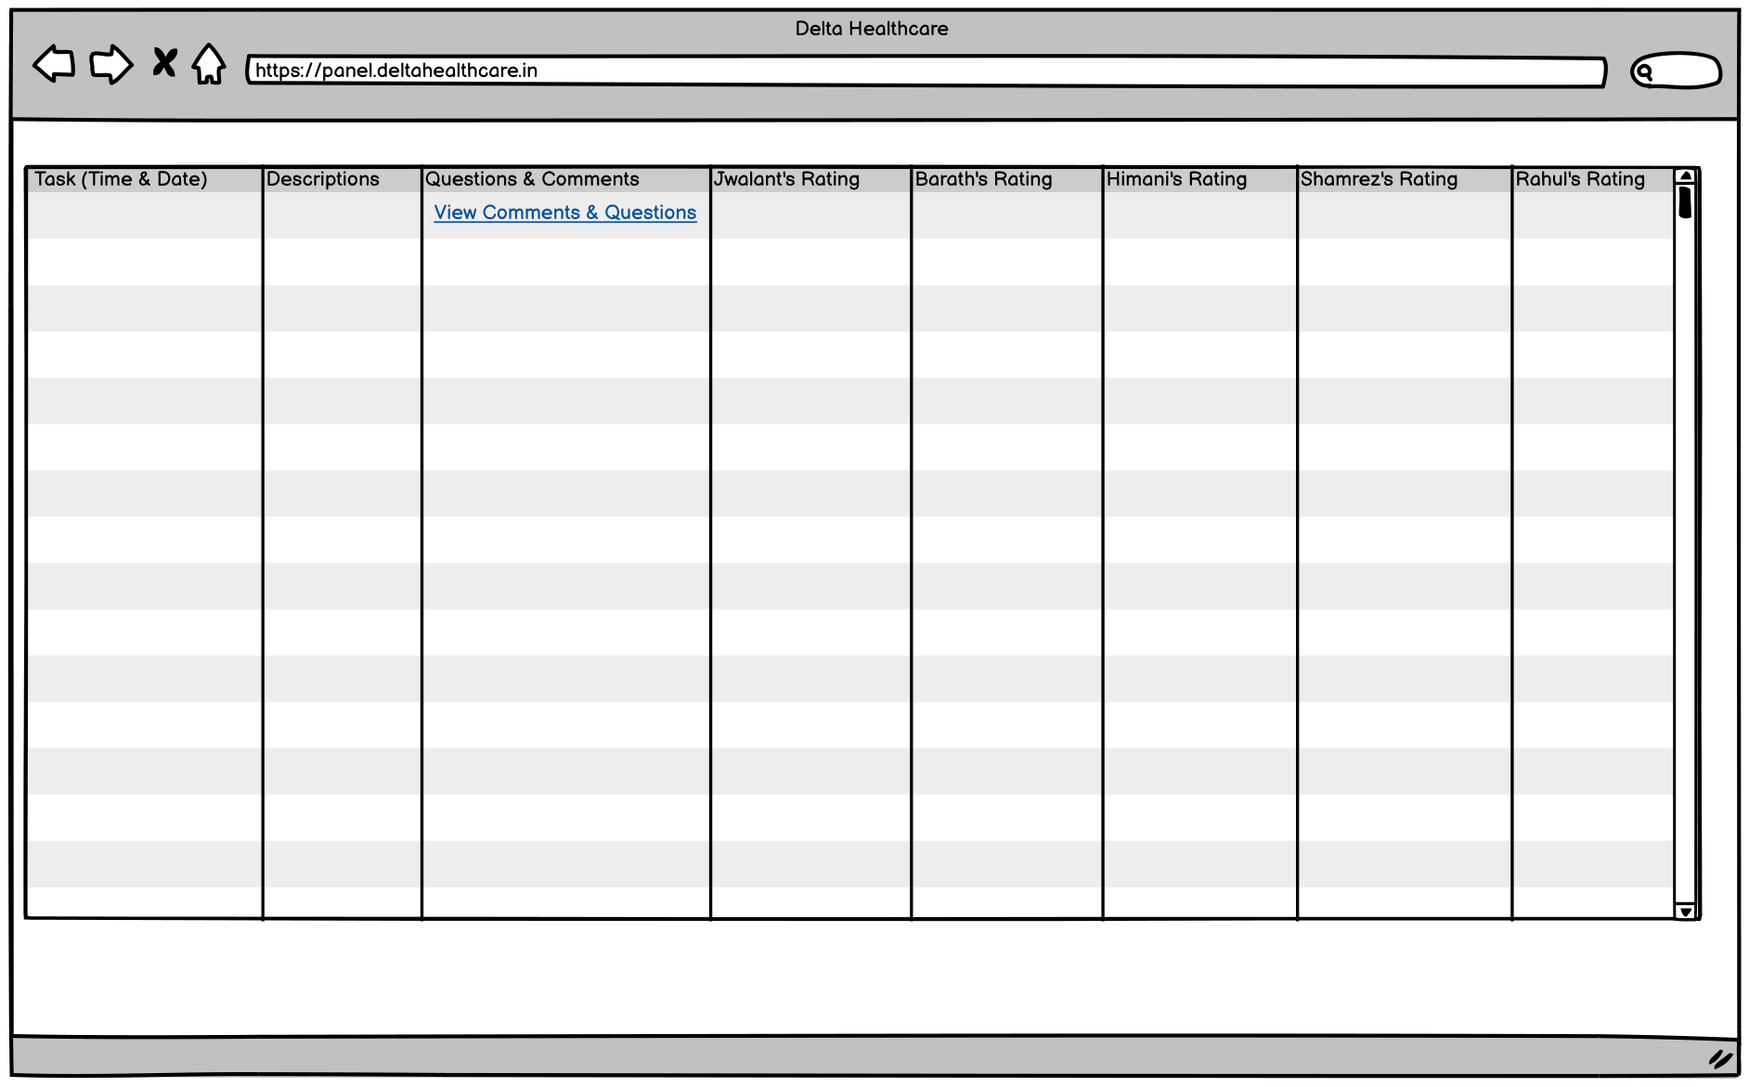

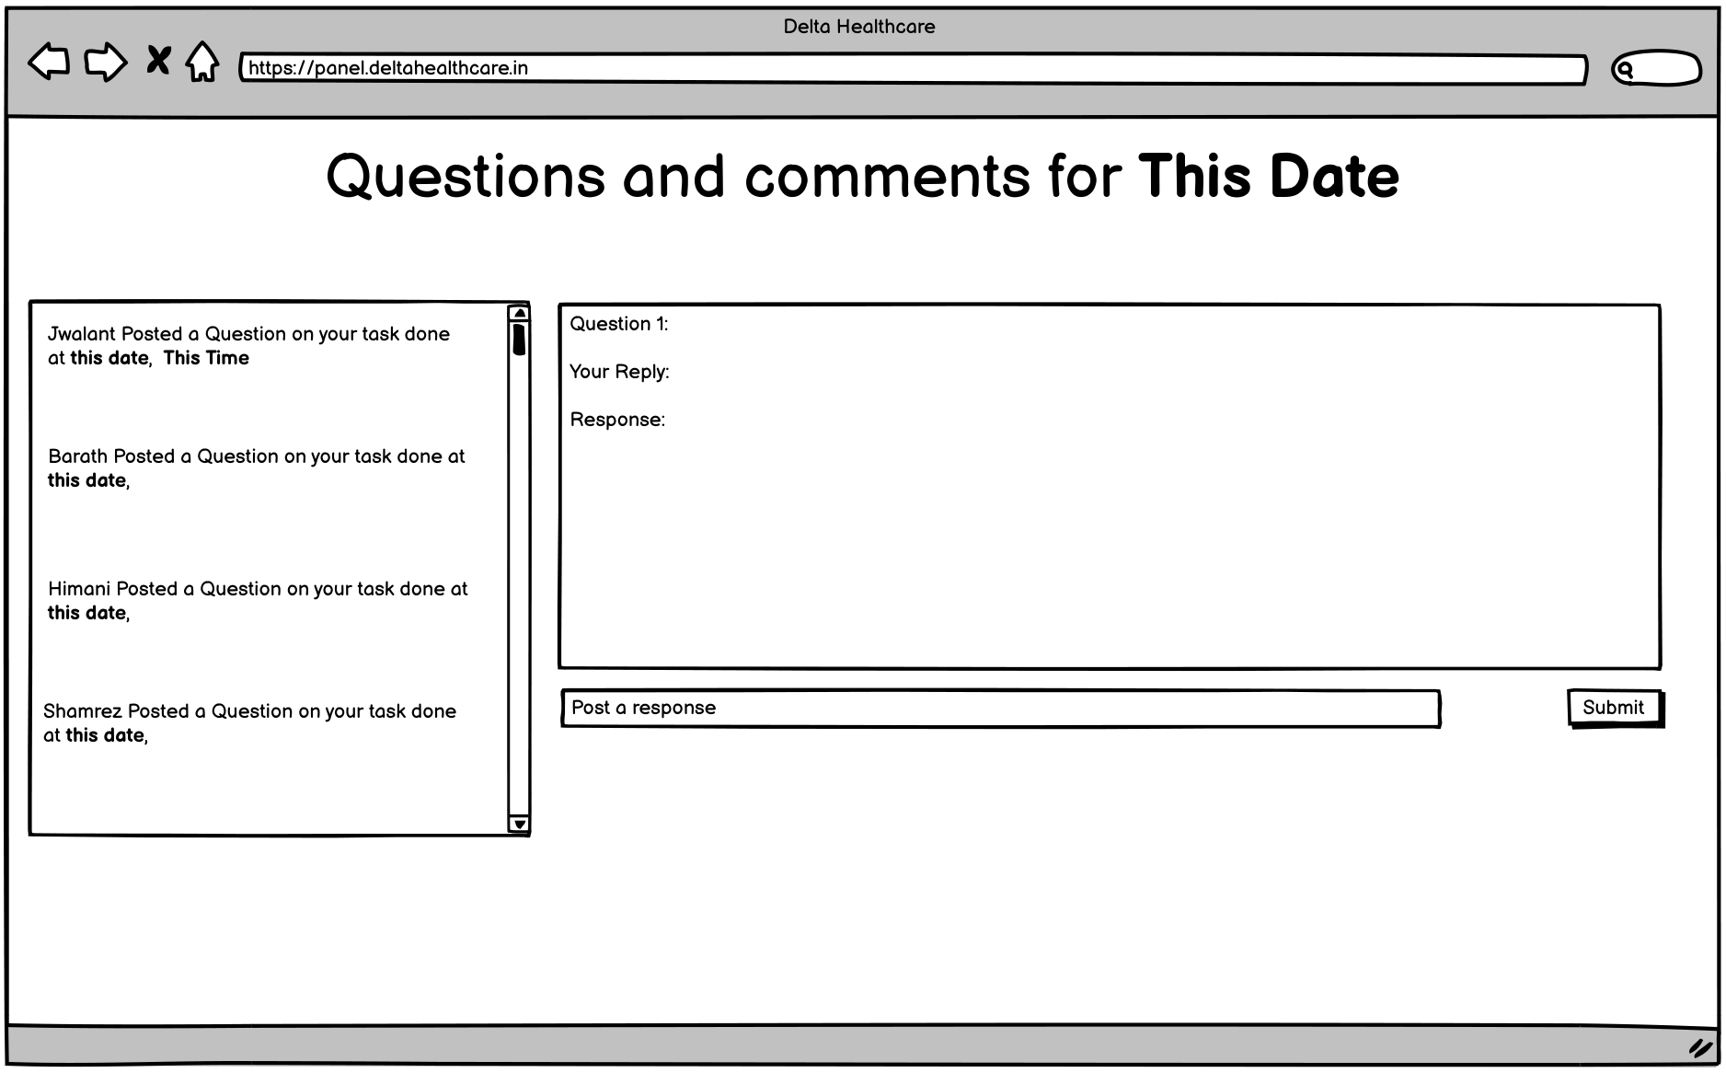
Expenses:
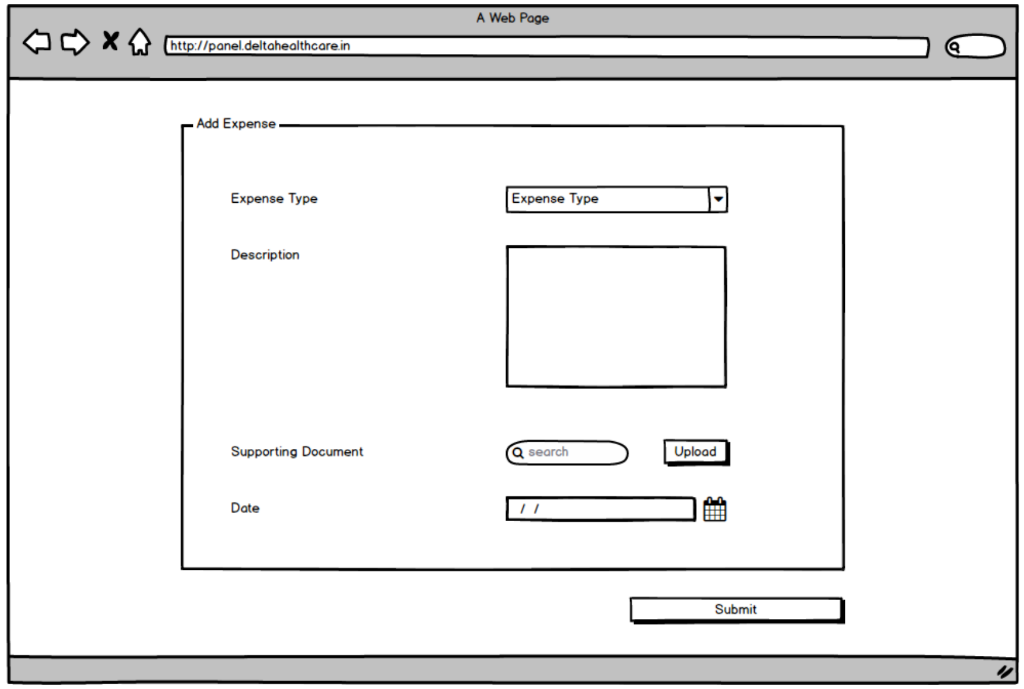
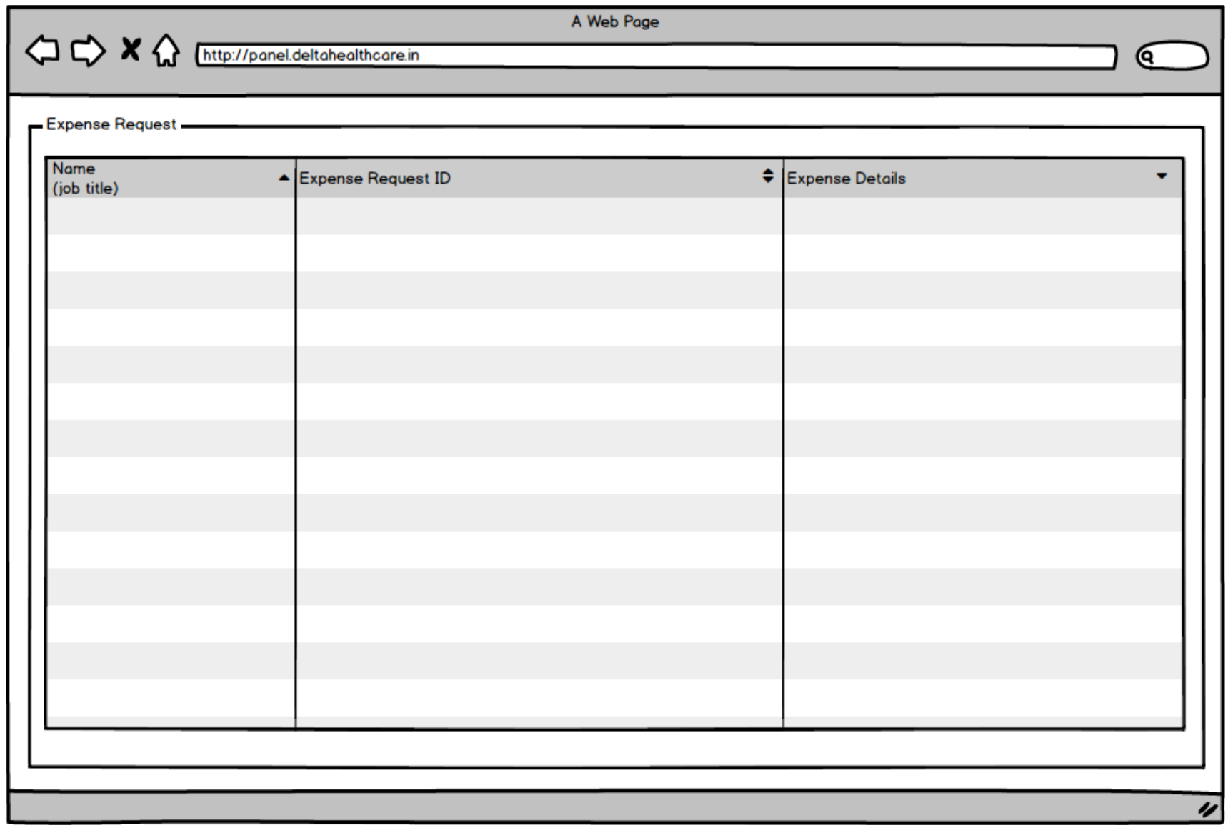
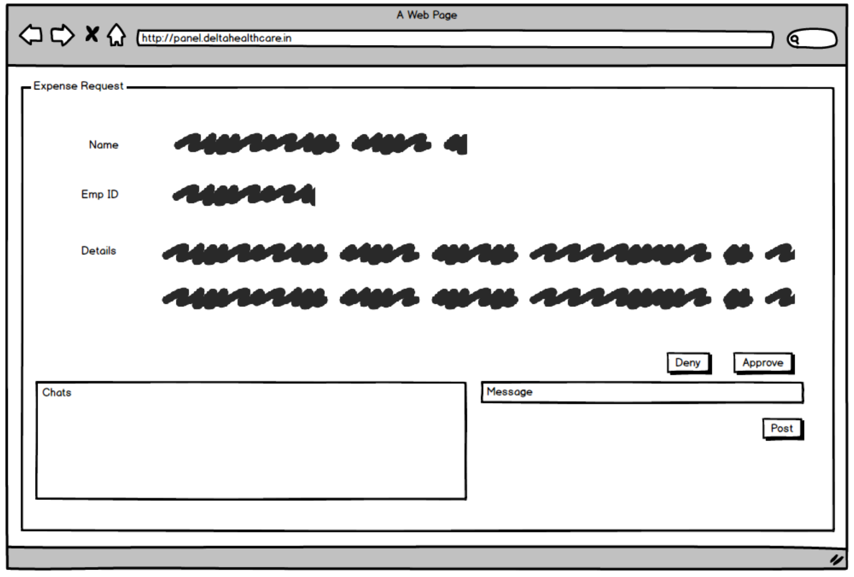

Leave Requests:
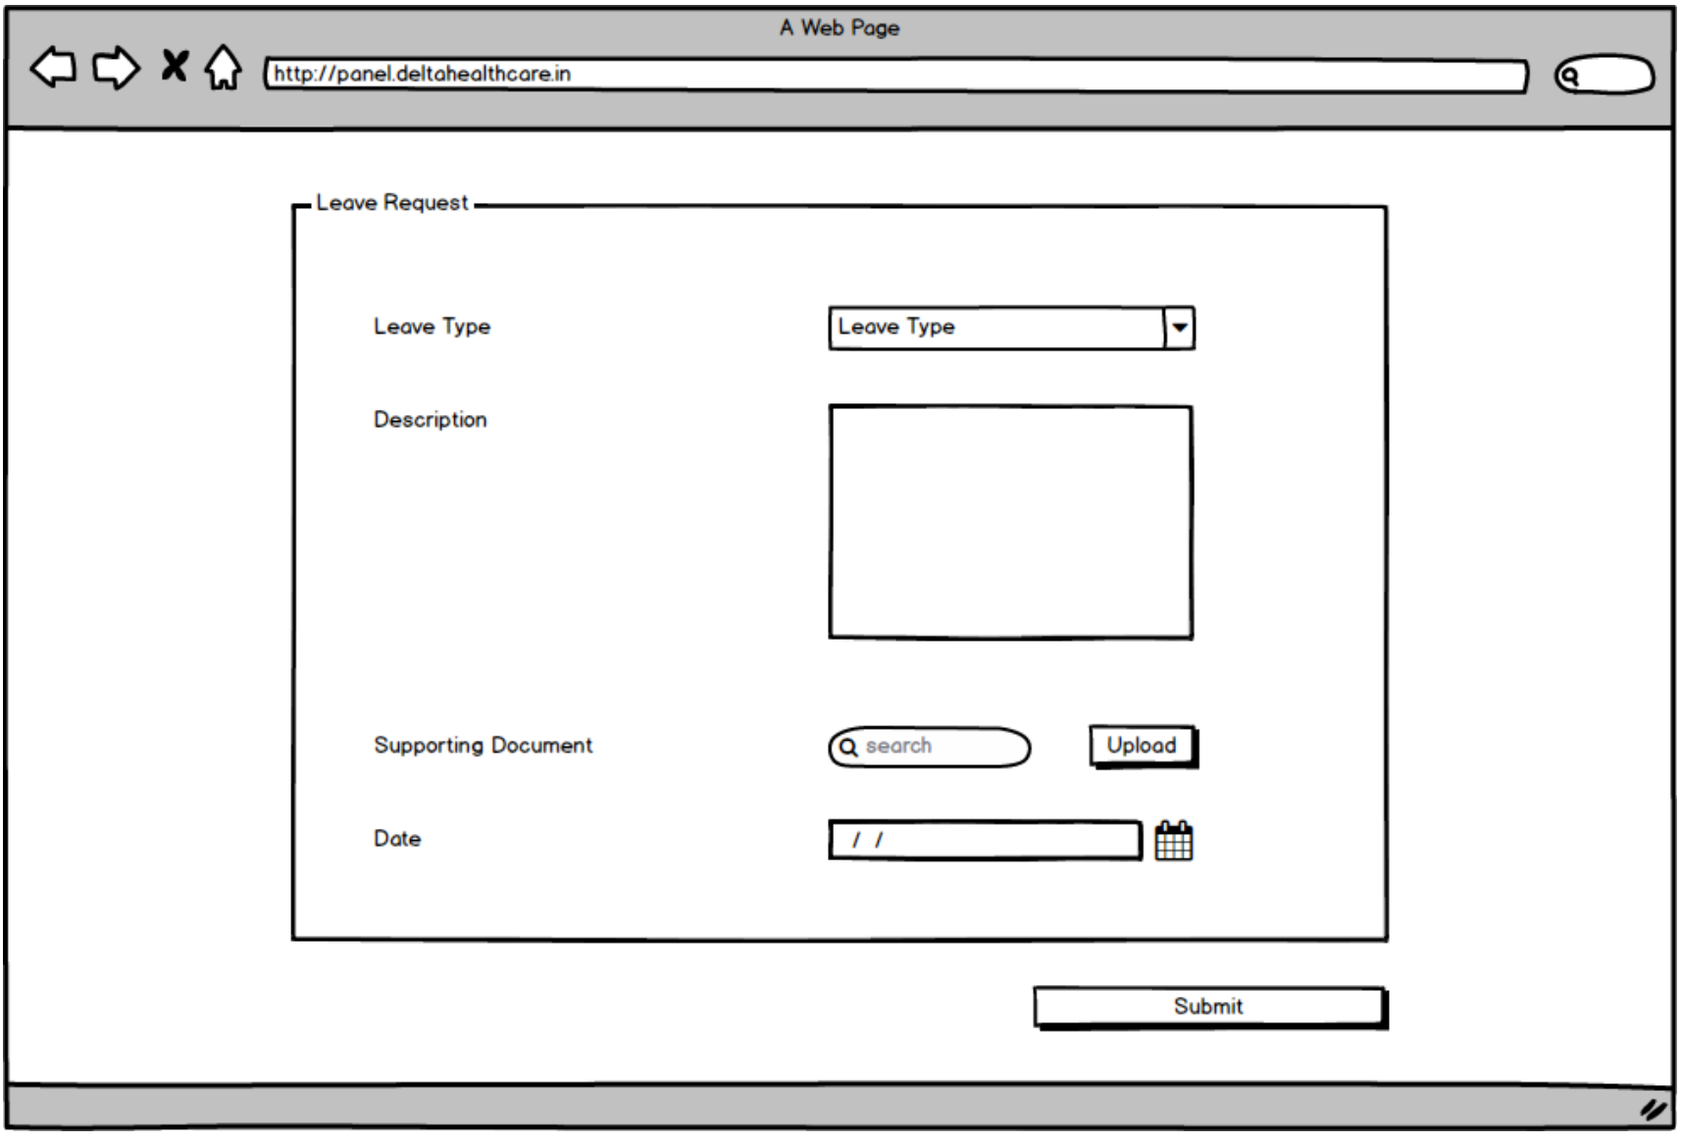
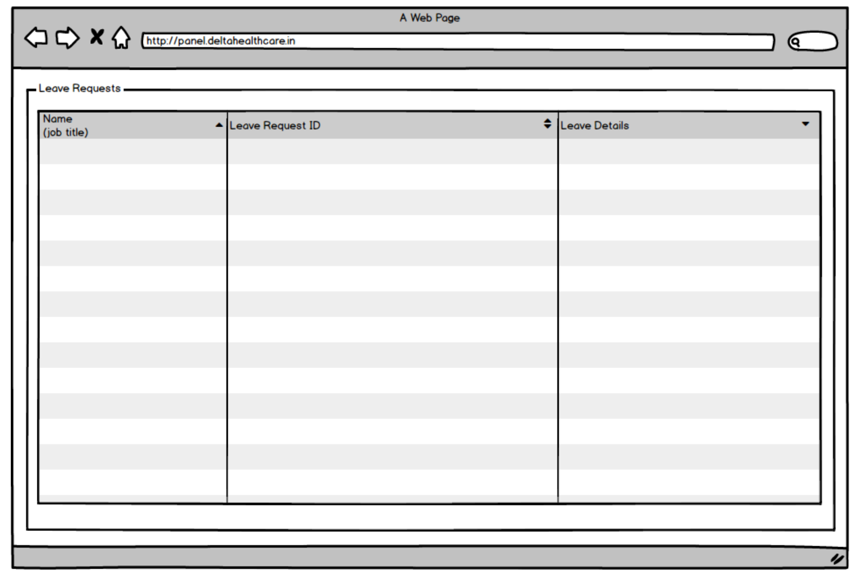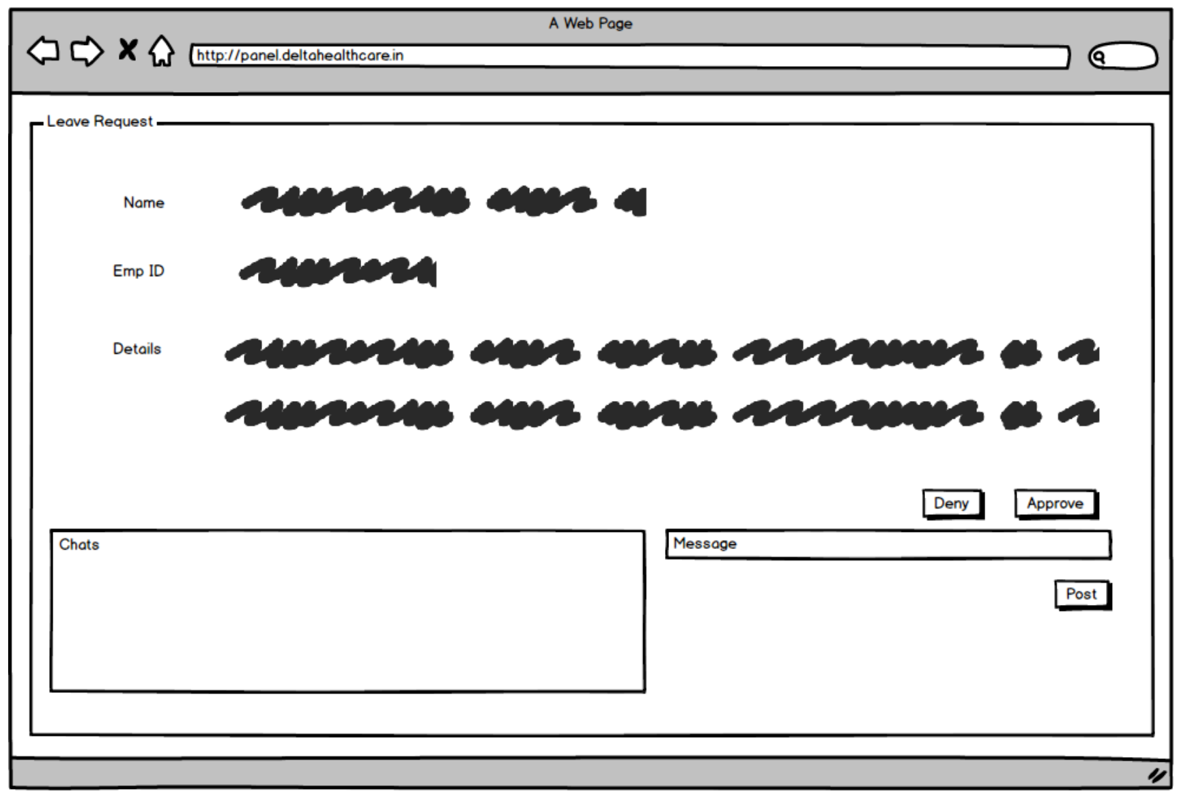

Meeting Logs:
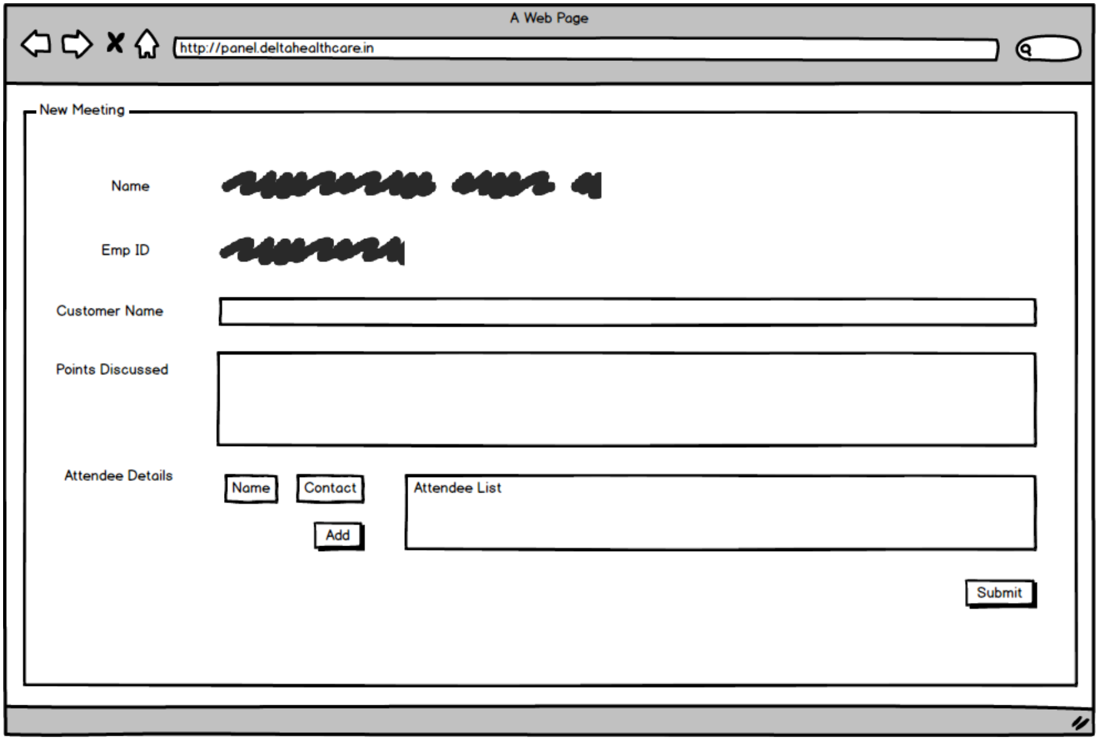
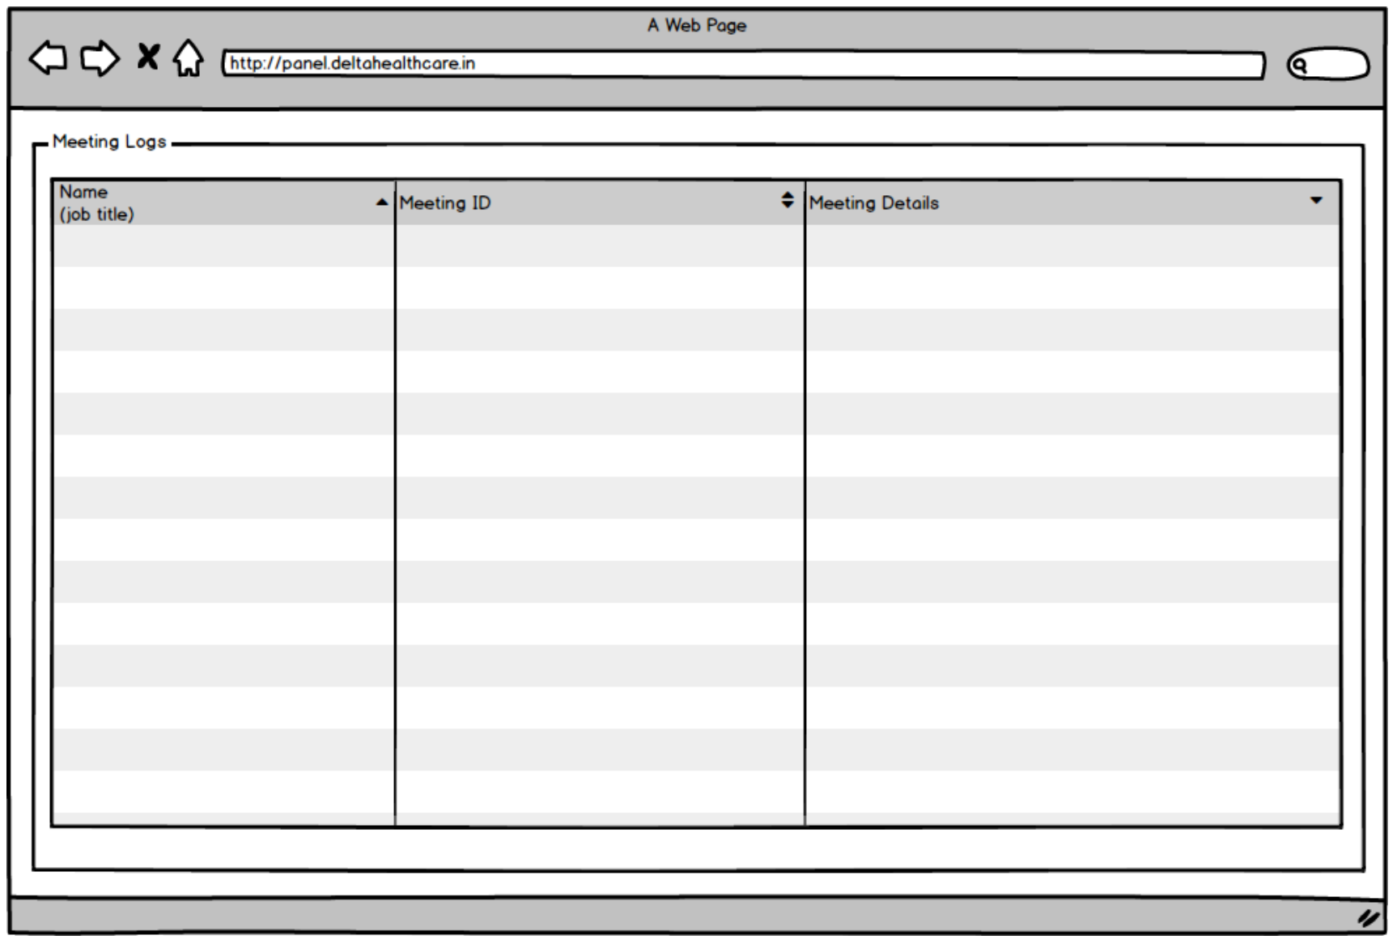
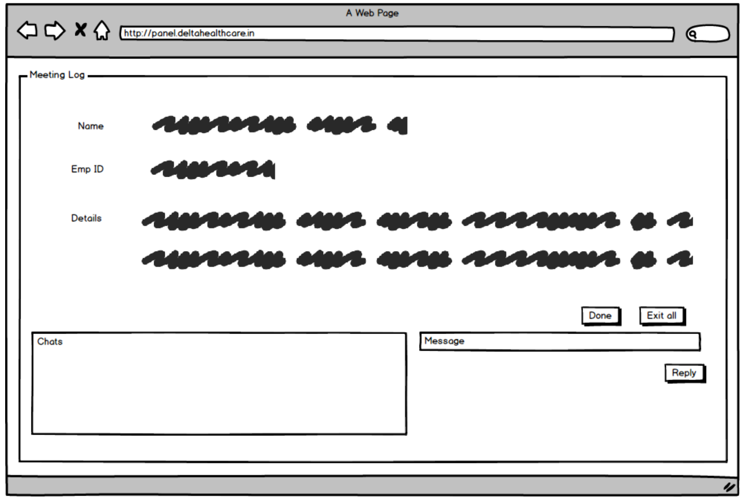

Document 8- Tools-Visio and Axure
During the course of the project, I had the opportunity to use both Microsoft Visio and Axure RP extensively for various stages of analysis and design. These tools played a vital role in the successful documentation and communication of business and system requirements. My experience with them not only enhanced the clarity and professionalism of the project deliverables but also deepened my understanding of visual modelling techniques and user experience prototyping.
Microsoft Visio was particularly helpful for creating process diagrams, use case diagrams, and activity diagrams. These diagrams served as visual representations of the business workflows, system functionality, and user interactions. I used Visio to design both the AS-IS and TO-BE process models, which helped clearly depict the changes expected from the new system. This visual clarity helped stakeholders understand complex processes easily and contributed significantly during review meetings. Visio’s drag-and-drop interface made it convenient to build diagrams quickly, while its integration with other Microsoft Office tools allowed easy inclusion of these visuals in documentation like the Business Requirements Document (BRD), use case specifications, and functional requirement documents. It helped ensure uniformity and professional quality across all documentation.
In addition to Visio, I used Axure RP to build interactive prototypes that simulated the actual system. Axure allowed me to create wireframes with interactive components such as drop-downs, buttons, and navigation links, which could be tested by users to validate functionality before any actual development began. This was especially helpful during the stakeholder review and validation phase, where demonstrating a working prototype helped bridge the gap between business needs and technical implementation. Axure also supported the development of user scenarios and task flows, providing a richer context for understanding how the end users would interact with the system. The feedback collected from users interacting with the Axure prototype helped refine the requirements and ensured that the final product would be more aligned with user expectations.
Overall, my experience using Visio and Axure in this project was highly productive and enriching. These tools not only improved the efficiency and accuracy of requirements gathering and design but also enhanced stakeholder engagement by providing visual and interactive means of communication. I feel more confident in using these tools for future business analysis projects and recognize their value in ensuring project success through clear documentation and stakeholder alignment.

Document 9- BA experience
My experience as BA in following phases:
Requirement gathering:
As a Business Analyst (BA), one of my core responsibilities during the project was to manage the requirement gathering phase with accuracy and attention to detail. To systematically gather and prioritize the client’s needs, we adopted the MoSCoW technique (Must have, Should have, Could have, and Won’t have). This prioritization framework helped us ensure that critical requirements were addressed early while still accounting for features that added value but were not immediately necessary. It provided a structured approach to conducting requirement elicitation sessions and became a valuable reference when negotiating features with stakeholders. However, the requirement gathering phase was not without challenges. One of the main hurdles I encountered was the intermittent unavailability of the client. During such periods, it was imperative to maintain project momentum. I took the initiative to identify and reach out to secondary stakeholders or point-of-contact representatives on the client’s side. These individuals were instrumental in providing insights into business workflows, operational constraints, and user needs. Through clear communication and timely follow-ups, I ensured that our requirement collection did not come to a standstill in the absence of the primary client.
After collecting the raw set of requirements, the next critical step was to validate and categorize them. For this, I employed the FURPS technique, which focuses on Functionality, Usability, Reliability, Performance, and Supportability. This validation framework helped me and the stakeholders evaluate whether the proposed requirements met technical and user-centric expectations. It also enabled us to identify areas that required further clarification or redesign, especially in terms of usability and performance expectations. During this validation process, I discovered a considerable number of duplicate or overlapping requirements, which could have led to redundancy and confusion during development. I made it a point to immediately cleanse the list by eliminating repeated entries, streamlining the requirements for clarity and consistency. This helped reduce ambiguity and ensured that developers would receive a clean and concise set of requirements.
To further refine and enhance the quality of the requirements, I introduced prototyping into our approach. By building simple wireframes or interactive mockups, we were able to demonstrate possible user interface layouts and workflows to the stakeholders. These prototypes acted as visual aids and helped clients understand what the final product might look and feel like. More importantly, they encouraged stakeholders to think through their needs more thoroughly and offer more specific and refined input, leading to stronger and more actionable requirements. This iterative feedback loop proved highly effective in narrowing down functional gaps and identifying hidden requirements early on.
Overall, my experience in the requirement gathering phase was both challenging and rewarding. Through structured prioritization, proactive communication, validation using FURPS, and prototyping, I was able to deliver a comprehensive, accurate, and validated set of requirements that formed a strong foundation for the rest of the project lifecycle.
Requirement Analysis:
As a Business Analyst (BA), my role in the requirement analysis phase was critical in translating business needs into structured and comprehensible formats that could guide the development process. One of the key activities involved was creating UML (Unified Modeling Language) diagrams, which served as a visual representation of the system’s functional and behavioural requirements. These diagrams helped bridge the communication gap between stakeholders and the technical team by providing a clear, standardized language to understand the system’s structure. Use case diagrams were particularly helpful in mapping the interactions between users and the system, while class diagrams defined the structure of the system’s data model. These visual models played a vital role in aligning the team’s understanding of the system and setting clear expectations.
In addition to UML diagrams, I used activity diagrams extensively to represent process flows and business workflows. These diagrams proved to be extremely useful when describing how various tasks and decisions flowed through the system. For instance, when outlining a complex business process like expense approvals or user registration, the activity diagrams visually captured the sequence of steps, decision points, and outcomes, enabling both technical and non-technical stakeholders to grasp the logic of the process easily. These diagrams also served as a reference during development and testing phases to ensure the logic was being implemented correctly.
One of the challenges I encountered during this phase was ensuring effective communication of the diagrams to the development and QA teams. While the diagrams were intended to bring clarity, there were instances where team members provided feedback or expressed concerns about the accuracy or feasibility of the flows. In such situations, I facilitated discussions, actively listened to their suggestions, and worked collaboratively to refine the diagrams. As a BA, it is important to remain open to feedback and maintain a flexible mindset. I ensured that all valid points were considered and incorporated into the updated diagrams to reflect a more accurate and feasible solution.
As part of formal documentation, I was also responsible for preparing the Business Requirement Specification (BRS) and Software Requirement Specification (SRS) documents. The BRS captured high-level business objectives and needs in a language understandable to stakeholders, while the SRS translated those business needs into detailed functional and non-functional specifications, serving as a blueprint for the technical team. These documents were meticulously reviewed and updated throughout the project to reflect any changes or refinements in scope. The SRS also included references to the diagrams created, helping to establish traceability between business requirements and technical implementation.
Overall, my experience in the requirement analysis phase strengthened my skills in visual modelling, communication, stakeholder management, and documentation. Creating and refining UML and activity diagrams, responding to team feedback, and delivering clear and structured requirement documents helped ensure that the project was grounded in a well-analysed and understood set of requirements, setting the stage for successful implementation.
Design:
During the design phase of the project, my role as a Business Analyst (BA) was pivotal in bridging the gap between the gathered requirements and the upcoming stages of development and testing. One of my primary responsibilities was to derive test cases from the use case diagrams we had previously created during the analysis phase. These test cases ensured that the functional requirements were thoroughly validated and that every possible user interaction was accounted for. Creating test cases at this stage also helped identify potential issues early, reducing the risk of major rework later in the development process.
As part of this responsibility, I focused on writing both positive and negative test cases. While positive test cases ensured that the system behaves as expected under normal conditions, negative test cases allowed us to verify how the system reacts to incorrect or unexpected inputs. This was crucial to building a robust application that handles real-world scenarios gracefully. I was meticulous in this task, recognizing that missing even a single test case could lead to undetected defects, which may severely impact the quality and stability of the final product. Hence, I followed a detailed and systematic approach to ensure complete coverage of all possible functional paths.
In addition to test case creation, I collaborated closely with the client to validate the design and solution documents. This communication ensured that the proposed design aligned with the client's expectations and business objectives. Regular walkthroughs and design reviews with the client enabled early feedback and timely adjustments, preventing costly changes during later stages. This interaction also helped in clarifying ambiguities in requirements, validating assumptions, and confirming that the solution design was technically feasible and functionally complete.
Another critical task during this phase was the preparation of test data. Properly curated test data is essential to simulate real-world use cases and validate system behavior accurately. I ensured that the test data covered edge cases and boundary values so that the system’s performance under various conditions could be evaluated comprehensively. This test data was shared with the testing and development teams for use in functional and integration testing.
One of the most important activities I undertook was the updating of the Requirements Traceability Matrix (RTM). The RTM helped track each requirement from the initial stages of the project through to design, development, and testing. It served as a checkpoint to ensure that no requirement was missed and that each was implemented, tested, and validated. Maintaining the RTM also supported quality assurance, regulatory compliance, and provided clarity during audits and status reporting.
In summary, my experience as a BA during the design phase involved detailed planning, coordination, and quality control. From translating use cases into test cases to communicating effectively with clients, preparing comprehensive test data, and updating the RTM, I played a central role in ensuring the project transitioned smoothly from design to development. This phase not only strengthened my analytical skills but also honed my attention to detail and reinforced the importance of comprehensive testing and documentation in project success.
Development:
During the development phase of the project, my role as a Business Analyst (BA) was to ensure seamless coordination between the technical team and the client. One of the key strategies I employed was organizing Joint Application Development (JAD) sessions. These sessions were critical in bringing together developers, testers, and business stakeholders to collaboratively understand the requirements, clarify technical concerns, and agree on development goals. The interactive nature of JAD sessions helped in accelerating decision-making and reducing the risk of miscommunication.
As development progressed, clarifying queries raised by the technical team became a routine part of my day. Developers often encountered ambiguity or sought confirmation on specific aspects of the requirement before proceeding with the code. I served as the single point of contact to resolve these issues promptly. My familiarity with the business objectives and the documented requirements helped in providing quick and accurate clarifications, keeping the project timelines on track.
However, not all discussions during JAD sessions went smoothly. There were instances where some team members disagreed with certain concepts or were hesitant to cooperate. In such cases, I took a calm and empathetic approach. I reached out to them individually to understand their concerns and explained how their actions could impact the overall progress of the project. By fostering open communication and mutual respect, I was able to resolve misunderstandings and establish a healthy and collaborative environment within the team. This effort went a long way in improving team dynamics and ensuring everyone was aligned toward common goals.
To aid developers in coding specific modules, I often referred to and explained the relevant diagrams like use case diagrams, sequence diagrams, and activity diagrams. These visual tools helped the team better understand the logic and flow of each unit, making it easier to translate requirements into code. By reinforcing the importance of aligning code with both functional and non-functional requirements, I contributed to the creation of a well-structured and efficient software product.
Another important responsibility during the development phase was to conduct regular meetings with the technical team and the client. These meetings ensured that progress was monitored, feedback was incorporated, and blockers were addressed promptly. However, coordinating such meetings came with its challenges—especially when some team members were unavailable due to different schedules or time zones. To manage this, I made sure to record the sessions and share the recordings with those who missed them. I also scheduled one-on-one follow-up discussions to ensure that no one was left out and that everyone was updated with the latest developments.
In conclusion, my experience as a BA in the development phase involved a combination of strategic facilitation, conflict resolution, technical support, and team coordination. From handling challenging interpersonal situations to making sure every member was on the same page, my goal was to maintain project momentum and foster a culture of collaboration. This phase not only deepened my understanding of the technical aspects of software development but also strengthened my skills in leadership and cross-functional communication.
Testing:
During the testing phase of the project, my role as a Business Analyst (BA) was pivotal in ensuring that the software met the expected business requirements and was ready for deployment. One of my primary responsibilities was to prepare detailed test cases based on the use case diagrams and functional requirements defined earlier. These test cases served as a foundation for both the internal testing processes and User Acceptance Testing (UAT). I ensured that all possible scenarios—positive and negative—were covered, leaving no room for ambiguity or assumption.
As the project progressed, I also performed high-level testing to verify the basic functionality and flow of the application. While the QA team conducted detailed testing, my role involved validating the system against business expectations. This high-level testing helped us identify major misalignments early, avoiding costly fixes at later stages. I collaborated closely with the testing team, cross-verifying results and ensuring that the application behaved as intended from a business user’s perspective.
Another crucial task was to request and collect test data from the client. In many cases, accurate and realistic test data was essential to simulate real-time scenarios. I coordinated with client-side stakeholders to gather this data while ensuring that privacy and confidentiality were maintained. This step was vital for running effective end-to-end testing and for mimicking real-world business operations.
In parallel, I consistently worked on updating the Requirements Traceability Matrix (RTM). This document helped us track each requirement from the BRS and SRS to the corresponding test cases, ensuring that no requirement was left untested. Keeping the RTM updated also made it easier to show compliance during audits and client reviews, reinforcing the transparency and accountability of our testing efforts.
Once the testing was complete and the application met the functional expectations, I initiated the client sign-off process. I presented the test results, discussed the coverage, and explained how all business requirements had been validated. Any issues identified during testing were clearly documented and addressed before seeking final approval. Taking this formal sign-off from the client marked the completion of the testing phase and a green signal for deployment preparation.
Before moving to the UAT phase, I took the initiative to prepare the client for UAT. I conducted walkthrough sessions to explain the application features, provided guidance on how to test the system, and shared the finalized set of UAT scenarios. I ensured that the client had the right test environment, access credentials, and documentation. This proactive approach helped the client conduct UAT confidently and efficiently, often resulting in faster approval and greater satisfaction.
In summary, my experience in the testing phase was all about ensuring end-to-end validation of requirements, maintaining traceability, and facilitating smooth coordination between QA and client teams. I brought structure, clarity, and business perspective into the testing process, making it an effective bridge between development and deployment. This phase further strengthened my ability to focus on details while keeping the bigger business picture in mind.
Deployment:
As a Business Analyst, my involvement in the deployment phase is crucial to ensuring a smooth transition of the project from development to production use. At this final yet vital stage, I take proactive steps to close the loop between the business stakeholders and the technical team, making sure every aspect of the deployment is clear, well-documented, and understood by the end users.
One of my key responsibilities is to forward the finalized Requirements Traceability Matrix (RTM) to the client, which serves as a critical attachment to the project closure document. The RTM provides a complete overview of how every requirement from the Business Requirements Specification (BRS) and Software Requirements Specification (SRS) has been addressed and validated through test cases. This document offers the client transparency and confidence that the solution delivered meets all agreed-upon expectations. It also serves as an audit trail for future reference.
In parallel, I actively coordinate the creation and delivery of end-user manuals. These documents are tailored to the client’s needs and the complexity of the application. I work closely with the development and QA teams to ensure the manuals are technically accurate, user-friendly, and aligned with the real-time functionalities of the product. These manuals are essential for helping the client’s internal teams adopt the solution seamlessly without constant support from the implementation team.
In addition to documentation, I take ownership of planning and organizing training sessions for the client’s end users. Understanding that effective training is key to user adoption, I prepare detailed agendas, presentation decks, and real-life scenarios to demonstrate system usage. The training sessions are designed to be interactive and solution-focused, ensuring participants not only understand how to use the application but also appreciate how it aligns with their day-to-day responsibilities.
One of the critical success factors in this phase is participation. I ensure that all relevant end users attend the training sessions by actively coordinating with the client’s project manager or department heads. I send invites well in advance, follow up with reminders, and even conduct multiple sessions if required to accommodate various teams and schedules. In cases where participants miss a session, I provide recordings or conduct one-on-one briefings to ensure that no one is left behind in understanding how to use the deployed solution.
Throughout the deployment phase, I maintain clear communication with all stakeholders, ensuring that any last-minute clarifications or change requests are addressed appropriately. I also ensure a smooth handover process by facilitating final feedback collection and identifying any small enhancements that may be considered in future updates or maintenance cycles.
In summary, my experience as a Business Analyst in the deployment phase revolves around completing documentation, enabling smooth user adoption, and driving training and communication efforts. This phase brings together all my efforts from earlier stages, and I take pride in ensuring that the transition from development to live use is organized, efficient, and well-supported by end users and stakeholders alike.

