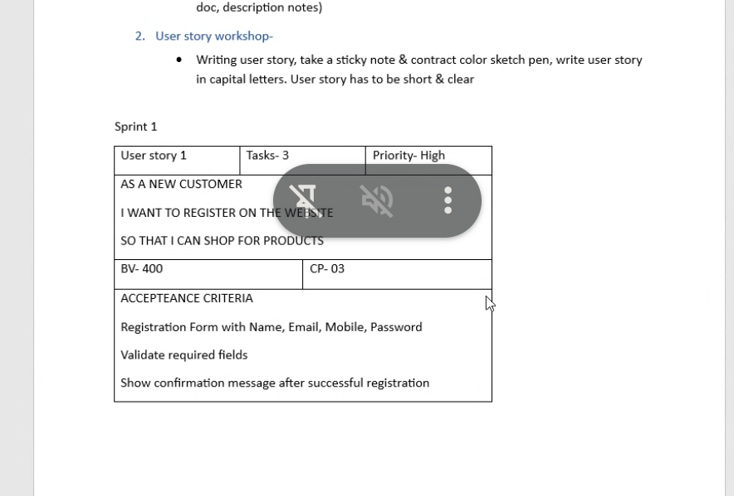
User Story- 01 | Task- 3 |  | Priority- High
As a farmer
I want to register an account
So that I can access product listings.
BV- 500 |  | CP- 02
Acceptance Criteria:
- Farmer should be able to register with name, email, mobile and password.
- Validate required fields.
- Show confirmation after successful registration.

User Story- 02 | Task- 3 |  | Priority- High
As a farmer
I want to log in using email and password
So that I can securely access my account.
BV- 500 |  | CP- 02
Acceptance Criteria:
- Login form with email and password.
- Validate the credentials.
- Redirect to dashboard.

User Story- 03 | Task- 2 |  | Priority- High
As a farmer
I want to browse fertilizer, seeds, pesticides
So that I can choose what I need
BV- 400 |  | CP- 01
Acceptance Criteria:
- The user clicks on the category.
- The system displays all available fertilizer, seeds, pesticides products.

User Story- 04 | Task- 2 |  | Priority- High
As a farmer
I want to search for seeds
So that I can quickly find the required products.
BV- 400 |  | CP- 01
Acceptance Criteria:
- The user types the product name in the search bar.
- The system filters and displays matching product.

User story- 05 | Task- 1 |  | Priority- High
As a farmer
I want to view product details
So that I can make informed decision
BV- 400 |  | CP- 01
Acceptance Criteria:
- The user clicks on a product.
- The system shows full details including name, price, and description.

User story- 06 | Task- 3 |  | Priority- High
As a farmer
I want to add products to the cart
So that I can review and buy them later
BV- 500 |  | CP- 02
Acceptance Criteria:
- The user clicks on “Add to cart” on a product.
- The system adds product to the users cart.
- The cart icon reflects updated item count.

User story- 07 | Task- 4 |  | Priority- Medium
As a farmer
I want to update the quantity in the cart
So that I can buy in the amount I need
BV- 400 |  | CP- 02
Acceptance Criteria:
- The user opens the cart.
- The user clicks on quantity input for an item.
- The user updates quantity.
- The system updates the total amount accordingly.

User story- 08 | Task- 03 |  | Priority- Medium
As a farmer
I want to delete items from cart
If I no longer want them
BV- 300 |  | CP- 01
Acceptance Criteria:
- The user opens the cart.
- The user clicks delete icon next to item.
- The system removes items from the list and refreshes cart view.

User story- 09 | Task- 04 |  | Priority- High
As a farmer
I want to proceed to checkout
So that I can place my order
BV- 500 |  | CP- 03
Acceptance Criteria:
- The user opens the cart.
- The user clicks on “Checkout”.
- The user enters delivery details.
- The system confirms and proceeds to payment.

User story- 10 | Task- 03 |  | Priority- High
As a farmer
I want to choose payment modes like COD, UPI, card
So I can pay easily.
BV- 500 |  | CP- 03
Acceptance Criteria:
- The user selects payment option (COD, UPI, Cards)
- The system processes selection.
- The system redirects to payment gateway or confirm COD.

User story- 11 | Task- 03 |  | Priority- High
As a farmer
I want to receive an order confirmation email
So that I know my order was place successfully
BV- 400 |  | CP- 02
Acceptance Criteria:
- The user completes payment or confirms COD.
- The system triggers confirmation email.
- The email includes Order ID, Items with details, Payment mode and delivery estimates.

User story- 12 | Task- 03 |  | Priority- High
As a farmer
I want to track my order
So that I can know the delivery status.
BV- 400 |  | CP- 03
Acceptance Criteria:
- The user goes to “My Orders”.
- The user clicks on the recent order.
- The system displays real-time delivery status with an estimated delivery date.

User story- 13 | Task- 02 |  | Priority- Medium
As a farmer
I want to view my past orders
So that I can reorder or track purchase history.
BV- 300 |  | CP- 02
Acceptance Criteria:
- The user navigates to “Order History”.
- The system fetches and display all complete and cancelled orders with details.

User story- 14 | Task- 03 |  | Priority- Medium
As a farmer
I want to save items to a wishlist to buy later
So that I can purchase them later.
BV- 300 |  | CP- 02
Acceptance Criteria:
- The user clicks “Add to Wishlist” on a product.
- The system adds items to the wishlist.
- The user can view or move items to cart anytime.

User story- 15 | Task- 03 |  | Priority- High
As a farmer
I want the platform to be available in the local language
So that I can use it more easily.
BV- 400 |  | CP- 04
Acceptance Criteria:
- The user selects the preferred language.
- The system loads interface in selected language.
- All content is translated correctly and consistently.

User Story- 16 | Task-03 |  | Priority- High
As a farmer
I want to register and log in
So that I can manage my products on the platform
BV- 500 |  | CP- 03
Acceptance Criteria:
- Manufacturer navigates to register/ login.
- Fills out details and credentials.
- The system confirms and grant access to product dashboard.
User Story- 17 | Task- 03 |  | Priority- High
As a manufacturer
I want to upload fertilizers, seeds or pesticides products with details
BV- 500 |  | CP- 04
Acceptance Criteria:
- Manufacturer clicks on “Add Product”.
- The user enters name, category, price, stock and description.
- The system validates and lists the product publicly.

User Story- 18 | Task-03 |  | Priority- Medium
As a manufacturer
I want to edit or delete products from list.
BV- 400 |  | CP- 03
Acceptance Criteria:
- The manufacturer accesses products list.
- The user clicks “Edit” or “Delete”.
- The systems updates or removes the product accordingly.

User Story- 19 | Task-03 |  | Priority- Medium
As a manufacturer
I want to view the sales reports
So that I can analyze my performance.
BV- 300 |  | CP- 04
Acceptance Criteria:
- Manufacturer opens “Report” section.
- The system displays sales by product/date.
- The option to download or filter the report.

User Story- 20 | Task-03 |  | Priority- High
As a farmer
I want the website to load quickly on low internet
So that I can access it from village.
BV- 400 |  | CP- 05
Acceptance Criteria:
- The platform is optimized for low bandwidth.
- The essential content loads under 3 sec.
- The images and script are compressed for performance

User Story- 21 | Task-03 |  | Priority- High
As a farmer
I want to filter products by price, category, or manufacturer
So I can narrow search
BV- 400 |  | CP- 03
Acceptance Criteria:
- The user opens the product page.
- Applies filter for price range, category or manufacturer.
- The system updates product list based on selected filters.

User Story- 22 | Task-04 |  | Priority- Medium
As a farmer
I want to rate and review products
So that I can share my feedback with others
BV- 300 |  | CP- 02
Acceptance Criteria:
- The user goes to purchase products.
- And clicks on “Add Review”.
- Submit rating and comments.
- The system posts and displays reviews publicly.

User Story- 23 | Task-04 |  | Priority- Low
As a manufacturer
I want to respond to product reviews
So that I can engage with customers
BV- 200 |  | CP- 03
Acceptance Criteria:
- The manufacturer accesses product reviews.
- Click “Reply” under a review.
- Posts a response.
- The system displays it under the original comment.

User Story- 24 | Task-03 |  | Priority- Medium
As a farmer
I want to view top rated products
So that I can buy trusted items.
BV- 300 |  | CP- 02
Acceptance Criteria:
- The user selects “Top Rated” filter.
- The system sorts and displays products by average rating.
- The ratings and number of reviews are visible on each product.

User Story- 25 | Task-04 |  | Priority- High
As an admin
I want to manage users
So that I can maintain platform security.
BV- 400 |  | CP- 03
Acceptance Criteria:
- The admin logs into the dashboard.
- This views user list with roles.
- The user can activate, deactivate or delete users.
- The system confirms changes and logs activity.

User Story- 26 | Task-04 |  | Priority- High
As an admin
I want to approve or reject new manufacturer registration
So that only verified users are onboarded.
BV- 400 |  | CP- 03
Acceptance Criteria:
- The admin receives notification for new registration.
- The admin views submitted documents.
- The admin clicks “Approve” or “Reject”.
- The system updates the account status.

User Story- 27 | Task-03 |  | Priority- High
As a farmer
I want to get SMS alerts for my order status
So I stay informed even without internet.
BV- 400 |  | CP- 04
Acceptance Criteria:
- The user provides mobile number.
- The system sends SMS for order placed, shipped and delivered events.
- Messages are timely and accurate.

User Story- 28 | Task-03 |  | Priority- Medium
As a manufacturer
I want to receive low stock alerts
So that I can restock products on time
BV- 300 |  | CP- 03
Acceptance Criteria:
- The system checks product inventory.
- If quantity < threshold, system sends email/SMS notification.
- The user restocks through dashboard.

User Story- 29 | Task-04 |  | Priority- High
As a farmer
I want to cancel an order before it is shipped
So I have control over my purchase.
BV- 400 |  | CP- 03
Acceptance Criteria:
- The user goes to “My Orders”.
- Clicks on a pending order.
- Clicks “Cancel”.
- The system confirms cancellation and updates status.

User Story- 30 | Task-04 |  | Priority- High
As a farmer
I want to securely login
So that my personal data is protected.
BV- 500 |  | CP- 02
Acceptance Criteria:
- The system requires email & password for login.
- Password stored with encryption.
- Account lockout after 3 failed attempts.
- Two-factor authentication optional.

User Story- 31 | Task-04 |  | Priority- High
As an admin
I want to manage product categories
So that the platform remains organized and searchable.
BV- 400 |  | CP- 02
Acceptance Criteria:
- The admin logs into the dashboard.
- Opens “Manage Categories”.
- Can add, edit or delete categories.
- Changes reflect immediately in catalog filter options.

User Story- 32 | Task-03 |  | Priority- High
As a manufacturer
I want to receive notification of new order
So that I can process them quickly.
BV- 500 |  | CP- 02
Acceptance Criteria:
- The system detects new orders for manufacturers products.
- Email/SMS/app notification is sent.
- Notification includes product, quantity and buyer info.

User Story- 33 | Task-04 |  | Priority- Medium
As a farmer
I want to reorder products from my past order
So that I can easily restock regularly used items.
BV- 400 |  | CP- 03
Acceptance Criteria:
- The user opens order history.
- Clicks “Reorder” on a past order.
- The system adds items to the cart.
- The user proceeds to payment and confirms order.

User Story- 34 | Task-04 |  | Priority- High
As a tester
I want to verify all payment options work correctly
So that the farmer has a smooth checkout process.
BV- 500 |  | CP- 04
Acceptance Criteria:
- The tester logs into test account.
- Makes test purchases using COD, UPI and Card.
- Validates transaction status and backend entry.
- Reports issues.

User Story- 35 | Task-04 |  | Priority- Medium
As a project manager
I want to generate progress reports
So that I can update stakeholders regularly.
BV- 300 |  | CP- 03
Acceptance Criteria:
- The PM logs into project dashboard.
- Opens “Reports”.
- Selects date range.
- The system generates downloadable reports showing tasks, blockers and progress.

User Story- 36 | Task-04 |  | Priority- High
As a farmer
I want to contact customer support easily
So that I can resolve any issues with orders or payments.
BV- 500 |  | CP- 02
Acceptance Criteria:
- The farmer accesses “Help & Support” section.
- Selects issue category.
- Fills form or uses live chat.
- Receives a response or ticket confirmation.

User Story- 37 | Task-03 |  | Priority- Medium
As a tester
I want to test delivery tracking
So that farmers can see accurate shipment status.
BV- 400 |  | CP- 03
Acceptance Criteria:
- The tester places a test order
- Simulates shipping stages
- Confirms that status updates are reflected in user dashboard.

User Story- 38 | Task-04 |  | Priority- High
As a network admin
I want the system to be protected from DDoS attack
So that service remains available.
BV- 400 |  | CP- 05
Acceptance Criteria:
- Configure firewall and anti-DDoS settings.
- Simulate high traffic scenario.
- The system remains stable and logs malicious requests.
- Alerts are generated.

User Story- 39 | Task-04 |  | Priority- Medium
As a developer
I want version control to be implemented
So we can track code changes and collaborate smoothly.
BV- 300 |  | CP- 02
Acceptance Criteria:
- Set up Git repository.
- Developers commit changes with messages.
- Pull requests are reviewed and merged.
- Branching strategy is documented.

User Story- 40 | Task-04 |  | Priority- High
As a farmer
I want the app to work offline for browsing saved items
So I can use it in low network areas
BV- 500 |  | CP- 05
Acceptance Criteria:
- The user saves products to device.
- Turns off internet.
- Opens app and accesses saved products.
- The system sync once connection is restored.

