Waterfall Project Part 1 - BA Implementation - Business Case, Diagrams, BRD, FS.

Document 1 – Business Case Document
1. Why is this project initiated?
The Renewable Energy Grid Integration project has been initiated as a strategic response to the increasing global demand for sustainable energy solutions. As climate change accelerates and natural resource depletion becomes a pressing issue, it is imperative to transition from non-renewable to renewable energy sources such as solar and wind.
Currently, the existing power grid infrastructure is heavily reliant on fossil fuels and lacks the flexibility and intelligence required to integrate renewable sources efficiently. This project aims to fill that gap by designing and implementing a structured and scalable integration plan for renewable energy. In doing so, the initiative aligns with national and international zero-emission goals, contributes to energy security, reduces carbon footprint, and sets the groundwork for a greener future.

2. What are the current problems?
The existing energy infrastructure faces multiple challenges in adopting renewable energy sources. These include:
- Fragmented Infrastructure: The current grid systems are designed around centralized fossil-fuel power plants and are not equipped to manage the decentralized nature of renewable generation, making integration complex and inefficient.
- Resource Utilization Inefficiencies: Due to the unpredictable nature of solar and wind output, energy often goes underutilized or is lost, leading to wastage and operational instability.
- Limited Monitoring and Adaptability: Real-time data analytics and smart grid technologies are either missing or insufficient, making it difficult to adapt dynamically to power flow variations.
- Incompatibility with Renewable Sources: Traditional grids cannot manage the fluctuating voltage and frequency levels produced by renewables, which can result in grid failures or shutdowns.

3. With this project how many problems could be solved?
This project has the potential to address and resolve the aforementioned challenges through a comprehensive integration and modernization effort:
- Infrastructure Upgrade: By modernizing grid components and adding storage systems, the infrastructure will become capable of handling renewable input.
- Enhanced Grid Stability: With advanced monitoring tools and analytics, grid operators will have better control, reducing chances of overloads or blackouts.
- Reduced Energy Wastage: Energy management systems will optimize power usage and minimize losses from surplus generation.
- Regulatory and Sustainability Compliance: By aligning with environmental standards and clean energy mandates, the project supports compliance while promoting corporate social responsibility.

4. What are the resources required?
To execute the project successfully, a combination of human, technical, and strategic resources will be essential:
- Human Resources:
  - Project Manager: Oversees the project execution, scope, and timelines.
  - Renewable Energy Specialists: Provide domain expertise on solar and wind integration.
  - IT Infrastructure Experts: Implement backend systems, monitoring tools, and ensure data integrity.
- Technological Resources:
  - Energy Storage Systems: For balancing load and storing excess energy.
  - Grid Monitoring Tools: Software platforms for real-time data analytics and decision-making.
  - Simulation Tools: To forecast performance and assess integration risks.
- External Inputs:
  - Vendor Support: Solar panel, wind turbine, and storage device suppliers.
  - Third-party Evaluations: To ensure compliance and technical validation.
  - Site Visits and Regulatory Guidelines: Insights from successful global implementations and legal benchmarks.

5. How much organizational change is required to adopt this technology?
The implementation of this project will necessitate moderate organizational transformation, including:
- Skill Development and Training: Operational staff and technicians will need to be trained in managing the new systems, understanding energy analytics, and using digital platforms.
- Process Reengineering: Existing energy management processes must be redefined to support decentralized power generation and intelligent distribution.
- Workflow Adaptation: Teams across departments will need to align with new procedures for performance tracking, issue resolution, and regulatory reporting.
- Change Management Strategy: Stakeholder engagement and internal communication plans will play a critical role in ensuring smooth adoption.

6. Time frame to recover ROI
Based on current market trends and expected operational efficiencies, the project is estimated to recover its investment within 2 to 3 years post-deployment. Contributing factors include:
- Cost savings from reduced fossil fuel usage
- Government subsidies and incentives for green energy projects
- Improved system reliability and reduced downtime costs
- Increased organizational reputation leading to future green investments

7. How to identify stakeholders?
Stakeholders will be identified through a structured selection process involving a cross-functional selection committee. This committee will ensure that all relevant perspectives—technical, regulatory, operational, and strategic—are represented. Key stakeholder groups include:
- Technical Teams: Grid engineers, data analysts, and IT personnel involved in integration and maintenance.
- Business Stakeholders: Business analysts, finance teams, and sustainability officers who define and track business outcomes.
- Regulatory Authorities and Policymakers: Entities involved in compliance, energy standards, and legal clearances.
- Vendors and Partners: Third-party suppliers and service providers responsible for delivering hardware, software, and support.

Document 2 – BA Strategy

1. Project Overview
The Renewable Energy Grid Integration project is a strategic initiative focused on integrating sustainable energy sources—specifically solar and wind power—into the existing electrical grid. This project supports the transition toward clean energy and aligns with international zero-emission mandates and national strategies like India’s National Electricity Plan 2023.
The Waterfall model has been selected as the delivery framework due to the project's structured nature, regulatory compliance requirements, and the need for clear phase-wise progression. By adopting this model, the project aims to address inefficiencies in current grid systems, minimize energy wastage, and ensure seamless integration, monitoring, and performance optimization of renewable sources into the traditional grid.
The project also emphasizes grid stability, energy efficiency, and stakeholder training, making it a model of sustainability and digital transformation within the energy sector.

2. Role of Business Analyst in This Project
As the central bridge between stakeholders, technical teams, and project leadership, the Business Analyst (BA) plays a pivotal role in the success of this initiative. Key responsibilities include:
- Requirement Gathering:
Engage with engineers, environmental specialists, government bodies, and end users through interviews, surveys, and workshops to elicit detailed functional and non-functional requirements.
- Documentation:
Prepare and manage critical deliverables such as the Business Requirement Document (BRD), Functional Requirement Document (FRD), Non-Functional Requirement Document (NFRD), and Requirement Traceability Matrix (RTM)—all synchronized with each phase of the Waterfall lifecycle.
- Gap Analysis:
Conduct detailed studies on the current (AS-IS) infrastructure to identify incompatibilities and technological deficiencies with respect to renewable energy systems, followed by formulation of TO-BE models.
- Stakeholder Communication:
Facilitate seamless and transparent communication between all parties involved—ensuring clarity in expectations, scope, and changes throughout the project lifecycle.
- Support for UAT and Sign-Off:
Collaborate with Quality Assurance teams to design test cases and coordinate User Acceptance Testing (UAT), ensuring final deliverables are aligned with business goals and regulatory standards.
- Regulatory and Compliance Alignment:
Act as a liaison with legal and compliance stakeholders to ensure all energy integration processes meet environmental standards and government policies.

3. BA Activities by Phase (Waterfall Approach)
Phase | Business Analyst Activities
Requirement Analysis | - Conduct stakeholder workshops and interviews  - Define high-level system goals and key performance indicators (KPIs)  - Document business case, scope, and success metrics
Design | - Collaborate with architects to model renewable integration  - Participate in feasibility studies and performance simulations  - Define solution blueprint
Implementation | - Track development progress against requirements  - Participate in sprint reviews (if hybrid practices are used for subsystem builds)  - Conduct training needs analysis
Verification/Testing | - Develop UAT scripts and coordinate test execution  - Facilitate defect triaging and root cause analysis  - Validate test coverage through RTM
Deployment | - Review final implementation and validate against requirements  - Prepare training content and support go-live readiness  - Coordinate with support teams
Maintenance | - Monitor system effectiveness via stakeholder feedback  - Track enhancement requests  - Evaluate KPIs and propose optimization improvements

4. Tools and Techniques Used
Tools
- MS Visio: For process modeling and infrastructure diagrams
- MS Excel: For traceability matrix, risk logs, and stakeholder mapping
- MS Project / Gantt Tools: For timeline and dependency tracking
- Simulation Tools: For load testing and performance forecasting (e.g., GridSim, Homer Pro)

Techniques
- SWOT Analysis: To identify strengths, weaknesses, opportunities, and threats in current systems
- MoSCoW Prioritization: To categorize requirements into Must, Should, Could, and Won’t have
- Use Case Modeling: To map system-user interactions for monitoring, reporting, and control
- RACI Matrix: To clearly define roles and responsibilities during requirement gathering and sign-off
- Stakeholder Analysis: To evaluate influence, impact, and engagement strategies for each stakeholder group
- Gap Analysis: To document current vs. future capabilities, ensuring solution alignment

5. Key Deliverables
The following are critical documents and artifacts that the Business Analyst will be responsible for producing and maintaining throughout the project:
- Business Case Document: Justification, problem statement, and ROI forecast
- BRD (Business Requirement Document): Captures all business needs and expectations
- FRD (Functional Requirement Document): Detailed specs for each system functionality
- NFRD (Non-Functional Requirement Document): Covers system performance, security, availability, etc.
- Requirement Traceability Matrix (RTM): Ensures all requirements are mapped and validated across design and testing
- Stakeholder Analysis Report: Categorization and influence/interest mapping
- UAT Plan and Summary: Test scenarios, validation outcomes, and sign-off record
- Change Request Logs & Feedback Reports: Maintained during post-deployment and maintenance phases

***************************************

Document 3 – Functional Specifications
Project Name: Renewable Energy Grid Integration
Customer Name: National Energy Authority
Project Version: 1.0
Project Sponsor: Nilansh Kohli
Project Manager: George Adam
Project Initiation Date: 01-Mar-2025

Functional Requirement Specifications

Req ID | Req Name | Req Description | Priority
FR0001 | Login | System users (engineers, operators) must be able to securely log in to the monitoring and control portal. | High
FR0002 | Renewable Source Integration | Accept real-time energy input from solar and wind sources with compatibility and synchronization checks. | High
FR0003 | Energy Flow Monitoring Dashboard | Display real-time data on energy generation, consumption, and storage levels. | High
FR0004 | Simulation Interface | Allow users to simulate grid scenarios for load balancing and performance forecasting. | Medium
FR0005 | Alert System | Send instant alerts for anomalies such as voltage spikes, system faults, and grid instability. | High
FR0006 | Data Reporting | Generate scheduled and on-demand reports on energy metrics, downtime, and efficiency KPIs. | Medium
FR0007 | Vendor Access Control | Enable controlled, role-based access for third-party vendors and service providers. | Low
FR0008 | User Training Module | Provide integrated user training guides, tutorials, and e-learning materials for system onboarding. | Low
FR0009 | Energy Storage Management | Monitor and control battery storage levels, charge/discharge cycles, and performance status. | High
FR0010 | Grid Load Balancer | Automatically balance power loads between renewable and traditional sources to avoid grid overload. | High
FR0011 | Historical Data Analysis | Store and visualize historical energy production and usage trends for planning and audits. | Medium
FR0012 | Role-Based Access Control | Ensure different levels of system access based on user roles (e.g., admin, technician, auditor). | High
FR0013 | Maintenance Scheduling Module | Schedule regular maintenance activities and alert teams for upcoming service intervals. | Medium
FR0014 | Mobile Access Capability | Provide secure access to dashboards and alerts via mobile devices for on-field technicians. | Medium
FR0015 | Environmental Impact Tracking | Track and report carbon savings and emissions offset based on renewable energy contribution. | Medium
FR0016 | Compliance and Audit Logs | Maintain logs for all system actions and events for compliance with regulatory authorities. | High
FR0017 | Real-Time Weather Integration | Integrate weather APIs to forecast renewable energy availability (e.g., sunlight, wind speed). | Medium
FR0018 | System Health Dashboard | Provide a graphical dashboard for system uptime, equipment status, and failure indicators. | High
FR0019 | Load Forecasting Engine | Predict energy demand using AI/ML algorithms based on historical usage and environmental factors. | Medium
FR0020 | Emergency Power Rerouting | Enable auto-rerouting of power in case of failure or overload to ensure uninterrupted supply. | High

*********************************

Document 4 – Requirement Traceability Matrix
Project Name: Renewable Energy Grid Integration
Customer Name: National Energy Authority
Project Version: 1.0
Project Sponsor: Nilansh Kohli
Project Manager: George Adam
Project Initiation Date: 04-Mar-2025

Requirement Traceability Matrix:
Req ID | Req Name | Req Description | Design | D1 | T1 | D2 | T2 | UAT
FR0001 | Login | System users must securely log in to the monitoring and control portal. | Yes | Pending | No | Yes | Yes | Yes
FR0002 | Renewable Source Integration | Accept real-time energy input from solar and wind sources. | Yes | Yes | Yes | Yes | Yes | Yes
FR0003 | Energy Flow Monitoring | Display real-time data on generation, consumption, and storage. | Yes | Yes | Yes | Yes | Yes | Yes
FR0004 | Simulation Interface | Allow scenario simulation for grid balancing and forecasting. | Yes | Yes | No | Yes | No | Yes
FR0005 | Alert System | Send alerts for anomalies like voltage spikes and instability. | Yes | Yes | Yes | Yes | Yes | Yes
FR0006 | Data Reporting | Generate scheduled/on-demand energy metric reports. | Yes | Pending | No | Yes | Yes | Yes
FR0007 | Vendor Access Control | Enable role-based access for third-party vendors. | Yes | Yes | Yes | No | No | Yes
FR0008 | User Training Module | Provide training guides and e-learning materials. | Yes | No | No | Yes | No | Yes
FR0009 | Energy Storage Management | Monitor and control battery storage and performance. | Yes | Yes | Yes | Yes | Yes | Yes
FR0010 | Grid Load Balancer | Balance loads between renewable and traditional sources. | Yes | Yes | Yes | Yes | Yes | Yes
FR0011 | Historical Data Analysis | Store and visualize energy trends for planning and audits. | Yes | Yes | Yes | No | No | Yes
FR0012 | Role-Based Access Control | Ensure access control based on user roles. | Yes | Yes | Yes | Yes | Yes | Yes
FR0013 | Maintenance Scheduling | Schedule maintenance and alert for service intervals. | Yes | Yes | No | Yes | Yes | Yes
FR0014 | Mobile Access Capability | Secure mobile access to dashboards and alerts. | Yes | No | No | Yes | Yes | Yes
FR0015 | Environmental Impact Tracking | Track and report carbon savings and emissions offset. | Yes | Yes | No | Yes | Yes | Yes
FR0016 | Compliance and Audit Logs | Maintain logs for system actions for regulatory compliance. | Yes | Yes | Yes | Yes | Yes | Yes
FR0017 | Real-Time Weather Integration | Forecast renewable availability using weather APIs. | Yes | Yes | No | Yes | No | Yes
FR0018 | System Health Dashboard | Dashboard for uptime, equipment status, and failure indicators. | Yes | Yes | Yes | Yes | Yes | Yes
FR0019 | Load Forecasting Engine | Predict energy demand using AI/ML algorithms. | Yes | Yes | No | Yes | Yes | Yes
FR0020 | Emergency Power Rerouting | Auto-reroute power during failures to maintain supply. | Yes | Yes | Yes | Yes | Yes | Yes

Document 5: Business Requirements Document (BRD)

Project Name: Renewable Energy Grid Integration
Project ID: REI-2025-01
Version ID: v1.0
Author: Nilansh Kohli

- Document Revisions
Date | Version Number | Document Changes
05/03/2025 | 0.1 | Initial Draft Created

- Approvals

Role | Name | Title | Signature | Date
Project Sponsor | Nilansh Kohli | Energy Strategy Lead |  | 05/03/2025
Project Manager | George Adam | Technical PM |  | 05/03/2025
System Architect | TBD
Development Lead | TBD
UX Lead | TBD
QA Lead | TBD

3. RACI Chart

Name | Position | R | A | S | C | I
Business Analyst | You | X |  | X
Project Manager | George Adam |  | X |  | X | X
Sponsor | Nilansh Kohli |  |  |  |  | X
IT Architect | TBD |  |  | X
QA Lead | TBD |  |  |  | X

4. Introduction
4.1 Business Goals
The primary business goal of this project is to transition from conventional fossil-fuel-dependent energy systems to a sustainable, scalable, and intelligent grid infrastructure. By enabling the integration of renewable sources such as solar and wind energy, the project aims to support national zero-emission targets, reduce operational costs, improve energy efficiency, and ensure long-term energy security.
4.2 Business Objectives
- Ensure smooth integration of renewable sources with the existing grid.
- Enhance grid reliability and reduce downtime through real-time system monitoring.
- Enable predictive capabilities through simulation and load forecasting tools.
- Develop user-centric training tools to assist in technology adoption.
- Improve decision-making with comprehensive energy analytics and reporting.
4.3 Business Rules
- All incoming energy from renewable sources must be logged with timestamps and source identification.
- Alerts for system faults or anomalies must be triggered within 60 seconds.
- Data must be stored in compliance with national data protection and energy reporting regulations.
- Only authenticated users are allowed access based on defined user roles.
4.4 Background
India’s current power grid infrastructure, while extensive, is optimized for centralized, fossil-fuel-based energy generation. The emergence of decentralized renewable sources, combined with regulatory pressure and environmental commitments, has highlighted critical limitations in the current system. These include instability, poor visibility, lack of real-time data, and inefficient energy routing.
This project seeks to modernize the infrastructure and introduce an intelligent control layer, enabling full-scale integration of renewables as envisioned in India's National Electricity Plan 2023.
4.5 Project Objective
To design and implement an integrated, scalable solution that facilitates the seamless flow of renewable energy into the national power grid, supported by advanced simulation, reporting, and real-time monitoring capabilities.
4.6 Project Scope
4.6.1 In Scope Functionality
- Integration of solar and wind energy inputs into the main power grid.
- Deployment of real-time dashboards for system performance monitoring.
- Role-based access and secure login system for various user categories.
- Alert systems for performance anomalies, overloads, and hardware malfunctions.
- Simulation engine for load forecasting and grid stress-testing.
- Centralized data reporting and visualization modules.
- Environmental impact tracking and regulatory compliance reporting.
- Maintenance scheduling and historical data tracking modules.
4.6.2 Out of Scope Functionality
- Integration of hydroelectric and bio-energy sources (may be considered in future phases).
- Development of mobile apps (only web-based access planned).
- Smart appliance integration and residential-level energy tracking.
- International regulatory compliance (current focus is on national/state-level policies).

5. Assumptions
- Solar and wind generation units are already operational at the pilot locations.
- Regulatory approvals and site access will be secured before infrastructure installation.
- Training sessions will be scheduled and attended by designated users.
- Third-party vendors will meet delivery and service level expectations.
- Data will be stored and managed on secure infrastructure (on-prem/cloud hybrid).

6. Constraints
- Project budget is capped at $3 million, with fixed allocations for hardware, software, and training.
- The total timeline for execution is 9 months, divided as:
- 3 months for planning and requirement gathering
- 4 months for design and implementation
- 2 months for testing, deployment, and handover
- Dependency on third-party vendors for hardware and software components.
- Compliance with environmental and grid regulations must be maintained throughout.

7. Risks
Category | Risk | Mitigation Strategy
Technological | Integration could result in voltage imbalance | Use of smart inverters and real-time sensors
Skills | Lack of trained personnel | Intensive training and certification programs
Political | Policy changes may affect implementation | Stakeholder engagement and fallback strategies
Business | ROI may be delayed post-deployment | Showcasing long-term environmental and cost benefits
Requirements | Misalignment of features with operator needs | Detailed requirement workshops and UAT validation
Operational | Vendor delivery delays or quality issues | Vendor SLAs and backup vendor contracts

8. Business Process Overview
8.1 Legacy System (AS-IS)
The current grid relies on centralized, non-renewable power sources with minimal automation. It lacks predictive monitoring, real-time dashboards, and the flexibility to accommodate variable energy from solar or wind. Maintenance is reactive, often leading to increased downtime and energy wastage.
Legacy Power Grid Operation (AS-IS):

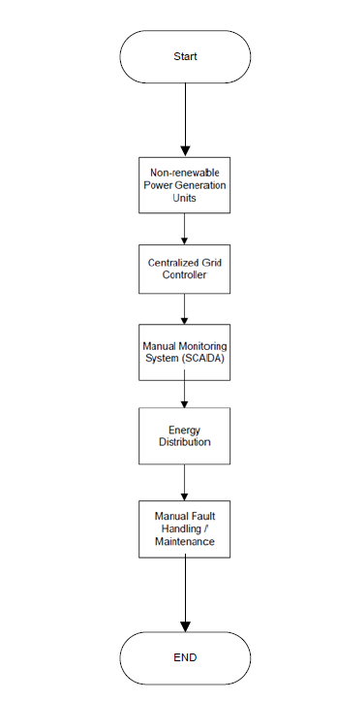

8.2 Proposed System (TO-BE)
The proposed system will act as a smart grid extension—able to ingest, route, and balance power from renewable sources in real time. It will feature dynamic dashboards, live grid analytics, automated alerting, and simulation tools. This transition is expected to reduce dependency on fossil fuels, improve load balancing, and support environmental objectives.

Smart Renewable Grid Operation (TO-BE):

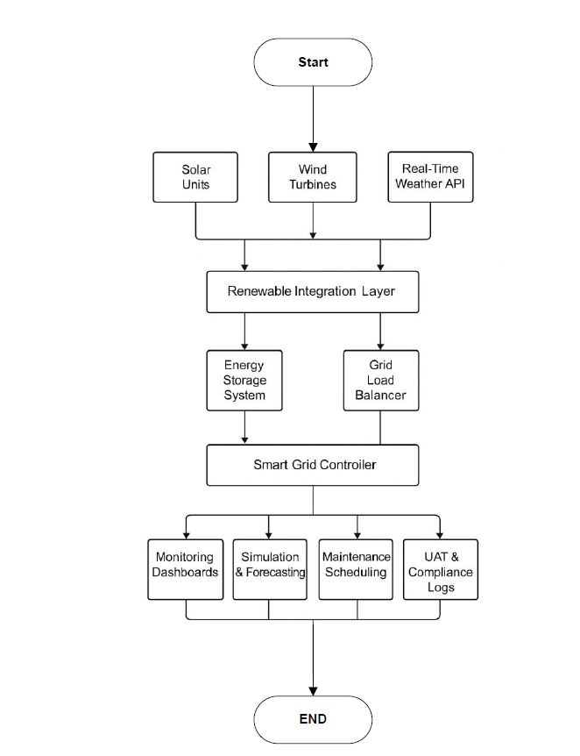

9. Business Requirements

ID | Description | Priority
BR001 | Integrate solar and wind inputs into the grid | High
BR002 | Display real-time data via dashboard | High
BR003 | Enable alerts for performance and safety anomalies | High
BR004 | Generate performance, usage, and compliance reports | Medium
BR005 | Provide secure login and vendor access controls | Medium
BR006 | Offer user training and learning modules | Low
BR007 | Include simulation engine for grid performance forecasting | Medium
BR008 | Track and report carbon savings from renewable contribution | Medium
BR009 | Support maintenance scheduling with automated alerts | Low
BR010 | Enable load forecasting with historical data and AI models | Medium

10. Appendices
10.1 List of Acronyms
- REI – Renewable Energy Integration
- UAT – User Acceptance Testing
- BRD – Business Requirements Document
- RTM – Requirement Traceability Matrix
- FRD – Functional Requirement Document
10.2 Glossary of Terms
- Grid Stability: The ability of the grid to handle generation variability and ensure uninterrupted power.
- Simulation: A digital model used to predict the behavior and performance of grid systems under various scenarios.
- Smart Grid: An electricity supply network that uses digital communications technology to detect and react to local changes in usage.
10.3 Related Documents
- National Electricity Plan 2023
- Project Charter
- RTM and FRD Documents
- Regulatory Guidelines for Renewable Energy Integration

