COEPD – Prep Exam 3 –Part 1/2

18 Questions - 100 Marks – Pass 60%

Instructions to follow:
- Copy paste (either image, diagram or text) is not entertained. If done, the document will not be evaluated.
- After submission of the answers of this prep exam, you should be prepared to attend viva and justify your answers in the prep exams. If in Viva, participant is NOT justifying the answers, Viva will be repeated until Candidates justify 60% correctness.
- Mentor calls are scheduled only if the participant have submitted their task at least for one time.
(should apply their knowledge in this task first)
- For attempting prep exams participant should be thorough on the topics using their references.
- Please format the document properly (Always have a question no., question and answer).
- Have a consistent format (Font name: Arial/ Calibri -Font size 12, Font Color: Black).
- Few Questions are related to the case study, check Questions thoroughly before you answer.
- Answers should be elaborated in detail (not as per the allotted marks).
- Please focus on learning and applying the knowledge as this knowledge will be helpful in contributing at your BA job.
- In the evaluation, students must answer all questions and should be able to justify at least 60% content and correctness of each answer.
Case Study 1 (Q1-Q6 → 24 Marks)
A customer can make a payment either by Card or by Wallet or by Cash or by Net banking. Q1. Draw a Use Case Diagram - 4 Marks
Q2. Derive Boundary Classes, Controller classes, Entity Classes. - 4 Marks Q3. Place these classes on a three tier Architecture. - 4 Marks
Q4. Explain Domain Model for Customer making payment through Net Banking - 4 Marks Q5. Draw a sequence diagram for payment done by Customer Net Banking - 4 Marks
Q6. Explain Conceptual Model for this Case - 4 Marks

Q7. What is MVC architecture? Explain MVC rules to derive classes from use case diagram and guidelines to place classes in 3-tier architecture - 8 Marks
Q8. Explain BA contributions in project (Waterfall Model – all Stages) – 8 Marks
Q9. What is conflict management? Explain using Thomas – Kilmann technique – 6 Marks Q10. List down the reasons for project failure – 6 Marks
Q11. List the Challenges faced in projects for BA – 6 Marks Q12. Write about Document Naming Standards – 4 Marks
Q13. What are the Do’s and Don’ts of a Business analyst – 6 Marks
Q14. Write the difference between packages and sub-systems – 4 Marks Q15. What is camel-casing and explain where it will be used- 6 Marks
Q16. Illustrate Development server and what are the accesses does business analyst has? -6

Marks
Q17. What is Data Mapping 6 Marks
Q18. What is API. Explain how you would use API integration in the case of your application Date format is dd-mm-yyyy and it is accepting some data from Other Application from US whose Date Format is mm-dd-yyyy 10 Marks

Case Study 1 (Q1-Q6 → 24 Marks)
A customer can make a payment either by Card or by Wallet or by Cash or by Net banking.
Q1. Draw a Use Case Diagram - 4 Marks

Q2. Derive Boundary Classes, Controller classes, Entity Classes. - 4 Marks

Ans:

Boundary classes | Payment option Boundary  CardPaymentBoundary  CashPaymentBoundary  Net Banking Payment Boundary
Controller classes | Payment initiated Controller  CardPayment Controller  Net Banking Payment Controller
Entity classes | Customer  Payment  Card  Wallet  Server

Q3. Place these classes on a three tier Architecture. - 4 Marks

Ans

User Layer
Payment Method Selection Boundary
Card Payment Boundary
Wallet Payment Boundary
CashPaymentBoundary
Net banking Payment Boundary
Business Logic
Payment Controller
Card Payment Controller
Wallet Payment Controller
Net banking Payment Controller
Data Tier
Customer (Entity Class)
Payment (Entity Class)
Card (Entity Class)
Wallet (Entity Class)
Bank Account (Entity Class)

Q4: Explain Domain Model for Customer making payment through Net Banking. - 4 Marks

Ans

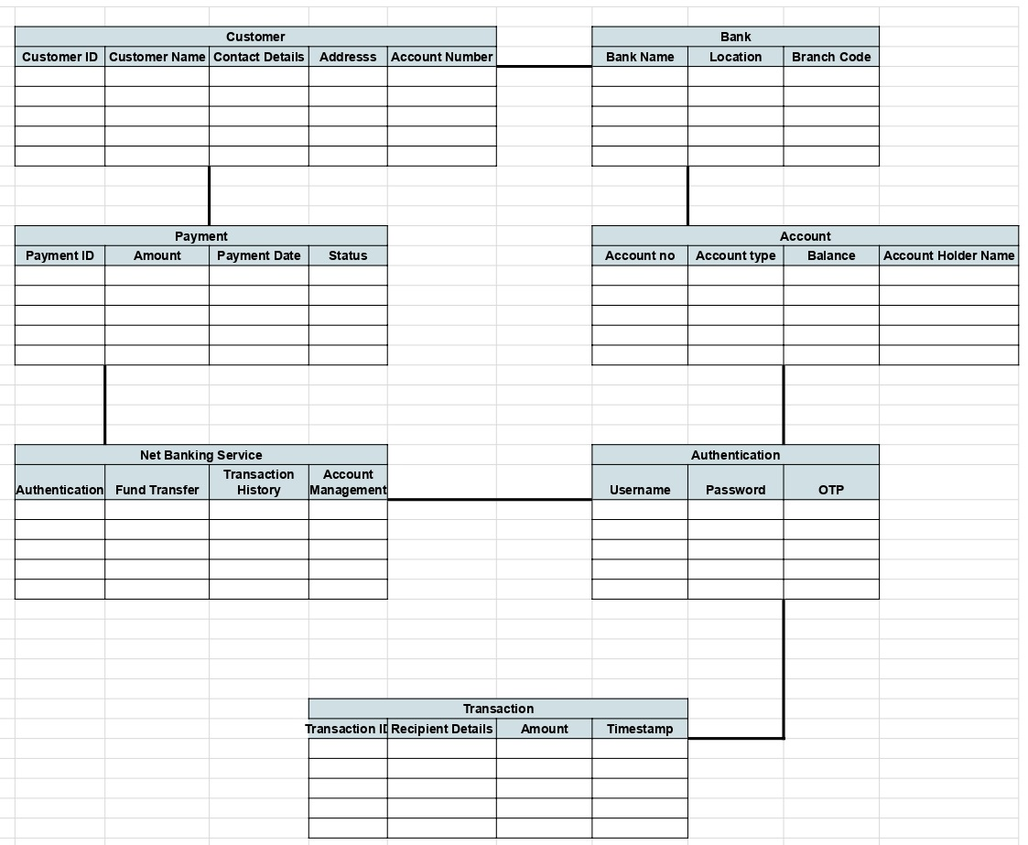

Domain model
A domain model is a conceptual representation of the entities, relationships, and behavior within a specific area of knowledge, often referred to as a domain. It's a blueprint that helps understand and model the real world within a software system.

Q5. Draw a sequence diagram for payment done by Customer Net Banking - 4 Marks

Ans
This diagram shows how the objects in the system interact and communicate with each other with time to achieve specific task.
Developer will draw this.
It is used to show the flow of messages, events or actions between the objects of the system.
This diagram helps to visualize the behaviour of the system.
This diagram shows the process in detail.

6. Explain the Conceptual Model for this Case. - 4 Marks

Ans: A conceptual model for the payment process done by a customer using net banking provides a high-level understanding of the key concepts and their relationship involved in the payment transaction. It helps in visualizing the overall structure and flow of the payment process.

Q7. What is MVC architecture? Explain MVC rules to derive classes from use case diagram and guidelines to place classes in 3-tier architecture - 8 Marks

Ans: MVC is a design pattern where, the application is divided into 3 logical parts- model view and controller
Each of these parts will have specific responsibility

Model-
The Model represents the data and the business logic of the application,
Model is responsible for multiple tasks like managing the application's data, performing data validation, implementing business rules, and handling data access operations.
Model does not depend on how the data is presented or how the user interacts with the application
The model class is known about all the data that is needed to be displayed.
This layer corresponds to the data-related logic that the user works with.
It represents the data that is being transferred between View and Controller.
It can add or retrieve the data from the database.
It responds to the controller’s request because the controller cannot interact with database by
itself.
The model interacts with the database and give the requested data.
All the model classes are nothing but the entities.
Model classes are represented as entity class.
View-
The View is responsible for presenting the data to the user
for handling the user interface.
The View can be a web page, a desktop application , or any other form of user interface.
It receives input from the user and passes it to the Controller for processing.
It represents the presentation of the application.
View refers to the model
It takes the data from the Model and renders it in a way that is suitable for the user's display or interaction.
For rendering the data, it uses query method.
View does not depend upon application logic.
View class are represented as boundary class.
Controller-
The Controller acts as an intermediary between the Model and the View.
It receives input from the user (via the View), processes the input by invoking the appropriate methods in the Model, and then updates the View with the new data or state.
The Controller handles user interactions, interprets user input, and translates it into instructions for the Model or the View.
It coordinates the flow of data between the Model and the View, ensuring that they remain separated and independent of each other.
Whenever the user requests for anything, that request first goes to the controller.
Controller works on the user’s request.
Takes input from the user/client.
It interacts with the model and view.
Controller class represents as use case.
Controller acts as a mediator between model and database.
Controller cannot directly get the data from the database.
So, controller interacts with the model.
Advantages of MVC-
MVC has the feature of scalability, which in turn helps the growth of application,
The components are easy to maintain.
A model can be used by multiple views that provide reusability of code.
By using MVC, the application becomes more manageable.
As all the three layers are different and independent, they are maintained separately
Consider the example of Online shopping application with the following use case:
Model Classes
Customer, Payment, Net Banking, Card, Cash
View Classer
Login View, Payment Option View, Net Banking View, Bank Selection View, Credentials View, Payment Amount View, Payment Confirmation View, Logout View
Controller Classes
Login Controller, Payment Option Controller, Net Banking Controller, Bank Selection Controller, Credentials Controller, Payment Amount Controller, Payment Confirmation Controller, Logout Controller
*Guidelines to place classes in 3-tier architecture-
Presentation Layer
This layer is nothing but a user interface.
View is inside this layer
These classes interact directly with the user.
Presentation layer is responsible for displaying information and also receiving the input from the user.
Application Layer-
This layer is nothing but business logic.
Model and controller are inside this layer.
Controller handles the user input, process the request and co-ordinates interaction between the model and view.
Data Laver
Classes which are responsible for data access and storage are in this layer.
It contains the classes which interacts with the database, files and other data sources.

MVC Architecture Rules
- Combination of one Actor and a use case results in one Boundary class.
- Combination of Two Actors and a use case results in two Boundary classes.
- Combination of Three Actors and a use case results in Three Boundary classes and so on.
Note: only one primary actor is to be considered with a use case.
- Use case will result in a controller class.
- Each Actor will result in one entity class.

Q8. Explain BA contribution in project (Waterfall Model-all stages). - 8 Marks

Ans: Role of BA in projects.
Stages | Activities | Artifacts & Resources
Pre project | Enterprise Analysis – SWOT Analysis, GAP Analysis, Market Research, Feasibility Study, Root Cause Analysis, Decision Analysis, Strategy Analysis, Enterprise Architectural Frameworks, Project Scope and Business case writing, Risk analysis | Business Case  SOW (Statement of Work)  PO (Purchase Order)  Sr. BA, Business Architects  Pre sales Consultants
Planning & Estimations & Assessment  Flash card – 2  Flash card – 45  Project Kick Off (Big Picture Plan) | 1. Understand Assumptions and Constraints along with Business Rules and Business Goals  2. Plan Packages for Big Projects  3. Understands the project plan from PM  4. BA conducts stakeholders Analysis  5. Plan BA approach strategy (Req. gathering techniques, communication, Req. mgmt., Documents to follow, Tools to use, Change Request Handling methodology) for this Project | PM  Sr. BA
Requirements Gathering  Flash card – 39 | 1. Stakeholders identify and document  2. Client gives BRD or BA prepares BRD by interacting with Client – Brainstorming, Document Analysis, Reverse engineering, Interviews, workshops, Focus Groups, Observation, Questionnaires  3. Prototyping can be used by BA to make the Client to give more specific requirements  4. Sort the gathered Requirements (avoiding duplicate Reqs, grouping into similar functionality or into modules)  5. Prioritize requirements – Moscow  6. Validate Requirements – FURPS | BRD (Business Requirements Document)  BA  PM
Requirements Analysis  Flash card – 40 | 1. Draws UML Diagrams (Use case and Activity Diagrams)  2. Prepares Functional Requirements from Business Requirements  3. All Architects come up with Technical Requirements (SSD)  4. SRS will have Functional Requirements and Technical Requirements  5. Takes Signoff on SRS from Client. SRS is the first legal binding Doc between the Business and the technical Team  6. BA prepared RTM from SRS before Design phase starts. (BA is the owner of RTM)  7. BA traces how requirements are dealt in each phase of development life cycle from Design till UAT | Functional Requirements Specification  SSD (Supplementary Support Document)  SRS (Software Requirements Specification)  RTM (Requirements Traceability Matrix)  BA  PM  Solution-Architect  DB – Architect  NW – Architect
Design  Flash card - 41 | 1. From Use case Diagram, Test Manager or BA will prepare Test Cases  2. Communicates with Client on the design and Solution documents (updates Status to Client and make them understand how the solution would look like to prepare them to drive UAT)  3. BA will initiate the preparation of End user manuals  4. Updates RTM  5. From Use case Diagram Solution-Architect recommends Architecture of the IT solution  6. DB Architect uses Persistence Classes (Entity Classes) and comes up with ER Diagrams or DB Schema.  7. GUI Designer will look into Transient Classes (Boundary Classes) and designs all possible Screens for the IT Solution | Solution Document  Design Document – HDD – ADD  BA  PM  Solution-Architect  DB – Architect  NW – Architect  GUI – Designer  Test Manager
Coding  Flash card - 42 | 1. BA organizes JAD Sessions  2. BA clarifies queries of Technical Team during Coding  3. Developers refer Diagrams and Transient (Controller Classes) of BA and code their unit  4. Update End user manuals  5. Update RTM  6. Conducts regular Status meetings with technical team and the Client and tuning Client for participation in UAT | LDD – CDD  Application  Development Team  BA  PM
Testing  Flash card - 43 | 1. BA prepares Test Cases from Use Cases or assists Test Manager to do so  2. BA performs high level testing  3. BA prepares Client for UAT  4. Test Data is requested by BA from Client  5. Updates End User Manuals  6. Updates RTM  7. Take signoff from Client on Client Project Acceptance form | Test Concerning Documents  Application with less errors  Testing Team  BA  PM  Client
Deployment and Implementation  Flash card - 44 | 1. Forwards RTM to Client or the PM which should be attached to the Project Closure Document  2. Coordinates to complete and share End User Manuals  3. Plans and Organizes Training Sessions for End Users  4. Prepares Lessons learned from this project (to take precautions for coming projects)

Q9: What is conflict management? Explain using Thomas- Kilmann technique. - 6 Marks

Ans: Conflict management refers to the process of handling and resolving conflicts or disagreements that arise between individuals or groups within an organization.
The Thomas-Kilmann Conflict Mode Instrument (TKI) is a widely used technique for understanding and managing conflict. The Thomas-Kilmann technique helps individuals understand their preferred
conflict-handling styles and provides insights into when each mode might be appropriate.
Effective conflict management involves recognizing the existence of conflicts, actively listening to the concerns of all parties involved, seeking common ground, and working towards collaborative solutions that meet the needs of everyone.

Q10. List down the reasons for project failure - 6 Marks

Ans: Reasons for Project Failures.
- Improper requirement gathering
- Continuous changes in requirements
- Lack of user involvement.
- Lack of executive support.
- Unrealistic expectations.
- Improper planning.
Q11: List the challenges faced in project failure for BA.? - 6 Marks
Ans:
Ambiguous or changing Requirements.
Stakeholder Management
Lack of stakeholder involvement
Unclear Project Objectives
Managing conflicts and Negotiations.
Project communication
Time and Resource Constraints
Resistance to Change.

Q12. Write about Document Naming Standards?
Ans: All documents will be named using some standards like
[Project ID] [Document Type] V[X]D[Y]. ext

Q13. What are the Do’s and Don’ts of a Business analyst? - 6 Marks

Ans: Dos and Don’ts as BA
- Never say No to Client
- There is NO word called as “BY DEFAULT”
- Never imagine anything in terms of GUI.
- Question the existence of existence/question everything in the world.
- Ex: What client gives is not always correct.
- Consult an SME for Clarifications in Requirements.
- Every problem of a client is unique. No two problems of different client are same, may be the approach, technology, place of use, local laws may be varied to make them (Problems) to be different.
- Got to Client with a plain mind with no assumptions. Listen carefully and completely until Client is done and then you can ask our Queries. Please do not interrupt the client, when he/she is giving you the problem. Maximum Try to extract the leads to Solution from the Client itself. Never try to give solutions to Client straight away with your previous experience and assumptions. Try to concentrate on the important and truly required Requirements. Don’t be washed away by add on Functionalities or don’t imagine solutions on Screen basis.

Q14. Write the difference between packages and sub-systems? - 4 Marks
Ans:
 | Packages | Subsystems
Granularity | Smaller and more focused in scope | Larger and encompasses multiple packages or modules.
Dependency Management | Manage dependencies at a class/component level. | Manage dependencies at a higher level, defining boundaries and interfaces between different parts of the system.

Q15. What is camel-casing and explain where it will be used - 6 Marks
Ans: Camel casing is a naming convention used in computer programming and is characterized by removing spaces between words and capitalizing the first letter of each word except for the first word. The name “camel casing” is derived from the appearance of the resulting string, which resembles the humps of a camel.
By using camel casing, developers can create meaningful and readable name that are easier to understand and follow coding standards. It promotes consistency within the codebase and improves collaboration among team members.
Q16. Illustrate Development server and what are the accesses does business analyst has?

Ans: A development server refers to ta dedicated environment or server that is used during the software development process. It provides a platform for developers and testers to build, test, and debug applications before they are deployed to a production environment. The development server typically replicates the target production environment to ensure compatibility and accurate testing.
Read only Access
Collaborative Access
Limited Configuration Access.

17. What is Data Mapping
Ans: Data mapping is the process of establishing a relationship or connection between data elements in a two or more different data sources or data formats. It corresponds to or transform into data in another source. Data mapping is commonly used in data integration, data migration, and the data transformation process.
The purpose of data mapping is to ensure that data can be accurately and effectively transferred, converted, or transformed between different systems, databases, or formats. It involves identifying the source data elements, determining their meaning and structure, and mapping them to the corresponding target data elements.
Q18. What is API. Explain how you would use API integration in the case of your application Date format is dd-mm-yyyy and it is accepting some data from Other Application from US whose Date Format is mm-dd-yyyy.
Ans: An API (Application Programming Interface) is a set of rules and protocols. That allows different software applications to communicate and interact with each other.
Establish API Communication: Setup API communication between your application and other applications to exchange data.

