Q1. Draw a Use Case Diagram - 4 Marks

A Use Case Diagram is a UML (Unified Modeling Language) diagram that visually represents:
- Actors (users, systems, or external entities interacting with the system).
- Use Cases (functionalities or features the system provides).
- Relationships between actors and use cases.

Purpose:
- Helps in requirements gathering.
- Provides a high-level overview of system functionality.
- Used in software development, business process modeling, and system analysis.

2. Types of Use Case Diagrams

A. Basic Use Case Diagram
- Shows primary interactions between actors and the system.
- Example:
  - Actor: Customer
  - Use Cases: Login, Make Payment, View Balance

B. Extended Use Case Diagram
- Includes extended functionalities (special cases, error handling).
- Uses «extend» relationship.
- Example:
  - Base Use Case: "Make Payment"
  - Extended Use Case: "Handle Payment Failure"

C. Included Use Case Diagram
- Represents reusable functionalities.
- Uses «include» relationship.
- Example:
  - Main Use Case: "Place Order"
  - Included Use Case: "Validate Payment"

D. Generalization Use Case Diagram
- Shows inheritance between use cases.
- Example:
  - Parent Use Case: "Payment"
  - Child Use Cases: "Credit Card Payment," "Net Banking Payment"

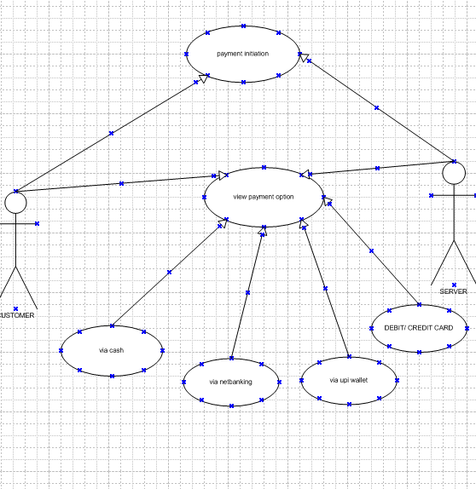

. Derive Boundary Classes, Controller classes, Entity Classes

Overview of the Three Class Types
These classes originate from Model-View-Controller (MVC) and Object-Oriented Analysis & Design (OOAD) principles. They help in separating concerns in software systems.
Class Type | Purpose | Example
Boundary Class | Handles user/system interactions | LoginScreen, PaymentUI
Controller Class | Manages business logic & flow | LoginController, PaymentProcessor
Entity Class | Represents data & business entities | User, Order, BankAccount

2. Boundary Classes

Definition:
- Act as intermediaries between external actors (users, systems) and the system.
- Typically represent UI components, APIs, or external interfaces.

Types:
- User Interface (UI) Classes
  - Example: LoginScreen, DashboardView.
- System Interface Classes
  - Example: ExternalAPIGateway (for third-party integrations).
- Device Interface Classes
  - Example: PrinterController, SensorInterface.

Advantages:
✅ Decouples UI from Business Logic
- Changes in UI (e.g., switching from web to mobile) don’t affect core logic.
✅ Improves Testability
- UI can be mocked for unit testing.
✅ Supports Multiple Frontends
- Same business logic can be reused for web, mobile, and API interfaces.

Disadvantages:
❌ Can Lead to Overhead
- Too many layers may slow down performance.
❌ May Duplicate Validation Logic
- Input validation might be needed in both UI and backend.

3. Controller Classes

Definition:
- Orchestrate system operations (e.g., processing payments, managing workflows).
- Act as the "traffic cop" between Boundary and Entity classes.

Types:
- Application Logic Controllers
  - Example: PaymentController (handles payment processing).
- Workflow Controllers
  - Example: OrderFulfillmentManager (manages order steps).
- Transaction Controllers
  - Example: BankTransactionProcessor (ensures ACID compliance).

Advantages:
✅ Centralizes Business Logic
- Rules are maintained in one place (e.g., "discount calculation").
✅ Improves Maintainability
- Changes to workflows don’t affect UI or data layers.
✅ Enables Reusability
- Same controller can be used by different UIs (web, mobile).

Disadvantages:
❌ Risk of Becoming a "God Class"
- If too much logic is dumped here, it becomes hard to manage.
❌ Tight Coupling Risk
- Poor design may lead to dependencies between controllers.

4. Entity Classes

Definition:
- Represent core business data (often mapped to database tables).
- Typically persistent (saved in a database).

Types:
- Domain Entities
  - Example: Customer, Product (pure business objects).
- Data Transfer Objects (DTOs)
  - Example: CustomerDTO (used for API responses).
- Persistence Entities
  - Example: CustomerEntity (JPA/Hibernate annotations for DB mapping).

Advantages:
✅ Encapsulates Business Rules
- Example: Account.withdraw() validates balance before allowing withdrawal.
✅ Database Agnostic
- Entities can be reused even if the DB changes (SQL → NoSQL).
✅ Clear Data Ownership
- Each entity manages its own state (e.g., Order.calculateTotal()).

Disadvantages:
❌ Can Become Anemic
- If only getters/setters are used (no business logic), it becomes a "dumb" data holder.
❌ Overhead for Simple Systems
- Small apps may not need this separation.

Place these classes on a three tier Architecture

Three-tier architecture is a client-server software design pattern that divides an application into three logical and physical layers:
- Presentation Tier (UI Layer)
  - What users interact with (e.g., web pages, mobile apps).
- Application/Business Logic Tier (Middle Tier)
  - Processes user requests, enforces business rules.
- Data Tier (Database Layer)
  - Stores and retrieves data (e.g., MySQL, MongoDB).

2. Types of Three-Tier Architecture

A. Traditional Three-Tier (Monolithic)
- All layers are deployed together (e.g., a single server running UI + logic + DB).
- Example: Legacy ERP systems.

B. Distributed Three-Tier
- Each tier runs on separate servers (e.g., web server, app server, DB server).
- Example: Modern e-commerce platforms.

C. Cloud-Based Three-Tier
- Uses cloud services (e.g., AWS S3 for UI, Lambda for logic, RDS for DB).
- Example: SaaS applications like Salesforce.

3. Advantages of Three-Tier Architecture

✅ 1. Modularity & Maintainability
- Each tier can be developed, updated, and scaled independently.
- Example: Changing the UI (e.g., from desktop to mobile) doesn’t require rewriting business logic.

✅ 2. Improved Security
- Database is isolated from the presentation layer.
- Example: SQL injection attacks are harder since the DB isn’t directly exposed.

✅ 3. Scalability
- Horizontal scaling is easier (e.g., add more app servers for heavy computation).
- Example: During Black Friday, an e-commerce site can scale just the middle tier.

✅ 4. Reusability
- Business logic can be reused across multiple UIs (web, mobile, API).
- Example: A banking app’s "transfer money" logic works for both web and mobile.

✅ 5. Better Performance
- Load balancing can be applied to each tier.
- Example: Caching frequently accessed data in the middle tier reduces DB calls.

4. Disadvantages of Three-Tier Architecture

❌ 1. Increased Complexity
- Requires more components (servers, APIs, networks).
- Example: Debugging issues across tiers can be challenging.

❌ 2. Higher Latency
- Network calls between tiers add delay.
- Example: A UI → Middle Tier → DB chain is slower than a monolithic app.

❌ 3. Cost Overhead
- More servers = higher infrastructure costs.
- Example: Running separate servers for UI, logic, and DB in AWS.

❌ 4. Deployment Challenges
- Synchronizing updates across tiers requires coordination.
- Example: A DB schema change might break the middle tier.

Q4. Explain Domain Model for Customer making payment through Net Banking - 4 Marks
A Domain Model is a structured representation of:
- Key business entities (objects)
- Their relationships
- Business rules governing their interactions
It provides a visual vocabulary for discussing system functionality in business terms.

Key Components Explained:
- Customer
  - Initiates the payment
  - Has one or more linked BankAccounts
- Payment (Abstract)
  - Base class for all payment types
  - Tracks common attributes: amount, date, status
- NetBankingPayment
  - Specialized payment type
  - Adds bank-specific fields: transactionRef, bankName
  - Handles authorization logic
- BankAccount
  - Stores account details and balance
  - Provides debit() operation for fund deduction
- Bank
  - Represents the external banking system
  - Validates transactions via validateTransaction()
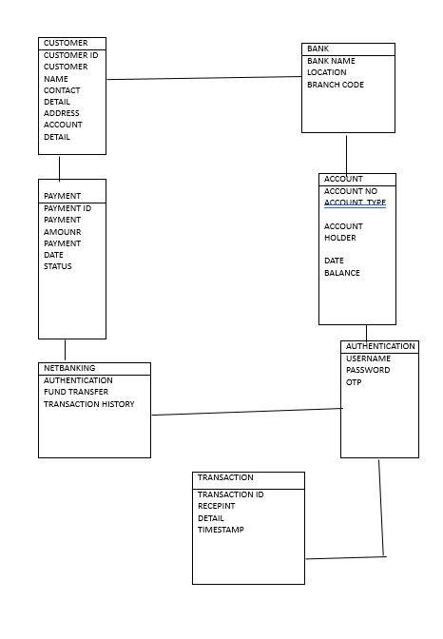

Q5. Draw a sequence diagram for payment done by Customer Net Banking - 4 Marks
A Sequence Diagram is a UML (Unified Modeling Language) diagram that shows:
- How objects interact in a system over time.
- The order of messages exchanged between objects.
- Lifelines of participating objects.

Key Components:
- Actors: External entities (users, systems).
- Objects/Lifelines: System components (e.g., Customer, PaymentController).
- Messages: Arrows showing method calls/events (e.g., processPayment()).
- Activation Bars: Vertical rectangles showing when an object is active.

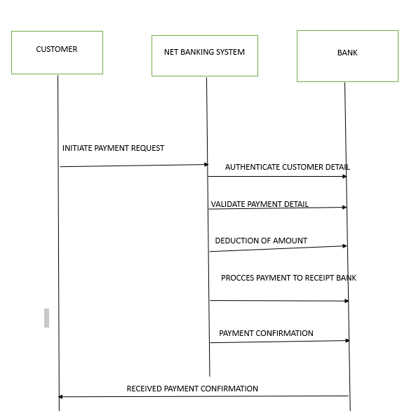

Q6. Explain Conceptual Model for this Case
A Conceptual Model is a high-level, abstract representation of:
- Key concepts in a system or problem domain
- Relationships between these concepts
- Business rules governing their interactions
It serves as a bridge between business stakeholders and technical teams by providing a shared vocabulary.

2. Types of Conceptual Models

A. Entity-Relationship Models (ER Models)
- Focuses on data entities and their relationships
- Used primarily for database design
- Example:
Diagram
Code

B. Object-Role Models (ORM)
- Uses natural language to describe relationships
- Example:
"Each Customer places one or more Orders"

C. Business Process Models
- Represents workflows and activities
- Example:
Diagram
Code

D. Taxonomy Models
- Hierarchical classification of concepts
- Example:
text
Payment Methods
├── Card
├── Net Banking
└── Wallet

E. System Context Models
- Shows the system and its external interfaces
- Example:
Diagram
Code

3. Advantages of Conceptual Models

✅ 1. Improved Communication
- Creates a common language between business and IT
- Example:
  - Both teams understand what "Payment Gateway" means

✅ 2. Early Problem Detection
- Reveals missing concepts or relationships
- Example:
  - Identifying that "Refund" was omitted from a payment model

✅ 3. Technology-Agnostic
- Focuses on what not how
- Example:
  - A "Customer" concept applies whether storing in SQL or NoSQL

✅ 4. Supports Multiple Views
- Can represent different perspectives:
  - Data (ER diagrams)
  - Processes (flowcharts)
  - Rules (decision tables)

✅ 5. Foundation for Implementation
- Guides development of:
  - Database schemas
  - Class diagrams
  - API designs

4. Disadvantages of Conceptual Models

❌ 1. Abstract Nature
- May be too vague for implementation
- Example:
  - "Process Payment" doesn't specify validation rules

❌ 2. Maintenance Overhead
- Requires updating as business evolves
- Example:
  - Adding cryptocurrency payments to an existing model

❌ 3. Potential for Ambiguity
- Relationships may be interpreted differently
- Example:
  - Does "Customer owns Account" mean exclusive ownership?

Q7. What is MVC architecture? Explain MVC rules to derive classes from use case diagram and guidelines to place classes in 3-tier architecture - 8 Marks
• MVC (Model-View-Controller): Architectural pattern that separates application into three interconnected components:
- Model: Domain data and business logic (entities, validation rules, persistence).
- View: UI layer rendering data and capturing user input (pages, components).
- Controller: Handles user input, invokes model operations, and selects views.
• Benefits: separation of concerns, easier testing, parallel development, reuse.
• MVC rules to derive classes from Use Case Diagram:
- Identify Actors & Interactions → Boundary (View) classes: For each actor/use case interaction, create a boundary class to represent the UI screens/forms.
- Identify Use Cases → Controller classes: For each use case, define one or more controllers to orchestrate the interaction between view and model. Controllers implement the workflow.
- Identify Nouns in Use Case → Entity (Model) classes: Extract nouns that represent persistent information (Customer, Payment, Card) and model them as entities.
- Refine with CRUD and Behavior → Services/Domain logic: For complex operations beyond CRUD, define service classes in the model layer or application services.
• Guidelines for placing classes in 3-tier architecture:
- Presentation Tier (View + thin controllers): All UI/boundary classes and validators for user input. Keep business logic minimal here.
- Application Tier (Controllers + Services): Controllers orchestrate use cases, implement transaction scripts, coordinate domain services and external APIs. Put business rules here if not in domain model.
- Data Tier (Model + Persistence): Entity classes, repositories/DAOs, and DB schema mapping. Ensure entities are persistence-friendly and include versioning/audit as needed.
• Example mapping for payment case: PaymentForm → View, PaymentController & PaymentService → Application, Payment & Customer → Data Tier.

Q8. Explain BA contributions in project (Waterfall Model – all Stages) – 8 Marks
Role of Business Analyst (BA) across Waterfall phases:
- Requirement Gathering / Analysis:
  - Elicit requirements via interviews, workshops, documents.
  - Produce Requirement Specification (SRS/FRD), use cases, functional requirements, and non-functional requirements.
  - Validate and get sign-off from stakeholders.
- System Design (High-Level & Detailed):
  - Convert requirements into system design: data models, interface specs, flow diagrams, UML diagrams (class/use case/sequence).
  - Work with architects to ensure requirements mapping.
- Implementation / Development:
  - Clarify requirements during development, resolve ambiguities.
  - Help developers with acceptance criteria and user stories (if split into smaller waterfall tasks).
- Integration & Testing:
  - Prepare test scenarios, acceptance criteria, and UAT test cases.
  - Assist QA in writing test cases and validating test coverage.
  - Validate fixes and coordinate regression testing.
- Deployment / Release:
  - Prepare deployment checklists, data migration plans, and user manuals.
  - Ensure stakeholders are aware of go-live impacts.
- Maintenance / Support:
  - Triage defects, work on change requests, analyze business impact, and update documentation.
  - Serve as liaison between users and technical teams.
BA contributions include stakeholder management, scope control, documentation, requirement traceability, and acceptance validation.
Q9. What is conflict management? Explain using Thomas–Kilmann technique – 6 Marks
- Conflict Management: Process of identifying and handling conflicts in a constructive manner to reach an acceptable outcome.
- Thomas–Kilmann Conflict Mode Instrument (TKI): Defines five conflict-handling modes based on assertiveness (concern for self) and cooperativeness (concern for others):
  - Competing (High Assertiveness, Low Cooperativeness): Pursue one's own concerns at other's expense. Use for urgent, important decisions.
  - Accommodating (Low Assertiveness, High Cooperativeness): Yield to others. Use to preserve relationships or when you're wrong.
  - Avoiding (Low, Low): Ignore or withdraw; appropriate for trivial issues or when cooling off is needed.
  - Collaborating (High, High): Work to find a win-win solution addressing all concerns. Best for complex issues where both parties' inputs matter.
  - Compromising (Medium, Medium): Find an expedient, mutually acceptable solution; both give up something.
- Usage in projects: BA chooses style depending on stakes, relationships, time, and importance. Prefer collaboration for requirement disagreements, use compromise when time-limited, avoid when issue trivial, compete when a quick decisive action required (e.g., security fix).
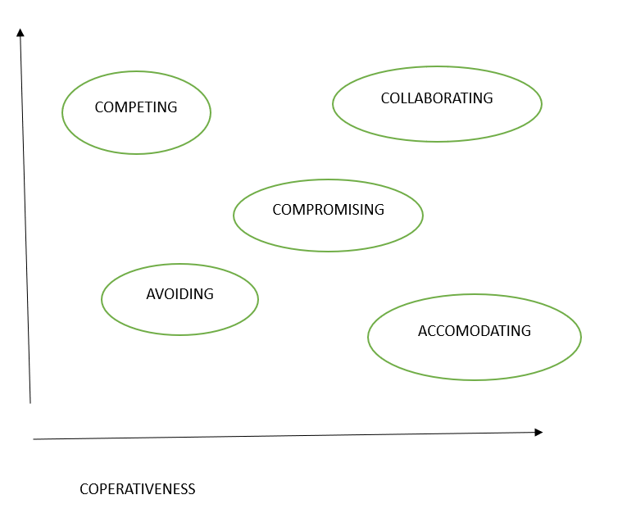

Q10. List down the reasons for project failure – 6 Marks
Common reasons:
- Poor requirements definition / scope creep / unclear objectives.
- Lack of stakeholder engagement or sponsor support.
- Inadequate planning and unrealistic schedules.
- Poor communication among teams and stakeholders.
- Insufficient resources or lack of skilled personnel.
- Technical issues: inadequate architecture, integration problems.
- Poor risk management and lack of change control.
- Incomplete testing, resulting in defects at deployment.
- Cost overruns and financial mismanagement.
- Cultural/resistance to change or organizational politics.

Q11. List the Challenges faced in projects for BA – 6 Marks
- Eliciting tacit requirements and dealing with stakeholders who can't articulate needs.
- Managing conflicting stakeholder priorities and expectations.
- Changing requirements (scope creep) and late changes.
- Ambiguous or incomplete documentation.
- Balancing technical constraints with business needs.
- Ensuring proper traceability from requirements to tests.
- Communicating effectively across technical and non-technical audiences.
- Time constraints and tight deadlines.
- Managing vendor/integrations and third-party dependencies.
Q12. Write about Document Naming Standards – 4 Marks
A consistent naming convention improves discoverability and version control. Example standard:
<ProjectCode>_<DocumentType>_<Module>_<Version>_<Date>_<AuthorInitials>.ext
Example: NURT_PF_REQS_PaymentModule_v1.2_09-08-2025_SN.docx
Guidelines:
- Use dashes or underscores, avoid spaces.
- Include project code and module for quick lookup.
- Versioning: vMajor.Minor (v1.0, v1.1).
- Date format standardized (dd-mm-yyyy or yyyy-mm-dd). In this exam use dd-mm-yyyy.
- Keep filenames <= 80 chars.
- Use access control and store documents in structured folders (Requirements/Design/Test/Release).
Q13. What are the Do’s and Don’ts of a Business analyst – 6 Marks
Do’s:
- Do actively listen and ask clarifying questions.
- Do document requirements clearly and get stakeholder sign-off.
- Do maintain traceability and version control.
- Do validate requirements with prototypes/walkthroughs.
- Do manage stakeholder expectations and communicate proactively.
- Do be solution-agnostic until requirements are clear.
Don’ts:
- Don’t assume requirements — always confirm.
- Don’t use ambiguous language (avoid "etc.", "maybe").
- Don’t ignore non-functional requirements (performance, security).
- Don’t skip stakeholder sign-offs.
- Don’t over-engineer solutions early.
- Don’t lock design without analysis and impacts considered.
Q14. Write the difference between packages and sub-systems – 4 Marks
- Package: A logical grouping of related classes or modules in design (often a namespace or folder-level grouping). It’s primarily for organization, reusability, and modularization within a system. Packages are language-level constructs (e.g., Java packages).
- Sub-system: A higher-level architectural component that may contain multiple packages and defines a distinct area of functionality with its own interfaces and responsibilities. Sub-systems often map to deployment or runtime boundaries (e.g., Payment Subsystem, Authentication Subsystem).
Key differences: scale (sub-system larger than package), architectural role (sub-systems define system decomposition and interfaces; packages are organizational), and deployment (sub-systems may be separately deployable).

Q15. What is camel-casing and explain where it will be used - 6 Marks
- Camel-casing (camelCase / PascalCase): A naming convention where words are concatenated without spaces and each word's first letter is capitalized except possibly the first word.
  - camelCase: first letter lowercase, subsequent words Capitalized (e.g., customerName, paymentId).
  - PascalCase (UpperCamelCase): first letter capitalized too (e.g., CustomerName, PaymentService).
- Usage:
  - Variable names, function/method names, and identifiers in code (depending on language conventions).
  - JSON keys in APIs (common to use camelCase).
  - UI element IDs, class names (often PascalCase for classes).
  - Database column naming depends on team conventions (snake_case often used in DBs).
- Why BA cares: When specifying field names in requirements, use consistent naming convention (e.g., customerName), document it, and map to technical teams’ conventions in data mapping.
Q16. Illustrate Development server and what accesses does business analyst has? - 6 Marks
- Development Server (dev): Environment where developers deploy builds for development and initial functional testing. It typically has less stringent security, can be reset often, and may contain synthetic or masked data.
- Characteristics:
  - Continuous integration builds deployed frequently.
  - Debugging/logging enabled.
  - May be on internal network only.
  - Not for production data (or data is masked/anonymized).
- BA Access & Activities:
  - Read-only access to validate flows and test use cases on UI.
  - Test accounts and test data provided for simulating scenarios.
  - Access to view logs or error dashboards usually through development team or with limited privileges.
  - Permission to request data setup (create test customers, payment methods).
  - Typically no direct write access to backend production data or admin-level DB access; any schema changes or deep DB queries handled by dev/db team with BA requesting reports.
  - BA may have access to defect tracking, build notes, and deployment logs (not infra-level credentials).
- Security & Governance: BA must follow data privacy rules; if real data used, ensure masking; use test accounts for customer PII.
Q17. What is Data Mapping — 6 Marks
- Data Mapping: Process of matching fields from a source system to a target system, defining transformations, formats, and rules needed to move data between systems.
- Components:
  - Source Field (e.g., dob in source) → Target Field (e.g., dateOfBirth).
  - Transformation Rules: e.g., date format change, currency conversion, concatenation of first+last name.
  - Validation Rules: required/optional, length, allowed values.
  - Null Handling / Default Values.
- Example for payment case: Map customer.email from frontend JSON to customer_email column in Payments DB, map amount to cents (multiply by 100), and map date with date format conversion.
- Deliverables: Data mapping spreadsheet, ETL spec, sample payloads, and test cases.
Q18. What is API. Explain how you would use API integration in the case of your application Date format is dd-mm-yyyy and it is accepting some data from Other Application from US whose Date Format is mm-dd-yyyy - 10 Marks
- What is an API: Application Programming Interface — a set of rules and endpoints that allow applications to communicate. For web services, RESTful APIs are common, exchanging JSON or XML over HTTP(S).
- API Integration in Payment App (general):
  - Use APIs to integrate with Bank Gateways, Card Processors, Wallet Providers, Fraud Detection services, and internal microservices (Customer Service, Order Service).
  - Typically use secure HTTPS calls, API keys/OAuth, request signing, and follow idempotency & retry best practices.
- Handling Date Format mismatch (dd-mm-yyyy vs mm-dd-yyyy):
  - Do not rely on string formats: Use ISO 8601 (YYYY-MM-DD or full datetime with timezone) internally and in API contracts whenever possible. Recommend all integrations use ISO 8601 to avoid ambiguity.
  - At integration boundary (adapter): Implement an API adapter/transformer that normalizes incoming dates to internal canonical format. Steps:
    - Identify the incoming API's documented date format (in this case mm-dd-yyyy).
    - Parse incoming date string using a strict parser (e.g., datetime.strptime(dateStr, "%m-%d-%Y")).
    - Convert to internal representation (e.g., datetime object) and then serialize to canonical YYYY-MM-DD or timestamp.
  - Validation & Error Handling: If parsing fails, return a clear 4xx response with message explaining expected format; log the raw payload for diagnostics.
  - Example Transformation Rule (Data Mapping):
    - Source (US App): paymentDate = "08-09-2025" (mm-dd-yyyy)
    - Adapter: parse → 2025-08-09 (ISO), store in DB field payment_date (YYYY-MM-DD).
  - API Contract & Documentation: Update API docs to specify accepted and produced date formats and preferred timezone handling (UTC recommended).
  - Testing: Create test cases for ambiguous dates (e.g., 03-04-2025) to ensure parsing is correct. Use unit tests and contract tests.
  - Backward Compatibility & Versioning: If existing clients send dd-mm-yyyy, support both temporarily with versioned endpoints (v1 expects mm-dd-yyyy, v2 uses ISO). Prefer explicit dateFormat parameter only if necessary.
  - Security & Logging: Avoid logging PII unnecessarily; but log enough metadata to debug parsing issues.
  - Implementation Options: Use middleware (API gateway) to normalize formats centrally, or implement adapters in microservices that own the integration.
- Practical advice for BA role:
  - Specify accepted formats in API spec (OpenAPI/Swagger).
  - Include sample payloads and transformation rules in integration document.
  - Agree on error codes and retries with integration partners.

