ONLINE AGRICULTURAL PRODUCT STORE

Project Title: Online Products Agricultural Store
Industry: Agricultural Sector

1Q Identify minimum 20 functional requirements

FRD ID | Title | Description | Priority
FR001 | User Registration | Users should be able to create buyer accounts on the portal after providing necessary information. | 9
FR002 | User Login | Registered users should be able to log in securely using their credentials. | 10
FR003 | Update User Profile | Users should manage their profiles, including updating contact information and changing passwords. | 7
FR004 | Product Catalogue Upload | Sellers should list agricultural products with details (name, description, price, quantity). | 8
FR005 | Product Search | Users should search for products by category, brand, contents, or keywords. | 10
FR006 | Product Filters | Users should filter results by product type, brand, and location. | 8
FR007 | Product Details Page | Users should view detailed information (images, descriptions, seller info). | 9
FR008 | Add to Cart | Users should add products to their shopping cart. | 10
FR009 | Cart Management | Users should edit their shopping cart (change quantity, remove items). | 9
FR010 | Checkout Process | Users should complete a secure checkout with shipping and payment info. | 10
FR011 | Payment Processing | The system should support cards, wallets, UPI, and process securely. | 10
FR012 | Order Confirmation | Users should receive confirmation (SMS/email) with unique order ID. | 9
FR013 | Order History | Users should access past orders and their statuses. | 7
FR014 | Seller Dashboard | Sellers should manage catalogue, inventory, orders, and payments. | 8
FR015 | Inventory Management | Sellers should update stock, mark out-of-stock, or remove products. | 8
FR016 | Product Reviews & Ratings | Users should leave reviews/ratings for purchased products. | 6
FR017 | User Notifications | Users should get updates on order status, promotions, and account info. | 8
FR018 | Shipping Options | Users should choose shipping methods (standard/express) with cost info. | 7
FR019 | Delivery Tracking | Users should track shipment status and location in order history. | 9
FR020 | Admin Dashboard | Admin should control portal operations, manage users, reconcile payments. | 10

NFRD ID | Title | Description | Priority
NFR001 | User Interface | The UI should be intuitive and simple as many users are less tech-savvy. | 9
NFR002 | Security | Implement enhanced security to protect data, prevent unauthorized access, secure payments. | 10
NFR003 | Performance | The system should handle high concurrent users and product listings smoothly. | 9
NFR004 | Reliability | Ensure high reliability and minimal downtime for 24/7 availability. | 10
NFR005 | Compatibility | Work across browsers, OS, and devices (desktop, mobile, tablet). | 8
NFR006 | Response Time | Pages, search, and checkout should load within 2–3 seconds. | 9
NFR007 | Compliance | Follow government regulations for agriculture product sales. | 9
NFR008 | Scalability | Support future growth (more users, products, orders). | 8
NFR009 | Maintainability | Codebase should allow easy updates, bug fixes, and enhancements. | 7
NFR010 | Documentation | Provide clear user guides, FAQs, and admin manuals. | 6
NFR011 | Accessibility | Support multiple local languages and WCAG 2.1 accessibility standards. | 8
NFR012 | Backup & Recovery | Daily backups; restore within 4 hours in case of system failure. | 9
NFR013 | Data Integrity | Ensure no duplicate orders and consistent stock updates. | 9
NFR014 | Fault Tolerance | System should continue functioning even if one server fails. | 8
NFR015 | Monitoring & Logging | Track user activity, errors, and generate system logs. | 7
NFR016 | Training | Provide training videos/materials for farmers and staff. | 6
NFR017 | Capacity | Store at least 1 million product records without lag. | 8
NFR018 | Interoperability | Integrate with external payment gateways, logistics APIs. | 8
NFR019 | Availability | Ensure 99.5% uptime for continuous service. | 10
NFR020 | Privacy | Adhere to data protection laws; mask sensitive personal and financial info. | 10

2Q Make wireframes
Answer – Wireframes - Wireframes are visual representations or blueprints of a user interface (UI) that outline the structure and layout of a web page, application, or system without focusing on detailed design elements like colours, fonts, or graphics. Wireframes are typically used to represent the basic framework of a product’s interface, showing how different elements will be arranged and how users will interact with the system.
Prototypes - Prototypes are early, simplified models or representations of a system or product that simulate the functionality, user interface (UI), or processes of the final solution. Prototypes allow stakeholders, including business users, clients, and the development team, to explore and evaluate the proposed system’s features before the final product is developed. They help gather feedback, validate requirements, and refine system design by providing a tangible representation of the software or product early in the project lifecycle.
Some examples are:

- Home page

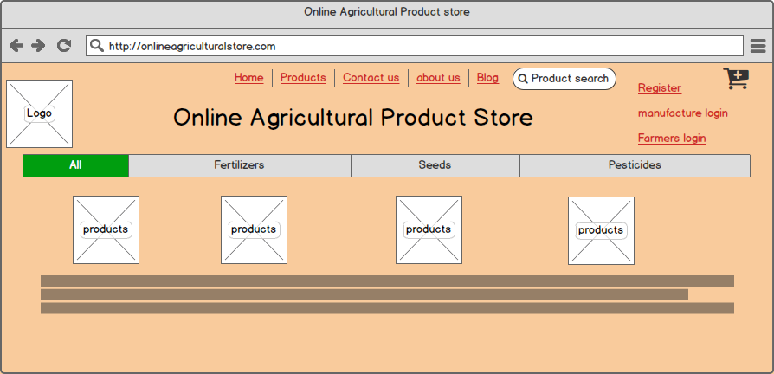

- Registration page:

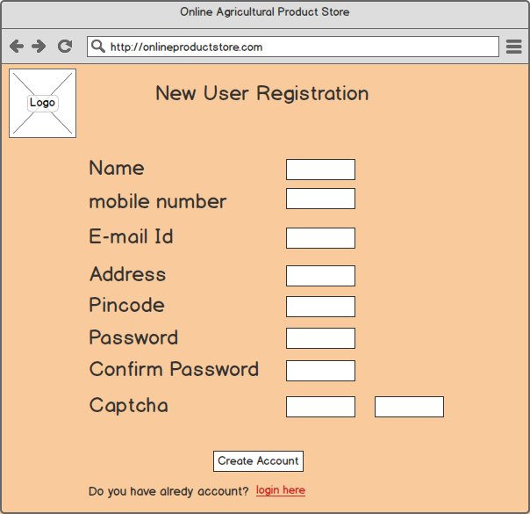

- Login page;

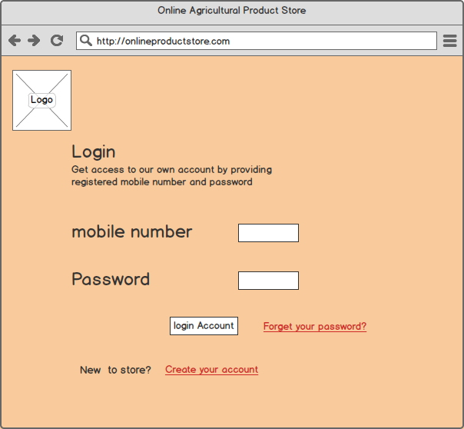

- Cart page:

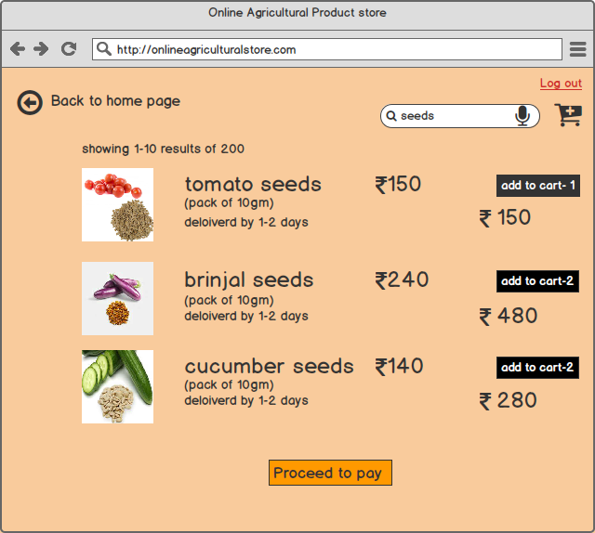

- Payment page:

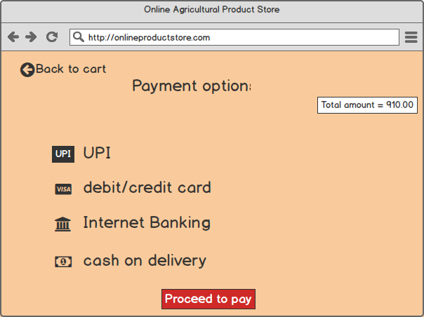

Q3 – Tools (Visio, Balsamiq)

Microsoft Visio

Microsoft Visio is a powerful diagramming and drawing tool that enables users to create a wide range of visual representations of data, processes, and concepts. It offers an intuitive interface and a vast library of shapes and templates, making it accessible to both novice and experienced users. Visio is designed to help individuals and organizations effectively communicate ideas, concepts, and complex information through diagrams and charts.

Uses of Microsoft Visio:

- Flowchart Creation: Visio is widely used to create flowcharts that represent the steps and processes within organizations, helping to visualize workflows and decision-making processes.

- Organizational Charts: It allows users to build organizational charts and hierarchy diagrams, making it easy to illustrate reporting structures, team relationships, and roles within a company.

- Network Diagrams: Visio is a valuable tool for IT professionals to design network diagrams, including LANs, WANs, and data center layouts. It can depict network topologies, device connections, and IP addressing.

- Software and Database Design: Software architects and database developers use Visio to design system architectures, entity-relationship diagrams (ERDs), and database schemas.

- Business Process Modeling: Visio supports the creation of business process diagrams, helping organizations document and optimize their workflows and procedures.

- Project Management: Users can build Gantt charts and timelines to manage project schedules and timelines, showing tasks, dependencies, and milestones.

- Data Visualization: Visio can connect to data sources such as Excel or SQL databases, enabling users to generate dynamic data-driven diagrams and dashboards.

- Mind Mapping: It can be used for mind mapping and brainstorming sessions, helping to organize and visualize ideas and concepts.

- Education: Visio is used in educational settings to teach diagramming concepts, allowing students to create visuals for various subjects and projects.

- Documentation: It aids in documenting and visualizing complex systems, processes, and architectures for better understanding and communication.

In summary, Microsoft Office Visio is a versatile tool that plays a crucial role in various industries and professions. Its ability to create diagrams and visuals enhances communication, decision-making, and understanding across different domains, making it an indispensable asset for individuals and organizations alike.

Balsamiq

Balsamiq is a user interface (UI) design and wireframing tool that helps designers and product teams create quick user interfaces. Known for its simplicity and sketch-like appearance, Balsamiq is designed to facilitate rapid prototyping and idea exploration in the early stages of software and web application development.

Uses of Balsamiq:

- Rapid Wireframing: Balsamiq is primarily used for creating wireframes, which are simplified visual representations of user interfaces. It allows designers to quickly sketch out UI ideas, layouts, and interactions without getting bogged down by intricate design details.

- User Interface Design: Designers and product teams use Balsamiq to design the user interface of websites, web applications, mobile apps, and software products. It helps in structuring content, arranging elements, and planning user interactions.

- Prototyping: Balsamiq facilitates the creation of interactive prototypes by linking wireframes together to demonstrate user flows and basic functionality. This helps in validating and refining design concepts.

- Requirement Documentation: Balsamiq wireframes serve as a form of requirement documentation, helping to convey design concepts and requirements to developers, stakeholders, and clients.

- Concept Visualization: It aids in visualizing and sharing conceptual ideas and design concepts before investing significant time and resources in full-fledged development.

- Storyboarding: Balsamiq can be used for creating storyboards and scenarios for user experiences, illustrating how users interact with a product or application.

- Mockups for Presentations: Balsamiq wireframes can be used in presentations to communicate design ideas and concepts to clients, investors, or stakeholders.

In summary, Balsamiq is a versatile tool for creating low-fidelity wireframes and prototypes, promoting collaboration, and streamlining the early stages of UI and UX design. Its simplicity and focus on functionality make it a valuable resource for designers and product teams seeking to iterate and validate design ideas efficiently.

4Q Prepare Requirement Traceability Matrix?
Answer – Requirement Traceability Matrix (RTM) - A Requirement Traceability Matrix (RTM) is a document used in business analysis, project management, and software development to ensure that all project requirements are being met throughout the project lifecycle. It helps track the relationship between requirements and various project elements, ensuring that each requirement is linked to corresponding deliverables, test cases, and design specifications.
RTM is prepared for the Online Agriculture Project is below:

Prepare RTM
D - Done IC – Incomplete IP – In Progress

FRD ID | Title | Design | D1 | T1 | D2 | T2 | D3 | T3 | D4 | T4 | UAT
FR001 | User Registration | D | D | D | D | D | D | D | D | D | IC
FR002 | User Login | D | D | D | D | D | D | D | D | D | IC
FR003 | Update User Profile | D | D | D | D | D | D | D | D | D | IC
FR004 | Product Catalogue Upload | D | D | D | D | D | D | D | D | D | IC
FR005 | Product Search | D | D | D | D | D | D | D | D | D | IC
FR006 | Product Filters | D | D | IP | IC | IC | IC | IC | IC | IC | IC
FR007 | Product Details Page | D | IP | IC | IC | IC | IC | IC | IC | IC | IC
FR008 | Add to Cart | IC | IC | IC | IC | IC | IC | IC | IC | IC | IC
FR009 | Cart Management | IC | IC | IC | IC | IC | IC | IC | IC | IC | IC
FR010 | Checkout Process | IC | IC | IC | IC | IC | IC | IC | IC | IC | IC
FR011 | Payment Processing | IC | IC | IC | IC | IC | IC | IC | IC | IC | IC
FR012 | Order Confirmation | IC | IC | IC | IC | IC | IC | IC | IC | IC | IC
FR013 | Order History | IC | IC | IC | IC | IC | IC | IC | IC | IC | IC
FR014 | Seller Dashboard | D | D | IP | IC | IC | IC | IC | IC | IC | IC
FR015 | Inventory Management | D | D | IP | IC | IC | IC | IC | IC | IC | IC
FR016 | Product Reviews and Ratings | IC | IC | IC | IC | IC | IC | IC | IC | IC | IC
FR017 | User Notifications | IC | IC | IC | IC | IC | IC | IC | IC | IC | IC
FR018 | Shipping Options | IC | IC | IC | IC | IC | IC | IC | IC | IC | IC
FR019 | Delivery Tracking | IC | IC | IC | IC | IC | IC | IC | IC | IC | IC
FR020 | Admin Dashboard | D | D | D | D | IC | IC | IC | IC | IC | IC

Q5 Prepare 10 Test Case Documents

Test Case Documents - Test Case Documents are structured documents used in software testing to define and outline the specific conditions, steps, and expected results for verifying a particular feature or functionality of a software application. They are essential for ensuring that software meets its requirements and behaves as expected in different scenarios.

Test case ID | TC0001 | Test Case Name | User Registration
Project ID | Agri0213 | Project Name | Online Agriculture Store Project
PM ID | 53483 | PM Name | Mr. Vandanam
Test Strategy ID | OAS001 | Tester ID | 67542
Test Plan ID | TOAS01 | Tester Name | Mr. Jason
Test Schedule ID | XXXX | Date of Test | 8-Feb-25
Scenario | To register new user inside web application using e mail id and creating password
Link to that page | www.onlineagristore.com
Pre Conditions | Internet connectivity should be stronger enough, Website URL is working
Post Condition | Registration successful, User able to login into system with username and password
Input Data | Email Id, Mobile Number, Name of the user
Expected Behaviour | Once user register using name, mail id / mobile number and create password, System should show user created successfully.
Actual Behaviour | After entering mandatory fields, if user clicks on Register button, then system shows pop up saying ‘User created successfully’
Comments | NA
Results (Pass/Fail) | Pass

Test case ID | TC0002 | Test Case Name | User Login
Project ID | Agri0213 | Project Name | Online Agriculture Store Project
PM ID | 53483 | PM Name | Mr. Vandanam
Test Strategy ID | OAS001 | Tester ID | 67542
Test Plan ID | TOAS01 | Tester Name | Miss Alekya
Test Schedule ID | XXXX | Date of Test | 4-Sep-25
Scenario | To login registered user using username and password
Link to that page | www.onlineagristore.com
Pre Conditions | User is already registered
Post Condition | Login successful, User is able to search for the required products
Input Data | Username, Password, Captcha
Expected Behaviour | User enters Username and Password along with Captcha to login and system shows login successfully
Actual Behaviour | After entering username, password, and captcha, if user clicks on ‘Login’ button, then system shows pop up saying ‘Login successfully’
Comments | NA
Results (Pass/Fail) | Pass

Test case ID | TC0003 | Test Case Name | Add to cart
Project ID | Agri0213 | Project Name | Online Agriculture Store Project
PM ID | 53483 | PM Name | Mr. Vandanam
Test Strategy ID | OAS001 | Tester ID | 67542
Test Plan ID | TOAS01 | Tester Name | Mr. Janson
Test Schedule ID | XXXX | Date of Test | 6-Sep-25
Scenario | User should be able to add selected products to cart
Link to that page | www.onlineagristore.com
Pre Conditions | Products are available in inventory and add to cart is enabled
Post Condition | Total price will be shown, payment option would be shown
Input Data | Products ID, products picture, product prices
Expected Behaviour | Once login, user will search products on the basis of requirements, and he must be able to add products in the cart for purchase
Actual Behaviour | After selecting required products, user clicks on add to cart option to add products in the cart for purchase
Comments | NA
Results (Pass/Fail) | Pass

Test case ID | TC0004 | Test Case Name | Coupon code apply
Project ID | Agri0213 | Project Name | Online Agriculture Store Project
PM ID | 53483 | PM Name | Mr. Vandanam
Test Strategy ID | OAS001 | Tester ID | 67542
Test Plan ID | TOAS01 | Tester Name | Miss. Alekhya
Test Schedule ID | XXXX | Date of Test | 8-Sep-25
Scenario | User should able to add coupon code at the checkout time to avaail discount
Link to that page | www.onlineagristore.com
Pre Conditions | Coupon code must be valid
Post Condition | Total price will be adjusted as per coupon code
Input Data | Coupon code, discount code
Expected Behaviour | At the time of checkout, user must be able to enter coupon code to get the discount on total bill
Actual Behaviour | After adding to cart, user puts coupon code and gets discount on total prices of the products
Comments | NA
Results (Pass/Fail) | Pass

Test case ID | TC0005 | Test Case Name | Payment
Project ID | Agri0213 | Project Name | Online Agriculture Store Project
PM ID | 53483 | PM Name | Mr. Vandanam
Test Strategy ID | OAS001 | Tester ID | 67542
Test Plan ID | TOAS01 | Tester Name | Mr. Jason
Test Schedule ID | XXXX | Date of Test | 12-Sep-25
Scenario | User must be able to chosse payment option and do the payment
Link to that page | www.onlineagristore.com
Pre Conditions | Product added to cart and total price is calculated
Post Condition | Redirected to 3rd party apps or COD option
Input Data | Card details, UPI details, payment method
Expected Behaviour | User should be able to choose payment option from net banking, UPI or cash on delivery
Actual Behaviour | At the payment stege user is able to select options from net banking, card payments, UPI or cash on delivery
Comments | NA
Results (Pass/Fail) | Pass

Test case ID | TC0006 | Test Case Name | Payment confirmation
Project ID | Agri0213 | Project Name | Online Agriculture Store Project
PM ID | 53483 | PM Name | Mr. Vandanam
Test Strategy ID | OAS001 | Tester ID | 67542
Test Plan ID | TOAS01 | Tester Name | Miss Alekhya
Test Schedule ID | XXXX | Date of Test | 14-Sep-25
Scenario | User should be get payment confirmation message in phone or mail
Link to that page | www.onlineagristore.com
Pre Conditions | Payment is successfull
Post Condition | Redirected to order confirmation page and expected delivery date
Input Data | Payment id, toatal price
Expected Behaviour | Once payment are done and amount deducted from the users account, user should get text or mail confirmation for payment
Actual Behaviour | After payment, user gets payments succesfulconfirmation message or mail that payment has been successfully processed
Comments | NA
Results (Pass/Fail) | Pass

Test case ID | TC0007 | Test Case Name | Order confirmation
Project ID | Agri0213 | Project Name | Online Agriculture Store Project
PM ID | 53483 | PM Name | Mr. Vandanam
Test Strategy ID | OAS001 | Tester ID | 67542
Test Plan ID | TOAS01 | Tester Name | Mr. Jason
Test Schedule ID | XXXX | Date of Test | 18-Sep-25
Scenario | User should get text or mail for order confirmation
Link to that page | www.onlineagristore.com
Pre Conditions | Payment is successfull
Post Condition | Tracking order is enabled
Input Data | Payment id, product picture, prodcut prices
Expected Behaviour | Once payment is done, User should get ordes confiramtion containing orders id, and expected delivery date
Actual Behaviour | After payments done, user should get orders confiramtion containg order id, and expected delivery date
Comments | NA
Results (Pass/Fail) | Pass

Test case ID | TC0008 | Test Case Name | Cancel order
Project ID | Agri0213 | Project Name | Online Agriculture Store Project
PM ID | 53483 | PM Name | Mr. Vandanam
Test Strategy ID | OAS001 | Tester ID | 67542
Test Plan ID | TOAS01 | Tester Name | Miss. Alekya
Test Schedule ID | XXXX | Date of Test | 20-Sep-25
Scenario | User should be able to cancel wrong order
Link to that page | www.onlineagristore.com
Pre Conditions | Product already ordered, cancel window is open
Post Condition | Order status is updated, refund initiated
Input Data | User account details, order id, product id
Expected Behaviour | User should be able to cancel the order or order done by mistake from ancel order
Actual Behaviour | User is able to cancel the order from cancel order page from the menu
Comments | NA
Results (Pass/Fail) | Pass

Test case ID | TC0009 | Test Case Name | Return of the Order
Project ID | Agri0213 | Project Name | Online Agriculture Store Project
PM ID | 53483 | PM Name | Mr. Vandanam
Test Strategy ID | OAS001 | Tester ID | 67542
Test Plan ID | TOAS01 | Tester Name | Mr. Jason
Test Schedule ID | XXXX | Date of Test | 24-Sep-25
Scenario | User should be able to return any order which they did not like
Link to that page | www.onlineagristore.com
Pre Conditions | Product already ordered, Return window is open
Post Condition | Order status is updated, Refund initiated
Input Data | Product ID, Order ID, User details
Expected Behaviour | User must be able to return the order from the Return Order page
Actual Behaviour | User can return the order from the Return Order page with the help of order ID and product ID
Comments | NA
Results (Pass/Fail) | Pass
Test case ID | TC0010 | Test Case Name | Session Timeout
Project ID | Agri0213 | Project Name | Online Agriculture Store Project
PM ID | 53483 | PM Name | Mr. Vandanam
Test Strategy ID | OAS001 | Tester ID | 67542
Test Plan ID | TOAS01 | Tester Name | Miss Alekya
Test Schedule ID | XXXX | Date of Test | 29-Sep-25
Scenario | Application must automatically session out after staying idle
Link to that page | www.onlineagristore.com
Pre Conditions | User is logged in and inactive
Post Condition | System should ask for re-login
Input Data | Product ID, Order ID, User details
Expected Behaviour | Application must session out after being idle for 30 seconds and should ask for login again
Actual Behaviour | Application gets session out after being idle for 30 seconds and asks for login again
Comments | NA
Results (Pass/Fail) | Pass

Q6 Draw database schema and ER diagram

DB SCHEMA: DB Schema is a blueprint that outlines the structure of the database, including its tables, fields, relationships, constraints and other characteristics.

ENTITY RELATION SHIP DIAGRAM: An Entity Relationship Diagram is a visual representation of the relationships between entities in a database. It depicts the entities (tables), attributes (properties/fields) and relationship between them.

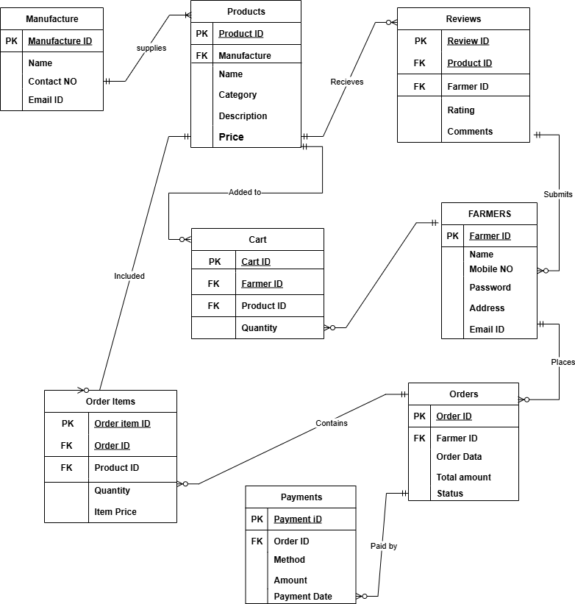

Q7 – Data Flow Diagram

What is a data flow diagram? Draw a data flow diagram to represent the in-flow and out-flow of data when a Farmer is placing an order for the product

A Data Flow Diagram (DFD) is a visual representation that illustrates the flow of data within a system or process. It is a modelling technique used to depict how data enters, moves through, and exits a system, highlighting the processes, data stores, data sources, and data destinations.
In the context of above question, we can create a simple data flow diagram to represent the order placing process.
Below are the steps farmer takes to place an order.
- The farmer initiates the order placement process by logging into his account.
- The farmer selects the needed products, adds them to the shopping cart.
- The system validates the order, validates the information, calculates the total cost including respective taxes and shipping charges.
- The system asks the farmer to make payment and once payment is received order is confirmed.
- Order details stored in the database, the inventory is updated for the order products.
- System generates the order confirmation email and SMS and is sent to the farmer.

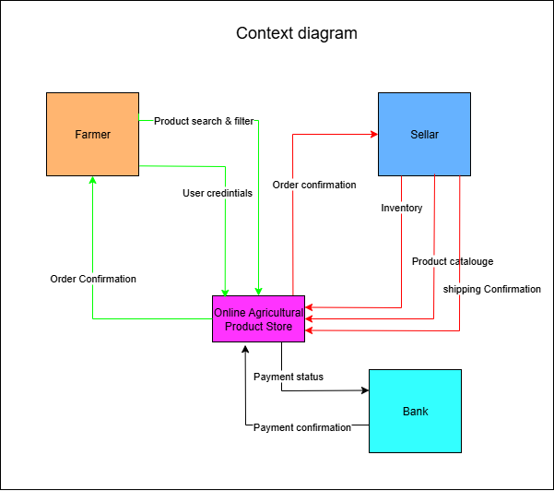

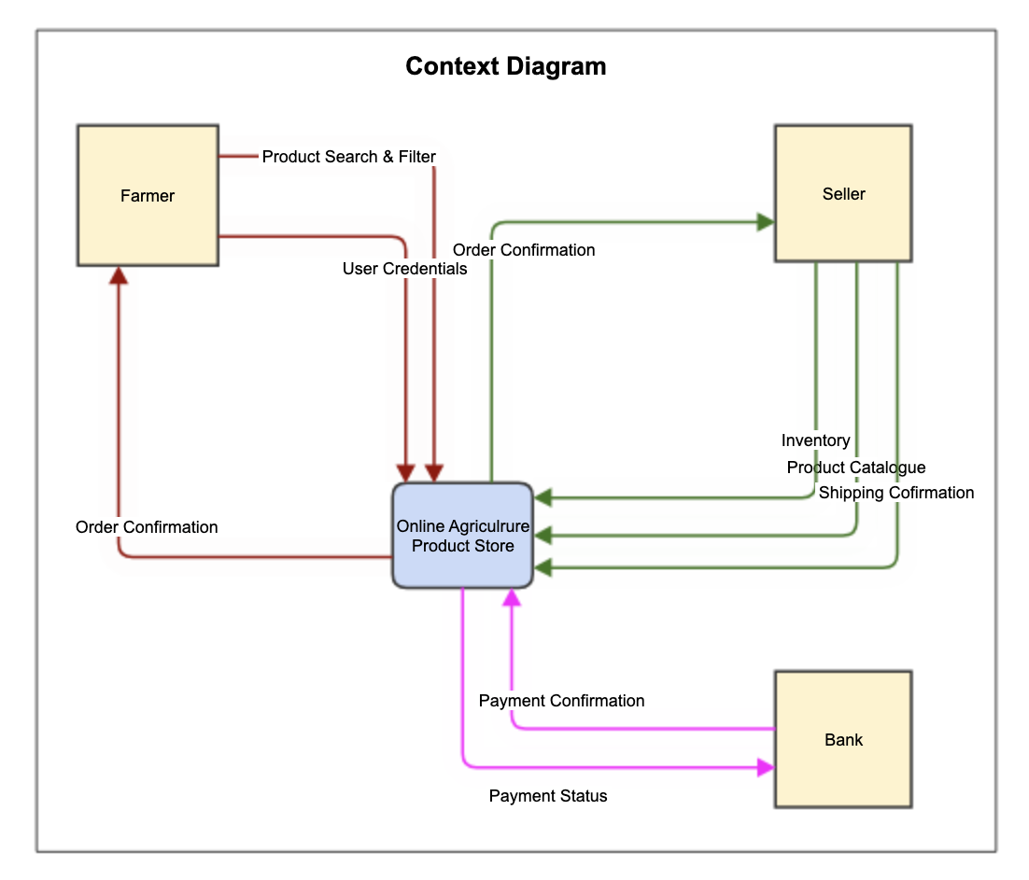

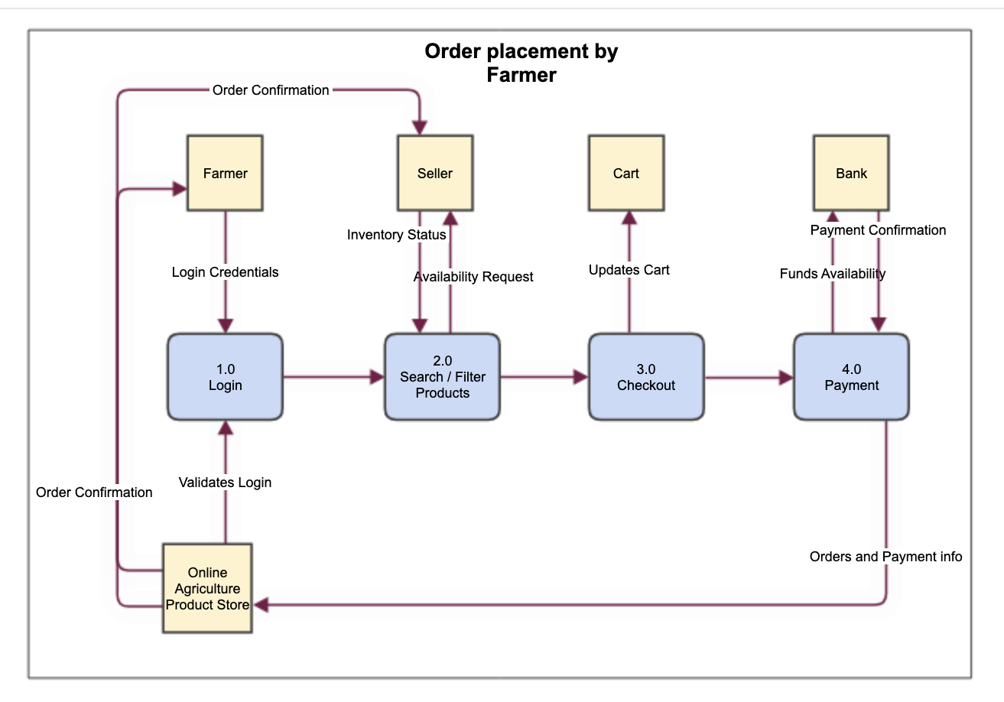

Q8 – Change Request
Due to change in the Government Taxation structure . we should change the Tax structure
How do you handle change requests in a project?-

As the project progresses through time, its en-evitable that some things will change that will affect the project. As requirements are inherent to change, they need to be managed throughout the life time of the project. As a BA we should always be prepared for change requests and their management.
In above case, as the government has amended the tax structure, we need to incorporate it into our project to comply with rules and regulations or it will have serious implications on company as a whole.

As a BA I will follow below steps in order to implement this change.
- Analyse the change request – Firstly I will analyse the change request in order to understand the nature and possible impact on the project. I will also speak to various stakeholders/SME to better understand the request.
- Document the change request – I will record and document the change request in change request log. The draft should include a clear description of the proposed change, reasons for change and its potential impact on the project. Also it will include the date we receive the change request, who has initiated it and so on.
- Initial Assessment – I will evaluate the change request to determine its feasibility, impact, and alignment with project objectives. I need to assess the potential effects on the project's scope, schedule, budget, and resources. Also need to decide the priority of the change in relation to existing project tasks and deadlines.
- Impact analysis – next I will perform a detailed impact analysis to understand how the change will affect the project. I will identify the tasks, resources, and deliverables that will be impacted. Also need to assess the potential risks associated with the change.
- Change Control Board (CCB) – I will initiate formation of CCB which will include project sponsors, key stakeholders, SME and PM. The documents prepared like change request log, assessment report, impact report will be put for discussion and review in front of CCB. How the change is going to be implemented is also discussed, cost, timelines and schedules will be considered for discussion. CCB will then approve or reject or defer the change request. But as in our case the change is to comply with government regulation, it must be approved.
- Estimation and Planning – once the change request is approved by CCB, the project team will provide its insights like time & budget, resources required to implement the change. PM need to adjust the project plan, existing schedule and budget accordingly.
- Implementation – Project team will execute the change according to the updated project plan. Need to ensure that change is properly integrated into project’s workflow.
- Testing and Validation - Verify that the change has been implemented correctly and meets the intended objectives. Conduct necessary testing and quality assurance to ensure the change does not introduce new issues.
- Documentation & Closure – Update the project documentation to reflect approved changes. Closure of change request and updating the change request log.

Q9 – Change Request Vs an Enhancemen

As the project is in process, Ben and Kevin have contacted you. The reason is to inform you that they want the Farmers to sell their crop yields through this application i.e. Farmers should be able to add their crop yields or products and display to general public and should be able to sell them. They also want to introduce Auction system for their Crop yields. As a BA, what will be your
response?

Is this a change request or an enhancement???
A change request is a formal proposal to modify something within a project, process, or system. Change requests are typically initiated when there is a need to alter project scope, requirements, budget, schedule, or other project-related aspects. Change requests can cover a wide range of modifications, including adding new features, revising requirements, addressing issues and risks that arise during the project's lifecycle.

Our project of online agriculture product store was initially started to facilitate the farmers from remote areas buy seeds/pesticides/fertilizers from the comfort of their homes. In this case farmers were buyers and manufacturers were sellers of the products.

Now as per the new request from Mr Ben and Mr Kevin, farmers also to be allowed to sell their crop products on our online agriculture product store, also facility to arrange online auctions for crop yields also to be implemented.

Clearly, its an enhancement request as we are completely building an extension of an existing system where farmers become sellers and general public will buy the crop yields from them.

Q10 – Estimations
Come up with estimations – How many Manhours required
--------------------------------------------------------------------------------------------------------------------------------------

Emp Name | Role | Hourly Rate (Rs) | Expected Hours | Billed Amount (Rs)
Mr Vandanam | Project Manager | 6000 | 600 | 3600000
Ms Juhi | Senior Java Developer | 5200 | 400 | 2080000
Mr Teyson | Java Developer | 4000 | 400 | 1600000
Ms Lucie | Java Developer | 4000 | 400 | 1600000
Mr Tucker | Java Developer | 4000 | 400 | 1600000
Mr Bravo | Java Developer | 4000 | 400 | 1600000
Mr Mike | Network Admin | 4800 | 320 | 1520000
Mr John | DB Admin | 4800 | 400 | 1920000
Mr Jason | Tester | 3200 | 400 | 1280000
Mr Alekya | Tester | 3200 | 400 | 1280000
You | BA | 4800 | 400 | 1920000
Total Billed Amount |  |  |  | 20000000

Q11 – UAT
Project has finally completed all the stages i.e., design, development, testing etc. Now, it is the role of a business analyst to contact the client for testing of the final product and have to successfully complete it. How are you going to handle this situation? And once it is done, what will be the process to close the project?
Explain UAT Acceptance process

The ultimate goal of any project is to provide value to the stakeholders. And as a BA I have to always ensure that project delivers the value that the business needs and expects.
UAT is a process wherein the users will understand the functionality of the system and validate the system. UAT helps the stakeholders to determine whether the system can be put to use in real-life business scenario. Handling User Acceptance Testing (UAT) and closing a project as a business analyst involves several important steps to ensure that the final product meets the client's requirements and is ready for deployment.

Below are the steps in UAT

- Preparation : Collaborate with project team to check all development and testing phases are completed and system has passed all test cases. Project team to confirm if system is ok for UAT. After their confirmation client should be contact to schedule UAT session.
- Test Plan and Test cases : Prepare test plan and test cases for users, need to make sure they contain both functional and non-functional requirements as specified in project scope.
- Testing : Provide necessary training to the users to help them understand the testing process.
- Execution : Facilitate UAT sessions wherein users test the system using test cases. Monitor the test process and address the queries raised during testing if any. Document the test results, defects and issues.
- Defect Management : Collaborate with development team to address the defects/issues raised by the users during UAT. Once development team resolves defects, confirm with users to check if resolution meets client’s requirement.
- Acceptance : Verify the project fulfils the acceptance criteria as defined in UAT test plan. Ensure that client is satisfied with the product’s functionality and usability.
- Sign-off : Once the client is satisfied with the UAT and accepts the project, obtain formal sign-off or approval from the client. The sign-off indicates that the project is ready for actual deployment.

Below are documents prepared for UAT
- UAT plan
- UAT test cases
- Defect/issues log

The UAT acceptance process ensures that the final product aligns with the client's expectations and requirements, reducing the risk of issues and defects after deployment.

Q12 – Project Closure Document
Explain Project closure document

Project Closure Document
A Project Closure Report is undertaken at the start of the Project Closure phase (i.e. after the end of the Project Execution phase). The document is usually prepared by the Project Manager and presented to the Project Sponsor for sign-off. Following sign-off, a suite of closure activities is undertaken to formally close the project. After these activities have been completed, a Post Implementation Review is undertaken to measure the success of the project and identify lessons learnt for future projects.
Below is a sample project closure report prepared for our online agriculture product store project.

Project Title: Online Agriculture Product Store
Project ID/Number: AGRO-2025
Project Manager: Mr Vandanam

Project Team:
- Mr. Vandanam (Project Manager)
- Ms. Juhi (Senior Java Developer)
- Mr. Teyson (Java Developer)
- Ms. Lucie (Java Developer)
- Mr. Tucker (Java Developer)
- Mr. Bravo (Java Developer)
- Mr. Mike (Network Admin)
- John (DB Admin)
- Mr. Jason (Tester)
- Ms. Alekya (Tester)
- You (Business Analyst)

Project Objectives:
- Develop and launch an online agriculture product store platform to connect farmers and manufacturers of seeds/pesticides/fertilizers.
- Improve accessibility to agricultural products and delivery of products at farmer’s locations.
- Enhance the efficiency of agricultural product transactions by aggregating various manufacturers on single platform

Project Scope:

The project scope included the design, development, testing, and deployment of the online agriculture product store platform. It covered all software development aspects, including analysis, design, front-end and back-end development, database management, testing, deployment.

Project Deliverables:

- Fully functional online agriculture product store platform.
- User manuals and documentation.
- Test cases and test reports.
- Lessons learned documentation.

Project Schedule:

- Start Date: 01/04/2024
- End Date: 30/09/2025

Budget Information:

- Total Project Budget: INR 2 Crore
- Actual Expenditures: INR 2 Crore

Stakeholders:

Name | Position | Remarks | Signature
Mr Henry | Project Sponser
Peter, Kevin, Ben | Key Statekolders
Mr Pandu | Finance Head
Mr Dooku | Project Co-ordinator
Mr Karthik | Delivery Head
Mr Vandanam | Project Manager
Ms Juhi, Mr Teyson, Ms Lucie, Mr Tucker, Mr Bravo | JAVA Team
Mr Mike | Network admin
Mr John | DB admin
Mr Jason, Mr Alekya | Testers
Me | BA

Project Success Criteria:
- Successful launch and functionality of the online agriculture product store.
- Positive feedback and acceptance from end-users.
- On-time and within-budget project completion.

Lessons Learned:

- Since this was very new kind of the project for the company, there were many learnings for the project team while developing and delivering this project.
- The stakeholders i.e. farmers were new to the technology and very less tech-savvy, therefor combination of requirement gathering techniques were used in order to be on same page.
- Concurrent development and testing approach was used so that stakeholders can check the progress and submit their reviews/suggestions.

Project Closure Date: 30/09/2025

Outstanding Issues/Risks:

- When the project was at the completion stage, client had submitted an enhancement change request, which is under analysis phase, and will be taken forward.

Documentation:

- All project documentation is archived and available for reference.
- All user manuals were submitted to the client.
- UAT testing and acceptance document has been finalized and is available for reference.

Client Satisfaction:

- The client expressed satisfaction with the project outcomes and the platform's functionality.
- Client has used the product in live environment and is satisfied with the workflow and process.

Formal Acceptance:

- The client formally accepted the project deliverables on 30/09/2025

Next Steps:

- Ongoing support and maintenance of the online agriculture product store platform.
- Monitoring and addressing any post-launch issues or enhancements.

Closure Meeting Minutes:

Project closure meeting was attended by all project stakeholders along with sponsor and the core team of Mr. Henry. Agenda of the meeting was to provide formal acceptance to the project, acknowledge project success and discuss next steps and future considerations.
The team reviewed the project closure document and confirmed that all relevant information, including financial details and stakeholder contacts, had been documented. It was noted that all project documentation had been finalized and archived for future reference. Outstanding issues and risks were reviewed, and it was confirmed that all had been addressed and resolved satisfactorily.
The meeting concluded with a unanimous agreement that the project had been successfully completed and closed.

%3CmxGraphModel%3E%3Croot%3E%3CmxCell%20id%3D%220%22%2F%3E%3CmxCell%20id%3D%221%22%20parent%3D%220%22%2F%3E%3CmxCell%20id%3D%222%22%20value%3D%22%22%20style%3D%22html%3D1%3Bdashed%3D0%3BwhiteSpace%3Dwrap%3B%22%20vertex%3D%221%22%20parent%3D%221%22%3E%3CmxGeometry%20x%3D%22150%22%20y%3D%2260%22%20width%3D%22600%22%20height%3D%22530%22%20as%3D%22geometry%22%2F%3E%3C%2FmxCell%3E%3CmxCell%20id%3D%223%22%20value%3D%22Farmer%22%20style%3D%22html%3D1%3Bdashed%3D0%3BwhiteSpace%3Dwrap%3BfillColor%3D%23FFB570%3B%22%20vertex%3D%221%22%20parent%3D%221%22%3E%3CmxGeometry%20x%3D%22200%22%20y%3D%22160%22%20width%3D%22100%22%20height%3D%2290%22%20as%3D%22geometry%22%2F%3E%3C%2FmxCell%3E%3CmxCell%20id%3D%224%22%20value%3D%22Sellar%22%20style%3D%22html%3D1%3Bdashed%3D0%3BwhiteSpace%3Dwrap%3BfillColor%3D%2366B2FF%3B%22%20vertex%3D%221%22%20parent%3D%221%22%3E%3CmxGeometry%20x%3D%22560%22%20y%3D%22160%22%20width%3D%22100%22%20height%3D%2290%22%20as%3D%22geometry%22%2F%3E%3C%2FmxCell%3E%3CmxCell%20id%3D%225%22%20value%3D%22Bank%22%20style%3D%22html%3D1%3Bdashed%3D0%3BwhiteSpace%3Dwrap%3BfillColor%3D%2333FFFF%3B%22%20vertex%3D%221%22%20parent%3D%221%22%3E%3CmxGeometry%20x%3D%22550%22%20y%3D%22460%22%20width%3D%22100%22%20height%3D%2290%22%20as%3D%22geometry%22%2F%3E%3C%2FmxCell%3E%3CmxCell%20id%3D%226%22%20value%3D%22Online%20Agricultural%20Product%20Store%22%20style%3D%22html%3D1%3Bdashed%3D0%3BwhiteSpace%3Dwrap%3BfillColor%3D%23FF33FF%3B%22%20vertex%3D%221%22%20parent%3D%221%22%3E%3CmxGeometry%20x%3D%22380%22%20y%3D%22380%22%20width%3D%22100%22%20height%3D%2250%22%20as%3D%22geometry%22%2F%3E%3C%2FmxCell%3E%3CmxCell%20id%3D%227%22%20value%3D%22%22%20style%3D%22endArrow%3Dclassic%3Bhtml%3D1%3Brounded%3D0%3BexitX%3D1.01%3BexitY%3D0.881%3BexitDx%3D0%3BexitDy%3D0%3BexitPerimeter%3D0%3BentryX%3D0.137%3BentryY%3D0.04%3BentryDx%3D0%3BentryDy%3D0%3BentryPerimeter%3D0%3BstrokeColor%3D%2300FF00%3B%22%20edge%3D%221%22%20source%3D%223%22%20target%3D%226%22%20parent%3D%221%22%3E%3CmxGeometry%20width%3D%2250%22%20height%3D%2250%22%20relative%3D%221%22%20as%3D%22geometry%22%3E%3CmxPoint%20x%3D%22290%22%20y%3D%22350%22%20as%3D%22sourcePoint%22%2F%3E%3CmxPoint%20x%3D%22340%22%20y%3D%22300%22%20as%3D%22targetPoint%22%2F%3E%3CArray%20as%3D%22points%22%3E%3CmxPoint%20x%3D%22394%22%20y%3D%22240%22%2F%3E%3C%2FArray%3E%3C%2FmxGeometry%3E%3C%2FmxCell%3E%3CmxCell%20id%3D%228%22%20value%3D%22User%20credintials%22%20style%3D%22edgeLabel%3Bhtml%3D1%3Balign%3Dcenter%3BverticalAlign%3Dmiddle%3Bresizable%3D0%3Bpoints%3D%5B%5D%3B%22%20vertex%3D%221%22%20connectable%3D%220%22%20parent%3D%227%22%3E%3CmxGeometry%20x%3D%220.0216%22%20relative%3D%221%22%20as%3D%22geometry%22%3E%3CmxPoint%20x%3D%22-10%22%20as%3D%22offset%22%2F%3E%3C%2FmxGeometry%3E%3C%2FmxCell%3E%3CmxCell%20id%3D%229%22%20value%3D%22%22%20style%3D%22endArrow%3Dclassic%3Bhtml%3D1%3Brounded%3D0%3BentryX%3D0.5%3BentryY%3D0%3BentryDx%3D0%3BentryDy%3D0%3BexitX%3D1%3BexitY%3D0.25%3BexitDx%3D0%3BexitDy%3D0%3BstrokeColor%3D%2300FF00%3B%22%20edge%3D%221%22%20source%3D%223%22%20target%3D%226%22%20parent%3D%221%22%3E%3CmxGeometry%20width%3D%2250%22%20height%3D%2250%22%20relative%3D%221%22%20as%3D%22geometry%22%3E%3CmxPoint%20x%3D%22350%22%20y%3D%22300%22%20as%3D%22sourcePoint%22%2F%3E%3CmxPoint%20x%3D%22394%22%20y%3D%22250%22%20as%3D%22targetPoint%22%2F%3E%3CArray%20as%3D%22points%22%3E%3CmxPoint%20x%3D%22300%22%20y%3D%22190%22%2F%3E%3CmxPoint%20x%3D%22430%22%20y%3D%22190%22%2F%3E%3C%2FArray%3E%3C%2FmxGeometry%3E%3C%2FmxCell%3E%3CmxCell%20id%3D%2210%22%20value%3D%22Product%20search%20%26amp%3Bamp%3B%20filter%22%20style%3D%22edgeLabel%3Bhtml%3D1%3Balign%3Dcenter%3BverticalAlign%3Dmiddle%3Bresizable%3D0%3Bpoints%3D%5B%5D%3B%22%20vertex%3D%221%22%20connectable%3D%220%22%20parent%3D%229%22%3E%3CmxGeometry%20x%3D%22-0.4351%22%20y%3D%221%22%20relative%3D%221%22%20as%3D%22geometry%22%3E%3CmxPoint%20x%3D%22-16%22%20as%3D%22offset%22%2F%3E%3C%2FmxGeometry%3E%3C%2FmxCell%3E%3CmxCell%20id%3D%2211%22%20value%3D%22%22%20style%3D%22endArrow%3Dclassic%3Bhtml%3D1%3Brounded%3D0%3BfillColor%3D%2300FF00%3BstrokeColor%3D%2300FF00%3B%22%20edge%3D%221%22%20source%3D%226%22%20target%3D%223%22%20parent%3D%221%22%3E%3CmxGeometry%20width%3D%2250%22%20height%3D%2250%22%20relative%3D%221%22%20as%3D%22geometry%22%3E%3CmxPoint%20x%3D%22225%22%20y%3D%22430%22%20as%3D%22sourcePoint%22%2F%3E%3CmxPoint%20x%3D%22275%22%20y%3D%22380%22%20as%3D%22targetPoint%22%2F%3E%3CArray%20as%3D%22points%22%3E%3CmxPoint%20x%3D%22250%22%20y%3D%22405%22%2F%3E%3C%2FArray%3E%3C%2FmxGeometry%3E%3C%2FmxCell%3E%3CmxCell%20id%3D%2212%22%20value%3D%22Order%20Confirmation%22%20style%3D%22edgeLabel%3Bhtml%3D1%3Balign%3Dcenter%3BverticalAlign%3Dmiddle%3Bresizable%3D0%3Bpoints%3D%5B%5D%3B%22%20vertex%3D%221%22%20connectable%3D%220%22%20parent%3D%2211%22%3E%3CmxGeometry%20x%3D%220.2281%22%20y%3D%221%22%20relative%3D%221%22%20as%3D%22geometry%22%3E%3CmxPoint%20as%3D%22offset%22%2F%3E%3C%2FmxGeometry%3E%3C%2FmxCell%3E%3CmxCell%20id%3D%2213%22%20value%3D%22%22%20style%3D%22endArrow%3Dclassic%3Bhtml%3D1%3Brounded%3D0%3BexitX%3D0.25%3BexitY%3D1%3BexitDx%3D0%3BexitDy%3D0%3BentryX%3D1%3BentryY%3D0.25%3BentryDx%3D0%3BentryDy%3D0%3BstrokeColor%3D%23FF0000%3B%22%20edge%3D%221%22%20source%3D%224%22%20target%3D%226%22%20parent%3D%221%22%3E%3CmxGeometry%20width%3D%2250%22%20height%3D%2250%22%20relative%3D%221%22%20as%3D%22geometry%22%3E%3CmxPoint%20x%3D%22460%22%20y%3D%22330%22%20as%3D%22sourcePoint%22%2F%3E%3CmxPoint%20x%3D%22480%22%20y%3D%22380%22%20as%3D%22targetPoint%22%2F%3E%3CArray%20as%3D%22points%22%3E%3CmxPoint%20x%3D%22585%22%20y%3D%22393%22%2F%3E%3C%2FArray%3E%3C%2FmxGeometry%3E%3C%2FmxCell%3E%3CmxCell%20id%3D%2214%22%20value%3D%22Inventory%22%20style%3D%22edgeLabel%3Bhtml%3D1%3Balign%3Dcenter%3BverticalAlign%3Dmiddle%3Bresizable%3D0%3Bpoints%3D%5B%5D%3B%22%20vertex%3D%221%22%20connectable%3D%220%22%20parent%3D%2213%22%3E%3CmxGeometry%20x%3D%22-0.7264%22%20y%3D%22-1%22%20relative%3D%221%22%20as%3D%22geometry%22%3E%3CmxPoint%20as%3D%22offset%22%2F%3E%3C%2FmxGeometry%3E%3C%2FmxCell%3E%3CmxCell%20id%3D%2215%22%20value%3D%22%22%20style%3D%22endArrow%3Dclassic%3Bhtml%3D1%3Brounded%3D0%3BentryX%3D1%3BentryY%3D0.5%3BentryDx%3D0%3BentryDy%3D0%3BexitX%3D0.61%3BexitY%3D0.978%3BexitDx%3D0%3BexitDy%3D0%3BexitPerimeter%3D0%3BstrokeColor%3D%23FF0000%3B%22%20edge%3D%221%22%20source%3D%224%22%20target%3D%226%22%20parent%3D%221%22%3E%3CmxGeometry%20width%3D%2250%22%20height%3D%2250%22%20relative%3D%221%22%20as%3D%22geometry%22%3E%3CmxPoint%20x%3D%22500%22%20y%3D%22360%22%20as%3D%22sourcePoint%22%2F%3E%3CmxPoint%20x%3D%22550%22%20y%3D%22310%22%20as%3D%22targetPoint%22%2F%3E%3CArray%20as%3D%22points%22%3E%3CmxPoint%20x%3D%22620%22%20y%3D%22405%22%2F%3E%3C%2FArray%3E%3C%2FmxGeometry%3E%3C%2FmxCell%3E%3CmxCell%20id%3D%2216%22%20value%3D%22Product%20catalouge%22%20style%3D%22edgeLabel%3Bhtml%3D1%3Balign%3Dcenter%3BverticalAlign%3Dmiddle%3Bresizable%3D0%3Bpoints%3D%5B%5D%3B%22%20vertex%3D%221%22%20connectable%3D%220%22%20parent%3D%2215%22%3E%3CmxGeometry%20x%3D%22-0.3686%22%20y%3D%22-1%22%20relative%3D%221%22%20as%3D%22geometry%22%3E%3CmxPoint%20x%3D%2220%22%20as%3D%22offset%22%2F%3E%3C%2FmxGeometry%3E%3C%2FmxCell%3E%3CmxCell%20id%3D%2217%22%20value%3D%22%22%20style%3D%22endArrow%3Dclassic%3Bhtml%3D1%3Brounded%3D0%3BentryX%3D1%3BentryY%3D0.75%3BentryDx%3D0%3BentryDy%3D0%3BexitX%3D0.883%3BexitY%3D0.993%3BexitDx%3D0%3BexitDy%3D0%3BexitPerimeter%3D0%3BstrokeColor%3D%23FF0000%3B%22%20edge%3D%221%22%20source%3D%224%22%20target%3D%226%22%20parent%3D%221%22%3E%3CmxGeometry%20width%3D%2250%22%20height%3D%2250%22%20relative%3D%221%22%20as%3D%22geometry%22%3E%3CmxPoint%20x%3D%22550%22%20y%3D%22380%22%20as%3D%22sourcePoint%22%2F%3E%3CmxPoint%20x%3D%22600%22%20y%3D%22330%22%20as%3D%22targetPoint%22%2F%3E%3CArray%20as%3D%22points%22%3E%3CmxPoint%20x%3D%22648%22%20y%3D%22418%22%2F%3E%3C%2FArray%3E%3C%2FmxGeometry%3E%3C%2FmxCell%3E%3CmxCell%20id%3D%2218%22%20value%3D%22shipping%20Confirmation%22%20style%3D%22edgeLabel%3Bhtml%3D1%3Balign%3Dcenter%3BverticalAlign%3Dmiddle%3Bresizable%3D0%3Bpoints%3D%5B%5D%3B%22%20vertex%3D%221%22%20connectable%3D%220%22%20parent%3D%2217%22%3E%3CmxGeometry%20x%3D%22-0.2712%22%20y%3D%22-1%22%20relative%3D%221%22%20as%3D%22geometry%22%3E%3CmxPoint%20x%3D%2235%22%20as%3D%22offset%22%2F%3E%3C%2FmxGeometry%3E%3C%2FmxCell%3E%3CmxCell%20id%3D%2219%22%20value%3D%22%22%20style%3D%22endArrow%3Dclassic%3Bhtml%3D1%3Brounded%3D0%3BexitX%3D0.874%3BexitY%3D-0.012%3BexitDx%3D0%3BexitDy%3D0%3BstrokeColor%3D%23FF0000%3BentryX%3D0%3BentryY%3D0.5%3BentryDx%3D0%3BentryDy%3D0%3BexitPerimeter%3D0%3B%22%20edge%3D%221%22%20source%3D%226%22%20target%3D%224%22%20parent%3D%221%22%3E%3CmxGeometry%20width%3D%2250%22%20height%3D%2250%22%20relative%3D%221%22%20as%3D%22geometry%22%3E%3CmxPoint%20x%3D%22470%22%20y%3D%22230%22%20as%3D%22sourcePoint%22%2F%3E%3CmxPoint%20x%3D%22470%22%20y%3D%22380%22%20as%3D%22targetPoint%22%2F%3E%3CArray%20as%3D%22points%22%3E%3CmxPoint%20x%3D%22467%22%20y%3D%22205%22%2F%3E%3C%2FArray%3E%3C%2FmxGeometry%3E%3C%2FmxCell%3E%3CmxCell%20id%3D%2220%22%20value%3D%22Order%20confirmation%22%20style%3D%22edgeLabel%3Bhtml%3D1%3Balign%3Dcenter%3BverticalAlign%3Dmiddle%3Bresizable%3D0%3Bpoints%3D%5B%5D%3B%22%20vertex%3D%221%22%20connectable%3D%220%22%20parent%3D%2219%22%3E%3CmxGeometry%20x%3D%22-0.0936%22%20y%3D%22-2%22%20relative%3D%221%22%20as%3D%22geometry%22%3E%3CmxPoint%20x%3D%2220%22%20as%3D%22offset%22%2F%3E%3C%2FmxGeometry%3E%3C%2FmxCell%3E%3CmxCell%20id%3D%2221%22%20value%3D%22%22%20style%3D%22endArrow%3Dclassic%3Bhtml%3D1%3Brounded%3D0%3BentryX%3D0%3BentryY%3D0.25%3BentryDx%3D0%3BentryDy%3D0%3BexitX%3D0.75%3BexitY%3D1%3BexitDx%3D0%3BexitDy%3D0%3B%22%20edge%3D%221%22%20source%3D%226%22%20target%3D%225%22%20parent%3D%221%22%3E%3CmxGeometry%20width%3D%2250%22%20height%3D%2250%22%20relative%3D%221%22%20as%3D%22geometry%22%3E%3CmxPoint%20x%3D%22480%22%20y%3D%22490%22%20as%3D%22sourcePoint%22%2F%3E%3CmxPoint%20x%3D%22530%22%20y%3D%22440%22%20as%3D%22targetPoint%22%2F%3E%3CArray%20as%3D%22points%22%3E%3CmxPoint%20x%3D%22455%22%20y%3D%22483%22%2F%3E%3C%2FArray%3E%3C%2FmxGeometry%3E%3C%2FmxCell%3E%3CmxCell%20id%3D%2222%22%20value%3D%22Payment%20status%22%20style%3D%22edgeLabel%3Bhtml%3D1%3Balign%3Dcenter%3BverticalAlign%3Dmiddle%3Bresizable%3D0%3Bpoints%3D%5B%5D%3B%22%20vertex%3D%221%22%20connectable%3D%220%22%20parent%3D%2221%22%3E%3CmxGeometry%20x%3D%22-0.5024%22%20y%3D%22-2%22%20relative%3D%221%22%20as%3D%22geometry%22%3E%3CmxPoint%20x%3D%228%22%20as%3D%22offset%22%2F%3E%3C%2FmxGeometry%3E%3C%2FmxCell%3E%3CmxCell%20id%3D%2223%22%20value%3D%22%22%20style%3D%22endArrow%3Dclassic%3Bhtml%3D1%3Brounded%3D0%3BentryX%3D0.356%3BentryY%3D1.065%3BentryDx%3D0%3BentryDy%3D0%3BentryPerimeter%3D0%3BexitX%3D0%3BexitY%3D0.667%3BexitDx%3D0%3BexitDy%3D0%3BexitPerimeter%3D0%3B%22%20edge%3D%221%22%20source%3D%225%22%20target%3D%226%22%20parent%3D%221%22%3E%3CmxGeometry%20width%3D%2250%22%20height%3D%2250%22%20relative%3D%221%22%20as%3D%22geometry%22%3E%3CmxPoint%20x%3D%22320%22%20y%3D%22530%22%20as%3D%22sourcePoint%22%2F%3E%3CmxPoint%20x%3D%22370%22%20y%3D%22480%22%20as%3D%22targetPoint%22%2F%3E%3CArray%20as%3D%22points%22%3E%3CmxPoint%20x%3D%22416%22%20y%3D%22520%22%2F%3E%3C%2FArray%3E%3C%2FmxGeometry%3E%3C%2FmxCell%3E%3CmxCell%20id%3D%2224%22%20value%3D%22Payment%20confirmation%22%20style%3D%22edgeLabel%3Bhtml%3D1%3Balign%3Dcenter%3BverticalAlign%3Dmiddle%3Bresizable%3D0%3Bpoints%3D%5B%5D%3B%22%20vertex%3D%221%22%20connectable%3D%220%22%20parent%3D%2223%22%3E%3CmxGeometry%20x%3D%22-0.0195%22%20y%3D%221%22%20relative%3D%221%22%20as%3D%22geometry%22%3E%3CmxPoint%20x%3D%2235%22%20as%3D%22offset%22%2F%3E%3C%2FmxGeometry%3E%3C%2FmxCell%3E%3CmxCell%20id%3D%2225%22%20value%3D%22%26lt%3Bfont%20style%3D%26quot%3Bfont-size%3A%2018px%3B%26quot%3B%26gt%3BContext%20diagram%26lt%3B%2Ffont%26gt%3B%22%20style%3D%22text%3Bhtml%3D1%3Balign%3Dcenter%3BverticalAlign%3Dmiddle%3BwhiteSpace%3Dwrap%3Brounded%3D0%3B%22%20vertex%3D%221%22%20parent%3D%221%22%3E%3CmxGeometry%20x%3D%22393%22%20y%3D%2280%22%20width%3D%22157%22%20height%3D%2230%22%20as%3D%22geometry%22%2F%3E%3C%2FmxCell%3E%3C%2Froot%3E%3C%2FmxGraphModel%3E

