Document 6- Please prepare a use case diagram, activity diagram and a use case specification document

Use Case Name | Description | Actors | Basic Flow | Alternate Flow | Exceptional Flows
Submit Loan Application | Loan Officer inputs applicant details into system. | Primary: Loan Officer  Secondary: Applicant | Select → Display form → Enter data → Validate & store | Pre-fill from existing records | Missing fields → highlight  DB down → error
Validate Loan Data | System ensures data is complete & correct | Primary: System  Secondary: Loan Officer | Review → Validate → Flag → Return status | Manual override by Officer | Inconsistent data → validation fails
Predict Loan Default Risk | System calculates likelihood of default | Primary: System  Secondary: Loan Officer | Fetch data → Run model → Generate score | Manual eval if model unavailable | Model down → notify IT
Review Prediction Output | Officer reviews risk score & decides | Primary: Loan Officer  Secondary: Risk Analyst | View score → Review → Decide | Analyst helps in complex cases | Score corrupted → prompt manual review
Approve/Reject Application | Officer makes final decision | Primary: Loan Officer | Select app → Review → Choose → Record | Escalate for manual review | System down → store offline
Manage Predictive Model | Analyst controls model lifecycle | Primary: Risk Analyst | Open console → Upload/activate → Monitor | Rollback on poor performance | Upload fails → log error
Monitor Model Performance | Analyst checks model accuracy & logs | Primary: Risk Analyst | Open dashboard → View metrics → Interpret | Retrain if needed | Missing data → system alert

Use Case Name | Pre-Conditions | Post-Conditions | Assumptions | Constraints | Dependencies
Submit Loan Application | Officer authenticated, data available | Application stored | Officer has accurate data | Must meet data standards | Database availability
Validate Loan Data | Data submitted | Data marked valid/invalid | Rules are current | Must meet compliance | Validation service working
Predict Loan Default Risk | Validated data, model deployed | Score stored | Model updated/trained | Accuracy depends on data | Model service working
Review Prediction Output | Score available | Decision recorded | Officer trained in score reading | Timeframes must be followed | Score must be available
Approve/Reject Application | Score available | Decision logged | Officer has authority | Must follow regulations | Data must be available
Manage Predictive Model | Analyst authenticated | Model active | Analyst is trained | Security enforced | Admin access required
Monitor Model Performance | Model is active | Status updated | Logs are accurate | Schedule enforced | Logs available

Use Case Name | Inputs & Outputs | Business Rules | Misc. Info
Submit Loan Application | In: Applicant data  Out: Confirmation | Fields required, validate data | KYC integration if needed
Validate Loan Data | In: Application data  Out: Status | No empty fields, correct dates | Logs maintained
Predict Loan Default Risk | In: Financial data  Out: Risk score | Score guides decisions | Scores logged
Review Prediction Output | In: Score  Out: Decision | Approval thresholds applied | Notes stored
Approve/Reject Application | In: App, risk score  Out: Decision | Officer may override system | Audit trail logged
Manage Predictive Model | In: Model file  Out: Status | Versioning tracked | Secure model storage
Monitor Model Performance | In: Metrics  Out: Report | Alert on exceeded thresholds | Reports archived

USE CASE DIAGRAM:
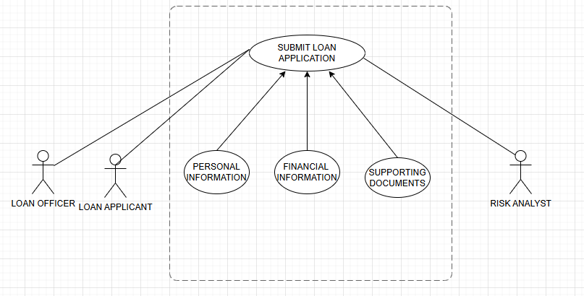

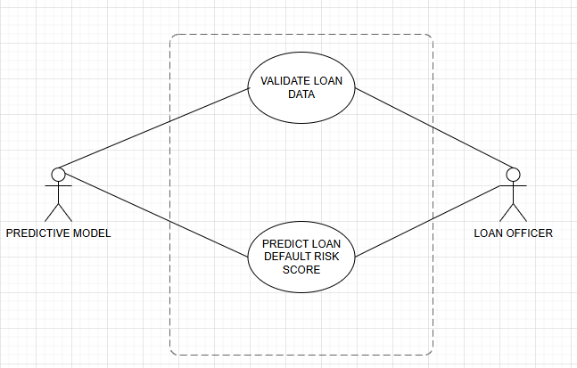

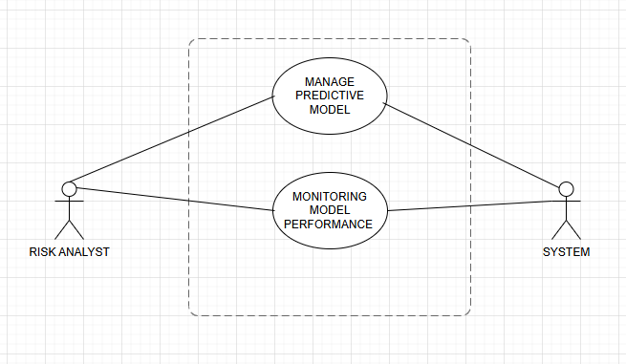

ACTIVITY DIAGRAM:
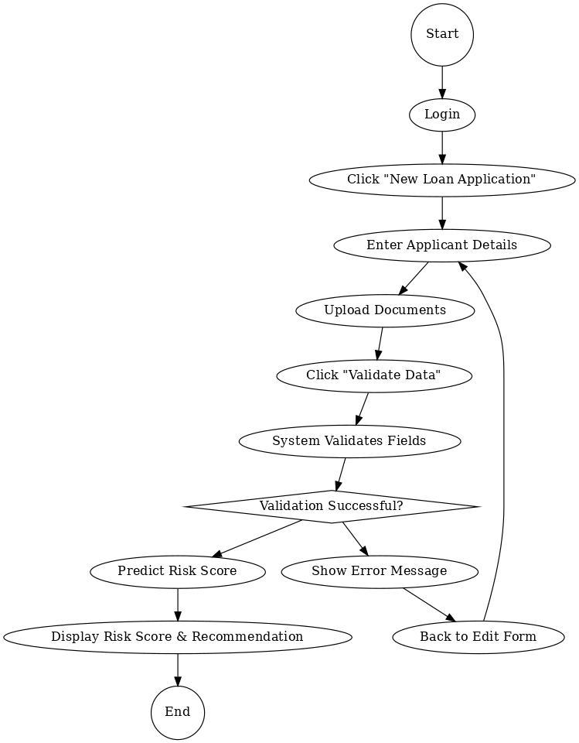
Document 7- Screens and pages

  - Home Page

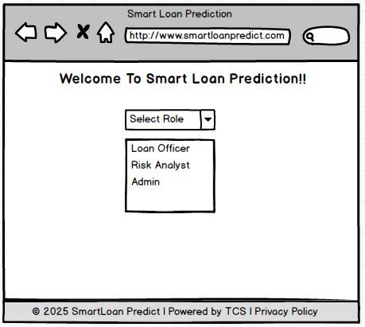

  - Login Page
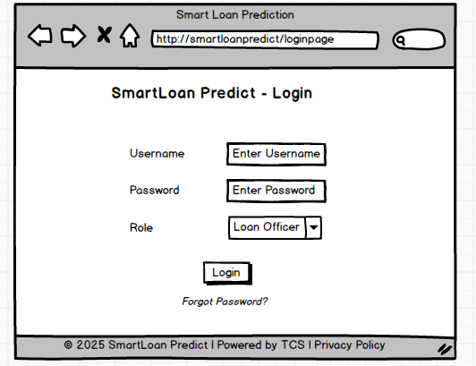

  - Loan Officer’s Home Page

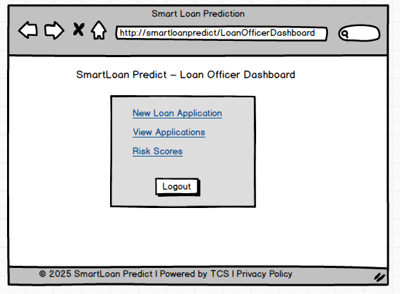

  - New Loan Application
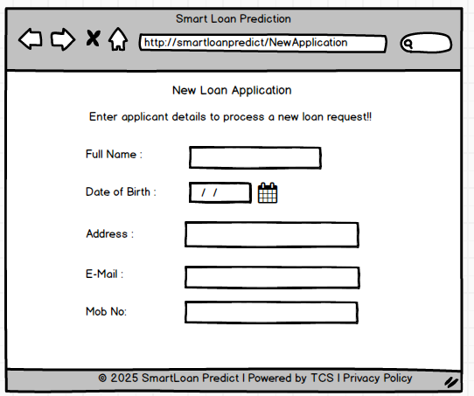
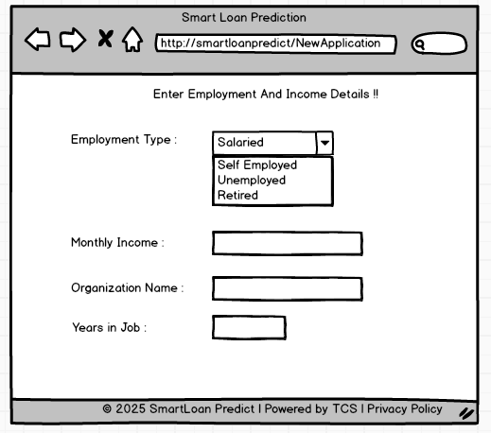

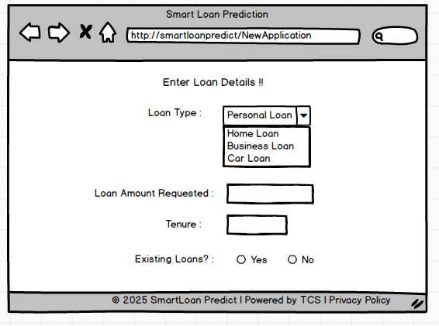

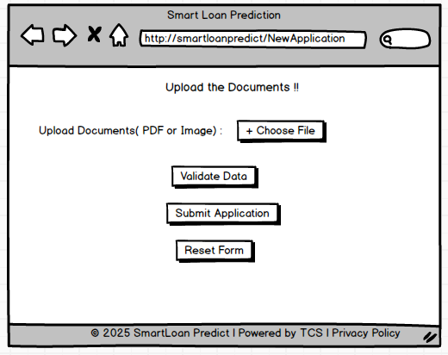
Document 8- Tools-Visio and Axure Write a paragraph on your experience using Visio and Axure for the project.
For this project, I primarily used Microsoft Visio and Balsamiq to support documentation and visualization of business requirements. Visio was instrumental in designing professional and clear use case diagrams, activity diagrams, and other UML artifacts, which helped communicate the system’s behaviour to stakeholders and the development team. Additionally, I used Balsamiq to create low-fidelity wireframes of key application screens. Its simple drag-and-drop interface made it easy to design mock-ups quickly and focus on layout and functionality without getting into visual details. Together, these tools enhanced collaboration across teams and ensured that both functional and non-functional requirements were well-understood during the Waterfall project lifecycle.

Document 9 – Business Analyst Experience.
As a Business Analyst, I was actively involved across key phases of the project lifecycle, particularly in requirement gathering and requirement analysis. Below is a summary of my experience:

1. Requirement gathering :
- I adopted the MoSCoW technique to categorize and prioritize requirements into Must Have, Should Have, Could Have, and Won’t Have. This helped manage stakeholder expectations effectively.
- During this phase, the client was intermittently unavailable, so I proactively identified alternative points of contact from their end to avoid project delays and collected the necessary inputs in a timely manner.
- I applied the FURPS model (Functionality, Usability, Reliability, Performance, and Supportability) to validate and evaluate the completeness and quality of gathered requirements.
- I identified and eliminated several redundant and duplicate requirements, ensuring clarity and avoiding confusion during later phases.
- I used prototyping techniques to help stakeholders better visualize the requirements, which encouraged more precise and practical inputs.

2. Requirement Analysis:
- I created various UML diagrams, including use case diagrams and activity diagrams, to clearly illustrate the functional requirements and process flows.
- These diagrams were shared with the cross-functional team for discussion. As a BA, I handled feedback from team members, facilitated discussions, and incorporated necessary modifications based on collaborative inputs.
- I was responsible for preparing detailed Business Requirement Specification (BRS) and Software Requirement Specification (SRS) documents, aligning them with both business needs and technical feasibility.

3. Design:
- Derived test cases directly from use case diagrams to ensure traceability.
- Engaged with the client to finalize design and solution documents.
- Authored both positive and negative test cases, ensuring coverage of all potential scenarios.
- Emphasized the importance of not missing test cases, as omissions can affect downstream development.
- Created relevant test data and ensured the RTM (Requirement Traceability Matrix) was continuously updated to reflect design decisions.

4. Development:
- Facilitated JAD (Joint Application Development) sessions to align development goals.
- Acted as the bridge between the technical team and business, clarifying requirements during implementation.
- Addressed conflicts or lack of cooperation by engaging in one-on-one discussions, promoting a healthy team environment.
- Encouraged developers to refer to visual diagrams (UML, activity flows) while coding.
- Coordinated regular meetings between the client and development team, handled attendance challenges by recording sessions and conducting follow-ups.

5. Testing:
- Prepared test cases using earlier use case documentation as a base.
- Participated in high-level functional testing to validate core business flows.
- Coordinated with the client to obtain realistic test data.
- Kept the RTM up-to-date and ensured complete coverage.
- Obtained client sign-off post testing and supported User Acceptance Testing (UAT) readiness.

6. Deployment:
- Sent the finalized RTM to the client, attaching it to the project closure document.
- Coordinated the creation and distribution of end-user manuals.
- Organized and facilitated training sessions for business users and stakeholders.
- Ensured full participation in training, tracked attendance, and addressed gaps proactively.

