Project Prep 1 Case Part 2
-RAVI KUMAR-
Question 1: Audits (Q1, Q2, Q3, Q4 for BA)
As a Business Analyst, quarterly project audits are vital checkpoints throughout the project lifecycle:
- Q1: Requirement Gathering Review
  - Inspect if business needs are fully captured.
  - Ensure stakeholder interviews, meeting notes, and elicitation records (e.g., workshop outputs) are well documented.
  - Verify requirement traceability, confirming all needs are linked to solutions.
- Q2: Analysis & Specification Audit
  - Confirm all requirements have supporting specs (BRD, SRS), and that documentation is current.
  - Check that UML diagrams and mapping (e.g., process, activity, use cases) are signed off.
  - Ensure requirements are clearly prioritized and any ambiguities are resolved.
- Q3: Design & Handoff Audit
  - Review alignment between requirements and technical design–are developer handoff packs (UML, RTM, user stories) validated by BA
  - Verify consistent communication records between BA and technical team.
- Q4: UAT and Final Readiness
  - Make sure test cases trace back to original requirements.
  - Validate that end-user manuals and UAT signoff forms are ready.
  - Check defect and change request logs for completeness and transparent closure.
Overall, the BA maintains records of all communications, approvals, and changes, enabling auditors to track project decisions and the current state effectively.
Question 2 – BA Approach Strategy
Key steps in my BA approach strategy are as follows:
- Discover & Plan
- Identify all stakeholders: farmers (users), buyers, technical team, business sponsors, logistics partners.
- Gather initial requirements by reviewing existing documents and attending project kick-off meetings to understand project goals such as facilitating buying and selling of agriculture products online.
- Elicit Requirements
- Conduct interviews with key stakeholders to understand their needs and challenges.
- Use interactive methods like process walkthroughs and quick prototyping to gather feedback.
- Conduct focus groups or workshops for collaborative insights, when possible.
- Analyse Stakeholders
- Create a detailed stakeholder map indicating roles and responsibilities.
- Develop a RACI matrix to clearly allocate who is Responsible, Accountable, Consulted, and Informed for various tasks.
- Clarify stakeholders’ influence and interest levels to manage expectations.
- Documenting Requirements
- Prepare key requirement documents including Business Requirements Document (BRD), Software Requirements Specification (SRS), use case specifications, and wireframes.
- Maintain version control and share these documents for peer and stakeholder reviews.
- Getting Approvals
- Use structured sign-off sheets or digital workflows to capture approvals for milestones and changes.
- Track versions and approval status to ensure accountability.
- Communication Channels
- Establish both synchronous communication (meetings, calls) and asynchronous communication (emails, project portal) channels.
- Maintain a stakeholder communication plan to provide regular updates and status reports.
- Change Management
- Set up a formal change request process to document, analyse, estimate, and gain approval for requirement changes.
- Ensure proper logging and impact analysis before implementing changes.
- Progress Reporting
- Provide periodic status reports and dashboards to keep stakeholders informed.
- Schedule regular review meetings to discuss progress, challenges, and next steps.
- UAT and Acceptance
- Prepare User Acceptance Testing (UAT) scenarios aligned with business requirements.
- Facilitate UAT sessions with end users such as farmers and buyers.
- Obtain signed Client Project Acceptance forms after successful UAT completion.

Question 3 – 3-Tier Architecture
3-Tier Architecture is a way of organizing software applications into three separate layers or “tiers.” Each tier has a clear role, making applications easier to build, manage, and scale.
1. Presentation Tier
- What it does: This is the layer users directly interact with. It displays information to the user and takes input from them.
- Example: Web pages, mobile app screens, or system dashboards.
2. Application (Business Logic) Tier
- What it does: This middle layer processes the actual business logic. It takes requests from the presentation layer, applies business rules, and decides what should happen next.
- Example: Applying discounts to orders, validating user logins, or calculating totals.
3. Data Tier
- What it does: This layer handles storing and retrieving all the application’s data. It interacts with databases to save, update, or fetch information as needed.
- Example: Managing product information, user data, or purchase records.
Why Use 3-Tier Architecture?
- Better Scalability: Each layer can be scaled separately based on demand.
- More Maintainable: Changes in one tier (like updating the user interface) don’t impact the others.
- Improved Security: Sensitive data access is limited to the data layer, reducing risk.
- Flexibility: Technology choices can differ between layers (e.g, web frontend, Java backend, SQL database).
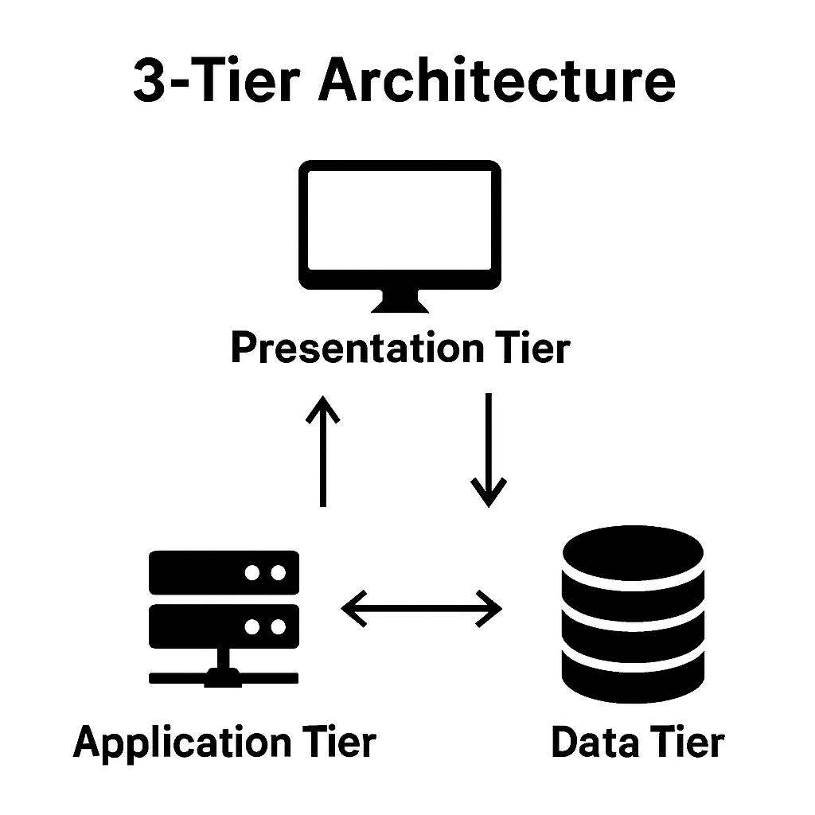

Question 4 – BA Approach for Framing Questions
1. 5W1H Method
I start with the 5W1H (Who, What, Where, When, Why, and How) framework:
- Who: Identify all key participants and decision-makers.
- What: Clarify the subject, process, or system under discussion.
- Where: Specify where processes take place or where the impact will be felt.
- When: Determine process times, deadlines, and timeframes.
- Why: Investigate the reasons, goals, or value behind actions or needs.
- How: Understand the process, workflow, or operational steps involved.
This holistic questioning helps provide a complete understanding of the situation and context.
2. SMART Criteria
- Specific: Address one issue or topic at a time.
- Measurable: Can be tracked or quantified for progress.
- Achievable: Realistic given the organization’s resources and constraints.
- Relevant: Directly linked to objectives or project goals.
- Time-Bound: Include timeframes for practical action.
This approach ensures that answers you receive are clear, actionable, and useful for follow-up.
3. Role Awareness (RACI)
I clarify stakeholders and accountability by referencing the RACI model:
- Responsible: Who does the work?
- Accountable: Who’s ultimately answerable?
- Consulted: Who needs to provide input?
- Informed: Who needs status updates?
Including these elements in questions ensures each person’s involvement and responsibility are clear.
4. Architectural Relevance
Questions are tailored for each layer of the system or organization. For example:
- For business processes, I ask about workflows and decision points.
- At the application or data level, I target integration, data flows, or security needs.
- For infrastructure, my questions address hardware, scalability, and reliability.
This guarantees that requirements at every “layer” are considered.
5. Scenario-Driven Approach
- Deep dive into the specific journeys, pain points, and needs of end-users or customers.
- Ask What would you do if questions to uncover requirements that might otherwise be overlooked.
6. Model Orientation
I often use visual aids, such as:
- Wireframes: To show basic screens or interfaces.
- Activity Diagrams: To map process flows step-by-step.
- Prototypes: To give stakeholders an early feel for solutions.
These models help everyone involved to better understand and respond to the questions being discussed.
7. User-Centricity
- The practical, day-to-day needs of real users.
- Varying levels of digital literacy and comfort with new systems.
- Operational realities—such as working environments, device constraints, or time pressures.
This ensures solutions are practical, usable, and widely accepted.
applying these methods ensures that the questions I ask as a business analyst are thorough, clear, actionable, and tailored to deliver the best possible outcomes for every stakeholder involved.
Question 5 – Elicitation Techniques
1. Brainstorming
- Purpose: Rapidly generate a wide range of ideas or solutions in a group, encouraging creative thinking.
- When useful: Early in the project to discover features, pain points, or process improvements.
Example: Host a brainstorming session with Peter, Kevin, Ben, and Mr. Henry to list all features that could make the app more accessible to local farmers (e.g., local language support, mobile access, simple navigation).
2. Document Analysis
- Purpose: Identify business rules, gaps, and system requirements by reviewing current documents, records, and manuals.
- When useful: Understanding existing processes or regulations before creating new solutions.
Example: Analyze fertilizer/seeds manufacturer catalogues, village procurement records, and agriculture policy guidelines to determine what product information must be collected and displayed.
3. Requirements Workshops
- Purpose: Collaborative, structured sessions with stakeholders to define, discuss, and prioritize requirements.
- When useful: Gaining consensus, resolving conflicts, and rapidly collecting detailed requirements.
Example: Organize a workshop with SOONY Committee members, APT IT Solution staff, and farmer representatives to map out the user registration and purchasing workflow.
4. Focus Groups
- Purpose: Gather diverse opinions, preferences, and experiences from a group of real or potential users.
- When useful: Understanding user expectations, usability requirements, and cultural nuances.
Example: Conduct a focus group including Peter, Kevin, Ben, and other local farmers to discuss frustrations with current buying processes and gather insights on what a user-friendly digital solution would look like.
5. Observation
- Purpose: Directly observe users performing tasks to uncover hidden needs, workarounds, and real-world challenges.
- When useful: Revealing issues users may not verbalize or be aware of.
Example: Watch Ben as he navigates his usual process of buying fertilizers learning about travel hassles, in-store product selection, and documentation, to inform easier digital workflows.
6. Joint Application Development (JAD) Workshops
- Purpose: Intensive group sessions for users, managers, and developers to collaboratively build and validate system solutions.
- When useful: When fast decision-making and creation of design artifacts are needed.
Example: Bring together project managers, developers, testers, and farmer representatives for a JAD session to plan out the app’s product catalog and order processing modules.
7. Job Shadowing
- Purpose: Closely follow users during their daily activities to deeply understand task flows and real work challenges.
- When useful: For intricate processes or jobs with many steps.
Example: Shadow Kevin throughout his day to see exactly how, when, and why he decides to buy seeds, and what issues or delays he faces guiding better app timing and notification features.

8. Interviews
- Purpose: Capture in-depth and specific information through one-on-one or small group conversations.
- When useful: Clarifying complex requirements, stakeholder goals, or technical constraints.
Example: Meet with Ms. Juhi (Senior Java Developer), Mr. Mike (Network Admin), and John (DB Admin) to learn what’s needed technically for farmers and manufacturers to interact safely and reliably on the platform.
9. Prototyping
- Purpose: Use simple models or mock-ups to elicit feedback and clarify requirements before full development.
- When useful: Early-stage validation of requirements, usability testing, and visualizing ideas.
Example: Show wireframes of the app’s main screens to Ben and the team, refining layouts and navigation based on immediate user reactions.
10. Questionnaires/Surveys
- Purpose: Collect consistent information from a large or geographically dispersed group efficiently.
- When useful: Gathering baseline data, preferences, or feedback at scale.
Example: Send out a survey to many farmers in the region, asking about their access to smartphones, internet, preferred languages, and challenges faced with current procurement methods.
11. User Task Analysis
- Purpose: Break down target user tasks step-by-step to identify pain points, requirements, and optimization opportunities.
- When useful: For detailed, workflow-based requirements gathering and improving user experience.
Example: Map the entire process Peter currently follows to buy pesticides, highlighting confusing or unnecessary steps, and redesign the digital process in the app to be faster and simpler.

Question 6 – Project Elicitation Techniques
1.Prototyping
Since many end users are farmers from remote areas with potentially low digital literacy, prototyping helps create tangible, visual representations of the application’s UI and features. Farmers can interact with these early models to understand workflows and provide feedback, ensuring the solution is user-friendly and intuitive before development. This reduces costly redesigns later and builds stakeholder confidence.
2. Use Case Specifications
Use cases document detailed step-by-step interactions between farmers, manufacturers, and the system (e.g., product browsing, ordering, delivery requests). This structured approach clarifies functional requirements for developers and testers and ensures all user scenarios—including exceptions—are considered comprehensively.
3. Document Review
Reviewing existing documents such as farming protocols, product catalogs, regulatory guidelines, and historical purchase records helps identify mandatory data fields, compliance needs, and existing gaps. This ensures the new system aligns well with real-life agricultural practices and legal constraints while uncovering implicit requirements that stakeholders might not articulate.
4. Brainstorming
Engaging all relevant parties Mr. Henry, the farmer representatives (Peter, Kevin, Ben), the SOONY Committee, and the APT IT SOLUTIONS project team in brainstorming sessions fosters creative thinking and collective problem solving. It surfaces innovative features, usability enhancements (such as local language support or offline notifications), and commercial opportunities, helping create a comprehensive, well-rounded requirements set.
.
Question 7
10 Business Requirements
- Multi-User Registration and Profiles
The application must allow registration and profile creation for two main types of users:
- Farmers (buyers)
- Manufacturers/Companies (sellers of seeds, fertilizers, pesticides)
- Product Catalogue Management
Manufacturers must be able to add, update, and remove product details (such as name, description, price, images, usage instructions, and quantity in stock) for seeds, fertilizers, and pesticides.
- Product Search and Filtering
Farmers should be able to browse all available products, search by product type, keywords, company, or filter by price, ratings, or best sellers.
- Product Ordering and Payment
Farmers must be able to add selected products to a cart and complete their purchase through secure online payment methods (e.g., net banking, UPI, credit/debit cards).
- Delivery and Shipping Management
The platform must support farmers to input their location/address and should track delivery status, expected delivery date, and shipping charges if any.
- Communication Channel
There must be a secure messaging or inquiry system allowing farmers to communicate with manufacturers regarding product details, bulk orders, or usage consultations.
- Multi-Language Support
To cater for remote area farmers, the application must support multiple regional languages for ease of use and accessibility.
- User-Friendly Interface
The application must be simple and intuitive to use for users with minimal technical know-how, including clear navigation menus, help guides, and tooltips.
- Order History and Receipts
Farmers should be able to view their order history, download invoices/receipts, and re-order previously bought products.
- Feedback and Ratings
Farmers should be able to rate products and write feedback/reviews after purchase, and companies should be able to respond to feedback.

Question 8 – Assumptions
- All users have fundamental familiarity with smartphones or web access.
- Reliable payment channels and logistics are accessible in rural locations.
- All compliance and digital transaction permissions are managed.
- Users can receive SMS/email notifications.
- Adequate end-user support is available.

Question 9 – Requirements Priority

Req ID | Name | Description | Priority
BR001 | Search Products | Find/browse products | 9
BR002 | Upload Inventory | Manufacturer posts items | 8
BR003 | User Auth | Login/registration | 10
BR004 | Wishlist | Add to wishlist | 6
BR005 | Payments | Multiple online/COD options | 9
BR006 | Notifications | SMS/email alerts | 8
BR007 | Order Tracking | Shipment tracking info | 7
BR008 | Security | Data/payment safety | 10
BR009 | Responsive UI | Mobile device compatibility | 7
BR010 | Local Language | Multilingual support | 6

Question 10 – Use Case Diagram
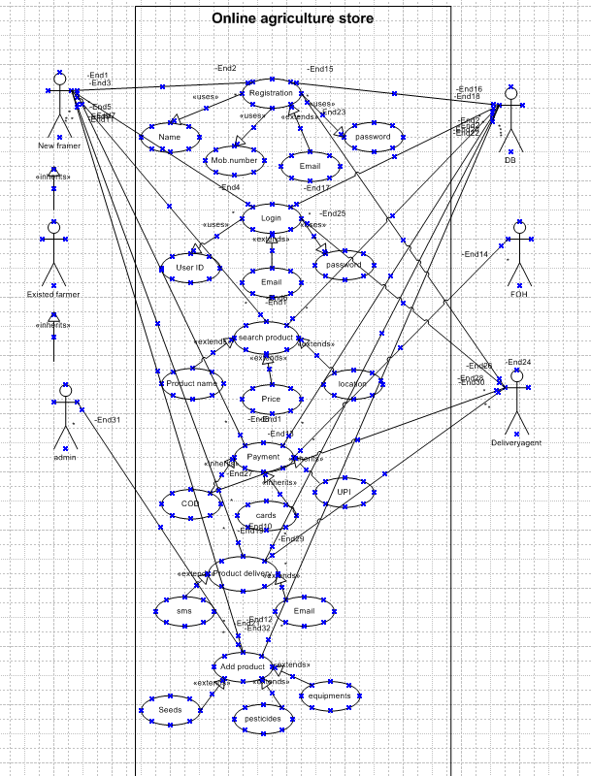

Question 11 – Minimum 5 Use Case Specs.
Use Case 1: Manufacturer Registers & Adds Product
Use Case | Manufacturer Registers & Adds Product
Actors | Manufacturer (Fertilizer, Seeds, Pesticides companies)
Preconditions | Manufacturer has access to the application and registration details.
Main Flow | 1. Manufacturer registers on the platform.  2. Manufacturer logs in.  3. Enters product details (fertilizers, seeds, pesticides).  4. Submits product details.  5. Product information is stored and displayed for farmers.
Alternative Flows | A1: If registration fails, display error and retry.  A2: If product info is invalid, prompt correction.
Postconditions | Product details are available for browsing by Farmers.
Exceptions | Network failure; system error during product submission.

Use Case 2: Farmer Browses Products
Use Case | Farmer Browses Products
Actors | Farmer
Preconditions | Farmer has access to the application with internet connectivity.
Main Flow | 1. Farmer logs into the system.  2. Navigates product categories (fertilizers, seeds, pesticides).  3. Views product details and prices.  4. Filters or searches for required products.
Alternative Flows | A1: No products available message.  A2: Farmer browses as guest (if allowed).
Postconditions | Farmer identifies required products for purchase.
Exceptions | Slow internet, product loading failure.

Use Case 3: Farmer Places Order
Use Case | Farmer Places Order
Actors | Farmer
Preconditions | Farmer is logged in and has selected products to buy.
Main Flow | 1. Farmer adds selected product(s) to cart.  2. Provides delivery address.  3. Confirms order.  4. System processes order and sends confirmation.  5. Order details sent to manufacturer for fulfillment.
Alternative Flows | A1: Modify order before confirmation.  A2: Order cancellation before dispatch.
Postconditions | Order successfully placed and pending delivery.
Exceptions | Payment failure; address validation failure.

Use Case 4: Manufacturer Confirms Order and Ships Product
Use Case | Manufacturer Confirms Order and Ships Product
Actors | Manufacturer
Preconditions | Manufacturer receives order notification from system.
Main Flow | 1. Manufacturer reviews the order details.  2. Confirms order acceptance.  3. Processes shipment to farmer’s delivery address.  4. Updates order status in the system.
Alternative Flows | A1: Manufacturer rejects order if out of stock.  A2: Manufacturer requests order modification.
Postconditions | Order is shipped and farmer receives shipment details.
Exceptions | Delay or failure to ship; inventory errors.

Use Case 5: Farmer Tracks Delivery Status
Use Case | Farmer Tracks Delivery Status
Actors | Farmer
Preconditions | Farmer has placed an order and has login access.
Main Flow | 1. Farmer logs in.  2. Navigates to order history.  3. Selects order to track.  4. Views current status and estimated delivery time.
Alternative Flows | A1: Farmer receives notification updates via email or SMS.
Postconditions | Farmer is informed of delivery progress.
Exceptions | Status update failure; delay in status information.

Question 12 – Minimum 5 Activity Diagrams
1.User Registration:
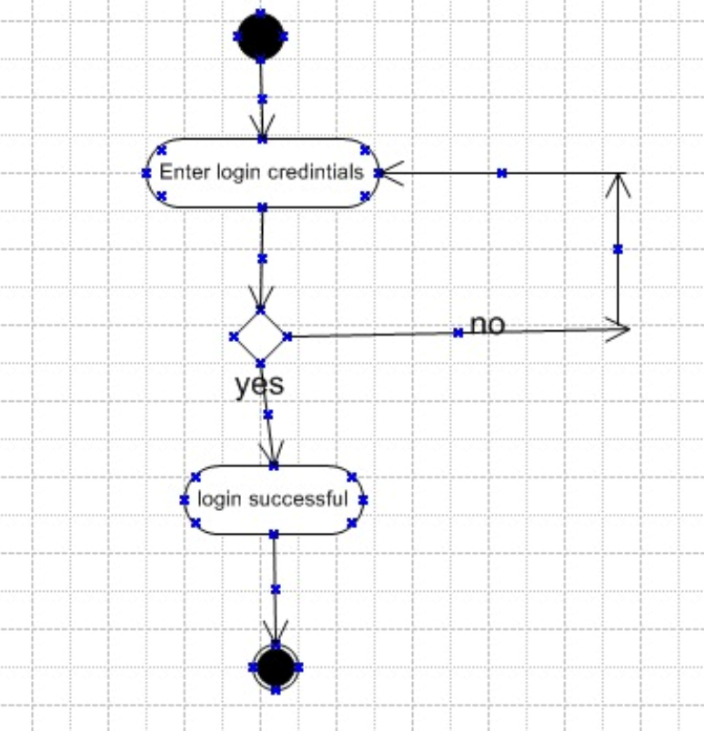

- Product delivery
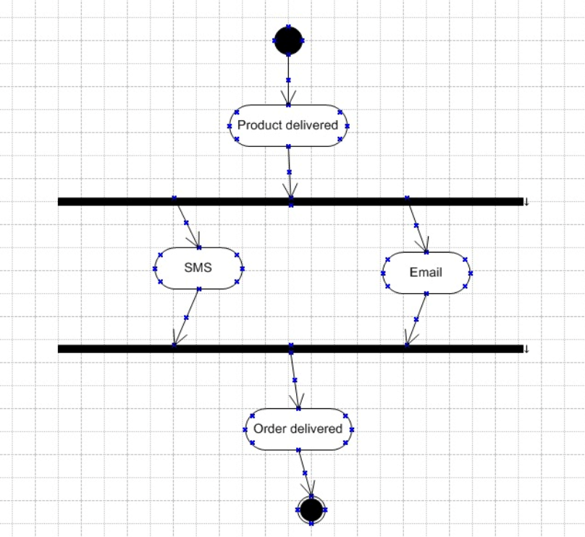

- Payment
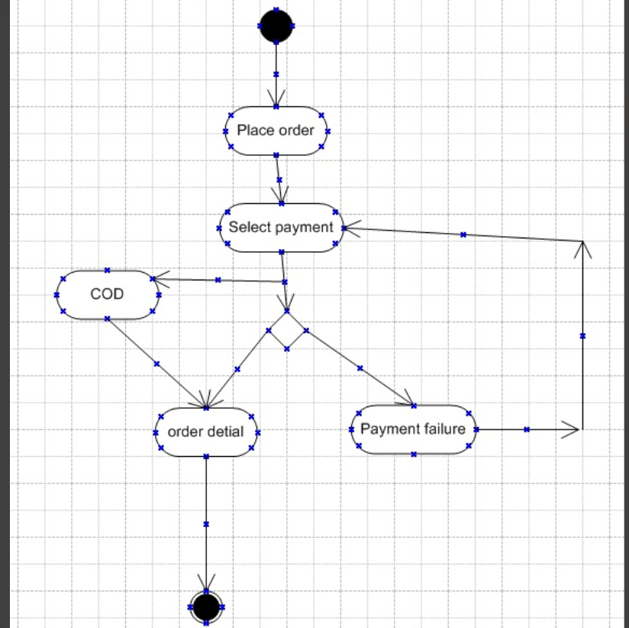

- Order placement
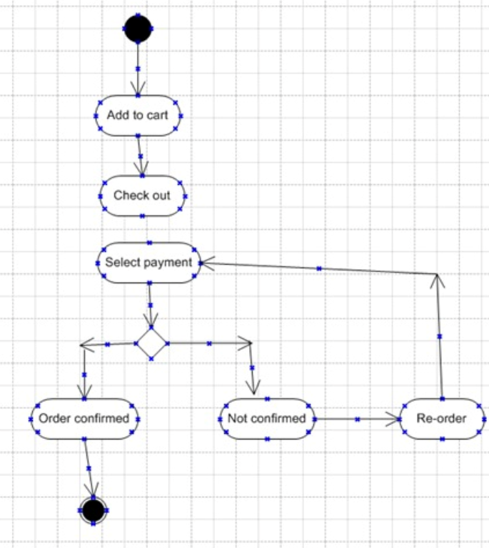

- Add products

