Nurturing Process – Waterfall Deliverables – Part -2/2- V2D2 August 2024
Part 2/2 Evaluation
Document 6- Please prepare a use case diagram, activity diagram and a use case specification document.
Document 7- Screens and pages
Document 8- Tools-Visio and Axure
Document 9- BA experience
Answers:
Document 6- Please prepare a use case diagram, activity diagram and a use case specification document.
Use Case Specification Document – View Account Statement
1. Use Case Name:
View Account Statement
2. Use Case Description:
This use case allows bank staff to view a customer’s account transaction history over a custom date range and export the statement in PDF or Excel format. It improves service quality and reduces the need for backend teams to generate statements manually.
3. Actors:
- Primary Actor: Bank Staff
- Secondary Actor: None (System-only interaction)
4. Basic Flow:
- Bank staff logs into the iView system.
- Staff enters the Customer ID or PAN/Mobile number.
- System fetches customer details.
- Staff selects the “View Statement” option.
- Staff enters the start date and end date for the desired range.
- System retrieves the transaction list within the date range.
- Staff reviews the on-screen transaction history.
- Optionally, staff selects “Export to PDF” or “Download as Excel”.
- System generates the file and allows download or printing.
- System logs the activity for audit.
5. Alternate Flow:
- If no transactions are found for the selected range, the system displays:
- “No transactions found for the selected date range.”
- Staff can select a different date range.
6. Exceptional Flows:
- Invalid date range (e.g., start date after end date): Show validation error
- System timeout or backend fetch failure: Display error message and suggest retry
- Customer ID not found or inactive account: Show appropriate error and stop further processing
7. Pre-Conditions:
- Bank staff is authenticated and authorized
- Customer ID is valid and account is active
8. Post-Conditions:
- Transaction data is displayed or exported
- User action is logged in the audit trail
9. Assumptions:
- The system has access to all historical transaction data
- Export functionality is properly configured and enabled
10. Constraints:
- Date range limited to a maximum of 12 months per query
- Exported files are read-only and digitally stamped
- Transactions older than 5 years may be archived and not available instantly
11. Dependencies:
- Backend transaction database
- Export module (PDF/Excel generation)
- Audit logging system
12. Inputs and Outputs:
- Inputs: Customer ID/PAN/Mobile, Start Date, End Date
- Outputs: On-screen transaction list, Exported PDF/Excel file, Audit entry
13. Business Rules:
- Only authorized staff can access customer transaction history
- Exported statements must include date, time, and staff ID
- Audit trail must capture every view/export action with timestamp
14. Miscellaneous Information:
- All exports should be watermarked with “Confidential – Internal Use Only”
- PDF should be digitally signed by the system
- Excel export to follow RBI-compliant formatting rules if applicable

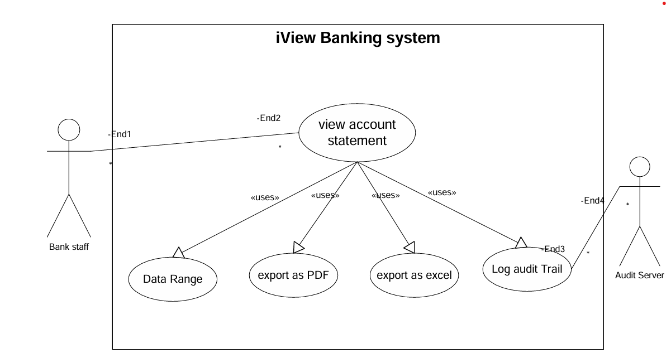

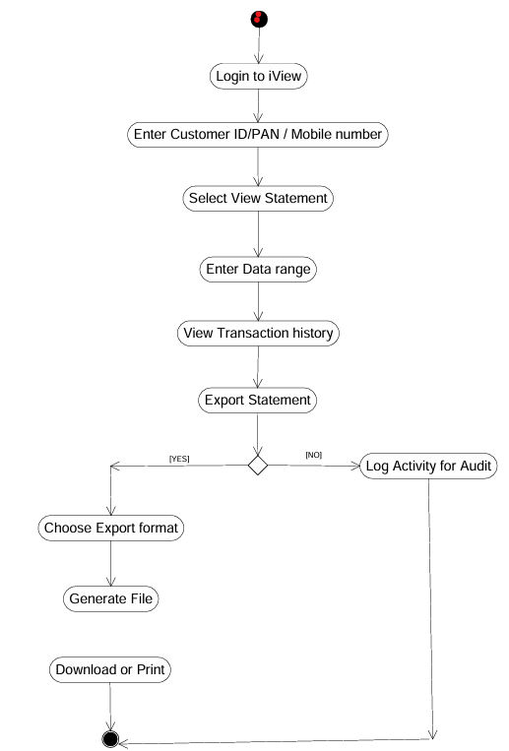

Use Case Specification Document – Use Case: Update Mobile Number
1. Use Case Name:
Update Mobile Number
2. Use Case Description:
- Allows bank staff to update the customer’s mobile number securely using OTP validation.
3. Actors:
- Primary: Bank Staff
- Secondary: OTP System
4. Basic Flow:
- Bank staff logs in to iView
- Enters Customer ID
- Selects “Update Mobile Number”
- Enters new number
- System sends OTP
- Staff enters OTP
- System validates OTP
- Mobile number is updated
- Confirmation shown
5. Alternate Flow:
- If OTP is not received, the staff can request to resend OTP (limit 3 attempts)
6. Exceptional Flows:
- Invalid OTP entered 3 times → process is blocked, and a manual request must be initiated
- System unable to send OTP due to network/server issues → show error and suggest retry later
7. Pre-Conditions:
- Staff is authenticated and logged into the iView system
- Customer ID is valid
8. Post-Conditions:
- Mobile number is updated and audit log is generated
- Customer record reflects the change
9. Assumptions:
- OTP service is integrated and active
- Customer has access to the new mobile number to receive OTP
10. Constraints:
- OTP valid for 5 minutes
- Maximum 3 attempts allowed per session
- Only authorized staff can perform this update
11. Dependencies:
- OTP/email gateway system
- Core customer database access
12. Inputs and Outputs:
- Input: Customer ID, New Mobile Number, OTP
- Output: Confirmation message, audit log entry
13. Business Rules:
- OTP must be validated before any contact update is made
- Every update must be logged for audit purposes
- System must notify of any failed attempts
14. Miscellaneous Information:
- Contact updates must comply with data security and KYC regulations
- Changes must reflect across all bank systems during the next sync
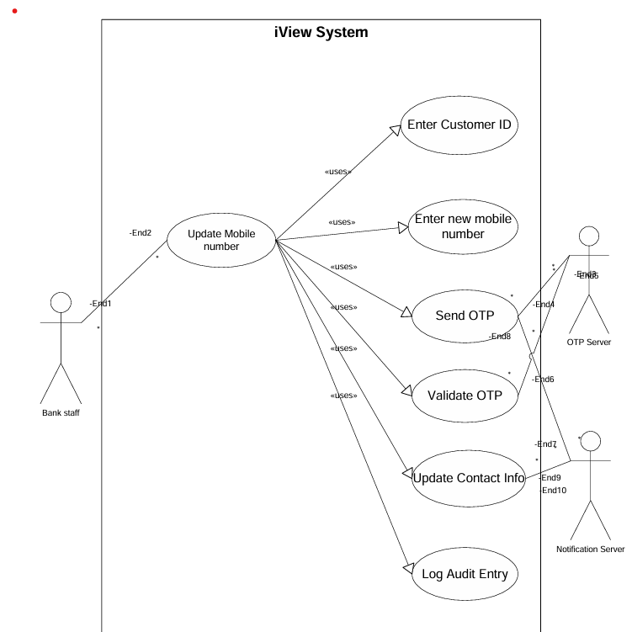

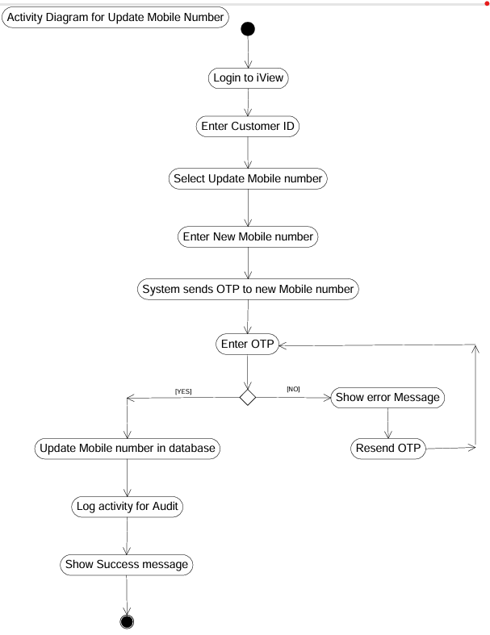

Use Case Specification – Update Email ID
1. Use Case Name:
Update Email ID
2. Use Case Description:
This use case enables bank staff to securely update a customer’s email ID through the iView system. The process includes OTP validation sent to the new email ID, ensuring compliance with data accuracy and audit requirements.
3. Actors:
- Primary Actor: Bank Staff
- Secondary Actor: Email System / OTP Service
4. Basic Flow:
- Bank staff logs into the iView system.
- Staff enters the Customer ID or PAN/Mobile Number to fetch customer details.
- Staff selects the “Update Email ID” option.
- Staff enters the new email ID.
- System sends a One-Time Password (OTP) to the new email ID.
- Staff enters the received OTP.
- System verifies the OTP.
- If valid, the email ID is updated in the system.
- System logs the activity for audit purposes.
- Confirmation message is displayed to the staff.
5. Alternate Flow:
- If the OTP is not received:
- Staff can select “Resend OTP” (allowed up to 3 times).
- If customer wants to cancel the update:
- Staff selects “Cancel Operation”, and no changes are made.
6. Exceptional Flows:
- Invalid OTP entered 3 times: System blocks the update process and prompts the staff to raise a manual service request.
- Email server/OTP service unavailable: Display error and suggest trying again later.
- New email ID is same as the old one: System shows a validation message and prevents submission.
7. Pre-Conditions:
- Bank staff is logged into the iView system.
- The customer record must be active and retrievable.
8. Post-Conditions:
- Email ID is updated in the system if OTP validation is successful.
- Audit log is recorded for compliance.
9. Assumptions:
- Customer has access to the new email inbox to retrieve the OTP.
- OTP service is reliable and timely.
- Staff has proper authorization.
10. Constraints:
- OTP must be validated within 5 minutes.
- Only 3 attempts to resend or validate OTP are allowed.
- System must comply with audit and data protection policies.
11. Dependencies:
- Email/OTP gateway integration.
- Customer database access.
- Audit logging mechanism.
12. Inputs and Outputs:
i. Inputs:
- Customer ID
- New Email ID
- OTP
ii. Outputs:
- Confirmation of successful update
- Audit log entry
- Error messages (if any)
13. Business Rules:
- Email updates must be validated via OTP.
- No update is permitted without successful OTP confirmation.
- Every update attempt must be logged, whether successful or failed.
- Staff ID and timestamp must be included in the audit trail.
14. Miscellaneous Information:
- Exportable activity logs may be required for internal or regulatory audits.
- Updates must reflect in downstream systems during the next sync cycle.
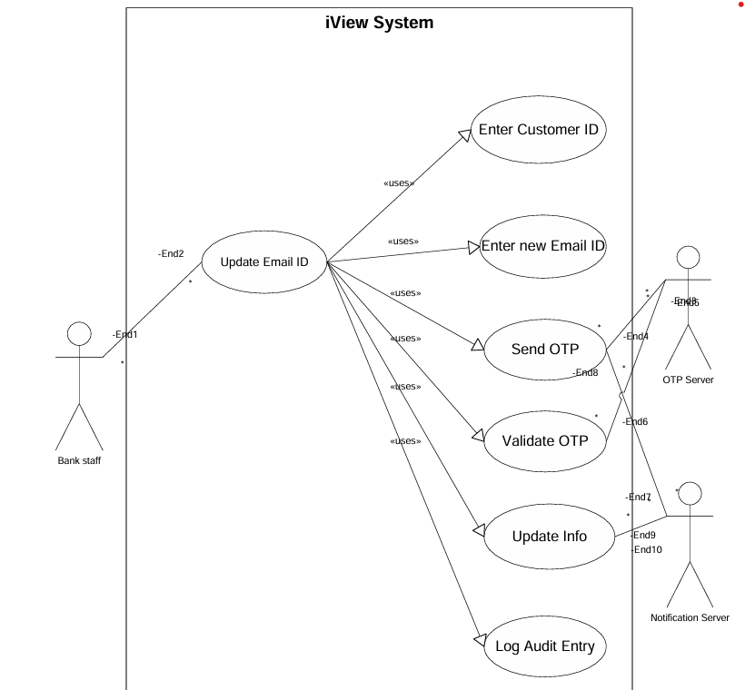

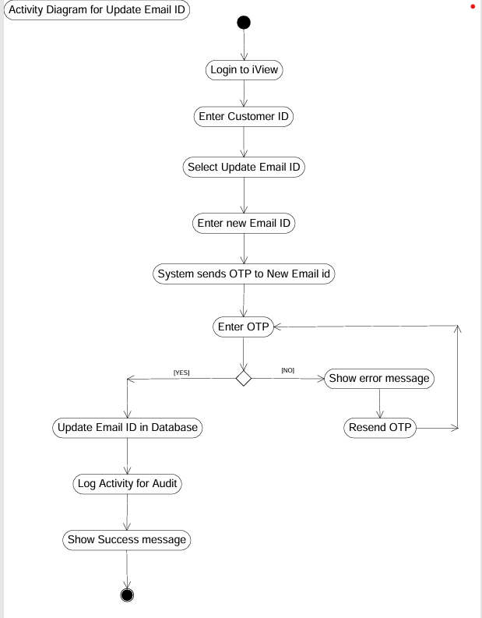

Use Case Specification – Update Address
1. Use Case Name:
Update Address
2. Use Case Description:
This use case enables authorized bank staff to update a customer’s communication address in the iView system. The process requires OTP-based authentication to ensure security and regulatory compliance. The new address will be reflected across bank systems after validation.
3. Actors:
- Primary Actor: Bank Staff
- Secondary Actor: OTP System (Email/SMS gateway)
4. Basic Flow:
- Bank staff logs into the iView application.
- Staff enters the Customer ID / PAN / Mobile number to retrieve details.
- Staff selects “Update Address”.
- Staff enters the new address (flat/building, street, city, state, PIN code).
- System sends an OTP to the customer’s registered mobile number or email ID.
- Staff enters the OTP received by the customer.
- System validates the OTP.
- If OTP is valid, the system updates the address.
- System logs the activity for audit purposes.
- System displays a success confirmation.
5. Alternate Flow:
- If OTP is not received, the staff may click on “Resend OTP” (up to 3 times).
- If the customer decides not to proceed, staff can click “Cancel Update”, aborting the process.
6. Exceptional Flows:
- Incorrect OTP entered 3 times: System blocks the update. Manual process must be initiated.
- System fails to send OTP (network/email issue): Display error message and suggest retry later.
- Entered address is same as current address: Validation error shown, update is not allowed.
7. Pre-Conditions:
- Staff is authenticated in the system.
- Customer record is active.
- OTP channel (mobile/email) is accessible.
8. Post-Conditions:
- Address is updated in the system after OTP verification.
- An audit entry is generated.
- Change is reflected during next system sync.
9. Assumptions:
- Customer has access to receive OTP.
- Staff is trained in handling sensitive data.
- System integration with core banking and audit log exists.
10. Constraints:
- OTP expires after 5 minutes.
- Max 3 OTP entry attempts per session.
- Staff must not bypass OTP process under any condition.
- Address must comply with Indian postal standards (valid PIN, etc.).
11. Dependencies:
- OTP/email/SMS gateway.
- Customer database.
- Core system for address synchronization.
- Audit trail component.
12. Inputs and Outputs:
i. Inputs:
- Customer ID
- New Address (including PIN code)
- OTP
ii. Outputs:
- Address update confirmation
- Audit log entry
- Error messages (if any)
13. Business Rules:
- No address update is accepted without OTP validation.
- Staff ID, timestamp, and customer ID must be logged.
- Only authorized staff roles can perform address changes.
- System must trigger downstream updates post-change.
14. Miscellaneous Information:
- Address updates may be subject to additional document collection (e.g., proof of address) based on internal policies.
- Optional notification may be sent to customer after update.
- May require periodic reporting for compliance tracking.
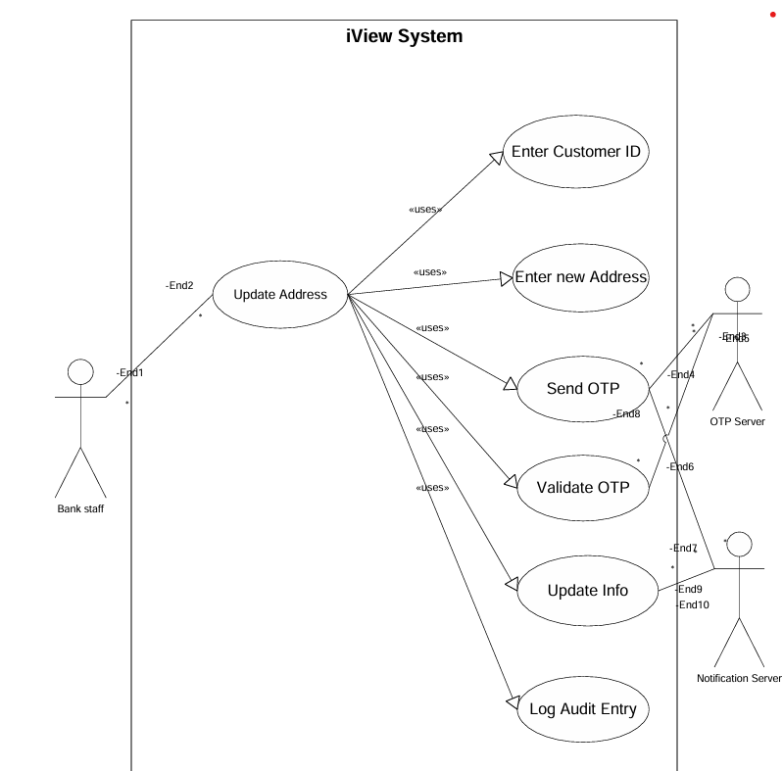

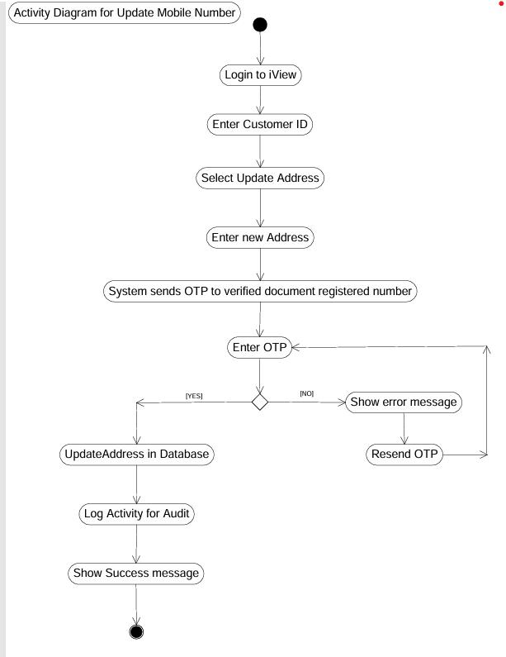

Document 7- Screens and pages
Mock-ups for viewing and downloading statement
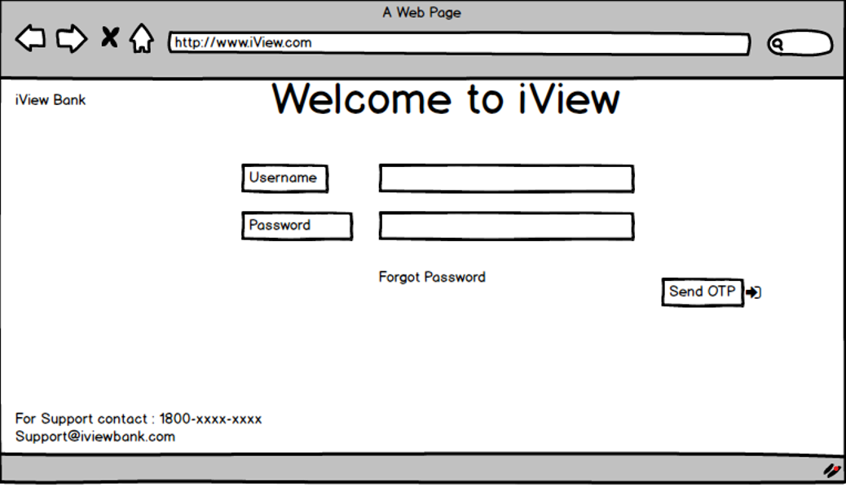
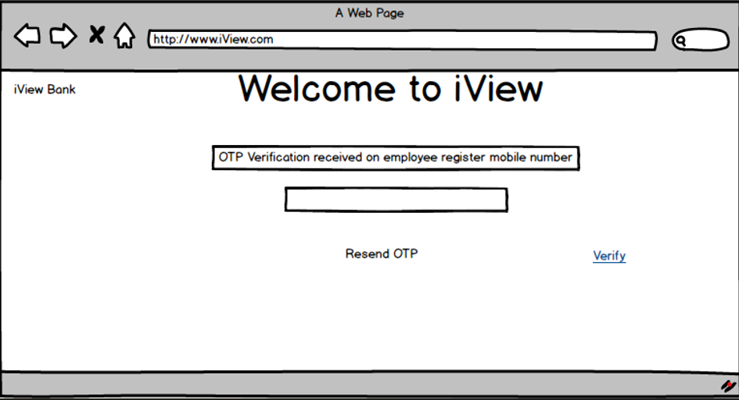
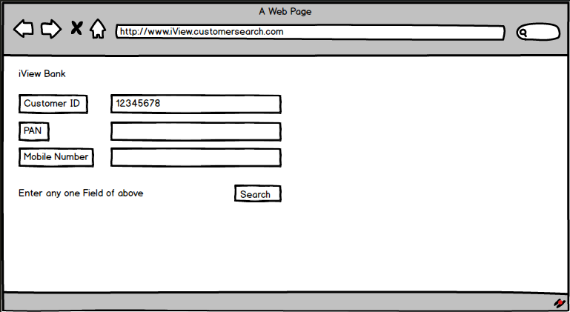
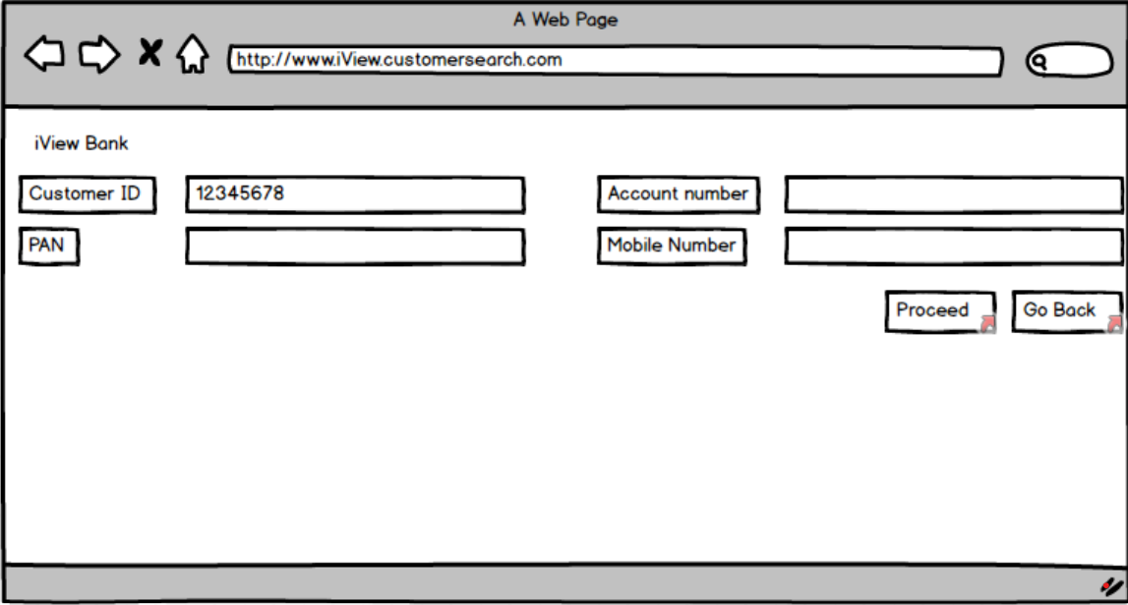
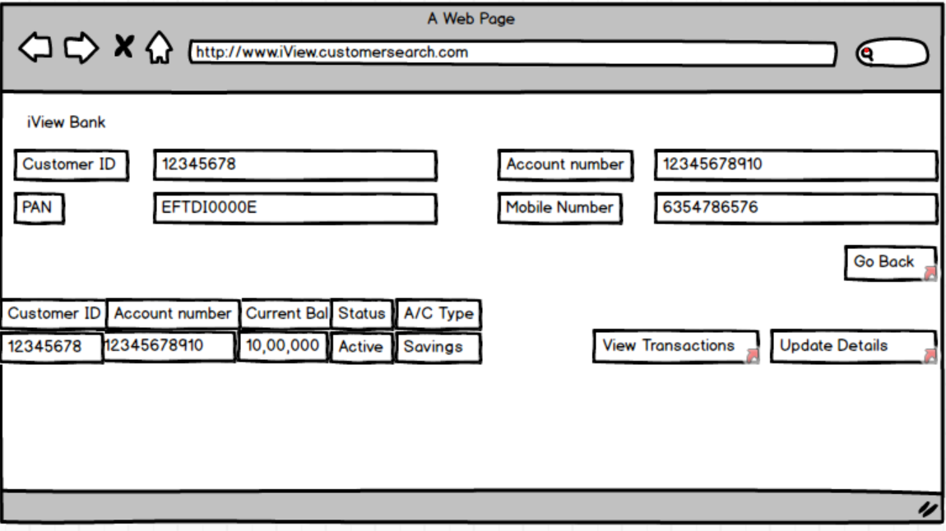
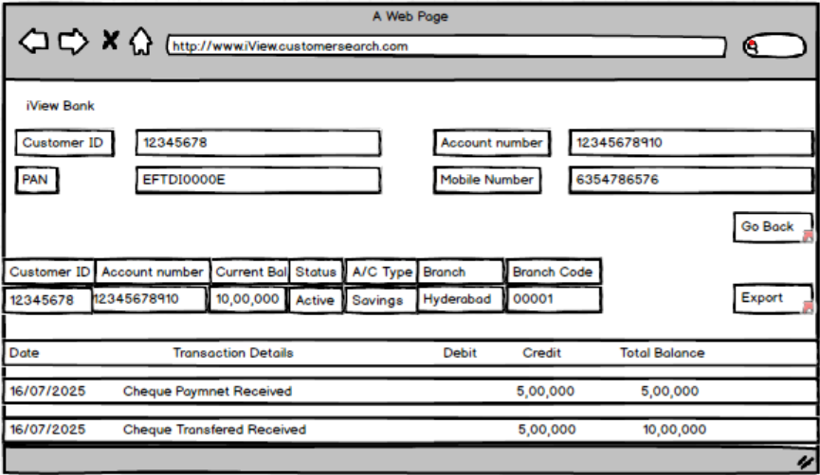
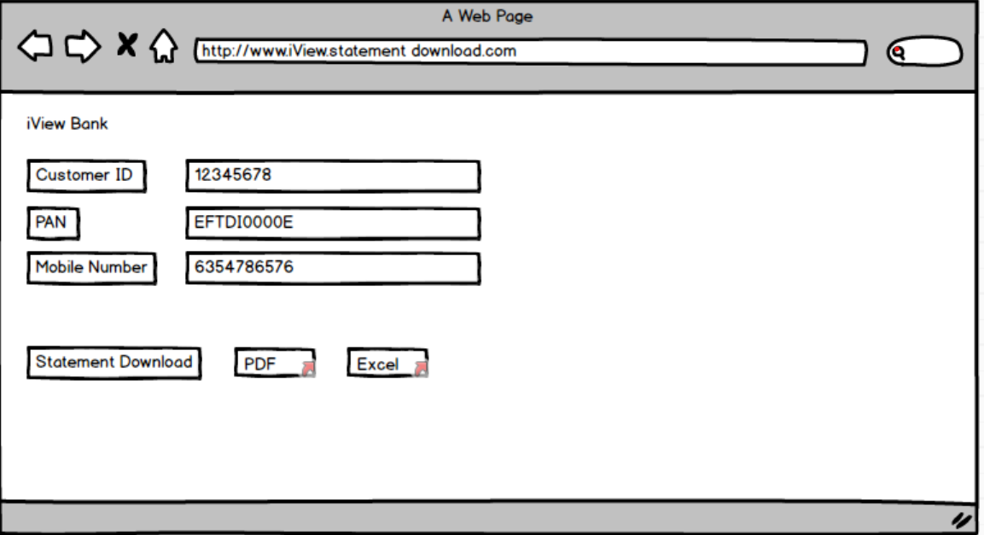

Mock-ups for Update Mobile number:
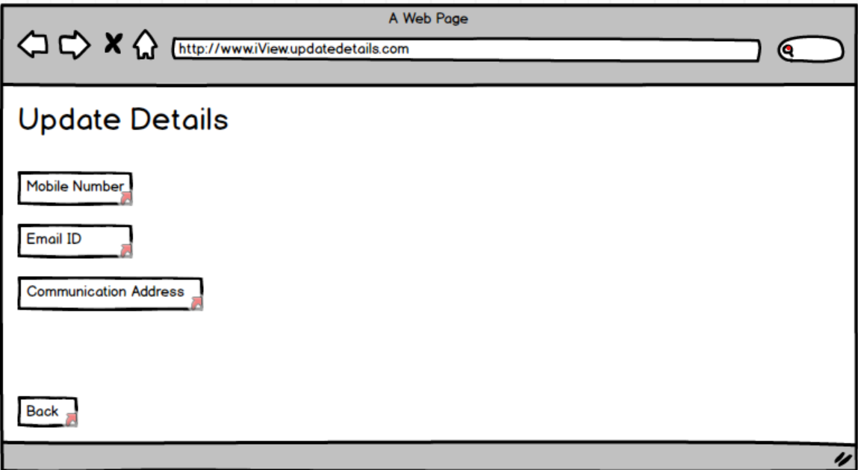
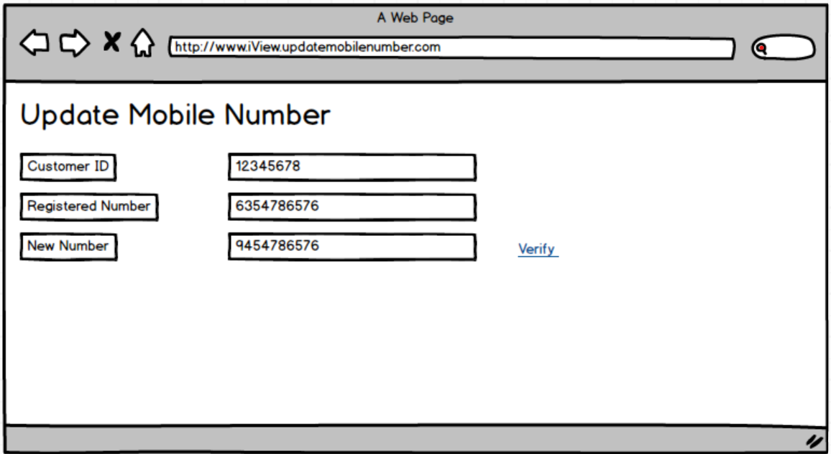
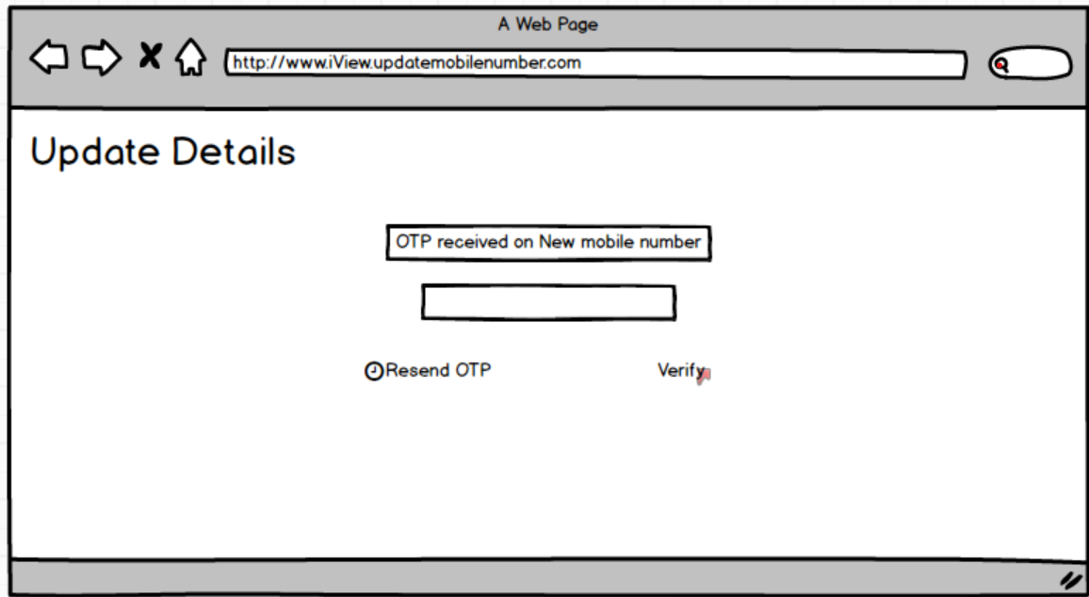
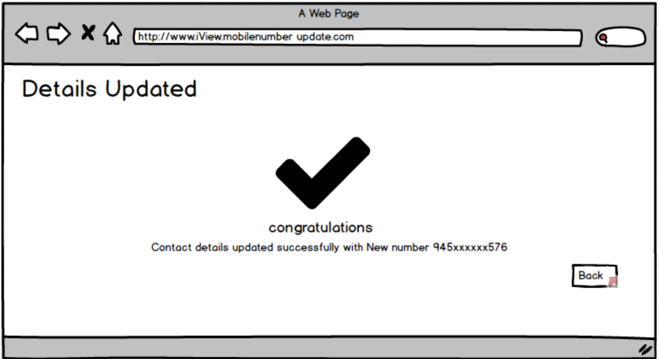
Mock-ups for Update Email ID
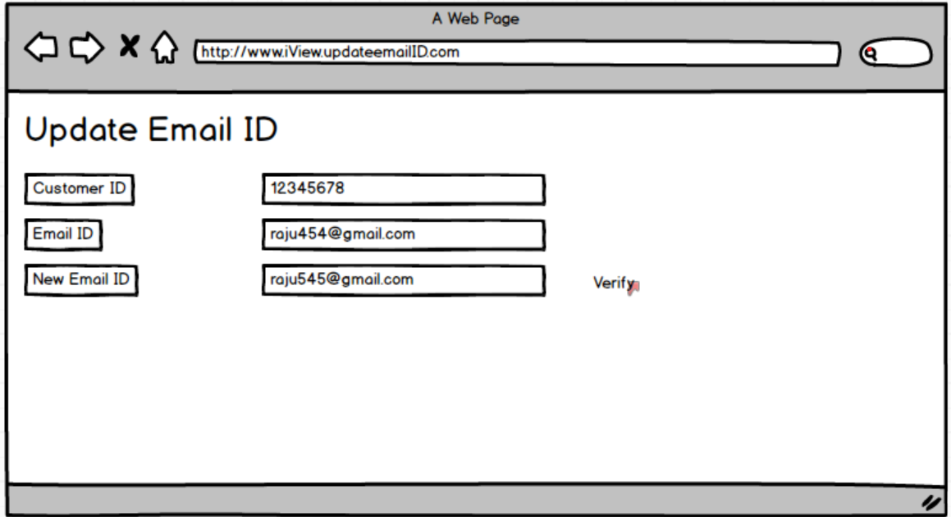
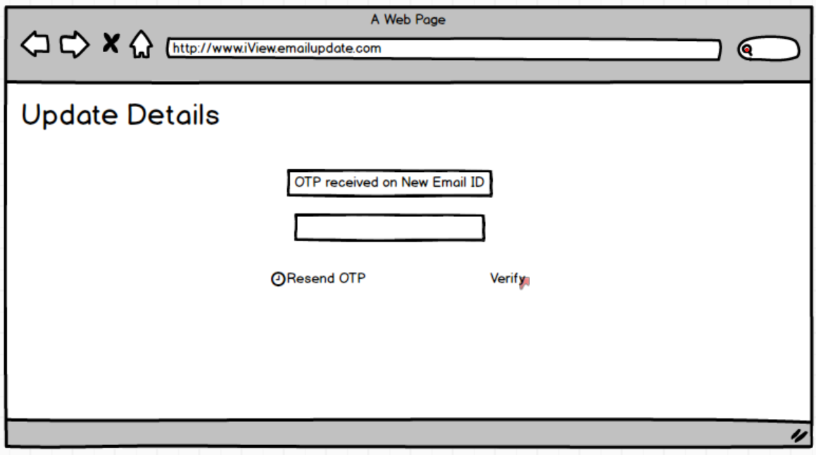
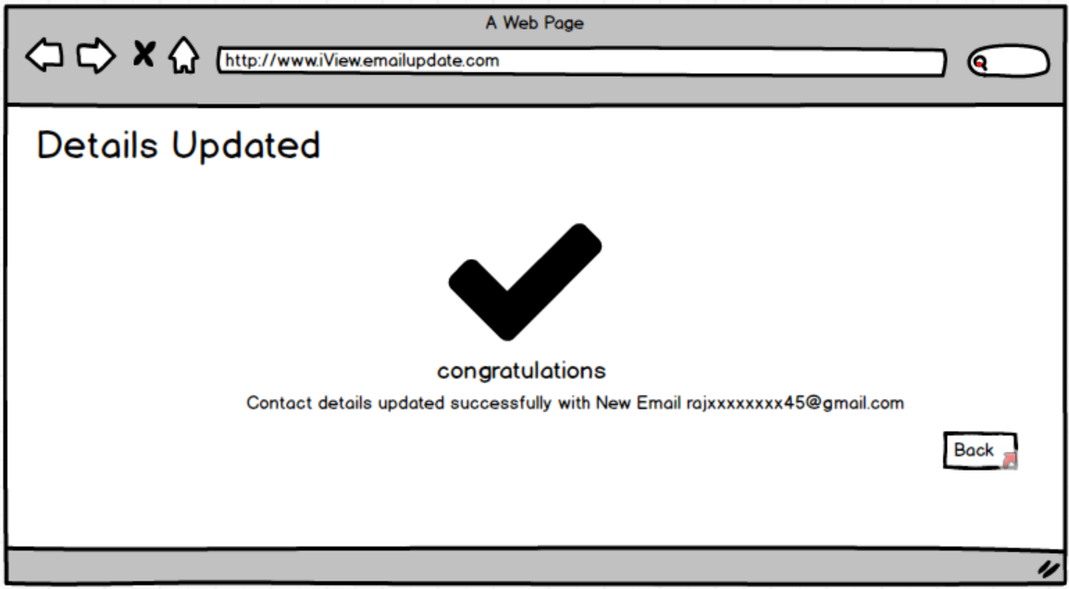

Mock-ups for Update Address
h
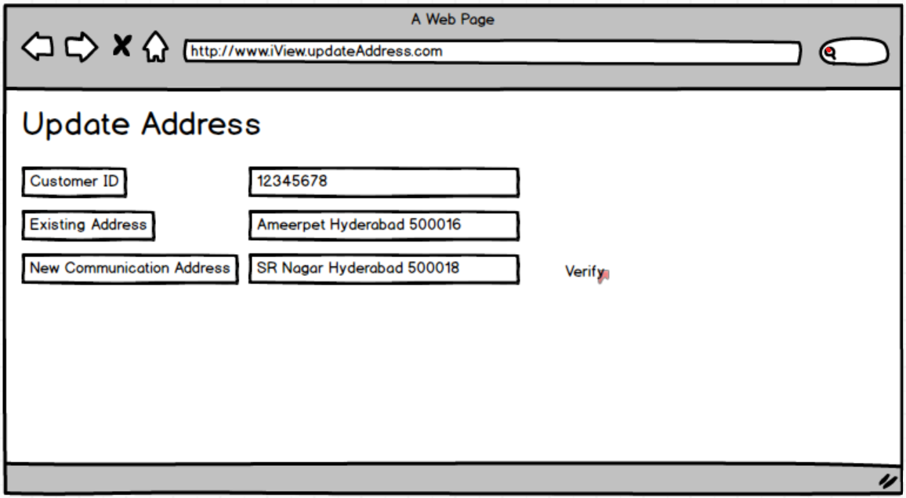
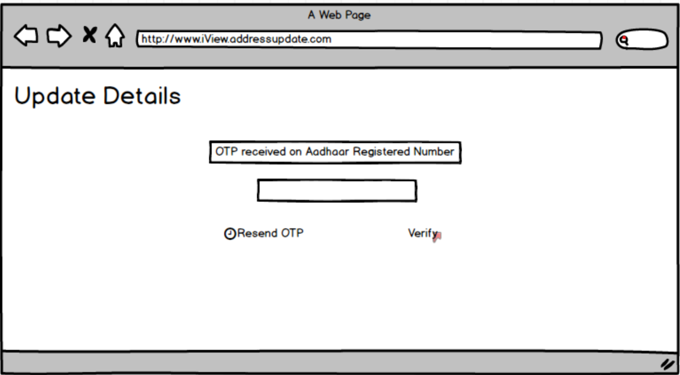
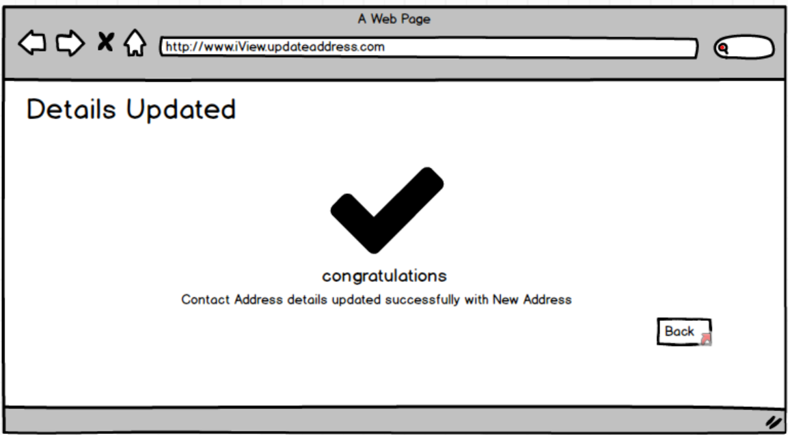
Document 8 : Tools-Visio and Axure
Tool | Purpose | Experience & Usage
Visio | To create UML diagrams like Use Case, Activity, and Business Process Flows | Used Microsoft Visio 2007 to design clear and structured diagrams that visualized workflows and system interactions. It helped in communicating functional logic and decision points effectively to both business and technical teams.
Axure RP | To design wireframes and create interactive prototypes | Used Axure to build low-fidelity wireframes and simulate user journeys for features like contact updates and statement viewing. This supported early UI/UX validation and helped stakeholders visualize the system before development.
Due to system issue I have used Balsamiq below is the difference for Tools-Visio and Balsamiq
Tool | Purpose | Experience & Usage
Visio | To create UML diagrams like Use Case, Activity, and Business Process Flows | Used Microsoft Visio 2007 to design structured diagrams that clearly represent system behavior, workflows, and actor interactions. It helped in aligning business requirements with development understanding.
Balsamiq | To design wireframes and low-fidelity UI prototypes | Due to system limitations, Balsamiq was used instead of Axure RP. It provided a quick and intuitive way to sketch wireframes for key screens such as login, contact update, and account statement views. The hand-drawn style helped focus discussions on functionality and layout without getting into visual design details.

Document 9- BA experience
My experience as BA in following phases:
1. Requirement Gathering
During the requirement gathering phase, I actively used the MoSCoW technique to prioritize requirements into Must-Have, Should-Have, Could-Have, and Won’t-Have categories. This helped in clearly defining the project scope early on. However, I faced a challenge when the client was unavailable for a portion of this phase. To mitigate delays, I proactively identified alternative points of contact from the client’s organization and coordinated with them to gather the required information promptly. Once initial requirements were collected, I validated them using the FURPS framework (Functionality, Usability, Reliability, Performance, and Supportability) to ensure their completeness and quality. I also observed that many requirements were duplicated or redundant, which I immediately resolved by cleaning and consolidating the list. To gain further clarity and to help stakeholders visualize the proposed functionalities, I created low-fidelity prototypes using Balsamiq, which significantly improved the specificity and accuracy of the requirements.
2. Requirement Analysis
In the requirement analysis phase, I focused on translating business needs into clear, structured documentation and visual models. I created UML diagrams, including Use Case Diagrams and Activity Diagrams, to represent the system’s functional and process flows in a visual format that the entire team could understand. These diagrams served as a key reference point for discussions and development. During walkthroughs, some team members raised concerns or proposed changes to the diagrams. As a BA, I encouraged this collaborative feedback, analyzed their suggestions, and made necessary adjustments to ensure alignment between the business and technical perspectives. In addition to the visual models, I was responsible for preparing both the Business Requirement Specification (BRS) and the Software Requirement Specification (SRS) documents. These documents captured all functional and non-functional requirements clearly and served as the baseline for design and development activities.
3. Design
During the design phase, my role as a Business Analyst was critical in ensuring that the documented requirements were accurately translated into design specifications and test scenarios. I used the previously created use case diagrams as the basis for developing comprehensive test cases, which included both positive and negative scenarios to ensure full coverage. I paid close attention to detail, knowing that even a missed test case could lead to functional gaps or defects during development. I also engaged in ongoing communication with the client to clarify and confirm design assumptions, ensuring that the solution documents aligned with their expectations. To support the testing team, I prepared relevant test data and updated the Requirement Traceability Matrix (RTM) to ensure that each requirement was properly accounted for and validated. This phase required both analytical rigor and cross-functional collaboration to lay a solid foundation for development and testing.

Feature: Update Mobile Number

Positive Test Cases

Test Case ID | Test Scenario | Expected Result
TC_UMN_01 | Enter valid Customer ID and valid new mobile number | System sends OTP to new number
TC_UMN_02 | Enter correct OTP within allowed time | Mobile number is updated, success message shown
TC_UMN_03 | OTP validation and audit logging | OTP validated and activity is logged in audit trail
TC_UMN_04 | Resend OTP (within allowed limit) | System resends OTP up to 3 times
TC_UMN_05 | Updated mobile number is reflected in backend system | Change confirmed across platforms after sync
Negative Test Cases
Test Case ID | Test Scenario | Expected Result
TC_UMN_06 | Enter invalid Customer ID | System displays “Customer not found”
TC_UMN_07 | Enter invalid mobile number format (e.g., 12345) | System displays validation error
TC_UMN_08 | Enter incorrect OTP 3 times | Mobile number update is blocked, manual request required
TC_UMN_09 | Try to bypass OTP screen | System blocks unauthorized access
TC_UMN_10 | Enter expired OTP | System shows “OTP expired” and does not proceed

Feature: View Account Statement
Positive Test Cases
Test Case ID | Test Scenario | Expected Result
TC_VAS_01 | Enter valid Customer ID and date range | Transaction list is displayed
TC_VAS_02 | Export statement to PDF | Downloadable PDF is generated
TC_VAS_03 | Export statement to Excel | Downloadable Excel file is generated
TC_VAS_04 | View statement within current month | Correct transactions are shown
TC_VAS_05 | View audit trail of export action | Audit entry is recorded with timestamp and user ID

Negative Test Cases

Test Case ID | Test Scenario | Expected Result
TC_VAS_06 | Enter invalid or non-existent Customer ID | System displays “Customer not found”
TC_VAS_07 | Select start date later than end date | System shows validation error
TC_VAS_08 | No transactions available in date range | System displays “No transactions found”
TC_VAS_09 | Try to export without viewing statement first | Export button is disabled or error shown
TC_VAS_10 | Attempt to open generated file with no permissions | Access is denied or error message shown

4. Development
In the development phase, I played a key role in bridging communication between the technical team and business stakeholders. I organized and facilitated JAD (Joint Application Development) sessions to ensure that developers had a clear understanding of the requirements and expected outcomes. During these sessions, I encountered situations where certain team members were either resistant to ideas or non-cooperative. As a Business Analyst, I addressed these challenges diplomatically by initiating one-on-one discussions, explaining the potential impact of their resistance on the project timeline and team morale. I worked to foster a healthy, collaborative environment by encouraging open communication and mutual respect. Throughout development, I also addressed technical team queries by referring to the relevant diagrams, specifications, and use cases. I ensured regular meetings were conducted with both the technical team and the client, even when attendance was inconsistent. In such cases, I recorded sessions and personally followed up with those who missed them, ensuring no stakeholder was left uninformed.
5. Testing
During the testing phase, my primary responsibility as a Business Analyst was to ensure that the system met all defined business requirements and performed as expected. I created detailed test cases derived directly from the use case diagrams and requirements defined in earlier phases. These test cases were designed to cover both functional and high-level business scenarios. I worked closely with the QA team to perform high-level testing and reviewed their findings to ensure accuracy. In cases where test data was required, I coordinated with the client to obtain realistic and relevant datasets to simulate actual system usage. I also took responsibility for maintaining and updating the Requirement Traceability Matrix (RTM) to confirm that all requirements had been tested and validated. After successful testing, I arranged client sign-off and helped prepare them for User Acceptance Testing (UAT) by walking them through key scenarios, addressing their concerns, and ensuring readiness for deployment.

Updated RTM iView Banking Application Enhancement

Requirement ID | Requirement Description | Test Case ID | Test Scenario | Status | Remarks
REQ_UMN_01 | Update mobile number with OTP validation | TC_UMN_01 | Enter valid Customer ID and new mobile number | Pass
REQ_UMN_01 | Update mobile number with OTP validation | TC_UMN_02 | Enter correct OTP within allowed time | Pass
REQ_UMN_01 | Update mobile number with OTP validation | TC_UMN_03 | OTP validation and audit logging | Pass
REQ_UMN_01 | Update mobile number with OTP validation | TC_UMN_04 | Resend OTP (within allowed limit) | Pass
REQ_UMN_01 | Update mobile number with OTP validation | TC_UMN_05 | Updated mobile number is reflected in backend system | Pass
REQ_UMN_01 | Update mobile number with OTP validation | TC_UMN_06 | Enter invalid Customer ID | Pass
REQ_UMN_01 | Update mobile number with OTP validation | TC_UMN_07 | Enter invalid mobile number format | Pass
REQ_UMN_01 | Update mobile number with OTP validation | TC_UMN_08 | Enter incorrect OTP 3 times | Pass
REQ_UMN_01 | Update mobile number with OTP validation | TC_UMN_09 | Try to bypass OTP screen | Pass
REQ_UMN_01 | Update mobile number with OTP validation | TC_UMN_10 | Enter expired OTP | Pass
REQ_VAS_01 | View account statement for a date range | TC_VAS_01 | Enter valid Customer ID and date range | Pass
REQ_VAS_01 | Export account statements | TC_VAS_02 | Export statement to PDF | Pass
REQ_VAS_01 | Export account statements | TC_VAS_03 | Export statement to Excel | Pass
REQ_VAS_01 | View account statement for current month | TC_VAS_04 | View statement within current month | Pass
REQ_VAS_01 | Audit log for export action | TC_VAS_05 | View audit trail of export action | Pass
REQ_VAS_01 | View account statement for a date range | TC_VAS_06 | Enter invalid or non-existent Customer ID | Pass
REQ_VAS_01 | Validate input dates | TC_VAS_07 | Select start date later than end date | Pass
REQ_VAS_01 | No transactions in range | TC_VAS_08 | No transactions available in date range | Pass
REQ_VAS_01 | Prevent export without viewing | TC_VAS_09 | Try to export without viewing statement first | Pass
REQ_VAS_01 | Access control for downloads | TC_VAS_10 | Attempt to open generated file with no permissions | Pass

Client Sign-Off for Requirement Traceability Matrix (RTM)

Project Name: iView Banking Application Enhancement
Document: RTM – Update Mobile Number & View Account Statement
Prepared By: Business Analyst – Lolabhattu Surya Likhitha
Date: 17/07/2025
Client Confirmation
I hereby confirm that I have reviewed the Requirement Traceability Matrix (RTM) for the features Update Mobile Number and View Account Statement. All associated requirements, test cases, validations, and system responses have been clearly defined and traceability has been accurately mapped. I acknowledge that:
- All functional and non-functional requirements have been appropriately covered
- Positive and negative test scenarios are in line with the agreed scope
- This RTM will serve as the baseline for User Acceptance Testing (UAT) and project closure activities
Sign-Off Section
Client Name | Designation | Organization | Signature | Date
Roja | Client | COEPD BANK |  | 17/07/2025

6. Deployment
In the deployment phase, my role as a Business Analyst involved ensuring a smooth transition of the application to the production environment and preparing stakeholders for successful adoption. I began by sharing the finalized Requirement Traceability Matrix (RTM) with the client, which served as an important part of the project closure documentation.

Project Closure Document – iView Banking Application Enhancement
1. Project Information
Project Name: iView Banking Application Enhancement
Client: [Insert Client Name]
Prepared By: Lolabhattu Surya Likhitha (Business Analyst)
Date of Closure: [Insert Closure Date]
2. Project Objectives and Deliverables
The project aimed to enhance the iView application with the following deliverables:
- Enable bank staff to view detailed customer account statements for a selected date range.
- Provide functionality to securely update customer contact details (mobile number, email ID, address) using OTP validation.
- Ensure audit logging for all updates and data access.
- Improve customer servicing efficiency and first-call resolution.
- Maintain compliance with banking security and audit requirements.
3. Summary of Work Completed
- Requirements gathered using MoSCoW prioritization and validated using FURPS.
- UML Use Case and Activity Diagrams created using Microsoft Visio.
- Prototypes developed using Balsamiq for stakeholder validation.
- Test cases prepared (positive and negative), test data created, and traceability ensured via RTM.
- RTM reviewed and signed off by the client.
- Final training conducted for end users and user manuals shared.
- System successfully deployed in production environment.
4. RTM and Testing Summary
A comprehensive Requirement Traceability Matrix (RTM) was maintained to ensure all requirements were covered through respective test cases. All critical and high-priority test cases have passed successfully. The RTM with client sign-off is attached as part of this document.
5. Lessons Learned
- Ensure stakeholder availability early to avoid delays in requirement gathering.
- Keep prototypes simple and focused on functionality to improve client feedback.
- Effective communication during JAD sessions helps resolve team conflicts.
- Thorough validation of test cases (both positive and negative) is crucial for deployment readiness.
6. Client Sign-Off
The client has reviewed all deliverables and confirmed that the project meets the agreed scope and objectives.

I coordinated with the relevant teams to ensure the preparation and distribution of comprehensive end-user manuals, providing clear guidance on how to use the newly implemented features. Additionally, I took the lead in planning and organizing training sessions for end users, ensuring the content was simple, relevant, and aligned with user roles. I made it a point to track attendance and participation, and followed up with any users who missed the sessions to ensure complete coverage. My goal during this phase was to support a seamless go-live process and ensure that users felt confident and capable of using the enhanced system effectively from day one.

