Question 1-4 Quarterly Audits are planned Q1, Q2, Q3, Q4 for this Project What is your knowledge on how these Audits will happen for a BA?
Answer- Quarterly audits are a part of good system and environment, especially quarterly audits are necessary for high profile projects, fixed duration project, and fixed budget project.
Business analyst will not be audited in a financial audit, but the deliverables and process will be under the inspection and will be audited. As a business analyst my role will be to ensure that my team are inline and in match with the client.
Q1 & Q2-Process and scope validation Audit
Audit Area | BA Deliverables/Evidence | What the Auditor Checks
Requirements Management Plan | The document outlining how requirements are elicited, documented, traced, and approved. | Is there a formal process? Are stakeholders like Peter, Kevin, and Ben signing off?
Scope Definition | Project Scope Statement, High-Level Requirements Document (HLRD), and User Stories/Use Cases. | Do the documented requirements align with the initial business case and budget? Are there any signs of uncontrolled Scope Creep?
Stakeholder Alignment | Meeting minutes and Requirements Sign-off/Approval Records. | Have all critical stakeholders (Mr. Henry, Peter, Kevin, Ben) formally agreed to the plan and priorities?
Traceability | Requirements Traceability Matrix (RTM) linking business needs to functional requirements. | Can the BA prove that every requirement in development directly supports one of the project's goals?

Q3 & Q4- Quality and Change Control Audit
Audit Area | BA Deliverables/Evidence | What the Auditor Checks
Requirements Quality | Functional Specifications Document (FSD) and detailed user stories. | Are requirements clear, unambiguous, testable, and complete? Poor quality requirements lead to rework and budget overruns.
Change Management | Change Request (CR) Log and Impact Analysis Documents. | Is every change tracked, analysed for impact (time/cost), and formally approved by the Project Committee Mr. Henry, Mr. Pandu, Mr. Dooku before development begins? This is crucial for controlling the ₹2 Crore budget.
Testing Linkage | Test cases documented by Jason and Alekya. | Do the test cases directly map back to the requirements documented by the BA? This confirms that the right features are being tested.

Question 2- Before the Project is going to Kick Start, The Committee asked Mr Karthik to submit BA Approach Strategy Write BA Approach strategy (As a business analyst, what are the steps that you would need to follow to complete a project – What Elicitation Techniques to apply, how to do Stakeholder Analysis RACI/ILS, What Documents to Write, What process to follow to Sign off on the Documents, How to take Approvals from the Client, What Communication Channels to establish n implement, How to Handle Change Requests, How to update the progress of the project to the Stakeholders, How to take signoff on the UAT- Client Project Acceptance Form )
Answer- BA Approach Strategy: Online Agriculture Product Store
Project: SOONY Online Agriculture Product Store (CSR Initiative) Client: SOONY Committee (Mr. Henry, Mr. Pandu, Mr. Dooku) Vendor: APT IT SOLUTIONS BA Lead: Sai Sushanth R
- Project Context and Objectives The primary objective is to build a user-friendly Web/Mobile platform within 18 months and ₹2 Crores INR to connect remote farmers with manufacturers of fertilizers, seeds, and pesticides. The BA’s role is to bridge the business vision Mr. Henry with the technical reality APT IT SOLUTIONS team and ensure the solution is directly usable by the end-users Peter, Kevin, Ben.

- Stakeholder Analysis and Communication

Stakeholder | Role | Influence | RACI | Engagement Strategy
Mr. Henry | Sponsor | High | A | Regular, high-level status updates (executive summaries). Focus on strategic impact.
Mr. Dooku | Project Coordinator | High | A | Weekly deep-dive meetings; primary go-to for approvals and conflict resolution.
Peter, Kevin, Ben | Farmer Reps | Medium | C | Focus group sessions, user story review, and UAT participation. Keep satisfied and engaged.
Mr. Vandanam | Project Manager | Medium | R | Daily sync-ups; collaboration on scope and change management.
APT IT Team | Dev/Test | Low | R | Detailed requirement walk-throughs and functional specifications (FSD).
Karthik | Delivery Head | Medium | I | overview infrastructure,Weekly Summary Reports
- Requirements Elicitation & Documentation

A. Elicitation Techniques
- Interviews: Primary technique for formal one-on-one sessions with key stakeholders (Mr. Dooku, Mr. Pandu).
- Focus Groups: Crucial for Peter, Kevin, and Ben. This will help us understand group consensus, common pain points (fertilizer logistics, seed viability), and validate initial mockups.
- Prototyping/Wireframing: Essential for user-friendliness. We will create low-fidelity wireframes and test them with the farmer representatives early to visually confirm the interface is intuitive before development starts.
- Process/Context Analysis: Studying the existing farming procurement process to identify pain points and how the app can solve them (e.g., "current process for fertilizer delivery").

Required Documents & Deliverables

Document | Responsibility | Purpose
HLRD | BA | Confirms overall scope and boundaries.
User Stories | BA (with Developers) | Defines specific features from the user's perspective (e.g., "As a farmer, I want to filter seeds by crop type...").
Functional Specification Document (FSD) | BA | Detailed technical specifications for developers (Juhi, Teyson, etc.) and testers (Jason, Alekya).
Requirements Traceability Matrix (RTM) | BA | Links requirements to design, development, and test cases. The key audit artifact.
UAT Plan | BA / Project Manager | Defines scenarios for client acceptance testing.

4. Documentation Sign-off & Client Approval Process
To protect the ₹2 Crore budget and 18-month timeline, formal approval gates are non-negotiable.
- Document Review & Sign-off:
  - Draft & Internal Review: BA writes the document and reviews it with the PM (Mr. Vanaman) and Tech Lead (Ms. Juhi).
  - Stakeholder Review: Document is shared with Mr. Dooku and Peter/Kevin/Ben for feedback.
  - Formal Approval: Document is submitted to Mr. Dooku and Mr. Vandanam for final digital or physical signature. This signals that the document is baselined.
- UAT Client Project Acceptance:
  - Testing (Jason & Alekya) is based only on the signed FSD.
  - UAT is performed using the pre-approved UAT Plan.
  - Upon successful completion, the client (Mr. Dooku, possibly Mr. Henry) will sign the Client Project Acceptance Form. This sign-off confirms the project deliverable meets the documented requirements and triggers the final financial release.
5.Change Request Management (Crucial for Budget)
Change is inevitable, but chaos is optional. Given the fixed budget, we must have a strict Change Control Process.
- Change Initiation: Any stakeholder submits a Change Request (CR) detailing the proposed change and its business justification.
- Impact Analysis (BA's Role): The BA assesses the CR against the baselined FSD and RTM. We detail the impact on: Scope, Cost, Schedule, and Technical Effort. This is presented to the PM.
- Approval Gate: Mr. Vandanam (PM) presents the CR and the BA's Impact Analysis to the SOONY Committee (Mr. Henry, Mr. Pandu, Mr. Dooku).
- Decision: The Committee either Approve, Reject, or Defer the change. No change is implemented by the developers (Teyson, Lucie, etc.) without a signed approval.

Question 3- Explain and illustrate 3-tier architecture?

Answer- The 3-Tier Architecture is a classic, robust, and highly scalable way to design enterprise applications like the SOONY Agri-Store. The 3-tier architecture system basically divides the application into 3 levels maintainability, scalability, and security.
3-Tier data base – Peter places the order,
Presentation Tier: Peter taps on a bag of fertilizer in the mobile app and clicks "Place Order.
Application Tier: The server receives the request, verifies Peter's credentials, checks the inventory in the database, calculates the total price, and creates a new order record.
Data Tier: The database executes the commands sent by the Application Tier (e.g., INSERT new order, UPDATE inventory count).
Application Tier: Sends the final confirmation message (e.g., "Order #123 Confirmed!") back to the Presentation Tier.
Presentation Tier: Peter sees a confirmation screen

Question 4- Business Analyst should keep What points in his/her mind before he frames a Question to ask to the Stakeholder
Framework/Concept | Purpose in Framing Questions | Questions to be Asked
5W1H (Who, What, When, Where, why, How) | Ensures the question is comprehensive and targets a complete requirement, not just a partial idea. | How does the farmer pay, When is the payment finalized, and What evidence is required for a successful transaction?
SMART (Specific, Measurable, Achievable, Relevant, Time-bound) | Ensures the answer will yield a testable, useful requirement, not a vague wish. | What is the maximum acceptable loading time (Measurable) for the product catalog page (Specific) on a 2G connection?
Stakeholder Analysis (ILS/RACI) | Tailors the question's focus and level of detail to the audience's role and influence. | To Mr. Henry -Why are we prioritizing pesticides over seeds (Focus on strategic Why). To Ms. Juhi -How will we handle concurrent orders?" (Focus on technical How).
3-Tier Architecture | Clarifies the nature of the requirement and which part of the system it affects (Presentation, Logic, or Data). | In the Data Tier, what is the key unique identifier (ID) needed to link a product's price (Data) to the order calculation (Logic)
Page Designs / Wireframes | Uses a visual aid to elicit concrete feedback and avoid abstract requirements, especially with non-technical users like farmers. | On this mock-up, is the quantity selector clear? Would you prefer a simple number entry or a plus/minus button?
Use Cases / Activity Diagrams | Ensures the question relates directly to a specific user goal or step in a process, preventing requirements from being missed. | In the 'Requesting Delivery' Use Case, after clicking 'Confirm,' what specific delivery details must the system capture to complete this step?

Question 5- As a Business Analyst, What Elicitation Techniques you are aware of?
Letter | Technique | Meaning
B | Brainstorming | Used with a small group to generate many ideas quickly.
D | Document Analysis | Reviewing existing documents to understand the current state.
R | Requirements Workshop | A structured, focused meeting with key stakeholders to define, refine, and scope requirements. Relevance: Essential for getting the SOONY Committee (Mr. Dooku) and the Farmer Reps (Peter, Kevin, Ben) in the same room to reach consensus on the MVP scope and priorities.
F | Focus Groups | Bringing together all the farmers at one, rather than having individual interviews to understand the problems.
O | Observation (Job Shadowing) | Watching the users perform their daily task like for example watching Peter what all he does to get the agricultural products by this we will understand the current problems.
W | Walkthroughs (Reviews) | Reviewing diagrams, documents, or prototypes with stakeholders to ensure correctness and completeness.
J | JAD (Joint Application Development) | It is a highly level joint meeting with the all the stakeholders to understand the requirement.
I | Interviews | The classic one-on-one session with the stakeholders to gather information.
P | Prototyping | Developing working models or mock-ups of the solution to elicit user feedback. Testing a simple Mobile App Mock-up with Peter before any code is written saves time and budget.
Q | Questionnaires/Surveys | Used to gather data from a large number of people quickly. While we only have three key farmer reps, a survey could be used later to gather feedback from a wider pool of initial pilot users beyond Peter, Kevin, and Ben.
U | User Stories | A technique for capturing requirements from the end-user's perspective. The primary documentation format for the developers, ensuring that everything built (by Ms. Juhi's team) is traceable back to a user need (e.g., Farmer needs to buy seeds).

1. Structured Interview
- Questions are pre-defined and asked in a fixed order.
- Used when consistency is required.
- Example: Asking every farmer the same set of questions about product needs.

2. Unstructured Interview
- No formal list of questions; free-flowing conversation.
- Helps discover hidden or unexpected requirements.
- Example: Having an open discussion with stakeholders to explore pain points.

3. Semi-Structured Interview
- Mix of pre-planned questions + open-ended discussion.
- Most commonly used by BAs.
- Example: Having guiding questions but allowing stakeholders to elaborate.

4. One-on-One Interview
- Interviewing a single stakeholder individually.
- Used for detailed or sensitive topics.

5. Group Interview
- Multiple stakeholders interviewed together.
- Useful when stakeholders share similar roles or viewpoints.

6. Panel Interview
- A group of interviewers (e.g., BA + PM + SME) interview one or more stakeholders.
- Used when validation from multiple experts is needed.

7. Ad-hoc / Informal Interview
- Spontaneous discussions during meetings or work observations.
- Often reveals real-time insights.

8. Contextual Inquiry
- Interview conducted while observing the user performing real tasks.
- Helps understand practical workflows and user behavior.

9. Walkthrough Interviews
- Discussion based on walking through a process, prototype, or document.
Helps stakeholders articulate steps and issues

1. Active Observation
- The BA participates in the activity while observing.
- Also called Participatory Observation.
- Useful when you need a deep understanding of the task.
- Example: BA helps a farmer simulate placing a product order to observe challenges.

2. Passive Observation
- The BA watches the user perform tasks without interfering.
- Also known as Non-Participatory Observation.
- Useful for understanding the natural workflow.
- Example: Watching a farmer navigate an existing product system.

3. Naturalistic Observation
- Observation done in the user’s real working environment.
- Helps in identifying the actual process, constraints, and pain points.
- Example: Visiting the farm to see how farmers currently procure products.

4. Controlled Observation
- Observation is done in a structured or simulated environment.
- Often used during usability testing or prototype testing.
- Example: Asking a farmer to test a prototype in a lab-like setup.

5. Overt Observation
- Stakeholders know they are being observed.
- Creates transparency and builds trust.

6. Covert Observation
- Stakeholders are unaware they are being observed.
- Rarely used by BAs due to ethical issues.
- Only used when necessary and with approvals.

7. Shadowing
- The BA follows the user throughout their workday.
- Helps identify real tasks, exceptions, and workarounds.
- Example: Shadowing a warehouse manager shipping agriculture products.

8. Task Analysis Observation
- Observing users performing a specific task step-by-step.
- Used to document actual workflows, screens, and interactions.

9. Remote Observation
- Observation done via screen-sharing or video tools.
- Useful in distributed teams.
1. Throwaway / Rapid Prototyping
- Built quickly to explore ideas or clarify requirements.
- Not intended to be part of the final system.
- Example: Quick UI sketches for the agriculture app’s product catalog.

2. Evolutionary Prototyping
- Continuously refined and improved until it becomes the final working system.
- Used when requirements are unclear or evolve frequently.

3. Incremental Prototyping
- The system is divided into smaller prototypes.
- Each prototype is built and tested, then integrated into the final product.
- Example: Prototype product listing first, payment later, delivery tracking last.

4. Extreme Prototyping (Used in Web Applications)
Three phases:
- Static UI mock-ups
- Fully functional screens
- Connected backend services
- Mostly used in web-based systems.

5. Low-Fidelity Prototyping
- Simple, rough, and hand-drawn (paper, whiteboard sketches).
- Used in early stages to explore ideas quickly.
- Example: Drawing screens of the farmer login page on paper.

6. High-Fidelity Prototyping
- Looks and behaves like the real application.
- Built with tools like Figma, Adobe XD, Axure, Sketch.
- Used for usability testing and stakeholder demos.

7. Horizontal Prototyping
- Focuses on the user interface layer only (broad view of the system).
- Does not include deep functionality.
- Example: Screens for browsing products without backend logic.

8. Vertical Prototyping
- Builds a full slice of functionality end-to-end.
- Includes UI, business logic, and data components.
- Used to test technical feasibility.

9. Storyboard Prototyping
- Sequence of drawings or images showing user interactions.
- Helps visualize user journeys.

10. Wireframe Prototyping
- Low or mid-fidelity visual structure of screens (without colors or branding).
- Shows layout, components, and navigation.

Question 6 List your assumptions
Answer-
Farmer Representation- If other farmers have significantly different needs or devices, the "user-friendly" app could fail to gain adoption.
Manufacturer Engagement- If manufacturers prefer existing distribution channels, the platform will lack product variety and fail its core purpose.
Product Data- Manual data entry will increase the BA's and DB Admin's (Mr. John) workload significantly, causing schedule delays.
SOONY Committee Authority- Requirements sign-off will be slow and may introduce unnecessary bottlenecks.
Internet Connectivity- If connectivity is non-existent, the app must include an offline mode for browsing/ordering, which is a massive, unbudgeted feature change.
Device Usage- If desktop or feature phone use is prevalent, the Presentation Tier design will need a major overhaul.
Payment Integration- We may have to integrate a complex cash-on-delivery (COD) or manual bank transfer process, introducing accounting complexity for Mr. Pandu.

Question 7 Which Elicitation Techniques can be used in this Project and Justify your selection of Elicitation Techniques?

Answer-
1. Interviews.
Description: One-on-one or small group sessions with stakeholders to ask questions and gather detailed information about their needs, expectations, and challenges.
Justification:
- Targeting Remote Farmers (Peter, Kevin, Ben): Since the farmers are in a remote village, direct, structured interviews (either in person or via call/video call if feasible) are the best way to understand their day-to-day farming processes, the specifics of their fertilizer, seed, and pesticide problems, and their expectations for a user-friendly application. This allows for open-ended questions and building rapport.
- Gaining Detail from Manufacturers: Interviews with company representatives will clarify the data structure for product uploads, inventory management, and fulfilment processes, which is crucial for the back-end functionality.
- Securing Project Vision: Interviews with the Committee Mr. Henry, Mr. Pandu, Mr. Dooku will confirm the overall scope, budget, timeline, and success criteria for the CSR initiative.

2. Observation (Job Shadowing)
Description: Watching stakeholders specifically the farmers perform their tasks in their actual working environment.
Justification:
- Understanding the "Why": Farmers often know what they need, but observation reveals how they currently manage their procurement (the "as-is" process), their existing technical literacy, and the context of use for the mobile/web application (e.g., connectivity issues, using the app while working).
- Identifying Implicit Requirements: This helps uncover requirements the farmers might not explicitly articulate, such as the need for simple, high-contrast interfaces or low data usage, which are vital for a "user-friendly" app in a remote setting.

3. Prototyping/Modelling (The Validation Technique)
Description: Creating simple visual models, wireframes, or low-fidelity mockups of the proposed Web/Mobile Application interface to present to stakeholders.
Justification:
- Validating User-Friendliness: Since the application "should be user friendly" and targets new users in remote areas, a prototype is essential. Farmers (Peter, Kevin, Ben) can interact with the mockups to provide concrete feedback on the navigation, layout, and language before significant development effort is expended.
- Bridging the Gap: This technique quickly confirms that the developers' understanding of the requirements aligns with the stakeholders' vision, reducing ambiguity about features like product browsing and ordering.
4. Document Analysis
Description: Reviewing existing documents that are relevant to the business area, such as existing invoices, procurement forms, or product specification sheets from the manufacturers.
Justification:
- Data Field Requirements: Manufacturers' existing documents (e.g., product catalogs, Material Safety Data Sheets for pesticides) will provide the precise data fields needed for product details (e.g., percentage of nitrogen in fertilizer, seed viability rates).
- Establishing Industry Standards: This helps ensure the platform captures all necessary legal, safety, and transactional data required for selling agriculture products.

Identify Business Requirements (which includes Stakeholder Requirements)
BR-01 The application must successfully facilitate the procurement of essential agriculture products (seeds, fertilizers, pesticides) by remote-area farmers.
BR-02 The application must be delivered and deployed within the approved budget of 2 Crores INR and the scheduled duration of 18 months.
BR-03 The application must provide a direct, two-way communication channel between farmers and product manufacturers/companies.
BR-04 The platform must achieve a minimum user satisfaction rating of 80% among pilot farmer groups (e.g., Peter, Kevin, Ben) concerning ease of use.
BR-05 The SOONY Committee must have access to reporting tools to measure the impact and success of the CSR initiative (e.g., total sales, products purchased, geographic reach).

Question 8 identify at least 10 Business Requirements.
ID | Requirement Category | Description
BR001 | Functionality | Farmers should be able to search for available products in fertilizers, seeds, and pesticides.
BR002 | Functionality | Manufacturers should be able to upload and display their products in the application.
BR003 | User Management | The application must provide a Login function for all user types (Farmers, Manufacturers, Admin).
BR004 | User Management | Farmers must be able to create a new account using their email ID and a secure password.
BR005 | User Management | Farmers must be able to log in using their email ID and password to buy products or add items to a buy-later list.
BR006 | Functionality | The application must display a product catalog of fertilizers, seeds, and pesticides for Farmers to browse.
BR007 | Functionality | The application must facilitate a secure and easy-to-use payment gateway process for purchases.
BR008 | Functionality | The payment gateway must include Cash-On-Delivery (COD), Credit/Debit card, and UPI options.
BR009 | Functionality | The application must provide a delivery tracking feature for Farmers to track the whereabouts of their order.
BR010 | Functionality | Farmers should receive an email confirmation regarding their order status.
BR011 | Quality/UX | The overall application must be user-friendly and intuitive, particularly for new users.

Question 9 Give Priority 1 to 10 numbers (1 being low priority – 10 being high priority) to these Requirements after discussions with the stakeholders.
ID | Requirement Category | Description | Priority (1-10)
BR001 | Functionality | Farmers should be able to search for available products in fertilizers, seeds, and pesticides. | 10
BR002 | Functionality | Manufacturers should be able to upload and display their products in the application. | 10
BR003 | User Management | The application must provide a Login function for all user types (Farmers, Manufacturers, Admin). | 9
BR004 | User Management | Farmers must be able to create a new account using their email ID and a secure password. | 8
BR005 | User Management | Farmers must be able to log in using their email ID and password to buy products or add items to a buy-later list. | 9
BR006 | Functionality | The application must display a product catalog of fertilizers, seeds, and pesticides for Farmers to browse. | 10
BR007 | Functionality | The application must facilitate a secure and easy-to-use payment gateway process for purchases. | 9
BR008 | Functionality | The payment gateway must include Cash-On-Delivery (COD), Credit/Debit card, and UPI options. | 7
BR009 | Functionality | The application must provide a delivery tracking feature for Farmers to track the whereabouts of their order. | 8
BR010 | Functionality | Farmers should receive an email confirmation regarding their order status. | 7
BR011 | Quality/UX | The overall application must be user-friendly and intuitive, particularly for new users. | 10

Question 10 - Draw use case diagram
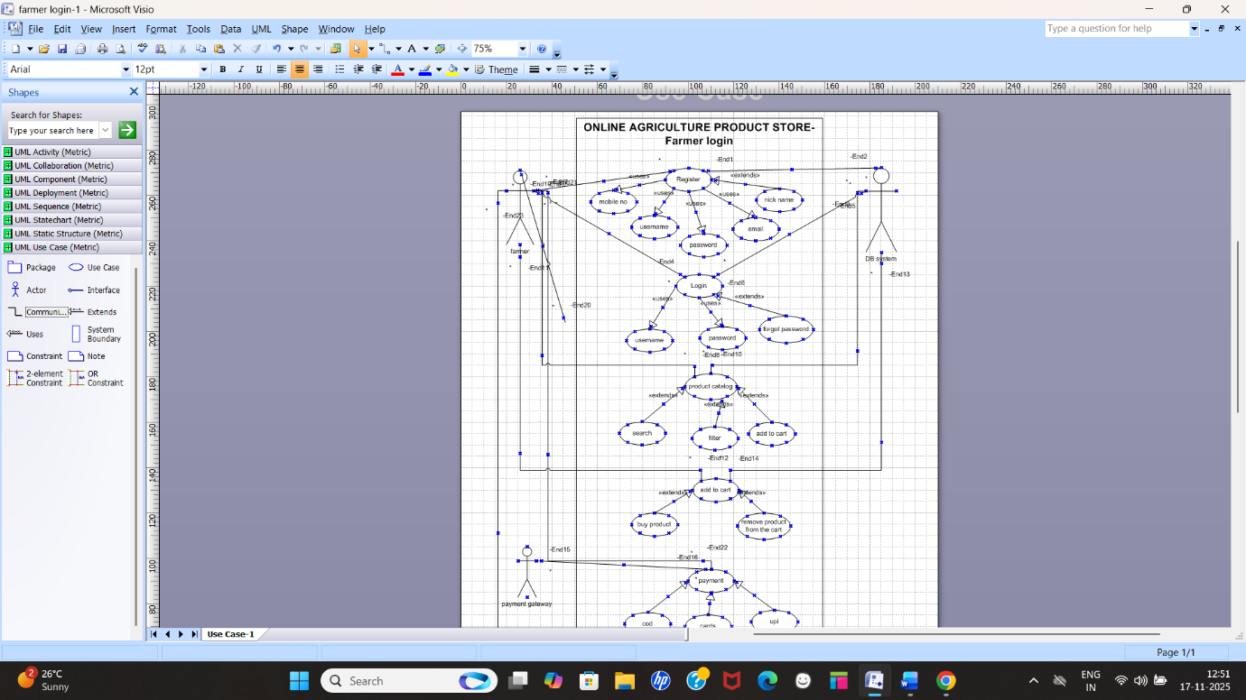

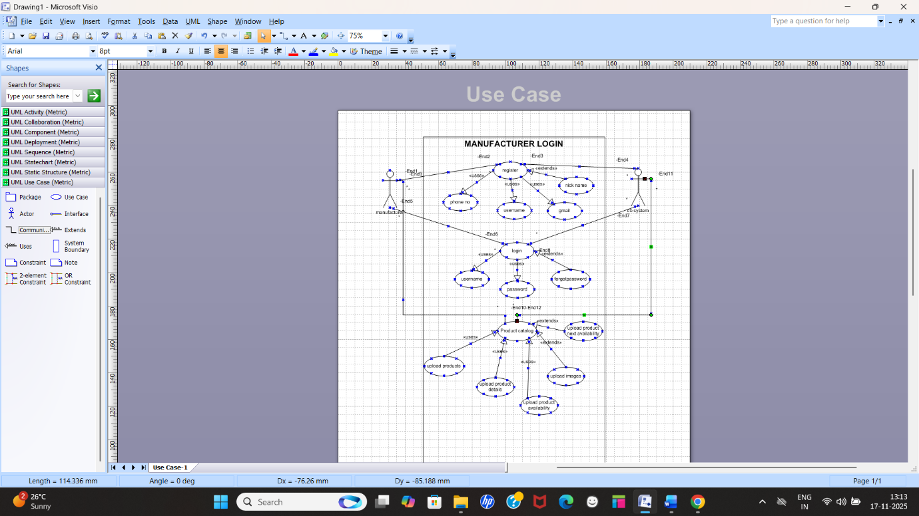
Question 11- Activity diagrams
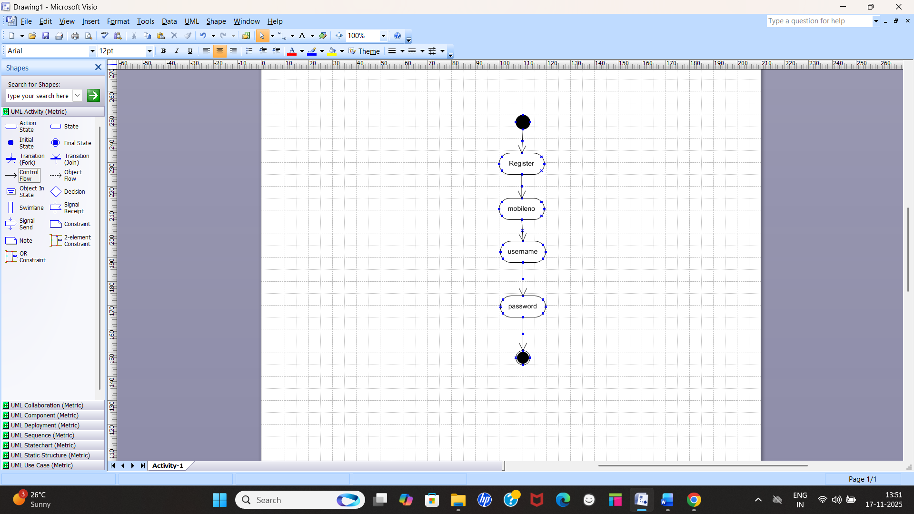

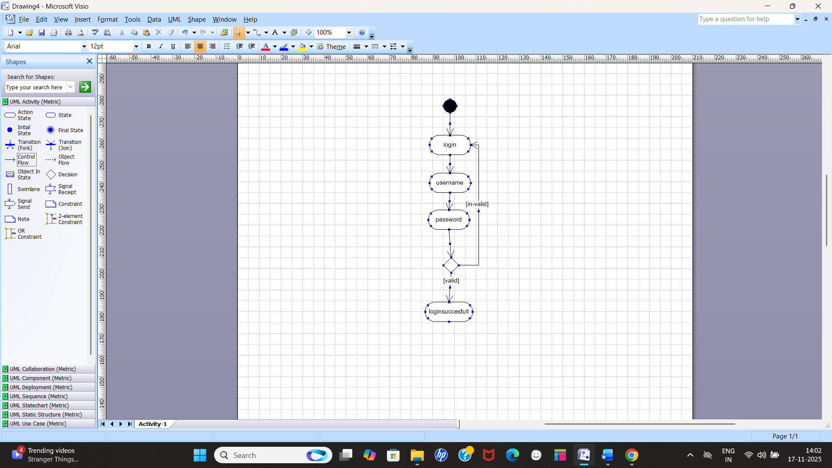
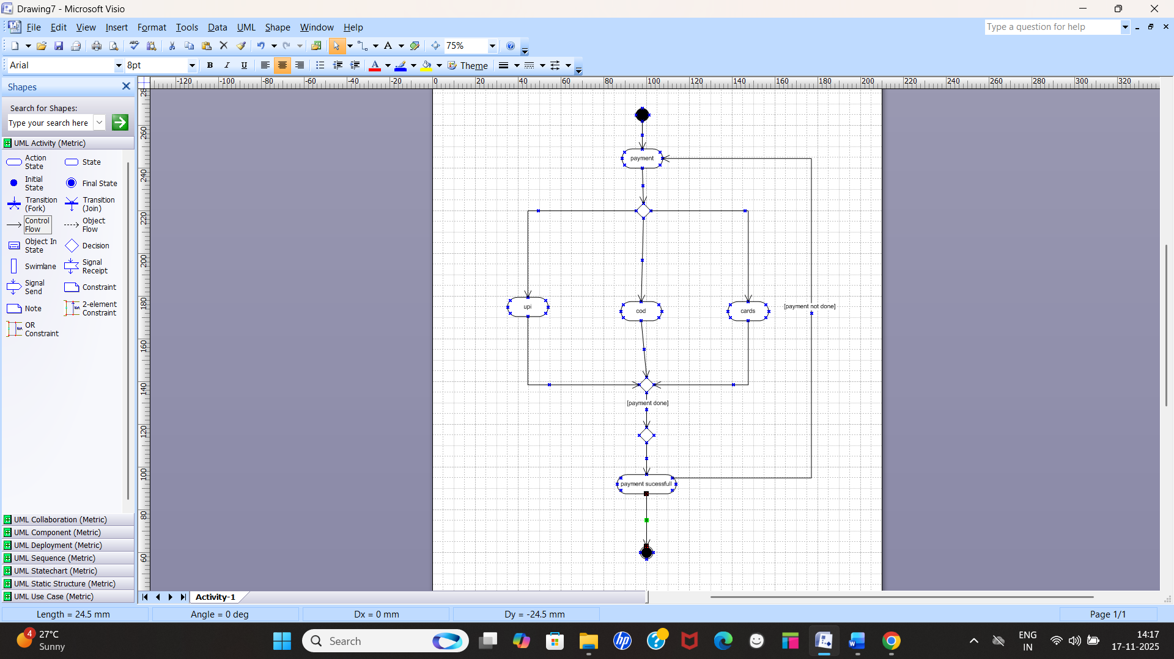

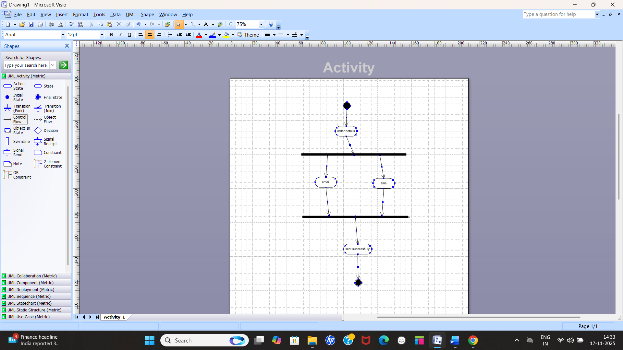

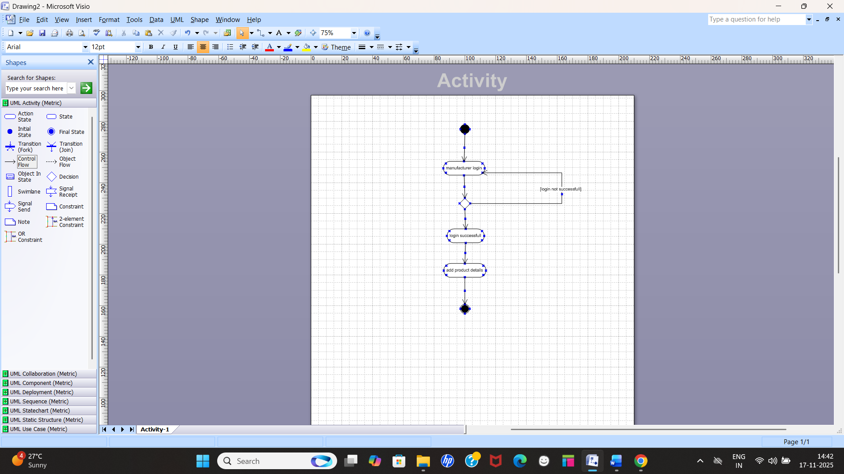

Question 8- Prepare use case specs for all use cases.
1. Use Case: Farmer Registration
Use Case Name:
Farmer Registration
Primary Actor:
Farmer
Goal:
To allow farmers to create an account and access the application.
Pre-conditions:
- Farmer must have a mobile device or computer with internet access.
Post-conditions:
- Farmer's account is created and stored in the system.
- Farmer receives a confirmation message.
Main Flow:
- Farmer clicks on Register.
- System displays the registration form.
- Farmer enters details (Name, Mobile, Address, etc.).
- Farmer sets username and password.
- System validates entered data.
- System saves the registration details.
- System confirms successful registration.
Alternate Flow:
Invalid Inputs
- System prompts the farmer to correct invalid or missing data.

2. Use Case: Farmer Login
Primary Actor:
Farmer
Goal:
To allow farmers to securely log into the system.
Pre-conditions:
- Farmer must be registered.
Post-conditions:
- Farmer gains access to the system dashboard.
Main Flow:
- Farmer enters username and password.
- System validates credentials.
- System redirects farmer to homepage.
Alternate Flow:
Invalid Password/Error
- System displays login error and asks for retry.

3. Use Case: Browse Products
Primary Actor:
Farmer
Goal:
To allow farmers to view available fertilizers, seeds, pesticides.
Pre-conditions:
- Farmer must be logged in.
Post-conditions:
- Products are displayed.
Main Flow:
- Farmer selects Browse Products.
- System fetches and displays product categories.
- Farmer selects a category.
- System shows a list of products with details.

4. Use Case: View Product Details
Primary Actor:
Farmer
Goal:
To display complete product information.
Pre-conditions:
- Farmer must be browsing products.
4.4 Post-conditions:
- Product details are displayed.
4.5 Main Flow:
- Farmer selects a product.
- System displays complete details (description, price, manufacturer, stock).

5. Use Case: Add to Cart
Primary Actor:
Farmer
Goal:
To allow farmer to add selected items to cart.
Pre-conditions:
- Product must exist.
Post-conditions:
- Product is added to cart.
Main Flow:
- Farmer clicks Add to Cart.
- System adds product to cart.
- System displays cart status.

6. Use Case: Place Order
Primary Actor:
Farmer
Goal:
To allow farmers to order products.
Pre-conditions:
- Cart must not be empty.
Post-conditions:
- Order is created and forwarded to manufacturer.
Main Flow:
- Farmer opens cart and clicks Place Order.
- System displays order summary.
- Farmer confirms the order.
- System creates order.
- System triggers payment use case.
Included Use Case:
- Make Payment

7. Use Case: Make Payment
Primary Actor:
Farmer
Goal:
To complete payment for the selected products.
Pre-conditions:
- Order must be created.
Post-conditions:
- Payment status is updated.
- Order is sent to manufacturer.
Main Flow:
- Farmer selects payment method (UPI, Card, Netbanking).
- System redirects to payment gateway.
- Payment is processed.
- System updates payment status.
- Confirmation message sent to farmer.
Alternate Flow:
Payment Failure
- System displays failure reason and asks to retry.

8. Use Case: Track Order
Primary Actor:
Farmer
Goal:
To allow farmers to monitor delivery progress.
Pre-conditions:
- Order must exist.
Post-conditions:
- Tracking information is displayed.
Main Flow:
- Farmer selects Track Order.
- System retrieves tracking details.
- System displays order status (Approved, Packed, Shipped, Delivered).

9. Use Case: Manufacturer Add Product
Primary Actor:
Manufacturer
Goal:
To enable manufacturers to add fertilizers/seeds/pesticides to app.
Pre-conditions:
- Manufacturer must be approved by admin.
Post-conditions:
- Product appears in product list for farmers.
Main Flow:
- Manufacturer logs in.
- Selects Add Product.
- Enters product details (name, type, stock, price).
- System validates data.
- System saves product.

10. Use Case: Approve Manufacturer (Admin)
Primary Actor:
Admin
Goal:
To approve or reject manufacturer accounts.
Pre-conditions:
- Manufacturer must have submitted registration request.
Post-conditions:
- Manufacturer gets approval status update.
10.5 Main Flow:
- Admin logs in.
- Admin opens Manufacturer Approval list.
- Admin reviews registration details.
- Admin selects Approve/Reject.
- System updates manufacturer status.

