- Draw a Use Case Diagram:-

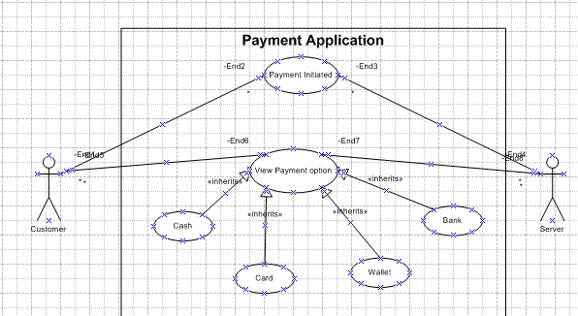

- Derive Boundary Classes, Controller classes, Entity Classes
Boundary:- Boundary classes are responsible for handling the interactions between the system and its external environment, which includes users or other systems.
Controller Class:- Controller classes encapsulate the use-case specific behaviour and the interactions between boundary and entity objects to fulfil the use case's requirements.
Entity Classes:- Entity classes represent core business concepts and the data (attributes) and behaviour related to those concepts. They are the objects that need to be stored and managed by the system, often mapping to database tables. For example, in an e-commerce application, Product, Customer, and Order are likely entity classes.

Boundary class (All use cases)  [combination of 1 actor and a use case is one boundary class]  [combination of 2 actors and a use case is two boundary class]  [combination of 3 actors and a use case is three boundary class] and so on  And those actors should be primary actors.  Primary actors means the actors who initiate the use case and interact with the system. | CustomerRegistration  CustomerLogin  BankServerLogin  CustomerLogout  BankServerLogout
Controller class(handles user input and process the data)  Use case will be considered as the controller classes | RegistrationController  LoginController  PaymentController  CredentialsController  NetBankingController  EmailController  LogoutController
Entity Class (All actors)  Each Actor will be considered as one entity. | Customer  Bank Server  Cash  Card  Net banking

- Place these classes on a three tier Architecture:-
Three-tier architecture is a well-established software application architecture that organizes applications into three logical and physical computing tiers: the presentation tier, or user interface; the application tier, where data is processed; and the data tier, where application data is stored and managed.
Presentation Layer | Customer  Bank Server  CustomerRegistration  CustomerLogin  BankServerLogin  CustomerLogout  BankServerLogout
Application Layer | RegistrationController  LoginController  PaymentController  CredentialsController  NetBankingController  EmailController  LogoutController
Data Layer | Customer  Bank Server  Cash  Card  Net banking

- Explain Domain Model for Customer making payment through Net Banking:-

Domain model is similar to the entity relationship model
The tables are connected to each other.
In the below diagram,
The customer table is connected to bank table, which is why the customer is able to make payment.
Customer table is also connected to payment table, bcoz he should make the payment.
Now the payment is done by netbanking, so payment table is connected to netbanking table.
The account is in the bank, so the account table is connected to the bank table.
The authentication table is connected to both net banking table and bank table, bocz authencation is too performed there.
Also the authentication table is connected to transaction table, becoz authentication will be done while transaction.
Difference between ER diagram and domain model-
ER Model – do not have attributes inside the box
Domain Model- do have attributes mentioned inside the box

ER Model – it is a data modelling technique used in database design to represent tables.
Domain Model- it is a conceptual model that represents real world entities.

ER Model – focuses on relationships required for storing and retrieving the data
Domain Model- It focuses on capturing the behaviour of application
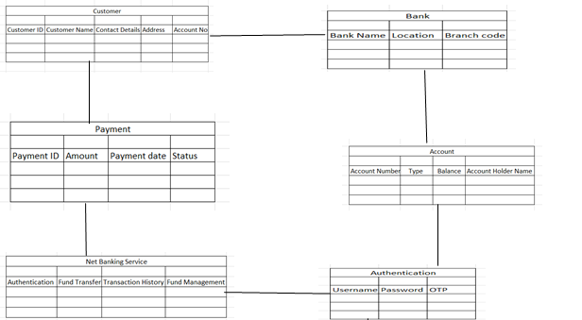

- Draw a sequence diagram for payment done by Customer Net Banking

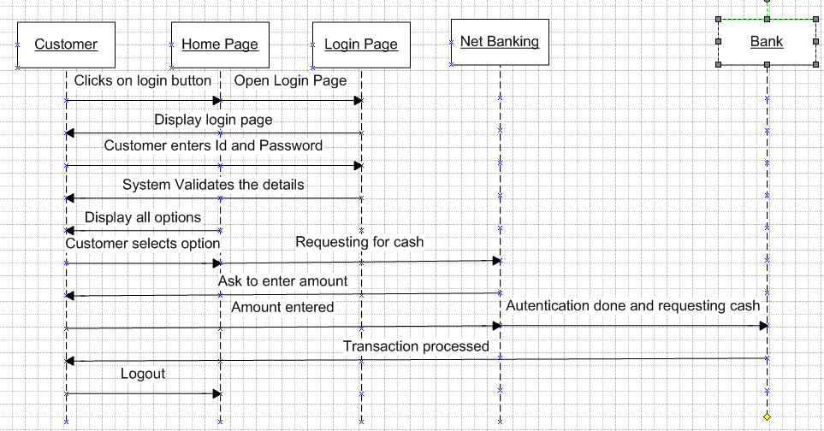

- Explain Conceptual Model for this Case

The conceptual model helps in understanding the key concepts, their relationships, and the overall structure of the net banking payment system.
It serves as a foundation for designing the database schema, defining the application architecture, and implementing the necessary functionalities within the system.

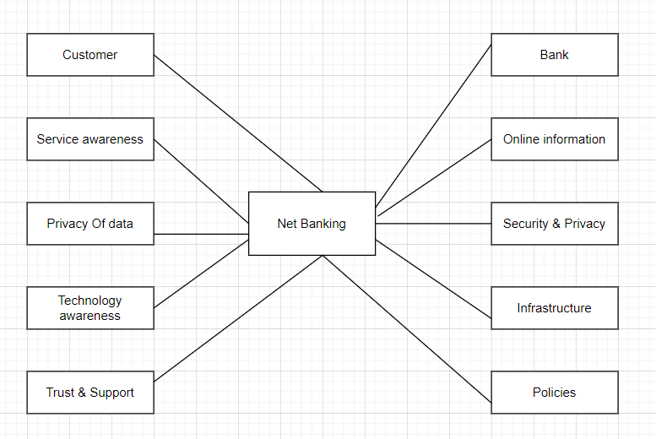

- What is MVC architecture? Explain MVC rules to derive classes from use case diagram and guidelines to place classes in 3-tier architecture

Model: This component handles the application's data and business logic, managing data and responding to requests. In web applications, this could involve interacting with databases.
View: The View represents the user interface, displaying data from the Model and sending user input to the Controller. This could be an HTML page or UI components.
Controller: The Controller acts as an intermediary, handling user input, interacting with the Model, and selecting the appropriate View. In web applications, it handles HTTP requests and returns responses

Rules to derive the classes from use case diagram-
1. Combination of one actor and one use case results in one boundary class.
Combination of two actor and one use case results in two boundary class.
Combination of three actor and one use case results in three boundary class.

2. Use case will result in controller class.
3. Each actor will result in one entity class.

Consider the example of Online shopping application with the following usecase:
Model Classes-
Customer, Payment, Net Banking, Card, Cash
View Classes-
Login View, PaymentOptionView, NetBankingView, BankSelectionView, CredentialsView, PaymentAmountView, PaymentConfirmationView, LogoutView
Controller Classes-
LoginController, PaymentOptionController, NetBankingController, BankSelectionController, CredentialsController, PaymentAmountController, PaymentConfirmationController, LogoutController

Guidelines to place classes in 3-tier architecture-
Presentation Layer-
This layer is nothing but a user interface.
View is inside this layer.
These classes interact directly with the user.
Presentation layer is responsible for displaying information and also receiving the input from the user.
Application Layer-
This layer is nothing but business logic.
Model and controller are inside this layer.
Controller handles the user input, process the request and co-ordinates interaction between the model and view.
Data Layer-
Classes which are responsible for data access and storage are in this layer.
It contains the classes which interacts with the database, files and other data sources.

- Explain BA contributions in project (Waterfall Model – all Stages)

Waterfall model is useful in the situation where the project requirements are well defined and the project goals are clear.
Waterfall model follows sequential approach.
In this model each phase is completed entirely and then only moved to the next phase.
Waterfall model relies on documentation to ensure that the project is well defined and project team is working toward clear goals.
Ones that particular phase has been completed and ones we move to the next phase , we cannot go back to the previous phase to make changes.
This model is stable for the projects when the requirements are clear.

Requirements Gathering-
First, the stakeholders are identified.
In this phase, all the requirements are gathered from the stakeholder.
BA and Project Manager participates in this phase.
After completing this phase, BRD will be generated.

Requirements Analysis-
The requirements are analysed to understand the scope of the project.
Analysing means the BA will check all the requirements, if he finds conflicting requirements then the BA will talk to the concerned stakeholder to clear it, remove the ambiguous requirements.
BA will prepare functional requirement.
The document which contains the functional requirements is called (FRS).[Functional Requirement Specifications]
Technical team will prepare non-functional requirement.
The document which contains the non-functional requirements is called (SSD).[Supplementary Support Document ]
BA will combine FRS and SSD to form SRS.[ Software Requirement Specifications]
BA will prepare RTM by referring SRS.

Design-
After the requirements are cleared, Design phase starts.
This has a detailed design document that outlines the software architecture, user interface, and system components.
HDD, ADD and solution document will be generated here.
[Highlevel Design Doc.]
BA Collaborate with designers, architects, and developers to translate requirements into system design.
BA ensure that the design aligns with the documented requirements and addresses stakeholder needs.

Development-
The Development phase includes implementation.
It involves coding the software based on the design specifications.
Programmers or developer are involved in this phase.
Here BA acts as a mediator between the development team and the stakeholders.
BA clarifies the requirements, check if the development is going on right track or not.
BA also participates in scrum meetings.

Testing-
In the testing phase, the software is tested as a whole to ensure that it meets the requirements and is free from defects.
Testers are involved in this phase.
Test documents are generated here.
BA works with the testing team to ensure that the solution meets the requirements.
BA facilitate UAT.
BA helps the users to know the functionality of the system and also helps them to use the system.

Deployment-
Once the software has been tested and approved, it is deployed to the production environment.
BA ensures that there is smooth transition from development phase to the production phase.

Implementation-
This is the final stage of waterfall model.
It involves running the code for the very first time in production phase.
Release manager handles this phase.
BA will update documentation and requirements specifications to reflect changes in the system over time

Maintenance-
Running the code for second time in the production phase is called maintenance.
This is done by support team.

- What is conflict management? Explain using Thomas – Kilmann technique

Conflicts can occur due to various reasons, such as differences in goals, values, personalities, resources, or communication breakdowns.
Conflict is an inevitable part of any workplace.
So it is important to resolve it to promote learning and growth.
Conflict management is nothing but the process of identifying and addressing conflicts in a healthy and constructive manner.
It consists of strategies and techniques aimed at resolving disputes, disagreements, or differing perspectives among individuals or groups.
By identifying the conflicts efficiently, it will in turn be helpful to reduce negative impact and increase positive impact.
It is a process or skill to find creative ways to handle the disagreement.
Thomas – Kilmann approach is widely used to recognize the approaches for conflict management.

High Assertiveness and High Cooperativeness – Collaboration- means working together to find solution
High Assertiveness and Low Cooperativeness – Competition- means defensive, that is standing for your individual beliefs and trying to win.
Low Assertiveness and High Cooperativeness – Accommodation- stakeholder will prioritize their needs over others.
Low Assertiveness and Low Cooperativeness – Avoidance- means ignoring the conflict

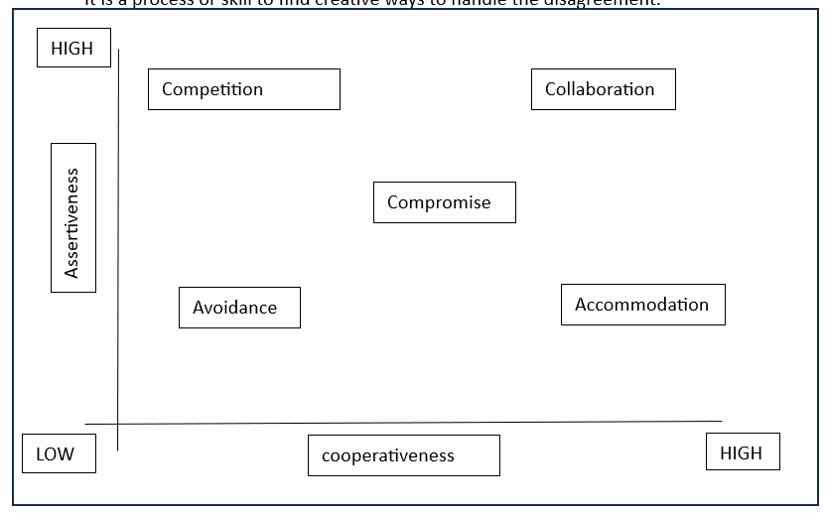

- List down the reasons for project failure

Reasons for project failure are:
Improper requirement gathering-
If the requirements of the project are not gathered correctly, then this can lead to project failure.
Lack of stakeholder involvement-
A project can fail if the stakeholders are not participating in the process.
The stakeholders input and feedback plays very important role to meet the goals.
Ineffective or less communication-
If there are communication issues between stakeholders, team members then this can lead to misunderstandings or delays in project or even can lead to project failure.
Continuous change in the requirement-
If the requirements keep on changing frequently, this can also lead to project failure.
Because the scope of the project will also keep on changing which will lead to project failure.
Poor risk management-
Poor risk management can also lead to project failure.
The team fails to identify the risks and do the risk mitigation, which can lead to unexpected challenges or delays in project.
Lack of user involvement.
Lack of executive support.
Unrealistic expectations-
Means the goals that cannot be achieved or the goals that are out of scope
Improper planning-
The project can fail if the planning is not done properly.
The milestones , goals should be discussed.
If there is no proper planning, then team may face difficulties in addressing the issues or to track the progress.
Insufficient resources-
Insufficient resources can also lead to project failure.
The project may fail due to lack of technology knowledge or lack of finances

- List the Challenges faced in projects for BA

- Lack of Domain Knowledge
- Lack of Up To Date Process (Process Documentation)
- Changing Business Needs or Requirements
- Inadequate Stakeholder Involvement
- Unrealistic Timelines
- Lack of Technical Skills
- Conflict with Users
- Scope creep- change in requirement or scope of the project during the project lifecycle can lead to scope creep
- Poor communication between stakeholder and BA

- Write about Document Naming Standards

[ProjectID][Document Type]V[x]D[y].extention
Example- [PQ777FRDV1D1.docx] or [PQ777FRD1.1.docx]

- What are the Do’s and Don’ts of a Business analyst

Never say “NO” to the client.
There is no word called as “BY DEFAULT”.
Never imagine anything in terms of GUI.
Question everything in the world.
Go to the client with plain mind i.e. with no assumptions.
Listen to the client very carefully and after he is done, then ask question.
Don’t interrupt the client.
Never try to give solutions to the client right away.
Try to concentrate only on important and required things.
Be like a lotus in mud- if a client comes with a fancy requirement, then talk to the project manager first.
Requirement hurried-project buried.
Never criticize the stakeholder.
Always appreciate the stakeholder even for small efforts.

- Write the difference between packages and sub-systems

Packages- it is a group of classes or use cases that are used to organize model elements.
Packages can be nested within other packages.
These are used as containers to organize elements.
It is very useful to represent system architecture.
Subsystems- It is collection of classes, packages, libraries and other sub systems that work together to deliver a specific set of functionalities.

- What is camel-casing and explain where it will be used-

Camel casing is a naming convention in programming where multiple words are combined into a single word
In camel-casing, the starting letter of first word starts with small letter and other words first letter starts with capital letters.
Ex- firstName, lastName
In BA, camel-casing is used in requirements documentation.
In requirement documentation, BA often use camel-casing to name the entities like use case, features, user stories like validateCustomerDetails, calculateInterestRate, etc
Business rules, which should be satisfied by the system use camel-casing.
While documenting business process or workflows, camel-casing can be used to individual in steps. This will help maintain consistency in the document.
The database tables name also uses camel-casing.
Requirement naming- camel casing is used in requirement document also, to name the functional and non-functional requirements.
By using camel casing in the documents, it helps to maintain consistency in the entire document and also increases readability.

- Illustrate Development server and what are the accesses does business analyst has?
A development server refers to a dedicated environment that is used during the software development process.
It provides platform for the developers and the testers to build, test, develop and debug the application.
The accesses a BA has are-
ReadOnly- BA’s may be granted with the readonly access to the development server.
This will allow them to view the user interface of the application, navigate through the features and also they will be able to observe the behavior of the application.
Limited Access-
Depending upon the project needs, the BA’s will be granted limited access to the specific modules in the application.
Limited Configuration Access- Means BA have the authority to make changes in certain areas of application where they have the access.

- What is Data Mapping

The database contains multiple tables in it.
There may come a scenario, where we need to map the data from one table to another.
Data mapping is necessary in cases where we want quick manner.
Data mapping is nothing but a process to establish connection between multiple data sources.
The purpose of data mapping is to ensure that the data is accurately transferred or converted into different format.
The main purpose of data mapping is-
Data integration-
While combining the data from different sources, it ensures that the data is properly matched.
Data Migration-
While migrating the data from legacy system(source) to the new system(destination), the data elements are mapped accurately into the new system.
Required techniques are applied to covert the data into the format that is required by the new system.
Data Transformation-
Data transformation means converting the data from one format to other.
In data mapping, data transformation plays very important role which ensures that the data of legacy system(source) is mapped correctly to the data in new system(destination).

- What is API. Explain how you would use API integration in the case of your application Date format is dd-mm-yyyy and it is accepting some data from Other Application from US whose Date Format is mm-dd-yyyy

API stands for Application Programming Interface.
It is a software intermediary that allows the two applications to communicate with each other.
It is the set of rules, protocols and tools that define how different software application should interact with each other.
API allows sharing of only necessary information and keeps the internal system details hidden, which helps the system security.
For the above scenario,
Establish API communication- set up API communication between your application and other application to exchange data.
Do Data formatting- while sending the data from one application to other, convert the date format from dd-mm-yyyy to mm-dd-yyyy.
While receiving the data from other application, parse the data and extract the date, month and year and re-arrange them accordingly.
Perform Data Validation and ensure that the converted date remains in a valid format.

