Document 6- Please prepare a use case diagram, activity diagram and a use case specification document.

Use Case Diagram:
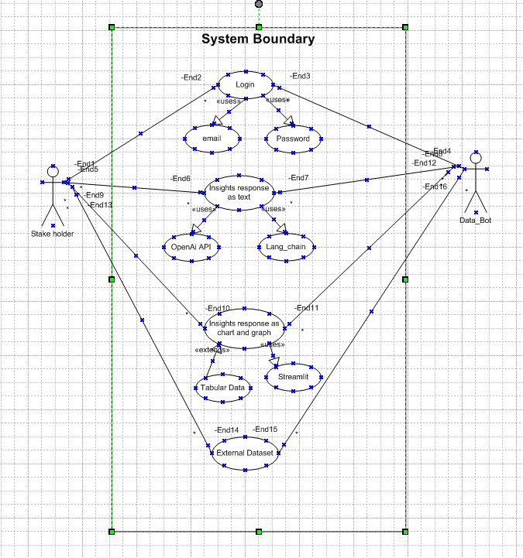

Activity Diagram
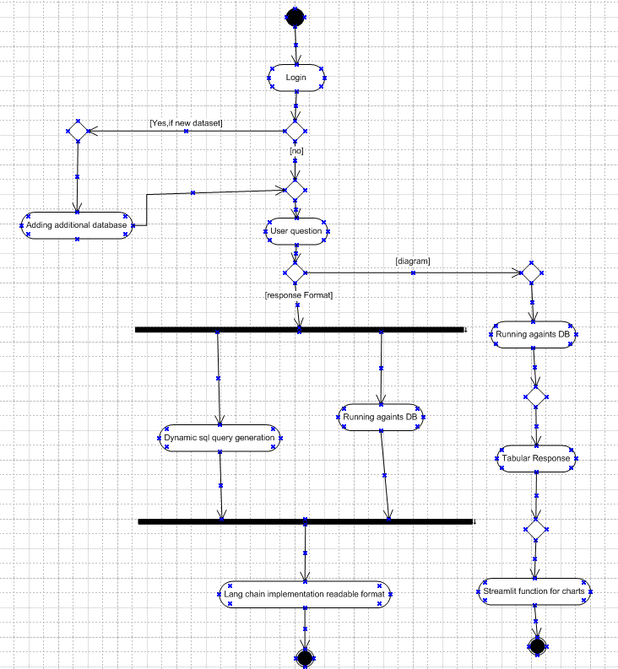

1. Use case Name: Getting login into the application
2. Use case Description: User name and password is required
3. Actors Primary Actors Secondary actors: Primary actor: Stakeholder, Secondary Actor: Data Bot
4. Basic Flow: The flow is username and password are correct
5. ALTERNATE FLOW: The flow is:
      - Password is wrong
      - Username is wrong
      - Username and password are wrong
6. Exceptional flows: The flow is
      - Forgot Password
      - Forgot Username
7. Pre- Conditions: Active internet connection, browser compatible
8. post-conditions: Home page of actor should be displayed
9. Assumptions:
Users have basic computer knowledge, English

10. Constraints:
Usernames cannot be names
11. Dependencies:
Users should exist registration process
12. Inputs and Outputs:
Input: Inputs-username and password
Output: error code or status flag
13. Business Rules:
- Username- valid and unique email ID

- Password 1 cap, 1small, 1num, 1special char

14.Miscellaneous Information: Interactive design browser compatible.

1. Use case Name: Getting Insights of Organization DB of a text format.
2. Use case Description: When a question is asked, we need to generate dynamic SQL queries with open Ai API, will convert as tabular data into readable format.
3. Actors Primary Actors Secondary actors: Primary actor: Stakeholder, Secondary Actor: Data Bot
4. Basic Flow: The flow is
- user question
- Dynamic SQL query
- Tabular output
- Readable format
5. ALTERNATE FLOW: The flow is:
      - Adding a new DB
      - User question
      - Tabular output
      - Readable format.
6. Exceptional flows: The flow is
      - User question
      - Tabular output
      - Visuals like chart and graph
7. Pre- Conditions: Need to create an account for credentials
8. post-conditions: Need to login to get the insights of a data
9. Assumptions:
- The login can be done by google account or any social media account
- The implementation voice recognition
- Chat memory management

10. Constraints:
- The open ai API has the specific usage limit for using the API request
- The Lang chain is the framework will support only open ai llm
- The data storage is in SQL server

11. Dependencies:
- The user needs to have credentials
- The open ai, langchain and streamlit are required
- The Database is required
12. Inputs and Outputs:
Input: The input is a question format based on the organization DB
Output: Readable text format
13. Business Rules:
- The procedures are waterfall method(req gathering, req analysis, design, development, testing and UAT)

- The business rules are follow the scope and finish the tasks within the given timeline.

14.Miscellaneous Information: The negative feedback and approaches are called miscellaneous information.

1. Use case Name: Getting Insights of Organization DB of visual format
2. Use case Description: When a question is asked, we need to generate dynamic SQL queries with open Ai API, will convert as tabular data into Visual format.
3. Actors Primary Actors Secondary actors: Primary actor: Stakeholder, Secondary Actor: Data Bot
4. Basic Flow: The flow is
- user question
- Dynamic SQL query
- Tabular output
- Visual Format.
5. ALTERNATE FLOW: The flow is:
      - Adding a new DB
      - User question
      - Tabular output
      - Visual Format.
6. Exceptional flows: The flow is
- user question
- Dynamic SQL query
- Tabular output
- Readable format
7. Pre- Conditions: Need to create an account for credentials
8. post-conditions: Need to login to get the insights of a data
9. Assumptions:
- The login can be done by google account or any social media account
- The implementation voice recognition
- Chat memory management

10. Constraints:
- The open ai API has the specific usage limit for using the API request
- The Lang chain is the framework will support only open ai llm
- The data storage is in SQL server

11. Dependencies:
- The user needs to have credentials
- The open ai, langchain and streamlit are required
- The Database is required
12. Inputs and Outputs:
Input: The input is a question format based on the organization DB
Output: visualization format like(charts and graphs)
13. Business Rules:
- The procedures are waterfall method(req gathering, req analysis, design, development, testing and UAT)

- The business rules are follow the scope and finish the tasks within the given timeline.

14.Miscellaneous Information: The negative feedback and approaches are called miscellaneous information.

1. Use case Name: Getting Insights from external Database
2. Use case Description: Adding a new dataset to get the insight of DB
3. Actors Primary Actors Secondary actors: Primary actor: Stakeholder, Secondary Actor: Data Bot
4. Basic Flow: The flow is
- Adding a new dataset
- user question
- Dynamic SQL query
- Tabular output
- Readable format
5. ALTERNATE FLOW: The flow is:
      - Adding a new DB
      - User question
      - Tabular output
      - Readable format.
6. Exceptional flows: The flow is
      - User question
      - Tabular output
      - Visuals like chart and graph
7. Pre- Conditions: Need to create an account for credentials
8. post-conditions: Need to login to get the insights of a data
9. Assumptions:
- The login can be done by google account or any social media account
- The implementation voice recognition
- Chat memory management

10. Constraints:
- The open ai API has the specific usage limit for using the API request
- The Lang chain is the framework will support only open ai llm
- The data storage is in SQL server

11. Dependencies:
- The user needs to have credentials
- The open ai, langchain and streamlit are required
- The Database is required
12. Inputs and Outputs:
Input: The input is a question format based on the organization DB
Output: Readable text format and visualization(charts and graphs)
13. Business Rules:
- The procedures are waterfall method(req gathering, req analysis, design, development, testing and UAT)

- The business rules are follow the scope and finish the tasks within the given timeline.

14.Miscellaneous Information: The negative feedback and approaches are called miscellaneous information.

Document 7- Screens and pages
Home Screen
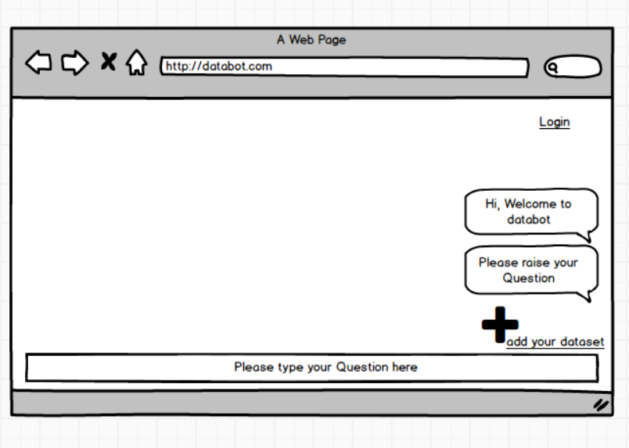

Login Page
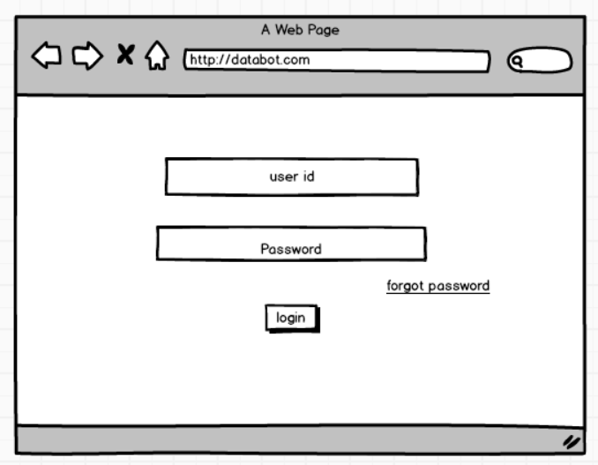

Text Output
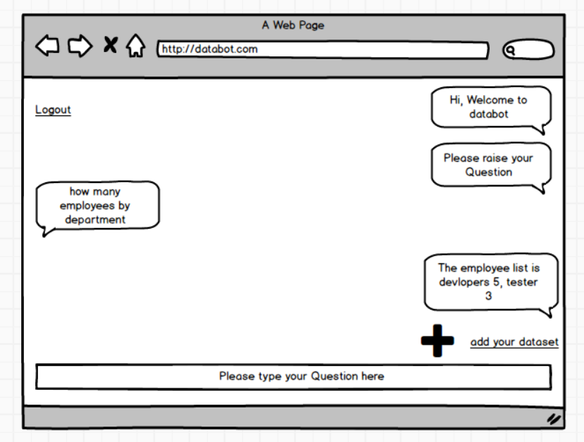

Chart Output
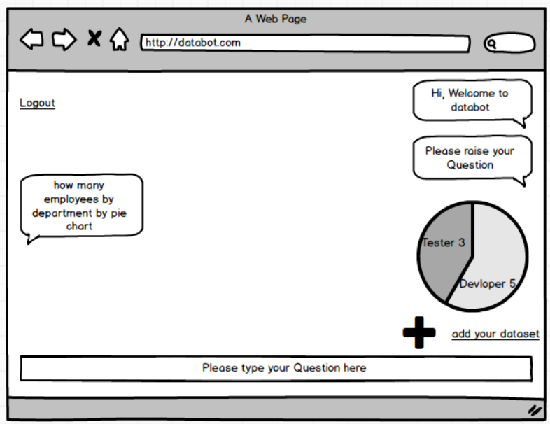

Adding Dataset
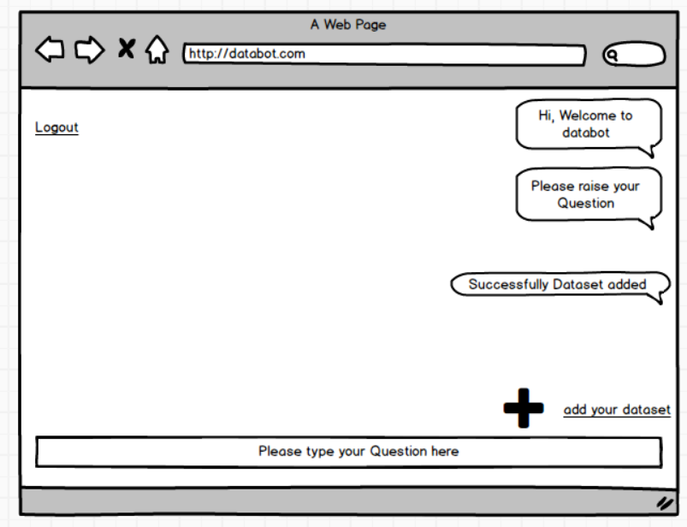

Logout Screen
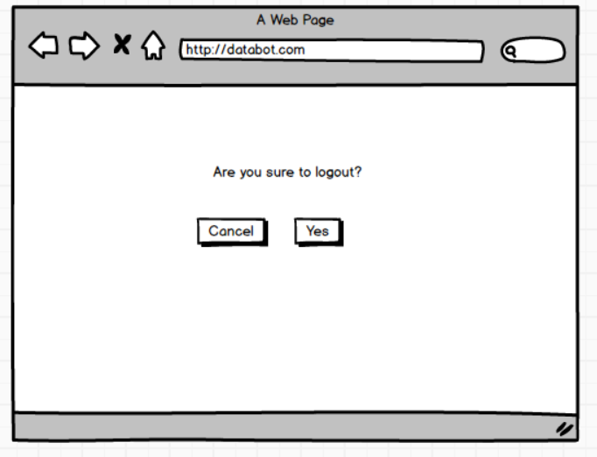

Document 8- Tools-Visio and Axure
Visio
- Microsoft Visio is a powerful diagramming tool widely used in business analysis and system design.
- It enables users to create professional flowcharts, process maps, organizational charts, and network diagrams, which help visualize workflows, business processes, and data relationships.
- Visio’s flexibility and integration with other Microsoft Office applications make it an effective choice for documenting system architecture and process flows in a clear and standardized format.

Axure
- Axure RP is a dynamic tool used for designing interactive wireframes and prototypes.
- It allows Business Analysts and UX designers to simulate user interactions, define business requirements through realistic mock-ups, and generate detailed documentation for development teams.
- With its advanced prototyping features, Axure helps bridge the gap between business requirements and technical implementation, ensuring better stakeholder understanding and validation of system functionality before development begins.

Document 9- BA experience
- Requirement gathering:
- MOSCOW technique: MOSCOW is a prioritizing technique which is used in business analysis and software development
Must – 100% compulsory Requirements (getting insights of text format, visual format and adding the external dataset)

Should – 100% important requirements (perquisites) (open ai Api, langchain, streamlit library)
Could – 100% important requirements (No conflicts) (Adding dataset will not conflict with other functionalities)
Would – less priority requirements can be carried out for next phase.(chat memory management, voice recognition)

- Client is not available for some period of time during this phase. So as a BA i need to source out point of contacts from his side and get the information ASAP.
- FURPS technique: This technique is used to validate must requirement.
F- Functionality (getting insights of text format, visual format and adding the external dataset)
U- Usability (The Usability is user friendly design of user interface)
R- Reliability (The databot will work 3 years until any version changes in OpenAI model)
P- Performance (The screen get load within 3 seconds)
S- Supportability (bug fixes and maintains are usability)
- There are many requirements which are duplicated or repeated. We need to remove them immediately
- Prototyping:

Home Screen
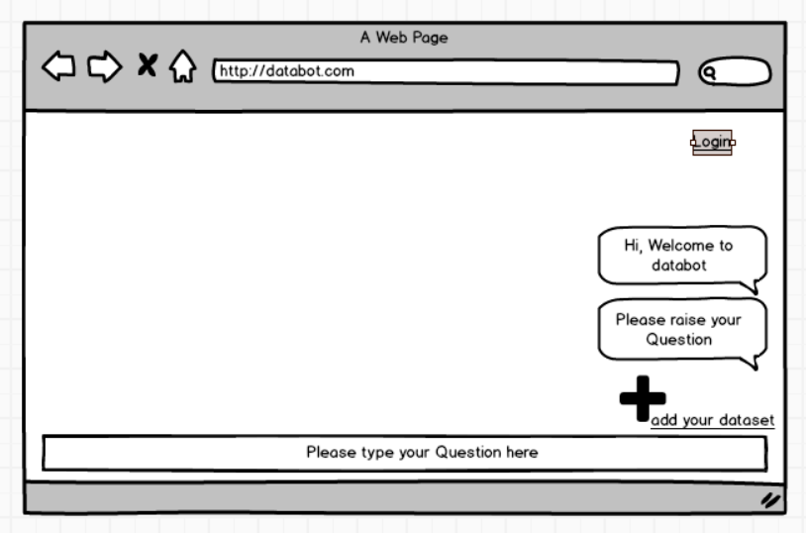

Login Page 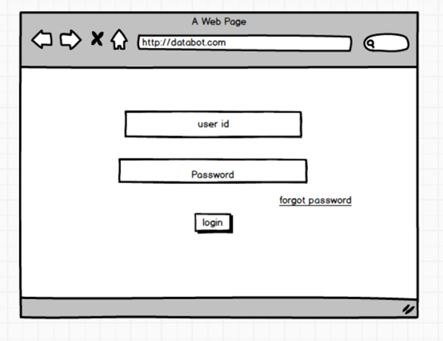

Text Output

Chart Output
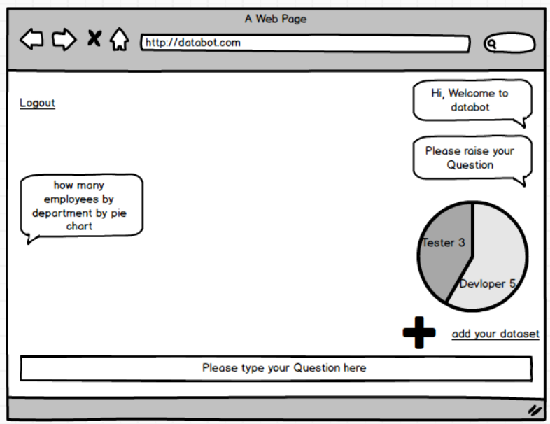

Adding Dataset

Logout Screen
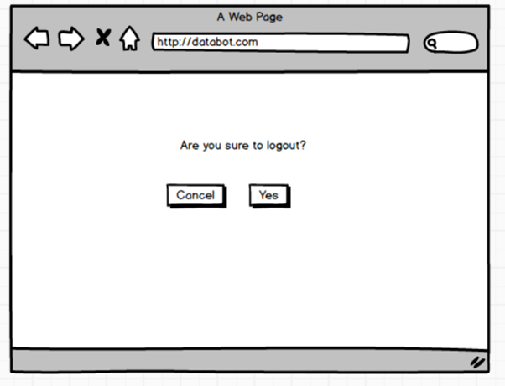

- Requirement Analysis:
- UML diagrams
Use Case Diagram:

- Activity diagrams

- Communicate the diagrams to team. Some team members might not agree with them and might make changes. As a BA we need to consider the points and make modifications
- BRS and SRS
Business Requirement Specification
Business Goals
The goal of the business is to bridge the gap stakeholder and organization data
Need: To build the chat bot for the stake holders.
Business Objectives
To provide an IT solution for:
This a chat bot which contains features like connecting organization database, getting the replies like readable format response, pictorial graphs and charts, feature of adding external datasets.

SRS
Functional Requirement: Functional requirement describe capabilities the system will be able to perform in terms of behaviour or operations.
Non- Functional Requirement: Non-functional requirement doesn’t directly relate to the behaviour or functionality of the solution, but rather describes environmental conditions under which the solution must remain effective like capacity, speed, security etc.
Req ID | Req Name | Req Description | Priority
FR0001 | User Registration | Users (Stakeholders) can create an account by providing email and password. | 10
FR0002 | User Login/Logout | Registered users can securely log in and log out of the application. | 10
FR0003 | Chat Window | Stake holders can use the chat window to raise queries and requests | 9
FR0004 | Function app API | In the back-end we need to connect the function app with open ai Api prompt and Lang chain library | 9
FR0005 | Streamlit library implementation | Streamlit library is used to generate the graphs and charts of the visualization | 10
FR0006 | Add New dataset feature | Stakeholders can upload their dataset to get insights and information of the uploaded dataset | 10
NFR001 | Usability | The application should have an intuitive and user-friendly interface. | 7
NFR002 | Performance | The application must load pages within 3 seconds. | 8
NFR003 | Security | The application must ensure secure user authentication. | 7

- Design:
prepare test cases:
Req ID | Requirement | Requirement Description | Input data | Expected behaviour | Actual Behaviour | Comments | Result
FR0001 | User Registration | Users (Stakeholders) can create an account by providing email and password. | Email id, password, confirm password | Credentials need to be created
FR0002 | User Login/Logout | Registered users can securely log in and log out of the application. | Email id, password. | Land to chat window page
FR0003 | Chat Window | Stake holders can use the chat window to raise queries and requests | Type any question related to the Organisation DB | Replies related to organization DB
FR0004 | Function app API | In the back-end we need to connect the function app with open ai Api prompt and Lang chain library | Type any question related to the Organisation DB | Replies related to organization DB
FR0005 | Streamlit library implementation | Streamlit library is used to generate the graphs and charts of the visualization | questions related to Visualization | replies related to Visualisation
FR0006 | Add New dataset feature | Stakeholders can upload their dataset to get insights and information of the uploaded dataset | uploads excel sheet or SQL DB | Upload Successful

- Communicate with client on design and solution documents
- Write negative test cases as well along with positive test cases.
Req ID | Requirement | Requirement Description | Positive test case | Negative test case
FR0001 | User Registration | Users (Stakeholders) can create an account by providing email and password. | Email id, password, confirm password | Invalid email-id, Invalid Password
FR0002 | User Login/Logout | Registered users can securely log in and log out of the application. | Email id, password. | Wrong email_id and password
FR0003 | Chat Window | Stake holders can use the chat window to raise queries and requests | Type any question related to the Organisation DB | Invalid questions
FR0004 | Function app API | In the back-end we need to connect the function app with open ai Api prompt and Lang chain library | Type any question related to the Organisation DB | Invalid questions
FR0005 | Streamlit library implementation | Streamlit library is used to generate the graphs and charts of the visualization | questions related to Visualization | wrong visual requests
FR0006 | Add New dataset feature | Stakeholders can upload their dataset to get insights and information of the uploaded dataset | uploads excel sheet or SQL DB | Empty dataset
- Do not miss a single test case. It might have huge impact on project development in later stages
- Prepare test data for testing
- Update RTM.
Req ID | Req Name | Req Description | D1 | T1 | D2 | T2 | D3 | T3 | D4 | T4 | UAT
FR0001 | User Registration | Users can create an account by providing email and password. | ✓ | ✓ | ✓ |  |  |  |  |  | ✓
FR0002 | User Login/Logout | Registered users can securely log in and log out of the application. | ✓ | ✓ | ✓ |  |  |  |  |  | ✓
FR0003 | Chat Window | Stake holders can use the chat window to raise queries and requests | ✓ | ✓ | ✓ |  |  |  |  |  | ✓
FR0004 | Function app API | In the back-end we need to connect the function app with open ai Api prompt and Lang chain library | ✓ | ✓ | ✓ |  |  |  |  |  | ✓
FR0005 | Streamlit library implementation | Streamlit library is used to generate the graphs and charts of the visualization | ✓ | ✓ | ✓ |  |  |  |  |  | ✓
FR0006 | Add New dataset feature | Stakeholders can upload their dataset to get insights and information of the uploaded dataset | ✓ | ✓ | ✓ |  |  |  |  |  | ✓
NFR001 | Usability | The application should have an intuitive and user-friendly interface. | ✓ |  |  | ✓ |  | ✓ |  |  | ✓
NFR002 | Performance | The application must load pages within 3 seconds. | ✓ |  |  |  | ✓ | ✓ |  |  | ✓
NFR003 | Security | The application must ensure secure user authentication. | ✓ | ✓ |  |  |  |  | ✓ |  | ✓

4. Development:
- Organized JAD sessions
Application developed through JAD has higher customer satisfaction and less number of errors as user is directly involved in the development process.
● Clarifying queries of tech team during coding
● There might be some team members who doesn't agree with the concept or who doesn’t cooperate during JAD sessions. As a BA i handle the situation gently and had one on one discussion with them. Explained how their actions are going to affect the project. Setup healthy environment within the team.
● Referred diagrams to code the Unit

● Conduct regular meetings with technical team and client which is challenging. Some team members might not be available for the meeting. Recording the session and providing that to missed one and having one to one discussion later with that missed person is all i need to do

5. Testing:
- ● Prepare test cases from use cases Design:
prepare test cases:
Req ID | Requirement | Requirement Description | Input data | Expected behaviour | Actual Behaviour | Comments | Result
FR0001 | User Registration | Users (Stakeholders) can create an account by providing email and password. | Email id, password, confirm password | Credentials need to be created
FR0002 | User Login/Logout | Registered users can securely log in and log out of the application. | Email id, password. | Land to chat window page
FR0003 | Chat Window | Stake holders can use the chat window to raise queries and requests | Type any question related to the Organisation DB | Replies related to organization DB
FR0004 | Function app API | In the back-end we need to connect the function app with open ai Api prompt and Lang chain library | Type any question related to the Organisation DB | Replies related to organization DB
FR0005 | Streamlit library implementation | Streamlit library is used to generate the graphs and charts of the visualization | questions related to Visualization | replies related to Visualisation
FR0006 | Add New dataset feature | Stakeholders can upload their dataset to get insights and information of the uploaded dataset | uploads excel sheet or SQL DB | Upload Successful

● Perform high level testing
● Test data is requested by BA from client
Req ID | Requirement | Requirement Description | Test data
FR0001 | User Registration | Users (Stakeholders) can create an account by providing email and password. | Email id, password, confirm password
FR0002 | User Login/Logout | Registered users can securely log in and log out of the application. | Email id, password.
FR0003 | Chat Window | Stake holders can use the chat window to raise queries and requests | Type any question related to the Organisation DB
FR0004 | Function app API | In the back-end we need to connect the function app with open ai Api prompt and Lang chain library | Type any question related to the Organisation DB
FR0005 | Streamlit library implementation | Streamlit library is used to generate the graphs and charts of the visualization | questions related to Visualization
FR0006 | Add New dataset feature | Stakeholders can upload their dataset to get insights and information of the uploaded dataset | uploads excel sheet or SQL DB

● Updated RTM
● Take signoff from client
● Prepare client for UAT
6. Deployment:
● Forwarded RTM to client which should be attached to project closure document
Req ID | Req Name | Req Description | D1 | T1 | D2 | T2 | D3 | T3 | D4 | T4 | UAT
FR0001 | User Registration | Users (farmers/manufacturers) can create an account by providing email and password. | ✓ | ✓ | ✓ |  |  |  |  |  | ✓
FR0002 | User Login/Logout | Registered users can securely log in and log out of the application. | ✓ | ✓ | ✓ |  |  |  |  |  | ✓
FR0003 | Chat Window | Stake holders can use the chat window to raise queries and requests | ✓ | ✓ | ✓ |  |  |  |  |  | ✓
FR0004 | Function app API | In the back-end we need to connect the function app with open ai Api prompt and Lang chain library | ✓ | ✓ | ✓ |  |  |  |  |  | ✓
FR0005 | Streamlit library implementation | Streamlit library is used to generate the graphs and charts of the visualization | ✓ | ✓ | ✓ |  |  |  |  |  | ✓
FR0006 | Add New dataset feature | Stakeholders can upload their dataset to get insights and information of the uploaded dataset | ✓ | ✓ | ✓ |  |  |  |  |  | ✓
NFR001 | Usability | The application should have an intuitive and user-friendly interface. | ✓ |  |  | ✓ |  | ✓ |  |  | ✓
NFR002 | Performance | The application must load pages within 3 seconds. | ✓ |  |  |  | ✓ | ✓ |  |  | ✓
NFR003 | Security | The application must ensure secure user authentication. | ✓ | ✓ |  |  |  |  | ✓ |  | ✓

● Coordinates to complete and share end user manuals
● Plans and organizes training sessions
● Make sure all the candidates attend the meeting

