Question 1: Identify minimum 20 Functional Requirement?
Answer:
Req ID | Req name | Req Description | Priority
FR0001 | Farmer Registration | Farmer should be able to register with the application | 9
FR0002 | Farmers search for product | Farmers should be able to search for available products in Fertilisers, Pesticides and seeds | 8
FR0003 | Manufacture’s registration | Manufacturer should be able to register with the application | 8
FR0004 | Manufacture product listing | Manufacturer should be able to list their product in the catalogue | 7
FR0005 | Product details | The application should be able to display about each product, including description, specification and pricing | 9
FR0006 | Add to cart | User should be able to add product to their shopping cart for purchase | 8
FR0007 | Cart management | User should be able to manage the contents of their shopping cart including adding or removing products | 8
FR0008 | Wish list management | User should be able to manage their wish list or buy-later list, including adding or removing products. | 7
FR0009 | Multiple payment gateways | The platform should integrate with multiple payment gateways to facilitate secure and convenient transactions. | 9
FR0010 | Order placement | User should be able to place order for selected products, specifying order and delivery address | 9
FR0011 | Order confirmation | User should receive order confirmation message with details like order no., product quantity, total amount and estimated delivery date9 | 9
FR0012 | Order tracking | User should be able to track the status and location of their orders in real-time | 9
FR0013 | Order history | User should be able to view their order history including past order | 7
FR0014 | Customer support | User should have access to customer support through e-mail, live-chat or phone for assistance with their order or enquiry | 8
FR0015 | User rating and reviews | User should be able to provide ratings and reviews for product they have purchased | 7
FR0016 | Product recommendations | The platform should provide personalized product recommendations based on user preferences and browsing history | 8
FR0017 | Social sharing | User should have the option to share the product or their purchase experience on social media platform | 7
FR0018 | Secure transaction | The platform should ensure secure transaction by implementing appropriate encryption and security measures | 9
FR0019 | Product filtering | Users should be able to filter products based on various criteria such as product type, price range or brand | 8
FR0020 | Account management | Users should be able to manage their account settings including profile information ,password change and e-mail preferences | 7

Req ID | Req name | Req Description | Priority
NFR001 | Usability | The application should be user friendly | 9
NFR002 | Performance | The application must load the page within 3 seconds | 8
NFR003 | Security | The application must secure user authentication | 8
NFR004 | Compatibility | The application should be compatible with major web browser | 8
NFR005 | Response time | The application should respond to the user input within 2 sec | 9
NFR006 | Representation | Visual representation of the pages must be detailed | 7
NFR007 | Auto readable | OTPs must be auto readable by application | 7
NFR008 | Session time out | Session time out must be up to 2 min | 6
NFR009 | Accuracy | Location must be accurate up to 50m | 8
NFR010 | Refresh | Pages must be refreshed after 30 sec | 6

Question 2: Make wireframes and prototypes?
Answer:
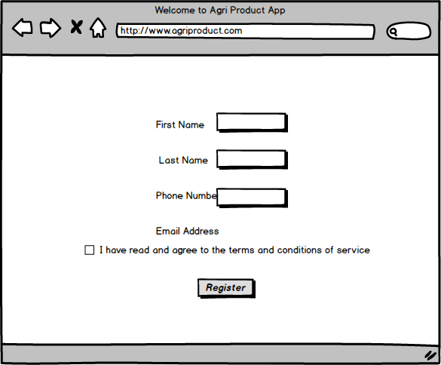

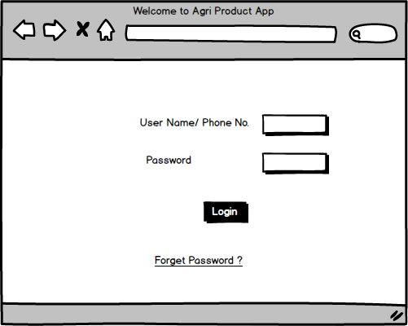
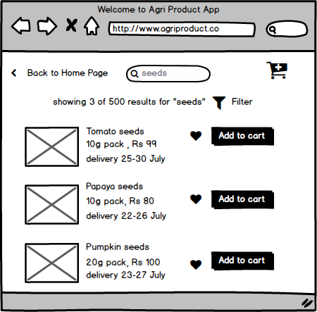
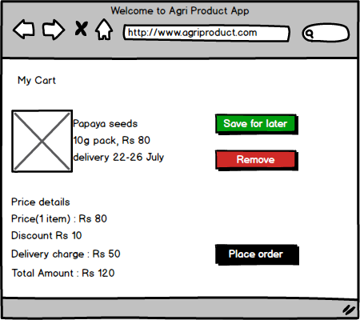

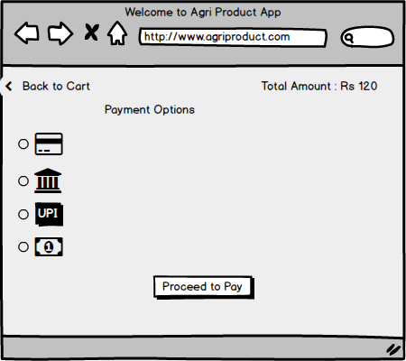

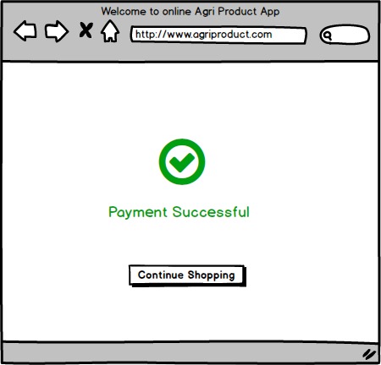

Question 3: Make a note of the tool which you are using above?
Answer:
Balsamiq- It is a popular light weight wireframe tool known for its simplicity and speed, enabling designers to quickly sketch out user interfaces and iterate on design ideas. Its hand drawn style helps to emphasize structure and layout over fine details, encouraging team collaboration and rapid ideation.
Balsamiq drag-and-drop interface, pre-built UI components and real time collaboration feature make it easy to create and modify wireframes, while its low fidelity design keeps the focus on functionality. However its basic interactivity and limited features may not suffice for complex projects requiring high-fidelity mock-ups.

Microsoft Visio: It’s a versatile diagraming tool used to create various diagrams including wireframes, flowcharts and network diagram. While not exclusively for wire framing, its extensive shape libraries and integration with Microsoft office tools make it popular choice for designing user interfaces and planning information architect.Visios drag-and –drop interface ,custom shapes, and data linking capabilities enhance productivity but its complexity and lack of specialised wire framing features can be a drawback for user seeking basic functionalities. Despite its higher cost it produces professional quality diagram and integrate seamlessly with other Microsoft applications.
Axure RP: it stand for Axure Rapid Prototyping which is a prototyping and wire framing tool used by BA, UI/UX Designers, product manager and developers to create interactive, high-fidelity prototypes and wireframes for website, applications, and digital products. It allow user to build more detailed and interactive prototypes that closely mimic the final user experience and behaviour of product.

Question 4: Prepare RTM?
Answer:
Red ID | Req Name | Design | D1 | T1 | D2 | T2 | D3 | T4 | D4 | UAT
FR001 | User registration | Complete | Complete | Complete | complete | Complete | In progress | In progress | incomplete | incomplete
FR002 | User login | Complete | Complete | Complete | Complete | Complete | Complete | In progress | In progress | incomplete
FR003 | Uploading product detail | Complete | Complete | Complete | Complete | Complete | Complete | In progress | In progress | incomplete
FR004 | Product search | Complete | Complete | Complete | Complete | Complete | Complete | In progress | In progress | incomplete
FR005 | Search filter | Complete | Complete | Complete | Complete | Complete | Complete | In progress | In progress | incomplete
FR006 | Product details | Complete | Complete | Complete | Complete | Complete | Complete | In progress | In progress | incomplete
FR007 | Adding product to cart | Complete | Complete | Complete | Complete | Complete | Complete | In progress | In progress | incomplete
FR008 | Payment method | Complete | Complete | Complete | Complete | Complete | Complete | In progress | In progress | incomplete
FR009 | Check out process | Complete | Complete | Complete | Complete | Complete | Complete | In progress | In progress | incomplete
FR010 | Order confirmation | Complete | Complete | Complete | Complete | Complete | Complete | In progress | In progress | incomplete
NFR001 | Loading time | Complete | Complete | Complete | Complete | Complete | Complete | In progress | In progress | incomplete
NFR002 | Response time | Complete | Complete | Complete | Complete | Complete | Complete | In progress | In progress | incomplete
NFR003 | Language support | Complete | Complete | Complete | Complete | Complete | Complete | In progress | In progress | incomplete
NFR004 | Accessibility | Complete | Complete | Complete | Complete | Complete | Complete | In progress | In progress | incomplete
NFR005 | Authenticity | Complete | Complete | Complete | Complete | Complete | Complete | In progress | In progress | incomplete
NFR006 | Data protection | Complete | Complete | Complete | Complete | Complete | Complete | In progress | In progress | incomplete
NFR007 | maintenance | Complete | Complete | Complete | Complete | Complete | Complete | In progress | In progress | incomplete
NFR008 | Delivery track | Complete | Complete | Complete | Complete | Complete | Complete | In progress | In progress | incomplete
NFR009 | Payment compliance | Complete | Complete | Complete | Complete | Complete | Complete | In progress | In progress | incomplete
NFR010 | scalability | Complete | Complete | Complete | Complete | Complete | Complete | In progress | In progress | incomplete

Question 5: Prepare 10 Test Case Documents?
Answer:
- User registration
Test case | Tc_001 | Test case name | User registration
Project ID | Agri0123 | Project name | Online agricultural product store
PM ID | PM_001 | PM Name | Mr vandanam
Test strategy ID | TS_001 | Tester name | John smith
Test plan ID | TP_001 | Date of test | 30-nov-2025
Test Schedule ID | TSCH_001
Scenario | To register new user inside the application using email ID and creating password
Example | Username:abc@example.com and password:iwant123
Action | Inputs | Expected output | Actual output | Test Browser | Test Results
Enter the username and password and click on register button | Username: abc@example.com  Password:iwant123 | User successfully registered and redirected to home page | After entering mandatory fields system should user created successfully | Chrome | pass

2 .User Login

Test case ID | Tc_002 | Test case name | User login
Project ID | Agri0123 | Project name | Online agricultural product store
PM ID | PM_001 | PM Name | Mr vandanam
Test strategy ID | Ts_001 | Tester name | Ms alekya
Test plan ID | Tp_001 | Date of test | 30-nov-2025
Test Schedule ID | TSCH_001
Scenario | The registered user enter valid Login credential and click on the login button
Example | Username:abc@example.com and password:iwant123
Action | Inputs | Expected output | Actual output | Test Browser | Test Results
Enter the username and password and click on the login button |  | User successfully login and redirected to home page | User successfully logged in and redirected to home page | chrome | Pass

3. Adding product detail by Manufacturer
Test case ID | TC_003 | Test case name | Product upload by manufacturer
Project ID | Agri0123 | Project name | Online agricultural product store
PM ID | PM_001 | PM Name | Mr vandanam
Test strategy ID | TS_001 | Tester name | Mr Jason
Test plan ID | TP_001 | Date of test | 30-nov-2025
Test Schedule ID | TSCH_001
Scenario | User should be able to add selected products to cart
Example
Action | Inputs | Expected output | Actual output | Test Browser | Test Results
Manufacturer should login and click on enter product detail button | Product name, product description,  product prices | Product is successfully added and visible in product catalogue | Product details are displayed | chrome | pass

Test case ID | TC004 | Test case name | Product search
Project ID | Agri0123 | Project name | Online agricultural product store
PM ID | PM_001 | PM Name | Mr vandanam
Test strategy ID | TS_001 | Tester name | Ms alekya
Test plan ID | TP_001 | Date of test | 30-nov-2025
Test Schedule ID | TSCH_001
Scenario | Verify that user can search for product
Example | If user want to find seeds of abc company
Action | Inputs | Expected output | Actual output | Test Browser | Test Results
Type the product name which user want to search in search box | Keywords  Pesticide  Seed organic | Relevant product are displayed in the search results | Search product is displayed | chrome | yes

5. Applying search filter
Test case ID | TC_005 | Test case name | Apply search filter
Project ID | Agri0123 | Project name | Online agricultural product store
PM ID | PM_005 | PM Name | Mr vandanam
Test strategy ID | TS_001 | Tester name | Ms alekya
Test plan ID | TP_001 | Date of test | 30-nov-2025
Test Schedule ID | TSCH_001
Scenario | Verify that user can apply filters to search result
Example | If user wants to filter one particular variety of seeds
Action | Inputs | Expected output | Actual output | Test Browser | Test Results
User should click on filter button to apply filter according to choice | Price range , brand , quantity, organic/chemical | Search result are refined based on applied filter |  | chrome | pass

6. View product detail
Test case ID | TC_006 | Test case name | View product detail
Project ID | Agri0123 | Project name | Online agricultural product store
PM ID | PM_001 | PM Name | Mr vandanam
Test strategy ID | TS_001 | Tester name | Ms alekya
Test plan ID | TP_001 | Date of test | 30-nov-2025
Test Schedule ID | TSCH_006
Scenario | Verify that user can view a detailed information about a product
Example | User click on product details like price, description, manufacturer name displayed
Action | Inputs | Expected output | Actual output | Test Browser | Test Results
User should click on view product detail button | Product A  Product B | Product detail displayed correctly including name, price, and manufacturer detail | Product detail are displayed when user clicked the product detail button | chrome | Pass

7. Adding product to the cart

Test case ID | TC_007 | Test case name | Adding product to Cart
Project ID | Agri0123 | Project name | Online agricultural product store
PM ID | PM_001 | PM Name | Mr vandanam
Test strategy ID | TS_004 | Tester name | Ms alekya
Test plan ID | TP_004 | Date of test | 30-nov-2025
Test Schedule ID | TSCH_004
Scenario | Verify that user can add products to shopping cart
Example | User click on selected product and add to cart
Action | Inputs | Expected output | Actual output | Test Browser | Test Results
When user click add to cart button | Seed A  Fertilizer B | Product is added to cart successfully with the correct quantity | Product is added to cart successfully | chrome | pass

8. Payment options
Test case ID | TC_008 | Test case name | Payment options
Project ID | Agri0123 | Project name | Online agricultural product store
PM ID | PM_001 | PM Name | Mr vandanam
Test strategy ID | TS_001 | Tester name | Ms alekya
Test plan ID | TP_001 | Date of test | 30-nov-2025
Test Schedule ID | TSCH_001
Scenario | Verify that user can select different payment option successfully and proceed
Example | User can choose UPI, COD, credit/debit card to make payment
Action | Inputs | Expected output | Actual output | Test Browser | Test Results
User click on proceed to pay button | Credit/debit card, UPI, COD | User can select the payment option successfully and proceed | User selected the payment option and payment was done successfully | chrome | pass

9. Order confirmation
Test case ID | TC_009 | Test case name | Order confirmation
Project ID | Agri0123 | Project name | Online agricultural product store
PM ID | PM_001 | PM Name | Mr vandanam
Test strategy ID | TS_001 | Tester name | Ms alekya
Test plan ID | TP_001 | Date of test | 30-nov-2025
Test Schedule ID | TSCH_001
Scenario | Verify that user receive an order confirmation after completing the payment
Example | User receive SMS or email regarding confirmation of order
Action | Inputs | Expected output | Actual output | Test Browser | Test Results
 | Order ID | Order confirmation is sent to the user via email/message | User received an email/message confirming the order | chrome | pass

10. Delivery tracking
Test case ID | TC_010 | Test case name | Delivery tracking
Project ID | Agri0123 | Project name | Online agricultural product store
PM ID | PM_001 | PM Name | Mr vandanam
Test strategy ID | TS_004 | Tester name | Ms alekya
Test plan ID | TP_004 | Date of test | 30-nov-2025
Test Schedule ID | TSCH_004
Scenario | Delivery tracking information is displayed with real-time after placement
Example | User can track the order whether shiped,in transit or out for delivery
Action | Inputs | Expected output | Actual output | Test Browser | Test Results
User should click on track the order button | Delivery tracking information is displayed with real-time | Delivery tracking information is displayed with real-time update | Delivery tracking information is displayed | chrome | pass
Question 6: Draw Database Schema and Entity Relationship diagrams?
Answer:
DB Schema: a blueprint that outline the structure and organisation of database. It describe table, column, and data types within a database.
Entity Relationship Diagram: A visual presentation of how different entities (people, object, concept) relate to each other within a system or database.

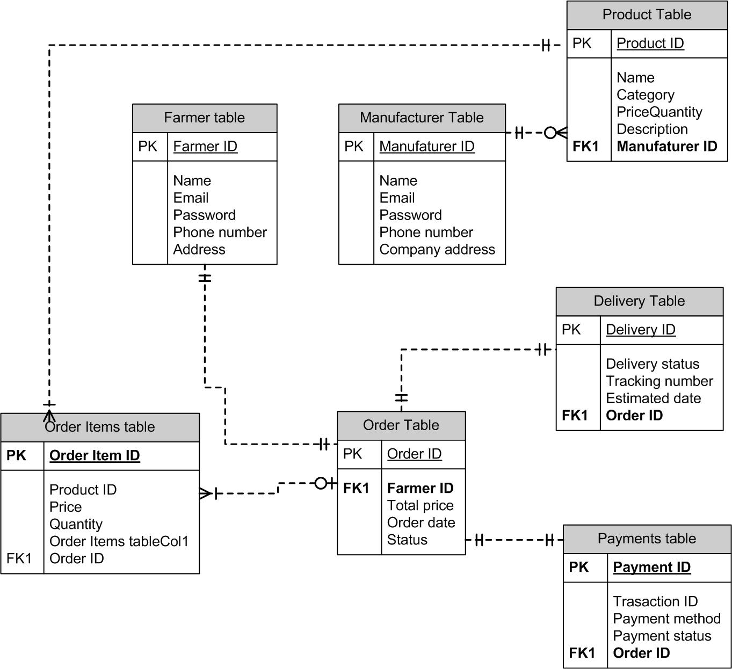

Question 7: What is a data flow diagram? Draw a data flow diagram to represent in-flow and out-flow of data when a farmer is placing an order for product?
Answer:
Data flow diagram is a graphical representation of the flow of data within a system. It shows how data enters, is processed, and exists the system. DFDs are used to analyse and model the structure of system by illustrating;
External entities: external source or destination of data (Farmers)
Processes: the operation or the activities performed on data (search product, place order, process payment and track delivery)
Data stores: where data is stored within the system (product catalogue, order database, Payment system, and delivery tracking)
Data Flows: the movement of data between entities, processes and data stores.

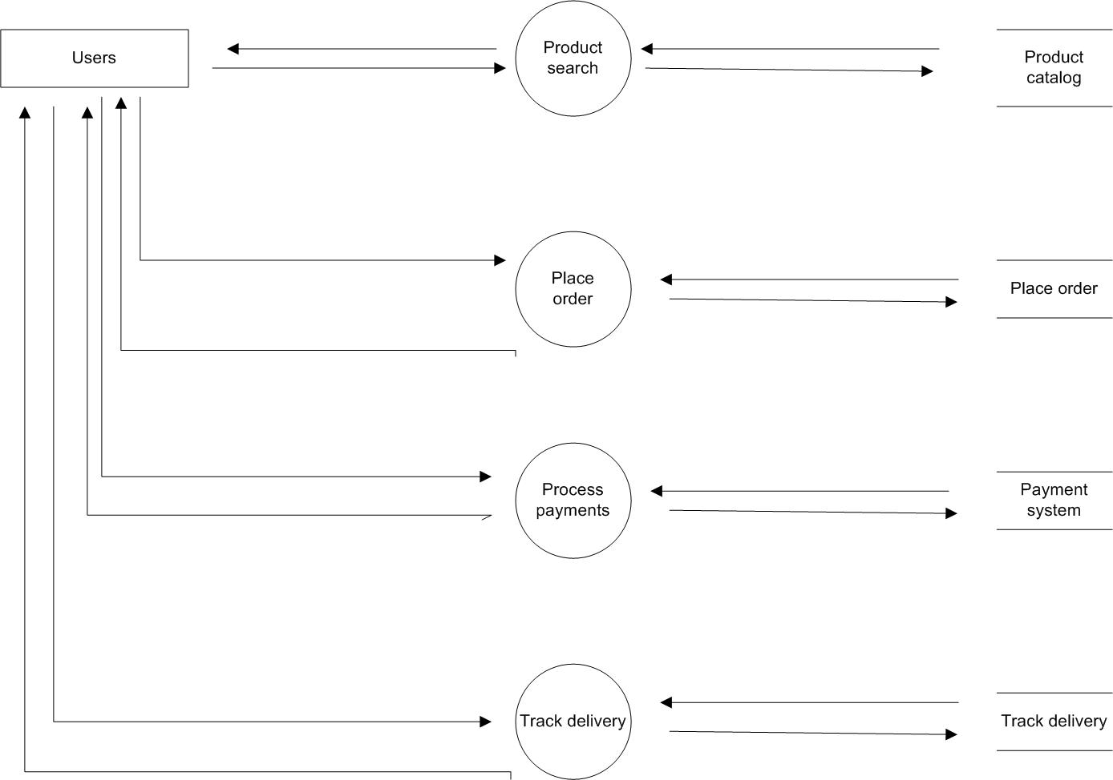

Question 8: Due to change in Government taxation structure. We should change the Tax structure. How do you handle the change request in a project?
1. Change request received: Due to modification in taxation policy the request will be initiated by financial team. Altering the Project Management Team about necessity to align with new taxation reputation. The Project Manager acknowledge request and begin formal process to address it.
2 Change request documented: change request is recorded in the system using change request form. The documentation includes reference to official government notice. It also specify impact on project.
3 Change request reviewed: it is done to understand the change request validity, scope and alignment with the project objective. The Project Manager, Key stakeholders and the project management team usually conduct this review.
4 Performing Impact Analysis: A detailed analysis is conducted to determine how the change in taxation structure will affect different aspects of the project: Scope, Time, Budget and Risk.
5 Updating project document: Document will be updated adding tasks for updating tax calculation algorithms in financial software and incorporating compliance review to ensure adherence to government mandated changes. TimeLine and budget have been adjusted to account for these activities.
6 Change control board (CCB): CCB INCLUCING Key stakeholders review the change. They assess the recommendations, and impact analysis then formally approve the change to proceed with implementation. The approval ensures alignment across the departments and prevent Scope Creep.
7 Communicate the change: Once the change is approved all the relevant teams are informed. Clear communication ensures everyone understands their roles during implementation.
8 Implementing the change: the approved changes are implemented by updating financial and billing software to incorporate new tax rates.
9 monitor and track the implementation: The project team closely monitor the implementation to ensure everything function as intended by running test cases to validate tax calculation across various scenarios, monitoring system performance to prevent disruptions and verify that all updates comply with government requirement
10 Update documentation and close the report: After successful implementation the project document is updated. Once verified and validated the change request is formally closed.
Question 9: Change Request VS Enhancement?
Answer:

Change Request:
- A change request is typically a formal proposal to alter a product, system or project in some way.
- It often arises when there is need to modify something that has already been defined or implemented
- Change request can involve fixing defects, addressing issue, or making adjustment to meet the new requirement.
- They are usually submitted when there is a deviation from initial plan and they often require approval from stakeholders before implementation.

Enhancement:
- An enhancement on the other hand refers to the improvement or addition to a product or system that goes beyond its specification.
- They are typically intended to add new feature, improve existing functionality or enhance user experience.
- Unlike change request these are often proactive and driven by a desire to make the product better rather than fixing something that’s broken
- They are more about adding value or staying competitive in the market.

As a BA based on the request from Ben and Kevin to enable to farmer to sell their crop yields and introduce an auction system, I would classify as an enhancement because it’s a new feature that add functionality to existing application rather than modifying or replacing existing feature and it doesn’t alter the core purpose of application rather it is improving the application

Question 10: Come up with estimation how many man-hour required?
Answer:
Time period provided for his project=18 months (78 weeks including weekend and public holidays)
Assuming weekend = 156
Assuming public holidays = 15
Total working day = 547-171 = 376
Number of working hours a day = 8 hours

Man-hour required= Total hour working per day x total number of days worked over specific period.
Hence estimated Man-hour = 8 x 376 = 3008 Man-hours required.

Question 11: Explain UAT acceptance process?
Answer: the process involves
- UAT planning: Prepare a plan for UAT with client. This plan should include scope of testing, test scenarios, test data, and timelines.
- Test environment setup: ensure suitable environment is set up for client to perform testing.
- Test execution: Coordinate with client to execute the planned test scenarios. Monitor the testing process provide support for any question or issue that arise, and track the result.
- Defect management: if any defects are identified during UAT, work closely with client to understand the issues, document them and track their resolution. Collaborate with development team to address the reported defects and verify their fixes.
- UAT signoff: Once the client has completed testing and satisfied with the product functionality, obtain their formal signoff or approval which includes RTM and closure document. This indicate that client has accepted the final product and ready to move with deployment.
- Closure meeting: A closure meeting is held with the stakeholders to discuss the success of the project, any; lesson learned and future recommendations.
- Project closure report: The BA prepares a closure report that includes the project review, documentation update, closure meeting outcomes, and any final recommendation.
- Archiving: Project documents and artefacts are archived for future reference, and the project team is disbanded.

Question 12: What is a project closure document and what points should be included in it?
Answer: A project closure document also known as a project closure report is a formal document that summarises the key outcomes, lesson learned, and final detail of a completed project.
It serves as a comprehensive report of the project’s accomplishment, challenges, and overall performance providing value insights for stakeholders and future projects
Points to be included in the project closure document are
- Project Overview
- Achievements
- Lesson Learned
- Quality assurance Resource utilization
- Risk management
- Challenges

S.No | Points to include | Details | Reference link
1 | Did the client Signoff the UAT Testing | 25-0ct-2025 | Business scope document.docx
 | Date of Signoff | 25-0ct-2025
 | Name of Resource | Ms jyoti
2 | Objective of the project
 | User friendly | Achieved
 | Customer satisfaction | ROI in 6 months
 | More option | Achieved
3 | Functionalities work on
 | Secure Payment | Achieved
 | More category | Achieved
4 | Infrastructure
 | Software installed | Achieved
 | Desktop purchased | Achieved
5 | Funding
 | Amount Approved | Rs 1 crore | Financebreakdown.docx
 | Amount used | Rs. 95lakhs
6 | Overall project information
 | Escalations | 50
 | Customer satisfaction | high
7 | Value to the company
 | Positive/Negative | Positive 90%  Increased user  Trained employee

