Q1. Draw a Use Case Diagram?
Answer:
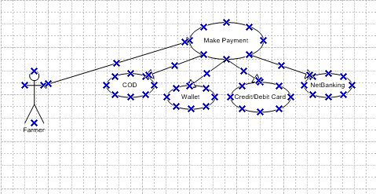

Q2. Derive Boundary Classes, Controller classes, Entity Classes?
Answer:
- Boundary Class – Interface between the system and external actors.
Boundary Class | Purpose
LoginForm | Interface for login inputs
RegistrationForm | New user registration
ProductCatalogPage | Display products
CartPage | Shows added products
PaymentGatewayUI | Payment inputs
OrderTrackingUI | Display delivery tracking info
ManufacturerUploadForm | Interface for uploading product details

- Controller Class – Manages the flow of the data between boundary and entity classes.
Controller class | Purpose
AuthenticationController | Handles login/logout and registration
ProductController | Manage product listing and search
CartController | Handles cart operation
OrderController | Manages placing and confirming orders
PaymentController | Handles different payment option
DeliveryController | Manages order delivery status
ManufacturerController | Validates and processes uploaded product

- Entity Class – Represents business object or persistent data in the system.
Entity Class | Attributes
User | userID, name, email, password, role
Farmer | farmerID, location, contactinfo
Manufacturer | manufacturerID, companyname, contactinfo
Product | productID, name, type, price, stock
Cart | cartID, userID, listofproducts
Order | orderId, userID, products, totalAmount, status
Payment | paymentID, method, status, transactionRef
delivery | deliveryID, orderId, trackingStatus

Q3. Place these classes on a three-tier Architecture?
Answer:
Tier | Class | Class Example | Description
Presentation Tier | Boundary Class | LoginForm, CartPage, PaymentGatewayUI, ProductCatalogPage | These are the UIS or APIS boundaries the user interacts with.
Business Logic Tier | Controller Class | CartController, PaymentController, OrderController, AuthController | Theses handles business rules and workflows between UI and data.
Data Tier | Entity Class | User, product, cart, oreder, payment, manufacturer | These are data entities stored in a database.

Q4. Explain Domain Model for Customer making payment through Net Banking ?
Answer:
A Domain Model is a conceptual model that visually represents the real-world entities, their attributes and relationships in a system for a specific scenario.
Lets define the domain modal for a customer making payment via Net Banking.
- Actors Involved:
- Customer.
- Order.
- Cart.
- Payment.
- NetBankingDetails.
- Bank.
- Transaction.
- Domain Model Entities & Attributes:
Entity | Key Attributes
Customer | customerID, name, email, contactinfo
Cart | cartID, items, totalAmount
Order | orderID, orderDate, status, deliveryAddress
Payment | paymentID, amount, paymentMethod
NetBankingDetails | Bankname, accountno, IFSC, customerID
Bank | bankID, bankname, bankbranch
Transaction | transactionID, transactiontime, responseno, status

- Relationships between Entities:
- A customer places an order.
- An order is associated with one cart.
- An order is paid through one payment.
- A payment uses one NetBankingDetails(payment method = NetBanking)
- NetBankingDetails are linked to a Bank.
- A payment result in a transaction.
Q5. Draw a sequence diagram for payment done by Customer Net Banking?
Answer:
A Sequence Diagram is a type of UML Diagram used to model the interaction between objects or components in a specific order over time. It shows how objects communicate with each other through messages and the sequence in which these interaction happen to fulfill a scenario or use case.
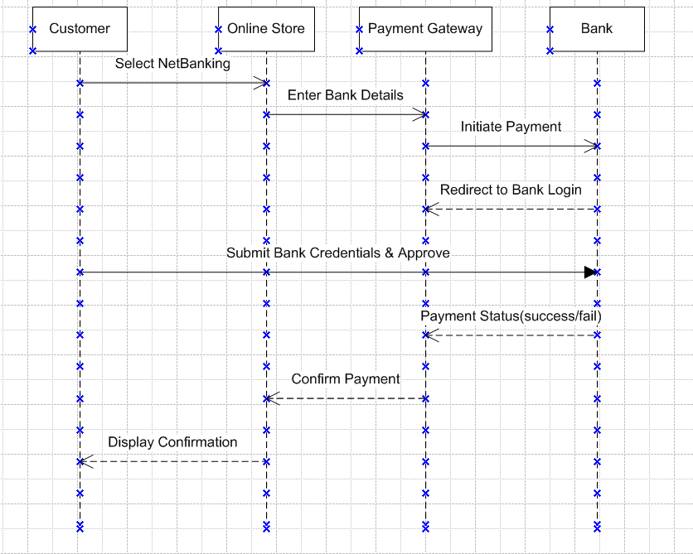

Q6. Explain Conceptual Model for this Case?
Answer:
A Conceptual Model is a high level and logical representation of the core real world business concepts involved in a process. It shows what entities exist, their key attributes and how they are related but not implemented.
- Key Conceptual Classes:
Conceptual Class | Description
Customer | Person who makes the purchase.
Order | Represents a confirmed list of items to be paid for.
Payment | A record of payment for an order
Bank | The customers bank where the net banking transaction is processed.
Net banking details | It contains LoginID, bankinfo which is needed for net banking
Transaction | It represents an actual debit attempt by the bank

- Relationship Between Concepts:
- Customer – places order
- Order – is paid via payment
- Payment – uses NetBankingDetails
- NetBankingDetails – belongs to bank
- Payment – results in transaction
- Customer – owns NetBankingDetails
Q7. What is MVC architecture? Explain MVC rules to derive classes from use case diagram and guidelines to place classes in 3-tier architecture?
Answer:
A MVP(Model-View-Controller) is a software architecture pattern used for designing applications that separate the user interface, business logic and data into three interconnected components:
Component | Description
Model | Represents the data and business rules
View | Represents the UI layer what the user sees and interacts with
Controller | Handles the logic that connects user input to the model.

- MVC Rules to Derive Classes:
- Boundary Classes (View in MVC):
It represents the interface between users and the system.
It is derived from: Actors and their interactions in use case diagram.
- Controller Classes (Controller in MVC):
It handle business workflows or process logic between boundary and entity.
It is derived from: use case names – each use case typically results in one controller.
- Entity Classes (Model in MVC):
It represent data or business domain objects that persist over time.
It is derived from: data objects used on the use case.
- Guidelines :
Tier | Classes | Guidelines
Presentation | Boundary class | It interacts with the user  - Forms, pages and screen
Logic | Controller class | It handles use case logic  - Validate inputs, coordinates entities
Data | Entity class | It represents persistent data  - Mapped to DB tables or APIs

Q8. Explain BA contributions in project (Waterfall Model – all Stages) ?
Answer:
- Requirement gathering & analysis:
- Interact with stakeholders to gather and document business needs.
- Create BRD, SRS and use case diagrams to define scope.
- Identify functional, non-functional requirements and validate them.
- System design:
- It translates requirements into design inputs and validate wireframes.
- Review data models, workflows and ensure they align with business goals.
- Support the technical team in functional design discussions.
- Implementation:
- It acts as a liaison to clarify business requirements for the development team.
- Handle requirements- related queries and support traceability via RTM.
- Manage scope and communicate changes if any arise.
- Testing:
- It supports QA in preparing test cases aligned with business flow.
- Participate in UAT and validate that the system meets business needs.
- Assist in defect triage and prioritization from a business perspective.
- Deployment:
- It ensure all business requirements are implemented before go-live.
- Support release planning and prepare end-user documentation.
- Validate readiness with stakeholders and confirm successful delivery.
- Maintenance:
- It analyze change request and enhancements post-deployment.
- Support issue analysis, business impact assessment and prioritization.
- Keep all requirement documents updated with the latest changes.

Q9. What is conflict management? Explain using Thomas – Kilmann technique?
Answer:
Conflict management is the process of identifying, addressing and resolving conflicts in a constructive way that supports team collaboration and business objectives.
The Thomas- kilmann is a well-known model that identifies 5 handling style based on 2 dimensions :
- Assertiveness – The extent to which a person tries to satisfy their own needs.
- Cooperativeness – The extent to which a person tries to satisfy the other person’s needs.
The 5 Conflict-Handling styles:
- Competing (high assertiveness, low cooperation):- “Win-Lose” approach. Own needs are prioritized over others.
- Collaborating (high assertiveness, high cooperation);- “Win-Win” approach. Find a solution that satisfies all parties.
- Compromising (medium assertiveness, medium cooperation);- “Split the difference”. Both sides give up something to reach agreement.
- Avoiding (low assertiveness, low cooperation):- “Ignore the conflict”. Postpone or withdraws from conflict.
- Accommodating (low assertiveness, high cooperation):- “Give in to others”. One party satisfies the other at own expense.

Q10. List down the reasons for project failure?
Answer:
- Unclear or incomplete requirements:- The project lacks clearly defined and agreed-upon business requirements. It leads to scope creep, missed expectations and rework.
- Lack of stakeholder involvement:- Key stakeholders are not engaged throughout the project. Results in misaligned priorities, delayed feedback and unmet business needs.
- Poor planning and estimation:- Inaccurate timelines, budget estimations and resource planning. It causes delays, overrun costs and rushed delivery.
- Ineffective communication;- Inconsistent or unclear communication between teams and stakeholders. It leads to confusion, duplicated efforts and missed deadlines.
- Inadequate risk management:- Risk are not identified or mitigated early in the project. Unexpected issues like tech failures, team turnover.
- Lack of skilled resources or training;- Teams may lack the necessary technical skills or domain knowledge. Results in poor quality output and increased dependency on a few individuals.
- Weak leadership or governance:- Absence of strong project management and decision-making structures. It causes unclear roles, conflicting directions and loss of control.
Q11. List the Challenges faced in projects for BA?
Answer:
- Unclear or Changing Requirements – Stakeholders provide vague or frequently changing needs.
- Conflicting Stakeholder Opinions – Different stakeholders have misaligned or opposing expectations.
- Lack of Domain Knowledge – Limited industry understanding affects requirement accuracy.
- Restricted Access to SMEs/Users – Difficulty in gathering insights due to limited stakeholder availability.
- Technology or System Limitations – Proposed solutions may not fit within technical constraints.
- Tight Deadlines – High pressure to deliver complete analysis in limited time.

Q12. Write about Document Naming Standards?
Answer:
Document naming standard refers to a consistent and structured way of naming files and documents to ensure clarity, traceability, version control and easy retrieval across the project lifecycle.
Key components:
- Project code.
- Document type.
- Document title.
- Version
- Date.

Q13. What are the Do’s and Don’ts of a Business analyst?
Answer:
- Do’s of a Business Analyst:
- Listen Actively – Understand stakeholder needs without assumptions—practice empathy and patience.
- Ask the Right Questions – Use open-ended, clarifying, and probing questions to uncover true requirements.
- Document Clearly and Completely – Maintain accurate and structured documentation like BRD, SRS, RTM, user stories, etc.
- Validate Requirements – Always confirm requirements with stakeholders before finalizing or handing off.
- Understand the Business Domain – Gain enough industry knowledge to speak the stakeholder’s language and suggest improvements.
- Maintain Traceability – Use tools like RTM to ensure every requirement is tracked from start to finish.
- Collaborate Across Teams – Act as a bridge between business and technical teams; ensure alignment.
- Think from End-User Perspective – Focus on usability and real-world impact of the product or system.
- Don’t of a Business Analyst:
- Don’t assume requirements – Always confirm facts instead of guessing or filling gaps based on assumptions.
- Don’t ignore stakeholders feedback – Ignoring feedback can lead to failed outcomes.
- Don’t use technical terms with business users – Speak in user friendly language not system codes or dev lingo.
- Don’t overcomplicate solution – Simpler solution are often better .
- Don’t miss documentation updates – always keep requirements and project artifacts up to date.

Q14. Write the difference between packages and sub-systems?
Answer:
- Package:
- A logical grouping of related elements like classes, components, etc.
- It organize model elements for clarity and modularity.
- It is typically used for logical grouping in design.
- Sub-systems:
- A self- contained module of the system that performs a specific function.
- It represents a functionally independent part of the system.
- It represents larger functional blocks of a system.
Q15. What is camel-casing and explain where it will be used?
Answer:
- Camel-casing is a naming convention in programming and documentation where the first word starts with a lowercase letter and each subsequent word starts with an uppercase latter with no space or underscore between them.
- Camel-casing is widely used in coding, development, and scripting environments to name variables, functions, methods and priorities.

Q16. Illustrate Development server and what are the accesses does business analyst has?
Answer:
A development server is an environment set up specifically for coding, testing and initial integration of software by developers. It replicates the application behaviour in a safe, controlled space before it is moved to testing or production.
Accesses a Business analyst has:
- Read- only application access – to verify requirements coverage.
- Test credentials – To help in walkthrough and demos.
- Database read access – for understanding data models
- Log access – To help during defect analysis
- Jira – for requirement traceability

Q17. What is Data Mapping ?
Answer:
- Data mapping is the process of matching fields from one data source to another. It
defines how data from a source system translates to the structure of a destination system.
- It is commonly used in system integration, data migration, and ETL (extract, transform, load) process.
- Types of mapping:
  - One-to-one single source field map to one target field.
  - One-to-many one source field map to multiple fields.
  - Many-to-one multiple source fields combine into one target.
  - Derived mapping target field is calculated using source data.

Q18. What is API. Explain how you would use API integration in the case of your application Date format is dd-mm-yyyy and it is accepting some data from Other Application from US whose Date Format is mm-dd-yyyy?
Answer:
- An API is a set of rules and protocols that allows different software to communicate and share data with each other.
- It defines how a request should be made what data should be sent and what response will be returned.
- API Integration is the process of connecting two applications using APIs so that they can exchange data or services automatically.
- API Integration:
- API contract agreement – Ensure both systems have a shared API document. Understand the date field format in response from the US app.
- Data mapping – In your integration logic, map the incoming US date format (mm-dd-yyyy) to internal format (dd-mm-yyyy).
- Data transformation logic – Use a date parser or transformation script in your application middleware.
- Validation and logging – Ensure the date is validated and converted before saved and displayed. Log the original and transformed date for audit/troubleshooting.

