Nurturing Process - Capstone Project1 – Part -1/3 V2D1- Mar2024 www.coepd.com
COEPD – Traditional Development Capstone Project1 – Part -1/3 – 100 Marks - Pass 60 % 14
Questions:
Question 1 – BPM - 5 Marks
- Identify Business Process Model for Online Agriculture Store – (Goal, Inputs, Resources, Outputs, Activities, Value created to the end Customer)
Answer:
Goal: To facilitate farmers for buy seeds, pesticides, and fertilizers through an online application from anywhere through the internet connectivity.
Input:
- Product and Manufacture details for product like seeds, pesticides, and fertilizers.
- Providing Internet Connectivity to Remote Farmers
- Farmer’s requirement for products which they need to buy.
Resources: Human Resource
- Manufacture’s (whose product will be salade in the Application)
- Farmer Location
- Developer Team
SW Resource
- Mobile/Web Application for the product
- Database to store Product Data
- Payment gateway
- Delivery/logistic Details
Outputs:
- Product get delivery in remote areas.
- Successful online transactions for agricultural products
Activities:
- Registration of Manufacture
- Application Login
- Product Upload
- Browse Product
- Select the Product and do the payment
- Order processing
- Delivery
- Feedback/ Support
Value created to the end Customer:
- User friendly Application to buy products.
- Time Saving
- Door step Delivery
- Cost Comparison in respect of local shop
- Feasibility of Delivery Date and Time
- Product Variety

Question 2 – SWOT - 5 Marks
- Mr Karthik is doing SWOT analysis before he accepts this project. What Aspects he Should consider as Strengths, as Weaknesses, as Opportunity and as Threats.
Answers:
Strengths-
- Clear Business Requirement
- Budget allocation of 2CR
- Skilled Team to support
- Fixed Timeline
Weaknesses –
- Application should be very user friendly
- Local Language should be enabled
- New requirement can be added.
Opportunity-
- attracting more client (market demand for end user expectation)
- In future can get more opportunity for the same kind of projects
Threats –
- Market Competition,
- Competitive Platform.
- Unable to delivery product due to location or weather.

Question 3 – Feasibility study - 5 Marks
- Mr Karthik is trying to do feasibility study on doing this project in Technology (Java), Please help him with points (HW SW Trained Resources Budget Time frame) to consider in feasibility Study.
Answers: (HW Requirement)
- Development Machine
- Server
- Network Setup
SW Requirement
- Backend – Java, Sprint Boot
- Frontend - React.js or Angular (for web), Android/iOS
- Database - MySQL/PostgreSQL
- Testing Tool – Selenium
- Project Management – Jira
- Security Tool - SSL

Resource Feasibility
- Java Developer
- Business Analyst
- Project Manager
- Tester
- DB Admin
- Network Admin
Budget Feasibility
- Development Cost – ₹1.2 – ₹1.4 Cr (18 months)
- Server- ₹10 – ₹15 Lakhs
- Testing/ QA -₹5 Lakhs
- Training/Workshops for Farmers - ₹10 Lakhs
- UX Design - ₹5 – ₹10 Lakhs
- Miscellaneous - ₹10 – ₹15 Lakhs
Time Feasibility
- Requirement Gathering - 1.5 months
- Requirement Analysis- 1 month
- Architecture/ System Setup- 1 months
- Development- 7 months
- Testing- 2 months
- Deployment- 1 month
- Maintance- 4 months (ongoing post-launch)
- UAT to Farmers - 1.5 months

Question 4 – Gap Analysis
- Mr Karthik must submit Gap Analysis to Mr Henry to convince to initiate this project. What points (compare AS-IS existing process with TO-BE future Process) to showcase in the GAP Analysis.
Answers:
AS-IS (Existing Process)
- Farmer facing difficulty in procuring fertilizer.
- Problem in buy seeds for certain crop.
- LaNot gets of Pesticides
- Traveling to the local shop.
- Price vary due to the middlemen
TO-BE (Future Process)
- Farmers can buy the fertilizer, seeds or pesticides through the online application with the help of internet.
- Travel cost be saved, since product will be deliver in the door.
- Can compare the price between the different Manufactures
- Can get the detail or track their product movement location.
- Can get there ordered data store for future reference.

Question 5 – Risk Analysis - 10 Marks
- List down different risk factors that may be involved (BA Risks And process/Project Risks)
Answers:
BA Risks
- Requirement Gathering
- Change in Requirement Gathering.
- New Idea may get added in between the requirement.

Process/Project Risks
- Farmers may find it difficult to use the application
- Poor Internet Quality
- Storage Issue
- Team Dependency
- Budget Overrun
- Delivery Problem.
Question 6 – Stakeholder Analysis (RACI Matrix) - 8 Marks
- Perform stakeholder analysis (RACI Matrix) to find out the key stakeholders who can take Decisions and Who are the influencers.
Answers:
- R – Responsible: Executes the task (e.g., Developer, Tester)
- A – Accountable: Final decision-maker/owner of the task
- C – Consulted: Gives input before task is completed (subject matter experts)
- I – Informed: Needs to be kept in the loop (status, updates)
Answer:
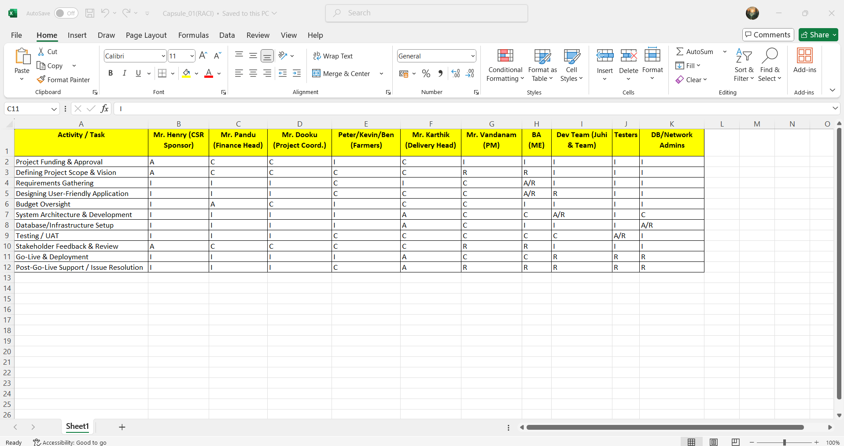
Question 7 – Business Case Document - 8 Marks
- Help Mr Karthik to prepare a business case document.

Answers:
Goal | The purpose is to build an Online Agriculture Platform which help Remote Farmer’s to procure essential agricultural supplies—seeds, fertilizers, and pesticides—easily and directly from manufacturers.
Preconditions | Internet access should be there, phone, Laptop, Tab or a Computer.
Success End Conditions | User successfully places an order and receives a confirmation message.
Failed End Conditions | - Order is not placed due to missing mandatory details or failed payment.  - System is down or products are out of stock.
Primary, Secondary Actors | - Farmers and Manufacturer,  - Product Manufacturer  - System  - Delivery Partner

Step | Action
1 | Once login user will able to see the dashboard of the Agri App
2 | System displays different categories of agriculture product like seeds, fertilizers, pesticides etc
3 | User navigate to the different categories and will search the type of product they need.
4 | Once user is ok with the product they have selected, they will move into the cart for futhur processing.
5 | User proceeds to checkout and is prompted to fill in mandatory details (Name, Mobile Number, Delivery Location.  Branching Actions  - If product is out of stock → User is shown a “Notify me” option.  - If location is outside serviceable area → Show message: “Currently not deliverable to your region.”  - If payment fails → Redirect user to retry or choose alternate payment method.  - If delivery is picked/packed → User is shown a “your order is packed/picked” notification.  - If delivery is on the way → User is shown a “Out of Delivery” notification.  - If product is returned → User is shown a “return pick-up” notification.
Triggers | User logs in and initiates the product browsing or buying process.
Related business analysts use Cases | - User Registration and Login.  - Product Upload by Manufacturer.  - Delivery Tracking and Notifications.  - User Feedback and Support Request.
Business rules | - Mandatory fields (Name, Contact Number, Location) must be validated.  - Minimum order value must be ₹100.  - Only verified users can place orders.  - Only in-stock products can be added to cart.
Priority | Highest - This is the core functionality of the Agri App.
Non-functional requirements (Performance, Security, Usability etc.) | - Performance: Response time should be <3 seconds for page loads.  - Security: User data should be encrypted; secure payment gateway to be used.  - Usability: App should support regional languages; UI must be farmer-friendly.
Frequency | Per Entity (Country/Village/Region) – Expected daily usage by multiple farmers.
Assumptions | - User has basic smartphone and internet access.  - Manufacturer regularly updates product stock and pricing.  - Delivery service is available in selected regions.

Question 8 – Four SDLC Methodologies - 8 Marks
- The Committee of Mr. Henry, Mr Pandu, and Mr Dooku and Mr Karthik are having a discussion on Project Development Approach. Mr Karthik explained to Mr. Henry about SDLC. And four methodologies like Sequential Iterative Evolutionary and Agile. Please share your thoughts and clarity on Methodologies.
Answer:
- Sequential: The most traditional SDLC approach. In this method, each phase such as Requirements Gathering, Design, Development, Testing, and Deployment is completed one after the other, without any overlap. This model works well when all the requirements are well-defined at the beginning and are not expected to change.

- Iterative: It focuses on building the system in small parts (iterations), where each cycle adds improvements or new features. After each iteration, feedback is taken and used to enhance the next version. This model is suitable when the requirements are not completely clear from the start and are expected to evolve. It allows the client to see early versions of the product, reducing the risk of failure and improving the final result through multiple refinements.

- Evolutionary: It is somewhat similar to the iterative model, but with a greater focus on early delivery. Here, the system is developed as a basic version initially and then gradually improved and expanded over time. This model is useful when quick deployment is needed with a basic set of core features, and further additions can be made based on user feedback and changing needs.

- Agile: It is a modern and highly flexible approach where the development is broken into small time-boxed iterations called sprints. In each sprint, a working piece of the product is delivered, reviewed by stakeholders, and feedback is taken immediately. Agile requires close collaboration between the development team and the stakeholders (in our case, the farmers and committee). It is ideal when requirements are expected to change frequently and when customer satisfaction is a high priority.

Question 9 – Waterfall RUP Spiral and Scrum Models – 8 Marks
- They discussed models in SDLC like waterfall RUP Spiral and Scrum. You put forth your understanding on these models.
Answers:
1. Waterfall Model
- It is a linear and sequential model where each phase (Requirements → Design → Development → Testing → Deployment) is completed one after another.
- It is best for the projects which has fixed scope, requirement and the timeline.
- It is difficult to perform any changes once the development gets started.

2. RUP (Rational Unified Process)
- It is an iterative model developed by IBM.
- I have 4 different phases: Inception, Elaboration, Construction, and Transition.
- It mainly focuses heavily on use cases, risk management.
- Useful for complex enterprise projects with structured documentation and tool support.

3. Spiral Model
- It is risk-driven development model that combines elements of both waterfall and iterative models.
- Consists of repeated cycles (spirals) with four activities: Planning, Risk Analysis, Engineering, Evaluation.
- Ideal for high-risk, large-scale, or R&D projects where new technologies are involved.

4. Scrum Model
- A type of Agile model focused on iterative and incremental delivery.
- Work is divided into small cycles called Sprints (2–4 weeks).
- Roles: Product Owner, Scrum Master, Development Team.
- Encourages daily stand-ups, quick feedback, and frequent releases.
- Suitable for dynamic projects where requirements change frequently.

Question 10 – Waterfall Vs V-Model - 5 Marks 20Write down the differences between waterfall model and V model.
Answers:
Waterfall Model:
- It is a linear Sequential Model
- Each phase completes entirely until the next phase is begun.
- Review / Feedback is done after the end of each phase, decided whether project is in right path or need to discard.
- Time is decided for one complete phase before the projects start.

V- Model:

Requirement Analysis
Requirement Gathering
System Testing
Acceptence Testing
Architecture/ Model Setup
Integration Testing

Development
Unit testing

Coding

- Testing is done in every phase, before the new phase starts
- V model is basically use for very critical Projects, where lot of testing is required before the project is handed over to the client.
Waterfall | V Model
A linear and sequential software development model. | It is an extension of the Waterfall model with a focus on testing at each phase.
It follows a straight-down linear flow (step-by-step). | Follows a V-shaped structure with development on one side and testing on the other.
Testing is done after development is completed. | Testing activities are planned parallel to development stages.
Client Involvement is mostly at the beginning and end. | Client can be involved during verification and validation reviews.
Project Monitoring is easy as phases are linear. | Requires more tracking because testing is integrated.
Validation Activities Mostly done during the testing phase. | Each development phase has a corresponding validation phase.

Question 11 – Justify your choice - 3 Marks
- As a BA, state your reason for choosing one model for this project.
Answer: As a BA I would choose a Waterfall Model for this project.
- Scopes and Requirement – For me choosing Waterfall is that the Project Scope and Requirement is fixed and clear, that they need an online agriculture platform from which Farmer can shop all the requirement needed for their farming.
- The project has a fixed timeline (18 months) and defined budget (₹2 Crores), which aligns well with Waterfall’s phase-by-phase execution (Requirements → Design → Development → Testing → Deployment).
- The technology stack (Java, Spring Boot, React, etc.) is stable and understood by the existing team, minimizing the need for iterative experimentation.
- Since end users (farmers) may not be available throughout, their involvement can be maximized during the User Acceptance Testing (UAT) phase, which Waterfall supports well.

Question 12 – Gantt Chart - 5 Marks
- The Committee of Mr. Henry, Mr Pandu, and Mr Dooku discussed with Mr Karthik and finalised on the V Model approach (RG, RA, Design, D1, T1, D2, T2, D3, T3, D4, T4 and UAT) Mr Vandanam is mapped as a PM to this project. He studies this Project and Prepares a Gantt chart with V Model (RG, RA, Design, D1, T1, D2, T2, D3, T3, D4, T4 and UAT) as development process and the Resources are PM, BA, Java Developers, testers, DB Admin, NW Admin.
Answer:
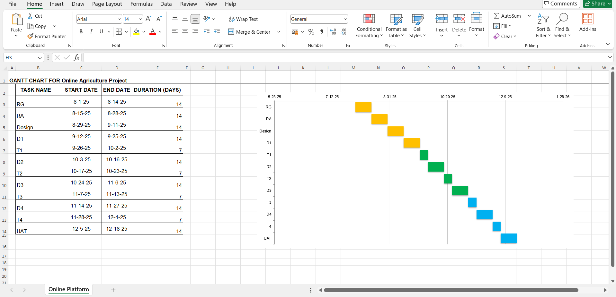

Question 13 – Fixed Bid Vs Billing - 5 Marks
- Explain the difference between Fixed Bid and Billing projects.
Answers:
- The total cost and scope of the project decided upfront.
- In case if work takes more time or effort, 3rd party/ vendor is responsible for that.
- It has a clear requirement and a fixed Budget.
Billing Projects:
- It has a flexible scope and the cost is based on the time used.
- The client pays based on (hourly or monthly)
- Flexible scope so can be changing any time when needed.
- Client takes the risk if it task require longer than expected.

Question 14 – - 20 marks
➢ Design Timesheet of a BA
Task | Hours/Day | Description
Requirement Workshops | 2 hrs | Conduct sessions with stakeholders (farmers, Mr. Henry, team)
BRD/SRS Documentation | 2 hrs | Draft and update Business Requirement Documents
Process Mapping | 1 hr | Create workflows, use case diagrams, data flow diagrams
Functional Specs Review | 1 hr | Collaborate with designer/development team to ensure functional coverage
Stakeholder Feedback | 1 hr | Share documents and get feedback
Team Meetings / Updates | 1 hr | Internal meetings with PM, Dev, UI/UX teams

➢ Development Timesheet of a BA
Task | Hours/Day | Description
Requirement Clarification | 2 hrs | Support developers with functional queries
Change Request Handling | 1 hr | Manage new changes or scope adjustments
User Story Validation | 1 hr | Review and approve development stories/tasks
Update Jira | 1 hr | Track progress, update documentation
Sprint Planning / Stand-ups | 1 hr | Participate in agile ceremonies (Scrum)
Gap/Impact Analysis | 2 hrs | Analyze deviations from original requirements

➢ Testing Timesheet of a BA
Task | Hours/Day | Description
Test Case Review | 2 hrs | Review test cases prepared by QA team
Requirement Traceability Matrix (RTM) | 1 hr | Ensure all requirements are tested
Defect Triage | 2 hrs | Help identify whether issues are bugs or requirement gaps
QA Collaboration | 1 hr | Support testers with functional understanding
Regression Testing Support | 1 hr | Validate if changes align with requirements
Stakeholder Status Updates | 1 hr | Share testing phase progress with stakeholders

➢ UAT Timesheet of a BA
Task | Hours/Day | Description
UAT Planning | 1 hr | Define UAT scope, environment, and test data
Coordinate with Farmers (Users) | 2 hrs | Arrange training/demo sessions for farmers
Support UAT Execution | 2 hrs | Assist users during testing, log feedback
Issue Logging & Prioritization | 1 hr | Record and classify issues raised during UAT
Requirement-Change Discussion | 1 hr | Discuss feasible changes with PM/Dev
Review UAT Sign-off Documents | 1 hr | Finalize sign-off forms with stakeholders

➢ Deployment n Implementation Timesheet of a BA
Task | Hours/Day | Description
Go-Live Checklist Review | 1 hr | Verify final checklist before deployment
Production Readiness Validation | 2 hrs | Validate configurations, roles, workflows post-deployment
Communication with Stakeholders | 1 hr | Inform stakeholders (Mr. Henry, team) of go-live updates
Training / User Manuals | 1 hr | Prepare or validate help documents for end-users
Post-Deployment Support | 2 hrs | Assist in early issue handling and farmer support
BA Sign-off | 1 hr | Validate solution matches requirements & sign off

