CAPSTONE PROJECT – 1- PART 3

Identify minimum 20 functional requirements
Example :
Functional requirement: When an order is fulfilled, the local printer shall print a packing slip.
Non-Functional Requirement: Packing slips shall be printed on both sides of 4”x 6” white paper, the standard size for packing slips used by local printers.
Req ID | Req Name | Req Description | Priority
FR0001 | Farmer Registration | Farmers should be able to register with the application | 8
FR0002 | Farmers Search for Products | Farmers should be able to search for available products in fertilizers, seeds, pesticides | 8
FR0003 | Product Browsing | Farmers can browse product catalog without logging in | 7
FR0004 | Wishlist/Buy Later | Farmers can add products to a Wishlist after logging in | 7
FR0005 | Add to Cart | Farmers can add items to cart before purchasing | 8
FR0006 | Place order | Farmers can place an order after login | 9
FR0007 | Payment Gateway | System should support COD, UPI, Credit/Debit card payments | 9
FR0008 | Order Confirmation Email | Farmers receive an email after successful order placement | 8
FR0009 | Track Order | Farmers can track delivery status of their orders | 8
FR0010 | Manufacturer Registration | Manufacturers can register and create accounts | 8
FR0011 | Manufacturer Product Upload | Manufacturers can upload fertilizers, seeds and pesticides to the system | 9
FR0012 | Login Functionality | Both Farmers and Manufacturers should be able to log in using credentials | 9
FR0013 | Forgot Password | Users should be able to reset password using registered email | 7
FR0014 | Profile Management | Users should be able to update their profile info | 6
FR0015 | Product Sorting and Filtering | Users can sort and filter products based on price, rating, category etc. | 7
FR0016 | Admin Dashboard | Admin should be able to manage users and products | 9
FR0017 | Product Details View | Users can view detailed information about products | 8
FR0018 | Notifications | System should notify users of status updates (email/SMS/ in-app) | 7
FR0019 | Reviews and Ratings | Farmers can provide ratings and reviews for purchased products | 6
FR0020 | Contact support | Users can contact support through an online form | 7

Non-Functional Requirements (NFR)

Req ID | Req Name | Req Description | Priority
NFR0101 | Page Loading Time | Each page should load within 2 seconds | 9
NFR0102 | WCAG 2.1 Compliance | The system must meet Web Content Accessibility Guidelines (WCAG 2.1) | 8
NFR0103 | Uptime Guarantee | Application should ensure 99.9% uptime monthly | 9
NFR0104 | Mobile Responsiveness | The application must be accessible on all modern mobile browsers | 8
NFR0105 | Data Encryption | All data should be encrypted using industry standards | 9
NFR0106 | Scalability | System should scale to support up to 100,000 concurrent users | 7
NFR0107 | Backup Frequency | System should perform full data backups every 12 hours | 7
NFR0108 | Disaster Recovery | System must recover within 5 minutes in case of failure | 9
NFR0109 | Response Time | API response time should not exceed 500ms for 95% of requests | 8
NFR0110 | Multi-Browser Support | Support Chrome, Firefox, Safari, Edge | 6
NFR0111 | Security Compliance | Comply with Top 10 security standards | 9
NFR0112 | Session Timeout | User sessions should auto-expire after 15 minutes of inactivity | 7
NFR0113 | Audit Logging | Log all user activities and system events for auditing purposes | 8
NFR0114 | Memory Usage | Application should not exceed 500MB RAM per container instance | 6
NFR0115 | UI Consistency | All UI components should follow a consistent design system | 6
NFR0116 | Language Support | System should support English and at least one regional language | 6
NFR0117 | Compliance – GDPR | User data should be handled in accordance with GDPR standards | 9
NFR0118 | Search Performance | Product search results should appear within 2 seconds | 7
NFR0119 | Documentation Availability | System features must be documented for end users and developers | 5
NFR0120 | Analytics Dashboard | Admin analytics dashboard should render in under 3 seconds | 6

2Q) Make wireframe and prototypes?
Ans:
Wireframes - A wireframe is a simple, low-fidelity visual layout that shows the basic structure of a webpage or application screen, indicating where elements like buttons, input fields, menus, and images will be placed. It focuses on layout and functionality without involving colors, styles, or detailed design elements, helping the team understand what will appear on each screen and ensuring clarity for developers and testers before actual development begins.

Prototypes - a Prototype is a high-fidelity, interactive model of the application that allows stakeholders to click through screens, simulate navigation, and experience the workflow as if they are using the real system. It helps in visualizing the system flow, identifying improvements in user experience, and gathering feedback from stakeholders before starting development, thereby reducing rework and ensuring the system aligns with user expectations.

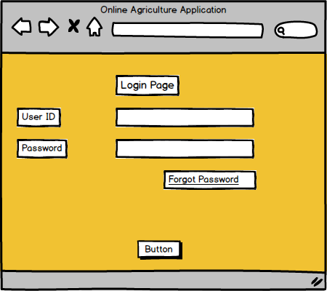

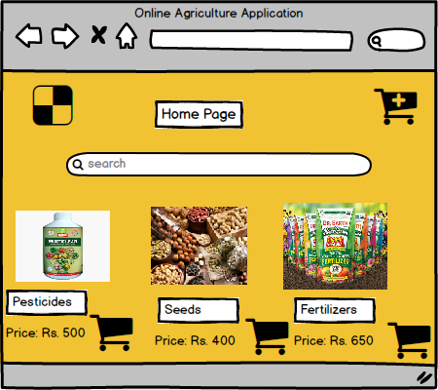

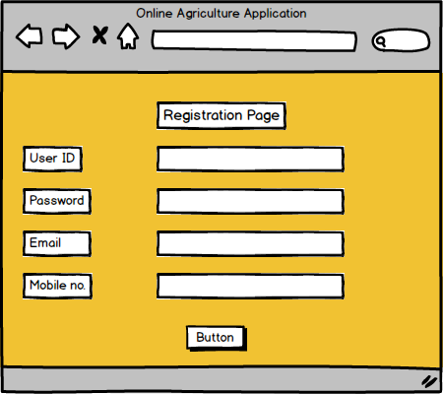

• Wireframes show Login, Registration, Product Catalog, Cart, Payment screens.
• Prototype allows stakeholders (Mr. Henry, Peter, Kevin, Ben) to click through the screens, add products to cart, simulate placing orders, and give feedback before actual coding.

3Q) Make a note of the T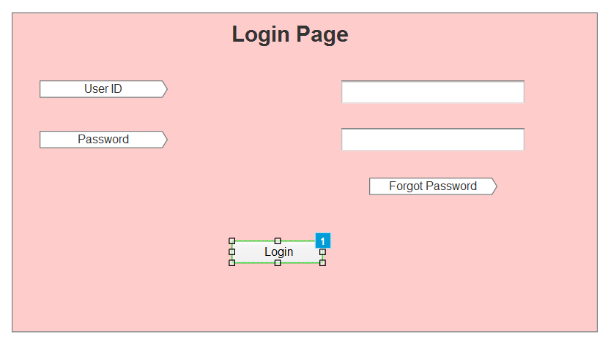
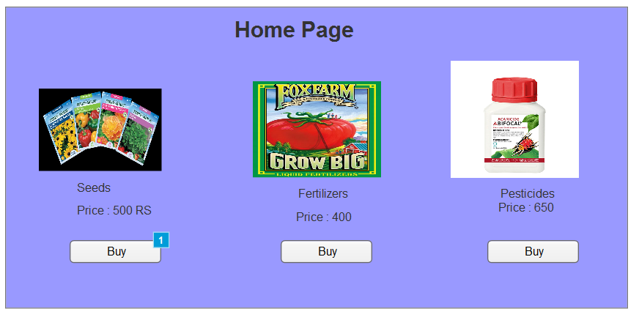

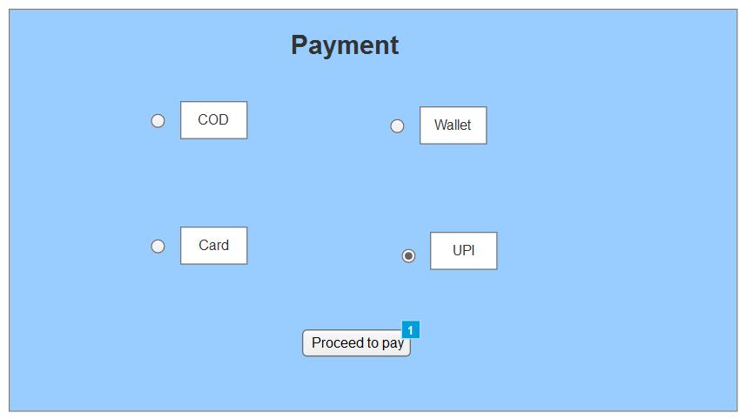

3Q)Make a note of the Tools, which you are using for above concepts.
Ans: During the Software Development Life Cycle (SDLC), especially in the requirements gathering and system design phase, various tools are used to model, visualize, and validate functional and non-functional requirements. Below are the tools I’ve utilized:
- Microsoft Visio :
Purpose:
- Used for creating UML diagrams like Use Case, Activity, Sequence, and Class Diagrams.
- Helps visualize system behavior, data flow, and business processes.
- Also used to create flowcharts for functional logic.
Pros:
- Easy drag-and-drop interface.
- Supports a wide range of diagram types.
- Integrates well with Microsoft Office tools (Word, PowerPoint, Excel).
- Widely used in the industry for formal documentation.
Cons:
- Not ideal for collaborative real-time editing.
- Limited interactive or clickable prototype features.
- More suitable for static diagrams than dynamic or UI-oriented work.

- Axure RP:
Purpose:
- Used to create interactive wireframes and functional mockups for websites and applications.
- Helps simulate real-world system behavior through click-through interactions.
- Supports conditional logic, dynamic content, and adaptive views.
Pros:
- Supports high-fidelity, realistic prototypes.
- Allows simulation of complex logic and workflows.
- Enables annotation and documentation for developers.
- Ideal for stakeholder demonstrations and usability testing
Cons:
- Has a learning curve for new users.
- Heavier application compared to lighter mockup tools.
- May be overkill for simple designs or early-stage concepts.

- Balsamiq :
Purpose:
- Used in early stages of requirement gathering to create sketch-style, low-fidelity wireframes.
- Helps quickly lay out the structure of web pages or app screens.
Pros:
- Very simple and intuitive to use.
- Great for brainstorming and rapid ideation.
- Encourages stakeholder participation without focusing on design details.
- Ideal for quick feedback loops in Agile development.
Cons:
- Limited interactivity (non-clickable).
- Not suitable for presenting polished or final designs.
- Doesn’t support dynamic or responsive behaviors.

4Q) Mr. Henry and peter have approached you regarding the status of the project. How will you tackle this situation?
Ans:
RTM for Functional Requirements:
Req ID | Req Name | Req Description | D1(Design) | T1(Unit Test) | T2(Integration Test) | T3(System Test) | T4(UAT)
FR0001 | Farmer Registration | Farmers should be able to register with the application | Complete | Complete | Complete | Complete | Pending
FR0002 | Farmer Search for Products | Farmers should be able to search for available products | Complete | Complete | Complete | Complete | Pending
FR0003 | Product Browsing | Farmers can browse product catalog without logging in | Complete | Complete | Complete | In Progress | Pending
FR0004 | Wishlist/Buy Later | Farmers can add products to a Wishlist after logging in | Complete | Complete | In Progress | Pending | Pending
FR0005 | Add to Cart | Farmers can add items to cart before purchasing | Complete | Complete | Complete | Complete | Pending
FR0006 | Payment Gateway | System should support COD, UPI, Credit/Debit card payments | Complete | Complete | In Progress | Pending | Pending
RTM for Non-Functional Requirements:
Req ID | Req Name | Req Description | D1(Design) | T1(Unit Test) | T2(Integration Test) | T3(System Test) | T4(UAT)
NFR0101 | Page Loading Time | Each page should load within 2 seconds | Complete | Complete | Complete | In Progress | Pending
NFR0102 | WCAG 2.1 Compliance | System must meet WCAG 2.1 accessibility guidelines | Complete | Complete | In Progress | Pending | Pending
NFR0103 | Uptime Guarantee | Application should ensure 99.9% uptime monthly | Complete | In Progress | Pending | Pending | Pending
NFR0104 | Mobile Responsiveness | Application accessible on all modern mobile browsers | Complete | Complete | In Progress | Pending | Pending
NFR0105 | Data Encryption | All data encrypted using industry standards | Complete | Complete | Complete | In Progress | Pending
NFR0106 | Scalability | System should scale to support up to 100,000 concurrent users | Complete | In Progress | Pending | Pending | Pending

5Q) Prepare 10 Test Case Documents?
Ans:
Test Case ID | TC_FR001 |  | Test Case Name |  | Farmer Registration
Project ID | P_AGRI_001 |  | Project Name |  | Online Agriculture Store
PM ID | PM_101 |  | PM Name |  | Mr. Henry
Test Strategy ID | TS_001 |  | Tester ID |  | T_001
Test Plan ID | TP_001 |  | Tester Name |  | Peter
Test Schedule ID | TSCH_001 |  | Date of Test |  | 30/06/2025
Scenario | Search for Product
Link to that page: Registration Page
Input Data | Set 1: Name=Raj | Set 2: Email=raj@gmail.com |  | Set 3: Password=Test@123 |  | Set 4: Phone = +1-9821345678 | Set 5: Address = 12 Greenfield Village
Expected Behavior | User should be registered and redirected to login page
Actual Behavior | User registered successfully and redirected to login page
Comments | Tested on Chrome and Firefox
Result (Pass/Fail) | Pass

Test Case ID | TC_FR002 |  | Test Case Name |  | Farmer Registration
Project ID | P_AGRI_001 |  | Project Name |  | Online Agriculture Store
PM ID | PM_101 |  | PM Name |  | Mr. Henry
Test Strategy ID | TS_001 |  | Tester ID |  | T_002
Test Plan ID | TP_001 |  | Tester Name |  | Peter
Test Schedule ID | TSCH_002 |  | Date of Test |  | 30/06/2025
Scenario | Farmers logs in with valid credentials
Link to that page: Login Page
Input Data | Set 1: Name=Email=raj@gmail.com | Set 2: Password=Test@123 |  | Set 3: Password=Test@123 |  | Set 4: Phone = +1-9821345678 | Set 5: Address = 12 Greenfield Village
Expected Behavior | User should be logged in and redirected to dashboard
Actual Behavior | User successfully logged in and redirected to dashboard
Comments | Functionality working on mobile and web
Result (Pass/Fail) | Pass

Test Case ID | TC_FR003 |  | Test Case Name |  | Farmer Registration
Project ID | P_AGRI_001 |  | Project Name |  | Online Agriculture Store
PM ID | PM_101 |  | PM Name |  | Mr. Henry
Test Strategy ID | TS_001 |  | Tester ID |  | T_003
Test Plan ID | TP_001 |  | Tester Name |  | Peter
Test Schedule ID | TSCH_003 |  | Date of Test |  | 30/06/2025
Scenario | Farmers searches for products
Link to that page: Product Search Page
Input Data | Set 1: Urea | Set 2: “Cotton Seeds” |  | Set 3: “Organic Pesticide” |  | Set 4: Tractor | Set 5: Irrigation Pipe
Expected Behavior | Product list should display matching items within 2 seconds
Actual Behavior | User successfully logged in and redirected to dashboard
Comments | Search with partial keywords returns relevant results
Result (Pass/Fail) | Pass

Test Case ID | TC_FR004 |  | Test Case Name |  | Add Product to Wishlist
Project ID | P_AGRI_001 |  | Project Name |  | Online Agriculture Store
PM ID | PM_101 |  | PM Name |  | Mr. Henry
Test Strategy ID | TS_001 |  | Tester ID |  | T_004
Test Plan ID | TP_001 |  | Tester Name |  | Peter
Test Schedule ID | TSCH_004 |  | Date of Test |  | 30/06/2025
Scenario | Farmers adds product to wishlist
Link to that page: Product Details Page
Input Data | Set 1: Urea | Set 2: “Seeds” |  | Set 3: “Tractor” |  | Set 4: “Fertilizer” | Set 5: “Sprayer”
Expected Behavior | Products added to Wishlist with success message
Actual Behavior | Wishlist updated correctly for all products
Comments | Wishlist count incremented correctly on each addition
Result (Pass/Fail) | Pass

Test Case ID | TC_FR005 |  | Test Case Name |  | Add Product to Cart
Project ID | P_AGRI_001 |  | Project Name |  | Online Agriculture Store
PM ID | PM_101 |  | PM Name |  | Mr. Henry
Test Strategy ID | TS_001 |  | Tester ID |  | T_005
Test Plan ID | TP_001 |  | Tester Name |  | Peter
Test Schedule ID | TSCH_005 |  | Date of Test |  | 30/06/2025
Scenario | Farmers adds product to cart
Link to that page: Product Details Page
Input Data | Set 1: Urea | Set 2: “Seeds” |  | Set 3: “Fertilizer” |  | Set 4: “Sprayer” | Set 5: “Tractor”
Expected Behavior | Products added to cart successfully
Actual Behavior | Cart updated, quantities reflected correctly
Comments | Search with partial keywords returns relevant results
Result (Pass/Fail) | Pass

Test Case ID | TC_FR006 |  | Test Case Name |  | Place Order
Project ID | P_AGRI_001 |  | Project Name |  | Online Agriculture Store
PM ID | PM_101 |  | PM Name |  | Mr. Henry
Test Strategy ID | TS_001 |  | Tester ID |  | T_006
Test Plan ID | TP_001 |  | Tester Name |  | Peter
Test Schedule ID | TSCH_003 |  | Date of Test |  | 30/06/2025
Scenario | Farmers places order
Link to that page: Checkout Page
Input Data | Set 1: COD | Set 2: UPI |  | Set 3: Debit Card |  | Set 4: Credit Card | Set 5: Net Banking
Expected Behavior | Order placed, order ID generated, redirected to confirmation page.
Actual Behavior | Order placement successful for all payment modes.
Comments | Confirmation email received after order.
Result (Pass/Fail) | Pass

Test Case ID | TC_FR007 |  | Test Case Name |  | Payment Gateway Verification
Project ID | P_AGRI_001 |  | Project Name |  | Online Agriculture Store
PM ID | PM_101 |  | PM Name |  | Mr. Henry
Test Strategy ID | TS_001 |  | Tester ID |  | T_003
Test Plan ID | TP_001 |  | Tester Name |  | Peter
Test Schedule ID | TSCH_007 |  | Date of Test |  | 30/06/2025
Scenario | Verify payment processing
Link to that page: Payment Page
Input Data | Set 1: COD | Set 2: Credit Card |  | Set 3: Debit Card |  | Set 4: UPI | Set 5: Net Banking
Expected Behavior | Payment processed and confirmation shown
Actual Behavior | Payment successful with status update and confirmation screen
Comments | Error displayed correctly for invalid payment details.
Result (Pass/Fail) | Pass

Test Case ID | TC_FR008 |  | Test Case Name |  | Order Confirmation Email
Project ID | P_AGRI_001 |  | Project Name |  | Online Agriculture Store
PM ID | PM_101 |  | PM Name |  | Mr. Henry
Test Strategy ID | TS_001 |  | Tester ID |  | T_008
Test Plan ID | TP_001 |  | Tester Name |  | Peter
Test Schedule ID | TSCH_008 |  | Date of Test |  | 30/06/2025
Scenario | Confirm order email sent
Link to that page: Confirmation Page
Input Data | Set 1: Valid Email | Set 2: Multiple Items |  | Set 3: Single Item |  | Set 4: COD Payment | Set 5: UPI Payment
Expected Behavior | Confirmation email sent with order details
Actual Behavior | Email received within 30 seconds post order placement
Comments | Email formatting and content verified
Result (Pass/Fail) | Pass

Test Case ID | TC_FR009 |  | Test Case Name |  | Track Order
Project ID | P_AGRI_001 |  | Project Name |  | Online Agriculture Store
PM ID | PM_101 |  | PM Name |  | Mr. Henry
Test Strategy ID | TS_001 |  | Tester ID |  | T_009
Test Plan ID | TP_001 |  | Tester Name |  | Peter
Test Schedule ID | TSCH_009 |  | Date of Test |  | 30/06/2025
Scenario | Track order using ID
Link to that page: Track Order Page
Input Data | Set 1: Valid Order ID | Set 2: Delivered Status |  | Set 3: Pending Status |  | Set 4: Cancelled Status | Set 5: In Transit
Expected Behavior | Order displayed correctly
Actual Behavior | Correct status shown for each order scenario
Comments | Edge case with invalid ID returns “Order Not Found” as expected.
Result (Pass/Fail) | Pass

Test Case ID | TC_FR010 |  | Test Case Name |  | Manufacturer Registration
Project ID | P_AGRI_001 |  | Project Name |  | Online Agriculture Store
PM ID | PM_101 |  | PM Name |  | Mr. Henry
Test Strategy ID | TS_001 |  | Tester ID |  | T_010
Test Plan ID | TP_001 |  | Tester Name |  | Peter
Test Schedule ID | TSCH_010 |  | Date of Test |  | 30/06/2025
Scenario | Manufacturer registration
Link to that page: Manufacturer Registration Page
Input Data | Set 1: Name =ABC Agro | Set 2: Email=abc@agro.com |  | Set 3: Password=Agro@123 |  | Set 4: Phone=+1-9263718289 | Set 5: Address=Farm Road, Pune
Expected Behavior | Manufacturer registered, redirected to login page and email received.
Actual Behavior | Registration successful, redirected and email received
Comments | Validated email verification and form validation
Result (Pass/Fail) | Pass

6Q) After the requirements are thoroughly explained to the entire project team by business analyst, the Database architects have decided to do the database design and also to represent the in-flow and out-flow of data – DB Design
Ans: A Database Schema is a structured framework that defines how data is organized in a database, detailing the tables, columns, data types, and the relationships among the tables. It acts like a blueprint for developers and database administrators, ensuring clarity on how data will be stored, retrieved, and managed within the system.
An Entity Relationship (ER) Diagram is a visual representation of this database schema, showcasing entities (tables), their attributes (columns), and the relationships between these entities using symbols like rectangles for entities, ovals for attributes, and diamonds for relationships, often with crow’s foot notation to indicate cardinality (one-to-one, one-to-many, many-to-many).

7Q) What is a data flow diagram? Draw a data flow diagram to represent the in-flow and out-flow of data when a Farmer is placing an order for the product
Ans: Data Flow Diagram – DFD is a graphical representation that shows how data moves within a system displaying Processes(actions performed on data), Data stores(where data is stored), Data flows(movement of data), External entities(people or systems interacting with the system).
It helps visualize inflow and outflow of data clearly for analysis and system design.

8Q) Due to change in the Government Taxation structure . we should change the Tax structure How do you handle change requests in a project?
Ans:
Handling change requests in a Project:
When there is a change in Government Taxation structure, leading to a tax structure change in the project, Change Request Handling involves the following systematic steps:

  - Receive and Document the Change Request:
- Record the change request formally from the stakeholder like what exactly is changing(e.g. GST %, tax calculation logic), why the change is required(government mandate), Impact urgency and requested timeline.

  - Analyze the Change Request:
BA and Project Manager assess the scope of change for
- Affected modules like order calculation, payment or invoice
- Database changes(tax tables/fields)
- UI changes like tax fields on forms
And identify affected requirements, test cases and workflows.
  - Impact Analysis:
Technical team evaluates:
- Effort estimation of developer and tester hours
- Impact on schedule and budget
- Dependencies on third party APIs or integrations.
Determine if ongoing work will be disrupted.
  - Approval Process:
Present the impact analysis to stakeholders and management.
Seek approval on – Change implementation, Timeline adjustment or Budget implications.
  - Update Project Artifacts:
- Update requirement documents like SRS and BRD’s, Test cases like RTM and Test Scenarios and Design documents and data flow diagrams.
- Communicate updates requirements to the development and testing teams.
  - Implement the Change:
- Development team implements the new tax structure logic in the codebase.
- Update database structures if necessary, like new rax rates table
- Perform unit, integration and system testing.
  - Test the Change Thoroughly:
- Ensure the updated tax structure reflects correctly:
- In all calculation points like cart and invoice
- Across different payment methods.
- Regression testing to ensure existing functionality remains unaffected.
  - Stakeholder Review and UAT:
- Share the changes with stakeholders for User Acceptance Testing (UAT)
- Collect feedback and confirm that the tax changes meet government requirements.
  - Deployment and Communication:
- Deploy changes in the production environment following the release process.
- Inform stakeholders and end-users of the change, if needed e.g. via a system notification or email.
  - Document and Close the Change Request:
- Update the Change Log with:
- Request details
- Implementation date
- Approval records
- Mark the change request as completed and closed.

Overall to handle the change requests in a project:
Request – Analyze – Impact Assessment – Approve – Update Documents – Implement – Test – UAT – Deploy – Documents & Close.
This ensures structured, traceable and low-risk handling of changes in projects like updating tax structures due to government policy changes.

9Q) As the project is in process, Ben and Kevin have contacted you. The reason is to inform you that they want the Farmers to sell their crop yields through this application i.e. Farmers should be able to add their crop yields or products and display to general public and should be able to sell them. They also want to introduce Auction system for their Crop yields. response?
Is this a change request or an enhancement???
Ans:
This is an Enhancement, not a Change Request.
- A Change Request modifies existing requirements or functionalities due to corrections, compliance, or stakeholder needs (e.g., tax updates).
- An Enhancement introduces new functionalities not originally planned in the initial requirements.
Since selling crop yields and auction systems are new functionalities that expand the scope of the project, they are classified as Enhancements.
If we get Enhancements during the project timeline:
- Acknowledge and document the enhancement request formally.
- Conduct impact analysis in:
- Scope, time and cost
- Database Design (crop table, auction table).
- UI screens for listing and bidding.
- Seek approval from stakeholder and PM for timeline and cost changes.
- Upon approval, update SRS, RTM and design documents.
- Plan development and testing phases for these new modules.
9Q) Come up with estimations – How many Manhours required
Ans: Man hours represent the required effort of the resources to complete the project.
There are 3 types of projects:
Small – Up to 500 hours
Medium – Up to 1000 hours
Large – Up to 1500 hours
Analysis:
- As per the case study, the project duration is 18 months with a team size of 12(PM, BA, 4 developers, 2 tester, DB Admin, network admin, senior developer, stakeholders).
- The project scope includes:
- Registration & login for users.
- Product catalog, search, and purchase
- Payment gateway, delivery tracking and email notifications
- Admin and manufacturer modules.

- As the team is trained and ready, no trainer effort is required.
- The required infrastructure is already available, so no additional setup time is needed.
Based on these factors, this project will come under a large project category.
Hence, the estimated man-hours required for this project are: 1500 Man-hours

This estimation will help in planning resource allocation, tracking progress and ensuring timely project delivery under the CSR initiative by Mr. Henry’s company.

11Q) Project has finally completed all the stages i.e., design, development, testing etc. Now, it is the role of a business analyst to contact the client for testing of the final product and have to successfully complete it. How are you going to handle this situation? And once it is done, what will be the process to close the project? Explain UAT Acceptance process.
Ans:
How will I handle UAT?
As a Business Analyst, once design, development and testing are completed, I will:
- Inform the client (Mr. Henry and Stakeholders) that the system is ready for testing.
- Schedule UAT sessions with them and explain how to test using the provided test cases.
- Guide them during testing and note down any issues or feedback they share.
- Coordinate with the development team to fix any bugs found during UAT.
- Retest the system with stakeholders to confirm all issues are resolved.
Once UAT is done, how will I close the project?
After UAT is successfully completed:
- Collect formal sign-off from Mr. Henry and stakeholders confirming the system meets their requirements.
- Conduct a project closure meeting with the client and the project team to review the work done and ensure all deliverables are completed.
- Prepare a Project Closure Document summarizing: Work completed, UAT sign-off details and Lessons learned for future projects.
- Hand over user manuals and necessary documentation to the client.
- Inform the client the system is ready to Go Live and officially close the project in tracking tools.
I will guide the client through UAT, fix any issues, collect sign-off, prepare closure documentation and formally close the project, ensuring a smooth end-to-end delivery.
Explain UAT Acceptance Process:
            - Planning: In this step, the BA prepares a clear plan for UAT testing, deciding which features will be tested, who will test(stakeholders), acceptance criteria for the system.
            - Designing: Test cases and teal-life scenarios are created to check the system thoroughly from the user’s point of view to ensure it meets business needs.
            - UAT Execution: Stakeholders (like Mr.Henry, Peter, Kevin, Ben) test the systems using these test cases, checking if the system is user-friendly and functioning as required.
            - Bug Fixing: If issues are found during UAT, the development team quickly fixes them and the system is rechecked by stakeholders to ensure the issues are resolved.
            - Sign Off: Once all the test pass and the stakeholders are satisfied, they give formal approval(sign-off) stating the system is ready to Go Live.
This process ensures the system is tested and approved by actual users before it is moved to the live environment, ensuring quality and client satisfaction.
12Q) Explain Project closure document?
Ans: Project Closure Document :
A project closure document (or closure report) is a formal document prepared at the end of a project that:
- Summarizes key outcomes, deliverables, and final details.
- Records lessons learned and challenges faced.
- Confirms the project has met its objectives and is officially closed.
It serves as a comprehensive record of the project’s accomplishments, challenges, and overall performance, providing valuable insights for stakeholders and helping improve future projects.
Points to be included in the Project Closure Document:
- Project Overview – Brief summary of project goals and scope.
- Achievements – Key milestones and deliverable completed.
- Lessons learned – Points for improvement in future projects.
- Quality Assurance – Confirmation of testing and quality checks.
- Resource Utilization – Details of how resources were used.
- Risk Management – Risks faced and how they were managed.
- Challenges – Major issues faced and how they were resolved.
- Client Acceptance – Confirmation that the client has accepted the final product.
This document helps ensure the transparency and accountability and marks the official closure of the project.

