CAPSTONE PROJECT1 PART3
ONLINE AGRICULTURE PRODUCTS STORE
Question 1. Identify minimum 20 functional requirements
10 Functional Requirements
Req ID | Req Name | Req Description | Priority
FR0001 | Farmer Registration | Farmers should be able to register using email and secure password. | 8
FR0002 | Farmer Login | Farmers should be able to log in with email and password. | 8
FR0003 | Product Catalogue Browsing | Farmers can browse through fertilizers, seeds, and pesticides catalogue. | 9
FR0004 | Product Search | Farmers should be able to search for specific products. | 8
FR0005 | Add to Cart | Registered farmers should be able to add products to a shopping cart. | 8
FR0006 | Buy Later List | Farmers should be able to add products to a “buy later” list. | 7
FR0007 | Place Order | Farmers should be able to place an order for products in the cart. | 9
FR0008 | Payment Gateway Integration | System should support payment via COD, Credit/Debit cards, and UPI. | 9
FR0009 | Order Confirmation Email | Farmers should receive a confirmation email after placing an order. | 8
FR0010 | Delivery Tracking | Farmers should be able to track the delivery status of their orders in real-time. | 9

10 Non-functional requirements
NFR0101 | Page Loading Time | Each page should load within 2 seconds. | 9
NFR0102 | WCAG 2.1 Compliance | The system must meet Web Content Accessibility Guidelines (WCAG) 2.1. | 8
NFR0103 | Mobile Responsiveness | The system should be accessible and usable from smartphones and tablets. | 9
NFR0104 | Data Security | User credentials and payment information must be stored securely and follow industry standards. | 10
NFR0105 | Availability | The application should be available 99.5% of the time monthly. | 9
NFR0106 | Scalability | The system must support growth in the number of users and transactions without performance loss. | 8
NFR0107 | Performance Under Load | System should support at least 500 concurrent users without degradation. | 8
NFR0108 | Usability | The application should be intuitive and easy to use even for non-technical farmers. | 10
NFR0109 | Backup and Recovery | Daily backups should be taken and restore time should be less than 2 hours in case of failure. | 7
NFR0110 | Browser Compatibility | Application should work seamlessly across major Browsers (Chrome, Firefox, Edge). | 8

Question 2. Minimum 5 page designs
Make wireframe and prototypes
1.Home Page
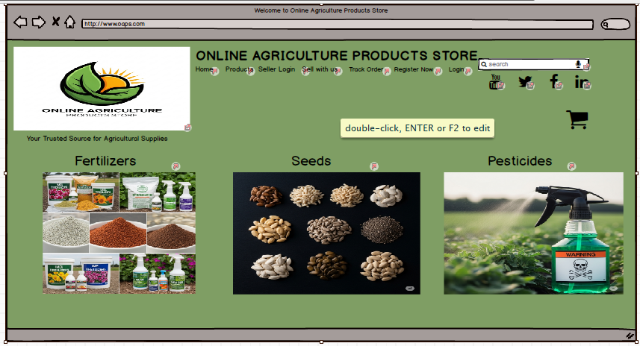

2.Login Page
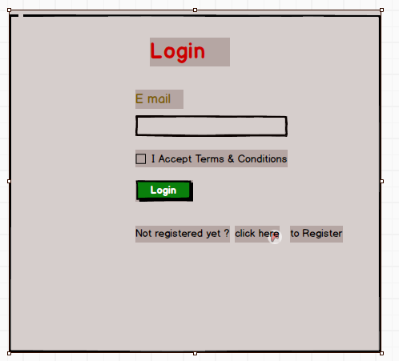

3.Registration
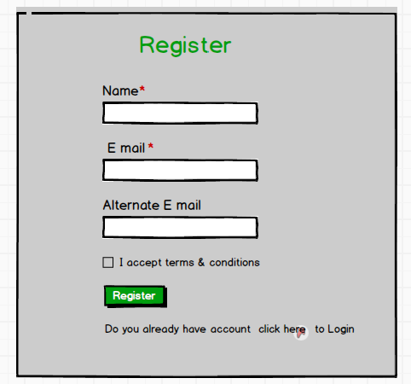

4.Search Product
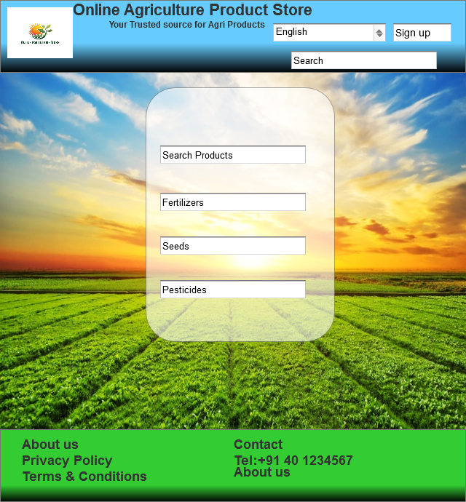

5.Track Order
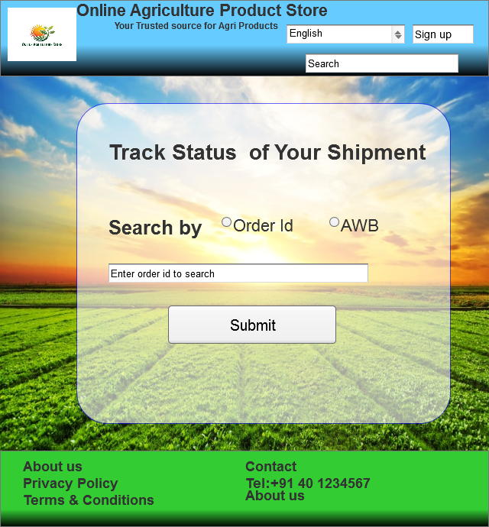

Question 3. Make a note of the Tools (Visio, Balsamiq), which you are using for above concepts.
- Microsoft Visio
MS Visio is a diagramming tool used for creating flowcharts, process diagrams, and system architecture designs. It's widely used for visualizing business and technical processes.
- Purpose: High-level diagrams such as Use Case Diagrams, Flowcharts, System Architecture.
- Use in Project:
  - Designing data flow diagrams (DFDs)
  - Creating user journey and process flow
  - Visualizing overall system architecture
- Balsamiq
Balsamiq is a wireframing tool that helps in creating low-fidelity mock ups of user interfaces, enabling quick design iterations and stakeholder feedback in early development stages
- Purpose: Quick, low-fidelity wireframes that look like sketches.
- Use in Project:
  - Creating black-and-white wireframes
  - Ideation and iterative UI design with stakeholders
  - Rapid prototyping of page layouts (e.g., Home Page, Login, Catalogue View)
Question 4. Prepare RTM
A business analyst’s key responsibilities are to keep track of the requirements and make sure that no requirement is missed.
Mr. Henry and Peter have approached you regarding the current status of the project. How will you tackle this situation?
RTM (Requirement Traceability Matrix) is a document that maps requirements to their corresponding design, development, and testing status, ensuring no requirement is missed. It shows the relationship between:
- Business Requirements
- Functional Requirements
- Design/Development Components
- Test Cases
- Status

Req ID | Req Name | Req Description | Design | D1 | T1 | D2 | T2 | D3 | T3 | D4 | T4 | UAT
FR0001 | Farmer Registration | Farmers should be able to register using email and secure password. | Complete | Complete | Complete | Complete | Complete | Complete | Complete | Complete | Complete | In Progress
FR0002 | Farmer Login | Farmers should be able to log in with email and password. | Complete | Complete | Complete | Complete | Complete | Complete | Complete | Complete | Complete | In Progress
FR0003 | Product Catalogue Browsing | Farmers can browse through fertilizers, seeds, and pesticides catalogue. | Complete | Complete | Complete | Complete | Complete | Complete | Complete | Complete | In progress | Not started
FR0004 | Product Search | Farmers should be able to search for specific products. | Complete | Complete | Complete | Complete | Complete | Complete | Complete | Complete | Complete | Not started
FR0005 | Add to Cart | Registered farmers should be able to add products to a shopping cart. | Complete | Complete | Complete | Complete | Complete | Complete | Complete | Complete | In progress | Not started
FR0006 | Buy Later List | Farmers should be able to add products to a “buy later” list. | Complete | Complete | Complete | Complete | Complete | Complete | Complete | Complete | Not started | Not started
FR0007 | Place Order | Farmers should be able to place an order for products in the cart. | Complete | Complete | Complete | Complete | Complete | Complete | Complete | Complete | Not started | Not started
FR0008 | Payment Gateway Integration | System should support payment via COD, Credit/Debit cards, and UPI. | Complete | Complete | Complete | Complete | Complete | Complete | Complete | In progress | Not started | Not started
FR0009 | Order Confirmation Email | Farmers should receive a confirmation email after placing an order. | Complete | Complete | Complete | Complete | Complete | Complete | Complete | In progress | Not started | Not started
FR0010 | Delivery Tracking | Farmers should be able to track the delivery status of their orders in real-time. | Complete | Complete | Complete | Complete | Complete | Complete | In progress | In progress | Not started | Not started
NFR0101 | Page Loading Time | Each page should load within 2 seconds. | Complete | Complete | Complete | Complete | Complete | Complete | Complete | Complete | Complete | In progress
NFR0102 | WCAG 2.1 Compliance | The system must meet Web Content Accessibility Guidelines (WCAG) 2.1. | Complete | Complete | Complete | Complete | Complete | Complete | Complete | Complete | In progress | In progress
NFR0103 | Mobile Responsiveness | The system should be accessible and usable from smartphones and tablets. | Complete | Complete | Complete | Complete | Complete | Complete | Complete | Complete | Not started | Not started
NFR0104 | Data Security | User credentials and payment information must be stored securely and follow industry standards. | Complete | Complete | Complete | Complete | Complete | Complete | Complete | In progress | Not started | Not started
NFR0105 | Availability | The application should be available 99.5% of the time monthly. | Complete | Complete | Complete | Complete | Complete | Complete | Complete | In progress | Not started | Not started
NFR0106 | Scalability | The system must support growth in the number of users and transactions without performance loss. | Complete | Complete | Complete | Complete | Complete | Complete | Complete | Complete | Not started | Not started
NFR0107 | Performance Under Load | System should support at least 500 concurrent users without degradation. | Complete | Complete | Complete | Complete | Complete | Complete | Complete | Complete | Not started | Not started
NFR0108 | Usability | The application should be intuitive and easy to use even for non-technical farmers. | Complete | Complete | Complete | Complete | Complete | Complete | Complete | In progress | Not started | Not started
NFR0109 | Backup and Recovery | Daily backups should be taken and restore time should be less than 2 hours in case of failure. | Complete | Complete | Complete | Complete | Complete | Complete | Complete | In progress | Not started | Not started
NFR0110 | Browser Compatibility | Application should work seamlessly across major Browsers (Chrome, Firefox, Edge). | Complete | Complete | Complete | Complete | Complete | Complete | In progress | In progress | Not started | Not started

Question 5. Prepare 10 Test Case Documents
Test Case 1: User Registration (New Farmer)
Test Case ID: TC001 | Test Case Name: User Registration (New Farmer)
Project ID: PRJ_AGR_001 | Project Name: Online Agriculture Products Store
PM ID: PM_VAND_01 | Tester ID: T_JASON01
Test Strategy ID: TS_FUNC_01 | Tester Name: Jason
Test Schedule ID: SCH_ITER1_01 | Date of Test: 2024-03-01
Description: | Verify new farmer registration
Precondition: | User not registered
Steps: | 1. Go to registration page.  2. Enter email & password.  3. Click "Register".
Expected Result: | Confirmation email sent.  - Account created

Test Case 2: User Login (Existing Farmer)
Test Case ID: TC002 | Test Case Name: User Login (Existing Farmer)
Project ID: PRJ_AGR_001 | Project Name: Online Agriculture Products Store
PM ID: PM_VAND_01 | Tester ID: T_ALEKYA01
Test Strategy ID: TS_FUNC_01 | Tester Name: Alekya
Test Schedule ID: SCH_ITER1_01 | Date of Test: 2024-03-01
Description: | Verify farmer login
Precondition: | User is registered
Steps: | 1. Enter credentials.  2. Click "Login".
Expected Result: | Redirected to dashboard.  - Session active.
Test Case 3: Browse Product Catalogue (Without Login)
Test Case ID: TC003 | Test Case Name: Browse Product Catalogue (Without Login)
Project ID: PRJ_AGR_001 | Project Name: Online Agriculture Products Store
PM ID: PM_VAND_01 | Tester ID: T_JASON01
Test Strategy ID: TS_UI_01 | Tester Name: Jason
Test Schedule ID: SCH_ITER1_02 | Date of Test: 2024-03-02
Description: | Verify product browsing
Precondition: | Products listed
Steps: | 1. Open homepage.  2. Click "Products".
Expected Result: | Products displayed.  - No login required.
Test Case 4: Search for a Product
Test Case ID: TC004 | Test Case Name: Search for a Product
Project ID: PRJ_AGR_001 | Project Name: Online Agriculture Products Store
PM ID: PM_VAND_01 | Tester ID: T_ALEKYA01
Test Strategy ID: TS_FUNC_02 | Tester Name: Alekya
Test Schedule ID: SCH_ITER1_02 | Date of Test: 2024-03-02
Description: | Verify product search
Precondition: | Products available
Steps: | 1. Enter keyword.  2. Click "Search".
Expected Result: | Relevant results shown.
Test Case 5: Add Product to Cart (Logged-In User)
Test Case ID: TC005 | Test Case Name: Add Product to Cart (Logged-In User)
Project ID: PRJ_AGR_001 | Project Name: Online Agriculture Products Store
PM ID: PM_VAND_01 | Tester ID: T_JASON01
Test Strategy ID: TS_FUNC_03 | Tester Name: Jason
Test Schedule ID: SCH_ITER1_02 | Date of Test: 2024-03-03
Description: | Verify cart functionality
Precondition: | User logged in
Steps: | 1. Search product.  2. Click "Add to Cart".  3. Check cart.
Expected Result: | - Product in cart.  - Price correct.

Test Case 6: Checkout & Payment (COD Option)
Test Case ID: TC006 | Test Case Name: Checkout & Payment (COD Option)
Project ID: PRJ_AGR_001 | Project Name: Online Agriculture Products Store
PM ID: PM_VAND_01 | Tester ID: T_ALEKYA01
Test Strategy ID: TS_PAY_01 | Tester Name: Alekya
Test Schedule ID: SCH_ITER2_01 | Date of Test: 2024-03-04
Description: | Verify COD payment
Precondition: | Check Items in cart
Steps: | 1. Proceed to checkout.  2. Select COD.  3. Confirm.
Expected Result: | Order placed.  - Email sent.
Test Case 7: Checkout & Payment (UPI Option)
Test Case ID: TC007 | Test Case Name: Checkout & Payment (UPI Option)
Project ID: PRJ_AGR_001 | Project Name: Online Agriculture Products Store
PM ID: PM_VAND_01 | Tester ID: T_ALEKYA01
Test Strategy ID: TS_PAY_02 | Tester Name: Alekya
Test Schedule ID: SCH_ITER2_01 | Date of Test: 2024-03-04
Description: | Verify UPI payment
Precondition: | Check Items in cart
Steps: | 1. Select UPI.  2. Enter details.  3. Confirm.
Expected Result: | Payment successful.
Test Case 8: Order Status Email Notification
Test Case ID: TC008 | Test Case Name: Order Status Email Notification
Project ID: PRJ_AGR_001 | Project Name: Online Agriculture Products Store
PM ID: PM_VAND_01 | Tester ID: T_ALEKYA01
Test Strategy ID: TS_NOTIF_01 | Tester Name: Alekya
Test Schedule ID: SCH_ITER2_01 | Date of Test: 2024-03-05
Description: | Verify email confirmation
Precondition: | Order placed.
Steps: | 1. Place order.  2. Check email.
Expected Result: | Email received with details.

Test Case 9: Delivery Tracking
Test Case ID: TC009 | Test Case Name: Delivery Tracking
Project ID: PRJ_AGR_001 | Project Name: Online Agriculture Products Store
PM ID: PM_VAND_01 | Tester ID: T_ALEKYA01
Test Strategy ID: TS_TRACK_01 | Tester Name: Alekya
Test Schedule ID: SCH_ITER2_03 | Date of Test: 2024-03-06
Description: | Verify order tracking
Precondition: | Order shipped
Steps: | 1. Go to "My Orders".  2. Click "Track".
Expected Result: | Real-time status visible.

Test Case 10: Manufacturer Product Upload
Test Case ID: TC010 | Test Case Name: Manufacturer Product Upload
Project ID: PRJ_AGR_001 | Project Name: Online Agriculture Products Store
PM ID: PM_VAND_01 | Tester ID: T_ALEKYA01
Test Strategy ID: TS_FUNC_04 | Tester Name: Alekya
Test Schedule ID: SCH_ITER3_01 | Date of Test: 2024-03-07
Description: | Verify product addition
Precondition: | Manufacturer logged in.
Steps: | 1. Fill product details.  2. Submit.
Expected Result: | Product visible in catalogue.

Question 6. DB Design
After the requirements are thoroughly explained to the entire project team by business analyst, the Database architects have decided to do the database design and also to represent the in-flow and out-flow of data.
Draw database schema and ER diagram

Question 7. What is a data flow diagram? Draw a data flow diagram to represent the in-flow and out-flow of data when a Farmer is placing an order for the product

Data Flow Diagram (DFD)
A Data Flow Diagram (DFD) is a graphical representation of the flow of data through an information system. It illustrates how data is processed by a system in terms of inputs, processes, and outputs. DFDs are a crucial tool for understanding, documenting, and analysing systems.
Question 8. Due to change in the Government Taxation structure. we should change the Tax structure. How do you handle change requests for the above project?
The change request regarding the government taxation structure will likely have impacts on the system's financial calculations, and potentially on how product information is stored and displayed. Here's a plan to handle it:
1. Change Request Scope & Initiation
- Document the Request:
As the Business Analyst, I would create a formal change request document. This document will include:
- Requestor: (In this case, likely Mr. Pandu, the Financial Head, or Mr. Dooku, the Project Coordinator)
- Date of Request
- Description of Change: "Update the system to reflect the new government taxation structure for agricultural products. This includes changes to tax rates, calculation methods, and potentially reporting requirements."
- Reason for Change: "The government has implemented a new taxation structure that
affects the sale of agricultural products. The system must be updated to comply with
these regulations."
- Priority: (High, since it's a legal requirement)
- Impact: (To be determined in the next step)
- Proposed Solution: (To be defined during analysis)
- Gather Details: I'll work with Mr. Pandu to obtain the specifics of the new tax laws, including:
  - Exact tax rates for different product categories (fertilizers, seeds, pesticides).
  - Any exemptions or special cases.
  - How taxes are calculated (e.g., on sale price, before/after discounts).
  - Reporting requirements for tax collection.
  - Effective date of the new tax structure.
2. Impact Analysis
I will analyse how this change affects the project in these areas and Collaborate with the technical team (Developers, DB Admin, Testers) to assess:
  - Scope of change.
  - Impact on business logic, database, UI/UX.
  - Compliance and legal implications.
  - Timeline and cost implications
- Scope of change
  - Will it require changes to the database schema (e.g., new fields for tax rates)?
  - Will it affect the user interface for farmers or manufacturers?
  - Which modules are impacted? (e.g., Product Catalogue, Shopping Cart, Order Management, Payment Processing, Reports)
- Impact on Business logic
  - How much time will it take for developers to implement and test the changes?
  - Will it delay the project timeline?
- Compliance and legal implications
  - What are the risks of not implementing the change (e.g., legal issues, financial penalties)?
  - What are the risks of implementing the change (e.g., errors in calculation, system instability)?
- Timeline and cost implications:
  - What is the estimated cost of development, testing, and deployment?
  - Will it require additional resources?
3. Prioritize Change Request
- Update Project Plan: The Project Manager (Mr. Vandanam) will update the project plan to include the approved changes, new tasks, and revised timelines.
- Development: The development team (Ms. Juhi, Mr. Teyson, Ms. Lucie, Mr. Tucker, Mr. Bravo) will implement the necessary changes to the code.
- Testing: The testing team (Mr. Jason and Ms. Alekya) will thoroughly test the changes to ensure they meet the requirements and don't negatively impact other functionality.
- Deployment: The updated system will be deployed to the production environment.
- Documentation: All changes will be documented, including code changes, test results, and deployment steps.

4. Change Evaluation and Approval
- Present Findings: I'll present the change request and impact analysis to the Change Control Board (CCB).
  - In this case, the CCB is Mr. Henry, Mr. Pandu, and Mr. Dooku.
- Recommendation: I'll provide a recommendation, which will likely be to approve the change due to the legal requirement.
- Decision: The CCB will review the information and decide whether to approve, reject, or defer the change.
- Documentation: The CCB's decision will be documented in the change request form and the project's change log.
5. Communication
- Stakeholder Communication: I will communicate the approved changes to all stakeholders, including:
  - Peter, Kevin, and Ben (to inform them of how the system will handle taxes)
  - Manufacturers (who will need to understand how taxes are displayed and calculated)
  - Farmers (so they understand the final price, including taxes)
- Team Communication: The project team will communicate regularly to ensure everyone is aware of the changes and their responsibilities.
Question 9 – Change Request Vs an Enhancement
As the project is in process, Ben and Kevin have contacted you. The reason is to inform you that they want the Farmers to sell their crop yields through this application i.e. Farmers should be able to add their crop yields or products and display to general public and should be able to sell them. They also want to introduce Auction system for their Crop yields. As a BA, what will be your response?
As a Business Analyst I would consider this as Enhancement.
Nature of the Request:
  - The original scope of the project was to facilitate farmers in purchasing agricultural products (fertilizers, seeds, pesticides) from manufacturers.
  - The new request introduces two major functionalities:
    - Farmers selling their crop yields (a marketplace model).
    - Auction system for crop yields (a new transactional mechanism).
  - Since this was not part of the initial requirements, it constitutes an enhancement to the existing system.

- Impact Analysis:
  - Functional Impact:
    - New user roles (Farmer as a Seller).
    - New modules (Product listing by farmers, bidding/auction system).
    - Additional workflows (approval of crop listings, auction management).
  - Technical Impact:
    - Database schema changes (new tables for auctions, bids, seller listings).
    - UI/UX modifications (new screens for auctions and seller dashboards).
    - Payment & logistics adjustments (reverse flow for farmer payouts).
  - Timeline & Budget Impact:
    - Likely requires additional development effort, possibly extending the timeline.
    - May need additional budget if the enhancement exceeds initial estimates.

- Stakeholder & Committee Approval Needed:
  - Since this is a significant functional addition, it should be treated as a Enhancement if:
    - It affects the approved budget (2 Crores INR).
    - It extends the 18-month timeline.
    - It requires additional resources (developers, testers).
  - The Committee (Mr. Henry, Mr. Pandu, Mr. Dooku) must approve this enhancement before proceeding.
- Next Steps:
  - Formalize the Enhancement Request (document details, benefits, risks).
  - Conduct a Feasibility Study (technical & cost analysis).
  - Present to the Committee for approval (if it impacts scope, cost, or timeline).
  - Update Requirements & Plan (if approved, refine user stories, and adjust project roadmap).

Final Response to Ben & Kevin:
"Thank you for your valuable input. This is an excellent idea to empower farmers further. However, since this was not part of the original scope, it is considered an enhancement. We will analyze the impact on budget, timeline, and resources and present it to the Committee for approval. If approved, we will incorporate it into the development plan."

Question 10 – Estimations
Come up with estimations – How many Manhours required

To estimate Manhours required for the project based on the original scope (i.e., Online Agriculture Products Store – allowing farmers to buy fertilizers, seeds, pesticides from manufacturers via a web/mobile app), we'll follow a Work Breakdown Structure (WBS) and apply standard effort estimation techniques. We'll then give a high-level effort estimation in manhours.
Scope Summary (Original Requirements)
Key Modules:
- User Management (Login/Registration for Farmers and Manufacturers)
- Product Management (Manufacturers upload product info)
- Product Catalogue (Farmers view/browse/search products)
- Shopping Cart & Buy Later List
- Payment Integration (UPI, COD, Cards)
- Order Management (Checkout, Order History)
- Delivery Tracking
- Email Notifications (Order confirmation/status)
- Admin Panel (Basic data management/reporting)
- Mobile responsiveness or app (optional/hybrid view)

Team Roles
- BA – Business Analyst
- PM – Project Manager
- Developers – 1 Senior, 4 Java Devs
- Testers – 2
- DBA – 1
- Network Admin – 1
Estimation Approach
Module/Task | Roles Involved | Estimated Hours
Requirements Gathering & Analysis | BA, PM, Stakeholders | 160
UI/UX Design | Dev, BA | 100
Backend Development | Sr. Dev, Java Devs | 500
Frontend Development | Java Devs | 400
Database Design & Setup | DBA, Dev | 100
User Authentication Module | Devs | 80
Product Catalogue & Search | Devs | 120
Shopping Cart & Buy-Later Feature | Devs | 100
Payment Gateway Integration | Devs | 100
Order Management Module | Devs | 120
Delivery Tracking System | Devs, Network Admin | 80
Email Notification System | Devs | 40
Admin Panel Development | Devs | 80
Testing (Functional + UAT + Bug Fixes) | Testers | 250
Deployment & Configuration | Network Admin, DBA, Dev | 80
Project Management & Coordination | PM, BA | 150
Documentation & Training | BA, Dev | 80
 | Total | 2540
- We will use top-down estimation based on similar project benchmarks and WBS breakdown.
If Auction & Farmer Crop Selling Features Are Added
This is a major extension, and the estimated effort increases significantly:
Module/Task | Roles Involved | Estimated Hours
Farmer Product Upload & Listing | Devs | 100
Public Product Viewing Module | Devs | 80
Buyer Cart/Checkout for Crops | Devs | 100
Auction System Design & Logic | Devs | 150
Bid Placement, Winner Selection, Timer Logic | Devs | 150
Notifications & History for Bids | Devs | 70
Testing & Integration | Testers, Devs | 150
 | Total | 800

Total manhours with original scope and enhancement (Crop Selling + Auction) are
2540+800 = 3340 Man Hours
Question 11 – UAT
Project has finally completed all the stages i.e., design, development, testing etc. Now, it is the role of a business analyst to contact the client for testing of the final product and have to successfully complete it. How are you going to handle this situation? And once it is done, what will be the process to close the project?
Explain UAT Acceptance process

As a Business Analyst (BA), once the project has reached the post-development stage
(design, development, testing completed), it is my responsibility to coordinate with
the client for User Acceptance Testing (UAT) and facilitate project closure.
Below is how I would handle this situation:

Step-by-Step Approach as a BA
1. Client Communication & UAT Kick-off
- Initiate Communication with key client stakeholders (Mr. Henry, Peter, Kevin, Ben).
- Formally inform them that the product has successfully completed internal testing and is now ready for User Acceptance Testing (UAT).
- Schedule a UAT Kick-off Meeting to explain:
  - Purpose of UAT
  - Modules they will test
  - UAT Plan & timelines
  - Communication channels for reporting issues

UAT (User Acceptance Testing) Process – Explained in 5 Stages
1. UAT Planning
- Define the objectives and scope of UAT.
- Identify who will be the UAT testers (in this case: Peter, Kevin, Ben).
- Prepare a UAT Plan Document which includes:
  - Entry/Exit Criteria
  - Schedule
  - Roles & Responsibilities
  - Communication Plan
- Ensure the environment (UAT server) is set up and stable.

2. UAT Designing
- Prepare UAT Test Scenarios & Test Cases based on business requirements and user stories.
- Review the test cases with client stakeholders to ensure completeness.
- Create UAT Test Scripts/Checklist in a user-friendly format (e.g., Excel/Google Sheets).
Example:
Test Case | Description | Expected Result | Pass/Fail Remarks
TC001 | Login with valid credentials | User is logged in | Pass
TC002 | Add product to cart | Product added to cart

3. UAT Testers
- UAT will be performed by end-users/client stakeholders:
  - Peter, Kevin, Ben (Farmers – Farmer view)
  - Mr. Henry/Mr. Dooku (Admin/Committee view)
- Provide credentials, instructions, and support during UAT execution.
- Monitor progress, collect feedback and issues reported.

4. Bug Fixing
- Gather all UAT issues or bugs reported by the testers.
- Log them in a Defect Tracker (JIRA, Excel, etc.).
- Coordinate with development and QA teams to:
  - Fix the issues
  - Retest fixed items
  - Update the status for each issue
- Maintain constant communication with the client for issue status.

5. UAT Sign-Off
- Once all critical issues are resolved and testers confirm that the system behaves as expected:
  - Prepare a UAT Summary Report
  - Get formal sign-off from stakeholders (e.g., email or signed document)
- This sign-off indicates the application is accepted by the client and ready for production deployment.

Project Closure Process
Once UAT is complete and signed off, proceed with project closure:
1. Final Deployment
- Coordinate with the technical team to deploy the system to the production/live environment.
2. Handover to Client
- Deliver:
  - User Manuals
  - Technical Documentation
  - Admin Credentials
  - Maintenance SOPs
3. Conduct Knowledge Transfer
- KT session to client's internal team (if applicable).
4. Post Go-Live Support Plan
- Outline warranty/support period (e.g., 30 days bug-fix support).
- Define escalation channels for post-live issues.
5. Lessons Learned & Internal Retrospective
- Organize a session with the internal team (APT IT SOLUTIONS) to discuss what went well, challenges, and improvements for future projects.
6. Formal Project Closure Document
- Prepare a final closure report including:
  - Project summary
  - Deliverables completed
  - UAT sign-off
  - Financials
  - Client feedback
- Get approval from PM and client for official project closure.

As a Business Analyst, I act as the bridge between the client and the development team to ensure the delivered product meets expectations. By planning and executing UAT systematically, handling bugs effectively, and obtaining final sign-off, I help ensure a smooth transition from development to production and successful project closure.

Question 12 – Project Closure Document
Explain Project closure document

A Project Closure Document is a formal record that signifies the completion of a project. It's a crucial part of the project management process, as it provides a summary of the project, confirms that its objectives were met, and documents important information for future reference.
Project Closure Document
Project Name: Online Agriculture Products Store
Client: SOONY (CSR Initiative by Mr. Henry)
Vendor: APT IT SOLUTIONS
Project Duration: 18 Months
Budget: ₹2 Crores INR
Business Analyst: Myself
1. Project Overview
The Online Agriculture Products Store project was initiated under the CSR initiative of Mr. Henry to enable farmers from remote areas to purchase agriculture-related products such as fertilizers, seeds, and pesticides online. The platform connects farmers directly with manufacturers, offering product catalogues, search functionality, payment gateways, order tracking, and notification systems.
Later in the project, an enhancement request was made to allow farmers to sell their crop yields, including an auction feature for price negotiation and competitive bidding.
The project has gone through all lifecycle phases:
Requirement Gathering → Design → Development → Testing → UAT → Production Deployment

2. Achievements
- Developed a fully functional web and mobile responsive platform for agriculture product transactions.
- Implemented a user-friendly registration and login system for both farmers and manufacturers.
- Enabled real-time product catalogue browsing and search with filtering capabilities.
- Integrated secure and multiple payment methods (UPI, Credit/Debit Cards, COD).
- Built a robust delivery tracking system.
- Introduced a notification system for order confirmations and status updates.
- Successfully implemented the Farmer Crop Selling module with auction functionality.
- Achieved UAT sign-off from all key stakeholders including Peter, Kevin, Ben.
- Completed within budget (₹2 Crores) and timeline (18 months).

3. Lessons Learned
- Early stakeholder involvement (especially farmers) made the requirements more realistic and aligned with actual needs.
- Keeping the client involved during design iterations prevented major reworks.
- A buffer for enhancement requests should be formally scoped earlier in large CSR-driven projects.
- Continuous feedback loops during UAT were essential for higher client satisfaction.
- Documentation and internal KT helped during team transitions mid-project.
4. Quality Assurance - Audit
- Conducted internal QA reviews and multiple test cycles including:
  - Unit Testing
  - Integration Testing
  - System Testing
  - User Acceptance Testing (UAT)
- Used traceability matrices to ensure all requirements were covered in test cases.
- Passed UAT with sign-off from primary users.
- Conducted an internal quality audit post-UAT with no major non-compliances.
- Achieved >95% test case pass rate in the final cycle.
5. Resource Utilization
- Team Composition:
  - 1 Project Manager, 1 BA, 1 Senior Developer, 4 Java Developers
  - 2 Testers, 1 DB Admin, 1 Network Admin
- Manhours Used:
  - Original Scope: 2,540 hours
  - Additional Scope (Auction & Selling): 800 hours
  - Total Estimated Manhours: 3,340 hours
- Efficiency:
  - All team members were utilized effectively.
  - Overlap between development and testing helped optimize delivery.
  - No significant under-utilization or over-allocation.

6. Risk Management
Risk Identified | Mitigation Strategy | Outcome
Unclear enhancement requests | Followed Change Management Process | Scope managed well
Delay in UAT completion | Regular coordination and training to stakeholders | UAT completed on time
Farmers’ digital literacy barrier | Simplified UI and conducted orientation sessions | Minimized user issues
Payment gateway failures | Integrated fallback payment options | No critical failure
Delayed feedback from stakeholders | Maintained constant communication and follow-ups | Feedback gathered timely
7. Challenges Faced
- Requirement changes during UAT: Midway change requests for auction and crop-selling were significant; handled with impact analysis and scope adjustment.
- Farmer tech-savviness: Simplifying interfaces and providing tutorials helped mitigate the challenge.
- Payment integration bugs: Resolved during QA phase with support from gateway vendor.
- Internet access in rural areas: Considered offline support in roadmap (future scope).

Conclusion
The Online Agriculture Products Store has been successfully delivered and accepted by the client. It fulfils both its commercial and social objectives, enabling digital access to essential farming supplies and creating a new revenue stream for farmers through crop selling and auctions.
All deliverables have been completed, verified, and accepted. The project is now officially closed.

