Capstone project - 2
Part 2/3.
Q1. 4 Quarterly Audits.
A.
Quarterly – 1 Audit Report
Stage | Requirement Gathering Phase
Completed | 10 weeks (week 1 to week 10)
Check list | BRD Template
 | Elicitation results report
 | Duplicate requirement report
 | Grouping functionality and client signoff
 | E-mail communication to CC, BCC

Quarterly – 2 Audit Report
A.
Stage | Requirement Analysis Phase
Completed | 7 weeks (week 18 to week 24)
Check list | UML Diagrams
 | Business functional requirement mapping
 | Client signs off documents
 | E-mail communication to CC, BCC

Quarterly – 3 Audit Report
A
Stage | Design and Development Phase
Completed | 21 weeks (week 33 to week 54)
Check list | Utilization of tools
 | Documents evidence on client communication
 | JAD session report
 | End user preparation document
 | BA and developers MOM
 | E-mail communication to CC, BCC

Quarterly – 4 Audit Report
A
Stage | Testing Phase
Completed | 18 weeks (week 52 to week 70)
Check list | Test case summary
 | Training report to end users
 | Lesson learnt document
 | E-mail communication to CC, BCC

Q2. BA Approach Strategy
A.
What are the elicitation techniques to apply.
There are many types of elicitation techniques we have in the business strategy some of the elicitation that might useful to the online agriculture product application are the brainstorming.
Document analysis, Interviews, focus group, Survey and Questionnaire
The brainstorming can be done either in individually or group and we can collect the ideas during the session and it is effective way to generate the lots of ideas to the project.
- The document analysis might be helpful after gathering the requirement and reading the document and understanding the product process and the project this might be a good option to understand do move the project forward.
- The focus group as it means elicit ideas and attitudes about a specific product service and this will use the project in the future. They will show how the project been and helps to do better activities for next stage.
- The survey/questionnaire is been useful for obtain the requirement details from users and stakeholders who have minor input and geographically remote interacting with the areas can be done in the surveys it would helpful to use in this project.
- How to do stakeholder analysis
The stakeholder analysis can be done by using the RACI matrix involve for the identification of stakeholders and defining their roles and responsibilities with in the project.
Responsibilities | Mr Juhi | Developer of the project
 | Mr Tyson | Developer of the project
 | Mr Luice | Developer of the project
 | Mr Bravo | Developer of the project
 | Mr Jason | Who does Testing
 | Mr Alekya | Who does Testing
Accountable | Mr Vandanam | Who handles project from start to end as project manager
 | Mr Shravan | Who handles project from start to end as business analyst
Consulted | Mr Mike | Who handles the network Infrastructure

* What document should to write
We should write the business requirement document which gives the overall idea about the project and next functional requirement document and the use case document it make easy to understand in detailed of project and test case document.
* What is the process to follow to sign on the project
The sign off can be taken on the SRS as it is a primary and the important document, so the sign off can be taken by using E-mail conformation from the client.
* How to take the approval from the client
We should establish the meeting with the client we should inform whatever progress we have made and get the feedback from them.
* What communication channels to establish and implement
We should do the regular meeting and weekly status meetings and monthly stakeholder updates through these meetings we can communication and know about the project that how we are doing the project.
* How to handle change request
The stakeholders will fill the change request from and then they will do the impact analysis about how far the change request is impact the project will the done in time and budget in this way we should do the impact analysis and we should take approval from the Mr.Vandanam.
* How to update the progress of the project to the stakeholders
We can update the progress of the project to the stakeholders by the weekly status reports monthly review meetings about the project.
* How to take sign off on the UAT client project acceptance form
Firstly we have to prepare the UAT preparation and next we have to conduct the UAT after that we have fix the issues and acceptance form and final review meeting and we can obtain sign off.

Q3. 3 – Tier Architecture
A. The illustrate 3 – tier architecture will divide the application into three layers
1. Presentation layer
2. Business logic layer
3. Database layer
* Presentation layer
This is the top layer what the user sees and interacts with. Its responsible for displaying data and collecting user input. And it acts as a bridge between the user and the application’s business logic
Eg: Web page, mobile app screens, forms, buttons etc.
* Business logic layer
This is the bottom logic layer is the middle layer of the architecture and it acts an intermediary between the presentation layer and the data storage layer contains the core logic of the application and depends on the third party the conformation and the payments receipt are been through messages and email depends on the client.
* Data base layer
This is the bottom most layer of the architecture and this is responsible for the storing the retrieving the data and this top layer data is been stored here by the help of storing the data the customers get the exact information in the front end by the data base layer for example its like data base servers.
Q4. BA Approach Strategy for Farming Questions
A. We have the many approach strategy for the farming we shell discuss about some of them
5W1H
This 5W1H is a useful tool for the gathering the information and understanding the situation by answering the questions about who, what, when, where, why and how for example
- Who are the stakeholders of the project
- What kind of requirement are needed
- When should be the project completed
- Where the project should reach
- Why the project initiated
- How we can resolve the current problems.
SMART
The SMART technique can also help to create the questions
And it stands for specific, Measurable, Attainable, Relevant and Time bond
- The project goal and object should be specific as well should deliver the product to the rural areas. It is a specific goal of the project.
- Can we complete the project and we also say we are able to complete it or not. This is an measurable.
- In attainable we should have that can we complete the project in the budget ad time frame is been done in this technique.
- In relevant exact team to and requirement to complete the project.
- Well the project can be done in the time frame or not.
Q5. Elicitation Techniques
A. There are many types of elicitation techniques
* Brainstorming
The brainstorming can be done either individually or in groups the ideas collected during the brainstorming sessions are reviewed. The brainstorming is very effective way to generate the lot many ideas on a specific issue and we should determine which idea is the best solution in the brainstorming.
* Document Analysis
Document analysis is done through reading the document and understanding the project process and the product.
* Reverse engineering
Reverse engineering is also called as the back engineering it is the process of extracting knowledge or design information from anything man made and reproduction it or we can also say reproducing anything based on the extracted information.
* Focus Group
The focus group means to elicit ideas and attitudes about the specific product, services and opportunity in the interactive group and it shows how the project is been in future and helps with giving the better solution to the project.
* Observations
Observation shadowing user are doing a part of there job, can provide information existing process inputs and outputs in simple words understanding the activities by the observations.
* Workshops
The requirement workshop is a structured approach to create requirement, A workshop can be used to scope, Discover define prioritize and the reach closure on the requirement for the target system that is practical in nature aim to completeness.
* JAD
The JAD stands for joint application development and this application developed through JAD has the higher customer satisfaction and a smaller number of errors because the users are been directly involved in the development process.
* Interviews
The interview of a user and stakeholder is very important to creating the software and the interviews is a systematic approach where in interview is going on to ask relevant questions related to the software and documenting the response.
* Prototyping
Prototyping is an alternative idea for complicated and large system for which there is no manual process or existing system to help determine the requirement.
* Survey/Questionaries
Questionnaire can be useful for obtaining limited system requirement details from the users’ stakeholders who have the minor inputs and geographically remote interacting with the areas are been done in the surveys.
Q6. This Project Elicitation Techniques
A. In this I chose the Prototyping and Brainstorming
* Prototyping
The reason why I selected the prototyping because we can show the sample of the working model generally the prototyping will start with the reference of the client by seeing that they will get an idea they can assume how should they get the application by this we can show the activity diagrams and flow charts.
As the business requirement as been told by peter kevin and ben as key stakeholders they are been expecting some things in the project and Mr Henry stated expecting to have a login for all users and farmer should able to browse through the product catalog and once they visit website they need to have the search option the all are been possible to show in the activity diagrams so the prototyping elicitation would be the priority option in our case.
* Brainstorming
The reason I have selected the brainstorming technique is very effective way to generate the many ideas on a specific issue and we should determine which idea is the best solution as kevin, peter beven.
Expectation on the application should get login screen and also should have the search option to search the product and the farmer should have to browse the application very easily so by the groups of brainstorming we can get greater ideas how to application should be very ease to use to the people from the rural areas email conformation cash on delivery so the manufacture company should also accept the request and by the group discussions we can generate the better ideas so this is the reason I have selected the brainstorming.
Requirement ID | Requirement Description
BR001 | Login should be for all the users
BR002 | A product catalog of fertilizers seeds pesticides and all agricultural products
BR003 | Users should easily able to browse through the product catalog
BR004 | A search option to search the products
BR005 | New user can create the new account with the help of mobile number and Email ID
BR006 | Customer should recognise the brand of the product
BR007 | User should get email conformation regarding the order status
BR008 | User should have order tracking details
BR009 | Customer should have indications to how to book the product and make the payments
BR010 | UPI payments, Card payments should be accepted along with the (COD) cash on delivery is must in the payment acceptance.
Q7. 10 Business Requirements
A.

Q8. Assumptions
A.
Assumption 1 – A user can login through phone or Email number OTP.
Assumption 2 – The online trends are increasing in new trends he prefers the online get satisfy.
Assumption 3 – The application should be design in such way every user should easily understand ever grow the application.
Assumption 4 – Payments should be done in secure way as online payments are also available.
Assumption 5 – Product available in online may increase the flow of sale.
Assumption 6 – Farmer can get needy products from this application which is not available in their towns.
Assumption 7 – Rural areas get awareness about the E-commerce.
Assumption 8 – Manufacturing company might do increase in production of products.

Requirement ID | Requirement Name | Requirement Description | Priority
BR001 | Login | All user should able to login in the application | 10
BR002 | Upload and display | A product catalog of fertilizers seeds pesticides and all agricultural products | 07
BR003 | Browse | Users should easily able to browse through the product catalog | 06
BR004 | Search | There should be search option to search the products | 09
BR005 | Registration | The new user can create the new account with the help of mobile number and email id | 05
BR006 | Manufacture | Customer should recognise the brand of the product | 02
BR007 | Confirmation | The users should get Email confirmation regarding the order status | 03
BR008 | Order Tracking | The user should have order tracking details | 04
BR009 | Instructions | The customer should have indications to how to book the product and make the payments | 01
BR010 | Payments | The UPI payments, Cards payments should be accepted along with the (COD) cash on delivery is must in the payment acceptance | 08
Q9. This Project Requirement Priority
A.

Q10. Use Case Diagram
A.
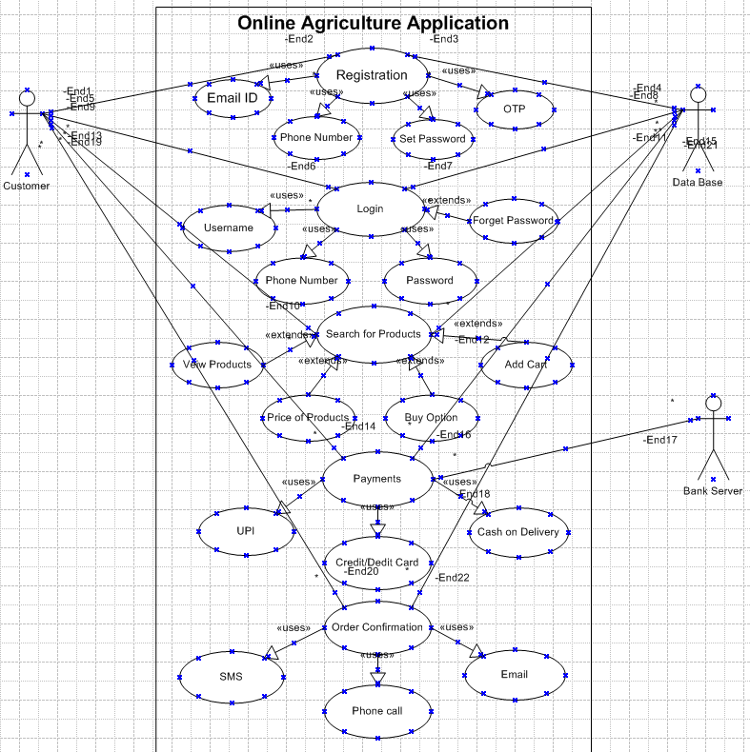

Use case ID | UC0001
Use case name | Online agriculture product
Created by | APT IT Solutions
Date created | 06/07/2025
Actor | Farmers as customers
Description | The use case describes how should users purchase the product through online agriculture application
Pre-condition | Customer should be registered to book the online product
Post Condition | Should be deliver valuable product to the farmers
Normal flow of happy path | - The customer should register using email id, for login customer should enter username and password.  - After login the customer can view the items and by search he can find the products  - User can purchase the product or he can add to cart  - If the customer purchase, he should select the payment method  - Then the order is been placed  - Once the order got placed he will receive a message confirmation
Alternative flows | - If the customer cannot login again it takes to the registration page  - If OTP is invalid it takes to registration again  - If the user can’t get the product, he can raise concern to customer care  - If the user selects the online payment mode and payment is not done. It will again take to payment page  - If the confirmation is not received you can raise the request
Frequency of use | The frequency of use is high
Assumption | - The user can login through the mobile phone and laptops  - The farmer might buy all the products by knowing about the applications through knowledgeable people
Q11. Use Case Specs
A.

Q12. Activity Diagrams
A.


