Project Title: Travel and Compliance Hub

Document 6: Use Case Diagram, Activity Diagram and Use Case Specification Document.

Use Case Diagram -

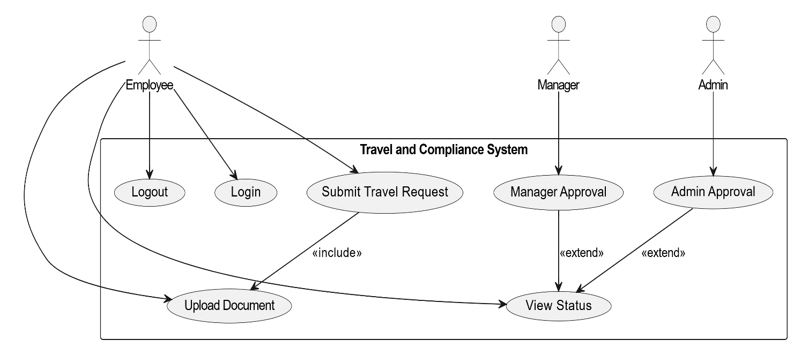

Activity Diagram -
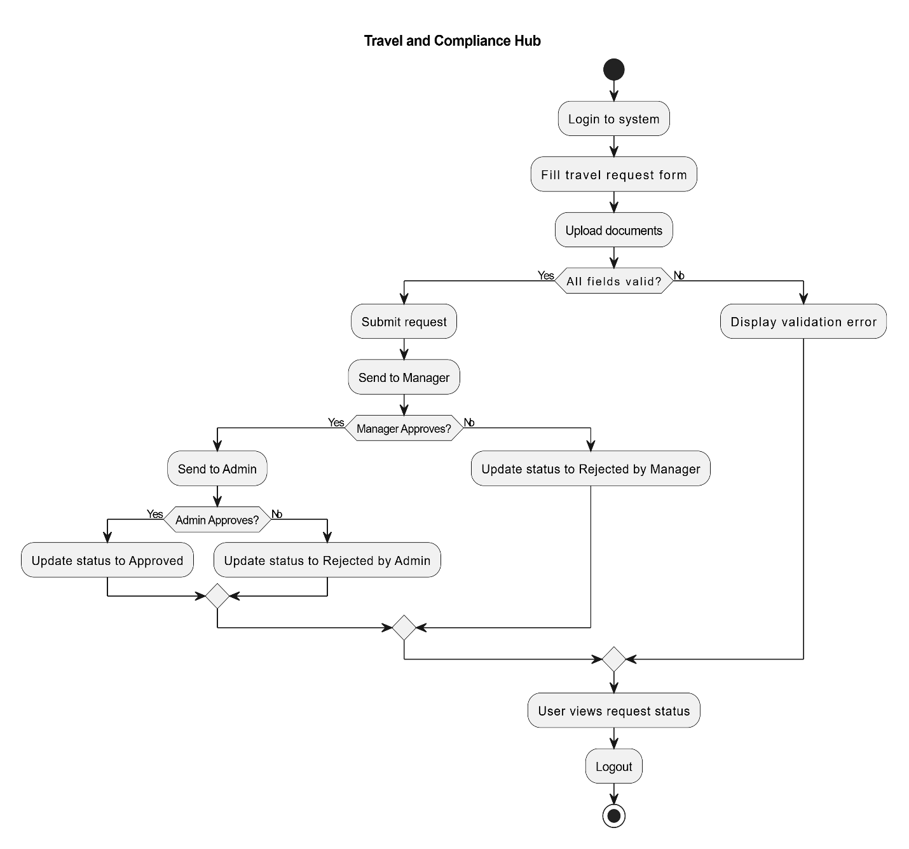

Use Case Specification Document –
Sr.No. | Field | Details
1 | Use Case Name | Submit Travel Request
2 | Use Case Description | This use case describes the process of an employee submitting a travel request along with required documents, followed by manager and admin approval.
3 | Actors | Primary Actor: Employee  Secondary Actors: Manager, Admin
4 | Basic Flow | 1. Employee logs in  2. Navigates to Travel Request form  3. Fills travel details  4. Uploads documents  5. Submits request  6. Manager reviews request  7. If approved, Admin reviews  8. Final decision is communicated to employee
5 | Alternate Flow | - If Manager rejects → Employee receives rejection notification  - If Admin rejects → Employee receives rejection notification
6 | Exceptional Flows | - Network failure during submission  - Invalid document format  - Session timeout
7 | Pre-Conditions | - Employee must be logged in  - All mandatory form fields must be filled
8 | Post-Conditions | - Travel request is saved in the system  - Employee receives status notification
9 | Assumptions | - Internet connection is stable  - Approvers are available  - Employee has access to upload documents
10 | Constraints | - File size limit: 5 MB  - Supported file types: PDF, DOCX  - Browser compatibility required
11 | Dependencies | - Login module  - Document upload service  - Email/SMS notification system
12 | Inputs and Outputs | Inputs: Travel request form, uploaded documents  Outputs: Approval/rejection notifications, status update
13 | Business Rules | - Only valid users can submit requests  - Manager and Admin must approve in sequence  - Backdated travel not allowed
14 | Miscellaneous Information | - All data stored securely with role-based access control  - Audit logs maintained for all approvals

Document 7 – Screens and Pages

- Login Page

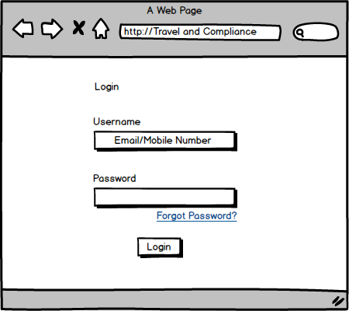

- Dashboard

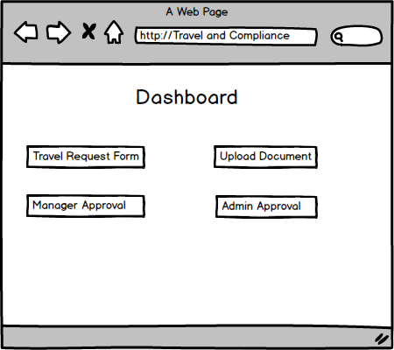

- Travel Request Form

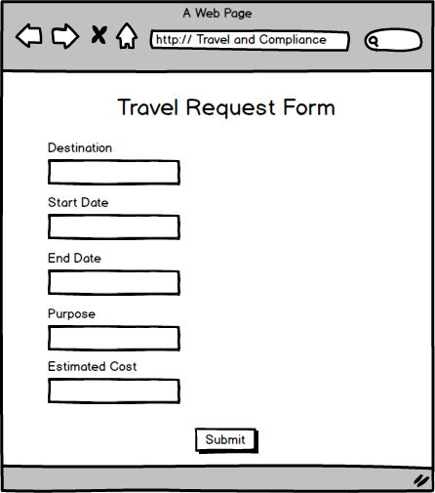

- Upload Documents

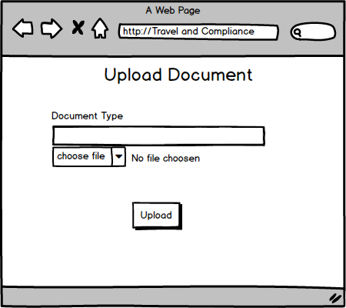

- Approval Page

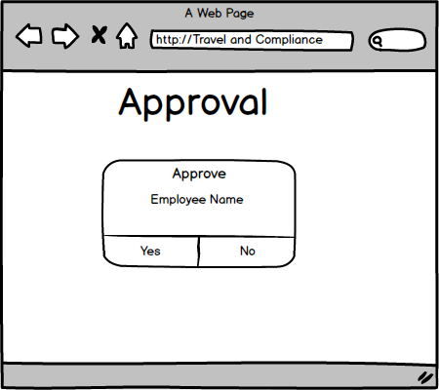

- Logout Page

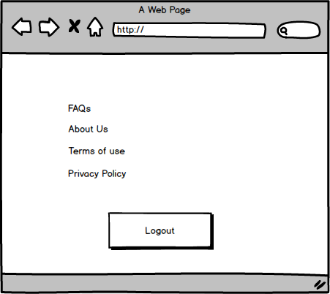

Documents 8 – Tools – MS Visio and Balsamiq

MS Visio:
During the Travel and Compliance Hub project, I extensively used Microsoft Visio to design and document various UML diagrams, particularly the use case diagram and activity diagram. Visio provided a user-friendly interface and a wide range of built-in shapes that made it easy to represent actors, system boundaries, and different process flows. It helped in creating precise, clean, and professional diagrams which were essential for effectively communicating the requirements and workflows to both the technical team and stakeholders. The drag-and-drop functionality, alignment tools, and ability to export diagrams in multiple formats significantly enhanced documentation quality and productivity. Visio also allowed me to maintain consistency across diagrams by reusing stencils and templates, making it a reliable tool throughout the analysis and design phases.

Balsamiq:
For UI mock-ups, I used Balsamiq, which proved to be an excellent wireframing tool due to its simplicity and speed. Balsamiq enabled me to create low-fidelity, sketch-style mock-ups for all critical screens, including the login page, dashboard, travel request form, document upload screen, and approval interfaces. Its drag-and-drop interface and vast library of UI components allowed me to quickly visualize the system layout and user interactions, even during early discussions with stakeholders. This helped gather more specific feedback on usability and functionality, ensuring that the screens aligned well with user expectations. Since Balsamiq focuses on functionality rather than design aesthetics, it was the perfect tool to keep discussions centred around user experience and business flow rather than visual styling. Overall, using Balsamiq played a vital role in validating user interface expectations early in the project, reducing the number of changes required later in development.

Documents 9 – BA experience
My experience as BA in following phases:
1. Requirement Gathering
- Interacted with the client and stakeholders to understand the project goals.
- Used the MoSCoW technique to prioritize requirements.
- Communicated with alternate client-side contacts when the primary client was unavailable.
- Applied the FURPS technique to validate requirements (Functionality, Usability, Reliability, Performance, Supportability).
- Identified and removed duplicate or unclear requirements.
- Created mock-ups to clarify vague requirements and gather detailed input.

2. Requirement Analysis
- Created UML diagrams like Use Case Diagrams and Activity Diagrams to represent system behaviour.
- Explained the diagrams to the technical team and considered their feedback.
- Made updates to diagrams based on team discussions and stakeholder reviews.
- Prepared detailed documentation: Business Requirement Document (BRD) and Software Requirement Specification (SRS).

3. Design
- Converted finalized use cases into detailed test cases (both positive and negative).
- Collaborated with the client to review and approve design documents and wireframes.
- Prepared test data for QA testing.
- Updated the Requirement Traceability Matrix (RTM) to track requirements across development and testing.

4. Development
- Conducted JAD (Joint Application Development) sessions with the development team and client.
- Resolved team doubts by explaining business logic and clarifying requirements.
- Addressed resistance or misunderstandings through one-on-one discussions to maintain team harmony.
- Ensured the team referred to UML diagrams and requirement docs during implementation.
- Followed up with absent team members using recorded meetings and summaries.

5. Testing
- Helped QA team create and review test cases derived from use cases.
- Performed high-level functional testing to ensure all key features worked correctly.
- Requested and provided test data from the client for real-world validation.
- Maintained the RTM by marking test status updates.
- Organized and supported User Acceptance Testing (UAT) and collected formal sign-off from the client.

6. Deployment
- Shared the final RTM with the client as part of closure documents.
- Coordinated creation and delivery of end-user manuals and training materials.
- Scheduled and managed training sessions for all relevant users.
- Ensured smooth transition and knowledge transfer to the client’s internal team.

