Answer 1: Agile Manifesto
The Agile Manifesto was created by 17 software developers in 2001 at Snowbird, Utah. It outlines four core values and twelve principles that define an Agile mindset for software development and project management.
The Four Core Values of Agile Manifesto are:
- Individuals and interactions over processes and tools
- Working software over comprehensive documentation
- Customer collaboration over contract negotiation
- Responding to change over following a plan
Explanation:
- Agile focuses on people and teamwork rather than heavy processes and rigid tools.
- Delivering a working product is considered more valuable than perfect paperwork.
- Agile encourages constant collaboration with the customer to ensure real needs are met.
- It embraces change, allowing the team to adapt quickly to shifting requirements.
The Twelve Principles behind Agile Manifesto:
- Our highest priority is to satisfy the customer through early and continuous delivery of valuable software.
- Welcome changing requirements, even late in development. Agile processes harness change for the customer's competitive advantage.
- Deliver working software frequently, from a couple of weeks to a couple of months, with a preference to the shorter timescale.
- Business people and developers must work together daily throughout the project.
- Build projects around motivated individuals. Give them the environment and support they need and trust them to get the job done.
- The most efficient and effective method of conveying information is face-to-face conversation.
- Working software is the primary measure of progress.
- Agile processes promote sustainable development. The sponsors, developers, and users should be able to maintain a constant pace indefinitely.
- Continuous attention to technical excellence and good design enhances agility.
- Simplicity—the art of maximizing the amount of work not done—is essential.
- The best architectures, requirements, and designs emerge from self-organizing teams.
- At regular intervals, the team reflects on how to become more effective, then tunes and adjusts its behavior accordingly
Question 2 – User Stories- Acceptance Criteria-BV-CP
User Stories - A User Story is a concise and simple description of a feature or functionality from the perspective of an end user or customer. It is a keycomponent of Agile development methodologies, helping teams understand whatusers need and why. User stories are written in plain language and focus ondelivering value to the user, guiding the team on what needs to be built.
SPRINT 1

User Story 1:
AS A Customer, I WANT TO Register an Account, SO THAT I can start ordering food.
- Acceptance Criteria: Registration form with Name, Email, Mobile, Password fields. Confirmation email sent.
- BV: 500 | CP: 2

User Story 2:
AS A Customer, I WANT TO Login securely, SO THAT I can access my account.
- Acceptance Criteria: Email & Password fields, Forgot Password option.
- BV: 500 | CP: 2

User Story 3:
AS A Customer, I WANT TO Search for Restaurants, SO THAT I can see food options nearby.
- Acceptance Criteria: Search bar, Location detection, Filter by Cuisine/Rating.
- BV: 500 | CP: 3

User Story 4:
AS A Customer, I WANT TO View Menu of a Restaurant, SO THAT I can choose items to order.
- Acceptance Criteria: Display menu items with images, description, and price.
- BV: 500 | CP: 3

User Story 5:
AS A Customer, I WANT TO Add Items to Cart, SO THAT I can place an order.
- Acceptance Criteria: Add/Remove items, View total amount dynamically.
- BV: 500 | CP: 2

User Story 6:
AS A Customer, I WANT TO Checkout Quickly, SO THAT I can confirm my order.
- Acceptance Criteria: View Cart, Confirm Order, Address selection, Payment method.
- BV: 500 | CP: 3

User Story 7:
AS A Customer, I WANT TO Track My Order in Real-Time, SO THAT I know its status.
- Acceptance Criteria: Map view, delivery boy location update every 30 seconds.
- BV: 500 | CP: 4

User Story 8:
AS A Customer, I WANT TO Pay Online Securely, SO THAT I can complete my order without cash.
- Acceptance Criteria: UPI, Debit Card, Net banking options with secure gateway.
- BV: 500 | CP: 4

User Story 9:
AS A Customer, I WANT TO Give Feedback after Delivery, SO THAT I can share my experience.
- Acceptance Criteria: Rating stars, Comment box after order completion.
- BV: 200 | CP: 2

User Story 10:
AS A Delivery Boy, I WANT TO Update Delivery Status, SO THAT the customer knows real-time updates.
- Acceptance Criteria: Picked up / On the way / Delivered status options.
- BV: 300 | CP: 2

SPRINT 2

User Story 11:
AS A Restaurant Owner, I WANT TO Update my Menu, SO THAT customers see the latest dishes.
- Acceptance Criteria: Add, Edit, Delete items; Upload image and set price.
- BV: 300 | CP: 3

User Story 12:
AS A Restaurant Owner, I WANT TO Set Offers and Discounts, SO THAT I can attract more customers.
- Acceptance Criteria: Create time-limited discounts on selected items.
- BV: 300 | CP: 3

User Story 13:
AS A Regional Admin, I WANT TO Manage Delivery Boys, SO THAT I ensure smooth operations.
- Acceptance Criteria: Approve, Suspend, Remove Delivery Boys.
- BV: 400 | CP: 3

User Story 14:
AS A Regional Admin, I WANT TO Manage Restaurants in My Region, SO THAT I ensure quality.
- Acceptance Criteria: Approve/Reject Restaurant registrations.
- BV: 400 | CP: 3

User Story 15:
AS An Admin, I WANT TO View Customer Feedback Reports, SO THAT I can identify service issues.
- Acceptance Criteria: Feedback summary reports by region/date.
- BV: 200 | CP: 2

User Story 16:
AS A Delivery Boy, I WANT TO View My Past Deliveries, SO THAT I can track my performance.
- Acceptance Criteria: List of previous deliveries, earnings per order.
- BV: 200 | CP: 2

User Story 17:
AS A Customer, I WANT TO Reorder Past Orders, SO THAT I can save time.
- Acceptance Criteria: "Order Again" option in order history.
- BV: 300 | CP: 2

User Story 18:
AS A Customer, I WANT TO Save Multiple Addresses, SO THAT I can choose easily.
- Acceptance Criteria: Add/Edit/Delete multiple addresses.
- BV: 300 | CP: 2

User Story 19:
AS A Customer, I WANT TO Cancel an Order, SO THAT I have flexibility.
- Acceptance Criteria: Cancel option before order is picked up.
- BV: 300 | CP: 2

User Story 20:
AS A Restaurant Owner, I WANT TO View My Revenue Reports, SO THAT I can monitor sales.
- Acceptance Criteria: Select date range, View daily/monthly revenue.
- BV: 400 | CP: 3
User Story 21:
AS A Customer, I WANT TO Apply Promo Codes, SO THAT I can get discounts.
- Acceptance Criteria: Enter promo code at checkout; validation and discount application.
- BV: 300 | CP: 2

User Story 22:
AS A Restaurant Owner, I WANT TO View Customer Feedback, SO THAT I can improve my service.
- Acceptance Criteria: List of feedback linked to orders.
- BV: 200 | CP: 2

User Story 23:
AS A Delivery Boy, I WANT TO Raise an Issue, SO THAT I can report delivery problems.
- Acceptance Criteria: Raise issue form linked to delivery ID.
- BV: 200 | CP: 2

User Story 24:
AS An Admin, I WANT TO Track Refunds, SO THAT I ensure proper handling.
- Acceptance Criteria: Refund requests, status updates, history.
- BV: 300 | CP: 3

User Story 25:
AS A Customer, I WANT TO Chat with Delivery Boy, SO THAT I can get real-time updates.
- Acceptance Criteria: Text chat interface after order is picked.
- BV: 300 | CP: 3

User Story 26:
AS A Customer, I WANT TO See Estimated Delivery Time, SO THAT I can plan accordingly.
- Acceptance Criteria: Show estimated time on tracking page.
- BV: 300 | CP: 2

User Story 27:
AS A Restaurant Owner, I WANT TO Verify Delivery Boys, SO THAT food reaches safely.
- Acceptance Criteria: Approve assigned delivery boys.
- BV: 300 | CP: 2

User Story 28:
AS A Delivery Boy, I WANT TO Update My Profile, SO THAT my contact information is correct.
- Acceptance Criteria: Edit Mobile, Email, Address, Profile picture.
- BV: 200 | CP: 2

User Story 29:
AS A Customer, I WANT TO Mark Favorite Restaurants, SO THAT I can access them quickly.
- Acceptance Criteria: "Add to Favorites" option, favorites list view.
- BV: 300 | CP: 2

User Story 30:
AS A Customer, I WANT TO Set Food Preferences (Veg/Non-Veg), SO THAT I see relevant menus.
- Acceptance Criteria: Food preference setting in profile, filter menus accordingly.
- BV: 300 | CP: 3

SPRINT 4

User Story 31:
AS A Customer, I WANT TO Share Order Details with Friends, SO THAT I can invite them.
- Acceptance Criteria: Share via WhatsApp, Email, etc.
- BV: 200 | CP: 2

User Story 32:
AS A Regional Admin, I WANT TO Generate Performance Reports of Delivery Boys, SO THAT I can reward top performers.
- Acceptance Criteria: Filter by rating, deliveries count.
- BV: 400 | CP: 3

User Story 33:
AS A Delivery Boy, I WANT TO View My Earnings Weekly, SO THAT I can plan finances.
- Acceptance Criteria: Weekly earnings report view.
- BV: 200 | CP: 2

User Story 34:
AS A Customer, I WANT TO Save Favorite Dishes, SO THAT I can reorder quickly.
- Acceptance Criteria: "Favorite" option on menu items.
- BV: 200 | CP: 2

User Story 35:
AS A Customer, I WANT TO Receive Push Notifications for Order Updates, SO THAT I stay informed.
- Acceptance Criteria: Notifications for each status update.
- BV: 300 | CP: 2

User Story 36:
AS An Admin, I WANT TO See System Health Reports, SO THAT I can maintain service uptime.
- Acceptance Criteria: Dashboard showing server uptime, order processing speed.
- BV: 300 | CP: 3

User Story 37:
AS A Restaurant Owner, I WANT TO Set Available Time Slots, SO THAT I handle orders efficiently.
- Acceptance Criteria: Set Opening/Closing times, Break times.
- BV: 300 | CP: 2

User Story 38:
AS A Customer, I WANT TO View Delivery Charges Clearly, SO THAT I know total costs before checkout.
- Acceptance Criteria: Delivery fee breakdown before payment.
- BV: 200 | CP: 1

User Story 39:
AS A Business Owner, I WANT TO Analyze Revenue by Region, SO THAT I plan expansion strategies.
- Acceptance Criteria: Regional revenue analytics dashboard.
- BV: 400 | CP: 3

User Story 40:
AS A Customer, I WANT TO Contact Customer Support Easily, SO THAT I can get help when needed.
- Acceptance Criteria: In-app customer support chat and call options.
- BV: 300 | CP: 2
Question 3 – What is Epic? Write 2 Epics (5 Marks)
What is an Epic?
An Epic is a large body of work that can be broken down into smaller, manageable User Stories.
It represents a significant feature, capability, or initiative that will deliver value to the end-users.
In Agile, Epics are too big to complete in a single sprint, so they are decomposed into multiple user stories across different sprints.

Two Example Epics for Scrum Foods:

Epic 1: Customer Order Management
- Description:
Enable customers to register, search for restaurants, select menu items, place orders, make payments, and track deliveries.
- Related User Stories:
  - Customer Registration
  - Customer Login
  - Search Restaurants
  - View Menu
  - Add Items to Cart
  - Select Payment Mode
  - Track Order

Epic 2: Delivery Boy Management System
- Description:
Provide functionality for delivery boys to register, accept orders, update delivery status, raise issues, and view their earnings.
- Related User Stories:
  - Delivery Boy Registration
  - View Orders to Deliver
  - Update Delivery Status (Picked up, Delivered)
  - Raise Issues
  - View Delivery History and Earnings
Question 4 – What is the Difference between BV and CP? (2 Marks)
Aspect | Business Value (BV) | Complexity Points (CP)
Definition | BV measures the importance or value of a user story to the business. | CP measures the effort, time, and complexity needed to develop a user story.
Estimated by | Product Owner and Stakeholders. | Scrum Development Team.
Purpose | Helps prioritize which features deliver maximum value to customers. | Helps estimate how difficult or time-consuming a feature is to build.
Unit | Business Currency (e.g., Rs. 1000, Rs. 500, Rs. 100). | Story Points (e.g., 1, 2, 3, 5, 8, 13, 20, etc.).
Focus Area | Customer and Business benefits. | Technical Effort and Complexity.

Question 5 – Explain about Sprint (5 Marks)
What is a Sprint?
A Sprint is a fixed period of time within the Agile Scrum framework during which a set of work must be completed and made ready for review.
It is the core development cycle in Scrum where usable product increments are created.

Key Characteristics of a Sprint:
- Duration:
Standard sprint duration is typically 2 weeks (can vary between 1 to 4 weeks).
For Scrum Foods project, sprint duration is 2 weeks.
- Goal:
To deliver a working, potentially shippable product increment.
- Sprint Planning:
Before the sprint starts, the Scrum Team conducts a Sprint Planning Meeting to decide which Product Backlog Items (PBIs) will be worked on.
- Daily Scrum:
Every day during the sprint, the team holds a Daily Scrum (15-minute stand-up meeting) to discuss:
  - What was done yesterday?
  - What will be done today?
  - Any obstacles (impediments)?
- Sprint Backlog:
The team selects user stories from the Product Backlog and moves them into the Sprint Backlog to focus on during the sprint.
- Increment:
At the end of the sprint, the team should have a working product increment that could potentially be delivered to the client.
- Sprint Review:
Held at the end of the sprint to showcase the completed work to the stakeholders.
- Sprint Retrospective:
Conducted after the Sprint Review, the Scrum Team discusses what went well, what can be improved, and how to become more effective in the next sprint.

Summary:
A Sprint allows the team to focus on a small set of work, deliver high-quality output, adapt to changes quickly, and continuously improve performance.
Question 6 – Explain Product Backlog and Sprint Backlog (5 Marks)
Product Backlog
- The Product Backlog is an ordered list of everything that might be needed in the product.
- It is the single source of requirements for any changes to be made to the product.
- It contains all features, enhancements, fixes, and requirements envisioned for the product.
- Maintained by the Product Owner.
- Dynamic in nature — it is constantly evolving as new needs and improvements are discovered.
- Items are prioritized based on business value, risk, necessity, and market conditions.
- Examples of Product Backlog Items (PBIs) for Scrum Foods:
  - Customer registration
  - Restaurant management
  - Delivery tracking
  - Payment integrations

Sprint Backlog
- The Sprint Backlog is a subset of the Product Backlog.
- It contains the user stories that the Scrum Team commits to completing during the current sprint.
- It also includes the tasks necessary to deliver the sprint goals.
- Owned and maintained by the Scrum Development Team.
- Fixed during a sprint — new work cannot be added once a sprint has started unless the team agrees.
- It provides a clear plan for the team and transparency on the current work status (e.g., PBI → Tasks → WIP → Done).
- Examples in Sprint Backlog for Scrum Foods:
  - Register new customer module
  - Enable online payment integration
  - Implement real-time tracking system

In simple words:
Product Backlog = "Everything we want to build someday."
Sprint Backlog = "What we are building right now in this sprint."
Question 7 – What is Impediments Log? Write 2 Impediments (5 Marks)
What is an Impediments Log?
An Impediments Log is a document or tool used by the Scrum Team to record all the obstacles, blockers, or challenges that hinder the team’s progress during a sprint.
- It helps the Scrum Master and team members to identify, track, prioritize, and resolve impediments quickly.
- The goal is to maintain continuous flow of work and ensure that the team stays productive.
The Impediments Log includes:
- Description of the impediment
- Impact on the sprint
- Owner (who will resolve it)
- Current status (Open, In Progress, Resolved)

Two Example Impediments for Scrum Foods Project:
Impediment 1:
- Description: Payment gateway integration failing during checkout testing.
- Impact: Customers cannot complete their orders online, delaying deployment.
- Status: Open (assigned to Technical Lead).

Impediment 2:
- Description: Delivery tracking map not updating real-time due to API limit exceeded.
- Impact: Real-time tracking feature not functional; affects customer experience.
- Status: In Progress (team working with third-party service provider).
Question 8 – Explain Velocity of the Team (1 Mark)
Answer 8:
Velocity is a measure of the amount of work a Scrum Team can complete during a single sprint.
- It is calculated by adding up the total number of Complexity Points (CP) completed by the team at the end of the sprint.
- Velocity helps teams predict how much work they can deliver in future sprints and improves sprint planning accuracy.
Example:
If the Scrum Foods team completed 80 CP in Sprint 1, then their Sprint 1 Velocity = 80 CP.
Question 9 – Draw Sprint Burn Down Chart and Product Burn Down Chart (3 Marks) Sprint Burn
Sprint burn down chart
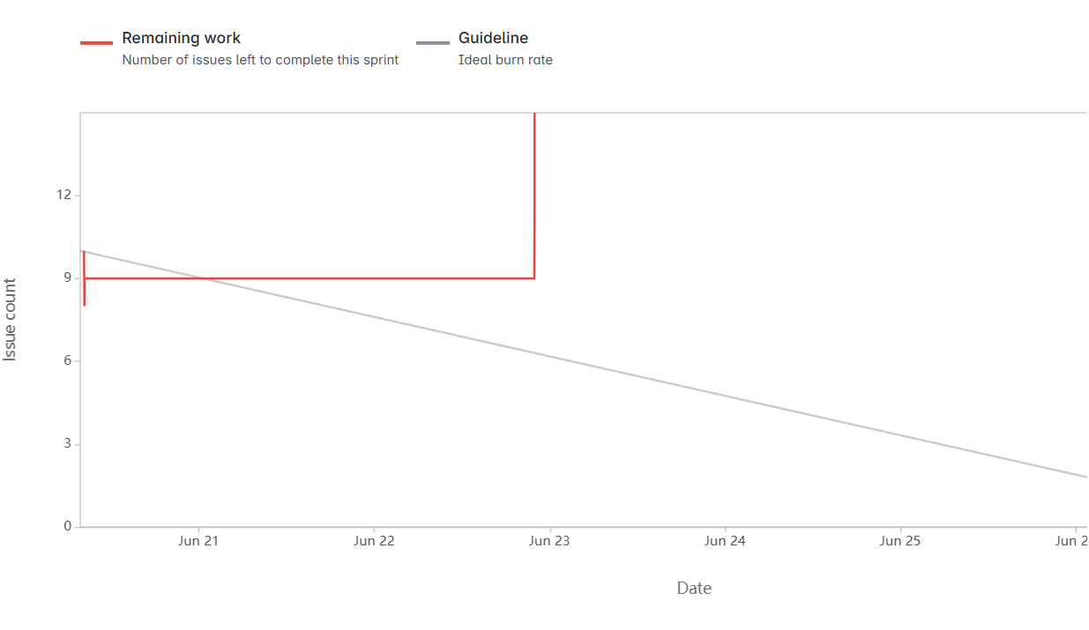

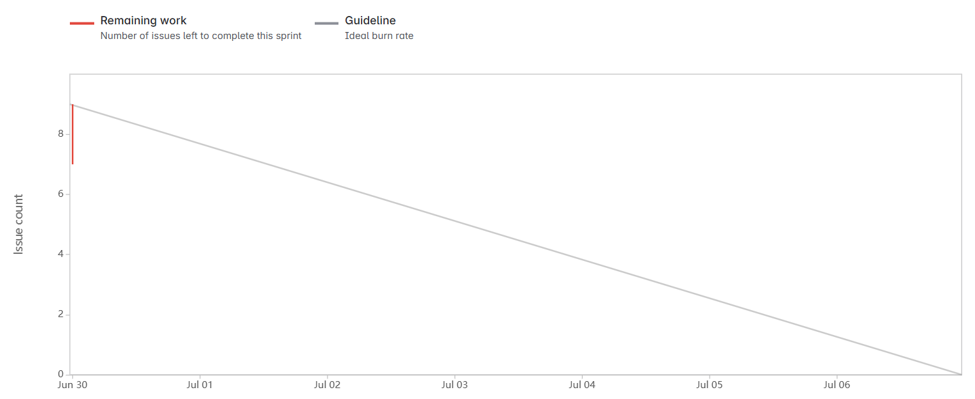
Question 10 – Explain about Product Grooming (2 Marks) Answer 10:
Product Grooming (also called Backlog Refinement) is the ongoing process in Agile Scrum where the Product Owner and the Scrum Team collaborate to:
- Review, refine, and prioritize Product Backlog Items (PBIs).
- Break down large epics into smaller user stories.
- Add new user stories based on customer feedback and business needs.
- Update acceptance criteria, estimates (BV and CP), and priorities.
Main goals of Product Grooming:
- Keep the Product Backlog clean, organized, and ready for upcoming sprints.
- Ensure that the highest priority items are well-defined and “Ready” for Sprint Planning.
Benefits:
- Reduces surprises during Sprint Planning.
- Ensures better understanding of the work among team members.
- Helps deliver valuable features quickly and efficiently.
Question 11 – Explain the Roles of Scrum Master and Product Owner (3 Marks)

Answer 11:
Scrum Master
- The Scrum Master is the facilitator and coach for the Scrum Team.
- Ensures the team understands and follows Scrum practices.
- Removes impediments that block team progress.
- Conducts and facilitates Scrum ceremonies like Daily Stand-ups, Sprint Planning, Reviews, and Retrospectives.
- Shields the team from external distractions to maintain focus.
Key Responsibilities:
- Guide the team in Agile best practices.
- Help resolve conflicts and team issues.
- Maintain transparency and communication within the team and with stakeholders.

Product Owner
- The Product Owner is the voice of the customer and business representative in the Scrum Team.
- Owns and manages the Product Backlog.
- Prioritizes features based on business value, customer needs, and market trends.
- Defines user stories with clear acceptance criteria.
- Works closely with stakeholders to gather requirements and ensure alignment.
Key Responsibilities:
- Write and prioritize user stories.
- Accept or reject work completed during sprint reviews.
- Maximize the product’s value delivered by the development team.

Summary Table:
Role | Scrum Master | Product Owner
Focus | Process & Team Facilitation | Product & Business Value
Owns | Scrum Process | Product Backlog
Key Activity | Remove Impediments | Prioritize Features & Define Scope
Works with | Development Team | Stakeholders & Customers
Question 12 – Explain all Meetings Conducted in Scrum Project (8 Marks)
In Scrum, several meetings (also called Scrum Ceremonies) are conducted to ensure smooth project execution, transparency, and collaboration.
The major meetings are:

1. Sprint Planning Meeting
- Conducted at the beginning of every Sprint.
- Attended by Product Owner, Scrum Master, and Scrum Development Team.
- Purpose:
  - Decide which Product Backlog Items (PBIs) will be completed in the sprint.
  - Define Sprint Goal.
  - Break PBIs into smaller tasks.
- Output: Sprint Backlog is created.

2. Daily Scrum (Daily Stand-up Meeting)
- A 15-minute meeting held every day during the sprint.
- Attended only by the Scrum Team (Scrum Master and Developers).
- Purpose:
  - Share progress updates.
  - Identify impediments.
  - Plan the next 24 hours of work.
- Typical questions answered:
  - What did I do yesterday?
  - What will I do today?
  - Are there any blockers?

3. Sprint Review Meeting
- Conducted at the end of the sprint.
- Attended by Scrum Team, Product Owner, Scrum Master, Stakeholders, and Clients.
- Purpose:
  - Showcase the Increment (completed work) to stakeholders.
  - Gather feedback and adapt the Product Backlog if needed.
- Output: Updated Product Backlog, capturing changes and new priorities.

4. Sprint Retrospective Meeting
- Conducted after the Sprint Review and before the next Sprint Planning.
- Only Scrum Team (Scrum Master and Developers) participate.
- Purpose:
  - Reflect on what went well.
  - Identify areas of improvement.
  - Define action items to improve the next sprint.
- Focus: Continuous team improvement.

5. Backlog Grooming (Product Backlog Refinement)
- Ongoing meeting (can be held weekly or mid-sprint).
- Attended by Product Owner and Development Team.
- Purpose:
  - Refine, prioritize, and clarify the Product Backlog.
  - Break down large PBIs (Epics) into smaller user stories.
  - Ensure the backlog is ready for future sprint planning.
- Helps save time during Sprint Planning Meetings.
Question 13 – Explain Sprint Size and Scrum Size (2 Marks)
Sprint Size
- Sprint Size refers to the duration of a Sprint cycle.
- In Scrum, Sprint Size is usually between 1 to 4 weeks.
- For the Scrum Foods project, the Sprint Size is 2 weeks.
- Sprint Size remains consistent throughout the project to maintain rhythm and predictability.

Scrum Size
- Scrum Size refers to the duration of a single Scrum event (Daily Stand-up Meeting).
- A typical Scrum Meeting lasts for 15 minutes every day.
- Scrum Size ensures that the team quickly shares updates without wasting time and stays aligned daily.

Simple Summary:
- Sprint Size = Total Duration of a Sprint (e.g., 2 weeks).
- Scrum Size = Daily Meeting Duration (e.g., 15 minutes).
Question 14 – Explain DOR and DOD (2 Marks)
DOR – Definition of Ready
- Definition of Ready (DOR) means that a user story or task is fully prepared and clear enough for the Scrum Team to start working on it.
- It ensures that all necessary details (requirements, acceptance criteria, designs) are available before a story is picked up for development.
Typical DOR Conditions:
- User Story is clearly written.
- Acceptance Criteria are defined.
- Dependencies are identified and resolved.
- Story is estimated (BV and CP assigned).

DOD – Definition of Done
- Definition of Done (DOD) means that a user story or task is completed to the team's agreed standards and is ready for release or delivery.
- It ensures quality and consistency in completed work.
Typical DOD Conditions:
- Code is written, reviewed, and tested.
- Unit tests are passed.
- Documentation is updated (if required).
- Accepted by the Product Owner.

Summary:
- DOR = Ready to Start
- DOD = Successfully Finished
Question 15 – Explain Prioritization Techniques and MVP (3 Marks)
Prioritization Techniques
Prioritization techniques help Product Owners and stakeholders decide which features or user stories should be developed first based on value, urgency, and effort.
Some of techniques are:
MoSCoW Method
  - Must Have: Essential features.
  - Should Have: Important but not critical.
  - Could Have: Nice to have.
  - Won't Have (now): Not included in current sprint/release.

MVP – Minimum Viable Product
- MVP is the smallest version of a product that can be released to users with only the most critical features.
- Purpose:
  - Validate the product idea with minimal resources.
  - Gather user feedback early.
  - Improve future versions based on real-world usage.
- For Scrum Foods: MVP could be registration, restaurant search, food ordering, and delivery tracking features.
Question 16 – Difference between Business Analyst and Product Owner (3 Marks)
Aspect | Business Analyst (BA) | Product Owner (PO)
Primary Focus | Understanding business needs and documenting requirements. | Maximizing the value of the product and managing the Product Backlog.
Role | Acts as a bridge between business stakeholders and technical team. | Acts as the owner and decision-maker of the product vision and features.
Responsibility | - Gather and analyze requirements.  - Create BRD (Business Requirement Documents), User Stories, Use Cases. | - Prioritize and maintain the Product Backlog.  - Accept or reject completed work.
Decision Making | Provides recommendations but does not make final decisions. | Makes final decisions on what to build and when.
Interaction | Works closely with stakeholders, developers, testers, and project managers. | Works closely with stakeholders, Scrum Master, and Scrum Team.
Example in Scrum Foods | BA would help gather features like customer registration and food tracking. | PO would prioritize these features and decide when they should be developed and delivered.

Simple Summary:
- BA focuses on "what is needed" and "why."
- PO focuses on "what is delivered" and "when."
Question 17 – Prepare a Sample Resume of 3 Years Experienced Product Owner (3 Marks)
Sample Resume: 3 Years Experienced Product Owner

Name: geethu gopakumar
Phone: 9930397407
Email: geethu.gopakumar@gmail.com
LinkedIn: geethu.gopakumar65
Location: Bangalore

Professional Summary
Dynamic and customer-focused Product Owner with 3 years of experience in Agile Scrum environments.
Skilled in managing Product Backlogs, writing clear User Stories, prioritizing features, and working closely with cross-functional teams to deliver high-value digital products.
Expert in backlog grooming, sprint planning, stakeholder management, and delivering MVPs aligned with business goals.

Key Skills
- Agile Scrum Framework
- Product Backlog Management
- User Story Writing (INVEST Criteria)
- Sprint Planning & Execution
- Prioritization Techniques (MoSCoW, WSJF)
- Stakeholder Collaboration
- MVP Planning and Delivery
- Jira, Confluence, Trello, MS Azure DevOps
- Excellent Communication and Negotiation Skills

Professional Experience
Product Owner
COEPD IT Solutions — Hyderabad, India
August 2021 – Present
- Owned and managed the Product Backlog for Scrum Foods – a 24/7 online food delivery application.
- Worked closely with Business Owners, Admins, and Regional Admins to gather requirements and define the product vision.
- Created over 100+ User Stories with clear acceptance criteria, assigned Business Value (BV) and Complexity Points (CP).
- Participated in Sprint Planning, Sprint Reviews, and Retrospectives with the Scrum Team.
- Prioritized backlog items to ensure maximum delivery of customer value in each sprint.
- Led Product Grooming sessions to refine and prepare backlog items.
- Monitored team velocity and adjusted sprint planning to ensure predictability.
- Released multiple MVP versions and captured customer feedback for continuous product improvement.

Education
- Bachelor of Technology (B.Tech) – [Your Branch]
[University Name], [Graduation Year]

Certifications
- Certified Scrum Product Owner (CSPO) – Scrum Alliance
- Agile Business Analyst Certification (Optional)

Projects
- Scrum Foods (Food Delivery Application):
Managed end-to-end product development, including order placement, payment gateway integration, real-time tracking, and feedback collection modules.

Personal Attributes
- Strong problem-solving skills
- Customer-centric mindset
- Proactive and highly organized

