Online Agriculture Product Store

- Quarterly Audits are planned Q1, Q2, Q3, and Q4 for this project what is your knowledge on how these Audits will happen for a BA?
Ans:
Q1: Initiation & Requirements Audit:
- Focus: Project Kickoff, Stakeholder alignment, and requirements gathering.
- BA Responsibilities:
  - Ensure all stakeholder requirements are documented
  - Validate use case models, activity diagrams, and business rules.
  - Confirm Traceability matrix is initiated.
  - Review minutes of meeting and requirement workshops.
- Audit Artifacts:
        - Business Requirement Document
        - Use case specification
        - Stakeholder Register
Q2: Design & Process Validation Audit:
- Focus: Functional design, process modeling and system workflows.
- BA Responsibilities:
  - Validate that requirements are correctly translated into design specs.
  - Review activity diagrams, data flow diagrams, and swim lane models.
  - Ensure exception handling and business rules are embedded in flows.
  - Collaborate with developers and testers to clarify requirements.
- Audit Artifacts:
        - Functional Specification Document(FSD)
        - Updated UML diagrams
        - Process models
        - Change request logs
Q3: Testing & Traceability Audit:
      - Focus: Test coverage, Traceability, and defect analysis.
      - BA Responsibilities:
      - Ensure all requirements are mapped to test cases(RTM).
      - Participate in UAT planning and execution.
      - Analyze defects and validate root causes.
      - Support testers with requirement clarifications.
      - Audit Artifacts:
      - Requirements Traceability Matrix(RTM).
      - UAT Scripts and results.
      - Defect logs and resolution reports.
      - Updated BRD/FSD based on changes.
Q4: Delivery & Closure Audit:
    - Focus: Final delivery, stakeholder satisfaction, and documentation closure.
    - BA Responsibilities:
      - Confirm all requirements are delivered and singed off.
      - Conduct lessons learned sessions.
      - Archive all documentation and ensure version control.
      - Support post-implementation review.
    - Audit Artifacts:
      - Final BRD/FSD
      - Sign-off documents
      - Closure report
      - Feedback forms

- Before the Project is going to kick start, The Committee asked Mr Karthik to submit BA Approach Strategy
Write BA Approach strategy (As a business analyst, what are the steps that you would need to follow to complete a project – What Elicitation techniques to apply, how to do Stakeholder Analysis RACI/ILS, What Documents to write, What process to follow to sign off on the documents, How to take Approvals from client, What Communication channels to establish n implement, How to Handle Change Requests, How to update the progress of the project to the stakeholders, How to take sign-off on the UAT-Client Project Acceptance Form)
Your Team
Project manager – Mr.Vandanam Senior
Java Developer – Ms.Juhi
Java Developers – Mr.Teyson, Ms.Lucie, Mr.Tucker, Mr.Bravo
Network Admin – Mr.Mike
DB Admin – Mr John.
Testers – Mr Jason and Ms Alekya
BA – You
Technical team have assembled to discuss on the project approach and have finalized to follow 3 – tier architecture for this project.
Ans:
Business Analyst Approach Strategy:
- Elicitation Techniques:
- Stakeholder interviews( Peter, Kevin, Ben, Mr. Henry)
- Workshops with Developers, Quality Assurance Testing, Database, and Network teams.
- Document analysis, prototyping for farmer app
- Stakeholder Analysis & RACI:
- Identify all stakeholders
      - Business: Mr. Henry , Mr. Pandu, Mr. Dooku, Peter, Kevin, Ben
      - Delivery: Mr. Karthik, Mr. Vandanam
      - Technical: Juhi, Teyson, Lucie, Tucker, Bravo, Mike, John
      - QA: Jason, Alekya
      - BA: Me
- RACI Matrix Sample:
Task |  | Business Analyst | Project Manager | Developers | Quality Assurance | Network | Database
 | Business Requirement Document Creation | Responsible | Accountable | Consulted | Consulted | Consulted | Consulted
 | Use Case/RTM | Responsible | Accountable | Consulted | Consulted | Consulted | Consulted
 | Prototype Review | Responsible | Accountable | Consulted | Consulted | Informed | Informed
 | User Acceptance Testing Coordination | Responsible | Accountable | Informed | Consulted | Informed | Informed

- BA Documents:
- Business Requirement Document
- Functional Specification Document
- Requirement Traceability Matrix
- Use Cases / User Stories
- UAT Plan & Sign-Off Form
- Change Request Log
- Document Sign-off Process:
- Internal review-> client review-> feedback-> final sign-off via email or form
- Communication Channels:
- Internal: Jira, Slack, Email
- Client : Zoom/ Google Meet, Email
- Status Reports: Weekly to project Manager & Bi-weekly to client
- Handling Change Requests:
- Log-> Analyze Impact->Discuss with PM/Tech -> Get committee Approval-> Updates Documents
- Progress update:
- Weekly report to Project Manager
- Bi-weekly reviews with client
- Track in Jira or Excel sheets
- UAT & Client Acceptance:
- Prepare User acceptance testing plan & test cases
- Coordinate testing with Peter, Kevin, Ben
- Resolve issues & get formal sign-off on UAT Acceptance Form
- Architecture:
- 3-Tier ( Presentation, Business Logic, Data Layer)
- Align requirements with this model

- Explain and illustrate 3 – tier architecture?
Ans: 3- tier architecture divided into three logical layers:
- Presentation Layer: Farmers browse and order products using a mobile/ web app. This layer ensures the UI simple and local-language friendly.
- Business Logic Layer: Validates user login, processes orders, and communicates between UI and database using Java
- Data Access Layer: Stores product details, user data, orders, feedback- managed by DB Admin Mr. John.

- – Tier Architecture
1.Presentation Layer
User Interface(UI): Web or mobile app
HTML,CSS, JS
Farmers viewing and ordering products
2. BUSINESS LOGIC LAYER
Core processing and rules
Java, Spring Boot
Validating orders, handling payments

3. DATA ACCESS LAYER
Stores and retrieve data
MySQL/ PostgreSQL
Storing product details, orders, users

- Business Analyst should keep What points in his/her mind before he frames a Question to ask to the stakeholder
( 5W1H- SMART – RACI – 3 Tier Architecture – Use Cases, Use case Specs, Activity Diagrams, models, page designs)
Ans:
- 5W1H: What, Why, Who, When, Where, How to get complete clarity.
- SMART: Ensure the requirement you’re clarifying is: Specific, Measurable, Achievable, Relevant, Time-Bound.
- RACI Matrix: Know the Roles: Responsible, Accountable, Consulted, Informed – ask the right person
- 3- Tier Architecture: Frame question aligned to : UI( Presentation), Business Logic, and Data Layer.
- Use Cases: Ask how the user interacts with system and what scenarios need to be supported.
- Use Case Specifications: Ask about actors, triggers, steps, exceptions, and outputs to frame complete functional flows
- Activity Diagrams: Consider the workflow- ask about decisions, conditions, and sequence of actions.
- Models: know if you’re capturing data structure or business process and frame questions accordingly.
- Page Designs(UI): Ask about screen layout, inputs, navigation and usability needs.

- As Business Analyst, What Elicitation Techniques you are aware of ? (BDRFOWJIPQU)
Ans:
Acronym | Technique | What it means/ When to use
B | Brainstorming | To generate multiple ideas quickly with stakeholders or team
D | Document Analysis | Review existing docs, reports, SOPs to understand current processes.
R | Requirements Workshops | Collaborative sessions to gather and finalize requirements with all stakeholders
F | Focus Groups | Discuss with a selected group of users for specific feedback or needs
O | Observation | Watch how users perform tasks to discover needs they may not express
W | Workshops | Interactive group sessions to explore ideas, priorities, and designs.
J | Job Shadowing | Sit with end-users while they work to understand their real problems.
I | Interface Analysis | Review system interfaces to understand data flow between components
P | Prototyping | Build mockups or wireframes to visualize requirements and get feedback
Q | Questionnaires/Surveys | Useful for getting inputs from large audiences efficiently
U | User Case Specification | A formal specification describing how users interact with system for specific goals.

- Which Elicitation Techniques can be used in this project and justify your selection of Elicitation Techniques?
Prototyping
Use case Specs
Brainstorming
Fertilizers, seeds, pesticides details from the manufacturers and should be able to display them to the Farmers.
To gather the business requirements from the client, you went to SOONY and met Mr. Henry. When Mr.henry was asked about the project and what are they expecting from the project, Mr.henry stated that he is expecting to have a login for all its users ( fertilizers, seeds, pesticides manufacturers and Farmers) , a product catalog of fertilizers, seeds, pesticides, a search option to search for products, payment process, and delivery tracking.
After doing the stakeholder analysis, you have found out that peter, Kevin, Ben are the key stakeholders and you have scheduled an appointment to meet them. After meeting with them and trying to gather the stakeholder requirements, Kevin said that, a Farmer should be able to browse through the products catalog once they visit the website and need to have a search option so that they can search for any product they need. Peter said that, if a farmer wants to buy any product or add them to buy-later list, they need to login first using their email id and password. If it is a new user, then they can create a new account by submitting their email ID and creating a secure password. Ben added saying that, farmers needs to have an easy-to-use payment gateway which should include cash-on-delivery(COD), Credit/Debit card and UPI options so that the user’s experience should be better. Kevin mentioned that, a user gets an email confirmation regarding their order status. A delivery tracker to track the whereabouts of their order.
Identify business Requirement (which includes Stakeholder Requirements)
BR001 – Farmers should be able to search for available products in fertilizers, seeds, pesticides
BR002 – Manufacturers should be able to upload and display their products in the application
Ans: Prototyping: To help non-technical stakeholders understand the look and feel of the application.
Used to present mock screens for:
- Login/ register Page
- Product catalog display
- Search bar
- Cart & Buy-later list
- Payment options(COD, UPI, Card)
- Delivery tracking
Prototyping were demonstrated to Mr. Henry, Peter, Kevin and Ben to gather early feedback and ensue the UI is simple amd intuitive.
Use case Specifications: To capture and document specific scenarios describing how different users interact with the system.
Like: Farmer searches for products, Manufacturer, uploads product, user logs in, Places order, Track delivery
Brainstorming: Used with Mr. Henry, Peter, Kevin, and Ben to gather a broad list of features expected by different Stakeholders.
Identified Business Requirements:
Business Requirement ID | Description
BR001 | Farmers should be able to search for available products in fertilizers, seeds, pesticides
BR002 | Manufacturers should be able to upload and display their products in the application
BR003 | Farmers should register/login using email and password
BR004 | Farmers should be able to add products to cart or buy-later list
BR005 | System should have payment gateway with COD, UPI and Card options
BR006 | Users should get email confirmation for order status
BR007 | Farmers should be able to track order delivery status.

- Make suitable Assumptions and identify at least 10 business Requirements.
Ans: Assumptions Made:
- Farmers and manufacturers have basic internet access and smart phones or desktop access.
- Users will register/login with an email ID and password
- The platform is bilingual( supports local language and English)
- Products will be categorized into fertilizers, Seeds and Pesticides.
- Payment options include COD, Credit/Debit card, and UPI
- Delivery services will be handled by third-party logistics integrated via API
- Manufacturers can manage their product listings independently
- Farmers need real-time updates on their orders via email/SMS
- Product reviews and ratings help other farmers make decisions
- Admin will moderate and approve new product listings and user registrations.
Business Requirements:
BR ID | Business Requirement Description
BR001 | Farmers should be able to browse and search for products( fertilizers, seeds, pesticides)
BR002 | Manufacturers should be able to register/login and upload/ manage their products
BR003 | Farmers must be able to register/login using a secure method( email and password)
BR004 | The System must support a shopping cart and buy later list functionality for farmers
BR005 | The application should multiple payment options: COD, Debit/Credit Card, UPI
BR006 | Framers should receive order confirmation and tracking updates via email/SMS
BR007 | The System should allow delivery tracking through a visual interface for farmers
BR008 | An admin module should be available to approve, edit or remove products or users
BR009 | The system should allow product ratings and reviews by farmers after purchase
BR010 | The application should provide reporting/dashboard features for manufacturers to track sales.

- List your assumptions
Ans: 1. Farmers and manufacturers have access to smartphones or desktops with internet connectivity
2. Users will register and log in using email ID and password( no social logins for now)
3. The application will bilingual- supporting English and regional language( e.g., Telugu/ Hindi)
4. All products will be categorized into Fertilizers, seeds, and Pesticides only
5. The platform will support Cash on Delivery( COD), UPI and Card payments
6. Delivery logistics will be managed by third-party courier services integrated via API
7. Manufacturers can upload and manage their product listings independently through a dashboard.
8. Farmers should receive notifications via email/SMS for order Status.
9. A central admin will verify and approve new product listings and user registrations
10. The Platform will include a review and rating system for products purchased by farmers.

- Give Priority 1 to 10 numbers( 1 being low priority – 10 being high priority) to these requirements after discussions with stakeholders
Requirements ID | Requirements Name | Requirements Description | Priority
BR001 | Farmer Search for Products | Farmers should be able to search for available products in fertilizers, seeds, pesticides | 8
BR002 | Manufacturers upload their Products | Manufacturers should be able to upload and display their products in the application | 8
Once the requirements are finalized, as a business analyst, one of the major roles is to act as a liaison between the client and the project team. To gather the requirements correctly from the client side and then to deliver those requirements to the project team in a way they understand. To make the project team understand the requirements, you need to convert those requirements into UML diagrams and screen mock-ups.
Ans:
Requirement ID | Requirement Name | Requirement Description | Priority(1-10)
BR001 | Farmer search for products | Farmers should be able to search for available products in fertilizers, seeds , pesticides | 8
BR002 | Manufacturers upload products | Manufacturers should be able to upload and display their products in the application | 8
BR003 | User Login & Registration | All users should be able to register/login using secure credentials | 10
BR004 | Shopping Cart & Buy Later | Farmers should be able to add products to cart or buy- later list | 7
BR005 | Payment options | The application must support COD, Card, and UPI for smoother payments | 9
BR006 | Order Confirmation Notification | Email/SMS confirmation should be sent after successful order | 6
BR007 | Delivery Tracking | A Visual order tracking feature should be available for farmers | 7
BR008 | Admin Control Panel | Admin should approve, edit and remove users/products as needed | 6
BR009 | Product Reviews& Ratings | Framers should be able to leave feedback after purchase | 5
BR010 | Manufacturer Sales Dashboard | A dashboard to track product views, orders, and sales metrics | 4

- Draw use Case Diagram
Ans: 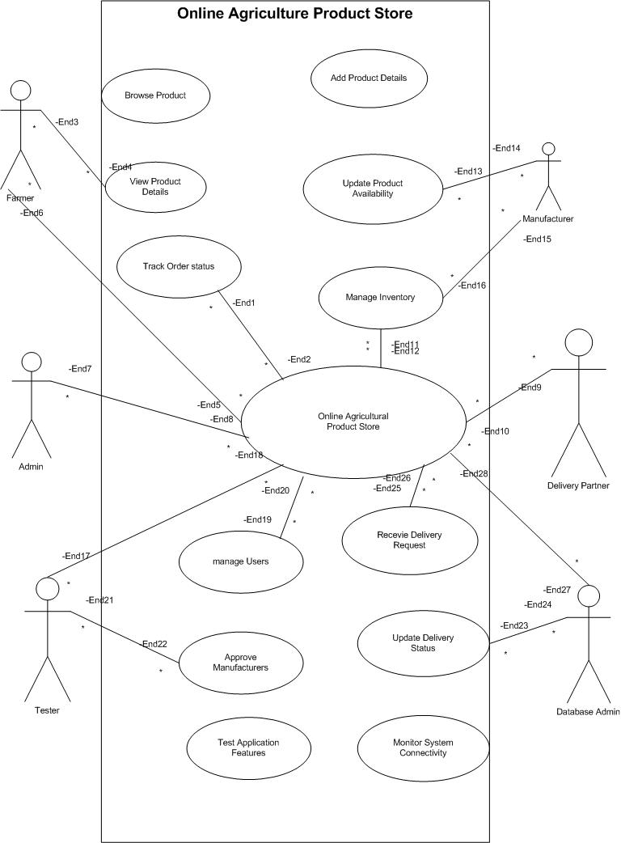
- Prepare use case specs for all use cases
Ans:
Use Case ID: | 1.0
Use Case Name: | Register/Login
Created By: | Reshma | Lasted Updated By: | Reshma
Date Created : | 24/07/25 | Date Last Updated: | 24/07/25
Actor(s): | Farmer, Manufacturer
Description: | Allows users( farmers and manufacturers) to register or login to access the platform
Preconditions: | -User is on login/registration page  -Internet connectivity is available
Post conditions: | -User is authenticated  -User is directed to dashboard
Normal Course: | -User selects register or Login  -Enter Email ID and Password  -Credentials are validated  -User is redirected to their dashboard
Alternative Courses: | -If login fails-> Show error message  -If new user-> Redirect to registration form
Exceptions: | None
Includes: | Email validation, password encryption
Priority: | 10
Frequency of Use: | Daily
Business Rules: | Unique email ID required, passwords must be encrypted
Special Requirements: | OTP-based Verification(If required)
Assumptions: | User has a valid email ID
Notes and Issues: | Consider integrating with social login in future
Use Case Graphic

Use Case ID: | 2.0
Use Case Name: | Search Products
Created By: | Reshma | Lasted Updated By: | Reshma
Date Created : | 24/07/25 | Date Last Updated: | 24/07/25

Actors | Description
Farmer: | Farmers search for fertilizers, seeds, and pesticides using filters and search options
Preconditions: | -User is logged in  -Products exist in the catalog
Post Conditions: | -Matching results are displayed  -User can view product details
Normal Course: | -User types in product keyword  -System filters product based on input  Display results
Alternative Courses: | -No results-> show “No product found” message  -search with filters( category, price, etc.)
Priority: | 9
Frequency of use: | Daily
Business Rules: | All products must be tagged correctly
Assumptions: | Product database is up-to-date

Use Case ID: | 3.0
Use Case Name: | Upload Product
Created By: | Reshma | Lasted Updated By: | Reshma
Date Created : | 24/07/25 | Date Last Updated: | 24/07/25

Actions | Description
Manufacturer: | Manufacturers upload details of new Products ( fertilizers, seeds, pesticides).
Preconditions: | -Manufacturer is logged in  -Manufacturer account is approved
Post conditions: | Product is listed in the product catalog
Normal Course: | -User clicks on ”Add product”  -Fills product details  -click submit  -Product appears in product listing
Alternative Courses: | -incomplete form  -Show validation errors  -System flags duplicate entry
Priority: | 8
Frequency of Use: | As needed
Business Rules: | Product info must be verified by admin before going live
Assumptions: | User uploads genuine information

Use Case ID: | 4.0
Use Case Name: | Payment Process
Created By: | Reshma | Lasted Updated By: | Reshma
Date Created : | 24/07/25 | Date Last Updated: | 24/07/25

Actors | Descriptions
Farmer, Payment Gateway: | Facilitates secure payment for selected agricultural products using multiple payment modes like UPI, credit/debit cards, and cash-on-delivery(COD).
Preconditions: | -User is logged in  -Items are added to the cart  -Delivery address is confirmed
Post conditions: | -Payment is processed successfully  -order confirmation is trigged  -inventory is updated
Normal Course: | -User reviews cart and clicks on “Proceed to payment”  -System displays payment options( UPI, Card, COD)  -User selects a preferred method and completes payment  -System verifies payment  -Payment successful-> Confirmation screen & email sent
Alternative Courses: | -If payment fails-> Display error, allow retry or switch mode  - If user selects COD-> Skip payment gateway, confirm order  -if network drops-> show “Transaction in process”, retry or cancel
Exceptions: | -Payment gateway timeout or service unavailable  -Fraudulent card detection  -UPI failure due to third-party issue
Includes: | -payment summary  -Transaction ID generation  -Email confirmation
Priority: | 10
Frequency of use: | After every order
Business Rules: | -Refund policy applies on cancellations  -COD allowed only for orders below Rs.5000  -Payment should be confirmed before dispatch
Special Requirements: | -Integrated with secure payment gateway( Razor Pay, Paytm, etc)  -PCI-DSS compliance for card payments
Assumptions: | -User has a valid payment method  -Payment gateway integrated is functional
Notes and issues: | -Retry mechanism required for UPI failure  -Log transaction status for backend audit

Use Case ID: | 5.0
Use Case Name: | Track Order
Created By: | Reshma | Lasted Updated By: | Reshma
Date Created : | 24/07/25 | Date Last Updated: | 24/07/25

Actors | Description
Farmer, System | Allows a logged-in user (farmer  ) to track the status and location of their order from purchase to delivery using a delivery tracking interface.
Preconditions: | -User is logged in  -An order has been placed successfully  -Order ID is available
Post conditions: | -Current order status is displayed  -Estimated delivery timeline is shown  -Delivery partner info may be displayed
Normal Course: | -User logs in and navigates to “ My Orders”  - Select a recent or past order  -System retrieves tracking information  -Displays real-time delivery status(e.g., Packed-> Shipped-> Out for delivery-> Delivered)  -Displays estimated delivery date
Alternative Courses: | -If tracking info is delayed-> Display “Awaiting courier update”  -If courier partner fails-> Display customer service contact  -If no order found-> Show “No orders available for tracking”
Exceptions: | -Network/API failure to courier system  -Wrong order ID or data sync issue
Includes: | -Order details  -Courier tracking status  -Date of expected delivery
Priority | 9
Frequency of use: | Used by farmers post every order
Business Rules: | -Order status should be updated every 6 hours by courier API  -Tracking should be available within 24 hours of order placement
Special Requirement: | -Integration with third-party delivery tracking APIs  -Mobile & web interface should support notifications
Assumptions | -Courier partner shares regular status updates  -Farmers understand basic order tracking terms
Notes and Issues: | -Consider SMS alerts for major status changes  -Add help section for first-time users

- Activity diagrams
1.
Ans: 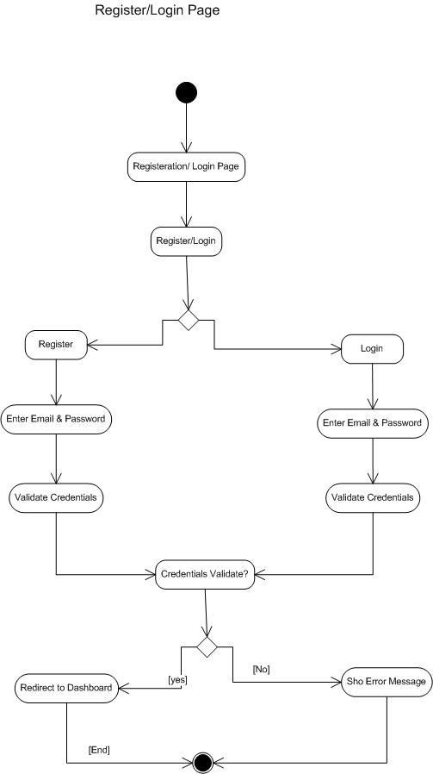
2.
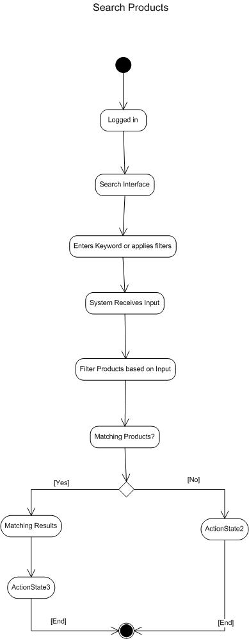
3.
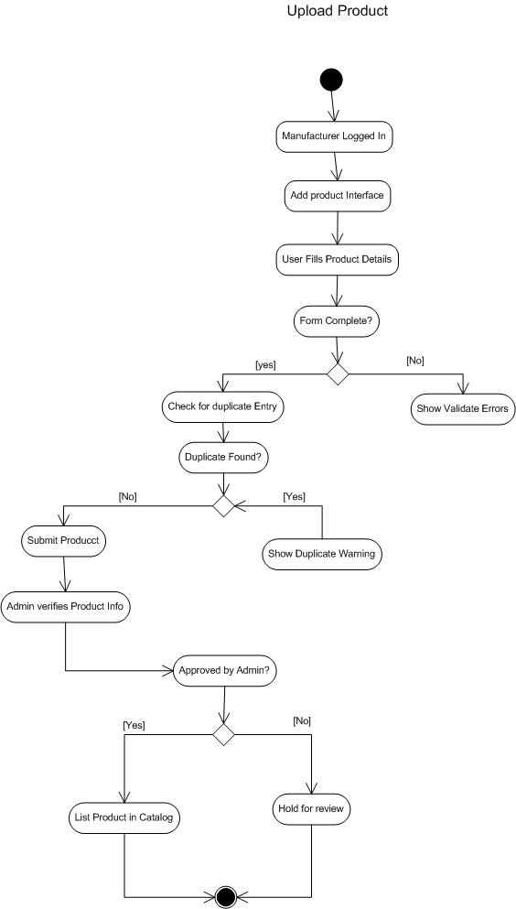
5.

