1Q Business case document

- Why is this project initiated?

The employee empower hub project is initiated to enhance payroll, security, attendance. More autonomous and supportive and work environment is initiated
- What are the current problems?

Employee empowerment hub is crucial in the organizational success but it comes with setoff own challenges in they are:

1 Inadequate training and resources
2 Un clear payrolls
3 Fear of authentication issues
3 Insufficient resources and support
4 issues with attendance recording

- With this project how many problems could be solved?
An employee empower hub can potentially solve numerous problems including:
1 Low employee engagement
2 poor communication
3 Lack of motivation
4 Insufficient skill development
5 Slow decision making
6 Accountability
7 improved customer and satisfaction

- What are the resources required for employee hub?
To establish employee empowerment hub need various resources required they are:

1 Human resources
2 Technology and tools
3 Training and development
4 Financial resources
5 infrastructure
- How much organizational change is required is adopt to technology.

It requires learning to anticipate issues that my arrive during the change process and create a plan for them

Hard ware and software updates
;
New technology may necessitate upgrades ton existences hardware, software or board
Process automation:

New technology can automate various process requiring adjustments to workflows and job roles.
New communication channels and collaboration methods, impacting how hour team interfaced

- Timeframe to recover ROI

The timeframe to recover a return of investments varies significantly depending on the type of investments and the factors of influencing its success as id project is short term low risk is investments it is it will have faster pay back period. Its verification or other security feature oriented the recovery my take ab it longer

- How to identify stakeholder

To effectively identify stake holders in this project, begin by brain storming or individuals and group potentially effected by or having an interest in the project both internally and externally.
Start by gathering a team familiar with this project and brainstorm potential stakeholders
Consider both internal stake holders (employees, manager, HR, IT) and external stakeholders (community partners, vendors)
Consider who might be impacted by the project success or failure. Determine each stakeholders level of interest in the project and their ability to influence its success or failure

Document 2

- BA strategy:

In this project I have initially understood the project, identified stakeholders, the business problem, Opportunities, documentations, business needs, requirements elicitation

For an employee empowerment hub project would focus on understanding the current state, defining the desired future state and identifying the gaps. This includes gathering requirements, analyzing process, and recommending solutions that empower employees through clarity, support, and autonomy. The BA would also ensure the project aligns with the organizations strategic goals and fosters a culture of trust and collaboration.

- Stakeholder analysis:

By conducting interviews and workshops techniques and gather information about the current process, pain points and decide and improvements related to employee empowerment.
Create clear documentation of functional and nonfunctional requirements for the hub understand. How the integrated hub will replace the existing system? In this project we have used RACI matrix to do stakeholder analysis, as it clearly defines roles and responsibilities of different involved.
- As a BA, the document I need to write are BRD, FRD, use case documentation and test case document.
- The signoff document to followed the sign off taken on SRS as this a primary and important document. Signoff has to be taken by using an email confirmation from the client.
- We need to establishes a formal meeting with the clients to keep them informed and get continuous feedback and prepare for approved request. Client review feedback and approval confirmation are considered best practices.
- The best communicational channel to establish with client is by conducting regular meeting, weekly status meeting, weekly sprint review and also monthly stakeholder update.
- Change request are documented in the change request from we need to prioritizing the change request based on its urgency, importance and impact on the project. Also the request needs to be communicated to all the relevant stakeholders, including the project team about its potential impacts.
- The project progress is needed to be update from to the stakeholders in weekly status reports monthly review meetings.
- To take sign off on UAT, we need to ensure client acceptance on UAT preparation, conduct UAT, fix the issues, Acceptance from the client we will have a final review meeting, them obtain the signoff.

Document-3

Functional specifications:

Project name: employee empowerment hub.

Customer name: HR solutions

Project Version: employee empowerment hub - BRD REQ – 10-05-23.Doc.

Project sponsors: HR solutions

Project manager: ABC

Project initiation date: 10-07-2025.

- Functional Requirement specification:

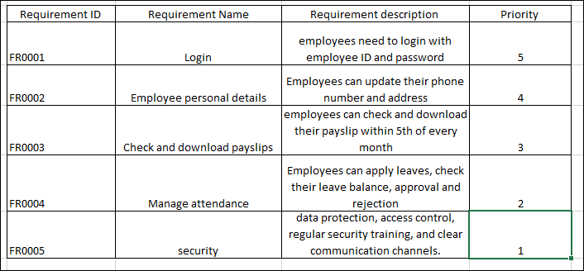

Document 4: Requirement traceability Matrix:

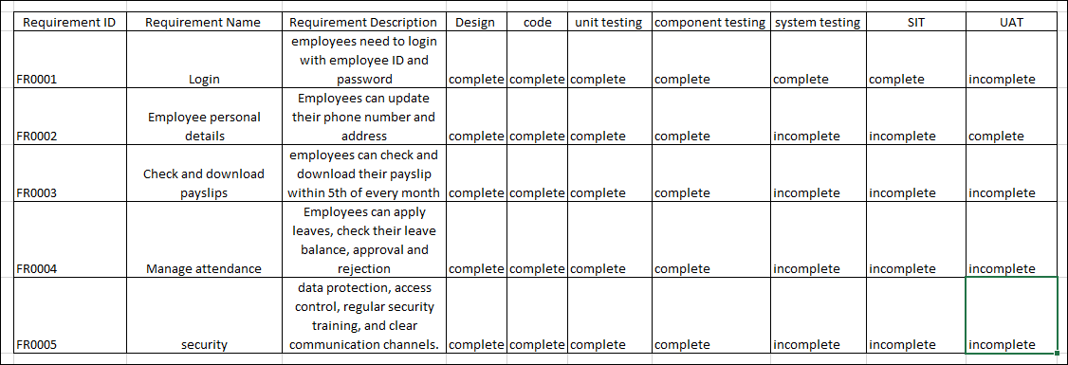

Document- 5:

BRD Template

Project name: employee empower hub

Project ID: enhancement of empower hub

Version ID:0.1

Author: Ganesh

Document revision:

Date | version number | document changes
10-07-2025 | 1.1 | Add features payslip, attendance and security

The initial BRD outlined a simple employee login portal process for employees who had forgotten their password.
- Reason for Revision:
After initial testing and user feedback, it became clear that the process needed to be more robust to handle situations like compromised accounts, fraud attempts.
Revision Focus:
  - Enhanced Security Measures: Add features to ensure security within an employee empowerment program like an "empower hub," organizations should focus on robust data protection, access control, regular security training, and clear communication channels.
  - Expanded User Support: Include a new section on how to handle different employee logins and scenarios, including the device, and network.

Approvals:
Role | Name | Title | signature | Date
Project spencer | HR solutions | employee empower hub |  | 10-07-2025
Business owner | HR solutions | employee empower hub |  | 10-07-2025
project manager | Visalini | employee empower hub |  | 10-07-2025
system architect | Ganesh | employee empower hub |  | 10-07-2025
Development lead | Sai | employee empower hub |  | 10-07-2025
User experience lead | Alex | employee empower hub |  | 10-07-2025
Quality lead | sirisha | employee empower hub |  | 10-07-2025
content lead | Mary | employee empower hub |  | 10-07-2025

RACI Chart:

The RACI chart will give an indication as to who is to be contacted whenever changes are made to this document. The code used to this chart describes the roles and responsibilities of the stakeholders (internal and external) in the product of BRD.

Code used to this chart:

- Authorize: Has the approving authority for any changes made.
- Responsible: Responsible for creating the document.
- Accountable: Accountable for the contents as well the process followed in creating.
- Consult: Input provided.
- Inform: Any changes in this document are to be informed.

Name | R | A | S | C | I
Requirement gathering | BA |  |  | Stake holders
Requirement Analysis | BA |  |  |  | project manager
Development |  | Java Developers |  | BA
Testing | Testers |  |  |  | BA, Project manager and Java developers

INTRODUCTION:

4.1 Business Goals:
To create a workplace where employees feel connected to their work and the organization's goals, leading to increased commitment and productivity.
4.2 Business Objectives:
Create a workplace where employees feel valued, supported, and motivated, leading to higher productivity and job satisfaction. Encourage employees to share ideas, take initiative, and contribute to continuous improvement, driving organizational growth and adaptability.
4.3 Business Rules:
Empowerment initiatives should demonstrably boost employee engagement, creating a more motivated and invested workforce. Giving employees greater control over their work and decision-making should lead to increased job satisfaction and a sense of ownership.
4.4 Background:
The term "Empower hub" in an HR context likely refers to a platform or initiative focused on employee empowerment. This could encompass various strategies, tools, and resources designed to give employees more autonomy, decision-making power, and ownership over their work.
4.5 Project Objective:
The project objective for the Employee Empower Hub project is to enhance employee engagement and performance by providing a centralized platform for resources, training, and support that fosters a more empowered and productive workforce.
4.6 Project Scope:
This project will focus on providing employees with the necessary resources, training, and autonomy to make decisions and contribute to organizational goals effectively. Key aspects include access to information, skill development, recognition, and open communication.
5.Assumptions:
- The project assumes that the organization has the necessary technological infrastructure (hardware, software, network) to support the portal, including access to computers, internet, and mobile devices.
- A key assumption is that employees will embrace the portal and actively use its features. This includes willingness to learn new tools, adapt to new processes, and engage with the platform for their daily tasks and information needs.
- The project relies on the assumption that there will be clear and consistent communication about the portal's purpose, features, and benefits to employees.
- Assumptions are made regarding data security and privacy, ensuring that sensitive employee information is protected and that the portal complies with relevant regulations.
6. Constraints:

- A fixed deadline or a limited time window to complete the project.

- Having a specific budget allocated for the project that must be a adhered to adhered.

- Having a specific quality standards or requirements that must be met.

- Any limitation on what can be delivered in project deliverable.

7 Risks Analysis:

Risk will be described in this section. Risk is some uncertainty that may have an impact on the project either positively (opportunities) or negatively (threats). Risks are supported to be analyzed as the project progresses. As risk is associated with the future, include likelihood of the risk event happing along with the impact the risk creates on the project and source the strategy for handling the risk strategies could be.
Avoid
Mitigate
Transfer/share
Accept

- Requirement Risk: In correct capture of the requirements is detailed in this section.
If stakeholders are not clear or if requirements keep changing in development, it could delay the project.
- Business Risks: This section will describe the implication that would be created of the business either due to
Implementation of the project or due to non-implementation project.
If comprehensive testing is not performed, errors could still keep coming with while trying to answer security questions.

3. Technological Risks: New technology issues that could have an impact on the project is provided in this section.
If system faces any technical failures post launch it could have it users losing in into any new devices other than their process. Integration of email system with automated processing may face technical glitch.

4.Resource Risks: Risk that come up due to not getting the required resource or not getting the resources on time is determined in this section. Resources could be human, material or facility.
Attackers can use phishing emails or social engineering techniques to trick users into revealing sensitive information, allowing them to gain access.

6. Skill Risks: Risk of not getting the staff with the required expertise will be elaborated in this section.
Unauthorized Access to Data and Services:
Once an account is recovered by a malicious actor, they can access the user's data, make unauthorized purchases, or use the account for other malicious purposes.

8Q Business process over view:

An employee empowerment hub facilitates various business processes by providing a centralized platform for communication, collaboration, and resource access, ultimately enhancing employee engagement and productivity. Key processes include on boarding new hires, managing performance, facilitating learning and development, and fostering a positive work environment.

Core Processes Supported by an Employee Empowerment Hub:
• On boarding:
The hub streamlines the process of bringing new employees on board. It provides access to essential information, training materials, and communication channels, ensuring a smooth transition and faster integration into the company culture.
• Performance Management:
The hub can facilitate regular performance reviews, goal setting, and feedback mechanisms. Employees can track their progress, receive constructive criticism, and access resources to improve their performance.
• Learning and Development:
The hub offers access to training courses, knowledge bases, and mentorship programs, empowering employees to acquire new skills and advance their careers.
• Communication and Collaboration:
The hub provides a space for employees to connect with each other, share ideas, and participate in discussions. This fosters a sense of community and encourages open communication.
• Recognition and Rewards:
The hub can be used to recognize and reward employees for their achievements and contributions, boosting morale and motivation.
• Policy and Procedure Access:
The hub provides easy access to company policies, procedures, and important documents, ensuring that employees are well-informed and compliant

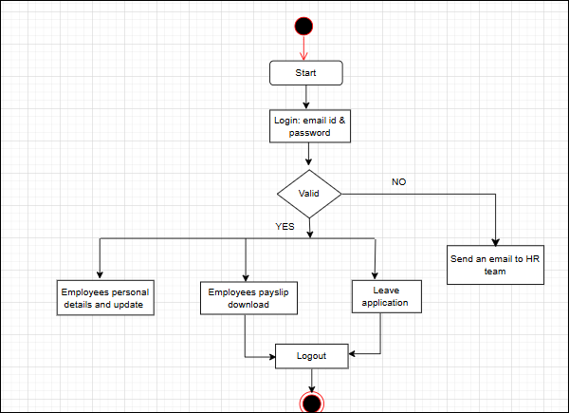

9Q Business requirement for an employee empower hub:

The Employee Empower Hub is a centralized digital platform aimed at streamlining and automating employee-centric HR operations including payroll management, attendance tracking, security access, and self-service capabilities. The goal is to empower employees with real-time access and control over their employment-related information while improving HR operational efficiency.
- Fostering a culture of trust and open communication:
Leaders must demonstrate trust in their employee’s abilities and decision making this means delegating responsibility and authority, and avoiding micro management. The employee empower hub should encourage open and honest communication between employees and management, creating a safe space for feedback and dialogue. The organization should cultivate a supportive and inclusive culture that values diversity, encourages innovation, and promotes psychological safety.

- Providing clear expectation and goals: Employees need clear, meaningful, well- defined goals to understand what is expected of them and how their work contributes to the overall business strategy.

- Facilitating professional growth:

- The employee empower hub should offer training, mentoring, and coaching programs to help employees enhance their skills and knowledge.
- The organization should be providing clear career paths and opportunities for advancement, allowing employees to grow professionally within the company.

- Ensuring access to necessary resources and support:
- Employees need access to the tools, information and resources required to perform their jobs effectively.
- Employees should have access to resources and support when they encounter challenges or need assistance with problem solving.

- Promoting team work and collaboration:
- The employee empower hub should encourage collaboration and team work among employees and across teams.
- Employees should feel a sense of shared success and ownership of team and organizational goals.

- Recognizing and appreciating contributions:
- The employee empower hub should facilitate regular recognition and appreciation of employee’s achievements and contributions.
- An implement a system for rewarding and incentivizing employees for their performance and contributions

