1. Please make a BRD which can be presented to the client along with complete development and resource plan.
Answer :-

Inventory and delivery platform
BRD09784
Version 1.0
Chetan Kapre

1. Document Revision: -
Date | Version No. | Document changes
04-04-2025 | 1.0 | -----------
07-05-2025 | 2.0 | -----------
10-06-2025 | 3.0 | -----------

2.Approvals
Role | Name | Title | Signature | Date
Project sponsor | Vikas Khanna
Business Owner | Rohit Nagpal
Project Manager | Chetan Kapre
System Architect | Mohit Jain
Development lead | Pankaj Shri Mali
User Experience Lead | Kunal Deshmukh
Quality Lead | Ankita Deodhar
Content Lead | Sonali

3. Stakeholder Identification / RACI Matrix :-
Phase/Task | Project Sponsor | Project Manager | Business Analyst | Designer | Database Architect | Developer | Tester | End User/  Client
Requirement Gathering & Analysis | * | A | R | C | C | C |  | I
Documentation | * | A | R | C | C | C |  | I
Design | * | A | C | R | R | S |  | I
Development |  | A |  | S | S | R |  | I
Testing |  | A |  |  |  | S | R | C
Deployment | * | A |  |  |  | S | S | C
Post-Implementation Review | * | A | R |  |  |  |  | C

4. Introduction
4.1 Business Goals: -
The goal is to streamline inventory management and enable faster, more efficient deliveries of perishable dairy products. This will reduce wastage, improve supply chain visibility, and enhance customer satisfaction. The system will support operational scalability and data-driven decision-making.
4.2 Business Objectives: -
Efficiently manage inventory across all manufacturing plants and warehouses by tracking stock levels, product expiry, and movement in real time.
Optimize order fulfillment and delivery by identifying the nearest warehouse with available stock and using intelligent routing to ensure the quickest possible delivery to customers.
Reduce operational losses by minimizing product wastage due to expiry and inefficient inventory turnover.
Provide actionable insights through dashboards and reports to support strategic decision-making and improve supply chain performance.
Enhance customer satisfaction by ensuring timely, accurate deliveries and consistent product availability.
4.3 Business Rules: -
- Stock Expiry Management:
All perishable items must follow a FIFO (First-In, First-Out) approach to reduce spoilage.
- Minimum Stock Threshold:
If inventory at any warehouse or plant falls below the defined reorder level, the system must trigger an automatic restocking alert.
- Order Fulfillment:
Customer orders must be fulfilled from the nearest warehouse with sufficient stock to ensure timely delivery.
- Product Validation:
Products must be registered in the system with batch number, manufacturing date, and expiry date before being available for dispatch.
- Delivery Assignment:
Delivery vehicles should be assigned based on route optimization and capacity availability.
- Access Control:
Only authorized users with assigned roles (e.g., Warehouse Manager, Delivery Agent) can access or update specific modules.
- Temperature-Sensitive Handling:
Certain products (like ice cream) can only be assigned to cold-chain enabled vehicles.
- Delivery SLA Monitoring:
Orders must be delivered within the defined SLA (Service Level Agreement), e.g., 24 hours for urban areas, 48 hours for remote areas.
- Legal Compliance Check:
All food safety regulations and labeling standards must be followed before dispatch.
- Audit Trail:
All stock movements, order updates, and delivery actions must be logged and auditable.
4.4 Background: -
The client is a well-established manufacturer of ice cream and dairy products with a network of manufacturing plants and warehouses across the country. With a growing customer base and increasing demand for faster deliveries, the current manual and semi-automated systems have become inefficient in handling real-time inventory updates, tracking product expiries, and ensuring timely order fulfillment.
Frequent issues such as stockouts, delivery delays, and wastage due to expired goods have impacted both operational costs and customer satisfaction. Additionally, the absence of an integrated platform has made it difficult for the management to make data-driven decisions and gain visibility into supply chain performance.
To address these challenges, the company has decided to implement a centralized Inventory and Delivery Management System that will automate core supply chain processes, optimize resource utilization, and enhance delivery efficiency—ultimately supporting business growth and customer retention.
4.5 Project objective
- Stock Expiry Management:
All perishable items must follow a FIFO (First-In, First-Out) approach to reduce spoilage.
- Minimum Stock Threshold:
If inventory at any warehouse or plant falls below the defined reorder level, the system must trigger an automatic restocking alert.
- Order Fulfillment:
Customer orders must be fulfilled from the nearest warehouse with sufficient stock to ensure timely delivery.
- Product Validation:
Products must be registered in the system with batch number, manufacturing date, and expiry date before being available for dispatch.
- Delivery Assignment:
Delivery vehicles should be assigned based on route optimization and capacity availability.
- Access Control:
Only authorized users with assigned roles (e.g., Warehouse Manager, Delivery Agent) can access or update specific modules.
- Temperature-Sensitive Handling:
Certain products (like ice cream) can only be assigned to cold-chain enabled vehicles.
- Delivery SLA Monitoring:
Orders must be delivered within the defined SLA (Service Level Agreement), e.g., 24 hours for urban areas, 48 hours for remote areas.
- Legal Compliance Check:
All food safety regulations and labeling standards must be followed before dispatch.
- Audit Trail:
All stock movements, order updates, and delivery actions must be logged and auditable.

Success Criteria
1. Accurate Inventory Tracking:
Inventory accuracy of ≥ 98% across all warehouses and manufacturing plants.
2. Reduced Product Wastage:
Reduction of ≥ 20% in expired or unsold products within the first 6 months post-implementation.
3. Faster Delivery Times:
95% of customer orders delivered within the defined Service Level Agreement (SLA) (e.g., 24–48 hours based on location).
4. System Uptime and Performance:
Minimum 99.9% system availability, with fast response times for all key functions.
5. User Adoption and Satisfaction:
100% onboarding of operational users across all locations within 4 weeks of go-live, with at least 85% positive user feedback.
6. Actionable Reporting:
Real-time dashboards and scheduled reports must be available for stock levels, deliveries, and wastage with zero manual consolidation.
4.6 Project Scope
4.6.1 In Scope Functionality
Inventory Management
- Real-time tracking of stock across warehouses and manufacturing plants.
- Product registration with batch number, quantity, expiry date, and location.
- FIFO (First-In, First-Out) stock allocation for perishable goods.
- Stock replenishment alerts when inventory falls below threshold.
Order Management
- Capture and process customer orders.
- Automatic assignment of orders to the nearest warehouse with available stock.
- Order tracking status: Pending, Packed, Dispatched, Delivered.
Warehouse Operations
- Inbound and outbound stock management.
- Goods receiving, inspection, and stock adjustments.
- Expiry and damaged product tracking.
Delivery Management
- Route optimization using GPS/Maps API to ensure fastest delivery.
- Assignment of delivery vehicles and drivers based on availability and location.
- Real-time delivery tracking and confirmation.
User and Role Management
- Role-based access for Admin, Warehouse Manager, Delivery Agent, and Client Viewers.
- Secure login and permission control for each user type.
Reports and Dashboards
- Inventory movement and stock level reports.
- Delivery performance metrics and SLA compliance.
- Product expiry and wastage summaries.
Notifications and Alerts
- Automated alerts for low stock, expiring products, and delayed deliveries.
- SMS/Email notifications for delivery updates.
System Integration
- Integration with third-party APIs (e.g., Google Maps for routing).
- Optional integration with existing ERP or accounting systems in future phases.

4.6.2. Out of Scope Functionality :-
Manufacturing Process Automation
- The system will not manage or automate production line activities like formulation, mixing, packaging, or machine operations.
Financial and Accounting Modules
- Features like invoicing, payments, taxation (GST), and full accounting integration are not included in this phase.
Customer-Facing eCommerce Platform
- The system will not include a customer portal or mobile app for end customers to place orders directly.
Cold Chain Monitoring Sensors
- While cold-chain vehicles are assumed to be available, the system will not track live temperature or integrate with IoT-based temperature sensors.
Third-Party Logistics (3PL) Integration
- Direct integration with third-party logistics service providers (like Delhivery, BlueDart) is excluded in the current scope.
Advanced AI/ML Forecasting
- Predictive analytics, demand forecasting, and auto-replenishment based on machine learning are excluded from this phase.
Multi-language or Internationalization Support
- The system will support only English in its current version.
HR & Payroll Integration
- Employee attendance, payroll, or shift scheduling are not part of this system.
5. Assumptions: -
Stable Internet Connectivity
- All warehouses, plants, and delivery points will have reliable internet access for system functionality and GPS-based services.
Trained Operational Staff
- Warehouse staff, delivery agents, and supervisors will be trained to use the new system before go-live.
Availability of Digital Devices
- Users (warehouse managers, delivery staff) will have access to smartphones or computers to access the web or mobile system.
GPS-Enabled Delivery Vehicles
- Delivery vehicles used for dispatch are GPS-enabled for route optimization and live tracking.
Standardized Product Data
- All SKUs (stock-keeping units) will be registered with clear attributes such as batch number, expiry, and quantity.
Single Country Deployment
- The system is designed for operations within a single country and does not support international logistics or tax structures in this phase.
Cold Chain Infrastructure Exists
- The company already has a cold chain (chillers, refrigerated trucks) and this infrastructure is outside the project scope.
Third-Party APIs Are Available
- Required external APIs (e.g., Google Maps) will be accessible and licensed appropriately.
Client Will Approve Deliverables Promptly
- Client stakeholders will provide timely feedback, approvals, and access to subject matter experts to avoid delays.
Security & Hosting Budget Provided
- Budget for secure cloud hosting, SSL, backups, and access control is approved and provisioned.
6. Constraints: -
Limited Project Timeline
- The project must be delivered within a 12-week timeline, which restricts the inclusion of complex features like AI forecasting or 3rd-party logistics integration.
Budget Limitations
- Development must stay within the allocated budget, limiting customization, premium third-party tools, or additional resources.
Fixed Infrastructure
- The system must work with the client’s existing warehouse and cold chain infrastructure, which cannot be modified within the scope.
Technology Stack Finalized
- The development must adhere to a predefined technology stack (e.g., React, Node.js, PostgreSQL) for compatibility and cost-efficiency.
Single Language Interface
- The application will be developed only in English, with no support for multi-language or localization in this phase.
Data Migration Scope is Limited
- Historical data from previous inventory systems will be migrated only if it meets formatting and compatibility standards.
Mobile App Is Optional
- A full-featured mobile app is not a mandatory part of this phase and may be deferred to Phase 2 based on time and budget.
External Dependency on APIs
- Route optimization and delivery tracking rely on external APIs (e.g., Google Maps), whose availability and service limits may impact performance.
Regulatory Compliance Responsibility
- Ensuring compliance with food safety and transport regulations remains the client's responsibility; the system only supports the process.
7. Risks: -
Risk ID | Description | Impact | Likelihood | Mitigation Strategy
R1 | Delay in stakeholder approvals or feedback | High | Medium | Establish clear approval timelines and regular follow-ups.
R2 | Resistance to adopt the new system by warehouse or delivery staff | Medium | High | Conduct early training, involve users in UAT, and provide job aids.
R3 | Downtime or rate-limit issues with third-party APIs (e.g., Google Maps) | High | Low | Ensure API limits are monitored; include fallback routing logic.
R4 | Data entry errors during inventory or order operations | Medium | Medium | Implement form validations, user prompts, and logging mechanisms.
R5 | GPS/device failure or delivery vehicle unavailability | Medium | Medium | Maintain a backup fleet; enable manual delivery entry and tracking.
R6 | Budget overrun due to uncontrolled scope changes | High | Medium | Freeze scope early; track all change requests through formal process.
R7 | Server downtime or critical data loss | High | Low | Use cloud-based hosting with automated backups and disaster recovery.
R8 | System non-compliance with food or transport regulations | High | Low | Involve legal/compliance teams in early reviews and system testing.

8. Business Process Overview
8.1 Legacy System (AS-IS Process) : -
Inventory Management
- Stock updates are maintained manually using Excel or paper registers at each warehouse/plant.
- No centralized visibility of inventory across multiple locations.
- Expiry tracking is done manually, often resulting in product wastage or missed alerts.
Order Management
- Orders from customers are received through phone calls, emails, or WhatsApp, and logged manually.
- Order fulfillment is delayed due to time spent checking availability at different warehouses.
- No automated system to select the nearest warehouse, leading to longer delivery times.
Warehouse Operations
- Inbound and outbound stock entries are managed through local spreadsheets.
- Lack of a standardized system for stock adjustments, damaged goods, or returns.
- Inventory reconciliation is done monthly, increasing errors and delays.
Delivery Process
- Delivery planning is manual — often based on driver familiarity or manager judgment.
- No real-time route optimization or vehicle tracking.
- Deliveries may be delayed or duplicated, especially during peak demand.
Reporting & Visibility
- Reports are manually compiled and may not reflect real-time data.
- Senior management lacks accurate insight into stock levels, product movement, or delivery performance.
8.2 Proposed Recommendations (TO-BE Process ) :-
1. Inventory Management
- All stock data is updated in real time across warehouses and manufacturing units via a centralized system.
- Inventory is automatically tracked by batch, expiry date, and quantity.
- System generates low-stock and expiry alerts to avoid wastage.
- FIFO (First-In, First-Out) logic ensures proper stock consumption.
2. Order Management
- Customer orders are logged digitally through a centralized order management module.
- System automatically assigns the nearest warehouse with available stock for faster fulfillment.
- Order status is tracked live — from creation to delivery confirmation.
3. Warehouse Operations
- Goods received, issued, returned, or adjusted are recorded in real time.
- Barcode or QR scanning can be used for accuracy (optional enhancement).
- Inventory reconciliation becomes automated and continuous.
4. Delivery Process
- Orders are routed through the shortest and fastest path using integrated GPS/Maps APIs.
- Delivery agents are assigned automatically based on proximity and load.
- Customers and managers can track deliveries in real-time.
- Proof of delivery is captured digitally.
5. Reporting & Visibility
- Dashboards provide live updates on stock levels, order statuses, delivery performance, and wastage.
- Management can access custom reports to make data-driven decisions.
- All transactions are auditable, ensuring transparency and accountability.
9. Business requirements:
Functional requirement:
1. User Management
- FR1.1: The system shall allow user registration and role assignment (e.g., Admin, Warehouse Manager, Delivery Agent).
- FR1.2: The system shall support secure user login with password protection.
- FR1.3: The system shall restrict module access based on user roles and permissions.
- FR1.4: The system shall log all user activities for auditing purposes.
2. Product & Inventory Management
- FR2.1: The system shall allow product creation with attributes like name, SKU, batch number, expiry date, and quantity.
- FR2.2: The system shall track real-time inventory at each warehouse and plant.
- FR2.3: The system shall apply FIFO logic during stock allocation and delivery.
- FR2.4: The system shall trigger alerts when inventory falls below the minimum threshold.
- FR2.5: The system shall automatically flag items that are near expiry.
- FR2.6: The system shall support stock adjustment entries (e.g., damaged goods, excess stock).
3. Order Management
- FR3.1: The system shall allow entry and management of customer orders.
- FR3.2: The system shall automatically assign an order to the nearest warehouse with available stock.
- FR3.3: The system shall allow order status tracking: Pending, Packed, Dispatched, Delivered.
- FR3.4: The system shall allow cancellation or modification of an order before dispatch.
4. Warehouse Operations
- FR4.1: The system shall support inbound entry of goods received at warehouses.
- FR4.2: The system shall support outbound entry for dispatched goods.
- FR4.3: The system shall allow movement of stock between locations with appropriate documentation.
- FR4.4: The system shall maintain an audit trail for all stock movements and adjustments.
5. Delivery Management
- FR5.1: The system shall assign delivery tasks to drivers based on location and availability.
- FR5.2: The system shall integrate with Google Maps (or similar) to optimize delivery routes.
- FR5.3: The system shall track delivery vehicle location in real time.
- FR5.4: The system shall capture proof of delivery via e-signature, OTP, or photo upload.
- FR5.5: The system shall update delivery status: En Route, Delivered, Failed Attempt.
6. Notification & Alert System
- FR6.1: The system shall send alerts for low stock, nearing expiry, and delivery delays via email or SMS.
- FR6.2: The system shall notify delivery personnel when a delivery task is assigned.
- FR6.3: The system shall send order confirmation and dispatch updates to the customer or client stakeholder.
7. Reports & Dashboards
- FR7.1: The system shall generate inventory reports showing current stock, movement, and expiry.
- FR7.2: The system shall generate delivery reports including status, delays, and average time.
- FR7.3: The system shall support graphical dashboards with KPIs (e.g., stock turnover, SLA compliance).
- FR7.4: The system shall allow export of reports in PDF and Excel formats.
8. Integration
- FR8.1: The system shall integrate with third-party GPS/Maps APIs for delivery routing.
- FR8.2: The system shall be capable of integrating with external ERP or CRM systems in future phases via REST APIs.
Non-Functional requirement: -
1. Performance
- NFR1.1: The system shall support at least 500 concurrent users without degradation in performance.
- NFR1.2: The system shall respond to any user action within 3 seconds under normal load.
2. Availability & Reliability
- NFR2.1: The system shall have a minimum uptime of 99.9%, excluding scheduled maintenance.
- NFR2.2: The system shall include automatic backup mechanisms at least once every 12 hours.
- NFR2.3: The system shall support disaster recovery with a maximum Recovery Time Objective (RTO) of 4 hours.
3. Scalability
- NFR3.1: The system shall be scalable to support additional warehouses, users, and delivery zones without major architectural changes.
- NFR3.2: The system should allow for easy addition of new features/modules in future phases.
4. Security
- NFR4.1: The system shall support role-based access control to ensure that users access only relevant modules.
- NFR4.2: All user data and transactions shall be transmitted over SSL-encrypted channels (HTTPS).
- NFR4.3: The system shall lock out users after 5 unsuccessful login attempts to prevent brute-force attacks.
5. Usability
- NFR5.1: The system shall have a user-friendly, responsive UI accessible via desktops, tablets, and smartphones.
- NFR5.2: System interfaces shall be designed in accordance with UX best practices to ensure ease of use.
6. Maintainability
- NFR6.1: The system shall be modular and allow updates or bug fixes with minimal impact to the live environment.
- NFR6.2: Logs and error reports shall be easily accessible to system administrators for troubleshooting.
7. Compliance
- NFR7.1: The system shall comply with relevant data privacy and food safety standards applicable in the operating region (e.g., FSSAI, ISO 22000).
- NFR7.2: All user and transaction logs shall be maintained for a minimum of 1 year for audit purposes.

9.3 Requirement Traceability Matrix
9.4 Links to Key Reference Material:-

9.5 Example Requirements by Priority
10.1. List of Acronyms

Que 2. Prepare process flow diagram using your imagination.

Ans :- 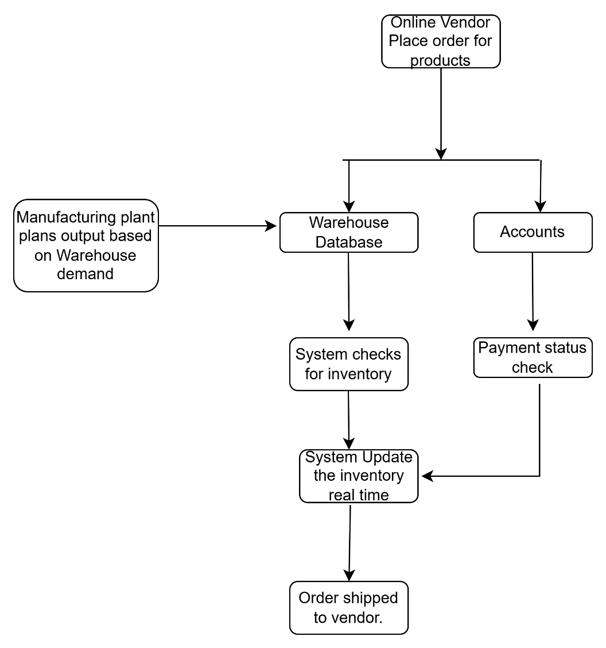

Assignment 2
Que1. Write an introduction letter to a client introducing yourself as a business analyst in charge of working with the client and his team to start the business understanding process.
Ans :-
Dear Sir,
My name is Chetan Kapre and I am the Business Analyst from [Company Name] who has been assigned to the [Warehousing software]project. I am writing to formally introduce myself and to initiate our collaboration. I am very much looking forward to working with you and your team.
My primary role is to act as a bridge between your business experts and our project team. To ensure the solution we develop perfectly aligns with your vision and requirements, my first step is to lead the business understanding process. This involves working closely with you to develop a deep and shared understanding of your business operations, objectives, challenges, and the specific goals you aim to achieve with this project.
To begin this process, I would like to schedule an initial discovery meeting with you and any key members of your team you deem essential for this phase. The purpose of this session will be to discuss your business at a high level, understand the project's background, and outline a plan for our subsequent information-gathering sessions.
Please let me know what days and times work best for you next week for a 60-minute meeting. I am also happy to work around your team's availability.
Thank you for the opportunity to be a part of this project. I am confident that by working together, we can achieve outstanding results.
Best regards,
Chetan Kapre BA

Que2. Prepare a brief BRD and SRS for a project- Ticketing system
Ans : -
Business Requirements Document (BRD): Help Desk Ticketing System
1. Introduction
1.1. Project Overview: This project aims to implement a Help Desk Ticketing System to streamline the process of logging, tracking, and resolving internal and external support requests. This system will replace the current manual process of tracking requests via email and spreadsheets, which is inefficient and prone to errors.
1.2. Business Goals and Objectives:
  - Improve the efficiency of the support team by 30% within the first six months.
  - Increase customer satisfaction by providing a transparent and timely resolution process.
  - Reduce the average time to resolve a support ticket by 40%.
  - Provide a centralized repository for all support requests to enable better reporting and analysis.
1.3. Project Scope:
  - In-Scope:
    - Automated ticket creation from email and a web portal.
    - Ticket assignment and routing to appropriate support agents.
    - A knowledge base for common issues and their resolutions.
    - Reporting and analytics on key performance indicators (KPIs) such as ticket volume, resolution time, and agent performance.
    - Integration with the company's existing email system.
  - Out-of-Scope:
    - Live chat functionality.
    - Integration with third-party social media platforms.
    - Asset management capabilities.
2. Stakeholder :-
Stakeholder Role | Name | Responsibilities
Project Sponsor | Vikash singh | Provides project funding and overall direction.
Head of IT | Vinod D | Ensures the system aligns with IT infrastructure and strategy.
Support Team Manager | Priyanka J | Represents the primary users and ensures their needs are met.
End-Users | All Employees & External Customers | Will use the system to submit and track support requests.

3. High-Level Requirements
3.1. Functional Requirements:
- The system must allow users to create a support ticket via a web portal and email.
- The system shall automatically assign a unique ID to each ticket.
- Support agents must be able to view, update, and close tickets assigned to them.
- The system should send automated email notifications to users and agents upon ticket creation, update, and closure.
- A searchable knowledge base of articles must be available to all users.
3.2. Reporting Requirements:
- The system must generate reports on the number of tickets created, resolved, and pending.
- Dashboards should display key metrics in real-time.
3.3. Security and Access Control:
- Different user roles (e.g., Administrator, Support Agent, End-User) with varying levels of access and permissions must be configurable.

- Software Requirements Specification (SRS): Help Desk Ticketing System
- 1. Introduction
1.1. Purpose: This document provides a detailed description of the functional and non-functional requirements for the Help Desk Ticketing System. It is intended for the development team, QA team, and project managers.
1.2. Scope: This SRS covers the features and functionalities of the Help Desk Ticketing System as defined in the BRD, including ticket creation, management, user roles, reporting, and knowledge base.
1.3. Definitions, Acronyms, and Abbreviations:
- BRD: Business Requirements Document
- SRS: Software Requirements Specification
- KPI: Key Performance Indicator
- GUI: Graphical User Interface
2. Overall Description
2.1. Product Perspective: The Help Desk Ticketing System will be a standalone web-based application. It will interface with the company's SMTP server for email notifications.
2.2. User Personas:
- Administrator: Responsible for configuring the system, managing user accounts, and defining business rules.
- Support Agent: Responsible for resolving support tickets assigned to them.
- End-User (Internal/External): Submits and tracks their support requests.
2.3. Product Features:
- Ticket Creation and Management
- User and Role Management
- Knowledge Base Management
- Reporting and Analytics Dashboard
- Email Notifications
- 3. Specific Requirements
3.1. Functional Requirements:
- FR-001: User Registration and Login: Users shall be able to register for an account. All users must log in with a unique username and password.
- FR-002: Ticket Creation: End-users shall be able to create a new ticket by filling out a web form with fields for subject, description, priority (Low, Medium, High), and attachments.
- FR-003: Email-to-Ticket Conversion: The system shall automatically create a ticket when an email is sent to a designated support email address.
- FR-004: Ticket Assignment: The system shall allow administrators to set up rules for automatic ticket assignment to support agents based on category or priority. Manual assignment shall also be possible.
- FR-005: Ticket Updates and Communication: Support agents and end-users shall be able to add comments and attachments to a ticket.
- FR-006: Knowledge Base: Administrators and support agents shall be able to create, edit, and publish articles in the knowledge base. End-users shall be able to search and view these articles.
3.2. Non-Functional Requirements:
- NFR-001: Performance: The system shall load any page within 3 seconds. The system must support at least 100 concurrent users without performance degradation.
- NFR-002: Security: All user passwords must be encrypted. The system must be protected against common web vulnerabilities such as SQL injection and cross-site scripting (XSS).
- NFR-003: Usability: The user interface shall be intuitive and easy to navigate. The system shall be accessible through modern web browsers (Chrome, Firefox, Safari, Edge).
- NFR-004: Reliability: The system shall have an uptime of 99.5%.
3.3. Interface Requirements:
- 3.3.1. User Interface (UI): The GUI shall be clean, modern, and responsive, providing a consistent look and feel across all pages.
- 3.3.2. Software Interfaces: Email: The system will use SMTP to send outgoing email notifications. It will use POP3/IMAP to fetch emails for ticket creation.
3.4. System Attributes:
- The system shall be scalable to accommodate future growth in the number of users and tickets.
- The system shall be maintainable, with well-documented code and a modular architecture.

Que 3 .Make an ERD of creating a support ticket/Ticketing life cycle.

Ans :-
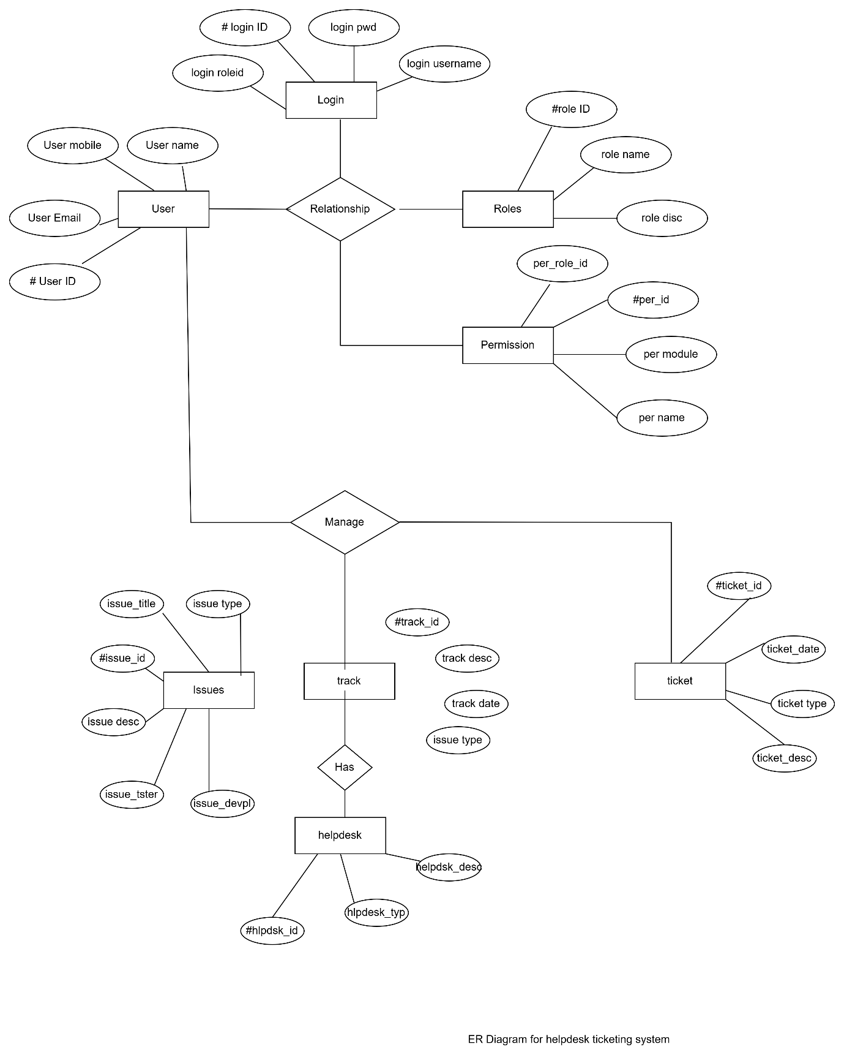

Que. 4 User story of shopping from ecommerce.
SPRINT 1
USER STORY- 1 | TASK 2 | PRIORITY : HIGHEST
As a shopper, I want to browse products by category so that I can easily find items that interest me.
BV - 100 | CP - 1
ACCEPTANCE CRITERIA:-Category list is displayed
User can select a category
Products related to the category are shown
SPRINT-1
USER STORY- 2 | TASK 2 | PRIORITY : HIGHEST
As a shopper, I want to search for products by name or keyword so that I can quickly locate specific items.
BV - 100 | CP - 1
ACCEPTANCE CRITERIA:-Search bar is available
User can enter keywords
Relevant products are displayed
SPRINT-1
USER STORY- 3 | TASK 2 | PRIORITY : HIGHEST
As a shopper, I want to filter products by price, brand, and rating so that I can narrow down my options.
BV - 50 | CP - 1
ACCEPTANCE CRITERIA:-Filter options for price, brand, and rating are available ,Selected filters update product list
SPRINT-1
USER STORY- 4 | TASK 2 | PRIORITY : HIGHEST
As a shopper, I want to sort products by price, popularity, or new arrivals so that I can view items in my preferred order.
BV - 100 | CP - 2
ACCEPTANCE CRITERIA:-Sorting options are available
Selected sort updates product list
SPRINT-1
USER STORY- 5 | TASK 2 | PRIORITY : HIGHEST
As a shopper, I want to view detailed product descriptions so that I can make informed purchase decisions
BV - 100 | CP - 3
ACCEPTANCE CRITERIA:-Product details page shows description, specs, and features
SPRINT-1
USER STORY- 6 | TASK 2 | PRIORITY : HIGHEST
As a shopper, I want to see multiple high-quality images of a product so that I can examine it from different angles
BV - 50 | CP - 3
ACCEPTANCE CRITERIA:-Product page displays image gallery
User can view images in larger size
SPRINT-1
USER STORY- 7 | TASK 2 | PRIORITY : HIGHEST
As a shopper, I want to read customer reviews and ratings so that I can understand other buyers’ experiences.
BV - 20 | CP - 6
ACCEPTANCE CRITERIA:-Product page displays reviews and ratings , Reviews are sorted by date or helpfulness
SPRINT-1
USER STORY- 8 | TASK 2 | PRIORITY : HIGHEST
As a shopper, I want to add products to my shopping cart so that I can purchase multiple items in one order.
BV - 100 | CP - 2
ACCEPTANCE CRITERIA:Add to cart button is present,
Cart updates with selected items
SPRINT-1
USER STORY- 9 | TASK 2 | PRIORITY : HIGHEST
As a shopper, I want to view and edit my shopping cart so that I can review and modify my selections before checkout.
BV - 50 | CP - 2
ACCEPTANCE CRITERIA:-Cart page lists all items,
User can update quantity or remove items
SPRINT-1
USER STORY- 10 | TASK 2 | PRIORITY : HIGHEST
As a shopper, I want to update the quantity of items in my cart so that I can buy the exact amount I need.
BV - 100 | CP - 2
ACCEPTANCE CRITERIA:-Quantity selector is available
Cart total updates accordingly
SPRINT-1
USER STORY- 11 | TASK 2 | PRIORITY : HIGHEST
As a shopper, I want to remove items from my cart so that I can change my mind before purchasing.
BV - 100 | CP - 6
ACCEPTANCE CRITERIA:-Remove option is present for each cart item , Cart updates after removal
SPRINT-1
USER STORY- 12 | TASK 2 | PRIORITY : HIGHEST
As a shopper, I want to save products to a wishlist so that I can easily find and buy them later
BV - 20 | CP - 3
ACCEPTANCE CRITERIA:Wishlist button on product page,
Wishlist page displays saved items
SPRINT-1
USER STORY- 13 | TASK 2 | PRIORITY : HIGHEST
As a shopper, I want to apply discount codes or coupons so that I can save money on my purchase.
BV - 100 | CP - 2
ACCEPTANCE CRITERIA:Coupon field at checkout
Discount applied to total if code is valid
SPRINT-1
USER STORY- 14 | TASK 2 | PRIORITY : HIGHEST
As a shopper, I want to see estimated delivery dates so that I know when to expect my order.
BV - 200 | CP - 6
ACCEPTANCE CRITERIA:Estimated delivery shown on product and checkout pages
SPRINT-1
USER STORY- 15 | TASK 2 | PRIORITY : HIGHEST
As a shopper, I want to choose from multiple payment options so that I can pay in the way that suits me best.
BV - 100 | CP - 3
ACCEPTANCE CRITERIA:Payment page lists all supported methods , User can select and use any method
SPRINT-1
USER STORY- 16 | TASK 2 | PRIORITY : HIGHEST
As a shopper, I want to securely save my payment information so that I can check out faster next time.
BV - 50 | CP - 3
ACCEPTANCE CRITERIA:Option to save payment details
Data is securely stored and encrypted
SPRINT-1
USER STORY- 17 | TASK 2 | PRIORITY : HIGHEST
As a shopper, I want to enter and save multiple shipping addresses so that I can ship to different locations.
BV - 100 | CP - 2
ACCEPTANCE CRITERIA:Address book in user profile
Option to add/edit/delete addresses
SPRINT-1
USER STORY- 18 | TASK 2 | PRIORITY : HIGHEST
As a shopper, I want to receive email or SMS notifications about my order so that I stay updated on its status
BV - 100 | CP - 3
ACCEPTANCE CRITERIA:Notifications sent on order, shipping, and delivery
SPRINT-1
USER STORY- 19 | TASK 2 | PRIORITY : HIGHEST
As a shopper, I want to view my order history so that I can reorder or reference previous purchases
BV - 50 | CP - 3
ACCEPTANCE CRITERIA:Order history page in account
Details of each past order
SPRINT-1
USER STORY- 20 | TASK 2 | PRIORITY : HIGHEST
As a shopper, I want to cancel an order before it ships so that I can change my mind.
BV - 20 | CP - 2
ACCEPTANCE CRITERIA:Cancel option available until dispatch, Order status updates after cancellation
SPRINT-1
USER STORY- 21 | TASK 2 | PRIORITY : HIGHEST
As a shopper, I want to initiate a return or exchange so that I can resolve issues with my purchase.
BV - 100 | CP - 3
ACCEPTANCE CRITERIA:Return/exchange option for eligible orders , Confirmation and instructions provided
SPRINT-1
USER STORY- 22 | TASK 2 | PRIORITY : HIGHEST
As a shopper, I want to receive a refund to my original payment method so that I am compensated for returned items
BV - 200 | CP - 6
ACCEPTANCE CRITERIA:Refund processed after return approval Status visible in order history
SPRINT-1
USER STORY- 23 | TASK 2 | PRIORITY : HIGHEST
As a shopper, I want to share product links with friends or family so that I can get their opinions or recommend items.
BV - 100 | CP - 1
ACCEPTANCE CRITERIA:Share button on product pages ,
Options for social media and messaging
SPRINT-1
USER STORY- 24 | TASK 2 | PRIORITY : HIGHEST
As a shopper, I want to subscribe to newsletters so that I can receive updates on new arrivals and special offers
BV - 50 | CP - 1
ACCEPTANCE CRITERIA:Newsletter signup form Confirmation email sent
SPRINT-1
USER STORY- 25 | TASK 2 | PRIORITY : HIGHEST
As a shopper, I want to buy gift cards so that I can give them to others as presents
BV - 20 | CP - 3
ACCEPTANCE CRITERIA:Gift card product available, Customizable value and message
SPRINT-1
USER STORY- 26 | TASK 2 | PRIORITY : HIGHEST
As a shopper, I want to redeem gift cards during checkout so that I can use them for purchases
BV - 50 | CP - 3
ACCEPTANCE CRITERIA:Gift card field at checkout, Balance applied to order total
SPRINT-1
USER STORY- 27 | TASK 2 | PRIORITY : HIGHEST
(As a shopper, I want to view detailed size charts for apparel and shoes so that I can choose the correct size
BV - 50 | CP - 3
ACCEPTANCE CRITERIA:Size chart link on product pages
Chart matches product type
SPRINT-1
USER STORY- 28 | TASK 2 | PRIORITY : HIGHEST
As a shopper, I want to see related products or frequently bought together items so that I can find complementary products.
BV - 100 | CP - 6
ACCEPTANCE CRITERIA: Related items displayed on product page
SPRINT-1
USER STORY- 29 | TASK 2 | PRIORITY : HIGHEST
As a shopper, I want to check product availability in my location so that I can avoid ordering out-of-stock items
BV - 50 | CP - 2
ACCEPTANCE CRITERIA: Availability check by pincode or location , Out-of-stock notice shown
SPRINT-1
USER STORY- 30 | TASK 2 | PRIORITY : HIGHEST
As a shopper, I want to schedule my delivery date and time so that I can receive my order when it’s convenient for me
BV - 50 | CP - 2
ACCEPTANCE CRITERIA: Delivery slot selection at checkout
Confirmation of chosen slot
SPRINT-1
USER STORY- 31 | TASK 2 | PRIORITY : HIGHEST
As a shopper, I want to receive invoices and payment receipts so that I have proof of purchase.
BV - 100 | CP - 2
ACCEPTANCE CRITERIA: Invoice sent via email and downloadable from order history
SPRINT-1
USER STORY- 32 | TASK 2 | PRIORITY : HIGHEST
As a shopper, I want to receive invoices and payment receipts so that I have proof of purchase.
BV - 100 | CP - 3
ACCEPTANCE CRITERIA: Review form available for purchased items, Ratings and comments saved
SPRINT-1
USER STORY- 33 | TASK 2 | PRIORITY : HIGHEST
As a shopper, I want to use a mobile-friendly website or app so that I can shop easily from my phone.
BV - 100 | CP - 2
ACCEPTANCE CRITERIA: Responsive design for all pages, App available for download
SPRINT-1
USER STORY- 34 | TASK 2 | PRIORITY : HIGHEST
As a shopper, I want to receive alerts for price drops on wishlist items so that I can buy them at the best price.
BV - 50 | CP - 3
ACCEPTANCE CRITERIA: Notification sent when wishlist item price decreases
SPRINT-1
USER STORY- 35 | TASK 2 | PRIORITY : HIGHEST
As a shopper, I want to view and update my account details so that my information is always accurate.
BV - 100 | CP - 2
ACCEPTANCE CRITERIA: Profile page for viewing and editing user info
SPRINT-1
USER STORY- 36 | TASK 2 | PRIORITY : HIGHEST
As a shopper, I want to shop in my preferred language and currency so that I have a comfortable shopping experience.
BV - 50 | CP - 5
ACCEPTANCE CRITERIA: Option to select language and currency , All pages and prices update accordingly

SPRINT-1
USER STORY- 37 | TASK 2 | PRIORITY : HIGHEST
As a shopper, I want to receive email or SMS notifications about my order so that I stay updated on its status
BV - 50 | CP - 2
ACCEPTANCE CRITERIA: Notifications sent on order, shipping, and delivery
SPRINT-1
USER STORY- 38 | TASK 2 | PRIORITY : HIGHEST
As a shopper, I want to contact customer support so that I can get help with my orders or products.
BV - 100 | CP - 1
ACCEPTANCE CRITERIA: Support contact options visible , Ticket or chat system available
SPRINT-1
USER STORY- 39 | TASK 2 | PRIORITY : HIGHEST
As a shopper, I want to share product links with friends or family so that I can get their opinions or recommend items.
BV - 50 | CP - 2
ACCEPTANCE CRITERIA: Share button on product pages, Options for social media and messaging
SPRINT-1
USER STORY- 40 | TASK 2 | PRIORITY : HIGHEST
As a shopper, I want to Save my payment method securely so that I have a fast but and secure payment experience.
BV - 20 | CP - 1
ACCEPTANCE CRITERIA: Option to select language and currency , All pages and prices update accordingly

