Question 1 – Write Agile Manifesto
Four main Values Individuals and interactions over processes and tools
Working software over comprehensive documentation
Customer collaboration over contract negotiation
Responding to change over following a plan
Twelve Principles of Agile Software
1. Satisfy the customer through early and continuous delivery of valuable software.
2. Welcome changing requirements, even late in development. Agile processes harness change for the customer's competitive advantage.
3. Deliver working software frequently, from a couple of weeks to a couple of months, with a preference to the shorter timescale.
4. Business people and developers must work together daily throughout the project.
5. Build projects around motivated individuals. Give them the environment and support they need and trust them to get the job done.
6. The most efficient and effective method of conveying information to and within a development team is face-to-face conversation.
7. Working software is the primary measure of progress.
8. Agile processes promote sustainable development. The sponsors, developers, and users should be able to maintain a constant pace indefinitely.
9. Continuous attention to technical excellence and good design enhances agility.
10. Simplicity the art of maximizing the amount of work not done is essential.
11. The best architectures, requirements, and designs emerge from self-organizing teams.
12. At regular intervals, the team reflects on how to become more effective, then tunes and adjusts its behaviour accordingly.

Question 2 – User Stories- Acceptance Criteria-BV-CP –
User Story No: 1 | Tasks: 2 |  | Priority: HIGHEST
AS A DELIVERY BOY
I WANT TO REGISTER IN SCRUM FOODS
SO THAT I CAN DELIVER ORDERS
BV: 500 |  | CP: 02
ACCEPTANCE CRITERIA
Registration Screen
Text Boxes for User Name, Password, Nation ID, Mobile No, Email, Address,
Phone Number.
Click on Register Button.
Send Successful Notification to the user

User Story No: 2 | Tasks: 2 |  | Priority: HIGHEST
AS A RESTAURANT OWNER
I WANT TO VIEW ORDERS
SO THAT I CAN VIEW THE LIST OF ORDERS
BV: 500 |  | CP: 02
ACCEPTANCE CRITERIA
View Order, Display List of orders in the tabular Form

User Story No: 3 | Tasks: 2 |  | Priority: HIGHEST
AS A CUSTOMER
I WANT TO ADD THE ADDRESS
SO THAT I CAN GET THE ORDER TO MY ADDRESS
BV: 500 |  | CP: 02
ACCEPTANCE CRITERIA
Text Box to enter.
Business Rules: Within the radius of 5 km

User Story No: 4 | Tasks: 2 |  | Priority: HIGHEST
AS A CUSTOMER
I WANT TO SELECT THE PAYMENT MODE
SO THAT I CAN MAKE PAYMENT OF MY CHOICE
BV: 500 |  | CP: 03
ACCEPTANCE CRITERIA
Display payment modes, radio buttons to select payment modes, payments button.
Business Rule. Can select only one payment mode

User Story No: 13 | Tasks: 2 |  | Priority: HIGHEST
AS A CUSTOMER
I WANT TO TRACK MY ORDER
SO THAT I CAN KNOW DELIVERY TIME
BV: 500 |  | CP: 08
ACCEPTANCE CRITERIA
Order Status should be visible
Estimated delivery time should be visible
Live map tracking option should be available
Live map tracking should show current location of delivery person if order is delayed time should be updated.

User Story No: 14 | Tasks: 2 |  | Priority: MEDIUM
AS A CUSTOMER
I WANT TO WRITE REVIEW FOR MY ORDER
SO THAT RESTRAUNT CAN GET FEEDBACK
BV: 100 |  | CP: 03
ACCEPTANCE CRITERIA
Display a review option after delivery is completed.
Display a text box to write a review.
Post review button at the bottom

User Story No: 15 | Tasks: 2 |  | Priority: MEDIUM
AS A DEVLVERY BOY
I WANT TO TRACK THE LOCATION OF CUSTOMER
SO THAT I CAN DELIVERY THE ORDER
BV: 500 |  | CP: 05
ACCEPTANCE CRITERIA
Display estimate time required to deliver the order using current location of delivery boy
Live map tracking option should be available
Live map should show delivery address of customer

User Story No: 16 | Tasks: 2 |  | Priority: LOW
AS A ADMIN
I WANT TO SEE THE NUMBER OF RESTAURANT REGISTERED
SO THAT I CAN PERPARE A REPORT
BV: 50 |  | CP: 02
ACCEPTANCE CRITERIA
Login to admin dashboard using registered mail id
Button for Registrations and Restaurant
User Story No: 17 | Tasks: 2 |  | Priority: MEDIUM
AS A ADMIN
I WANT TO SEE THE TOTAL SALE OF MONTH
SO THAT I CAN TRACK BUSINESS PERFORMANCE
BV: 100 |  | CP: 13
ACCEPTANCE CRITERIA
Login to admin dashboard using registered mail id, dashboard should display sales option. Admin should be able to select the year, month, day from dropdown calendar and sales graph should be displayed.

User Story No: 18 | Tasks: 2 |  | Priority: HIGH
AS A DELIVERY PARTNER
I WANT TO SEE THE ORDERED DISHES
SO THAT I CAN PERPARE ORDER
BV: 500 |  | CP: 5
ACCEPTANCE CRITERIA
Login with registered mail id
Recent order tab should be visible in which the list of order should be visible with the quantity and special note if any.

User Story No: 19 | Tasks: 2 |  | Priority: MEDIUM
AS A DELIVERY PARTNER
I WANT TO SEE THE TOTAL SALE OF THE YEAR
SO THAT I CAN PERPARE ORDER
BV: 100 |  | CP: 5
ACCEPTANCE CRITERIA
Login with registered mail id, dashboard should display the total sales option which should show the sale of the year in graphical representation

User Story No: 20 | Tasks: 2 |  | Priority: HIGH
AS A CUSTOMER
I WANT TO ADD SPECIAL NOTE
SO THAT I CAN GET CUSTOMIZE MY ORDER AS PER MY PREFERENCES.
BV: 100 |  | CP: 2
ACCEPTANCE CRITERIA
There should be a text-box available to add special note of about order with limit of 200 words.

User Story No: 21 | Tasks: 2 |  | Priority: HIGH
AS A DELIVERY PERSON
I WANT TO KNOW IF CUSTOMER HAS CANCELLED ORDER
SO THAT I WON’T PROCEED THE DELIVERY IF I AM ON MY WAY.
BV: 500 |  | CP: 5
ACCEPTANCECRITERIA
There should be a notification to “STOP: This order has been cancelled” delivery boys if his trip has already started
Notification bell should have particular sound

User Story No: 22 | Tasks: 2 |  | Priority: HIGH
AS A CUSTOMER
I WANT TO CANCEL ORDER
SO THAT I CAN AVAOID UNWANTED DELIVERY
BV: 500 |  | CP: 3
ACCEPTANCECRITERIA
Customer should be able to cancel the order from the “My Orders” or “Track Order” screen before it reaches the "Out for Delivery" stage.
On clicking "Cancel", customer should be asked to select a reason after cancellation notification should be should be sent to vendor & delivery person immediately.

User Story No: 23 | Tasks: 2 |  | Priority: HIGH
AS A DEVLVERY BOY
I WANT TO RAISE ISSUE
SO THAT I CAN SEE THE DELIVERY LOCATION
BV: 100 |  | CP: 3
ACCEPTANCECRITERIA
Delivery boy’s dashboard should have Raise issue button so that he can raise issue and contact the Restaurants and Customer if there’s any problem.
User Story No: 24 | Tasks: 2 |  | Priority: HIGH
AS A RESTAURANTS
I WANT TO DO DELIVERY BOY VERIFICATION
SO THAT I CAN HANDOVER THE DELIVERY
BV: 500 |  | CP: 8
ACCEPTAN CECRITERIA
4-digit Verification code should be sent on delivery boy’s dashboard so that restaurant can fill the OTP and hand over the parcel to delivery boy, If the OTP is wrong error message should appear “Wrong OTP/ Try again” else screen should get green showing text “OTP Verified”

User Story No: 25 | Tasks: 2 |  | Priority: LOW
AS A DELIVERY BOY
I WANT TO VIEW FEEDBACK
SO THAT I CAN UNDERSTAND HOW CUSTOMERS FEEL ABOUT MY SERVICE AND IMPROVE MY PERFORMANCE.
BV: 50 |  | CP: 2
ACCEPTAN CECRITERIA
Delivery boy should be able to view feedback and rating left by the customer for each completed delivery. Feedback should include Customer’s star rating (1 to 5) Optional comment (if provided) Order ID and delivery date/time

User Story No: 26 | Tasks: 2 |  | Priority: HIGH
AS A REGIONAL ADMIN
I WANT TO VIEW REGIONAL REVENUE
SO THAT I CAN TRACK THE BUSINESS PERFORMACE
BV: 500 |  | CP: 8
ACCEPTAN CECRITERIA
Login with registered mail id the dashboard should show Track regional revenue and should represent the graphical view with the calendar where user should be able to select date, month and year

User Story No: 27 | Tasks: 2 |  | Priority: HIGH
AS A ADMIN
I WANT TO VIEW REGIONAL ADMIN
SO THAT I CAN MANAGE REGIONAL ADMIN
BV: 500 |  | CP: 5
ACCEPTAN CECRITERIA
Login with registered mail id the dashboard should show the tab of regional admins when clicked on it list of regional admins should appear on screen. User should be able to edit names, add phone number, block, add, delete and see the manage regional admin option

User Story No: 28 | Tasks: 2 |  | Priority: HIGH
AS A REGIONAL ADMIN
I WANT TO ISSUES BUSINESS AGREEMENTS & DOCUMENTS TO RESTAURANT OWNERS
SO THAT I CAN INCREASE THE BUSINESS AND CUSTOMERS
BV: 1000 |  | CP: 8
ACCEPTAN CECRITERIA
Login with registered id after that Documents tab should appear where the list of documents should be visible and regional admin can check with which Restaurant he/she has signed the agreements and should be able to view the documents

User Story No: 29 | Tasks: 2 |  | Priority: HIGH
AS A CUSTOMER
I WANT TO SEE THE MENUE OF RESTAURANT
SO THAT I CAN ORDER THE FOOD I WANT
BV: 1000 |  | CP: 5
ACCEPTAN CECRITERIA
Login with registered id the customer should be able to search for particular Restaurant with search bar and see the menu of Restaurant. Button should be visible to select the menu and for placing order.

User Story No: 30 | Tasks: 2 |  | Priority: HIGH
AS A REGIONAL ADMIN
I WANT TO SEE THE STATUS OF OERDER
SO THAT I CAN MONITOR DELIVERY PROGRESS AND TAKE ACTION IN CASE OF DELAYS OR ISSUES.
BV: 500 |  | CP: 5
ACCEPTAN CECRITERIA
Regional Admin should be able to view a list of all active orders in their assigned region. Each order should show order id, customer name, restaurant name, delivery boy name and current status

User Story No: 31 | Tasks: 2 |  | Priority: HIGH
AS THE BUSINESS OWNER
I WANT TO APPROVE PAYMENTS FOR RESTAURANTS AND DELIVERY BOYS
SO THAT THEY RECEIVE TIMELY COMPENSATION.
BV: 500 |  | CP: 5
ACCEPTAN CECRITERIA
Payment dashboard lists pending payouts with amount and due date.
Owner can click “Approve” after verifying totals.
Once approved, payment status updates to “Processing”.
Option to download payment report for accounting.

User Story No: 32 | Tasks: 2 |  | Priority: HIGH
AS A REGIONAL ADMIN
I WANT TO TRACK COMPLAINTS RAISED IN MY AREA
SO THAT I CAN RESOLVE THEM PROMPTLY.
BV: 500 |  | CP: 5
ACCEPTAN CECRITERIA
Complaints are categorized by type (Delivery, Food Quality, App Issue).
Each complaint shows status (Open, In Progress, Closed).
Admin can assign issues to relevant team or escalate to central admin.
Resolution and response must be logged in the system.

User Story No: 33 | Tasks: 2 |  | Priority: MEDIUM
AS A RESTAURANT
I WANT TO UPDATE MY MENU ITEMS
SO THAT CUSTOMERS SEE CORRECT AVAILABILITY.
BV: 500 |  | CP: 5
ACCEPTAN CECRITERIA
Restaurant can mark items as “Available” or “Out of Stock”.
Prices can be edited for individual items. Changes must reflect immediately in the customer app.
Any edited item must go through admin approval

User Story No: 34 | Tasks: 2 |  | Priority: HIGH
AS A RESTAURANT
I WANT TO ACCEPT OR REJECT INCOMING ORDERS
SO THAT I CAN MANAGE KITCHEN LOAD EFFICIENTLY.
BV: 100 |  | CP: 5
ACCEPTAN CECRITERIA
Incoming orders appear with a timer
Restaurant can click “Accept” or “Reject” with reason.
If rejected, customer is notified immediately and payment is reversed.
Accepted orders are added to the "Preparing"

User Story No: 35 | Tasks: 2 |  | Priority: MEDIUM
AS A DELIVERY BOY
I WANT TO UPDATE DELIVERY STATUS
SO THAT THE SYSTEM KNOWS WHERE I AM IN THE PROCESS.
BV: 100 |  | CP: 2
ACCEPTAN CECRITERIA
The app should provide buttons for status: “Picked Up”, “Out for Delivery”, “Delivered”.
Once status is updated, customer and restaurant should get notified. Status history should be saved with timestamps. Status cannot be changed once marked “Delivered”.

User Story No: 36 | Tasks: 2 |  | Priority: MEDIUM
AS A CUSTOMER
I WANT TO APPLY A COUPON CODE
SO THAT I CAN GET A DISCOUNT ON MY ORDER.
BV: 50 |  | CP: 2
ACCEPTAN CECRITERIA
Valid coupons should reduce the bill as per rules (e.g., flat ₹50 off). Invalid coupons should show an error message.
Only 1 coupon should be applied per order. Discount amount should be clearly shown in the final price.

User Story No: 37 | Tasks: 2 |  | Priority: MEDIUM
AS A CUSTOMER
I WANT TO SEARCH FOR RESTAURANTS NEAR ME
SO THAT I CAN FIND FOOD OPTIONS QUICKLY.
BV: 500 |  | CP: 5
ACCEPTAN CECRITERIA
Customer can enter their location or allow GPS.
System displays restaurants within a defined radius. Search bar should support name, cuisine, or dish type. Closed restaurants should appear greyed out or filtered.

User Story No: 38 | Tasks: 2 |  | Priority: LOW
AS A CUSTOMER
I WANT TO VIEW MY PAST ORDERS
SO THAT I CAN REORDER EASILY.
BV: 100 |  | CP: 2
ACCEPTAN CECRITERIA
Past orders show item details, price, restaurant, and date.
“Reorder” button should auto-fill the cart with previous items.
System should notify if any item is unavailable or price changed.
Only delivered/cancelled orders should appear in history

User Story No: 39 | Tasks: 2 |  | Priority: MEDIUM
AS A DELIVERY BOY
I WANT TO VIEW MY EARNINGS SUMMARY
SO THAT I CAN TRACK MY DAILY INCOME.
BV: 100 |  | CP: 5
ACCEPTAN CECRITERIA
Daily, weekly, and monthly earnings breakdown.
Includes order payments, tips (if any), and bonuses. Shows pending payouts and payout dates. Summary is exportable as PDF or viewable in-app.

User Story No: 40 | Tasks: 2 |  | Priority: MEDIUM
AS A RESTAURANT
I WANT TO SET MY WORKING HOURS
SO THAT I DON’T RECEIVE ORDERS DURING CLOSING TIME.
BV: 500 |  | CP: 2
ACCEPTAN CECRITERIA
Restaurant can set open and close times for each day.
During closed hours, restaurant appears as “Unavailable” in customer app.
Admin is notified of changes for approval. Customers cannot place orders outside working hours.

Epics
Question 3– What is epic? Write 2 epics
Epic 1: Cancel Order & Refund
As a user, I want to cancel my order so that I don’t get any unwanted delivery.
As a user, I want to receive a refund after cancelling my order so that I don’t lose my money.
Acceptance criteria:
- User can cancel their order from “My orders” or “Track order”.
- The system allows cancellation before the order reached the “Out of delivery” status.
- In case the order is already out of delivery the Cancel order button is disabled and pop-up notification should appear on screen “Order cannot be cancelled after dispatch”.
- Upon cancellation user are prompted to select reason for order cancellation.
- A confirmation screen appears and asks for confirmation and status changes to “order cancelled”.
- System automatically initiates the refund if payment was already done.
- Refund amount and estimated time are clearly displayed to users.
- Customer also receives a notification about order cancelation and refund.
- Cancelled orders shown in user history with clear label “Cancelled”.

Epic 2: Order History & Reorder
As a user I want to track my order history so that I can easily view my past orders and reorder or refer them when needed.

Acceptance criteria:
- User should be able to access a “My Orders” or “Order History” section from the main menu.
- Each past order should display:
Restaurant name, ordered items, Date & time, Total amount paid and Order status
- The order history should be sorted by most recent first by default.
- User should be able to click on any past order to see full details.
- There should be a “Reorder” button that automatically adds the same items to the cart
- User can filter past orders by status (Delivered, Cancelled) or date range.
- If any item is unavailable while reordering, the app should notify the user with a suggestion to edit.

Question 4 –What is the difference between BV and CP
Business Value (BV) determines how important is a particular feature for project, what is its impact on project. It is determined by MoSCoW and Currency note techniques.
Complexity Point (CP) determines how hard, how difficult, what efforts are required to build certain feature. It is determined by Planning poker techniques.

Question 5 –Explain about Sprint–
Sprint is short, fixed-length time period usually 2-4weeks during which a scrum team work on a specific task or feature and delivery the working product in increments. It has fixed start date and fixed end date which cannot be extended. Every Sprint begins with a Sprint Goal – a clear, concise objective that the team aims to achieve by the end of the Sprint. This is the meeting that starts the Sprint. The team selects items from the Product Backlog to work on and creates a Sprint Backlog. A short 15-minute meeting held every day during the Sprint. Each team member answers- What did I do yesterday? What will I do today? Are there any blockers? During the Sprint, developers build the features and testers perform continuous testing. QA and development often work together. At the end of the Sprint, the team produces a working product increment this allows Early feedback from stakeholder, Reduced risk, Fast reaction to changes. Internal team meeting to reflect on- What went well? What didn’t? What can be improved in the next Sprint? A regular activity during the Sprint where the Product Owner and team: Clarify and prioritize backlog items, break large tasks into smaller stories, estimate effort (Story Points), Prepare items for the next Sprint

Question 6 – Explain Product backlog and sprint back log–
Product backlog is the list of all features, enhancements, bug fixes, and technical work needed for entire project. It is maintained by Product Owner. It keeps changing, items are added, removed and reprioritise according to business needs. It contains everything that team might work on in future Sprints.
Sprint Backlog is the subset of Product backlog. It is smaller list of items select from Product backlog that team commits to complete during one sprint. It is created during sprint planning, it is owned by development team, it cannot be changed during sprint, it breaks each selected item into detailed tasks

Question 7 – What is impediments log? write 2 impediments –
Impediments log is a document in Scrum and Agile used to track record and manage any obstacles that prevents scrum team from making progress during Sprints. Impediments could be any like technical issue, unclear requirements, team conflicts or external dependencies, Scrum master is responsible for maintaining the impediments log and ensure that each issue is resolved quickly.

Log Id | 1
Description
  Delivery boy is not able to track the customer's location accurately
Impact
  Delayed or failed deliveries; poor customer experience
Priority | High
Assigned to | Maps Integration Team
Status | In progress
Action taken | checking Google Maps API configuration; collecting device logs
Resolution | Finding alternate geolocation method if this fails.

Log Id | 2
Description | Customer not receiving refund after order cancellation, even after 7 days.
Impact | Loss of customer trust, increase in complaints, and risk of negative reviews.
Priority | High
Assigned to | Finance Integration Team / Backend Developer
Status | In progress
Action taken | Verified failed transactions, escalated to payment gateway provider
Resolution | Pending- working on retry mechanism and alert system for failed refunds

Question 8 – Explain Velocity of the Team
Velocity refers to amount of work development team can complete during the sprint.
The calculation of velocity is determined by the development team itself. It helps in forecasting how much work the team can handle in future sprints
- Here we have 40 User stories. Out of 40 let’s assume 32 are of them are completed.
- So, we have to count Complexity Point (CP) of each completed user story.
- Here we are adding the completed Complexity point
2+2+2+3+8+3+5+2+13+5+5+2+5+3+3+8+2+8+5+8+5+5+5+5+5+5+2+2+5+2+5+2=142
- So, our total completed CP is 142.
- Velocity = Completed CP ÷ Number of Sprints
- 142/40= 3.55 ≈ 3-4 Story point per Sprint
Question 9 – Draw Sprint Burn Charts and Product Burn Down Charts
Burn Up report-
A sprint burn-up chart visually represents a sprint's progress by tracking the amount of work completed over time, compared against the total scope of the sprint
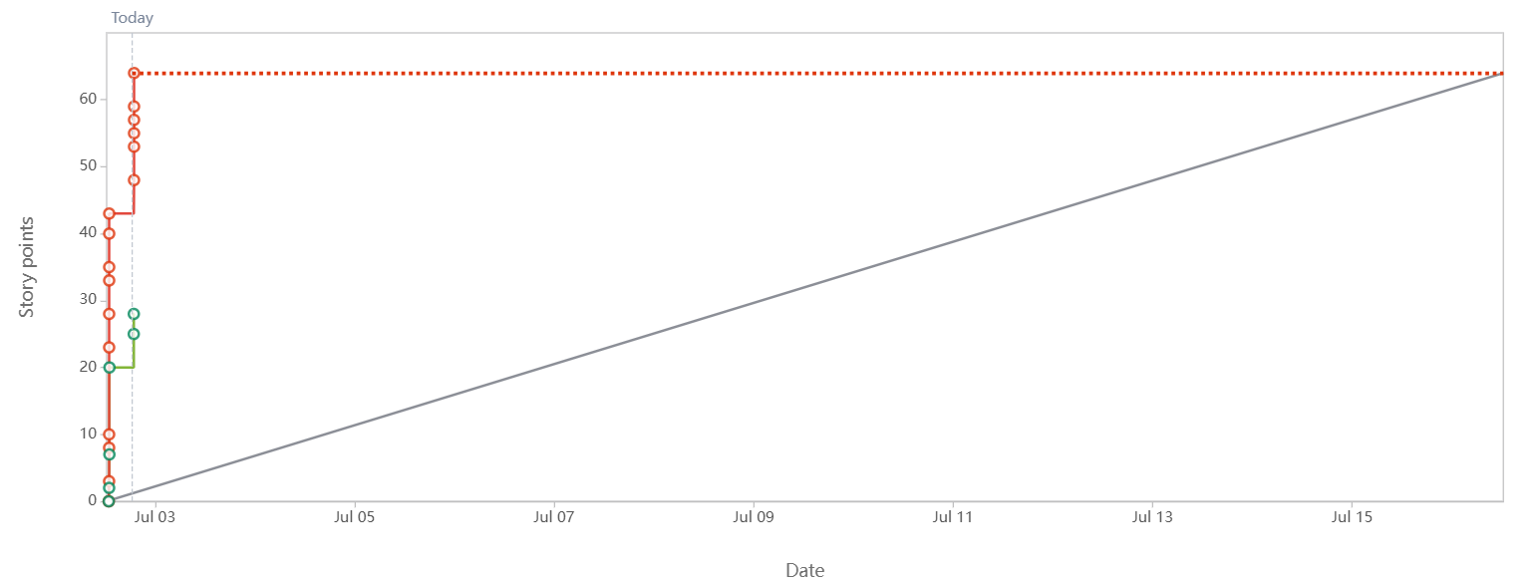
Sprint burn down chart-
A sprint burndown chart visually represents the amount of work remaining in a sprint against the time elapsed
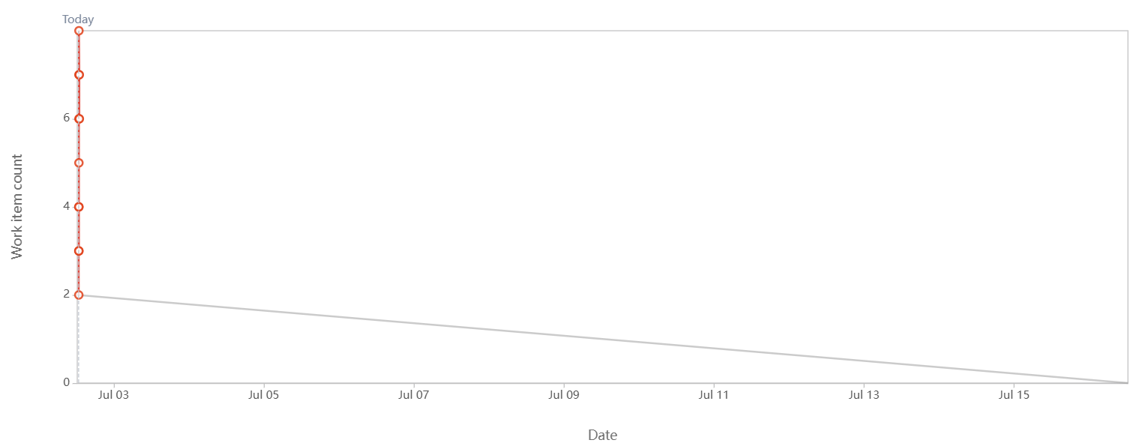

Question 10 – Explain about Product Grooming
Product grooming is also known as backlog grooming or backlog refinement.
It is an important activity in Agile software development that involves review, update, and prioritize items in product backlog to keep it clean, clear and ready for upcoming sprint. It involves Product Owner, Business Analyst, and the Scrum Team and other relevant stake holders.
Reviews existing backlog items
Clarifies the requirements
Breaks down large Epics into smaller user stories
Adds or updates Acceptance Criteria
Estimates story points using techniques like Planning Poker
Prioritizes items based on Business Value (BV)
Removes outdated or irrelevant items

Question 11 – Explain the roles of Scrum Master and Product Owner –
The Scrum Master is responsible for ensuring that the Scrum process is followed correctly by the team. They act as a leader, helping the team work effectively and removing any impediments that may slow progress.
Key responsibility
Facilitate Scrum ceremonies: Sprint Planning, Daily Stand-ups, Sprint Review, Retrospective
Remove impediments faced by the team
Coach the team on Agile/Scrum principles
Protect the team from outside distractions
Ensure a healthy team environment and collaboration

The Product Owner is responsible for defining the product vision, managing the Product Backlog, and ensuring that the team is always working on the most valuable tasks for the business.
Key responsibility
Define and prioritize user stories in the Product Backlog
Write clear acceptance criteria
Communicate with stakeholders and customers
Ensure the team delivers value to the business
Make decisions on scope and priority
Question 12 – Explain all Meetings Conducted in Scrum Project –
Sprint planning- This meeting is scheduled at the beginning of each sprint.
Purpose of this meeting is what work will be done in sprint and how it will be done.
The product owner shares the prioritised product backlog items, and the development team collaborates to select the item on which they will work next. Team sets the Sprint Goal and user stories are broken into tasks and estimated.
Daily Scrum (Daily stand up)-This is the short meeting which is conducted daily for 15 minutes, it involves the development team and each member shares their updates. Questions like What did you do yesterday? What will you do today? Are there any impediments in your way?
Sprint Review- It is conducted at the end of the sprint. Development team presents complete work done to the stakeholders, including product owner. Team demonstrates functionality or features implemented and gathers feedback.
Sprint Retrospective-It is conducted immediately after sprint review. It is conducted to discuss the improvements needed in team’s process. In this meeting it is discussed what went well in sprint, what need to be improvement, what didn’t go well?
Backlog Grooming- This meeting involves product owner and development team and focuses on reviewing, refining, estimating backlog items for upcoming sprints. It ensures that the backlog is well prepared and ready for implementation.

Question 13 – Explain Sprint Size and Scrum Size
Sprint size- The sprint size refers to the length or duration of sprint in scrum. A sprint is a time boxed period during which the development team works to deliver a potentially shippable product increment. The sprint size is determined during the project planning phase and typically ranges from one to four weeks. Most common duration of sprint is two weeks, but it can change according to project’s need, complexity, and team dynamics.
Scrum Team Size- It refers to number of individuals who collaborate together to deliver the product increment in scrum. The scrum team is self-organised and cross-functional, typically consisting of a product owner, scrum master and development team. The team size can vary depending on specific project requirements, complexity and organisation.

Question 14 – Explain DOR and DOD
In Scrum, the Definition of Ready (DOR) and Definition of Done (DOD) are important checklists that ensure quality and clarity during a Sprint.
The DOR refers to the criteria that a user story must meet before the team can pull it into a Sprint. This includes things like a clear user story, acceptance criteria, proper estimation, and all dependencies identified. A story that meets the DOR is considered well-prepared and ready to be worked on.
Definition of Done (DOD)
On the other hand, the DOD defines what it means for a story to be considered fully complete. This typically includes development, testing, code review, documentation, and deployment (if needed). While DOR helps the team start work with confidence, DOD ensures that they finish work to a consistent standard. Both are essential for delivering high-quality, predictable outcomes in Agile projects.

Question 15 – Explain Prioritization Techniques and MVP
In Agile projects, prioritization techniques help teams decide which features or user stories to build first, based on business value, urgency, and customer needs. One popular technique is the MoSCoW method, which stands for Must Have, Should Have, Could Have, and Won’t Have. “Must Have” features are essential for the product to work; “Should Have” features are important but not critical; “Could Have” features are optional; and “Won’t Have” are out of scope for the current release. This helps teams focus on what truly matters within a fixed timeline. Connected to this is the concept of MVP – Minimum Viable Product, which is the simplest version of a product that delivers value to users. An MVP includes only the core Must Have features necessary for early users to use and give feedback. It allows teams to test the product idea quickly and improve based on real-world usage, without building everything at once. Both MoSCoW and MVP are key tools for delivering value faster and smarter in Agile projects.
Question 16 – Difference between Business Analyst n Product Owner
Product Owner | Business Analyst
Owns the product vision & roadmap. | Focuses on detailed requirement analysis
Responsible for prioritizing the Product Backlog | Helps in writing and refining user stories
Makes final decisions on what features to build | Supports the PO by clarifying and detailing features
 | Acts as the bridge between business and technical teams
  Acts as the voice of the customer
Works directly with stakeholders and Scrum team | Works closely with PO, developers, testers, and stakeholders
Defines what to build and when | Defines how the feature should behave(functional details).
Typically, one per Scrum team | There can be one or more BAs supporting a PO
Drives product-level decisions | Drives requirement-level clarity
More focused on business value | More focused on process and documentation
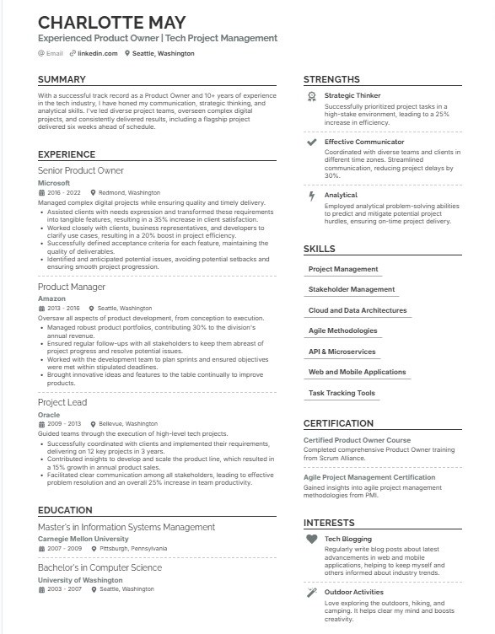
Question 17 – Prepare a sample Resume of 3yrs exp Product Owner

