QUESTION 1:
Functional Requirements
Functional Requirement ID | Description | Priority  (1-10)
FR1 | User registration and login functionality | 10
FR2 | Browse product catalog (seeds, fertilizers, etc.) | 9
FR3 | Product search using keyword or filters | 9
FR4 | Add product to cart or buy later list | 8
FR5 | Secure payment gateway integration | 10
FR6 | Order tracking system for farmers | 8
FR7 | Email notifications for order status | 7
FR8 | Manufacturers can upload product details | 9
FR9 | Delivery status update by manufacturer | 7
FR10 | Admin approval for product listings (optional) | 6

Non-functional Requirements

Non-Functional  Requirement ID | Description | Priority  (1-10)
NFR1 | Application must be mobile responsive | 10
NFR2 | System should support minimum 1000 concurrent users | 9
NFR3 | System uptime should be 99.5% or higher | 9
NFR4 | Payment processing time must be under 5 seconds | 8
NFR5 | Application should be secure with HTTPS & data encryption | 10
NFR6 | Easy-to-use interface for users in rural areas | 9
NFR7 | Email notifications must be delivered within 1 minute | 7
NFR8 | Search results should load within 2 seconds | 8
NFR9 | System should support both English and local languages | 6
NFR10 | Backup and recovery should happen daily | 7

QUESTION 2:
Wireframes
A wireframe is a basic visual layout that outlines the structure of a screen or page.
It shows the placement of elements like buttons, menus, images, and text — without colors or design.
Wireframes help plan user navigation and functionality early in the project.
They are usually low-fidelity and focus on "what goes where" rather than how it looks.
Wireframes act as the blueprint before moving to detailed designs or prototypes.
Screen  No. | Wireframe Page Name | Description
WF1 | Login / Register Page | Email, Password, Login, Register
WF2 | Home Page (Farmer) | Welcome banner, categories (seeds, fertilizers, etc.)
WF3 | Product Details Page | Product name, price, description, Add to Cart / Buy Later
WF4 | Cart & Payment Page | Cart items, total amount, payment options
WF5 | Track Order Page | Order history + live tracking for current orders

Wireframe 1: Login / Register Page

Wireframe 2: Home Page
Wireframe 3: Product Details Page
Wireframe 4: Cart & Payment Page
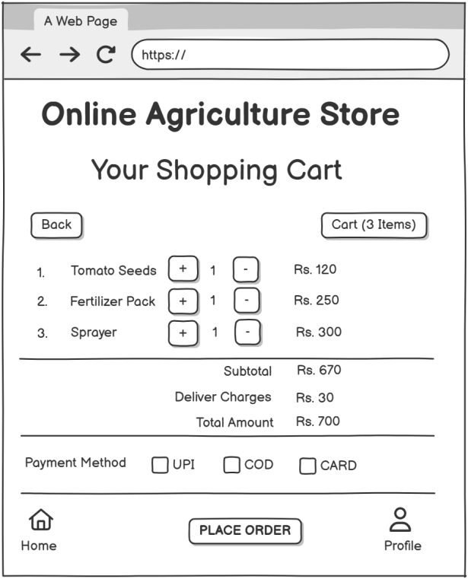
Wireframe 5: Order Confirmation Page
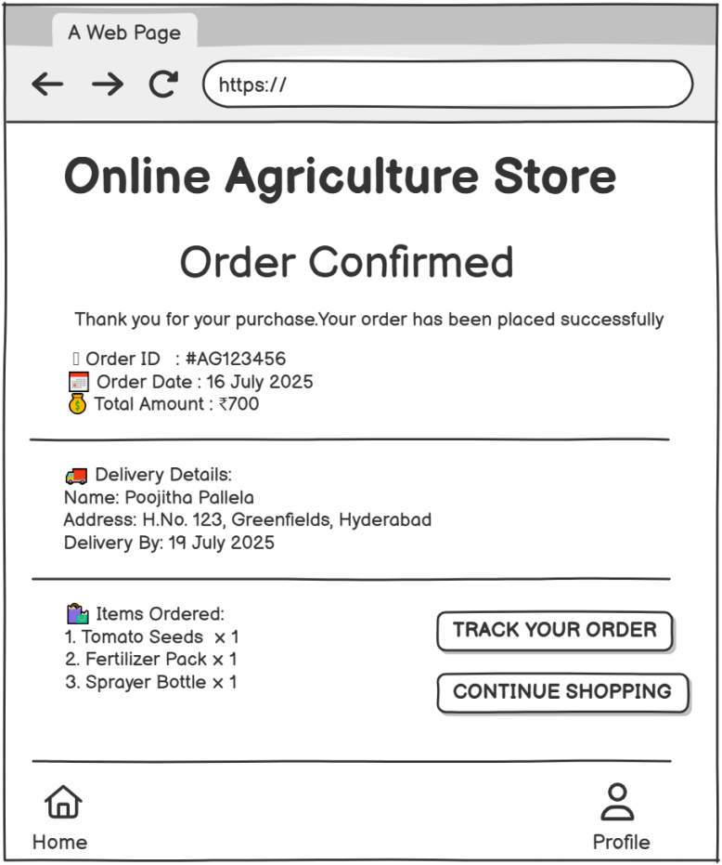

Prototypes
A prototype is a visual model that shows how an app or system will look and function. It helps stakeholders understand the design, layout, and user flow before development begins. Prototypes can be simple (static images) or interactive (clickable). They are used to gather feedback early and avoid costly changes later.
In projects, prototypes bridge the gap between business requirements and the final product.
Screen Name | UI Elements | User Actions
1. Login / Register | Mobile Number field | Enter credentials and tap Login
1. Login / Register | Password field | Tap Register Now → go to registration
1. Login / Register | Remember Me checkbox | Tap Forgot Password → reset screen
1. Login / Register | Forgot Password link
1. Login / Register | Login button
1. Login / Register | Register Now button
1. Login / Register | Social login options
2. Home/Dashboard | Search bar | Tap product → go to Product Details
2. Home/Dashboard | Category icons (Seeds, Fertilizers, Tools, More) | Tap Cart → go to Cart & Payment
2. Home/Dashboard | Featured products (with price and View button) | Tap Profile → open account
2. Home/Dashboard | Cart & Profile icons
3. Product Details | Product Image | Tap Add to Cart → goes to cart
3. Product Details | Name, Price, Description | Tap Buy Now → goes to payment
3. Product Details | Quantity Selector ([-] [+])
3. Product Details | Add to Cart button
3. Product Details | Buy Now button
4. Cart & Payment | List of items with quantity & price | Modify quantity
4. Cart & Payment | Subtotal, Delivery, Total | Select payment method
4. Cart & Payment | Payment method options (UPI, COD, Card) | Tap Place Order → go to Order Confirmation
4. Cart & Payment | Place Order button
5. Order Confirmation | Order ID, Date, Total | Tap Track Order → go to tracking
5. Order Confirmation | Delivery Address, ETA | Tap Continue Shopping → return to Home
5. Order Confirmation | Item Summary
5. Order Confirmation | Track Order & Continue Shopping buttons

Prototype 1: Login / Register Page

2. Home/Dashboard

3. Product Details

4. Cart & Payment

5. Order Confirmation

QUESTION 3:
Tools Used Each Concept
Concept | Tool / Method Used | Purpose
Text-Based Prototypes | Manual design using plain text layout | To easily visualize UI flow without graphics (ideal for planning in docs)
Wireframes | Paper sketch / MS Visio / Balsamiq / Figma (low-fi) | For low-fidelity wireframes showing screen layout before visual styling
High-Fidelity Prototypes (optional) | Figma / Adobe XD / Sketch / proto.io | For clickable or visual mockups with UI elements
Activity Diagrams | Lucidchart / MS Visio / Draw.io / Creately | To show process flow and user interaction with system components
Requirements Tables | Microsoft Excel / Google Sheets | For listing functional & non-functional requirements with priorities
Project Planning / Notes | Notion / MS Word / Google Docs | To document the capstone process, assumptions, goals, and test cases
Presentation / Report | MS PowerPoint / Canva / Google Slides | To present the final capstone solution professionally

QUESTION 4:

Showing how requirements link to use cases, design elements, and test cases
ID | Requirement Description | Type | Priority | Related  Use Case | Design Element | Test  Case ID
FR1 | User should be able to register/login | Functional | High | UC1 | Login/Register Page Wireframe | TC01
FR2 | User can browse product categories | Functional | High | UC2 | Home Page Wireframe | TC02
FR3 | View detailed product info | Functional | High | UC3 | Product Details Page | TC03
FR4 | Add product to cart | Functional | High | UC4 | Product Details & Cart Page | TC04
FR5 | Edit quantity and remove items from cart | Functional | Medium | UC5 | Cart Page | TC05
FR6 | Place an order using multiple payment modes | Functional | High | UC6 | Payment Section - Cart Page | TC06
FR7 | Confirm order and display details | Functional | High | UC7 | Order Confirmation Page | TC07
FR8 | Track order status | Functional | Medium | UC8 | Future Scope UI / Placeholder | TC08
NFR1 | App must load under 3 seconds | Non-Functional | High | All | N/A | TCN01
NFR2 | App must be mobile responsive | Non-Functional | High | All | All Pages | TCN02

RTM
Req ID | Req Name | Req Description | Design | T1 | T2 | T3 | T4 | UAT
FR1 | User Login/Register | User should be able to register/login | D1 | Complete | Complete | Complete | Complete | Planned
FR2 | Browse Categories | User can browse product categories | D2 | Complete | Complete | Complete | Complete | Planned
FR3 | View Product Details | View detailed product info | D3 | Complete | Complete | Complete | In Complete | Pending
FR4 | Add to Cart | Add product to cart | D4 | Complete | Complete | Complete | In Complete | Pending
FR5 | Edit/Remove Cart Items | Edit quantity and remove items from cart | D5 | Complete | Complete | Complete | In Complete | Pending
FR6 | Place Order | Place an order using multiple payment modes | D6 | Complete | Complete | Complete | In Complete | Pending
FR7 | Confirm Order | Confirm order and display details | D7 | Complete | Complete | Complete | In Complete | Pending
FR8 | Track Order | Track order status | D8 | Complete | Complete | In Complete | In Complete | Planned
NFR1 | Page Load Time | App must load under 3 seconds | D9 | Complete | Complete | In Complete | In Complete | Not Required
NFR2 | Mobile Responsiveness | App must be mobile responsive | D10 | Complete | In Complete | In Complete | In Complete | Pending

QUESTION 5:
Test Case Document 1
Test Case ID | TC_001 | Test Case Name | User Registration Functionality
Project ID | AGSTORE_2025 | Project Name | Online Agriculture Products Store
PM ID | PM_101 | PM Name | Varshini T
Test Strategy ID | TS_001 | Tester ID | TST_001
Test Plan ID | TP_001 | Tester Name | Priya Thoudishetty
Test Schedule ID | SCH_001 | Date of Test | 08-Aug-2025
Scenario | Verify that a new user can successfully register in the application
Link to the page | https://agstore.example.com/register
Input Data | Name: Ramesh Kumar  Mobile: 9876543210  Email: ramesh@gmail.com  Password: Ramesh@123
Expected Behavior | User should be registered successfully and redirected to the home page
Actual Behavior | User registered successfully and redirected to home page
Comments | Validation messages are shown correctly for invalid inputs
Result | Pass

Test Case Document 2
Test Case ID | TC_002 | Test Case Name | User Login with Email
Project ID | AGSTORE_2025 | Project Name | Online Agriculture Products Store
PM ID | PM_101 | PM Name | Varshini T
Test Strategy ID | TS_001 | Tester ID | TST_001
Test Plan ID | TP_001 | Tester Name | Priya Thoudishetty
Test Schedule ID | SCH_001 | Date of Test | 08-Aug-2025
Scenario | Verify that a user can successfully log in using email and password
Link to the page | https://agstore.example.com
Input Data | Email: ramesh@gmail.com  Password: Ramesh@123
Expected Behavior | User should be logged in and redirected to home/dashboard
Actual Behavior | User logged in successfully and redirected to dashboard
Comments | All validations and flows working as expected
Result | Pass

Test Case Document 3
Test Case ID | TC_003 | Test Case Name | Search Products
Project ID | AGSTORE_2025 | Project Name | Online Agriculture Products Store
PM ID | PM_101 | PM Name | Varshini T
Test Strategy ID | TS_001 | Tester ID | TST_001
Test Plan ID | TP_001 | Tester Name | Priya Thoudishetty
Test Schedule ID | SCH_001 | Date of Test | 08-Aug-2025
Scenario | Verify that a user can search for products using the search bar
Link to the page | https://agstore.example.com
Input Data | Search Term: Fertilizer
Expected Behavior | Relevant products should be displayed in search results
Actual Behavior | Relevant products displayed
Comments | All validations and flows working as expected
Result | Pass

Test Case Document 4
Test Case ID | TC_004 | Test Case Name | Browse Categories
Project ID | AGSTORE_2025 | Project Name | Online Agriculture Products Store
PM ID | PM_101 | PM Name | Varshini T
Test Strategy ID | TS_001 | Tester ID | TST_001
Test Plan ID | TP_001 | Tester Name | Priya Thoudishetty
Test Schedule ID | SCH_001 | Date of Test | 08-Aug-2025
Scenario | Verify that users can browse products by category
Link to the page | https://agstore.example.com
Input Data | Selected Category: Seeds
Expected Behavior | All seed-related products should be shown
Actual Behavior | Seed-related products displayed correctly
Comments | All validations and flows working as expected
Result | Pass

Test Case Document 5
Test Case ID | TC_005 | Test Case Name | View Product Details
Project ID | AGSTORE_2025 | Project Name | Online Agriculture Products Store
PM ID | PM_101 | PM Name | Varshini T
Test Strategy ID | TS_001 | Tester ID | TST_001
Test Plan ID | TP_001 | Tester Name | Priya Thoudishetty
Test Schedule ID | SCH_001 | Date of Test | 08-Aug-2025
Scenario | Verify that clicking on a product displays detailed information
Link to the page | https://agstore.example.com
Input Data | Product: Organic Fertilizer
Expected Behavior | Product details (name, price, description, image) should be shown
Actual Behavior | Product details shown as expected
Comments | All validations and flows working as expected
Result | Pass

Test Case Document 6
Test Case ID | TC_006 | Test Case Name | Add Product to Cart
Project ID | AGSTORE_2025 | Project Name | Online Agriculture Products Store
PM ID | PM_101 | PM Name | Varshini T
Test Strategy ID | TS_001 | Tester ID | TST_001
Test Plan ID | TP_001 | Tester Name | Priya Thoudishetty
Test Schedule ID | SCH_001 | Date of Test | 08-Aug-2025
Scenario | Verify that a user can add a product to the cart
Link to the page | https://agstore.example.com
Input Data | Product: Organic Fertilizer  Quantity: 2
Expected Behavior | Product should be added to cart with correct quantity
Actual Behavior | Product added to cart with quantity 2
Comments | All validations and flows working as expected
Result | Pass

Test Case Document 7
Test Case ID | TC_007 | Test Case Name | Edit Cart Quantity
Project ID | AGSTORE_2025 | Project Name | Online Agriculture Products Store
PM ID | PM_101 | PM Name | Varshini T
Test Strategy ID | TS_001 | Tester ID | TST_001
Test Plan ID | TP_001 | Tester Name | Priya Thoudishetty
Test Schedule ID | SCH_001 | Date of Test | 08-Aug-2025
Scenario | Verify that users can update the quantity of a product in the cart
Link to the page | https://agstore.example.com
Input Data | Cart Item: Organic Fertilizer  Change Quantity: 3
Expected Behavior | Cart should update the item quantity to 3
Actual Behavior | Cart updated successfully
Comments | All validations and flows working as expected
Result | Pass

Test Case Document 8
Test Case ID | TC_008 | Test Case Name | Place Order with UPI
Project ID | AGSTORE_2025 | Project Name | Online Agriculture Products Store
PM ID | PM_101 | PM Name | Varshini T
Test Strategy ID | TS_001 | Tester ID | TST_001
Test Plan ID | TP_001 | Tester Name | Priya Thoudishetty
Test Schedule ID | SCH_001 | Date of Test | 08-Aug-2025
Scenario | Verify that a user can place an order using UPI payment
Link to the page | https://agstore.example.com
Input Data | Cart Total: ₹800  Payment Method: UPI (user@upi)
Expected Behavior | Order should be placed and confirmation should be displayed
Actual Behavior | Order placed and confirmation message shown
Comments | All validations and flows working as expected
Result | Pass

Test Case Document 9
Test Case ID | TC_009 | Test Case Name | Order Confirmation Screen
Project ID | AGSTORE_2025 | Project Name | Online Agriculture Products Store
PM ID | PM_101 | PM Name | Varshini T
Test Strategy ID | TS_001 | Tester ID | TST_001
Test Plan ID | TP_001 | Tester Name | Priya Thoudishetty
Test Schedule ID | SCH_001 | Date of Test | 08-Aug-2025
Scenario | Verify that the order confirmation screen displays correct details
Link to the page | https://agstore.example.com
Input Data | Order ID: 12345678
Expected Behavior | Order details and delivery estimate should be displayed
Actual Behavior | Order confirmation displayed with delivery details
Comments | All validations and flows working as expected
Result | Pass

Test Case Document 10
Test Case ID | TC_010 | Test Case Name | Track Order Status
Project ID | AGSTORE_2025 | Project Name | Online Agriculture Products Store
PM ID | PM_101 | PM Name | Varshini T
Test Strategy ID | TS_001 | Tester ID | TST_001
Test Plan ID | TP_001 | Tester Name | Priya Thoudishetty
Test Schedule ID | SCH_001 | Date of Test | 08-Aug-2025
Scenario | Verify that users can track their order status
Link to the page | https://agstore.example.com
Input Data | Order ID: 12345678
Expected Behavior | Current order status (e.g., Packed, Shipped) should be shown
Actual Behavior | Order status displayed as 'Shipped'
Comments | All validations and flows working as expected
Result | Pass

QUESTION 6:
Database schema
Table | Field Name | Data Type | Description
Customer | Customer_id (PK) | INT | Unique User ID
Customer | First_name | VARCHAR(100) | First Name
Customer | Last_name | VARCHAR(100) | Last name
Customer | Email | VARCHAR(100) | Email id
Customer | Password | VARCHAR(100) | Encrypted password
Customer | Address | VARCHAR(100) | Farmer address
Customer | Phone_number | VARCHAR(100) | Contact number
Wishlist | Wishlist_id(PK) | INT | Wishlist id
Wishlist | product_id(FK) | INT | Unique Product ID
Wishlist | Customer_ID(PK),(FK) | INT | Customer id
Cart | cart_id(PK) | INT | Cart id
Cart | Quantity | INT | Quantity
Cart | Customer_id(PK) (FK) | INT | Customer id
Cart | Product_id(FK) | INT | Product id
Orders | order_id | INT | Unique order ID
Orders | order_date | DATETIME | Dast and time of order
Orders | total_amount | Decimal(10,2) | Order amount
Orders | Customer_ID(FK) | INT | Customer id
Orders | Payment_id(FK) | INT | Payment reference id
Orders | Shippment_id(FK) | INT | Shipment id
Shippment | Shippment_id(PK) | INT | UPI / COD / Card
Shippment | Shipment_date | DATETIME | Shipment date
Shippment | Address | VARCHAR(100) | Customer address
Shippment | City | VARCHAR(100) | City
Shippment | State | VARCHAR(100) | State
Shippment | Country | VARCHAR(100) | Country
Shippment | Zip_Code | VARCHAR(100) | Postal code
Shippment | customer_id(FK) | INT | Unique Customer ID
Payment | payment_id(PK) | INT | Linked to Users
Payment | Payment_date | datetime | Linked to Products
Payment | Payment_method | Varchar(100)
Payment | amount | Decimal(10,2)
Payment | Customer-id(FK) | INT | Selected quantity
Product | Product_id(PK) | INT | Unique id
Product | SKU | Varchar(100) | Stock keeping unit code
Product | Description | Varchar(100) | Product description
Product | Price | Decimal(10,2) | Product price
Product | Stock | INT | Stock quantity
Product | Category_ID(FK) | INT | Category id
Order item | Order item_id(PK) | INT | Ordered item id
Order item | Quantity | INT | Quantity ordered
Order item | Price | DECIMAL(10,2) | Item price
Order item | Product_id(FK) | INT | Product id
Order item | Order_id(PK)(FK) | INT | Order id
Category | Category_id(PK) | INT | Item category id
Category | Name | VARCHAR(100) | Item category name

ER diagram
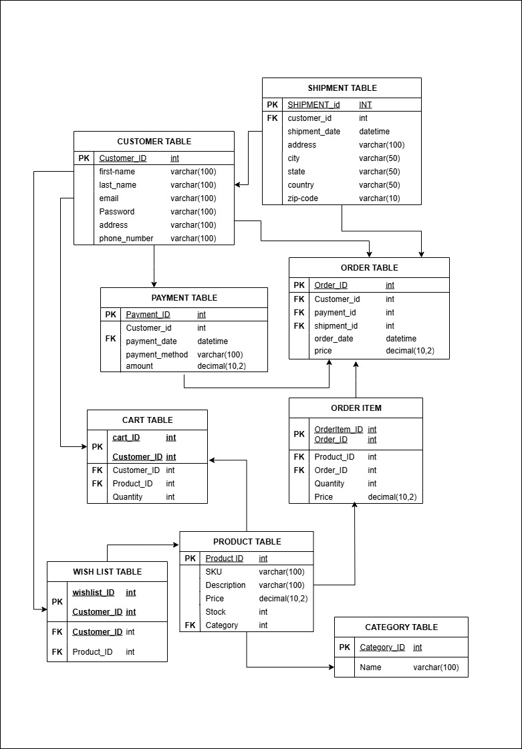
QUESTION 7:
A Data Flow Diagram (DFD) is a graphical representation of how data moves through a system. It shows:
- Processes (actions or tasks)
- Data Stores (storage locations)
- External Entities (users or systems interacting with your app)
- Data Flows (movement of data between the components)
DFDs help visualize the flow of information, making it easier to understand how input is transformed into output within the system.
Data flow diagram to represent the in-flow and out-flow of data when a Farmer is placing an order for the product
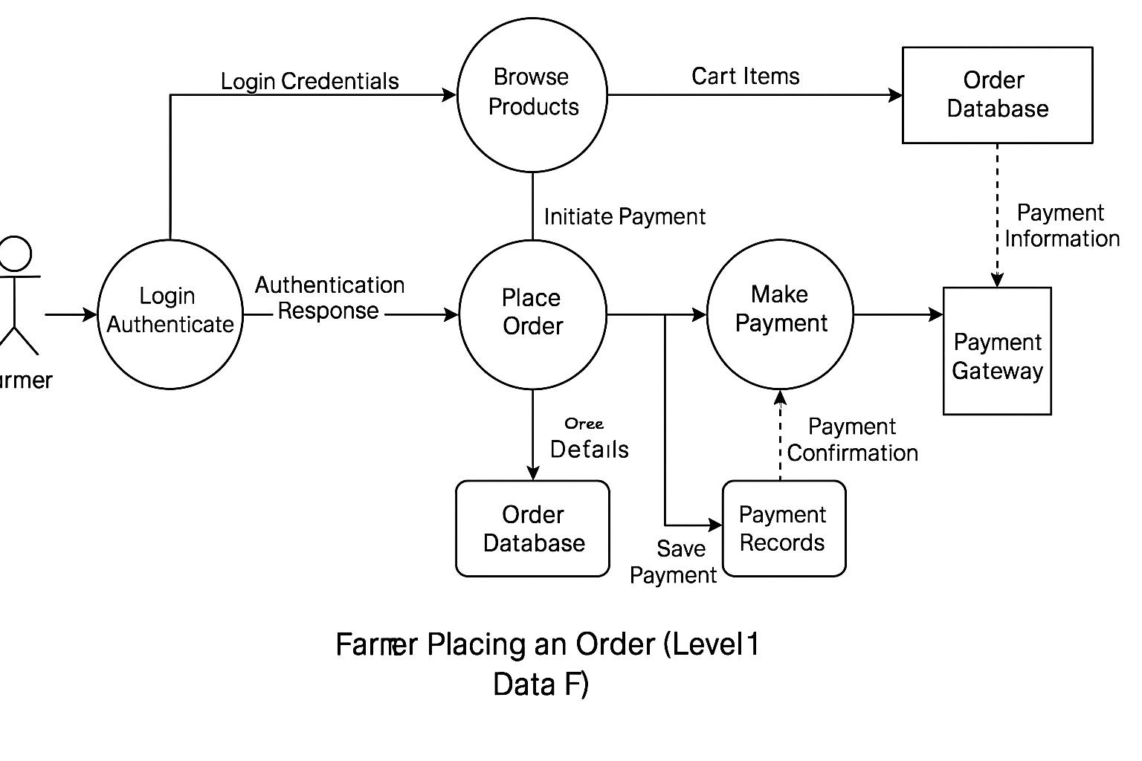

Question 8:
Change Request
1. Identify and Document the Change Request
When the client (e.g., Mr. Henry or Project Committee) informs about the change in taxation policy, I will:
- Record the change request using a Change Request Form (CRF)
- Capture the reason: “Government has changed taxation structure applicable to agricultural products”
- Mention what areas it may impact (product prices, checkout calculations, invoices, backend formulas)
2. Analyze the Impact
Conduct Impact Analysis along with Project Manager and Technical Team:
- Affected modules: Pricing logic, Payment Gateway API, Invoice generation, Tax Reports
- Check how much code, DB, UI logic will be affected
- Determine if this affects timeline or cost
- Assess if any regression testing is needed
3. Discuss with Stakeholders
- Present findings to key stakeholders: Mr. Henry, Mr. Dooku, and APT IT team
- Discuss whether the change is critical and how soon it needs implementation
- Get formal approval before proceeding
4. Update Documentation
- Update BRD, FRD, and RTM to reflect new tax rules
- Include it in sprint backlog (if Agile) or raise a Change Control Form (if Waterfall)
5. Plan and Implement
- Work with developers and testers to implement new tax logic
- Coordinate testing for price calculations and invoice generation
- Ensure compliance with new tax regulations
6. Communicate and Confirm
- Update all stakeholders once the change is deployed
- Include it in the release notes
- Get a sign-off from client (Mr. Henry/Committee)
7. Archive the Change
- Store change request documents with versioning
- Update the project change log for audit/compliance

Change Request Template
Section | Details
CR ID | CR-2025-001
Project Name | Online Agriculture Products Store
Request Date | 19 July 2025
Requested By | Mr. Henry (Client – SOONY)
Raised By | Poojitha Pallela (Business Analyst)
Description of Change | Update tax calculation logic due to changes in Government Taxation Structure
Type of Change | Regulatory Compliance
Business Justification | The government has issued new tax slabs applicable to agricultural products
Impact Areas | Product Pricing, Checkout Page, Invoice Generation, Payment Module
Priority | High
Effort Estimation | 40 man-hours (Development + Testing)
Timeline Impact | +2 working days
Cost Impact | None (CSR-funded)
Risk | Incorrect tax may lead to legal or financial issues
Approval Status | Approved by Committee on 20 July 2025
Signature (Client)
Signature (Project Manager)
Impact Analysis
Component | Impacted  (Yes/No) | Details of Impact | Action Required
Product Catalog | No | Product base prices remain unchanged | No action
Price Calculation Logic | Yes | Need to apply new tax % as per updated slabs | Update backend pricing service
Checkout Page | Yes | Recalculate total incl. tax | Modify UI to reflect updated totals
Invoice Generation | Yes | Invoices must show correct tax breakdown | Update invoice template and engine
Payment Gateway | No | No direct change unless invoice total is sent | Retest to confirm
Database (Tax Tables) | Yes | Tax values may need to be stored or updated | Alter DB schema or table entries
Reports/Analytics | Yes | Tax component affects financial reporting | Modify report generation logic
Testing Scope | Yes | Regression testing needed on price flows | Plan and execute test cases

Question 9:
As a Business Analyst, after evaluating the request from Ben and Kevin to introduce:
- Farmer-to-Customer (F2C) crop selling
- An Auction system for crop yields
I would classify this as an Enhancement, not a simple change request.

Justification:
Factor | Reason
Scope Impact | This introduces a new business module: farmers becoming sellers, public becoming buyers, and auction features.
New Users | It adds a new user role (general public/buyers) not covered in original scope.
New Features | Requires major functional additions: Product listing by farmers, buyer interface, bidding logic, time-based auctions, payment flow.
Complexity | Adds complexity to database, user flows, admin moderation, and pricing logic.
Timeline & Budget | Would affect initial delivery timeline and possibly exceed current CSR-funded budget.

Proposed Next Steps:
- Document Enhancement Request (ERF)
Record the new requirements formally and present to the client committee (Mr. Henry, Mr. Pandu, Mr. Dooku).
- Conduct Feasibility Study
Collaborate with Tech Lead, PM, and Developers to analyze impact on architecture, timeline, and cost.
- Get Client Approval
Share feasibility findings with SOONY committee for approval and potential budget extension.
- Update Project Scope
If approved, update SRS, BRD, RTM, and add new use cases & wireframes for:
  - Farmer Product Upload
  - Public Buyer Portal
  - Auction Bidding System

Question 10:
Man-hours required
Gantt-Chart
Task | Role | Estimated Hours
Requirement Gathering & Analysis | Business Analyst | 30
Wireframes & UI Design | UI/UX Designer | 20
Frontend Development | Frontend Developer | 50
Backend Development | Backend Developer | 70
Database Design & Changes | DB Admin | 15
Testing & Bug Fixing | Tester (QA) | 30
Project Coordination | Project Manager | 15
Deployment & Release | DevOps | 10

Task | Role | Duration  (Days) | 22/07/2025 | 25/07/2025 | 26/07/2025 | 28/07/2025 | 29/07/2025 | 04/08/2025 | 05/08/2025 | 14/08/2025 | 8/215/2025 | 16/08/2025 | 17/08/2025 | 21/08/2025 | 22/08/2025 | 24/08/2025 | 25/08/2025 | 26/08/2025
Requirement Gathering & Analysis | Business Analyst | 4
Wireframes & UI Design | UI/UX Designer | 3
Frontend Development | Frontend Developer | 7
Backend  Development | Backend Developer | 10
Database Design & Changes | DB Admin | 2
Testing & Bug Fixing | Tester (QA) | 5
Project  Coordination | Project Manager | 3
Deployment & Release | DevOps | 2

Question 11:

Step 1: Initiating UAT (User Acceptance Testing)
As a Business Analyst, your role is to coordinate with the client (e.g., Ben and Kevin) to ensure they:
- Understand the testing scope,
- Have access to the UAT environment,
- Are clear on how to use the application,
- Know what scenarios/test cases to verify.

Actions to Take:
- Send UAT Kickoff Email to stakeholders with:
  - Project overview
  - Features ready for testing
  - Test credentials (if needed)
  - UAT schedule/timeline
  - UAT Guide/User Manual (if applicable)
- Provide UAT Test Cases
Share a UAT test case document with predefined steps and expected outcomes.
- Monitor & Support Testing
  - Be available for clarifications.
  - Collect feedback from users.
  - Record any defects or change requests.

Step 2: UAT Acceptance Process

Typical Flow:
Stage | Description
1. Plan UAT | Define scope, prepare test cases, and schedule testing.
2. Execute UAT | Client performs tests using real-world scenarios.
3. Log Defects | Issues are reported and tracked to resolution.
4. Retesting | Once fixed, client retests the affected areas.
5. Final Approval | Client signs the UAT Sign-Off Document indicating satisfaction.

UAT Sign-Off Includes:
Module-wise test status, Pending issues (if any) and their impact, Client's approval for release & Date and signature

Question 12:

Project Closure Process
Once UAT is complete and accepted, the following steps ensure proper project closure:

Project Closure Document
Project Name: Online Agriculture Products Store
Client: SOONY Company (CSR Initiative)
Project Duration: 18 Months
Budget: ₹2 Crores
Prepared By: Business Analyst – Varshini
Date: 08.08.2025

1. Project Overview
The Online Agriculture Products Store was initiated under SOONY Company’s CSR program to address the supply challenges faced by farmers in remote areas in procuring fertilizers, seeds, and pesticides. The client, Mr. Henry, inspired by the needs of his farmer friends Peter, Kevin, and Ben, aimed to develop a web and mobile application where farmers could directly connect with manufacturers and purchase agricultural products conveniently.
The project was awarded to APT IT SOLUTIONS, with Mr. Vandanam as Project Manager, a development team led by Ms. Juhi (Senior Java Developer), supported by developers Mr. Teyson, Ms. Lucie, Mr. Tucker, and Mr. Bravo, with infrastructure managed by Mr. Mike (Network Admin) and Mr. John (DB Admin). Testing was handled by Mr. Jason and Ms. Alekya, and business analysis by myself.
Scope Delivered:
- Multi-user login functionality for farmers and manufacturers.
- Product catalog for fertilizers, seeds, and pesticides.
- Advanced search feature for easy product discovery.
- Secure payment gateway (COD, Credit/Debit cards, UPI).
- Delivery tracking and email order confirmations.
- User-friendly interface optimized for remote area accessibility.

2. Achievements
- Completed requirement gathering through stakeholder meetings with Mr. Henry, Peter, Kevin, and Ben.
- Designed wireframes, prototypes, and functional requirements that matched client expectations.
- Delivered a fully functional product catalog with search and filtering capabilities.
- Integrated secure multi-payment options to enhance user experience.
- Implemented real-time delivery tracking and automated email notifications.
- Achieved 100% compliance with the defined functional and non-functional requirements.
- Successfully completed UAT with approval from all primary stakeholders.

3. Lessons Learned
Positive Takeaways:
- Early involvement of end-users (farmers) ensured the product was aligned with real-world needs.
- Regular communication between APT IT SOLUTIONS and SOONY Company avoided scope creep.
Areas for Improvement:
- The payment gateway integration faced delays due to third-party dependencies, highlighting the need for early vendor coordination.
- More structured timelines for UAT could improve efficiency.
Knowledge Gained:
- Experience in bridging urban technology solutions for rural application.
- Enhanced skills in designing intuitive UI for first-time internet users.

4. Quality Assurance
- Conducted unit, integration, and system testing to ensure defect-free delivery.
- Maintained a defect log and ensured all high/critical severity bugs were resolved before deployment.
- Cross-verified requirements with the RTM to ensure full coverage.
- Performed UAT in real network conditions to validate usability for rural internet speeds.
- Final deployment was signed off by the client after successful quality review.

5. Resource Utilization
Human Resources:
- BA: Requirement gathering, documentation, stakeholder communication.
- Development: Backend, frontend, and database implementation.
- Testing: Functional, regression, and UAT support.
- Infrastructure: Hosting, network setup, and database management.
Technical Resources:
- Java for backend, MySQL for database, HTML/CSS/JavaScript for frontend.
- Payment gateway APIs, delivery tracking modules, and email notification service.
Time & Budget:
- Delivered within the planned 18-month schedule.
- Maintained adherence to the allocated ₹2 crore budget.

6. Risk Management
Risks Identified:
- Integration Risk: Payment gateway API delays.
  - Mitigation: Engaged vendor early and maintained backup payment provider.
- Connectivity Risk: Rural internet speed limitations.
  - Mitigation: Optimized app performance for low bandwidth.
- Adoption Risk: Farmers’ unfamiliarity with digital platforms.
  - Mitigation: Created a simplified UI and added tutorials.

7. Challenges
Technical Challenges:
- Payment gateway required additional compliance checks.
- Delivery tracking integration with third-party logistics systems.
Operational Challenges:
- Coordinating requirement sign-offs between SOONY Company committee and APT IT SOLUTIONS teams.
- Managing feedback from multiple farmer stakeholders while maintaining scope.
Resolutions:
- Used collaborative tools for real-time updates.
- Conducted multiple prototype reviews before final development.

Closure Activities:
- Final Documentation Submission:
  - User Manuals
  - Architecture Diagrams
  - Codebase handover (if agreed)
  - UAT Sign-Off Sheet
- Production Deployment:
  - Coordinate with DevOps for live deployment
  - Perform sanity checks in production
- Project Closure Meeting:
  - Review deliverables
  - Gather feedback from client
  - Identify lessons learned
- Prepare Closure Report:
  - Summary of the project lifecycle
  - Budget and time comparisons
  - Key decisions and learnings
- Client Handover & Training:
  - Train client team if necessary
  - Share support contacts

