Waterfall Part 2 / 2

Document 6 ::
Use Case: IGRS 2.0
1. Use Case Diagram

2. Activity Diagram

3. Use Case Specification Document

Use Case Name:
IGRS 2.0

Use Case Description:
This use case describes how a Trade Desk Officer and Auditor knock of Shipping bills and generate reports respectively through the IGRS system.

Actors:
- Primary Actor: Trade Desk Officer
- Secondary Actors:
  - Compliance Officer
  - Auditor

Basic Flow:
- Trade Compliance Officer logs into IGRS system
- Selects the “Export Compliance” module
- Enters/remits transaction reference ID (e.g., GRS tracking number)
- AI matches Remittance with SB
- If it is not matched the Trade Compliance officer matches it
- Status is updated in records for the auditor
- Auditor enters the date range
- Gets the result for auditing and reconciliation

Alternate Flow:
- If the user provides an invalid reference ID:
  - System prompts “Invalid Reference ID. Please check and try again.”

Exceptional Flows:
- If user session times out during tracking
- If reference number is not yet initiated in SWIFT system

Pre-Conditions:
- Trade officer must be logged into the IGRS system with proper access rights
- AI must be integrated and active

Post-Conditions:
- System shows the latest status of the SB Knock off
- Auditing is done

Assumptions:
- AI integration is tested and stable
- Reference numbers are unique and traceable

Constraints:
- Limited to inward remittances only

Dependencies:
- AI system developed
- Internet connectivity

Inputs and Outputs:
Inputs | Outputs
Reference ID / UTR | Remittance timeline, current status
User credentials | System log entry, view access logs

Business Rules:
- Only authorized bank users can initiate tracking
- Only specific roles can see full details
- System logs every access for audit compliance

Miscellaneous Information:
- User interface to include visual progress bar or status timeline
- Multilingual labels for international branches (future enhancement)
- Optional customer-facing email trigger with tracking link

Document 7

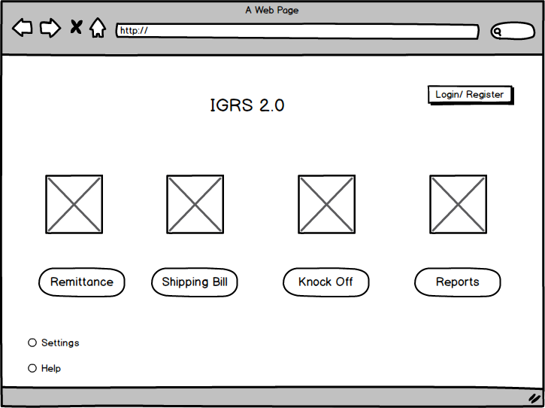
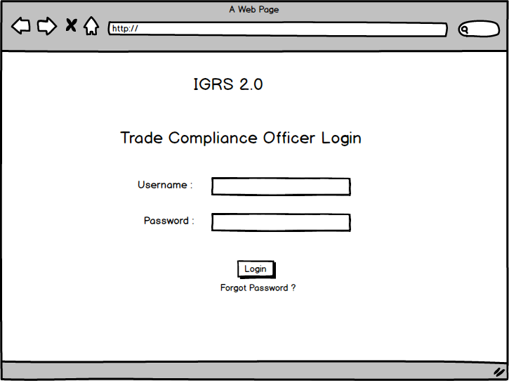

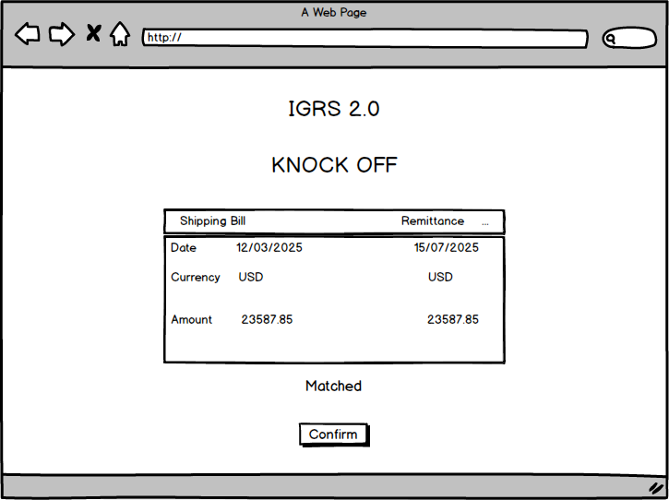

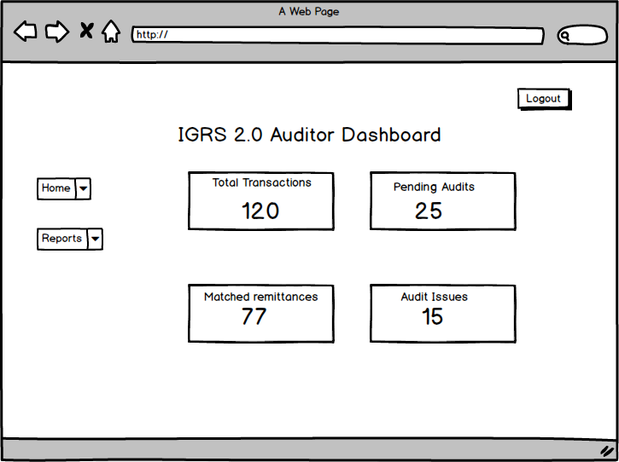

Document 8

During the IGRS Enhancement Project,
Visio was extensively used for creating process flow diagrams, use case diagrams, and activity diagrams. Its intuitive drag-and-drop interface made it easy to model the legacy (AS-IS) and proposed (TO-BE) workflows, ensuring clarity in system understanding for both technical and non-technical stakeholders.
On the other hand, Axure (and Balsamiq-style wireframing) was employed to design mock-ups of critical user interfaces like the Trade Compliance Officer dashboard, Auditor Dashboard, Home page. Axure’s dynamic linking and widget-based prototyping helped visualize user interactions early in the SDLC, allowing smoother feedback cycles.
The combination of both tools greatly enhanced collaboration between business analysts, developers, and the client, especially in the Waterfall context where upfront documentation and clarity are crucial

Document 9
1. Requirement Gathering:
During the initial phase of the IGRS Enhancement Project, I actively engaged with key stakeholders including the Project Sponsor, Compliance Officers, Trade Operation Managers,Auditors and IT Architects.
I conducted interviews, workshops, and document analysis to elicit business needs and system expectations.
To gather requirements we used MOSCOW technique.
I prepared documents like the Business Case, BRD, and Stakeholder Analysis, ensuring all requirements were well-documented, validated, and approved before progressing.

2. Requirement Analysis:
Post-gathering, I analyzed and categorized the requirements into functional and non-functional specifications.
I created the Requirement Traceability Matrix (RTM) to ensure full coverage throughout the project lifecycle.
We created Use case diagrams and Activity diagrams and all the rquirements were communicated to the team

3. Design:
I collaborated with the design and solution architecture teams to translate business requirements into system-level features.
From the use case diagrams test cases were prepared in order to validate the working of the prototype
.RTM was regularly updated

4. Development:
Although not directly involved in coding, I participated in daily stand-ups and design walkthroughs to clarify requirements and resolve developer queries. I supported the technical team with business context and helped ensure alignment between the BRD and technical implementation, especially around the integration of AI and Invoice Matching modules.

5. Testing:
I supported the QA team in preparing Test Scenarios, Test Cases, and UAT criteria. I reviewed test plans for completeness and helped validate test coverage based on the RTM.
I also coordinated User Acceptance Testing (UAT) with business users, collected feedback, and facilitated sign-off by the client on the Client Project Acceptance Form.

6. Deployment:
In the deployment phase, I contributed to the forwarding of RTM to the client.
End user manuals were shared, and ensured that all final documentation was approved.
I conducted training sessions for end-users and shared detailed process documents.

Use case case elements/ components
Activity diagrams elements—how activity diagram

