Q.1. 4 Quarterly Audits are planned Q1, Q2, Q3, Q4 for this Project. What is your knowledge on how these Audits will happen for a BA?
Ans. Quarterly audits (Q1, Q2, Q3, Q4) for a business analyst typically assess:
Q1 (Initiation Audit): Ensure project objectives are well-defined. Validate stakeholder expectations and initial requirements.
Q2 (Requirements Audit): Review elicited requirements, stakeholder sign-offs, and document consistency. Ensure alignment with business needs.
Q3 (Implementation Audit): Track development progress against requirements. Validate testing outcomes, compliance, and stakeholder feedback.
Q4 (Final Audit & Closure): Ensure deployment readiness. Conduct UAT sign-off with stakeholders. Perform lessons learned analysis.
Q.2. Before the Project is going to Kick Start, The Committee asked Mr Karthik to submit BA Approach Strategy Write BA Approach strategy (As a business analyst, what are the steps that you would need to follow to complete a project – What Elicitation Techniques to apply, how to do Stakeholder Analysis RACI/ILS, What Documents to Write, What process to follow to Sign off on the Documents, How to take Approvals from the Client, What Communication Channels to establish n implement, How to Handle Change Requests, How to update the progress of the project to the Stakeholders, How to take signoff on the UAT- Client Project Acceptance Form )
Your Team: Project Manager - Mr Vandanam, Senior Java Developer - Ms. Juhi Java Developers - Mr Teyson, Ms Lucie, Mr Tucker, Mr Bravo, Network Admin - Mr Mike, DB Admin - Mr John. Testers - Mr Jason and Ms Alekya, BA - You
Technical Team have assembled to discuss on the Project approach and have finalised to follow 3-tier architecture for this project.
Before the project kick-starts, the BA must establish a systematic approach:
- Elicitation Techniques: Brainstorming, Document Analysis, Prototyping, Use Case Analysis.
- Stakeholder Analysis: Use RACI Matrix to define roles; ILS Analysis to assess involvement level. ILS- Identify, List, Summary
- Documents to Prepare: BRD, FRD, Use Case Specs, Activity Diagrams.
- Sign-off Process: Obtain approvals at each phase—requirements, design, implementation, UAT.
- Approvals & Communication: Define structured channels—weekly meetings, email updates, dashboards.
- Handling Change Requests: Follow a structured Change Control Process—impact analysis, stakeholder approvals, documentation.
- Project Progress Updates: Maintain progress tracking dashboards, regular reviews, stakeholder feedback.
- UAT & Client Acceptance: Facilitate User Acceptance Testing with stakeholders, validate business needs, ensure a formal acceptance sign-off.

Q.3. Explain and illustrate 3-tier architecture?
Ans. Explanation & Illustration: A 3-tier architecture consists of:
- Presentation Layer (UI): User interface for farmers and manufacturers to interact with the application.
- Application Layer (Business Logic): Processes transactions, handles requests, validates inputs.
- Data Layer (Database): Stores user credentials, product catalogues, transactions.
Q.4. Business Analyst should keep What points in his/her mind before he frames a Question to ask to the Stakeholder ( 5W 1H – SMART – RACI – 3 Tier Architecture – Use Cases, Use case Specs, Activity Diagrams, Models, Page designs)
Ans. When framing questions for stakeholders, a Business Analyst should consider:
- 5W1H Approach: Ensure clarity by covering Who, What, When, Where, Why, How.
- SMART Criteria: Questions should be Specific, Measurable, Achievable, Relevant, and Time-bound.
- RACI Framework: Clarify responsibilities by aligning questions with Responsible, Accountable, Consulted, Informed roles.
- Architecture Considerations: Ensure compatibility with the 3-Tier Architecture design.
- Use Case Analysis: Cover Use Cases, Use Case Specs, Activity Diagrams, Models, Page Designs for clarity.
Q.5. As a Business Analyst, What Elicitation Techniques you are aware of? ( BDRFOWJIPQU)
Ans. A Business Analyst should be familiar with elicitation techniques such as:
- Brainstorming
- Document Analysis
- Reverse Engineering
- Focus Groups
- Observation
- Workshops
- Joint Application development (JAD)
- Interviews
- Prototyping
- Questionnaires
- User Stories
Q.6. Which Elicitation Techniques can be used in this Project and Justify your selection of Elicitation Techniques? Prototyping Use case Specs Document Analysis Brainstorming Fertilizers, seeds, pesticides details from the manufacturers and should be able to display them to the Farmers. To gather the business requirements from the client, you went to SOONY and met Mr. Henry. When Mr. Henry was asked about the project and what are they expecting from the project, Mr. Henry stated that he is expecting to have a login for all its

users (fertilizers, seeds, pesticides manufacturers and Farmers), a product catalogue of fertilizers, seeds, pesticides, a search option to search for products, payment process, and delivery tracking. After doing the stakeholder analysis, you have found out that Peter, Kevin, Ben are the key stakeholders and you have scheduled an appointment to meet them. After meeting with them and trying to gather the stakeholder requirements, Kevin said that, a Farmer should be able to browse through the products catalogue once they visit the website and need to have a search option so that they can search for any product they need. Peter said that, if a farmer wants to buy any product or add them to buy-later list, they need to login first using their email id and password. If it is a new user, then they can create a new account by submitting their email ID and creating a secure password. Ben added saying that, Farmers needs to have an easy-to-use payment gateway which should include cash-on-delivery (COD), Credit/Debit card and UPI options so that the user’s experience should be better. Kevin mentioned that, a user gets an email confirmation regarding their order status. A delivery tracker to track the whereabouts of their order.
Identify Business Requirements (which includes Stakeholder Requirements) BR001 – Farmers should be able to search for available products in fertilizers, seeds, pesticides BR002 – Manufacturers should be able to upload and display their products in the application.
Ans. For the Online Agriculture Products Store, the following elicitation techniques are ideal:
- Prototyping: Helps farmers and manufacturers visualize product listings and navigation flow.
- Use Case Specs: Defines structured user interactions with the system.
- Document Analysis: Reviews previous market studies and similar platform implementations.
- Brainstorming: Gathers diverse perspectives from farmers, manufacturers, and stakeholders.
Justification:
- Prototyping enhances usability by allowing stakeholders to interact with mock designs.
- Use Case Specs help map out system interactions for seamless user experience.
- Document Analysis ensures regulatory compliance and industry alignment.
- Brainstorming uncovers hidden challenges and generates innovative solutions.
Q.7. Make suitable Assumptions and identify at least 10 Business Requirements.
Ans. Identified Business Requirements:
- Farmers should be able to register and log in securely.
- Manufacturers must upload product details efficiently.
- Product search functionality should be available.
- Farmers must be able to add items to a "Buy Later" list.
- The platform should support multiple payment options (COD, Credit/Debit, UPI).
- Email notifications should confirm orders and updates.

- A delivery tracker must provide real-time order status.
- The application should allow customer reviews and ratings.
- Farmers should receive personalized recommendations based on purchase history.
- The platform should support multilingual interfaces for accessibility.
Q.8. List your assumptions.
Ans. 1. Farmers and manufacturers have internet access.
2. Users are comfortable using online platforms.
- Secure payment processing is available.
- Delivery logistics are pre-arranged with vendors.
- The project follows Agile methodology for iterative updates.
Q.9. Give Priority 1 to 10 numbers (1 being low priority – 10 being high priority) to these Requirements after discussions with the stakeholders.

Req ID | Req Name | Req Description | Priority
BR001 | Farmer Search for Products | Farmers should be able to search for available products in fertilizers, seeds, pesticides | 8
BR002 | Manufacturers upload their Products | Manufacturers should be able to upload and display their products in the application | 8

Once the requirements are finalized, as a business analyst, one of the major roles is to act as a liaison between the client and the project team. To gather the requirements correctly from the client side and then to deliver those requirements to the project team in a way they understand. To make the project team understand the requirements, you need to convert those requirements into UML diagrams and screen mock-ups.
Ans.

Req ID | Req Name | Req Description | Priority (1-10)
BR001 | Farmer Search for Products | Farmers can search for fertilizers, seeds, pesticides. | 8
BR002 | Manufacturers Upload Items | Manufacturers must upload product details. | 8
BR003 | Secure Login for Users | Farmers and manufacturers must authenticate. | 9
BR004 | Buy-Later List Feature | Farmers can save products for future purchase. | 6
BR005 | Multi-Payment Methods | Support COD, credit/debit cards, UPI payments. | 10

Q.10. Draw use case diagram

Ans. 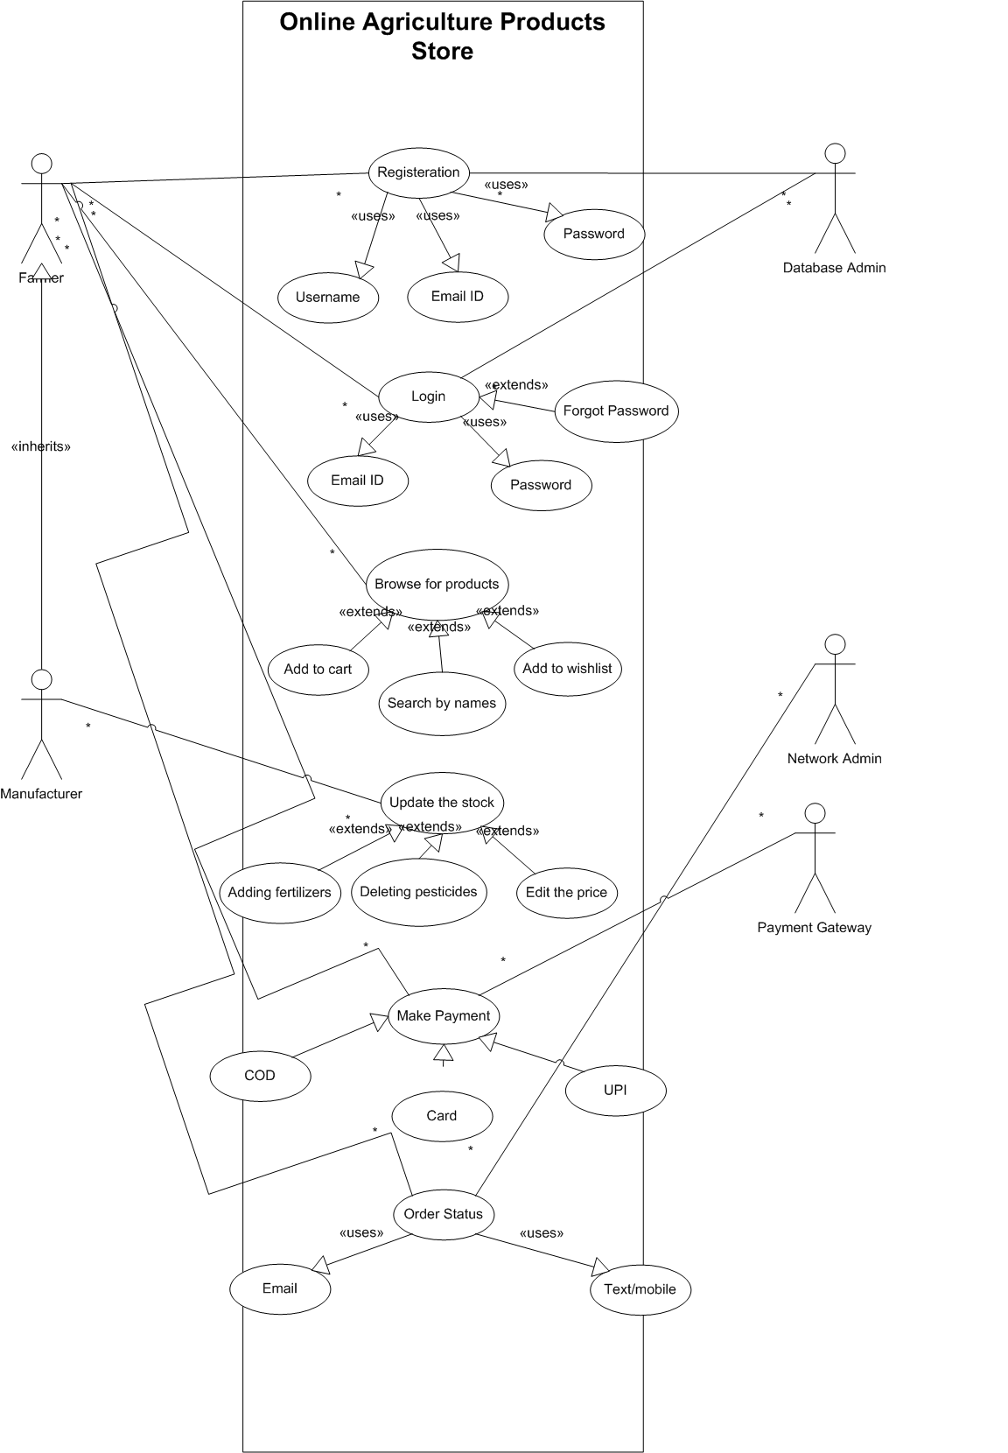
Q.11. Prepare use case specs for all use cases.
Ans. Use Case Specs for at least 5 interactions include:
- Login Authentication
- Search Products
- Add to Buy-Later List
- Place Order
- Track Delivery

Q.12. Activity diagrams
Ans. User Login Process
Actors: Farmer / Manufacturer Flow:
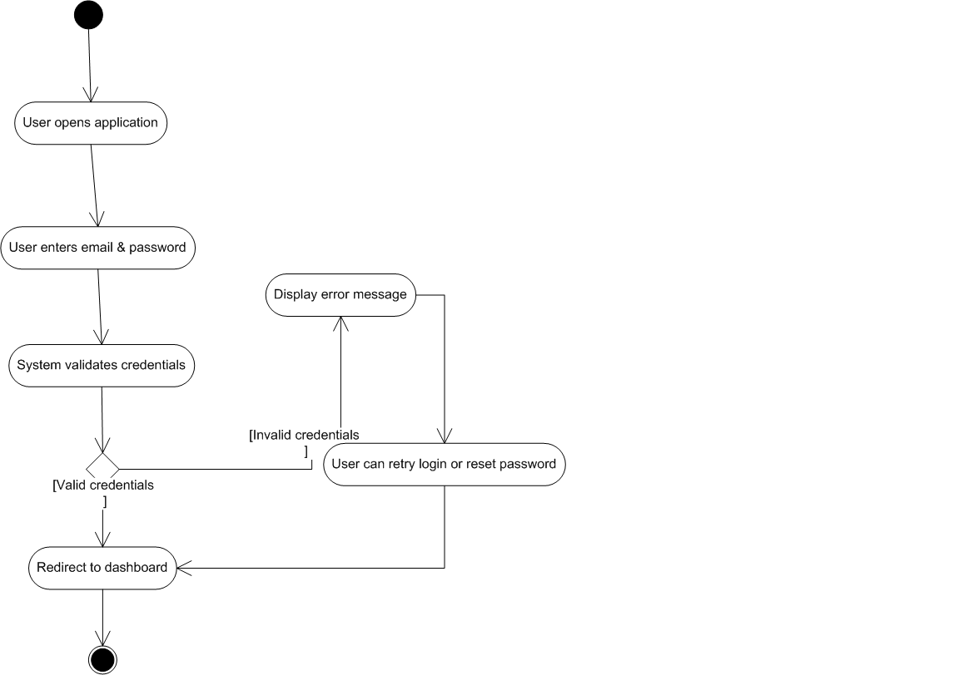

Product Search & Selection
Actors: Farmer Flow:
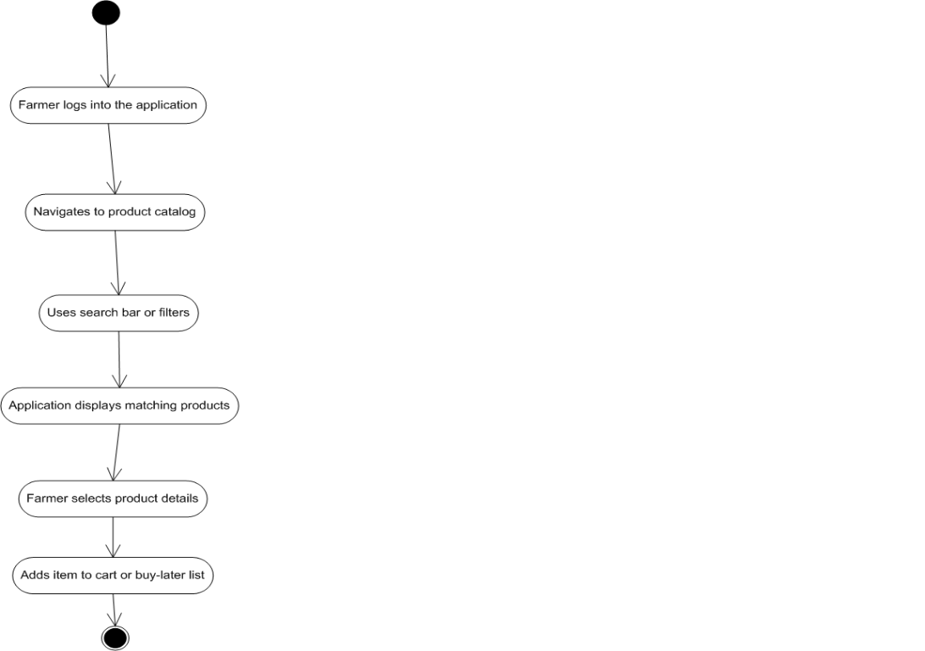

Order Placement & Payment
Actors: Farmer Flow:
Delivery Tracking
Actors: Farmer Flow:

