Question 1: Identify minimum 10 functional and 10 non-functional requirements
Answer:
Functional requirements: These requirements define the specific behaviour or functions of a system and how the system should work. It applies business logic as well.
Req Id | Req Name | Description
FR001 | User Registration and Login | Farmers and manufacturers must be able to register and log in using email ID and password.
FR002 | Product Catalogue Display | The system should display a categorized catalogue of fertilizers, seeds, and pesticides.
FR003 | Search Option | Farmers should be able to search for products using keywords
FR004 | Add to cart | Farmers should be able to add products to the cart
FR005 | Buy later option | Farmers should be able to save the products to a buy later list
FR006 | Order placement | Farmers should be able to place orders after logging in
FR007 | Payment Option | Farmers should be able to use different payment modes like COD/CC/DC/UPI
FR008 | Email alerts | Once order is placed, email should be sent to the user’s registered email
FR009 | Delivery Tracking | Farmers should be able to track their orders
FR10 | Manufacturer order approval | Manufacturers should be able to approve the orders placed by farmers and update tracking details

Non-Functional requirements: These requirements define the qualities and constraints that the system should meet. The inclusion on integrated external peripherals along with the quality requirements like usability, performance, compatibility, reliability etc form the non-functional requirements
Req Id | Req Name | Description
NFR001 | Usability | The application must be easy to use for non-technical users, especially farmers in rural areas
NFR002 | Performance | The system should load product pages and search results in under 3 seconds.
NFR003 | Security | The application must ensure secure user authentication
NFR004 | Scalability | The system should support a growing number of users and products without performance degradation.
NFR005 | Compatibility | The app should be compatible with all the major browsers
NFR006 | Reliability | The system should be up and functional at least 99.5% of the time (excluding maintenance).
NFR007 | Maintainability | The system should have clean and well-documented code to facilitate updates and bug fixes
NFR008 | Multilingual Support | The application should support multiple Indian languages for broader reach
NFR009 | Accessibility | The application should be accessed by everyone
NFR10 | Data Backup | Daily data backups should be maintained

Question 2: Make wire frames and prototypes
Answer:

Wireframes:
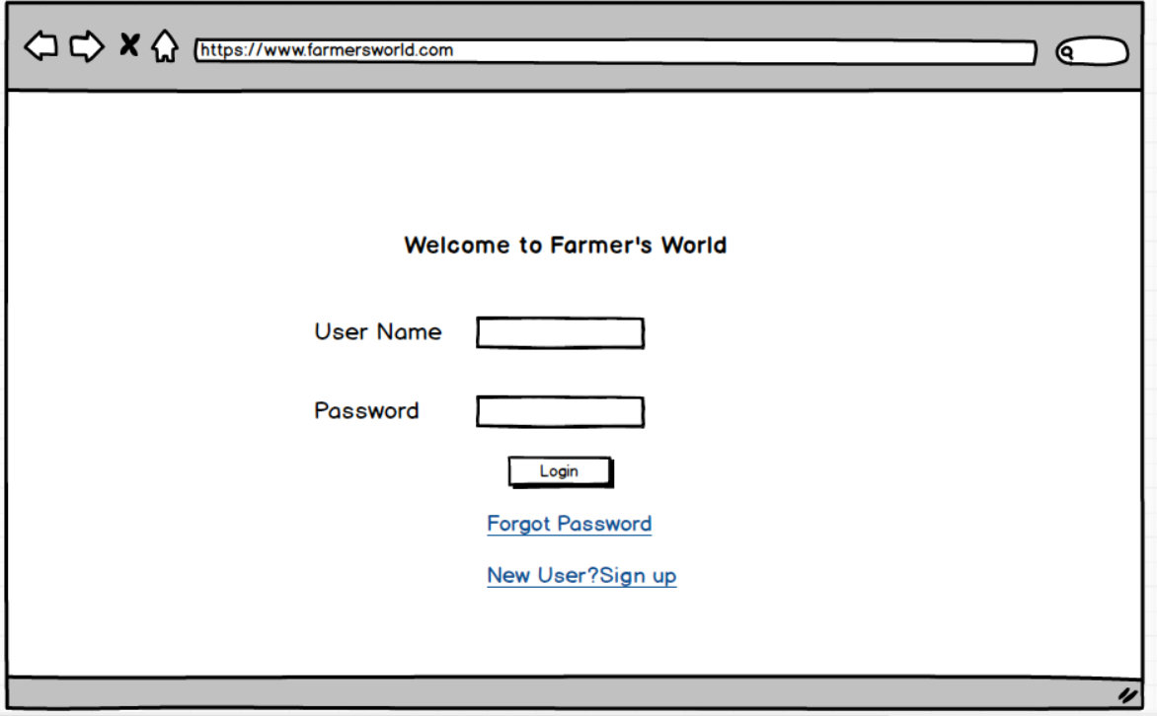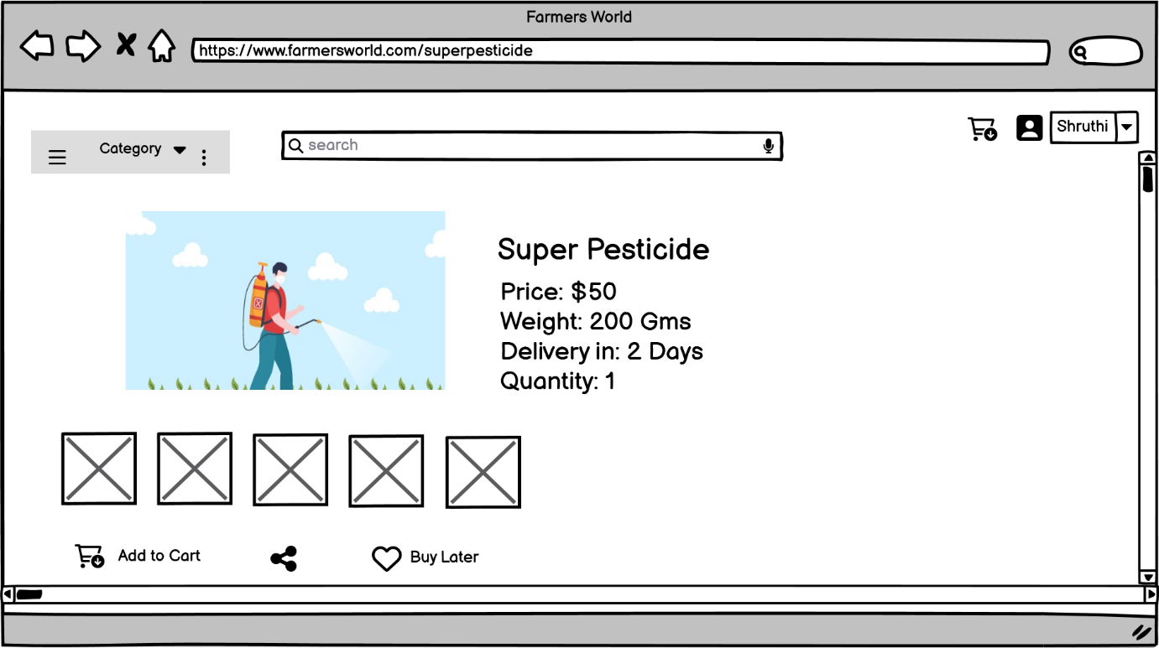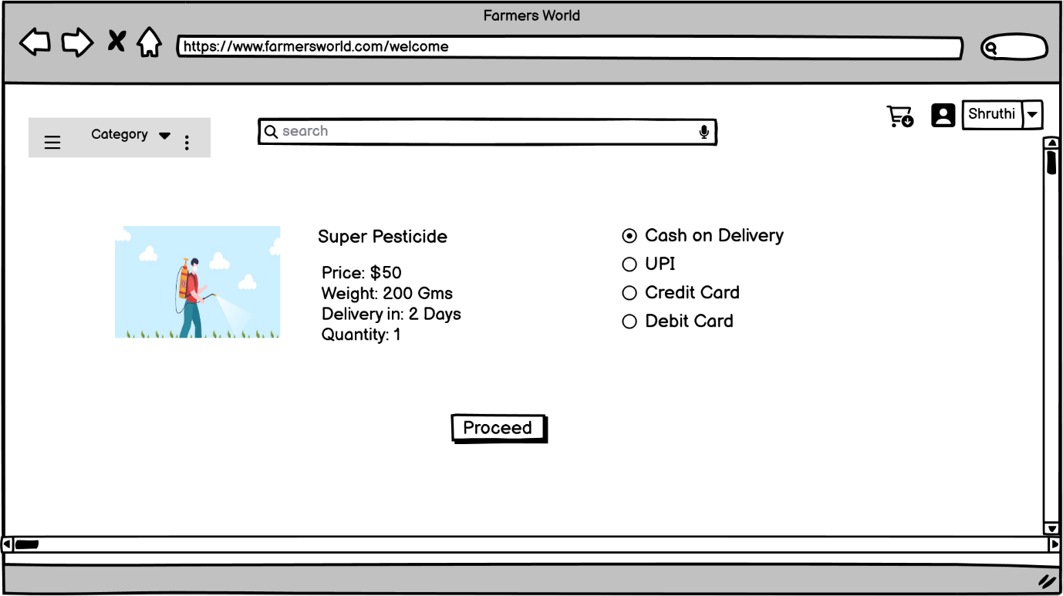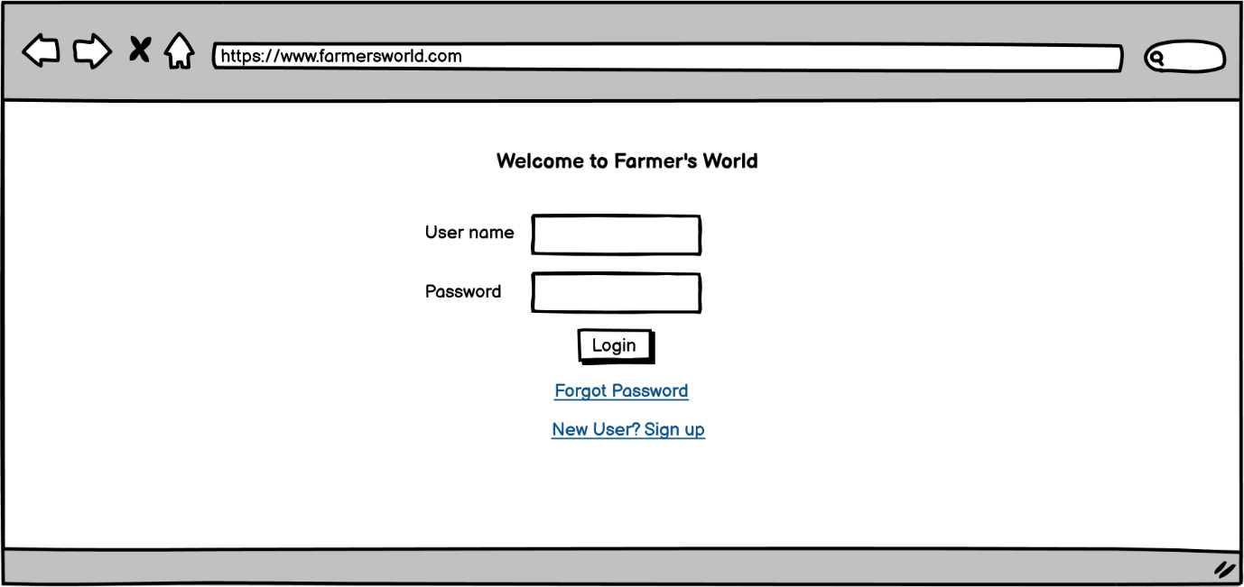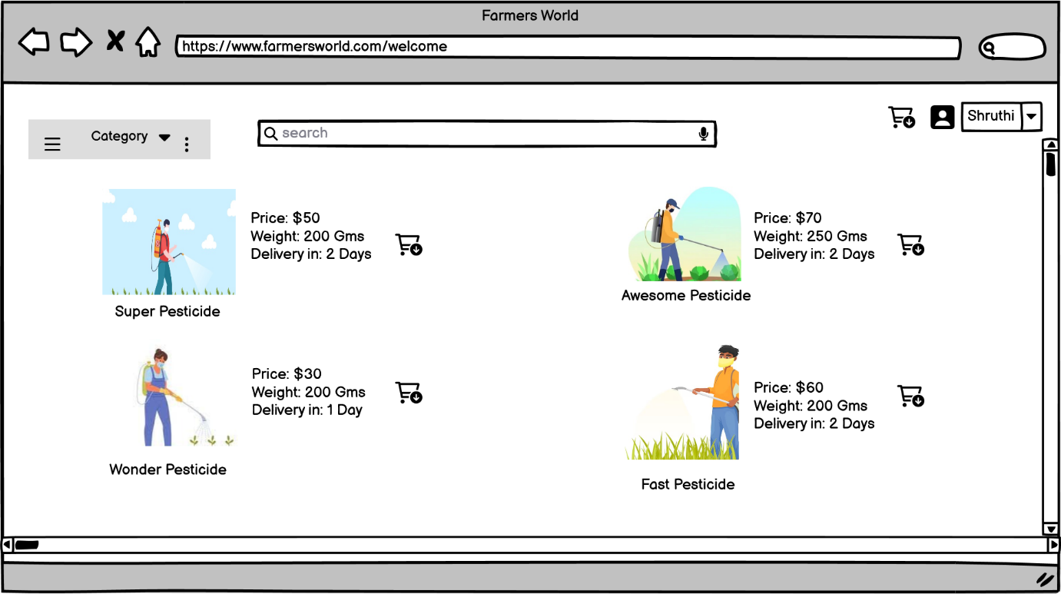

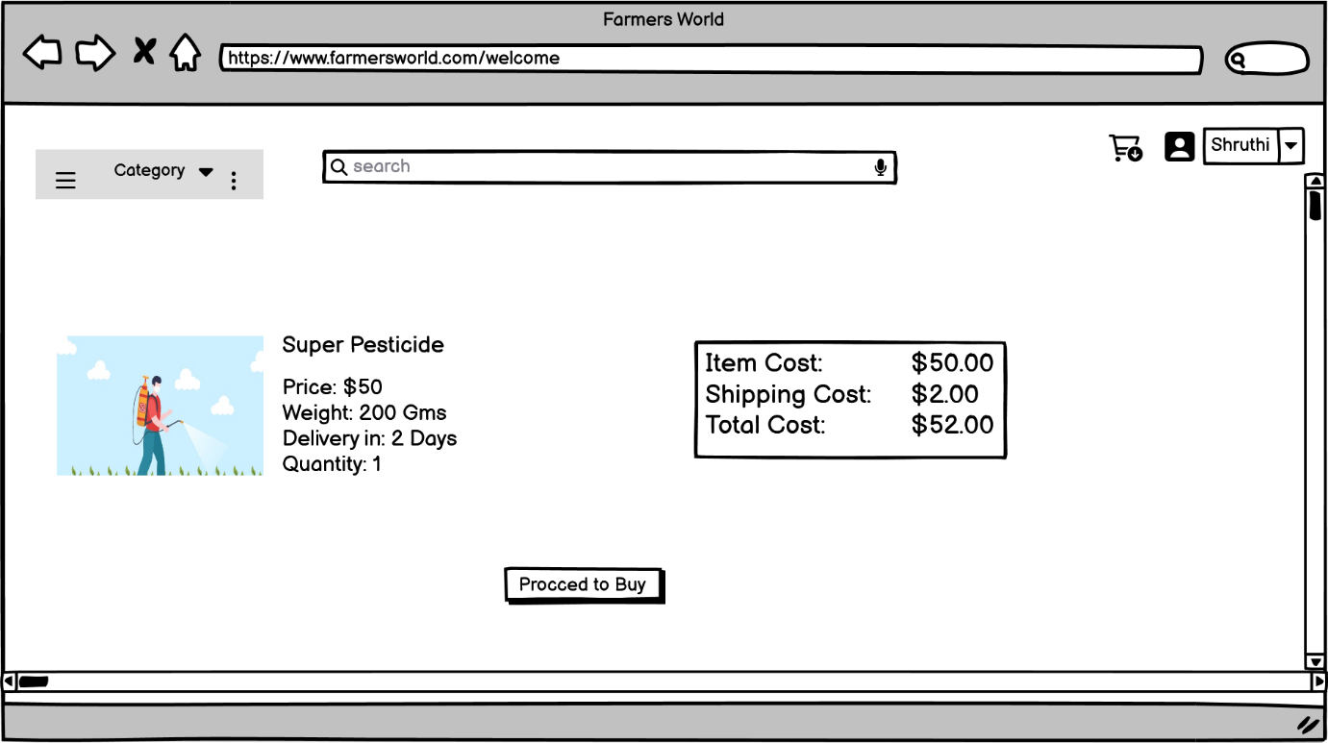
Prototype:
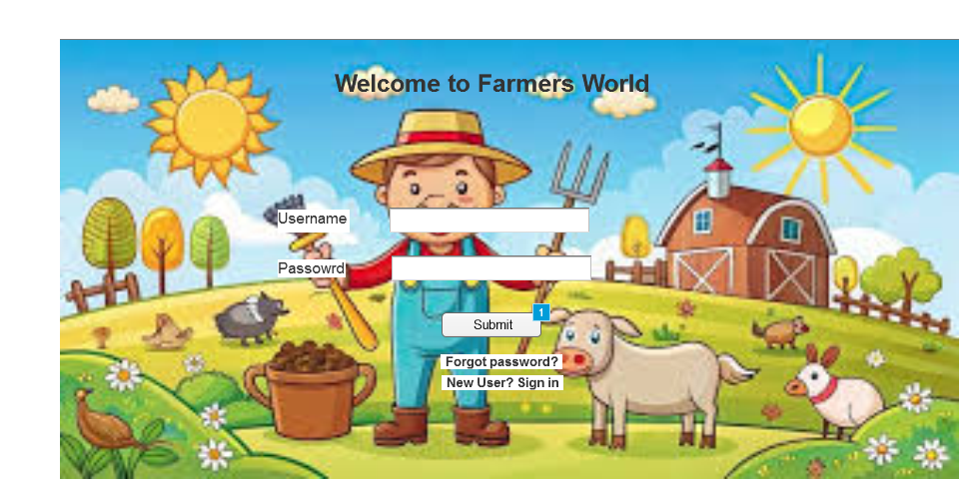
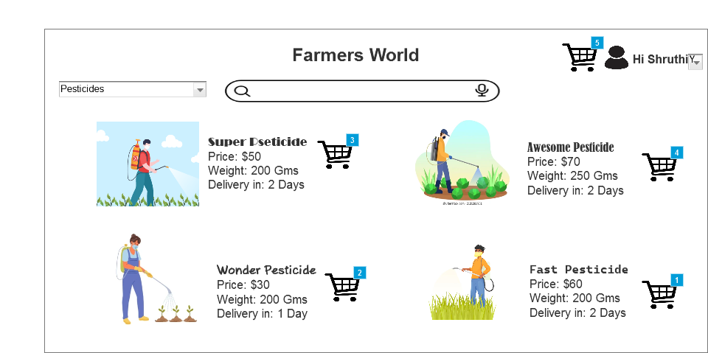
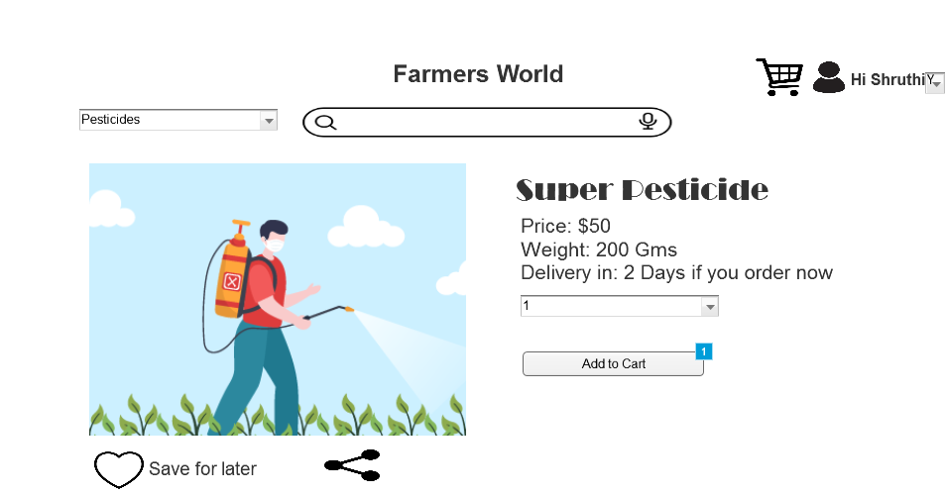
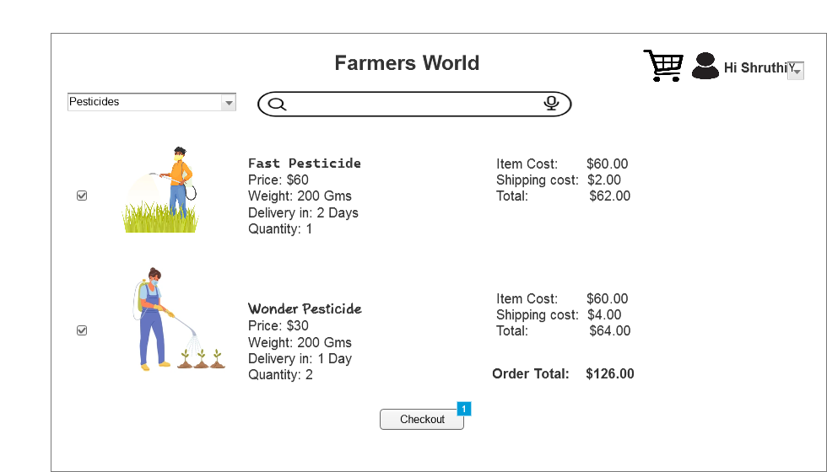
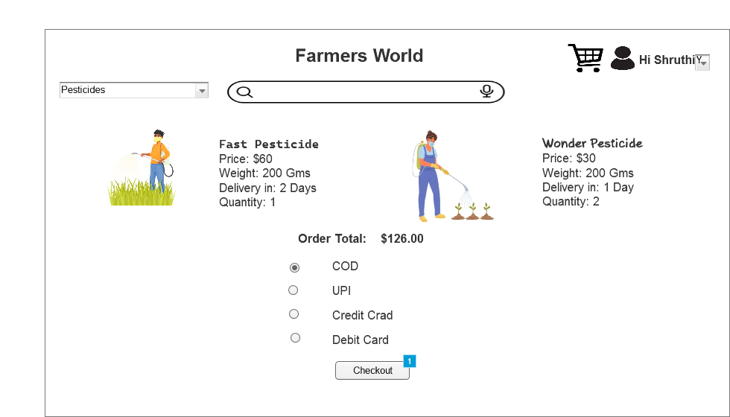
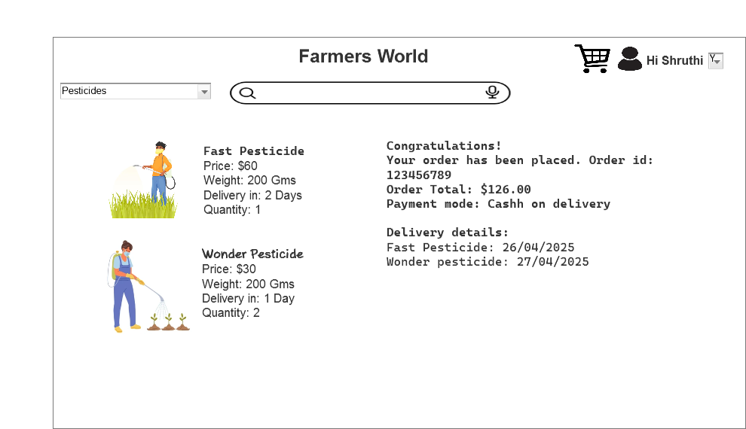

Question 3: Make a note of the Tools, which you are using for above concepts.
Answer:
As a Business Analyst we use 3 tools majorly which are MS Visio, Balsamiq and Axure rp. These are used to draw diagrams, wireframe and prototypes. Here’s the detailed explanation about each tool.
MS Visio:
Microsoft Visio is a diagramming tool developed by Microsoft that allows users to create a wide variety of professional diagrams, including:
- Flowcharts
- UML diagrams
- Process diagrams
- Use case diagrams
- Gantt charts etc.
You can create visual representations that help explain complex ideas or workflows clearly.
Through Visio, we can communicate ideas clearly to both technical and non-technical users. We can translate requirements into visuals for developers, testers, and clients. Document workflows and systems in a standardized and understandable format. Create Visuals for presentations, reports or stakeholder meetings.
Balsamiq:
Balsamiq is a wireframing tool designed to help sketch out user interfaces for web or mobile applications quickly and simply. It focuses on low-fidelity design, meaning your mockups look like hand-drawn sketches. They are great for brainstorming and discussing ideas.
We can easily drag and drop the pre-built elements like text bar, buttons, sliders, scroll bars etc., It only focuses on the structure and layout and not much detailed information and can help during early discussion with stakeholders on how the application may look. We can also export them as images or pdfs.
Axure rp:
Axure RP (Rapid Prototyping) is a professional prototyping tool that allows you to create high fidelity interactive prototypes. It helps us in not only how the application may look but mostly how it works.
We can use the tools on Axure rp like drop down menus, typable text boxes, etc which are more interactive and easier for the developers to understand and as well as for the stakeholders.
These closely mimic the real applications. It is not only used to see how the tool may look but also how it behaves.
Question 4: A business analyst’s key responsibilities are to keep track of the requirements and make sure that no requirement is missed.

Re id | Req Name | Desc | Design | Code | UT | CT | ST | SIT | UAT
FR001 | User Registration and Login | Farmers and manufacturers must be able to register and log in using email ID and password. | Complete | C | C | C | C | C | C
FR002 | Product Catalogue Display | The system should display a categorized catalog of fertilizers, seeds, and pesticides. | Complete | C | C | C | C | C | C
FR003 | Search Option | Farmers should be able to search for products using keywords | Complete | C | C | C | C | C | C
FR004 | Add to cart | Farmers should be able to add products to the cart | Complete | C | C | C | C | C | C
FR005 | Buy later option | Farmers should be able to save the products to a buy later list | Complete | C | C | C | C | C | C
FR006 | Order placement | Farmers should be able to place orders after logging in | Complete | C | C | C | C | C | C
FR007 | Payment Option | Farmers should be able to use different payment modes like COD/CC/DC/UPI | Complete | C | I | I | I | I | I
FR008 | Email alerts | Once order is placed, email should be sent to the user’s registered email | Complete | C | C | C | I | I | I
FR009 | Delivery Tracking | Farmers should be able to track their orders | Complete | C | C | C | C | C | I
FR10 | Manufacturer order approval | Manufacturers should be able to approve the orders placed by farmers and update tracking details | Complete | C | C | C | C | I | I
NFR001 | Usability | The application must be easy to use for non-technical users, especially farmers in rural areas | Complete | I | I | I | I | I | I
NFR002 | Performance | The system should load product pages and search results in under 3 seconds. | Complete | C | C | C | C | C | I
NFR003 | Security | The application must ensure secure user authentication | Complete | C | C | I | I | I | I
NFR004 | Scalability | The system should support a growing number of users and products without performance degradation. | Complete | I | I | I | I | I | I
NFR005 | Compatibility | The app should be compatible with all the major browsers | Complete | C | C | C | I | I | I
NFR006 | Reliability | The system should be up and functional at least 99.5% of the time (excluding maintenance). | Incomplete | Incomplete | I | I | I | I | I
NFR007 | Maintainability | The system should have clean and well-documented code to facilitate updates and bug fixes | Incomplete | Incomplete | I | I | I | I | I
NFR008 | Multilingual Support | The application should support multiple Indian languages for broader reach | Incomplete | Incomplete | I | I |  | I | I
NFR009 | Accessibility | The application should be accessed by everyone | Incomplete | Incomplete | I | I | I | I | I
NFR10 | Data Backup | Daily data backups should be maintained | Incomplete | Incomplete | I | I | I | I | I

Question 5: Prepare 10 Test Case Documents
Answer: Test
 | Test Case Id | FMT001 |  |  | Test Case Name |  |  |  | User registration
 | Project Id | FM123 |  |  | Project name |  |  |  | Famers World
 | PM ID | VM123 |  |  | PM Name |  |  |  | Vandanam
 | Test Strategy ID | FWTS001 |  |  | Tester ID |  |  |  | 007
 | Test Plan ID | FWTS001 |  |  | Tester Name |  |  |  | Alekya
 | Test Schedule ID | FWTS001 |  |  | Date of Test |  |  |  | 25/03/2025
 | Scenario | User registration should be done with registered unique id and password
 | Link to that page
 |  | Set 1 | Set 2 |  |  |  | Set 3 | Set 4 |  |  | Set 5
 | Input Data | Correct email id  Password  Click register | Incorrect email id  Password  Click register |  |  |  | Incorrect email & wrong password format | Correct email & incorrect password format |  |  | Incorrect email id format and password
 | Expected Behaviour | Successful registration | Unsuccessful registration |  |  |  | Unsuccessful registration | Unsuccessful registration |  |  | Unsuccessful registration
 | Actual Behaviour | Successful registration | Unsuccessful registration |  |  |  | Unsuccessful registration | Unsuccessful registration |  |  | Unsuccessful registration
 | Comments | Tested | Tested |  |  |  | Tested | Tested |  |  | Tested
 | Result (Pass/Fail) | Pass | Pass |  |  |  | Pass | Pass |  |  | Pass
Test Case Id |  | FMT002 |  |  | Test Case Name |  |  |  | Product Catalog
Project Id |  | FM123 |  |  | Project name |  |  |  | Farmers World
PM ID |  | VM123 |  |  | PM Name |  |  |  | Vandanam
Test Strategy ID |  | FWTS002 |  |  | Tester ID |  |  |  | 007
Test Plan ID |  | FWTS002 |  |  | Tester Name |  |  |  | Alekya
Test Schedule ID |  | FWTS002 |  |  | Date of Test |  |  |  | 28/03/2025
Scenario |  | The home screen should have product catalog with all the products
Link to that page
 |  | Set1 |  | Set2 |  | Set 3 |  | Set 4 |  | Set 5
Input Data |  | Click on seeds from product catalog | Click on fertilizers from product catalog |  |  |  | Click on pesticides from product catalog | Click on Farming accessories from product catalog |  |  | Click on brands from product catalog
Expected Behaviour |  | Only seeds should be displayed | Only fertilizers should be displayed |  |  |  | Only pesticides should be displayed | Only farming accessories should be displayed |  |  | All brands should be displayed
Actual Behaviour |  | Only seeds should be displayed | Only fertilizers should be displayed |  |  |  | Only pesticides should be displayed | Only farming accessories should be displayed |  |  | All brands should be displayed
Comments |  | Tested | Tested |  |  |  | Tested | Tested |  |  | Tested
Result (Pass/Fail) |  | Pass | Pass |  |  |  | Pass | Pass |  |  | Pass

Test Case Id | FMT003 |  | Test Case Name |  |  | Search Product with keywords
Project Id | FM123 |  | Project name |  |  | Farmers World
PM ID | VM123 |  | PM Name |  |  | Vandanam
Test Strategy ID | FWTS003 |  | Tester ID |  |  | 007
Test Plan ID | FWTS003 |  | Tester Name |  |  | Alekya
Test Schedule ID | FWTS003 |  | Date of Test |  |  | 30/03/2025
Scenario | Users should be able to search products with keyword
Link to that page
 | Set 1 | Set 2 |  | Set 3 | Set 4 |  | Set 5
Input Data | Wow Pesticides | Super Fertilizers |  | Cotton seeds | Wheat grains |  | Lentil seed
Expected Behaviour | Pesticides from wow brand should be displayed | Fertilizers from super brand should be displayed |  | All brands cotton seeds to be displayed | All brands wheat grains to be displayed |  | All brands lentil seeds to be displayed
Actual Behaviour | Pesticides from wow brand are displayed | Fertilizers from super brand are displayed |  | All brands cotton seeds are displayed | All brands cotton seeds are displayed |  | All brands lentil seeds are be displayed
Comments | Tested | Tested |  | Tested | Tested |  | Tested
Result (Pass/Fail) | Pass | Pass |  | Pass | Pass |  | Pass

Test Case Id | FMT004 |  | Test Case Name |  |  | Add to Cart
Project Id | FMT123 |  | Project name |  |  | Farmers World
PM ID | VM123 |  | PM Name |  |  | Vandanam
Test Strategy ID | FWTS004 |  | Tester ID |  |  | 009
Test Plan ID | FWTS004 |  | Tester Name |  |  | Jason
Test Schedule ID | FWTS004 |  | Date of Test |  |  | 02/04/2025
Scenario | Customers should be able to add product to cart
Link to that page
 | Set 1 | Set 2 |  | Set 3 | Set 4 |  | Set 5
Input Data | Click on product to add to cart | Click on add to cart option |  | Click on category | Move cursor on product |  | Click on cart icon next to product
Expected Behaviour | Should not add | Product added to cart |  | Should not add product to cart | Should not add product to cart |  | Should add product to cart
Actual Behaviour | Did not add | Product added to cart |  | Did not add | Did not add |  | Product added
Comments | Tested | Tested |  | Tested | Tested |  | Tested
Result (Pass/Fail) | Pass | Pass |  | Pass | Pass |  | Pass

Test Case Id | FMT005 |  | Test Case Name |  |  | Buy Later Option
Project Id | FMT123 |  | Project name |  |  | Farmers World
PM ID | VM123 |  | PM Name |  |  | Vandanam
Test Strategy ID | FWTS005 |  | Tester ID |  |  | 009
Test Plan ID | FWTS005 |  | Tester Name |  |  | Jason
Test Schedule ID | FWTS005 |  | Date of Test |  |  | 07/04/2025
Scenario | Customer should be able to add products to buy later list
Link to that page
 | Set 1 | Set 2 |  | Set 3 | Set 4 |  | Set 5
Input Data | Click on buy later icon | Click on Buy later option under product |  | Click on buy later icon | Move cursor on buy later option |  | Buy later icon enable and diable
Expected Behaviour | Adds product to buy later list | Adds product to buy later list |  | Should not add product to cart | Should not add product to cart |  | Should be able to add and remove directly with icon
Actual Behaviour | Added | Added |  | Did not add | Did not add |  | Adding and removing with one click
Comments | Tested | Tested |  | Tested | Tested |  | Tested
Result (Pass/Fail) | Pass | Pass |  | Pass | Pass |  | Pass

Test Case Id | FMT006 |  | Test Case Name |  |  | Order placement
Project Id | FMT123 |  | Project name |  |  | Farmers World
PM ID | VM123 |  | PM Name |  |  | Vandanam
Test Strategy ID | FWTS006 |  | Tester ID |  |  | 009
Test Plan ID | FWTS006 |  | Tester Name |  |  | Jason
Test Schedule ID | FWTS006 |  | Date of Test |  |  | 10/04/2025
Scenario | Customer should be able to place order by clicking on place order option
Link to that page
 | Set 1 | Set 2 |  | Set 3 | Set 4 |  | Set 5
Input Data | Click on place order option | Click on cart option |  | Click on place order directly from product detail page | Click on buy later list |  | Hover on place order option
Expected Behaviour | Page directed to payment page | Page should not be directed to payment |  | Page directed to payment page | Page should not be directed to payment |  | Page should not be directed to payment
Actual Behaviour | Page directed to payment page | Page not directed to payment |  | Page directed to payment page | Page not directed to payment |  | Page not directed to payment
Comments | Tested | Tested |  | Tested | Tested |  | Tested
Result (Pass/Fail) | Pass | Pass |  | Pass | Pass |  | Pass

Test Case Id | FMT007 |  | Test Case Name |  |  | Payment option
Project Id | FMT123 |  | Project name |  |  | Farmers World
PM ID | VM123 |  | PM Name |  |  | Vandanam
Test Strategy ID | FWTS007 |  | Tester ID |  |  | 007
Test Plan ID | FWTS007 |  | Tester Name |  |  | Alekya
Test Schedule ID | FWTS007 |  | Date of Test |  |  | 13/04/2025
Scenario
Link to that page
 | Set 1 | Set 2 |  | Set 3 | Set 4 |  | Set 5
Input Data | Click on COD | Click on UPI |  | Click on DC | Click on CC |  | Click on proceed without choosing any option
Expected Behaviour | Order placed | Page directed to UPI app |  | Load DC details page | Load CC details page |  | Prompt user to choose payment option
Actual Behaviour | Order placed | Page directed to UPI app |  | Loaded DC details page | Loaded CC details page |  | Prompting user to choose payment option
Comments | Tested | Tested |  | Tested | Tested |  | Tested
Result (Pass/Fail) | Pass | Pass |  | Pass | Pass |  | Pass

Test Case Id | FMT008 |  | Test Case Name |  |  | Email alert
Project Id | FMT123 |  | Project name |  |  | Farmers World
PM ID | VM123 |  | PM Name |  |  | Vandanam
Test Strategy ID | FWTS008 |  | Tester ID |  |  | 007
Test Plan ID | FWTS008 |  | Tester Name |  |  | Alekya
Test Schedule ID | FWTS008 |  | Date of Test |  |  | 18/04/2025
Scenario | User should be able to receive an email alert after successful order placement
Link to that page
 | Set 1 | Set 2 |  | Set 3 | Set 4 |  | Set 5
Input Data | Click on place order after COD | Click on place order after giving incorrect CC details |  | Click on place order after giving incorrect DC details | Click on place order after giving incorrect UPI details |  | Click on register after filling registration forms
Expected Behaviour | Order placed and email alert sent | Email alert with information on payment rejection |  | Email alert with information on payment rejection | Email alert with information on payment rejection |  | Receive email after entering registration details
Actual Behaviour | Email received by user | Email not received |  | Email not received | Email not received |  | Email received
Comments | Tested | Tested |  | Tested | Tested |  | Tested
Result (Pass/Fail) | Pass | Failed |  | Failed | Failed |  | Pass

Test Case Id | FMT009 |  | Test Case Name |  |  | Delivery tracking
Project Id | FMT123 |  | Project name |  |  | Farmers World
PM ID | VM123 |  | PM Name |  |  | Vandanam
Test Strategy ID | FWTS009 |  | Tester ID |  |  | 009
Test Plan ID | FWTS009 |  | Tester Name |  |  | Jason
Test Schedule ID | FWTS009 |  | Date of Test |  |  | 21/04/2025
Scenario | User should be able to track his order
Link to that page
 | Set 1 | Set 2 |  | Set 3 | Set 4 |  | Set 5
Input Data | Click on track order from website | Click on track order through app |  | Click on track order from email conf | Click on order id |  | Click on product image from orders page
Expected Behaviour | Redirect to tracking info page | Redirect to tracking info page |  | Redirect to tracking info page | Don’t redirect to tracking page |  | Don’t redirect to tracking page
Actual Behaviour | Redirected | Redirected |  | Redirected | Not redirecting |  | Not redirecting
Comments | Tested | Tested |  | Tested | Tested |  | Tested
Result (Pass/Fail) | Pass | Pass |  | Pass | Pass |  | Pass

Test Case Id | FMT010 |  | Test Case Name |  |  | Manufacturer product upload
Project Id | FMT123 |  | Project name |  |  | Farmers World
PM ID | VM123 |  | PM Name |  |  | Vandanam
Test Strategy ID | FWTS010 |  | Tester ID |  |  | 009
Test Plan ID | FWTS010 |  | Tester Name |  |  | Jason
Test Schedule ID | FWTS010 |  | Date of Test |  |  | 25/04/2025
Scenario | Manufacturer should be able to upload his products on the website
Link to that page
 | Set 1 | Set 2 |  | Set 3 | Set 4 |  | Set 5
Input Data | Click on add product from category page | Click on add product from home page |  | Click on pesticide option | Click on seeds option |  | Click on fertilizers option
Expected Behaviour | Give option to choose product and add | Give option to choose product and add |  | Given option to add only pesticides | Given option to only add seeds |  | Given option to add only fertilizers
Actual Behaviour | Given option to choose product and add | Given option to choose product and add |  | Given | Given |  | Given
Comments | Tested | Tested |  | Tested | Tested |  | Tested
Result (Pass/Fail) | Pass | Pass |  | Pass | Pass |  | Pass
Question 6: After the requirements are thoroughly explained to the entire project team by business analyst, the Database architects have decided to do the database design and also to represent the in-flow and out-flow of data.
Draw database schema and ER diagram
Answer:
DB Schema: In a database all the data is stored in the form of tables and each table is given a name.
The columns are called as ‘Entities’ and the data inside the columns are called as ‘Data record’.
All the tables in the database along with their entities forms Database Schema
Product Table
Product ID | Product Name | Category | Price | Quantity
123456 | Wow Pesticide | Pesticide | $60 | 1
123567 | Super pesticide | Pesticide | $60 | 1
123789 | Fast Pesticide | Pesticide | $50 | 1
123123 | Wheat grains | Seeds | $80 | 1
123896 | Manure magic | Fertilizer | $100 | 1
124567 | Cotton cure | Seeds | $200 | 1
127894 | Lets go fertilize | Fertilizer | $80 | 1

Customer Table
Customer ID | Customer Name | DOB | Contact # | Age
0022233 | Ram | 12/12/2001 | 1234567890 | 15
2165121 | Shyam | 01/01/1993 | 0123456798 | 20
5561325 | Sudha | 08/15/1988 | 6545145441 | 18
8965369 | Madhu | 07/12/1999 | 5475210121 | 25
8484512 | Karthik | 08/08/1997 | 5478721000 | 33
4973263 | Karthika | 02/05/2000 | 8787454151 | 31
7976114 | Akhil | 08/05/2001 | 5845161610 | 25

Customer Product Table
Account No | Customer ID | Product ID | Sale Date | Quantity
1548151 | 0022233 | 123456 | 01/01/2025 | 3
5165462 | 2165121 | 123567 | 08/05/2022 | 2
4197562 | 5561325 | 123789 | 04/05/2025 | 1
1548841 | 8965369 | 123123 | 05/05/2024 | 5
8795622 | 8484512 | 123896 | 08/08/2020 | 4
6487961 | 4973263 | 124567 | 06/04/2021 | 2
5796411 | 7976114 | 127894 | 09/08/2023 | 1

Transaction Table:
Transaction ID | Account No | Customer ID | Amt | Balance
00004494 | 1548151 | 0022233 | $100 | $100
0000514941 | 5165462 | 2165121 | $80 | $50
6468451616 | 4197562 | 5561325 | $50 | $0
9795626112 | 1548841 | 8965369 | $200 | $0
0000044646 | 8795622 | 8484512 | $150 | $25
0000487956 | 6487961 | 4973263 | $110 | $35
0000587941 | 5796411 | 7976114 | $90 | $200

From the above details, all the 4 tables Product, Customer, Customer Production and Transaction tables along with their entities Product ID, Product Name, Category, Price, Quantity, Customer ID, Customer Name, DOB, Age, Phone #, Account No, Customer ID, Product ID, Sale Date, Transaction ID, Amt, Balance together form the DB schema
ER diagram or Entity relation diagrams are a visual way of representing structure of a database. It shows how the tables, entities are related to each other.
Visual representation of ER diagram.
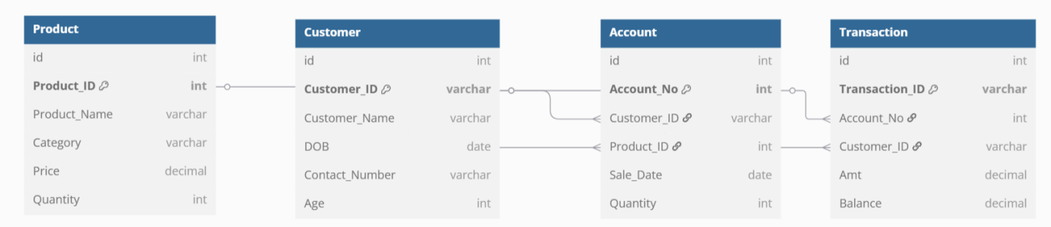

Question 7: What is a data flow diagram? Draw a data flow diagram to represent the in-flow and out-flow of data when a Farmer is placing an order for the product
Answer:
Data Flow diagram represents how the data flows through a system visually. It helps us understand how the data we input transforms into output results. It shows how the Processes, data, external factors flow.

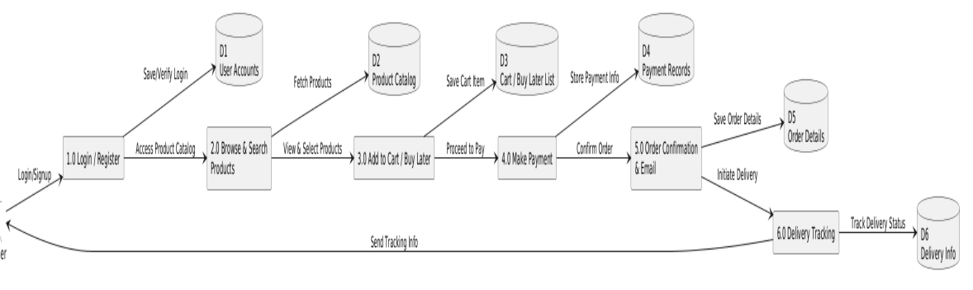
Question 8: Due to change in the Government Taxation structure. we should change the Tax structure How do you handle change requests in a project?
Answer: A "change request" is a formal proposal for an alteration to a product, system, or project, often initiated by a client or team member, and requiring a structured process for evaluation and approval.
Here's a breakdown of what a change request is and its key aspects:
- Definition:
A change request is a formal document that outlines a proposed modification to a project, system, or product.
- Purpose:
It serves as a mechanism to manage changes during a project's lifecycle, ensuring that any alterations are documented, assessed for impact, and approved before implementation.
- Common Scenarios:
Change requests can arise when a client wants to modify the scope, schedule, budget, or quality of a project, or when a team member identifies a need for an improvement or correction.
- Key Elements of a Change Request:
  - Project Name: Clearly identifies the project to which the change request applies.
  - Request Number: A unique identifier for the change request.
  - Requester: The individual or team initiating the change request.
  - Description of the Change: A detailed explanation of the proposed modification.
  - Reason for the Change: Justification for why the change is needed.
  - Impact of the Change: Assessment of the potential effects of the change on the project's scope, schedule, budget, and quality.
  - Proposed Action: The specific steps or actions required to implement the change.
  - Business Priority: The importance of the change in relation to the overall project goals.
- Change Request Process:
  - Collect Information: Gather all necessary documentation and information related to the proposed change.
  - Evaluate Impact: Assess the potential impact of the change on the project.
  - Prioritize: Determine the priority of the change request based on its importance and urgency.
  - Approve or Reject: Review and either approve or reject the change request.
  - Plan Implementation: If approved, plan the implementation of the change.
- Types of Changes:
  - Standard Changes: Re-authorized, low-risk changes that follow a well-known procedure.
  - Emergency Changes: Changes that must be implemented immediately, for example, to resolve a major incident.
  - Normal Changes: All other changes that are not standard or emergency changes.

To effectively handle change requests, establish a clear process, collect necessary information, evaluate the impact, prioritize requests, seek approval, and communicate and implement approved changes, ensuring transparency and documentation throughout.
Here's a more detailed breakdown of how to handle change requests:
1. Establish a Clear Process:
- Formalize the Process:
Develop a structured approach for handling change requests, including a change request form or template.
- Define Roles and Responsibilities:
Clearly outline who is responsible for submitting, reviewing, approving, and implementing change requests.
- Communicate the Process:
Ensure all stakeholders are aware of the change request process and how to submit requests.
- Use Change Management Tools:
Consider using project management software or dedicated change management tools to streamline the process.
2. Collect Information:
- Gather Documentation: Request all relevant supporting materials, including the reason for the change, its scope, and potential impact.
- Determine Scope: Clearly define whether the change is within or outside the project scope.
- Assess Priority: Have your team assess the priority of the change request based on its importance and urgency.
3. Evaluate and Prioritize:
- Impact Assessment:
Evaluate the potential impact of the change on project scope, schedule, budget, and resources.
- Risk Analysis:
Identify potential risks associated with implementing the change and develop mitigation strategies.
- Prioritize Requests:
Determine which change requests should be addressed first based on their importance and feasibility.
4. Seek Approval:
- Obtain Sign-Off:
Ensure that all necessary stakeholders and approvals are obtained before implementing the change.
- Document Decisions:
Record all decisions related to change requests, including approvals, rejections, and reasons.
5. Communicate and Implement:
- Inform Stakeholders:
Communicate the status and outcome of each change request to all relevant stakeholders.
- Plan Implementation:
Develop a plan for implementing the approved change, including timelines, resources, and responsibilities.
- Monitor Progress:
Track the progress of the change implementation and address any issues that arise.
6. Document and Close:
- Document the Outcome: Document the outcome of the change request, including the reasons for the change, the implementation process, and any lessons learned.
- Close the Request: Once the change is implemented and verified, close the change request.
- What is Change Request Management

Question 9: As the project is in process, Ben and Kevin have contacted you. The reason is to inform you that they want the Farmers to sell their crop yields through this application i.e. Farmers should be able to add their crop yields or products and display to general public and should be able to sell them. They also want to introduce Auction system for their Crop yields. As a BA, what will be your response?
Is this a change request or an enhancement???
Answer:
This is not a small change. We consider it as an enhancement because it’s a new feature altogether and it’s a great opportunity for the farmers to sell their yield online and an auction system would help them even better.
In order for us to implement this, we need to use new workflows, new procedures.
This becomes a new requirement that requires new feature development on the app and add new screens and pages and we need to check if it is feasible even before getting into development.
We need to see how its going to benefit the farmers and the buyers as well and also check what can be sold and report our findings to the stakeholders and get an approval from them.

Question 10: Come up with estimations – How many Man hours required
Answer:
Estimated Manhours:
BA – 20 Hours – gather req, sort, validate, document, approval
Developers – 200 Hours
Database design – 20 Hours
Testing – 80 Hours
Deployment – 30 Hours
Total hours – 320 Man hours
Question 11: Project has finally completed all the stages i.e., design, development, testing etc. Now, it is the role of a business analyst to contact the client for testing of the final product and have to successfully complete it. How are you going to handle this situation? And once it is done, what will be the process to close the project?
Explain UAT Acceptance process
Answer: We will handle by performing UAT.
User Acceptance Testing (UAT) is a crucial phase in software development where real users test the software to ensure it meets their needs and expectations before deployment, validating functionality and usability in real-world scenarios.
Here's a more detailed breakdown of the UAT process:
Purpose of UAT:
- Validation, not Verification:
UAT focuses on validating that the software meets the business requirements and user needs, rather than just verifying that it functions correctly according to specifications.
- Early Issue Detection:
UAT helps identify and address potential issues and discrepancies before the software is released to the end-users, saving time and resources.
- Improved User Experience:
By involving real users in the testing process, UAT ensures that the software is user-friendly and meets the needs of the target audience.
- Reduced Post-Release Issues:
Thorough UAT can significantly reduce the number of issues that arise after the software is released, improving user satisfaction and product credibility.
Key Steps in the UAT Process:
- 1. Planning and Preparation:
  - Define Scope: Determine the scope of UAT, including which features and functionalities will be tested.
  - Identify Testers: Select a representative group of end-users or stakeholders to participate in UAT.
  - Create a UAT Plan: Develop a comprehensive plan that outlines the objectives, scope, test cases, and expected outcomes of UAT.
  - Prepare the Test Environment: Set up a test environment that closely mirrors the production environment to ensure realistic testing conditions.
- 2. Test Case Development:
  - Develop Test Cases: Create detailed test cases that cover all key functionalities and scenarios, based on user requirements and business needs.
  - Prioritize Test Cases: Prioritize test cases based on their importance and potential impact on the user experience.
- 3. Execution and Reporting:
  - Execute Test Cases: Conduct UAT by having users interact with the software in a real-world context.
  - Record and Report Defects: Document any defects or issues identified during UAT, along with details on how to reproduce them.
  - Prioritize Defects: Prioritize defects based on their severity and impact on the user experience.
- 4. Defect Resolution and Re-testing:
  - Address Defects: Developers should address and fix the identified defects, and then re-test the software to ensure that the issues have been resolved.
- 5. Sign-Off and Release:
  - Obtain Sign-Off: Once all critical defects have been resolved and the software is deemed ready, obtain sign-off from the users or stakeholders to proceed with the release.
  - Release the Software: Deploy the software to the production environment.

Benefits of UAT:
- Improved Software Quality:
UAT helps ensure that the software is of high quality and meets the needs of the end-users.
- Reduced Costs:
Identifying and resolving issues early in the development process can save significant time and costs.
- Increased User Satisfaction:
UAT helps ensure that the software is user-friendly and meets the needs of the target audience, leading to increased user satisfaction.
- Enhanced Product Credibility:
A well-tested product that meets user expectations enhances the credibility of the product and the organization.
After successful User Acceptance Testing (UAT), project closure involves obtaining sign-off, documenting test results, addressing any remaining issues, and preparing for the final release, ensuring a smooth transition to production.
Here's a more detailed breakdown of the project closure process after UAT:
1. Obtain Sign-Off:
- Document Tester Approval:
After UAT, the most crucial step is to document the tester's approval, signifying that the system meets business requirements and is ready for deployment.
- Sign-Off Methods:
Consider using email approvals (perhaps with voting buttons) or physical signatures, depending on your company's culture and communication style.
- Assign Responsibility:
Assign one or more team members to collect sign-offs from testers, ensuring that all necessary approvals are obtained.
- Communicate Next Steps:
Proactively explain the next steps of the project to the testers to address any concerns about abandonment and ensure a smooth transition.
2. Document Test Results and Finalize Reports:
- Create a Comprehensive Report: Compile all test results, including defect reports, bug-fix verifications, and any other relevant documentation.
- Include Out-of-Scope Testing: Mention any out-of-scope testing or retests from previous UAT cycles.
- Sign-Off on the Report: Ensure that all relevant stakeholders sign off on the final UAT report, confirming that the planned tests were conducted and any outstanding issues are addressed.
3. Address Remaining Issues and Prepare for Release:
- Prioritize and Resolve Bugs:
Address any remaining critical or high-priority defects identified during UAT.
- Finalize Release Plan:
Prepare the final release plan, including deployment procedures, rollback plans, and communication strategies.
- User Training and Documentation:
Arrange for user training and ensure that all necessary documentation is finalized and readily available.
- Prepare for Post-Release Support:
Plan for post-release support, including feedback processing infrastructure and a clear process for addressing user queries.
4. Project Closure:
- Finalize Project Documentation: Ensure all project documentation, including test plans, test cases, and final reports, are archived and accessible.
- Conduct a Post-Project Review: Evaluate the project's success, identify lessons learned, and make recommendations for future projects.
- Release the Product: Deploy the product to production, following the finalized release plan.
User Acceptance Testing (UAT) Process Explained -
Question 12: Explain Project closure document
Answer: Project closure document means a detailed report of what has happened in the project including achievements, lessons learned, achievements, Quality assurance, resources utilized, risk management, challenges faced.

S No | Points to Include | Details | Reference link
1 | Did the client sign off on UAT
 | Date of sign off | 25/04/2025
 | Name of the resource | Mr. Pandu
2 | Objectives of the project
 | Farmers to be able to buy/sell products | Achieved
 | User friendly app | Achieved
3 | Functional worked on
 | Payment processing | Achieved
 | Adding category list | Achieved
 | Manufacturers selling products | Achieved
 | Delivery tracking | Achieved
4 | Infrastructure
 | Software Installed | Achieved
 | Laptops Purchased | Achieved
5 | Funding
 | Amount approved | 2 Crores
 | Amount Used | 1,87,58,318
6 | Overall Project Information
 | Escalations | 53
 | Customer satisfaction | High
7 | Value to the company
 | Positive | Farmers are able to buy products online very easily  More number of farmers started using the app

