Assignment 1:
Q 1. Please make a BRD which can be presented to the client along with complete development and resource plan.
Business Requirements Document (BRD)
Project Title: Inventory and Delivery Optimization System
Client: Fluent Grid Ltd.
Prepared By: Venkatesh Dhanana, Business Analyst
Date: 30-07-2025
Document Revision
Sr. No | Document Title | Version No:
1. | Current Process documents | 1.0, 1.1, 1.2
2. | Company policies | 1.1 to 2.1
3.

Approvals
Role | Name | Signature | Date (MMDDYY)
Project Sponsor | Mr. Manoj Kumar | Manoj | 07-10-25
Business Owner | Mr. James | James | 07-10-25
Project Manager | Mr. Kiran Kumar | Kiran | 07-11-25

1. Business Goal / Summary
Fluent Grid Ltd. operates manufacturing plants and warehouses across various regions to produce and distribute ice cream and milk products. The company is seeking to develop a software solution that will:
- Efficiently manage inventory levels across all locations.
- Enabling fastest delivery to customers using optimized routing and logistics tracking
The proposed system will centralize inventory visibility and automate logistics planning to reduce delays, minimize waste and improve customer satisfaction.

2. Business Objectives
- Gain real-time visibility into inventory levels across plants and warehouses.
- Optimize product distribution to ensure faster deliveries.
- Automate stock transfers between warehouses to meet demand.
- Minimize inventory wastage due to expiry.
- Enable advanced order tracking and delivery status updates for customers.
- Provide centralized reporting and decision-support dashboards.

3. Project Scope
In Scope
- Real-time inventory tracking
- Demand forecasting module
- Delivery route optimization
- Stock transfer management
- Integration with existing ERP (if any)
- Customer order and delivery tracking
- Mobile access for warehouse and delivery staff
- Alerts and notifications (e.g., low stock, delayed deliveries)
- Dashboard for operations team and management
Out of Scope
- HR or payroll management
- Financial accounting system (unless integration required)

4. Stakeholders
Name | Role | Responsibility
Client Sponsor | Project Sponsor | Budget approval, strategic decisions
Plant Managers | Operations Stakeholders | Provide inventory process inputs
Logistics Head | Delivery & Distribution | Provides delivery routing requirements
IT Manager | Technical Representative | Coordinates system integration
Venkatesh D | Business Analyst | Requirement gathering & documentation
Development Team | Software Engineers | System design and development
QA Team | Testers | System testing and validation

5. Business Requirements
ID | Requirement Description | Priority
BR1 | Track stock levels at each plant/warehouse in real-time | High
BR2 | Automatically generate low-stock alerts | High
BR3 | Enable transfer of stock between warehouses | Medium
BR4 | Allow placing and managing customer orders | High
BR5 | Assign orders to nearest warehouse with available stock | High
BR6 | Optimize delivery route based on customer location | High
BR7 | Track delivery vehicle status in real-time | Medium
BR8 | Generate MIS reports for stock, orders and delivery | Medium
BR9 | User role management and access control | Medium

6. Functional Requirements
Inventory Management
- FR1: The system shall provide real-time inventory updates from all locations.
- FR2: The system shall allow warehouse managers to update stock movements.
- FR3: The system shall raise alerts for low stock or stock expiry.
- FR4: The system shall support inter-warehouse stock transfers.
Order Management & Delivery
- FR5: The system shall capture and validate customer orders.
- FR6: The system shall suggest the best warehouse to fulfil the order.
- FR7: The system shall optimize the delivery route based on location and stock.
- FR8: The system shall update delivery status in real-time.
- FR9: The system shall send delivery confirmation to customers.
Reporting and Dashboards
- FR10: The system shall generate daily, weekly and monthly stock reports.
- FR11: The system shall show KPIs like delivery time, order fulfilment rate and wastage.

7. Non-Functional Requirements
NFR ID | Requirement
NFR1 | System should be accessible 24/7 with 99.9% uptime
NFR2 | Response time for dashboards should be <3 seconds
NFR3 | Support 100+ concurrent users
NFR4 | Compatible with mobile, tablet, desktop
NFR5 | Ensure data encryption and access control for all sensitive data

8. Assumptions and Constraints
- All warehouses and plants will have internet connectivity.
- API access will be available for integration with existing ERP systems.
- Delivery personnel will use smartphones to update status.

9. Development Plan
Methodology: Agile Scrum (2-week sprints)
Phase | Timeline | Key Deliverables
Requirement Gathering | Week 1 – Week 2 | BRD, Use Case Diagrams, Feature List
UI/UX Design | Week 3 – Week 4 | Mock-ups, Wireframes
Development Sprint 1 | Week 5 – Week 6 | Inventory Module (Basic)
Development Sprint 2 | Week 7 – Week 8 | Order & Delivery Module
Development Sprint 3 | Week 9 – Week 10 | Reports & Dashboard
Testing & UAT | Week 11 – Week 12 | Test Cases, Bug Fixing
Go-Live & Training | Week 13 | Deployment, User Manuals
Post-Deployment Support | Week 14 – Week 16 | Bug Fixes, Minor Enhancements
Total Duration: 16 Weeks

10. Resource Plan
Role | Resource Count | Responsibility
Business Analyst | 1 | Requirements, Stakeholder Communication
UI/UX Designer | 1 | Design Mockups & User Interface
Backend Developers | 2 | API and DB development
Frontend Developer | 1 | Web & Mobile UI development
Tester (QA) | 1 | Test plan creation and execution
DevOps/Deployment | 1 | CI/CD pipeline, Hosting
Project Manager | 1 | Planning, Monitoring, Risk Management

11. Risk Management
Risk | Mitigation Plan
Delay in requirements finalization | Conduct early workshops with key stakeholders
Integration challenges | Early technical feasibility assessment
Resistance to change | Include training and pilot testing
Network/infrastructure issues | Recommend cloud-based solution with offline support

12. Approval Sign-Off
Name | Role | Signature & Date
Manoj Kumar | Project Sponsor
Venkatesh Dhanana | Business Analyst
Kiran Kumar | Project Manager

Q 2. Prepare process flow diagram using your imagination
Process flow diagram for entire process – From Receiving customer ordering to delivering the product to customer.
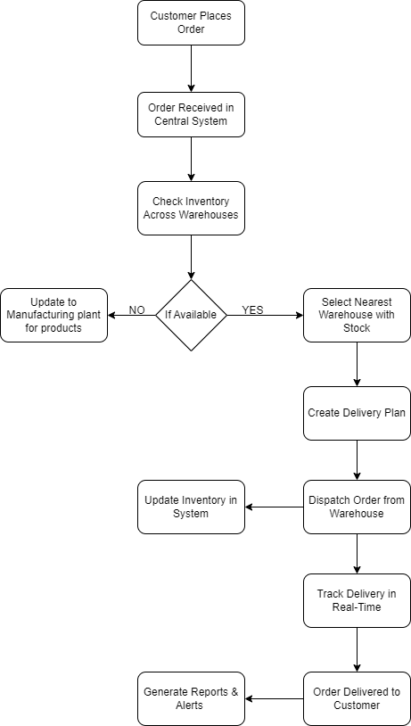

Process Flow diagram - Manufacturing to Warehouse Flow
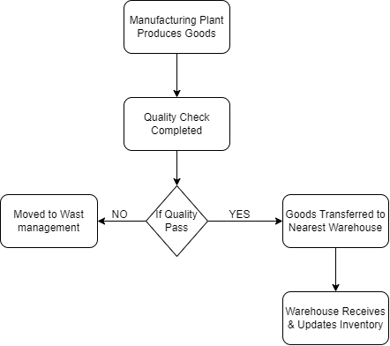

Process Flow diagram - Inventory Rebalancing (if stock is low in one warehouse)
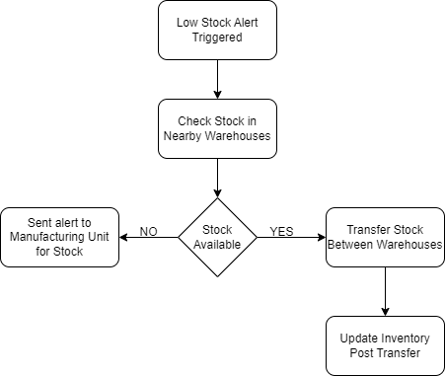

Assignment 2:
Q 1. Write an introduction letter to a client introducing yourself as a business analyst in charge of working with the client and his team to start the business understanding process.
Subject: Introduction – Business Analyst Assigned to Your Project
Dear Fluent Grid Ltd.,
I hope this message finds you well.
My name is Venkatesh Dhanana, and I am pleased to introduce myself as the Business Analyst assigned to work with you and your team on “Inventory and Delivery Optimization System”.
As part of this engagement, I will be your primary point of contact for gathering and analysing business requirements, understanding your goals and expectations and translating them into clear, actionable documentation for our development and delivery teams. Our shared objective is to ensure that the final solution aligns seamlessly with your business needs and adds real value to your operations.
Over the coming days, I would like to schedule initial discussions to kick off the business understanding phase, where we can walk through your current processes, challenges and desired outcomes. Your insights will be key to shaping the right solution.
Please feel free to share any relevant documents or background materials in advance, and let me know your availability for an introductory meeting.
Looking forward to collaborating with you.
Warm regards,
Venkatesh Dhanana
Business Analyst
xyz company
abcdefg.gmail.com | 987 *** ****

Q 2. Prepare a brief BRD and SRS for a project Online Horoscope.
Business Requirements Document (BRD)
Project Title: Online Horoscope
Prepared By: Venkatesh D
Client: Know Your Horoscope
Date: 31-07-2025
Document Revision
Sr. No | Document Title | Version No:
1. | Current Process documents | 1.0, 1.1, 1.2
2. | Company policies | 1.1 to 2.1
3.

Approvals
Role | Name | Signature | Date (MMDDYY)
Project Sponsor | Mr. Manoj Kumar | Manoj | 07-10-25
Business Owner | Mr. James | James | 07-10-25
Project Manager | Mr. Kiran Kumar | Kiran | 07-11-25

1. Business Goal / Summary
The Online Horoscope project aims to build a web and mobile application that provides personalized horoscopes based on users' birth details. It will generate daily, weekly, monthly and yearly predictions and allow users to consult astrologers for deeper insights.

2. Business Objectives
- Offer personalized horoscope readings based on date, time and place of birth.
- Provide daily, weekly, monthly, and yearly forecasts.
- Allow users to generate and download birth charts (Kundali).
- Enable live chat or call consultations with astrologers.
- Drive revenue through subscriptions and pay-per-use consultations.

3. Project Scope
In Scope
- User registration and profile creation
- Horoscope generation (daily, weekly, etc.)
- Birth chart (Kundali) creation
- Astrologer booking and consultation
- Payment gateway integration
- Admin panel for content and astrologer management
Out of Scope
- Integration with third-party astrology platforms (unless specified)
- Non-English language support (initially)

4. Stakeholders
Name | Role | Responsibility
Client Sponsor | Business Owner | Defines goals and budget
End Users | Customers | Use horoscope and consultation
Astrologers | Service Providers | Offer consultations
Business Analyst | Venkatesh Dhanana | Requirements gathering
Development Team | Engineers | Build the application
QA Team | Testers | Validate functionality

5. Functional Requirements
- User login, registration, and profile management
- Horoscope display module
- Astrology calculation module (Kundli, predictions)
- Appointment and chat module with astrologers
- Admin dashboard for content and astrologer management
- Payment and subscription module

6. High-Level Functional Requirements
- FR1: Users can register and log in securely.
- FR2: Users can input their birth details to receive horoscopes.
- FR3: System generates personalized horoscopes.
- FR4: Users can download their birth chart.
- FR5: Users can book consultation sessions with astrologers.
- FR6: Payments can be made for subscriptions or consultations.
- FR7: Admins can manage users, astrologers, and content.

7. Non-Functional Requirements
- NFR1: Platform must support 24/7 availability
- NFR2: Mobile responsiveness for all screens
- NFR3: Encryption for user DOB/time/place and payment data
- NFR4: Prediction delivery latency < 2 seconds
- NFR5: Must support 50,000+ active users in phase 1
8. Assumptions and Constraints
- Prediction logic and astrology content will be provided by certified astrologers.
- The application will initially support English; multilingual support is a future enhancement.
- The platform will follow Indian astrology (Vedic) for the initial version.
Software Requirements Specification (SRS)
Project Title: Online Horoscope
Version: 1.0
Date: 31-07-2025
Prepared By: Venkatesh Dhanana

1. Introduction
1.1 Purpose
This document outlines the functional and non-functional requirements for the Online Horoscope application.
1.2 Intended Audience
- Project Managers
- Developers
- Testers
- Stakeholders
1.3 Product Scope
The product will deliver astrological predictions and consultation services through a digital platform for global users.

2. Functional Requirements
ID | Requirement
FR1 | The system shall allow users to register using email/mobile.
FR2 | The system shall authenticate users with password/OTP.
FR3 | The system shall accept birth details to generate horoscopes.
FR4 | The system shall display daily, weekly, monthly, and yearly predictions.
FR5 | The system shall generate a downloadable birth chart (PDF).
FR6 | The system shall allow users to book and schedule consultations.
FR7 | The system shall support online payments for services.
FR8 | The system shall provide an admin dashboard to manage users and astrologers.

3. Non-Functional Requirements
ID | Requirement
NFR1 | The application shall be available 24/7 with 99.9% uptime.
NFR2 | The application shall support at least 10,000 concurrent users.
NFR3 | The system shall encrypt user data and payment details.
NFR4 | The mobile version shall be responsive on Android and iOS.
NFR5 | The application shall load pages in less than 3 seconds.

4. External Interfaces
Type | Description
API Integration | Planetary data APIs for astrological calculations
Payment Gateway | Razorpay, Stripe or PayPal for processing payments
Calendar API | To manage astrologer availability and booking slots

5. Constraints
- Initial launch will be in English only.
- No third-party astrology engine unless APIs are verified.
- Cloud hosting will be used (e.g., AWS/Azure).

Q 3. Make an ERD of creating a support ticket/Ticketing life cycle.
Key Entities in the Ticketing System
- User: A person who raises support tickets.
- Ticket: The issue or request being raised.
- Category: Classification of tickets (e.g., Technical, Billing).
- Priority: Level of urgency (e.g., Low, Medium, High, Critical).
- Status: Current state of the ticket (e.g., Open, In Progress, Resolved, Closed).
- Support Agent: A staff member who handles tickets.
- Ticket History: Tracks updates to the ticket over time.
- Attachment: Optional files/images associated with tickets.
Key Relationships:
- A User creates many Tickets.
- A Ticket belongs to one Category, Priority and Status and is assigned to one Support Agent.
- A Ticket can have many Attachments and Ticket History records.
- A User can also appear as the Changed_By in Ticket History.

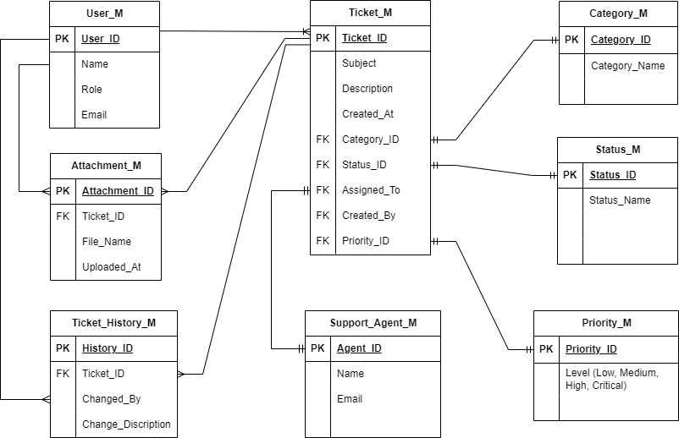

Q 4. Create 40 user stories of shopping from e-commerce.
Browsing & Searching Products
User Story 1: Search products using category
Priority: High
Statement:
As a user,
I want to browse products by category,
So that I can easily find what I need.
BV: 1000 CP: 8
Acceptance Criteria:
- Given I am on the homepage,
- When I click on a category,
- Then I should see a list of products under that category.

User Story 2: Search products using keywords
Priority: High
Statement:
As a user,
I want to search for products using keywords,
So that I can quickly find specific items.
BV: 500 CP: 5
Acceptance Criteria:
- Given I enter a search term,
- When I press enter,
- Then I should see products related to the term.

User Story 3: Filter products using price range
Priority: Medium
Statement:
As a user,
I want to filter products by price, brand and rating,
So that I can narrow down my choices.
BV: 500 CP: 5
Acceptance Criteria:
- Given I apply a price filter,
- When the product list updates,
- Then only products in that range are displayed.

User Story 4: Sort products by price / Popularity
Priority: Low
Statement:
As a user,
I want to sort products by price and popularity,
So that I can find the best deals.
BV: 200 CP: 5
Acceptance Criteria:
- Given I select “Price” / "Popularity" sort,
- When the list reloads,
- Then the most popular or Low price items appear first.

User Story 5: View products details
Priority: Medium
Statement:
As a user,
I want to view product details,
So that I can decide if it meets my needs.
BV: 500 CP: 5
Acceptance Criteria:
- Given I click on a product,
- When I view the product page,
- Then I see name, price, description, reviews and images

Cart Management
User Story 6: Adding items to Cart
Priority: High
Statement:
As a user,
I want to add items to the cart,
So that I can purchase multiple items in one order.
BV: 1000 CP: 13
Acceptance Criteria:
- Given I click "Add to Cart",
- When the item is added,
- Then the cart icon updates with the correct count.

User Story 7: Removing items from Cart
Priority: Medium
Statement:
As a user,
I want to remove items from the cart,
So that I can change my mind before purchasing.
BV: 500 CP: 8
Acceptance Criteria:
- Given I click "Remove" on an item,
- When the cart refreshes,
- Then the item no longer appears and subtotal updates.

User Story 8: Edit quantity in Cart
Priority: Medium
Statement:
As a user,
I want to edit item quantities in my cart,
So that I can buy more or less as needed.
BV: 500 CP: 8
Acceptance Criteria:
- Given I change the quantity,
- When I update,
- Then the subtotal and total adjust accordingly

User Story 9: View the Cart
Priority: Low
Statement:
As a user,
I want to view my cart,
So that I can review selected items.
BV: 100 CP: 8
Acceptance Criteria:
- Given I click the cart icon,
- When the cart page loads,
- Then I see item names, prices, quantities and subtotal.

User Story 10: Cart to persist
Priority: High
Statement:
As a user,
I want the cart to persist across sessions,
So that I don’t lose items if I close the browser.
BV: 500 CP: 5
Acceptance Criteria:
- Given I add items to cart and log out,
- When I log back in,
- Then my cart still contains the items.

User Account & Authentication
User Story 11: Signing Up
Priority: High
Statement:
As a new user,
I want to sign up with email/mobile,
So that I can create an account.
BV: 1000 CP: 8
Acceptance Criteria:
- Given I provide valid details,
- When I submit the registration form,
- Then my account is created and I'm logged in.

User Story 12: Secure Login
Priority: High
Statement:
As a returning user,
I want to log in securely,
So that I can access my account and orders.
BV: 500 CP: 5
Acceptance Criteria:
- Given I enter correct credentials,
- When I log in,
- Then I’m redirected to my account page.

User Story 13: Password Reset
Priority: High
Statement:
As a user,
I want to reset my password,
So that I can regain access if I forget it.
BV: 1000 CP: 8
Acceptance Criteria:
- Given I click "Forgot Password",
- When I enter my email,
- Then I receive a reset link.

User Story 14: Profile Update
Priority: Medium
Statement:
As a user,
I want to update my profile,
So that my personal information is current.
BV: 500 CP: 5
Acceptance Criteria:
- Given I edit my profile,
- When I save changes,
- Then the system updates my information.

User Story 15: Order history
Priority: Low
Statement:
As a user,
I want to view my order history,
So that I can track past purchases.
BV: 100 CP: 8
Acceptance Criteria:
- Given I'm logged in,
- When I go to "Order History",
- Then I see a list of previous orders.

Checkout & Payment
User Story 16: Placing order
Priority: High
Statement:
As a user,
I want to proceed to checkout from the cart,
So that I can place my order.
BV: 500 CP: 5
Acceptance Criteria:
- Given I have items in my cart,
- When I click "Checkout",
- Then I’m taken to the checkout page.

User Story 17: Choosing Address
Priority: High
Statement:
As a user,
I want to choose a shipping address,
So that the order reaches the correct location.
BV: 500 CP: 8
Acceptance Criteria:
- Given I have saved addresses,
- When I choose one,
- Then it is selected for this order.

User Story 18: Payment method selection
Priority: High
Statement:
As a user,
I want to select a payment method,
So that I can complete the transaction.
BV: 500 CP: 5
Acceptance Criteria:
- Given I'm on payment page,
- When I choose a method and submit,
- Then payment is processed securely.

User Story 19: Order confirmation
Priority: High
Statement:
As a user,
I want to receive an order confirmation,
So that I know my order was placed.
BV: 1000 CP: 13
Acceptance Criteria:
- Given my payment is successful,
- When the confirmation page loads,
- Then I receive an email and reference number.

User Story 20: Coupon selection
Priority: Medium
Statement:
As a user,
I want to use coupons at checkout,
So that I can get discounts.
BV: 100 CP: 13
Acceptance Criteria:
- Given I apply a valid coupon code,
- When the discount is applied,
- Then the total is reduced accordingly.

Order Management
User Story 21: Checking past orders
Priority: Medium
Statement:
As a user,
I want to view my past orders,
So that I can track my purchase history.
BV: 100 CP: 8
Acceptance Criteria:
- Given I click on ‘Orders History’,
- When I click order item
- Then purchase details should be available

User Story 22: Choosing Address
Priority: Medium
Statement:
As a user,
I want to track my current order,
So that I know when it will arrive.
BV: 100 CP: 5
Acceptance Criteria:
- Given I view order details,
- When the status changes,
- Then I see updates like "Shipped", "Out for Delivery".

User Story 23: Cancel Order
Priority: High
Statement:
As a user,
I want to cancel an order before shipping,
So that I can change my mind.
BV: 500 CP: 8
Acceptance Criteria:
- Given my order is still "Processing",
- When I click "Cancel",
- Then the order is cancelled and refund initiated.

User Story 24: Reorder
Priority: High
Statement:
As a user,
I want to reorder previous purchases,
So that I can quickly buy again.
BV: 500 CP: 8
Acceptance Criteria:
- Given I’m in "Order History",
- When I click "Reorder",
- Then items are added to my cart.

User Story 25: Shipping updates notifications
Priority: Medium
Statement:
As a user,
I want to receive notifications for shipping updates,
So that I’m informed.
BV: 500 CP: 8
Acceptance Criteria:
- Given my order is shipped,
- When status updates occur,
- Then I receive SMS/email notifications.

Reviews & Feedback
User Story 26: Writing own experience
Priority: High
Statement:
As a user,
I want to write a review for a product,
So that I can share my experience.
BV: 500 CP: 8
Acceptance Criteria:
- Given I opened the product from order history,
- When click on write review,
- Then it should allow to write my experience in the product.

User Story 27: Reading Customer reviews
Priority: Low
Statement:
As a user,
I want to read customer reviews,
So that I can make informed decisions.
BV: 50 CP: 3
Acceptance Criteria:
- Given I open a product page,
- When I scroll down,
- Then I see all submitted reviews.

User Story 28: Product Rating
Priority: Medium
Statement:
As a user,
I want to rate a product,
So that others can benefit from my feedback.
BV: 100 CP: 5
Acceptance Criteria:
- Given I’ve purchased a product,
- When I go to the product page,
- Then I can leave a star rating and comment.

User Story 29: Report on fake reviews
Priority: Low
Statement:
As a user,
I want to report inappropriate reviews,
So that the platform stays trustworthy.
BV: 20 CP: 5
Acceptance Criteria:
- Given I see a suspicious review,
- When I click "Report",
- Then the admin is notified for review.

User Story 30: View average ratings
Priority: Medium
Statement:
As a user,
I want to view average ratings of products,
So that I can identify best-rated items.
BV: 500 CP: 8
Acceptance Criteria:
- Given I’m on a listing or product page,
- When I view ratings,
- Then I see the average of all user ratings.

Admin or Back Office
User Story 31: Add Product
Priority: High
Statement:
As an admin,
I want to add new products,
So that customers have new items to buy.
BV: 1000 CP: 13
Acceptance Criteria:
- Given I enter product info,
- When I save it,
- Then the product shows on the site.

User Story 32: Manage Inventory
Priority: High
Statement:
As an admin,
I want to update product inventory,
So that stock levels are accurate.
BV: 500 CP: 8
Acceptance Criteria:
- Given I enter Inventory tab,
- When I save it,
- Then the Stock details are updated.

User Story 33: Manage user
Priority: High
Statement:
As an admin,
I want to manage user accounts,
So that I can assist or block when needed.
BV: 500 CP: 8
Acceptance Criteria:
- Given I’m in admin panel,
- When I search for a user,
- Then I can edit, suspend or delete the account.

User Story 34: Update product
Priority: High
Statement:
As an admin,
I want to edit or delete products,
So that the catalogue is accurate.
BV: 500 CP: 8
Acceptance Criteria:
- Given I access the product list,
- When I make changes,
- Then it reflects immediately.

User Story 35: Order report
Priority: Medium
Statement:
As an admin,
I want to view order reports,
So that I can analyse performance.
BV: 100 CP: 8
Acceptance Criteria:
- Given I’m in the reports section,
- When I filter by date range,
- Then I see revenue, orders and returns.

Security & Privacy
User Story 36: Payment details to be secure
Priority: High
Statement:
As a user,
I want my payment information to be encrypted,
So that my data stays safe.
BV: 500 CP: 8
Acceptance Criteria:
- Given I enter card info,
- When I pay,
- Then it's encrypted and never stored.

User Story 37: Safe logout
Priority: High
Statement:
As a user,
I want to log out securely,
So that others cannot access my account.
BV: 500 CP: 5
Acceptance Criteria:
- Given I click "Logout",
- When I confirm,
- Then I’m signed out and redirected.

User Story 38: Order confirmation to Email
Priority: Medium
Statement:
As a user,
I want to receive order confirmation by email,
So that I have proof.
BV: 200 CP: 5
Acceptance Criteria:
- Given I place an order,
- When it completes,
- Then I receive an email with invoice.

User Story 39: Product Wish listing
Priority: Low
Statement:
As a user,
I want to save my favourite products,
So that I can revisit them later.
BV: 20 CP: 8
Acceptance Criteria:
- Given I’m logged in,
- When I click "Add to Wish list",
- Then it appears in my favourites.

User Story 40: Manage notification
Priority: Low
Statement:
As a user,
I want to manage notifications,
So that I control what I receive.
BV: 50 CP: 5
Acceptance Criteria:
- Given I go to notification settings,
- When I toggle options,
- Then I receive only selected alerts.

