Waterfall Project2 – Part -2/2

Document 6- Please prepare a use case diagram, activity diagram and a use case specification document.
Use Case Diagram:
Use Case Description-
This use case describes how a user interacts with the payment transaction automation system to receive, track, and process payment requests that were previously handled manually via email and Outlook folders. The system ensures that no transaction is missed or delayed by automating the import, tracking, and processing workflow. It includes alert mechanisms for missed requests and provides a structured interface for users to validate and post transactions.

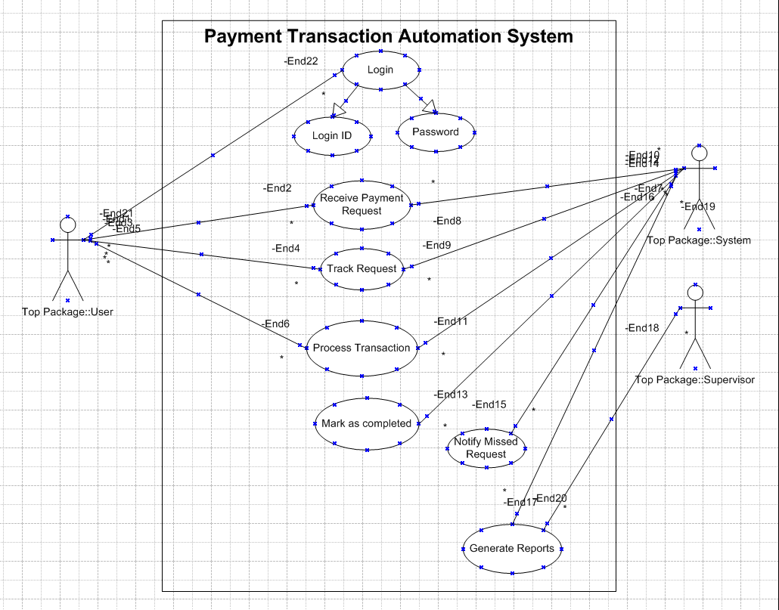

Activity Diagram:
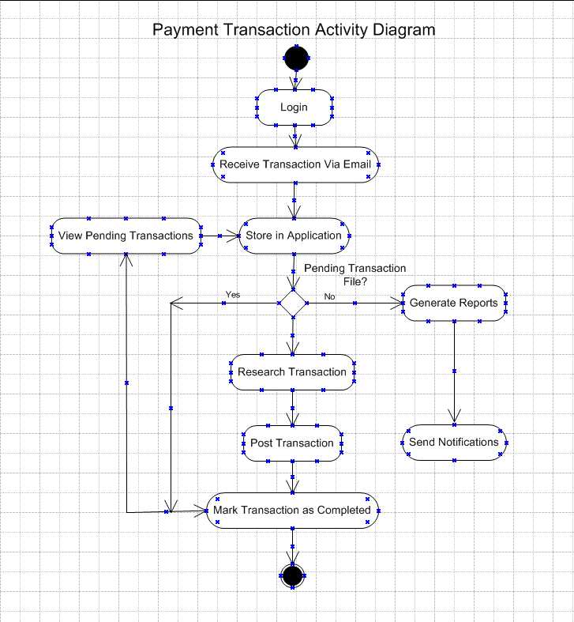

Use Case Specification:

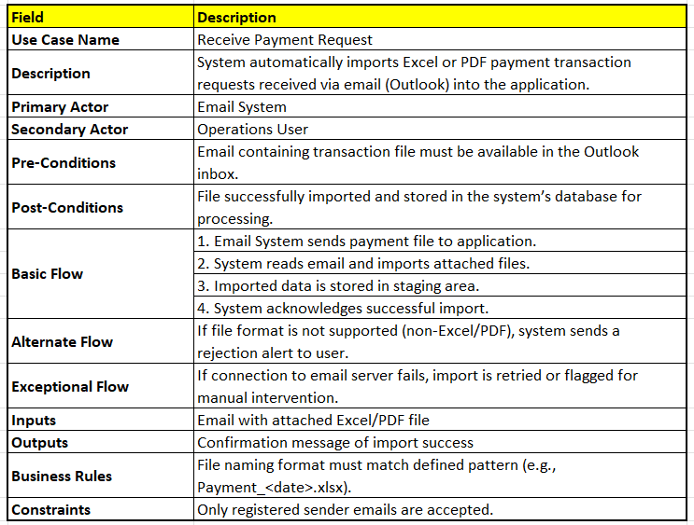
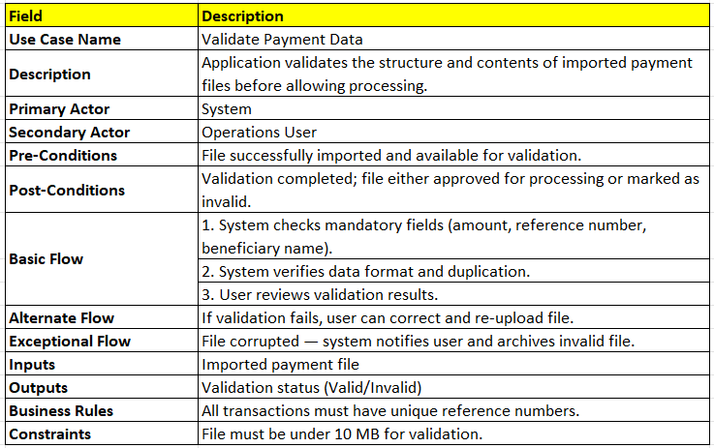
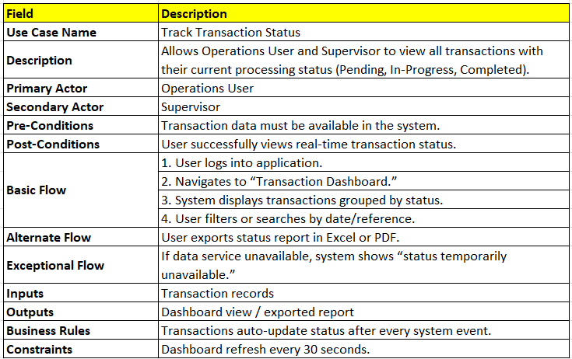
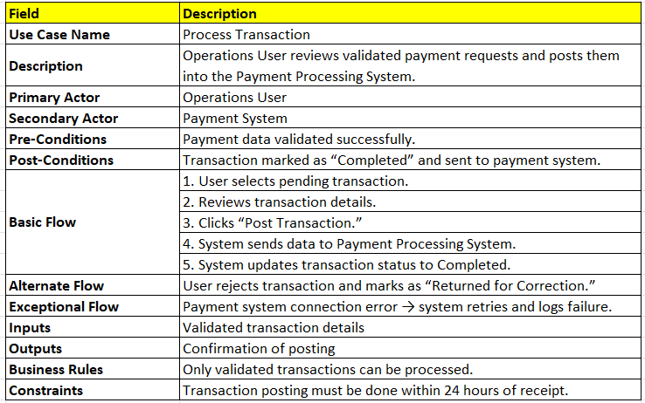
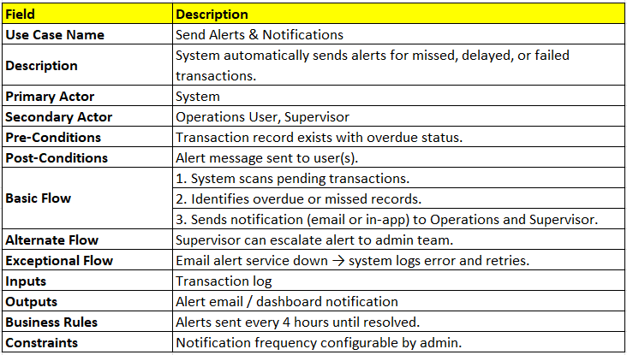
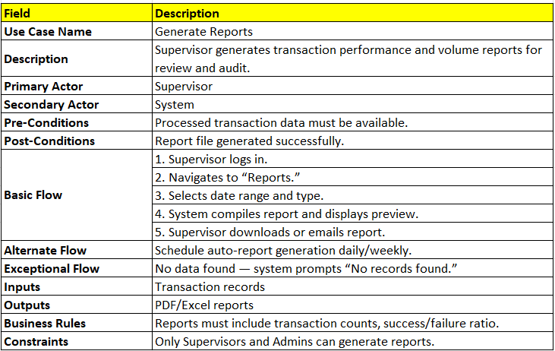

Document 7- Screens and pages:
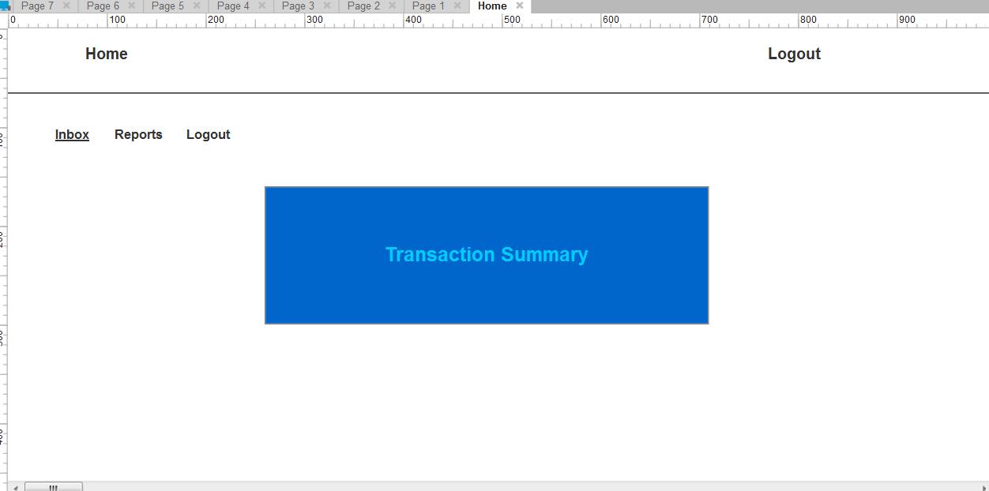

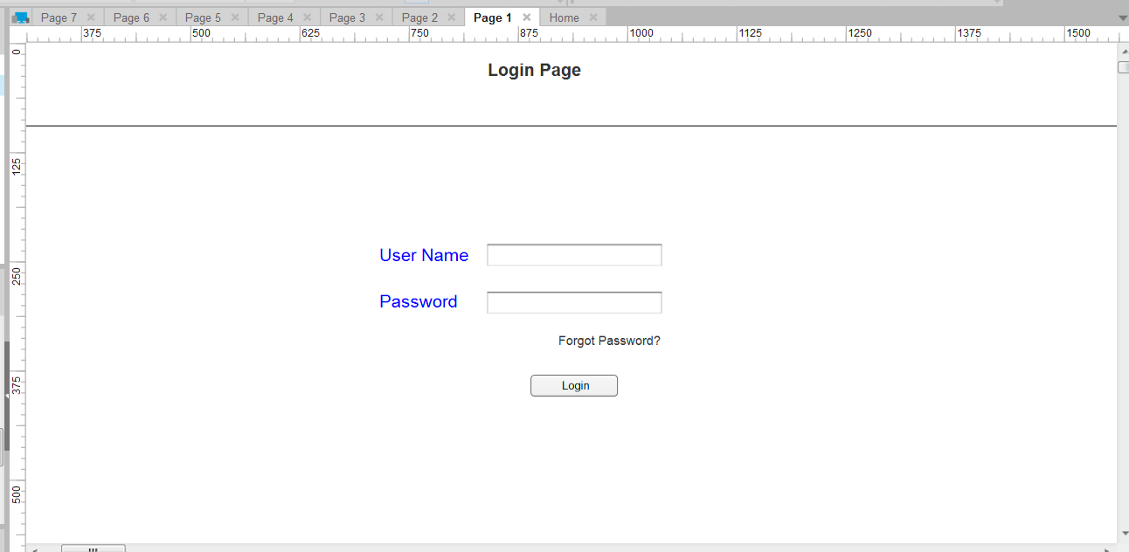
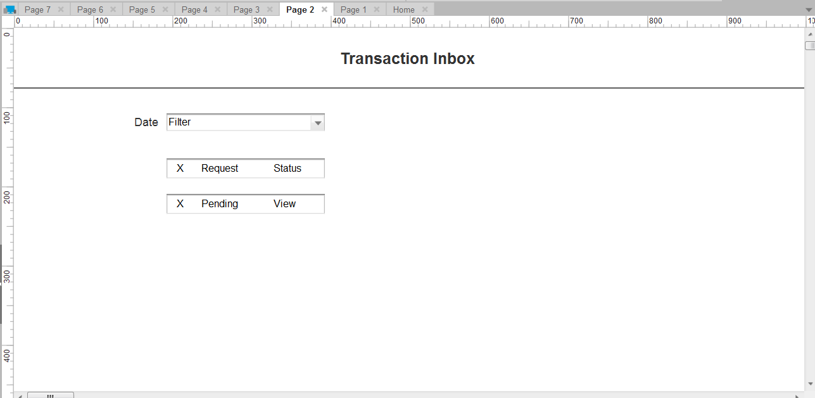

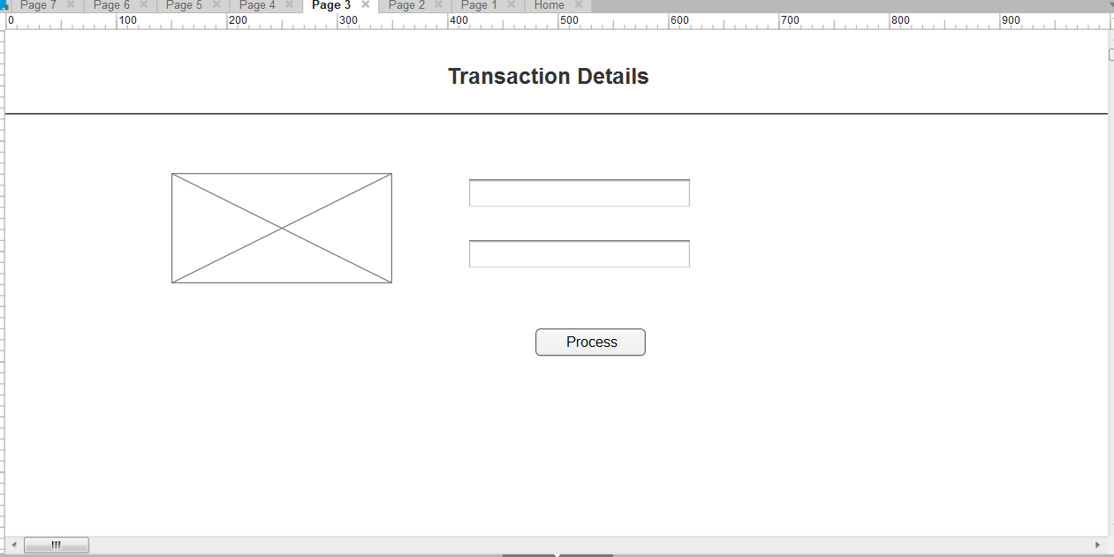

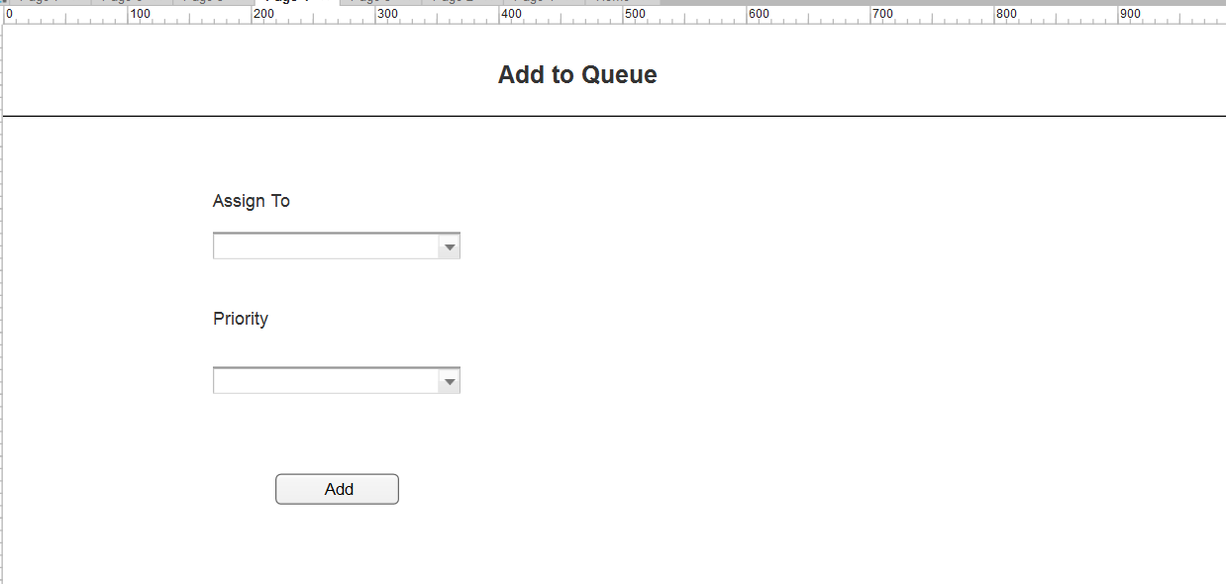

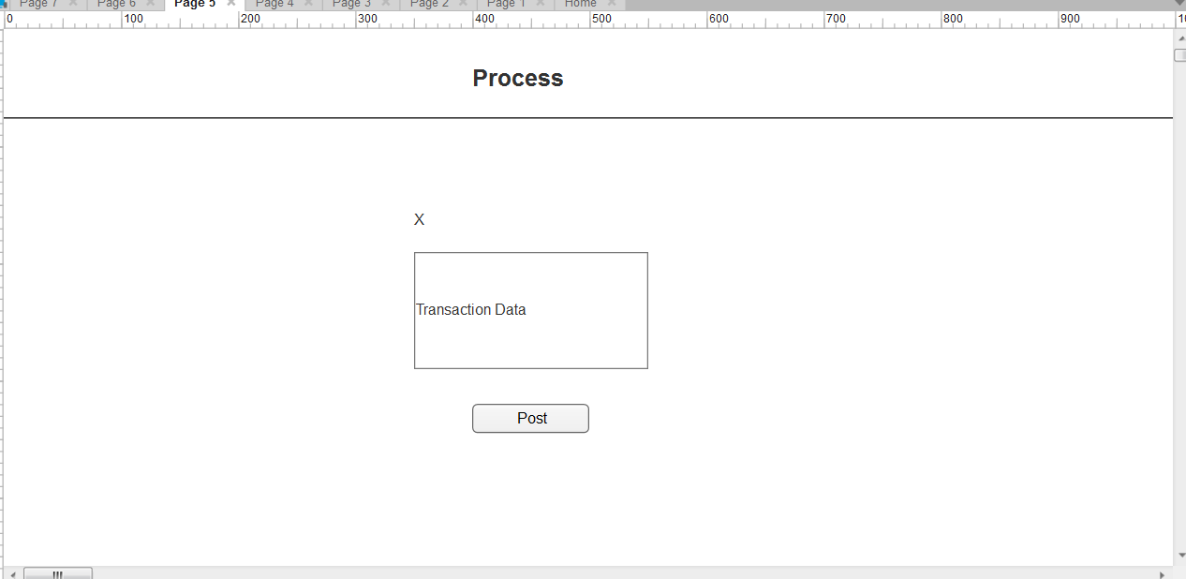

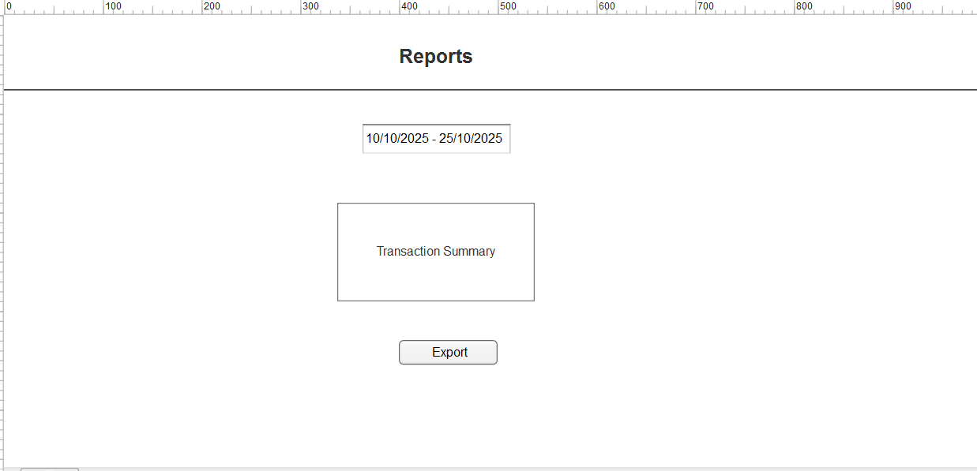

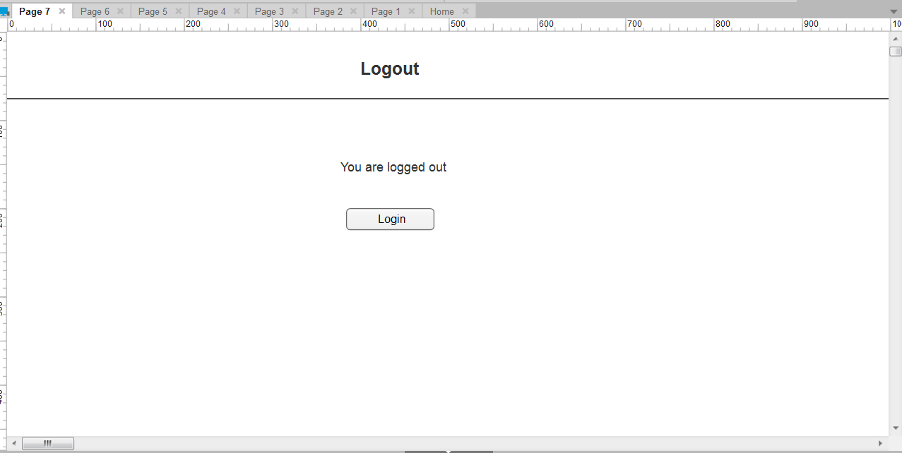

Document 8- Tools-Visio and Axure, write a paragraph on your experience using Visio and Axure for the project.

- For this project, I extensively used Microsoft Visio to create clear and structured diagrams such as the use case and activity diagrams. Visio’s intuitive interface and support for UML elements made it easy to visually represent system interactions and workflows, which helped stakeholders quickly grasp the process logic. On the other hand, Axure was instrumental in designing interactive mock-ups screens that simulate the user experience. I used Axure to build wireframes for key pages like the transaction inbox, detail view, and reports dashboard, enabling early validation of layout and functionality. Together, these tools enhanced both the clarity of documentation and the effectiveness of stakeholder communication.

Document 9- BA experience
1. Requirement Gathering:
- I applied the MoSCoW technique to prioritize critical features such as transaction tracking, alerting for missed requests, and automated imports from email.
- Since the client was intermittently unavailable, I proactively identified alternate points of contact to ensure uninterrupted information flow.
- Requirements were validated using the FURPS model, focusing on reliability and usability to prevent missed transactions.
- I identified and eliminated duplicate requirements, especially around manual email handling and folder management.
- Used prototyping to clarify expectations for the transaction inbox, alert system, and reporting dashboard.
2. Requirement Analysis:
- Created UML diagrams including use case and activity diagrams to visualize the end-to-end transaction flow.
- Designed activity diagrams to highlight decision points like missed transactions and alert triggers.
- Collaborated with stakeholders to refine diagrams; incorporated feedback from tech and operations teams.
- Prepared both BRS and SRS documents to formally capture functional and non-functional requirements.
3. Design:
- Derived test cases from use case flows, covering both positive and negative scenarios (e.g., missed transaction alerts).
- Engaged with the client to validate design documents and ensure alignment with business goals.
- Created mockup screens using Axure to simulate the user journey from login to transaction processing and reporting.
- Developed test data for various transaction types and ensured traceability by updating the RTM.
4. Development:
- Conducted JAD sessions to align development efforts with business needs.
- Acted as a bridge between developers and stakeholders, resolving conflicts and clarifying requirements.
- Used diagrams and mockups to support unit development and reduce ambiguity.
- Managed stakeholder availability by recording meetings and following up individually when needed.
5. Testing:
- Created comprehensive test cases based on use cases and mockups.
- Facilitated high-level testing and coordinated with the client to gather necessary test data.
- Updated the RTM to ensure all requirements were validated.
- Secured client sign-off and prepared them for UAT by organizing walkthrough sessions.
6. Deployment:
- Attached the final RTM to the project closure document for audit and compliance.
- Coordinated the creation of end-user manuals and ensured clarity in transaction handling procedures.
- Organized training sessions for all stakeholders, ensuring full attendance and readiness.
- Monitored post-deployment feedback to identify areas for future enhancement.

