Document 6- Please prepare a use case diagram, activity diagram and a use case specification document.

1. Use Case Diagram for the GCOS porting project:
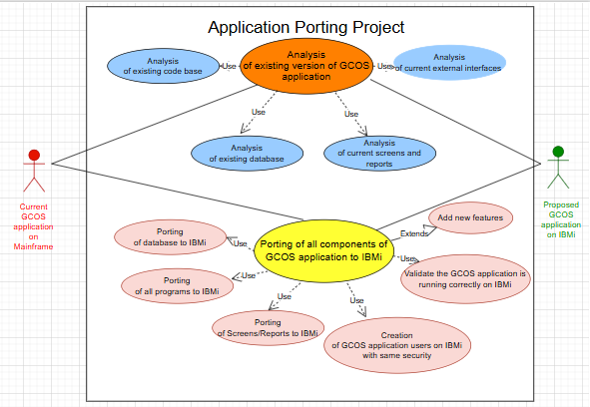

2. Use Case Specifications for the GCOS porting project:

Use case Name | Analyse Existing GCOS application on Mainframe
Use case Description | Analyse all the components of existing GCOS application
Primary/Secondary actors | Codebase, Database, Screens/Reports, External Interfaces
Basic Flow | 1. Go thru current version of GCOS application to understand below:  - List of modules and their functionality  - Screen navigations  - External interfaces  - Business rules  - Security details  - List of Users and their permissions  2. Go thru current code base of GCOS application to understand below:  - Different types of programs used  - Inventory of all programs as per program types (Cobol/EC/TCL/ /Screens/Reports etc)  - List of Scheduled jobs and their functionality  3. Go thru current database of GCOS application to understand below:  - How the data is stored?  - Inventory of database files  - How the data/files are related to each other  - Data types used  - Identify master/transaction files and volume of data  4. Go thru current screens/reports of GCOS application to understand below:  - How screens are designed?  - How error messages are shown to user?  - How data is validated?  - How report layouts are built?  - How reports are sent to users?  5. Go thru current external interfaces to GCOS application and determine how data is sent and received for each interface.
Alternate Flow | 1. Document the entire functionality of the application  2. Capture inventory of all the components in the application.
Exceptional flows | Analyse and document all error handling at UI as well as in backend programs
Pre- Conditions | GCOS application must be up and running on current Mainframe server
Post-Conditions | Centralised storage is available to keep all the analysis documents and application understanding documents
Assumptions | 1. Current version of GCOS application is up and running  2. Access to existing GCOS application is given
Constraints | 1. Deadlines for porting an application is tight.  2. Lack of expertise in mainframe components (i.e. EC/TCL etc) can hinder progress
Dependencies | Required support will be given from application users and support team to understand existing GCOS application.
Inputs and Outputs | Input - Entire Codebase of existing application, Discussions with application users and support team  Output - 1. Complete analysis of current GCOS application with documentation. 2. Inventory of entire application
Business Rules | All business rules need to be captured and documented.
Miscellaneous Information | None

Use case Name | Porting of GCOS application to IBMi
Use case Description | Port all the components of GCOS application to IBMi
Primary/Secondary actors | Current Codebase, Various tools to convert GCOS components to IBMi, Application porting team, IBMi application users
Basic Flow | 1. Design a process to port the GCOS application database to IBMi  2. Design a process to port the GCOS application Cobol programs to IBMi  3. Design a process to port the GCOS application EC/TCL programs to IBMi  4. Design a process to port the GCOS application screens/reports to IBMi  5. Design a process to port the GCOS application jobs to IBMi  6. Design a process to verify that the GCOS application is running correctly on IBMi
Alternate Flow | Design a process to create GCOS application users on IBMi with same permission as Mainframe
Exceptional flows | Design a process to do all error handling at UI as well as in backend programs.
Pre- Conditions | 1. IBMi server is ready to use with required configuration  2. Analysis of current GCOS application is complete
Post-Conditions | None
Assumptions | Application Users can connect to new IBMi system
Constraints | 1. Complex applications with many integrations require more time and resources  2. Data loss, corruption, or improper formatting can lead to some problems  3. Unplanned downtime can lead to lost productivity and revenue
Dependencies | All the external interfaces to GCOS will be able to connect to IBMi server.
Inputs and Outputs | Input - Analysis and documentation of current GCOS system  Output - GCOS application up and running on IBMi with same behaviour as on Mainframes.
Business Rules | Core business logic of the application will remain same on IBMi
Miscellaneous Information | None

3. Activity Diagram for the GCOS porting project:

Analyse Existing GCOS application on Mainframe:
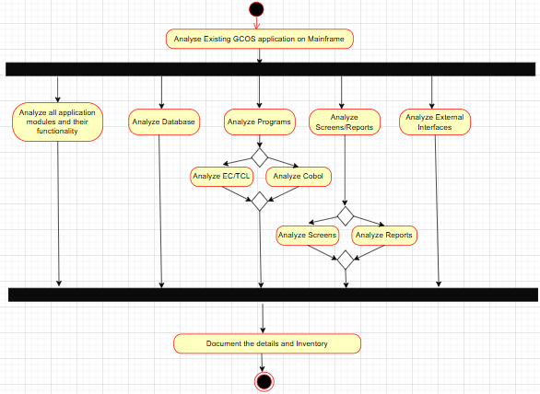

Porting of GCOS application to IBMi:

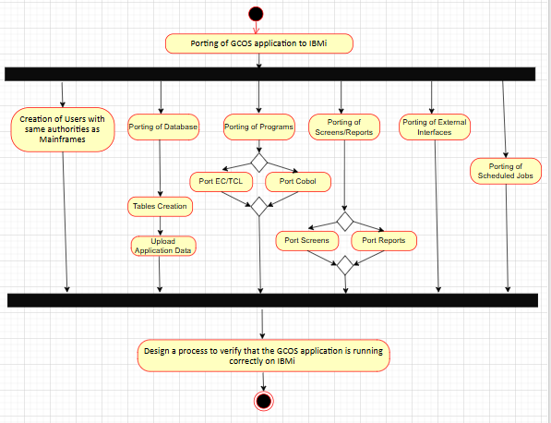

Document 7- Mock-up screens of GCOS application on IBMi

1. Login Page:

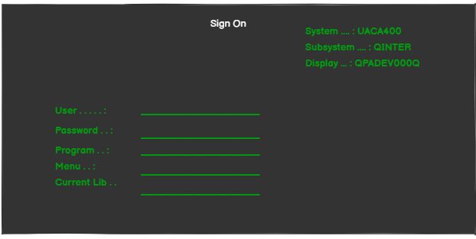

2. Main Menu and going to specific screen:

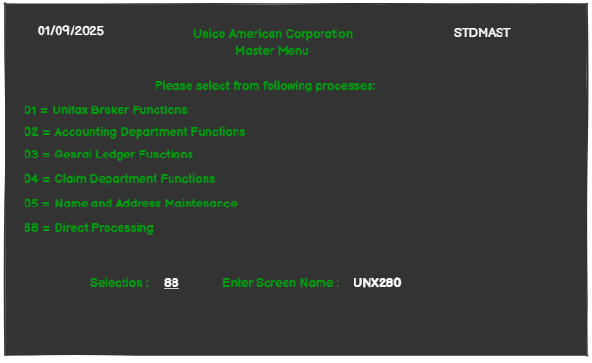

3. Named Insured Amendment Screen UNX280:

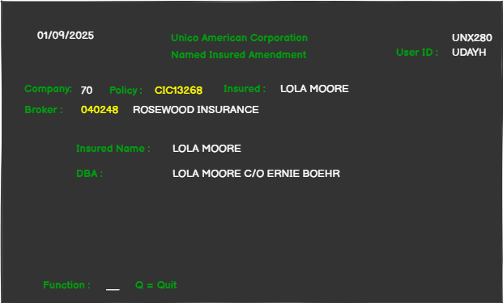
4. Claim Diary Inquiry/Maintenance Screen:

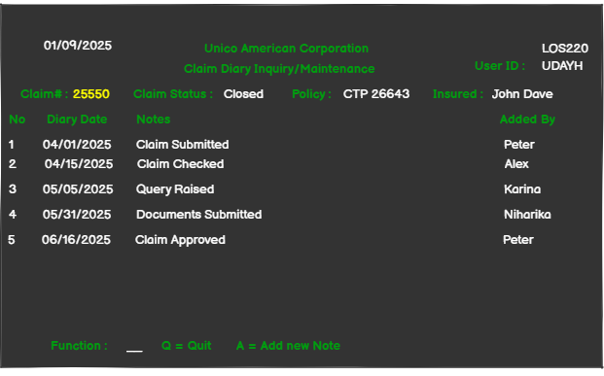

5. Name and Address Maintenance Screen:

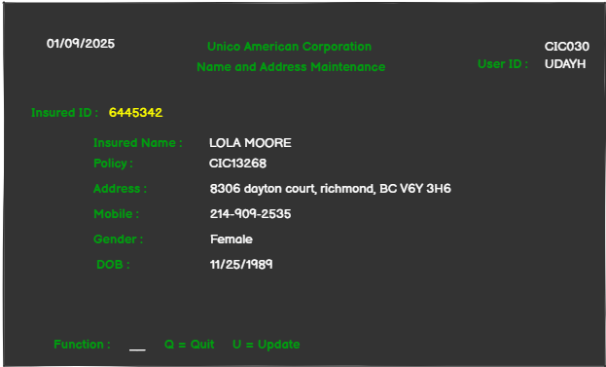

6. Claims summary screen:

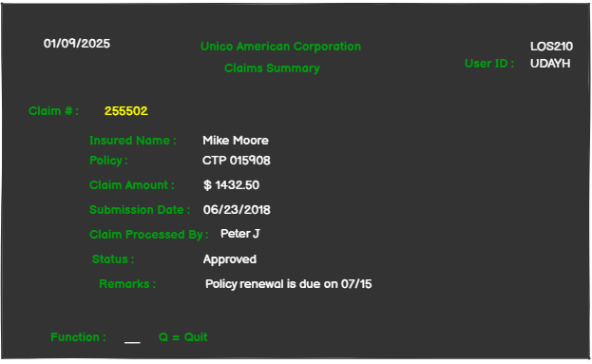
7. Policy Payments Inquiry:

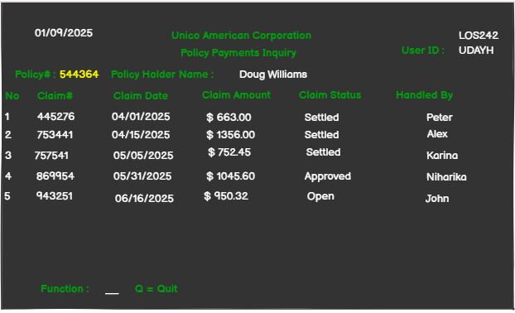

Document 8- Tools-Visio and Axure

Visio:

As BA, I found Microsoft Visio very helpful to visualize and draw the functionalities. This clarifies requirements and improves communication with stakeholders.

In this project, I used Visio to do document stakeholder analysis i.e. RACI charts and org charts. I also used it to design mock-ups of the GCOS screens on IBMi. This gave good idea to customer about how the GCOS application will look like on IBMi. I find Visio helpful to draw the data flow diagrams (DFD) also. I also used this tool to draw the AS-IS and TO-BE functionality of the project.

Using this tool, I also draw the Entity-relationship diagrams (ERDs) to show the relationships between database entities, which is critical for database design.

This tool helped me in improving communication with all stakeholders.

It is a diagramming application used to create flowcharts, use case and activity diagrams. It provides various shapes like Rectangle, Circle, Arrows etc. It also provides basic flowchart shapes. It has got UML section to get the shapes needed for use case and activity diagrams like Use Case, Actor, Relations (Use, Extend).

Axure:

As BA, I used this tool to create interactive prototypes, wireframes, and user flow diagrams. This toll helped me to show navigation of the GCOS application i.e. how to reach to particular screen from the main menu OR in specific functionality which all screens are involved and in what sequence.

It allows me to gather requirements, share design ideas with stakeholders. Also using this tool I created detailed documentation by adding conditions, variables to simulate realistic user experiences before development begins.

Axure's drag-and-drop interface allow me to create complex prototypes without needing to write any code.

It is a more advanced prototyping tool used to create interactive wireframes for user interfaces. I mainly used in design phase of SDLC to model the requirements. In Widgets section there are various shapes (like Image, Heading, Text etc) to design the page. It has also got the Master section to copy the design of one wireframe to multiple pages. We can add links to other pages in the wireframe and also give URLs to images.

Document 9- BA experience

My experience as BA in following phases:

1. Requirement gathering:
- First, I identified all the required Stakeholders using RACI method.
- Then using different elicitation techniques, I started gathering all the requirements from stakeholders.
- To gather requirements, I used MOSCOW technique (i.e. Must have, Should have, Could have, and Won't have). Using this method I categorizes items into four priority levels to establish a clear hierarchy of requirements.
- During this phase of project, some users or current application support team members were not available to give the requirements. In that case, I had to find alternate person who know the functionality and can give me the requirements.
- I validate the requirements using FURPS technique (i.e. Functionality, Usability, Reliability, Performance, and Supportability). It ensured that all crucial aspects of a GCOS application requirements are considered during porting.
- After collecting all the requirements and consolidating them at one place, I found that there are many requirements which are duplicated or repeated. I removed those immediately.
- Create Prototyping or mock-ups of the application screens helped me to get more specific requirements. Because prototype give visual representation of the screens involved in the specific functionality.
- I also experience that sometimes while giving the requirements, Client used to go out of track and start talking about something else. Bringing him back on track was needed to save the time and effort.

2. Requirement Analysis:
- After capturing the requirement from client, to verify it, I used to draw the UML diagrams to visually describe the requirements. This helped in bringing me and client on same page for the requirement.
- To get the bigger picture of the application that include all main requirements, I draw the activity diagrams that describes the overall process flow in the GCOS application.
- During verification of the requirements, sometimes there was a situation where some client was not agreeing with the captured requirement and wants to make changes in it. As a BA I considered all those changes and made modifications accordingly
- In this phase I also prepared Business Requirements Specification (BRS) document. It provides a general, big-picture view of what the business needs are. It served as an interface between the client and the technical team, defining the project's purpose, scope, and high-level features. This ensures alignment with the client's vision and business objectives, before detailing technical specifications.
- Another document that was prepared is SRS (Software Requirements Specification). This document translated high-level business needs into functionals and non-functional requirements.
- I also prepared use case diagrams for the project. It visually represents a system's functionality by showing the interactions between actors and use cases.
- I created the RTM and started updating it.

3. Design:
- In design phase, team started preparing the test cases based on the use case diagrams.
- Test cases were written for both positive and negative i.e. happy path testing as well as edge cases testing.
- Test case review was done to ensure that no important test case is missing …that might have large impact on the overall functionality.
- Along with test cases, test data was also prepared to test all the scenarios mentioned in test cases.
- Regression testing plan was also made to make sure that the added functionality is NOT impacting any other part of application.
- Database design and UI design was done by respective expert.
- Design of tools to help porting process was also done.
- Once design document is ready, I will share it with relevant stakeholders and get sign-off.
- Update the RTM for design completed requirements.

4. Development:
- Dring development of project, JAD sessions were conducted with the team to bring the ideas to implement the solution. How to port the different components of GCOS application. What tools we can write to reduce manual work ad time etc.
- There were some queries raised by team, as BA, I clarified them.
- There were situations where some team members were not in agreement with suggested solutions, and they were not co-operating. As BA, I had one on one discussion with them. I explained how their actions are going to affect the project. This was necessary to setup healthy environment within the team.
- I suggested development team to refer to earlier documents like BRD, Design, Test cases etc to get good understanding of the project. This helped them while developing the code.
- I conducted regular meetings with technical team and client. There were situations when some team members were not be available for the meeting. I recorded the meeting session and provided to missing members, so that they are on same page.
- The RTM was updated to reflect the current status.

5. Testing:
- Test case review was done, and signoff was taken.
- Test data was requested by me to Client for testing.
- I had planned and perform the high-level testing.
- Next, I scheduled the UAT session with Client and conducted it.
- Team captured and fixed all the bugs identified during UAT.
- UAT signoff was taken from Client.
- I updated the RTM.
- Decide the project deployment date with Client. Send out the communication to all regarding deployment.
- I also prepared the user manual about how to use the GCOS application on IBMi.

6. Deployment:
- In this last phase of project, I prepared the project closure document.
- We shared the RTM and project closure document to client.
- We completed the end user manual and shared with Client.
- The training sessions were conducted with end users to make them familiarize with GCOS application on IBMi.
- We prepared document for lessons learnt from this project.

