``````````````````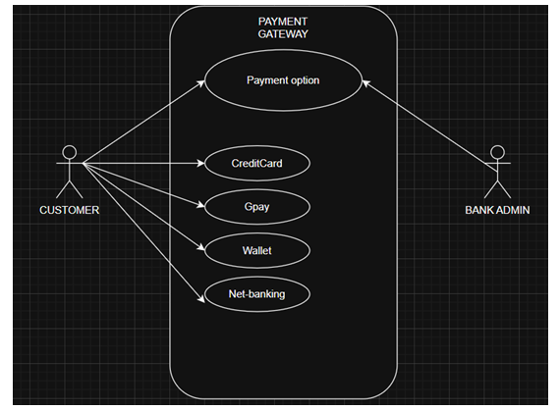

Q5. Draw a sequence diagram for payment done by Customer Net Banking –

Interaction between classes in the sequential order. It is a step- step process .

It is used to show the flow of message (Event or action)

Creating Sequential diagram is a collaborative effort, but typically led by specific roles

WHO DRAWS SEQUENTIAL DIG :

Software Architects / Senior Developers: They often create the initial high-level sequence diagrams to define the flow of interactions

Business Analysts: Might create a "business-level" sequence diagram to validate the process with stakeholders.

Who will be the part ?

Primary Actor - Customer: The user initiating the entire process. They interact with the interface.

High-level sequence diagram (conceptual level).

- Initially customer opens the bank website & then he or she will be entering their credentials to login.

- Once it takes you to the home-screen

- Select for payment (Netbanking)

- Add the details of the person to whom the transfer must be done. (Which includes his Name - account number- branch code- ifsc)

- Enter the amount - Initiate the payment – get otp – transaction done

Q7. What is MVC architecture? Explain MVC rules to derive classes from use case diagram and guidelines to place classes in 3-tier architecture

MVC = Model – View – Controller

It is a software design pattern that separates the application into 3 logical components:
Model
Represents core entities and rules of the system.
Example in Payment Case: Customer, Payment, Transaction, WalletAccount

View
What the customer sees → screens, forms, outputs
Example in Payment Case: PaymentPage, CardForm, NetBankingUI.

Controller
The decision maker → receives input from View, communicates with Model, and updates View.

Example in Payment Case: PaymentController, TransactionController.

With the Real examples I can say customers pay via net-banking

VIEW (Presentation Layer)

Customer opens Payment-Page and selects Net Banking.

CONTROLLER (Application Layer):
Payment Controller receives the request.
It validates user, amount, bank details (IFSC / BANK CODE).
And then calls to the transaction controller to initiate the payment process , I mean the transaction

Model (Data Layer):
Transaction entity created with status = Payment Approved / Pending
Bank Account validated with API.
Once it integrates successfully the payment will be done

Q15. What is camel-casing and explain where it will be used

Camel-casing is a naming convention where multiple words are written together without spaces, and each word starts with a capital letter.

Data Mapping process of connecting data fields from one system to another so that information flows correctly between them.
It shows how “Source Data” corresponds to “Target Data”
Used in API integrations & database migration

Source Field– Customer ID / Payment Method / Transaction Amount
Target Field – Cust_id/ Pay_mode/ Amount

Q16. Illustrate Development server and what are the accesses does business analyst has? Also Production server

A Development server is a dedicated environment where software is built, integrated, and tested before moving into QA/ UAT

• Payment application is under construction.
• Developers configure mock bank APIs to test Net Banking.

BA can verify logs/screens → confirm that the transaction status moves from Initiated → Success.

The reason why development server is important - Safe Experimentation / Testing Ground / Bug Fixing / Free from RISK

Production Server (PROD Server)

The reason why production server is important - Handles Real Customer Transactions / Generates Revenue for the Business / Delivers Customer Experience

Characteristics:
- Purpose: Real transactions for end customers.
- Developers → no direct access.
- Business Analyst → usually read-only access (can view reports, transaction logs, dashboards).

- • Real customers log in to pay bills/orders.
- • They choose Card, Wallet, Cash, or Net Banking.

BA Access in Production Server
View business reports (payment success rate, failure logs).

Feature | Development Server (DEV) | Production Server (PROD)
Purpose | Build & test system | Real-time customer usage
Data | Fake/test data | Real payment data
Example | Test Net Banking payment | Customer pays ₹1000 via Net Banking – real debit from account

Camel Casing: A naming convention where words are joined without spaces, and each new word begins with a capital letter
Database fields: transactionId, paymentMethod, customerId

Q17. What is Data Mapping / Data Integration

Data Mapping process of connecting data fields from one system to another so that information flows correctly between them.
It shows how “Source Data” corresponds to “Target Data”
Used in API integrations & database migration

Source Field– Customer ID / Payment Method / Transaction Amount
Target Field – Cust_id/ Pay_mode/ Amount

Data Integration - When a customer makes a payment, data comes from different external systems:
Card → Card Network (Visa, MasterCard, Rupay)
Wallet → Paytm, PhonePe, Google Pay
Why Data Integration is Important
Combines all payments (Card, Wallet, Cash, Net Banking) into one account history.

