CAPSTONE PROJECT 3

Question 1: Use Case Diagram

Question 2 Boundary Classes, Controller classes, Entity Classes
In Object-Oriented Analysis and Design (OOAD), especially when using UML and the MVC (Model-View-Controller) pattern, we categorize system components into three types of classes:
1. Entity Classes (Model Layer)
Purpose: Represent business logic and persistent data (real-world objects).
Think: What data is stored in the system?
Examples:
- User
- Product
- Order
- Payment
- Farmer
- Restaurant

🔹 2. Boundary Classes (View Layer)
Purpose: Handle interaction between system and external actors (UI, API, devices).
Think: How does the system communicate with users?
Examples:
- LoginPage
- OrderForm
- PaymentPage
- MobileAppInterface
In Your Projects:
- For the Agriculture Store: FarmerLoginPage, ProductSearchPage, CheckoutPage
- For Scrum Foods: CustomerMobileApp, RestaurantDashboard, DeliveryBoyApp

🔹 3. Controller Classes (Control Layer)
Purpose: Handle system logic and workflow between boundary and entity classes.
Think: What logic or coordination is needed between UI and data?

📌 Example for "Place Order" Use Case (Scrum Foods)
Class Type | Example Class Name | Description
Entity Class | Order, Customer, MenuItem, Restaurant | Core data involved in placing an order
Boundary Class | PlaceOrderPage, CustomerAppUI | Interface for placing the order
Controller Class | OrderController | Handles placing the order and interaction between UI and database
Boundary Classes

Question 3 Place these classes on a three tier Architecture
🧱 3-Tier Architecture Overview
Tier | Description | Contains
Presentation Tier (UI Layer) | Front-end interface users interact with | Boundary Classes
Application Tier (Business Logic Layer) | Handles processing, rules, workflows | Controller Classes
Data Tier (Persistence Layer) | Manages data storage and retrieval | Entity Classes

Example: “Place Order” – For Scrum Foods Project
Tier | Class Type | Example Classes | Description
1. Presentation Tier (UI) | Boundary Classes | CustomerApp, OrderFormUI, CheckoutScreen | Interfaces for users to view menu, select food, place order
2. Application Tier (Logic) | Controller Classes | OrderController, PaymentController, CartManager | Handles business rules: verifies availability, calculates price, coordinates payment
3. Data Tier (Database) | Entity Classes | Order, Customer, MenuItem, Restaurant, Payment | Stores persistent data related to customers, orders, menus, payments

Question 4 Domain Model

A domain model is a conceptual representation that defines the structure, relationships, and behavior of entities within a specific problem domain.

Objective:
To represent the core business objects (entities) and relationships involved when a customer chooses Net Banking to make a payment.

🧩 Key Domain Classes (Entities):
Class Name | Attributes | Description
Customer | customerId, name, email, phone | The person initiating the payment
Order | orderId, orderDate, totalAmount, status | Represents the order to be paid for
Payment | paymentId, amount, paymentDate, status, mode | Abstract class or entity for any kind of payment
NetBankingPayment | bankName, accountNumber, ifscCode, transactionId | Specific to Net Banking, could inherit from Payment
Bank | bankId, bankName, IFSCCode, bankURL | The bank selected by the customer for net banking
Transaction | transactionId, timestamp, amount, status, referenceNumber | Represents the finalized bank transaction

🔗 Relationships:
- A Customer places an → Order
- An Order is paid through a → Payment
- Payment is of type → NetBankingPayment
- NetBankingPayment uses a → Bank
- NetBankingPayment generates a → Transaction

Question 5 Sequence Diagram
A sequence diagram is a type of interaction diagram used in software engineering and systems design to illustrate how processes operate with one another and in what order.

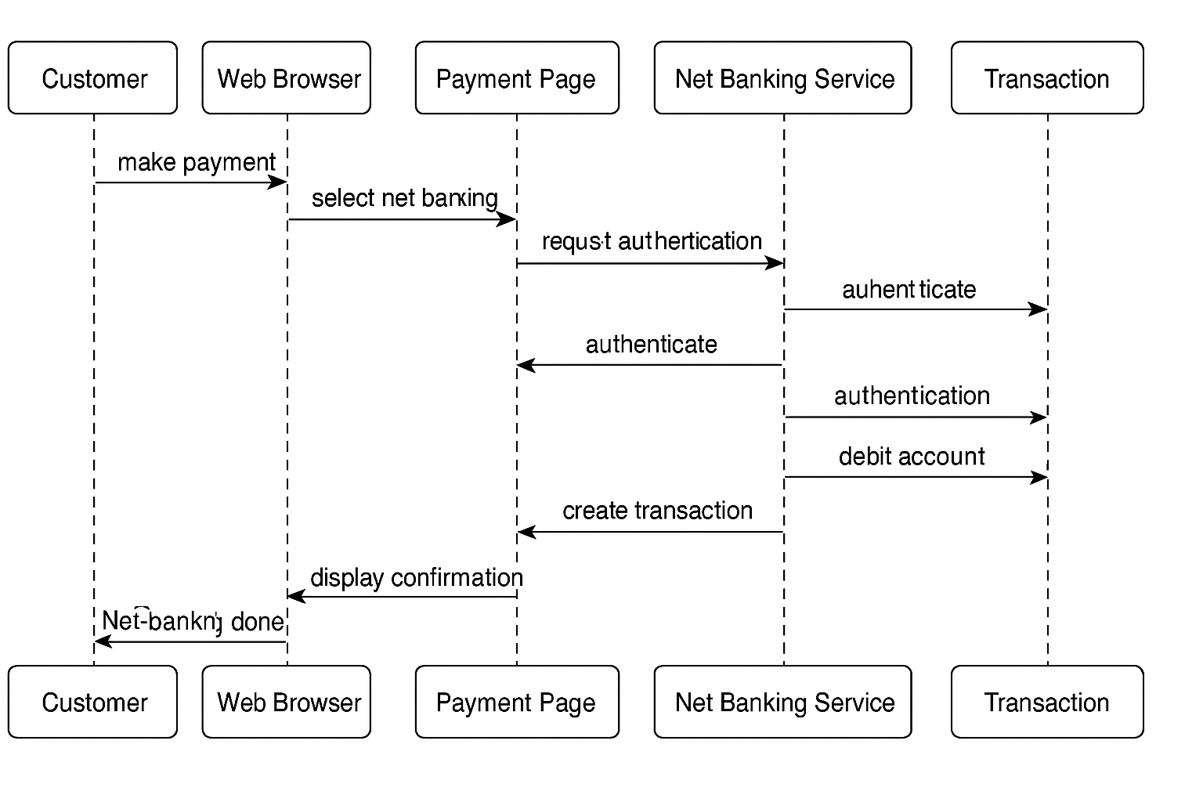

Question 6 Conceptual model

A conceptual model is a high level representation of a system that helps in understanding, visualizing and communicating the essential aspects of domain
It provides a clear and simplified view of domain, making it easier to understand.
Key Elements of a conceptual model:
  - Entities:: Customer, product, order and payment
  - Attributes:: CustomerID, name, email, phone number
  - Relationships:: For example, a customer places and order

Question 7 MVC Architecture
The Model-View-Controller (MVC) framework is an architectural pattern that separates an application into 3 main logical components i.e. Model, View, Controller.
MVC stands for Model - View - Controller.
It is a design pattern that helps in separating an application into three interconnected components.
Component | Description | Example
Model | Manages data, business rules, and logic | Customer, Order, Product
View | UI elements seen by the user (input/output interface) | Login Page, Payment Screen
Controller | Handles user input, acts as a link between Model and View | OrderController, PaymentController

Flow of Control in MVC:
- User interacts with View
- View calls Controller
- Controller updates Model
- Model sends data to View

2. MVC Rules to Derive Classes from Use Case Diagram
When analyzing Use Case Diagrams, follow these steps to derive the 3 class types:
Class Type | How to Derive from Use Case | Example
Entity (Model) | Look for nouns in use case descriptions (business objects or data) | Customer, Order, Product, Cart
Boundary (View) | Look for actors and interfaces they use to interact with the system | LoginPage, OrderForm, PaymentScreen
Controller | Look at main use case actions, especially verbs (handling business logic) | LoginController, OrderController, PaymentManager

3. Guidelines to Place MVC Classes in 3-Tier Architecture
3-Tier Layer | MVC Component | Class Type | Description
Presentation Tier | View | Boundary Classes | Interfaces/screens/forms that users interact with
Application/Logic Tier | Controller | Controller Classes | Coordinates interaction between UI and backend
Data Tier | Model | Entity Classes | Business objects/data stored in the system

Example (Use Case: Place Order)
MVC Class | Type | 3-Tier Layer
Customer, Order, MenuItem | Entity | Data Tier (Model)
OrderPage, CheckoutPage | Boundary | Presentation Tier (View)
OrderController, CartManager | Controller | Application Tier (Controller)

Question 8 BA Contributions in project

Waterfall Model – Stages & BA Role
The Waterfall Model is a linear, sequential software development approach. Each phase must be completed before the next begins.

1. Requirement Gathering & Analysis
🎯 Objective: Understand and document what the client needs.
🔹 BA Contributions:
- Conduct stakeholder interviews, workshops, and surveys.
- Elicit functional and non-functional requirements.
- Document Business Requirements Document (BRD).
- Create Use Case Diagrams, Process Flows, Gap Analysis.
- Identify project scope and feasibility.
- Get formal sign-off from the client.
📄 Deliverables:
- BRD / SRS (Software Requirement Specification)
- Requirement Traceability Matrix (RTM)
- Use Cases

2. System Design
🎯 Objective: Define how the system will meet the documented requirements.
🔹 BA Contributions:
- Collaborate with architects and developers to explain requirements.
- Validate system design against the BRD.
- Ensure UI/UX wireframes and prototypes match business expectations.
- Support creation of Entity Relationship Diagrams (ERD) and Data Flow Diagrams (DFD).
📄 Deliverables:
- Review and validate design documents
- Annotated wireframes / screen mockups
- Updated RTM

3. Implementation (Coding)
🎯 Objective: Developers build the actual system.
🔹 BA Contributions:
- Clarify doubts or missing logic for developers.
- Participate in daily/weekly reviews to ensure scope adherence.
- Act as a bridge between business and technical teams.
- Update stakeholders on progress.
📄 Deliverables:
- Change Request (CR) documents if needed
- Mid-development validations
- Functional walk-throughs

4. Testing
🎯 Objective: Verify the system works as per requirements.
🔹 BA Contributions:
- Review and help create test cases (especially for UAT).
- Participate in System Testing, Regression Testing, and UAT.
- Ensure defects are fixed as per business expectations.
- Help users during User Acceptance Testing (UAT).
📄 Deliverables:
- Test Scenarios
- UAT Plan & Sign-off Document
- Defect Reports (with priorities)

5. Deployment
🎯 Objective: Deliver the completed product to the production environment.
🔹 BA Contributions:
- Assist in the Go-Live preparation.
- Coordinate with DevOps/IT team and stakeholders.
- Ensure all business processes are aligned with the final system.
- Prepare training documents/user manuals.
📄 Deliverables:
- Deployment Readiness Checklist
- Training Docs/User Guides
- Handover Document

6. Maintenance & Support
🎯 Objective: Support the live system and handle any issues or improvements.
🔹 BA Contributions:
- Log and analyze change requests or enhancements.
- Gather feedback and suggest system improvements.
- Conduct periodic reviews with stakeholders.
- Monitor system performance against business KPIs.
📄 Deliverables:
- Change Request Logs
- Enhancement Proposals
- Feedback Reports

🧩 Summary Table
Stage | BA Role Summary | Key Documents
Requirements | Gather, analyze, document | BRD, RTM, Use Cases
Design | Validate solution design | Wireframes, ERD, Design Review Notes
Implementation | Support developers | Clarifications, CR Logs
Testing | Support testing, validate requirements | Test Cases, UAT Plan
Deployment | Coordinate Go-Live, train users | Training Docs, Sign-off
Maintenance | Handle changes, feedback | CR Docs, Feedback Reports

Question 9 Conflict Management
Conflict management is the process of resolving conflicts or disagreements between individuals or groups in a constructive manner
Thomas killman technique is used to asses conflict resolution styles and guiding individuals in selecting appropriate strategies to manage conflicts
5 steps of conflict management:
- Identify conflict
- Discuss the details
- Agree with the root problem
- Check for every possible solution for the conflict
- Negotiate the solution to avoid future conflicts

Question 10 Reasons for project failure
🔹 1. Unclear or Incomplete Requirements
- Vague or poorly documented requirements
- Constant changes without proper impact analysis
- Lack of stakeholder involvement during elicitation
🔹 2. Scope Creep
- Adding features without formal change control
- Weak scope management and no boundaries defined
- Overpromising to stakeholders
🔹 3. Lack of Stakeholder Engagement
- Key users or business owners are unavailable or disengaged
- Misalignment between business and IT teams
🔹 4. Poor Communication
- Miscommunication between teams
- Lack of proper documentation or progress reports
- No single point of contact (like a BA or PM)
🔹 5. Inadequate Planning
- No clear project timeline or resource allocation
- Overly optimistic estimates
- Missing risk management plan
🔹 6. Ineffective Leadership or Governance
- Poor project sponsorship or stakeholder leadership
- No escalation or decision-making structure
- Weak project governance or steering committee
🔹 7. Budget Overruns
- Underestimated cost at the start
- Unexpected expenses
- Poor financial tracking or control
🔹 8. Missed Deadlines / Poor Time Management
- Unrealistic deadlines
- Delays due to dependencies or approvals
- Frequent rework due to misunderstood requirements
🔹 9. Technical Failures
- Choosing the wrong technology stack
- Poor system design or architecture
- Inadequate testing leading to critical bugs post-deployment
🔹 10. Lack of Skilled Resources
- Inexperienced or undertrained team
- High resource turnover or poor resource allocation
🔹 11. Ineffective Risk Management
- Ignoring potential risks or mitigation plans
- No contingency planning
- Delayed action on known blockers
🔹 12. Lack of UAT or Poor User Involvement
- UAT not performed or poorly managed
- Users not involved in testing or feedback collection
🔹 13. Resistance to Change
- Users or stakeholders not willing to adopt new systems
- No proper training or change management
🔹 14. Inadequate Testing
- Missing functional/non-functional test coverage
- Skipping regression or integration testing
- Defects found late in production
Question 11 Challenges faced in projects for BA
Unclear or Evolving Requirements
Stakeholders don’t know exactly what they want.
Requirements keep changing without formal change control.
Conflicting expectations from different stakeholders.

2. Limited Stakeholder Availability or Engagement
Stakeholders are busy or unresponsive.
Late feedback or delayed approvals.
Inconsistent participation in meetings/workshops.

🔹 3. Scope Creep
Additional features requested without adjusting timeline/cost.
Pressure to accommodate requests beyond initial scope.
No formal process to control scope changes.

🔹 4. Communication Gaps
Miscommunication between business and technical teams.
Misinterpretation of requirements due to lack of domain knowledge.
Language or cultural barriers in global teams.

🔹 5. Inadequate Domain Knowledge
Difficulty understanding industry-specific processes (e.g., finance, healthcare, agriculture).
Reliance on SMEs for every small detail.

🔹 6. Lack of Proper Documentation
Time pressure leading to skipping key documents like RTM, process flows, or test scenarios.
No version control or tracking of requirement changes.

🔹 7. Conflicting Stakeholder Interests
Different departments have different goals (e.g., marketing vs. IT).
Difficulty in prioritizing requirements.

🔹 8. Limited Access to End Users
Only intermediaries (like managers) are available for requirement gathering.
No direct feedback from those who will actually use the system.

🔹 9. Poorly Defined Acceptance Criteria
Requirements are approved without clear testable conditions.
Leads to confusion during UAT and sign-off delays.

🔹 10. Time Constraints / Unrealistic Deadlines
Not enough time to do proper analysis and validation.
BA is rushed to deliver documents or sign off on requirements.

🔹 11. Ineffective Tools or Processes
Lack of access to proper BA tools (e.g., JIRA, Confluence, Visio, Balsamiq).
Project not following any standard methodology (Waterfall/Agile/Hybrid).

🔹 12. Lack of BA Involvement in All Phases
BA included only during requirements phase and not in testing or post-deployment.
Missed opportunities to validate or clarify scope during design/development.

🔹 13. Technical Constraints
Business requirements cannot be implemented due to technical limitations.
Need to frequently compromise or re-scope.

🔹 14. Resistance to Change
Users reluctant to adopt new systems or processes.
Need for strong change management and communication.

Question 12 Document Naming standards
A document numbering standard is a systematic approach to assigning unique identifiers to various documents created and used throughout the development process
Ex- PROJ12-REQ-1.0-2025-06-25

Question 13 Do’s and Don’ts of a business analyst

S No. | Do’s | Don’ts
1. | Consult an SME for clarification in requirements | Never say No to a client
2. | Go to the client with plain mind with no assumption. Listen carefully and completely until the client is done | There is no word as by default
3. | Try to extract maximum leads to the solution from the client himself | Never imagine anything in terms of GUI
4. | Concentrate on the important requirements | Don’t interrupt the client when he is giving you the problem
5. | Question the existence of the existence | Never try to give solution to the client right away with your previous experience and assumptions

Question 14 Packages and Subsystems
Packages: Collection of components which are not reusable in nature
Ex-- Application development companies work on packages

Subsystems: Collection of components which are reusable in nature.
Ex- Product development companies work on subsystems.

Feature | Package | Subsystem
Definition | A logical grouping of related UML elements like classes, interfaces, etc. | A higher-level component that represents a self-contained part of a system
Purpose | Organizes and manages large models for simplicity and clarity | Represents a functional division of the system with defined responsibilities
Abstraction Level | Lower abstraction — focuses on code/module organization | Higher abstraction — focuses on system-level decomposition
Used In | Class diagrams, Use Case diagrams, deployment modeling | Architectural modeling, Component diagrams
Contains | Classes, interfaces, other packages | Use cases, packages, classes, interfaces, components
Visibility | Not always exposed outside unless made public | Designed to interact with other subsystems via interfaces
Communication | Typically internal to a development team | Interacts with other subsystems or external systems via defined interfaces
UML Notation | Folder icon | Package icon with «subsystem» stereotype
Example | com.shopping.payment, utils, models | PaymentSubsystem, OrderManagementSubsystem, UserAuthSubsystem

Question 15 Camel Casing and its uses
Camel casing is a naming convention used in computer programming
It is used for naming variables, functions and identifiers
Example:
camelCaseExample

Question 16 Development server
A development server refers to a dedicated environment or server that is used during the software development process
It provides a platform for developers and testers to build, test and debug applications before they are deployed to a production environment
As a BA, we have limited access only
Characteristics:
- Contains in-progress code and modules.
- May have dummy/test data.
- Used by developers, testers, and sometimes BAs.
- Usually mirrors production partially, but not fully secure or stable.
- Common BA Access Rights:
Access Type | Description
🔹 Read-Only Access | BA can view pages, forms, or application modules as they are built.
🔹 Demo/Test Access | BA can perform walkthroughs, test business logic, and validate against requirements.
🔹 Staging Data Access | Access to test or dummy data to simulate business scenarios.
🔹 Access to Logs (sometimes) | Limited access to application logs to trace functional issues (not deep technical logs).
🔹 Access via Frontend/UI only | Most access is through the web interface — not backend, not the codebase.

Question 17 Data Mapping
Data mapping is the process of connecting data from one source to another
Its creating a guide or map that shows how data in one place corresponds to data in another place.
This is especially important when you’re moving data between different system or databases to ensure that the data stays consistent and accurate.
Why is Data Mapping Important?
- Ensures accurate data transfer between systems (e.g., legacy to new system)
- Facilitates ETL (Extract, Transform, Load) processes
- Enables system integration (e.g., CRM to ERP)
- Ensures data consistency and compliance

Question 18 API
Application Programming Interface is a set of rules and tools that allows different software applications to communicate with each other
It defines the methods and data formats that applications can use to request and exchange information
Real-world Example in Your Application
Let’s say in "Online Agriculture Product Store" application, you are integrating with:
- A U.S.-based payment gateway or
- A partner’s inventory system or
- A third-party order tracking system
These external systems send data via API, such as:
- Date of Order
- Transaction Time
- Delivery Date

🗓️ The Challenge: Date Format Mismatch
Source System (US) | Your System (India)
mm-dd-yyyy format | dd-mm-yyyy format
Example: 06-24-2025 | Expected: 24-06-2025
If not handled, this mismatch can lead to:
- Incorrect order dates
- Data validation errors
- Integration failures

🧠 How Would a Business Analyst Handle This?
✅ Step 1: Identify API Integration Touchpoints
- Determine where the external system sends/receives date data.
- Example: /orderDetails, /paymentInfo, /deliveryStatus

✅ Step 2: Add Date Format Rule to Data Mapping Sheet
Field Name | Source Format (US App) | Target Format (Our App) | Transformation Logic
order_date | mm-dd-yyyy | dd-mm-yyyy | Convert before storing
delivery_date | mm-dd-yyyy | dd-mm-yyyy | Use date converter function

✅ Step 3: Define Transformation Rule (Functional Requirement)
In the API Integration Document or BRD:
"When receiving dates via API, the system must parse and convert any incoming dates from mm-dd-yyyy format to dd-mm-yyyy format before displaying or storing."

✅ Step 4: Collaborate with Dev & Test Team
- Developers will write logic to convert date format using a date parser or formatter.
- Testers will simulate date inputs from the U.S. API and check the conversion.
- You’ll validate that the data is correct and consistent in UI and database.

