Assignment 1

1. Executive Summary
The client operates multiple manufacturing plants and warehouses across India, producing and distributing ice cream and milk products. This BRD outlines the development of a centralized software system to manage inventory efficiently and optimize delivery logistics, ensuring timely delivery to customers.

2. Document Revisions
Date Version Number Document Changes
05/02/2025 0.01 Initial Draft
07/02/2025 0.01 System Requirements Specification (SRS)
07/02/2025 0.01 Wireframes
08/02/2025 0.01 Prototypes
08/02/2025 0.01 Gap Analysis Documents

3 Approvals
Role | Name | Title | Signature | Date
Project Sponsor | M Diwakar | Project Sponsor | M Diwakar | 07-02-2025
Business Owner | Rajeshwari Kamath | Business Owner | Rajeshwari Kamath | 07-02-2025
Project Manager | Shrinivas K | Project Manager | Shrinivas K | 10-02-2025
System Architect | Manjunath K | System Architect | Manjunath K | 10-02-2025
Development Lead | Pradeep P | Development Lead | Pradeep P | 12-02-2025
User Experience Lead | Kanak | User Experience Lead | Kanak | 12-02-2025
Quality Lead | Ruchika S | Quality Lead | Ruchika S | 14-02-2025
Content Lead | Deep | Content Lead | Deep | 14-02-2025

4. RACI
Name | Position | * | R | A | S | C | I
M Diwakar | Project Sponsor | Rajeshwari Kamath | Development Lead | Project Sponsor | Development Lead | Business Analyst | Business Owner
Rajeshwari Kamath | Business Owner | Rajeshwari Kamath | Development Lead | Project Sponsor | Development Lead | Business Analyst | Business Owner
Shrinivas K | Project Manager | Rajeshwari Kamath | Development Lead | Project Sponsor | Development Lead | Business Analyst | Business Owner
Manjunath K | System Architect | Rajeshwari Kamath | Development Lead | Project Sponsor | User Experience Lead | Business Analyst | Business Owner
Pradeep P | Development Lead | Rajeshwari Kamath | Development Lead | Project Sponsor | Quality Lead | Business Analyst | Business Owner
Kanak | User Experience Lead | Rajeshwari Kamath | Development Lead | Project Sponsor | Content Lead | Business Analyst | Business Owner
Ruchika S | Quality Lead | Rajeshwari Kamath | Development Lead | Project Sponsor | User Experience Lead | Business Analyst | Business Owner
Deep | Content Lead | Rajeshwari Kamath | Development Lead | Project Sponsor | User Experience Lead | Business Analyst | Business Owner
Tarun Pongallu | Business Analyst | Rajeshwari Kamath | Development Lead | Project Sponsor | Project Manager | Business Analyst | Business Owner

5. Business Objectives
- To provide real-time inventory visibility across all warehouses and plants.
- To enable automated inventory management, including restocking and expiry tracking.
- To ensure efficient dispatching and delivery, minimizing delays and optimizing route planning.
- To support data-driven decision-making through reporting and analytics.

6. Project Scope

In Scope:
- Centralized inventory management system.
- Delivery management module with real-time tracking.
- Integration with existing ERP and supply chain software (if applicable).
- Web and mobile interfaces for warehouse staff and delivery personnel.
- Role-based access control for Admin, Warehouse Manager, Delivery Manager, and Staff.

Out of Scope:
- Customer-facing e-commerce platform.
- Hardware procurement for warehouses (RFID, barcode scanners).

7. Requirements

Functional Requirements:
- Inventory Management
  - Product registration and categorization.
  - Batch tracking, expiry date monitoring.
  - Stock level alerts and reorder automation.
  - Transfers between warehouses.
- Warehouse Operations
  - Goods inward and outward entries.
  - Quality checks and logging.
  - Warehouse space utilization monitoring.
- Delivery Management
  - Order assignment to nearest warehouse.
  - Delivery route optimization.
  - Live delivery tracking.
  - Proof of delivery and customer feedback collection.
- Reporting & Dashboard
  - Inventory aging report.
  - Stock movement report.
  - Delivery performance analytics.
  - Forecasting and trend analysis.

Non-Functional Requirements:
- Scalability to support additional locations.
- High availability (uptime > 99.9%).
- Secure access and encrypted data transmission.
- Mobile-responsive user interface.

8. Assumptions
- All warehouses have internet access.
- Staff will be trained on the new system.
- Data migration support will be available from the client.

9. Constraints
- Integration must not affect ongoing operations.
- Development budget capped at ₹ 10 Lacs.
- Delivery timelines must align with peak seasons (avoid rollout during high-demand summer months).

10. Dependencies
- Availability of warehouse and delivery personnel for testing and feedback.
- Access to current ERP/inventory management system (if any).
- Cooperation from logistics partners.

11. Timeline (Waterfall Approach)
Phase | Description | Duration
1. Requirements | BRD finalization and approvals | 2 weeks
2. Design | System architecture, UI/UX mockups | 3 weeks
3. Development | Module-wise software development | 8 weeks
4. Testing | Unit, system, integration, UAT | 4 weeks
5. Deployment | Final deployment on production servers | 1 week
6. Maintenance | Initial support & training phase | 2 weeks
Total Duration |  | ~20 weeks

12. Resource Plan
Role | Responsibility | Allocation
Project Manager | Overall project coordination | 100%
Business Analyst | Requirement gathering, documentation | 100% (first 5 weeks)
UI/UX Designer | Design mockups and interface layouts | 100% (weeks 3-5)
Backend Developers | Develop business logic and database APIs | 2 Full-time (weeks 6–13)
Frontend Developers | Build UI for web and mobile | 2 Full-time (weeks 6–13)
QA Engineers | Perform testing (manual and automated) | 2 Full-time (weeks 14–17)
DevOps Engineer | Deployment and server management | 1 Part-time (weeks 17–20)
Trainers | Staff training, support documentation | 1 Part-time (weeks 18–20)

13. Cost Estimate (Indicative)
Category | Estimated Cost (INR)
Human Resources | ₹3-5 Lacs
Software Tools/Licenses | ₹ 10-12 Lacs
Hosting & Infrastructure | ₹2-3 Lacs
Miscellaneous | ₹ 1-2 Lacs
Total | ₹ 22-24 Lacs

14. Risk Management
Risk | Mitigation Strategy
Scope Creep | Strict change management
Delivery delays | Buffer in timeline, milestone tracking
Resistance to adoption | User training and change management
Integration failures | Early access and mock testing

15. Success Criteria
- Inventory discrepancies reduced by 90%.
- Delivery time improved by 30% within 3 months post-implementation.
- 100% warehouse and delivery personnel trained and onboarded.

16. Appendices
- Meeting minutes
- Detailed process flows
- Technical specifications
- Diagrams
- Mock-ups
- Reference documents
- Letters of intent or key contracts
- Endorsements
- Resumes of key managers
- Technical information

16. Approval & Sign-off
Name & Designation | Signature | Date
Rajeshwari Kamath | Rajeshwari Kamath | 13-06-2025
Rivera Gomez | Rivera Gomez | 13-06-2025
Tarun Pongallu | Tarun Pongallu | 13-06-2025

2 - Prepare process flow diagram using your imagination.
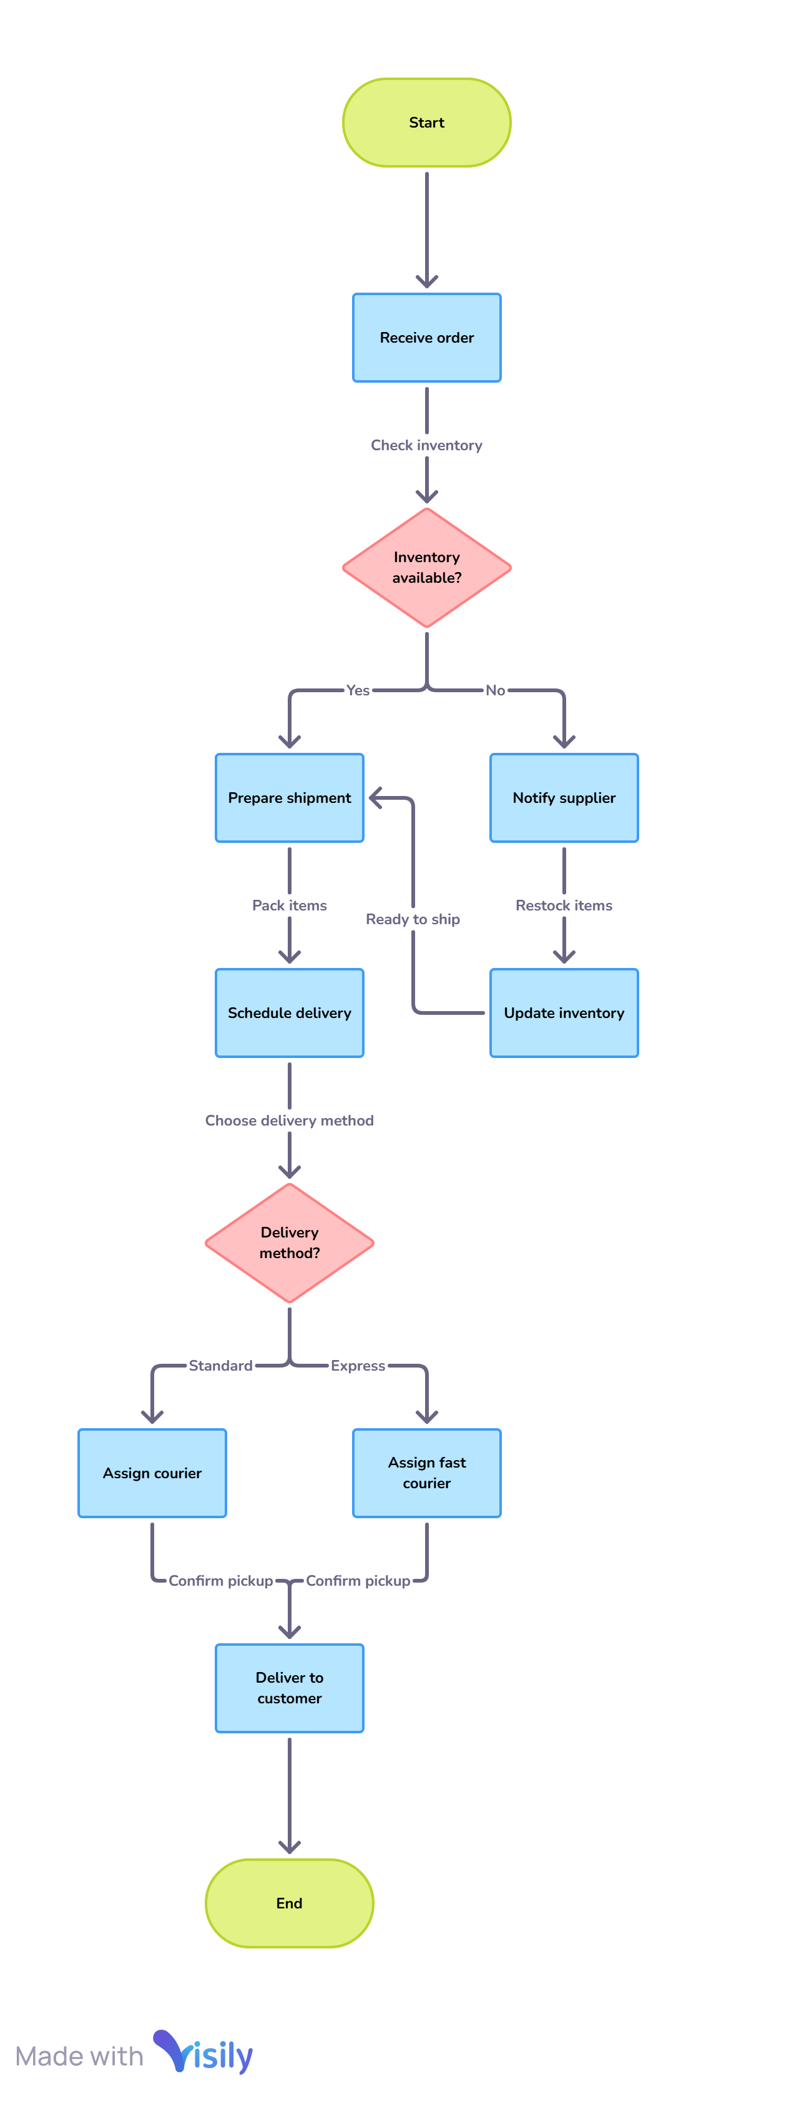

Assignment 2
- Write an introduction letter to a client introducing yourself as a business analyst in charge of working with the client and his team to start the business understanding process.

Subject: Introduction – Business Analyst for Inventory & Delivery Management Software Project
Dear Dairy Pvt. Ltd.,
I hope you are doing well.
My name is Tarun Pongallu, and I have been assigned as the Business Analyst for your upcoming project focused on building a software solution to manage inventory and ensure the quickest delivery of your ice-cream and milk products across your nationwide network of manufacturing plants and warehouses.
As the key point of contact during the business understanding phase, my responsibility will be to work closely with you and your team to understand your current operations, challenges, and goals in detail. This includes gathering and documenting all the necessary business and functional requirements that will guide the design and development of a solution aligned with your objectives.
Given the scale of your operations and the perishable nature of the products, I understand the importance of optimizing inventory visibility and delivery efficiency. My aim is to ensure that the final solution is both practical and impactful, delivering value across all your locations.
I would be happy to schedule an initial meeting at your convenience to begin this process and align on next steps.
Please feel free to reach out to me directly with any questions or to suggest a suitable time for our first discussion.
Looking forward to working with you.
Warm regards,
Tarun Pongallu
Business Analyst
ABD Pvt. Ltd.
Email: Tarun.Pongallu@ ABD.COM
Phone: 9511881435
- Prepare a brief BRD and SRS for a project- Horoscope or Ticketing system or online store.
Online Store for Ice-Cream & Milk Products with Inventory & Delivery Management
Client: Dairy Pvt. Ltd.
Prepared By:
Tarun Pongallu – Business Analyst

Project Overview:
The company has multiple manufacturing plants and warehouses across the country. To streamline operations and improve customer experience, it wants to develop an online store that integrates real-time inventory management and enables fastest delivery of ice-cream and milk products directly to consumers.

Business Objectives:
- Enable online ordering of dairy products via web/mobile platform
- Manage stock levels across multiple warehouses and plants
- Fulfill customer orders from the nearest warehouse
- Optimize delivery routes for speed and efficiency

Key Stakeholders:
- Operations Manager
- E-Commerce Team
- IT/Technical Team
- Warehouse Staff
- Delivery Team
- End Customers

Business Requirements:
- E-commerce storefront (product listing, cart, checkout)
- Inventory sync from warehouses in real-time
- Geo-based warehouse selection for delivery
- Delivery tracking for customers
- Reports for inventory, orders, and delivery performance

Scope:
In Scope:
- Web & mobile online store
- Integration with inventory and delivery modules
- Real-time notifications to customers
- Admin portal for order & stock management
Out of Scope:
- Physical POS integration
- Employee payroll or HR features

Success Criteria:
- 90%+ order fulfillment within 24 hours
- 100% real-time inventory visibility
- 95% delivery accuracy and satisfaction
Software Requirements Specification (SRS)

1. Functional Requirements:

1.1 User Management
- Customer registration/login
- Admin and warehouse user roles
- Password recovery and profile management

1.2 Product Catalog
- List products with images, prices, expiry
- Filter by category and availability
- Product detail view and nutritional info

1.3 Inventory Integration
- Live stock status per product per warehouse
- Stock deduction after order confirmation
- Automatic low-stock alerts

1.4 Order Management
- Add to cart, place order
- Assign to nearest warehouse based on location
- Order confirmation via SMS/email
- Order cancellation and refund handling

1.5 Delivery Management
- Auto-routing and delivery time estimation
- Assign delivery partner and vehicle
- Real-time GPS tracking
- Delivery confirmation (OTP or signature)

1.6 Reporting & Analytics
- Orders by region, product, and date
- Inventory aging and expiry report
- Delivery time and performance metrics

2. Non-Functional Requirements:
- Performance: 2-second max load time for pages
- Scalability: Support 10,000+ daily users and orders
- Security: SSL encryption, role-based access
- Availability: 24/7 uptime with cloud hosting
- Compatibility: Web + Android/iOS support
- Backup: Daily automatic backups

3. System Users:
- Customers
- Admin Users
- Warehouse Managers
- Delivery Agents

4. Suggested Tech Stack:
- Frontend: React / Flutter (for mobile)
- Backend: Node.js / Django
- Database: PostgreSQL or MySQL
- Cloud Hosting: AWS or Azure
- APIs: Google Maps (delivery), Razorpay/Stripe (payment), Twilio (notifications)

- Make an ERD of creating a support ticket/Ticketing life cycle

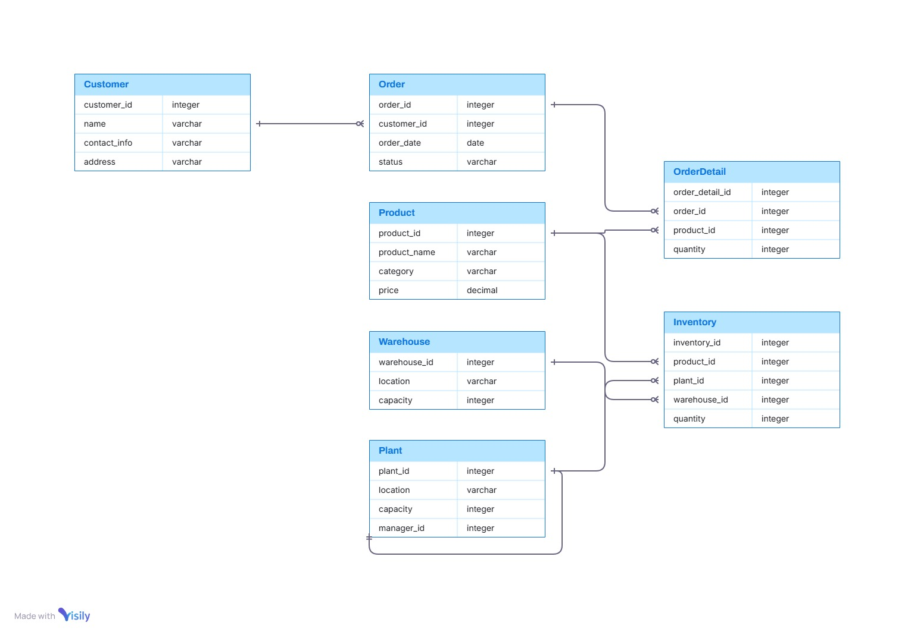

- User story of shopping from ecommerce.

User story No:1 | Task 1 |  | Priority : High
As a new user, I want to sign up using my email or mobile so that I can create an account.
BV:500 |  | CP: 100
ACCEPTANCE CRITERIA:
- Able to Change Password/Login
- All mandatory fields are filled in correctly
- Should receive a verification email

User story No:2 | Task 2 |  | Priority: Medium
As a returning user, I want to log in securely so that I can access my previous orders and wishlist
BV:250 |  | CP: 400
ACCEPTANCE CRITERIA:
Enter a valid email/mobile number and correct password
Should be able to access their previous orders and wishlist

User story No:3 | Task 3 |  | Priority : Medium
As a user, I want to reset my password so that I can regain access if I forget it
BV:10 |  | CP: 50
ACCEPTANCE CRITERIA :
Should ableto click on the “Forgot Password” link
Password should meets all security requirements

User story No:4 | Task 4 |  | Priority : Medium
As a user, I want to receive a confirmation email/SMS after registration for verification
BV:10 |  | CP: 50
ACCEPTANCE CRITERIA :
Should contain a secure verification link or OTP code

User story No:5 | Task 5 |  | Priority : Medium
As a user, I want to log in with Google or Facebook for quick access.
BV:10 |  | CP: 50
ACCEPTANCE CRITERIA :
User has a valid Google or Facebook account
System should link the social login to the existing account

User story No:6 | Task 6 |  | Priority : Medium
As a user, I want to search for products using keywords so that I can find specific items quickly
BV:20 |  | CP: 50
ACCEPTANCE CRITERIA :
Enter a keyword in the search bar
Product should be highlighted / visible in the results page

User story No:7 | Task 7 |  | Priority : Medium
As a user, I want to filter products by categories, price, brand, and ratings so that I can narrow down my options.
BV:20 |  | CP: 50
ACCEPTANCE CRITERIA :
ENABLE THE TIME SHEET AND ATTENDANCE IN LOG IN

User story No:8 | Task 8 |  | Priority : Medium
As a user, I want to sort products by price, popularity, or reviews so that I can browse efficiently.
BV:100 |  | CP: 02
ACCEPTANCE CRITERIA :
ENABLE THE COMMENT AND PHOTO UPLOAD ACCESS IN LOG IN

User story No:9 | Task 9 |  | Priority : Medium
As a user, I want to view detailed product information including images, price, reviews, and specifications
BV:50 |  | CP: 02
ACCEPTANCE CRITERIA :
ENABLE THE FEEDBACK OPTION IN LOG IN

User story No:10 | Task 10 |  | Priority : Medium
As a user, I want to see related/suggested products to discover more items I might like
BV:50 |  | CP: 02
ACCEPTANCE CRITERIA :
ENABLE THE GPS IN THE LOG IN

User story No:11 | Task 11 |  | Priority : HIGHEST
As a user, I want to add products to my wishlist so I can purchase them later
BV:500 |  | CP: 02
ACCEPTANCE CRITERIA :
ENABLE THE PAYMENT GET WAY , ACCESS TO THE POOLING ACCOUNT TO CHECK PAYMENT RECEIVED

User story No:12 | Task 12 |  | Priority : Medium
As a user, I want to remove items from my wishlist if I change my mind
BV:500 |  | CP: 05
ACCEPTANCE CRITERIA :
NAME , KYC , TRADE LICENCE , EMAIL ID , NO OF EMPLOYEES , ESTABLISHED ON , HOUSE TYPE ,

User story No:13 | Task 13 |  | Priority :HIGHEST
As a user, I want to add items to my cart so I can review them before purchase.
BV:100 |  | CP: 05
ACCEPTANCE CRITERIA :
LOGG IN WITH USER ID AND PASSWORD

User story No:14 | Task 14 |  | Priority : Medium
As a user, I want to view my shopping cart to review selected items, quantity, and total price
BV:100 |  | CP: 02
ACCEPTANCE CRITERIA :
DISPLAY MENUS WITH CHOOSE / ADD BUTTON

User story No:15 | Task 15 |  | Priority : Medium
As a user, I want to update the quantity of items in my cart so I can order the desired amount
BV:100 |  | CP: 10
ACCEPTANCE CRITERIA :
ENABLE THE UNIQUE ORDER ID AND DELIVERY BOYS ORDER ID

User story No:16 | Task 16 |  | Priority : Medium
As a user, I want to remove items from the cart before checking out
BV:100 |  | CP: 05
ACCEPTANCE CRITERIA :
ACCEPT / DECLINE THE ORDER BASED ON AVAILABILITY

User story No:17 | Task 17 |  | Priority : Medium
As a user, I want to add my shipping address so that my order is delivered to the right location
BV:50 |  | CP: 02
ACCEPTANCE CRITERIA :
ENABLE THE OPEN AND CLOSURE TIMING

User story No:18 | Task 18 |  | Priority : Medium
As a user, I want to choose from multiple payment options (credit card, UPI, wallet, COD) so I can pay conveniently
BV:50 |  | CP: 02
ACCEPTANCE CRITERIA :
ENABLE THE UPDATION OF AVAILABLE DISH

User story No:19 | Task 19 |  | Priority : Medium
As a user, I want to apply a promo code or coupon to receive a discount
BV:50 |  | CP: 02
ACCEPTANCE CRITERIA :
ENABLE THE CUSTOMERS CONTACT NUMBER ALONG WITH THE ORDER

User story No:20 | Task 20 |  | Priority : Medium
As a user, I want to view order summary before placing my order.
BV:50 |  | CP: 02
ACCEPTANCE CRITERIA :
ENABLE THE REPORT OF FREQUENTLY ORDERED DISH

User story No:21 | Task 21 |  | Priority : Medium
As a user, I want to receive order confirmation by email/SMS after successful checkout
BV:100 |  | CP: 02
ACCEPTANCE CRITERIA :
ENABLE THE EDIT AND UPDATION IN MENU OPTION

User story No:22 | Task 22 |  | Priority : Medium
As a user, I want to track my order status (processing, shipped, delivered) in real-time
BV:50 |  | CP: 02
ACCEPTANCE CRITERIA :
ENABLE THE UPDATE OPTION IN MENU

User story No:23 | Task 23 |  | Priority : Medium
AS A REGIONAL ADMINISTATOR
I WANT TO VALIDATE THE EMPLOYEES WITH KYC
SO THAT VALID EMPLOYEES GET ENROLLED TO SCRUM FOOD
BV:500 |  | CP: 100
ACCEPTANCE CRITERIA :
ENABLE THE KYC VALIDATION PROCESS OF EMPLOYEES

User story No:23 | Task 23 |  | Priority : Medium
AS A REGIONAL ADMINISTATOR
I WANT TO INITIATE THE POLICE VERIFICATION AND BGC OF EMPLOYEES
SO THAT VALID EMPLOYEES GET ENROLLED TO SCRUM FOOD
BV:500 |  | CP: 100
ACCEPTANCE CRITERIA :
ENABLE THE KYC VALIDATION PROCESS OF EMPLOYEES

User story No:24 | Task 24 |  | Priority : Medium
AS A REGIONAL ADMINISTATOR
I WANT TO ACCESS THE TIME SHEET OF THE EMPLOYEES
SO THAT I CAN APPROVE ON TIME
BV:500 |  | CP: 05
ACCEPTANCE CRITERIA :
ENABLE THE ACCESS TO THE TIMESHEET UPDATE

User story No:25 | Task 25 |  | Priority : Medium
AS A REGIONAL ADMINISTATOR
I WANT TO VALIDATE THE PAYROLL AND INCENTIVES OF THE EMPLOYEES
SO THAT I CAN DISBURSE ONTIME
BV:500 |  | CP: 100
ACCEPTANCE CRITERIA :
ENABLE PAYROLL AND TIMESHEET OF EMPLOYEES

User story No:26 | Task 26 |  | Priority : Medium
AS A ADMINISTATOR
I WANT TO VIEW CUSTOMER FEEDBACK
SO THAT I CAN WORK ONTHAT
BV:500 |  | CP: 100
ACCEPTANCE CRITERIA :
ENABLE PAYROLL AND TIMESHEET OF EMPLOYEES

User story No:27 | Task 27 |  | Priority : Medium
AS A ADMINISTATOR
I WANT TO SET UP CUSTOMER SERVICE CENTER
SO THAT I CAN RESOLVE QUERRIES ONTIME
BV:500 |  | CP: 100
ACCEPTANCE CRITERIA :
ENABLE EMPLOYEES QUERIES , CUSTOMER QUERIES , EMPLOYEES QUERIES

User story No:28 | Task 28 |  | Priority : Medium
AS A ADMINISTATOR
I WANT TO VALIDATE THE PAYMENT DONE BY THE CUSTOMER
SO THAT I CAN VERIFY THE SAME
BV:500 |  | CP: 100
ACCEPTANCE CRITERIA :
REPORT GENERATION OF PAYMENTS

User story No:29 | Task 29 |  | Priority : Medium
AS A ADMINISTATOR
I WANT TO EDIT THE PAYMENT METHOD
SO THAT CUSTOMER CAN MAKE PAYMENT SEAMLESSLY
BV:500 |  | CP: 100
ACCEPTANCE CRITERIA :
ENABLE AND EDIT PAYMENT METHODS

User story No:30 | Task 30 |  | Priority : Medium
AS A ADMINISTATOR
I WANT TO MANAGE THE DATABASE
SO THAT I CAN MONITOR THEM PROPERLY
BV:500 |  | CP: 100
ACCEPTANCE CRITERIA :
ENABLE DATABASE OF EMPLOYEES ,CUSTOMERS
EDITING AND MODIFICATION

User story No:31 | Task 31 |  | Priority : Medium
AS A REGIONAL ADMINISTATOR
I WANT TO PUBLISH ADD FOR EMPLYEMENTS
SO THAT I CAN RECRUIT NEW EMPLOYEES
BV:100 |  | CP: 02
ACCEPTANCE CRITERIA :
1.PUBLISH ADVIRTIZATION,
2 ACCEPT APPLICATIONS ,
3.ROUTE THEM TO THE RECRUITEMENT TEAM

User story No:32 | Task 32 |  | Priority : Medium
AS A REGIONAL ADMINISTATOR
I WANT TO MONITOR THE REGIONAL REVENUE
SO THAT I CAN MONITOR THAT
BV:500 |  | CP: 100
ACCEPTANCE CRITERIA :
1 .REPORT GENERATION
2.TOTAL COST
3.TOTAL PROFIT GAINED

User story No:33 | Task 33 |  | Priority : Medium
AS A REGIONAL ADMINISTATOR
I WANT TO ACCESS TO EMPLOYEES RESIGNATION
SO THAT I CAN APPROVE
BV:100 |  | CP: 02
ACCEPTANCE CRITERIA :
1.RESIGNATION REQUEST
2. APPROVAL
3.FOREWARD THAT TO THE NEXT AUTHORITY

User story No:34 | Task 34 |  | Priority : Medium
AS A REGIONAL ADMINISTATOR
I WANT TO LOGG OUT FROM PORTAL
SO THAT I CAN LOGG OUT
BV:100 |  | CP: 02
ACCEPTANCE CRITERIA :
1.LOG OUT RADIO BUTTON

User story No:35 | Task 35 |  | Priority : Medium
As a user, I want to cancel an order before it's shipped
BV:500 |  | CP: 100
ACCEPTANCE CRITERIA :
- NAME
- GENDER
- CONTACT NUMBER
- EMAIL ID
- VALIDATION BY OTP
- ADDRESS
- REGISTER

User story No:36 | Task 36 |  | Priority : Medium
AS A CUSTOMER
I WANT TO EDIT ADDRESS
SO THAT I CAN UPDATE THE ADDRESS
BV:500 |  | CP: 100
ACCEPTANCE CRITERIA :
1.ADD ADDRESS MANUALLY
2.ENABLE CURRENT LOCATION

User story No:37 | Task 37 |  | Priority : HIGHEST
AS A CUSTOMER
I WANT TO VIEW OFFERS
SO THAT I CAN CHOOSE
BV:500 |  | CP: 500
ACCEPTANCE CRITERIA :
1.OFFERS IN SPECIFIC RESTURANT
2.OFFERS FOR THE DAY

User story No:38 | Task 38 |  | Priority : Medium
AS A CUSTOMER
I WANT TO VIEW PICTURES OF MENUS WITH PRICE
SO THAT I CAN CHOOSE

BV:500 |  | CP: 100
ACCEPTANCE CRITERIA :
1.ITEM NAME
2.PRICE

User story No:39 | Task 39 |  | Priority :HIGHEST
AS A CUSTOMER
I WANT MANAGE THE CART
SO THAT I CAN ADD AND ORDER
BV:500 |  | CP: 100
ACCEPTANCE CRITERIA
1.ADD TO CART
2.EDIT
3.CHECK OUT
4.DELETE

User story No:40 | Task 40 |  | Priority : Medium
AS A CUSTOMER
I WANT TO VIEW TOTAL AMOUNT PAYBLE
SO THAT I CAN KNOW THE PRICE BREAK UP AND TAX
BV:500 |  | CP: 100
ACCEPTANCE CRITERIA :
1.BILL GENERATION
2.TOTAL AMOUNT PAYBLE
3.SERVICE TAX

User story No:41 | Task 41 |  | Priority : HIGHEST
AS A CUSTOMER
I WANT ADD COUPON AND OFFERS ON DIFFERENT PAYMENT METHODS
SO THAT I CAN USE THEM
BV:500 |  | CP: 100
ACCEPTANCE CRITERIA :
RADIO BUTTON
1.ADD COUPON
2.OFFERS ON THE CARDS
3. OFFERES ON THE WALLETS
4.OFFERES ON THE PAYMENT METHODS

User story No:42 | Task 42 |  | Priority : HIGHEST
AS A CUSTOMER
I WANT TO TRACK THE FOOD DELIVERY
SO THAT I KNOW WHEN I CAN GET THE FOOD
BV:500 |  | CP: 100
ACCEPTANCE CRITERIA :
1.GPS ACTIVATED FOR THE DELIVERY BOY
2.TRACKING SYSTEM ENABLED

User story No:43 | Task 43 |  | Priority : Medium
AS A CUSTOMER
I WANT TO CALL THE DELIVERY BOY
SO THAT I CAN TRACK THE DELIVERY
BV:500 |  | CP: 100
ACCEPTANCE CRITERIA :
1.A CONFIRMATION MESSAGE DELIVERED TO CUSTOMERS NUMBER WITH THE DELIVERY BOYS NUMBER

User story No:44 | Task 44 |  | Priority : Medium
AS A CUSTOMER
I WANT TO ADD CUTLERY TO THE ORDER
SO THAT I CAN ADD CUTLERY AND EDIT IT
BV:500 |  | CP: 100
ACCEPTANCE CRITERIA :
RADIO BUTTON
- ADD CUTLERY TO ORDER
- YES/NO

User story No:45 | Task 45 |  | Priority : Medium
AS A CUSTOMER
I WANT TO RATE THE FOOD AND COMENT
SO THAT I CAN GIVE RATING
BV:500 |  | CP: 100
ACCEPTANCE CRITERIA :
1.RATING TO DISH
2.RATING TO DELIVERY BOY
3.FEEDBACK OPTION

User story No:46 | Task 46 |  | Priority : HIGHEST
AS A CUSTOMER
I WANT TO VIEW OTHER CUSTOMERS FEEDBACK
SO THAT I CAN TAKE DECISION
BV:500 |  | CP: 100
ACCEPTANCE CRITERIA :
1.CHECK FEEDBACK ON THE DISH
2.CHECK RATING OF THE DISH

User story No:47 | Task 47 |  | Priority : HIGHEST
AS A CUSTOMER
I WANT TO INTERACT WITH CUSTOMER CARE
SO THAT I CAN RAISE QUERRIES
BV:500 |  | CP: 05
ACCEPTANCE CRITERIA :
CUSTOMER CARE ACCESS
RADIO BUTTON : CONTACT US (CALL/ ARRANGE A CALL BACK/CHAT )

User story No:48 | Task 48 |  | Priority : HIGHEST
AS A CUSTOMER
I WANT TO VIEW MY ORDER ID
SO THAT I CAN RAISE THE QUERY AND TRACK
BV:500 |  | CP: 50
ACCEPTANCE CRITERIA :
ORDER PLACED –UNIQUE ORDER ID CREATED

User story No:49 | Task 49 |  | Priority : Medium
AS A CUSTOMER
I WANT TO CHOOSE PAYMENT OPTION
SO THAT I CAN MAKE PAYMENT
BV:500 |  | CP: 100
ACCEPTANCE CRITERIA :
1.RADIO BUTTON OF PAYMENT OPTION
2.PAYTM
3.PHONE PAY
4.CARD(DEBIT CARD/CREDIT CARD)
5.COD
6.INTERNET BANKING
7.GOOGLE PAY

User story No:50 | Task 50 |  | Priority : Medium
AS A CUSTOMER
I WANT TO VIEW MY LAST ORDER
SO THAT I CAN REPEAT
BV:100 |  | CP: 05
ACCEPTANCE CRITERIA :
PREVIOUS ORDERS
1.REPEAT
2. MODIFY

