Document 1
Definition of Done (DoD)
Project Title: Financial System Enhancements – Dividends & Capital Events
Framework: Agile / Scrum
Based on: Agile Extension to the BABOK® Guide v2

Definition of Done – User Story Level
A user story is considered "done" when all of the following criteria have been met:
🔹 Functional & Acceptance Criteria
- All acceptance criteria for the user story are met
- The functionality aligns with country-specific rules and SOPs
- Feature behavior is verified with actual user inputs and data
🔹 Code Quality & Development
- Code is written for all intended features and edge cases
- The story builds without errors or warnings
- Unit tests are written and all pass successfully
- Refactoring (if any) is completed
🔹 Testing & QA
- Deployed to test/staging environment (matching production setup)
- Passed all QA testing, including:
  - Functional testing
  - Validation rule testing
  - Error message pop-up testing
  - Cross-browser or device-specific testing (if UI is affected)
- Peer Code Review performed
- No critical or major defects remain unresolved
🔹 UX / UI (if applicable)
- UI/UX changes reviewed and approved by UX Designer (if affected)
- Consistency and usability verified
🔹 Product Ownership
- User story demonstrated to Product Owner during sprint review
- Product Owner formally accepts the user story
🔹 Documentation & Communication
- All changes documented (e.g., logic, validations, config files)
- Any relevant SOPs or user guides updated
- Configuration or environment changes noted in release plan

Definition of Done – Sprint Level
A Sprint is considered "done" when:
- All committed user stories meet their individual Definition of Done
- Sprint review held with stakeholders
- Feedback from the review is recorded and added to the backlog (if applicable)
- Sprint retrospective conducted with team participation
- Sprint burndown and performance metrics updated

Definition of Done – Release Level
A Release is considered "done" when:
- All included sprints are complete and tested end-to-end
- UAT (User Acceptance Testing) is signed off by key stakeholders
- No open high-severity defects remain
- Rollback plan is documented
- Production deployment steps tested in pre-prod
- All documentation (tech, user, SOP) finalized
- Training completed (if needed)
- Support handover done to operations or production support team

Document 2- Product Vision
Scrum Project Name: | Dividend & Capital Events Automation System
Venue: | APT IT Solutions – Conference Room / MS Teams
Date: | 12/07/2025
Client: | ICE Data Services
Stakeholder List: | - Operations Head  - Compliance Manager  - Business Analyst  - QA Lead  - Product Owner  - IT Infrastructure Lead
Scrum Team
Role | Name (Example Entries)
Scrum Master | Priya Mehta
Product Owner | Rakesh Sharma
Scrum Developer 1 | Devraj Nair
Scrum Developer 2 | Aditi Rao
Scrum Developer 3 | Rohit Das
Scrum Developer 4 | Neha Suri
Scrum Developer 5 | Anand Krishnan

Document 2: Product Vision
Vision:
To build an intelligent, rule-driven automation system within the existing RDOS platform that ensures accurate, timely, and regulation-compliant updates of corporate actions — such as dividend dates and capital events — across all operational screens, while minimizing manual errors, reducing operational risks, and enhancing end-to-end data quality and process transparency.
This product will empower operations teams to make faster and more accurate updates by leveraging automated country-specific logic, error pop-ups, SOP-based validations, and reminder mechanisms, thereby contributing to the overall business goals of compliance, efficiency, and customer trust.

Target Group | Needs | Product | Value
Financial operations teams in capital markets <br> - Internal stakeholders like QA, Compliance, and Portfolio Admins <br> - External regulators relying on timely and correct corporate action data | - Manual entry of dividend & capital event dates increases error risk  - Inconsistent adherence to country rules  - Lack of early validation and pop-up error control  - No reminder for X-ref events | A smart automation layer integrated into the RDOS system  - Automatically adjusts ex-date, record date, pay date based on jurisdictional rules  - Triggers pop-up errors for incomplete or incorrect inputs  - Reminds users of dependent updates like X-ref screens | Reduced processing time by up to 50% for corporate action entries  - Stronger compliance with international SOPs and regulations  - Improved data quality and operational efficiency  - Business goal: Enhanced accuracy, faster turnaround, reduced compliance risk

User Story No: 1
Tasks: 02 | Priority: High
As a user,
I want to view company details on every screen,
so that I can quickly verify and validate event information in context.
BV: 500 | CP: 3
Acceptance Criteria:
- Company name, ID, and logo are displayed on all related screens
- Display must remain fixed across navigation
- Responsive and clear across different resolutions
- QA-validated across modules

User Story No: 2
Tasks: 05 | Priority: High
As a user,
I want the ex-date, record date, and pay date to be updated automatically as per country rules when I update any one of them,
so that I can ensure compliance without manual calculations.
BV: 1000 | CP: 5
Acceptance Criteria:
- Updating one date auto-updates the others using the country-specific logic
- Validation messages shown for incorrect country configurations
- Rule engine supports all applicable countries
- Unit test coverage >90%

User Story No: 3
Tasks: 03 | Priority: High
As a user,
I want the system to auto-update Dealing Date or Ex-date when I update one,
so that I can reduce errors and improve efficiency.
BV: 500 | CP: 3
Acceptance Criteria:
- On updating either date, the corresponding date auto-updates per rules
- Option to override manually with warning
- Logging of all automatic adjustments
- Unit and integration tested

User Story No: 4
Tasks: 02 | Priority: Medium
As a user,
I want to get a reminder to check X-Ref Event screen after updating capital events,
so that I can complete dependent event tracking without missing steps.
BV: 500 | CP: 2
Acceptance Criteria:
- Reminder message appears once event is saved
- Message includes link to X-Ref screen
- User can snooze or acknowledge
- QA and UX tested

User Story No: 5
Tasks: 03 | Priority: High
As a user,
I want to be alerted with specific error messages if mandatory fields or formats are incorrect,
so that I can correct them before submission and prevent invalid records from entering RDOS.
BV: 1000 | CP: 5
Acceptance Criteria:
- Mandatory fields validated on update
- Pop-up shows detailed error/warning messages with type
- Event cannot be saved unless all validations pass
- Full error log retained

Document 4: Agile Product Owner (PO) Experience
Product Owner Role Summary
As the Product Owner for this enhancement project, I was responsible for defining the product vision, managing stakeholder expectations, prioritizing features based on business value, and ensuring that the development team delivered maximum value in every sprint. My role bridged the gap between the business stakeholders and the development team by translating strategic goals into actionable stories and epics.

Key Responsibilities and Experience
1. Market Analysis
- Conducted a market needs assessment to understand gaps in similar financial event management systems.
- Identified that several global event systems lacked intelligent auto-update logic and SOP enforcement for capital events.
- Analyzed the competitive landscape and noted that automated compliance checks are growing in demand, especially in the financial domain.
2. Enterprise Analysis
- Performed opportunity analysis by engaging internal stakeholders and compliance departments.
- Validated the enhancement demand via feedback from existing system users and compliance leads.
- Aligned the scope of enhancement with the organization's goal of reducing manual effort and increasing system automation.
3. Product Vision and Roadmap
- Product Vision: Enhance the capital events module to deliver a smarter, rules-driven, and compliance-oriented experience that reduces manual effort and improves audit readiness.
- Created a product roadmap aligned with quarterly goals and business deadlines, including:
  - Auto-update logic for ex-date, record date, and pay date.
  - SOP validation integration with pop-up alerts.
  - Reminder functionality for cross-referencing related events.
4. Managing Product Features
- Collaborated with stakeholders to define high-priority features that support internal SOPs and regulatory compliance.
- Prioritized enhancements based on ROI, user impact, and criticality.
- Ensured regular communication and feature reviews with stakeholders and subject matter experts.
5. Managing Product Backlog
- Maintained and prioritized the product backlog in collaboration with the Scrum Master and Business Analyst.
- Reprioritized epics and user stories based on new compliance requirements or stakeholder feedback.
- Broke down high-level epics into actionable user stories with clear acceptance criteria.
6. Managing Overall Iteration Progress
- Participated in Sprint Planning Meetings to define sprint goals and commit to deliverables.
- Monitored Sprint Progress by reviewing burndown charts, backlog items, and blockers.
- Participated in Sprint Retrospectives to evaluate what went well, what could improve, and how to adjust priorities for future sprints.
- Ensured all enhancements met the Definition of Done and quality benchmarks before being marked complete.

Sprint Planning Meeting Experience
From this project, I have learned the importance of:
- Aligning team capacity with sprint goals.
- Defining clear Sprint Objectives.
- Breaking down stories into tasks that are achievable within the sprint timeline.
- Planning for dependencies and reviewing velocity from previous sprints.
- Fostering collaboration between the PO, BA, and Developers to ensure shared understanding.
Managing Product Features
- Collaborated closely with stakeholders to understand business needs, market trends, and user expectations.
- Prioritized epics, features, and stories based on business criticality, risk, and ROI.
- Regularly communicated scope changes and feature prioritization decisions to stakeholders and the Scrum team to ensure alignment.
- Ensured that delivered features aligned with customer value, usability, and system capability.

➢ Managing Product Backlog
- Maintained a clear, well-prioritized product backlog, ensuring it reflected the most up-to-date needs of the business.
- Performed backlog grooming sessions with the team to break down epics into user stories and ensure clarity and completeness.
- Collaborated with stakeholders and the Scrum Master for reprioritization of user stories based on shifting requirements, dependencies, or risks.
- Managed epic-level planning, ensuring a balance between business value and development capacity.

➢ Managing Overall Iteration Progress
- Conducted Sprint Progress Reviews regularly with the development team and stakeholders to evaluate work completed versus planned scope.
- Adapted the sprint plan based on current progress, changing business priorities, or technical challenges.
- Participated in Sprint Retrospectives, alongside the Business Analyst, to identify continuous improvement opportunities in workflow, communication, and delivery.
- Supported the Scrum Master in keeping the team focused and unblocked throughout the iteration.
Sprint Ceremonies Participated
As part of the Product Owner responsibilities in this enhancements project, I actively participated and contributed to the following Agile ceremonies:

➢ Daily Scrum Meeting
- Attended daily stand-up meetings to stay informed of the team's progress.
- Provided clarifications to the development team on user stories.
- Addressed blockers promptly and communicated any business-side updates impacting development.

➢ Sprint Review Meeting
- Reviewed the completed functionalities with stakeholders.
- Validated that the enhancements aligned with business goals and acceptance criteria.
- Collected feedback for refining or expanding upcoming features.

➢ Sprint Retrospective Meeting
- Participated in team retrospectives to evaluate sprint performance.
- Discussed what worked well, what didn’t, and proposed actionable improvements.
- Took notes to refine backlog grooming and planning processes for better efficiency.

➢ Backlog Refinement Meeting
- Regularly reviewed and updated the product backlog.
- Ensured user stories were well-defined, estimated, and prioritized before each sprint.
- Collaborated with the Scrum Master and Developers to break epics into user stories.

User Story Creation
As a Product Owner, I was responsible for the creation and refinement of user stories. Each story was structured with the following key components:
➢ Story Number
- Unique identifier for tracking within the backlog.
➢ Tasks
- List of development, testing, and documentation activities associated with the story.
➢ Priority
- Categorized based on business urgency (High, Medium, Low).
➢ Acceptance Criteria
- Detailed conditions that must be met for the story to be accepted as complete.
- Reflects user expectations and defines the boundaries of a story.
➢ Business Value (BV)
- A value (e.g., 1–10 scale) that indicates the impact the story has on business goals.
➢ Complexity Points (CP)
- Story point estimation that reflects development effort and complexity.
- Liaison Role: Acted as the communication bridge between business stakeholders and the Scrum team.
- Vision & Strategy: Developed a clear vision of the product’s purpose, aligning it with business needs and market gaps.
- Feature Definition: Defined and detailed key features, converted them into actionable user stories, and prioritized based on ROI and urgency.
- Backlog Management: Maintained and refined the product backlog, ensuring clarity, completeness, and alignment with goals.
- Stakeholder Collaboration: Ensured that all areas of the business remained informed and involved throughout the project lifecycle.
- Continuous Improvement: Actively involved in retrospectives and reviews to optimize delivery efficiency and team collaboration.

Document 5: Product and sprint backlog and product and sprint burndown charts

Product Backlog
User Story ID | User Story | Tasks | Priority | BV | CP | Sprint
RDOS-101 | As a user, I want faster product page load times | Implement Redis cache, Optimize DB queries, Profile bottlenecks | High | 10 | 5 | Sprint 3
RDOS-102 | As an admin, I want alert notifications on RDOS failures | Define failure triggers, Setup alert system, Test notification delivery | Medium | 8 | 4 | Sprint 3

Sprint Backlog (Sprint 3)
User Story ID | User Story | Tasks | Owner | Status | Estimated Effort
RDOS-101 | As a user, I want faster product page load times | Implement Redis cache | Developer 1 | In Progress | 5 hrs
 |  | Optimize DB queries | Developer 2 | To Do | 4 hrs
 |  | Profile bottlenecks | Developer 3 | Done | 3 hrs
RDOS-102 | As an admin, I want alert notifications on RDOS failures | Define failure triggers | Developer 1 | In Progress | 4 hrs
 |  | Setup alert system | Developer 2 | To Do | 5 hrs
 |  | Test notification delivery | Developer 3 | To Do | 3 hrs

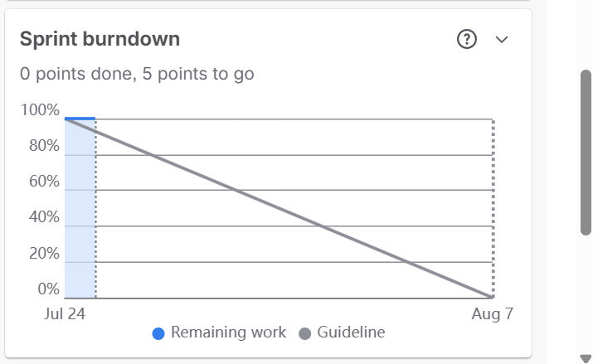

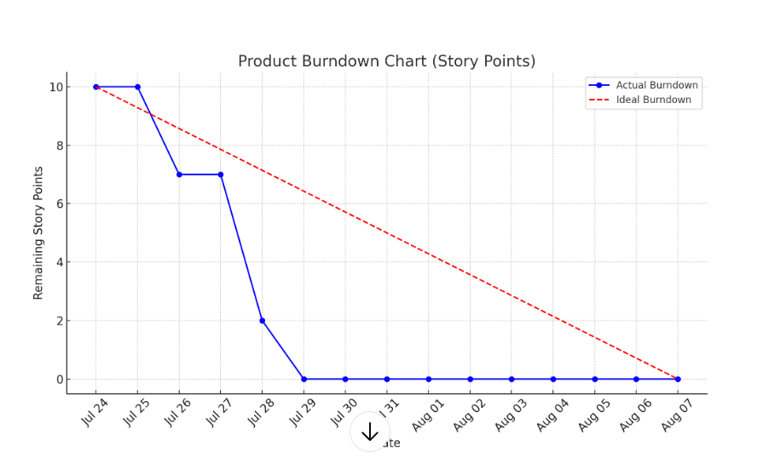

Document 6: Sprint meetings
Meeting Type 1: Sprint Planning Meeting
Date | 23rd July 2025
Time | 10:00 AM – 11:30 AM
Location | ICE Data Services– Conference Room
Prepared By | Product Owner
Attendees | Scrum Master, Product Owner, Scrum Developers

Agenda Topics
Topic | Presenter | Time Allotted
Review Sprint Goal | Product Owner | 15 mins
Review & Select Backlog Items | Scrum Team | 30 mins
Define Tasks for Each Story | Scrum Developers | 30 mins
Capacity Planning & Estimation | Scrum Master | 15 mins

Other Information
Observers | Client Representative
Resources | Product Backlog, Jira Board, Laptop, Sprint Velocity Chart
Special Notes | Focus on high-priority backlog items based on ROI

Meeting Type 2: Sprint Review Meeting
Date | 23rd July 2025
Time | 2:00 PM – 3:00 PM
Location | APT IT Solutions – Online (MS Teams)
Prepared By | Scrum Master
Attendees | Product Owner, Scrum Team, Stakeholders

Sprint Status | Things to Demo | Quick Updates | What’s Next
Sprint 4 – 90% items completed | - Auto-update of Ex-date & Record date in Dividends screen  - Country rule logic implementation | - Minor bugs in date sync fixed  - UX signoff received | - Remaining 10% stories to be completed  - Sprint 5 planning tomorrow

Meeting Type 3: Sprint retrospective meeting
Date: 23-07-2025
Time: 03:00 PM – 04:00 PM
Location: Scrum Room A / Microsoft Teams
Prepared By: Scrum Master – Priya Mehta
Attendees: Product Owner, Scrum Master, Dev Team, QA Team
Agenda | What went well | What didn’t go well | Questions | Reference
Sprint Goal Review | Most stories completed as planned | Some stories carried over due to unclear requirements | How can we clarify requirements more effectively? | Sprint Backlog, User Stories
Team Coordination | Daily stand-ups were consistent and effective | One member had workload imbalance | Can we improve task allocation next sprint? | Sprint Board, Jira
QA and Testing | Bugs were caught early and resolved quickly | Regression testing was delayed | How to schedule regression testing earlier? | Test Reports, QA Logs
Code Integration | CI/CD pipeline worked smoothly with minimal errors | A few build failures due to overlooked merge conflicts | Should we do pre-merge code reviews more strictly? | GitHub, Jenkins Logs
Improvement Actions | Plan estimation session & setup documentation checklist | — | — | Sprint Review Notes
Meeting Type 4: Daily Stand-up meeting

Week 1 (from 22-07-2025 to 28-07-2025)
Daily Stand-up Table with RDOS Enhancements
Question | Name/Role | Monday | Tuesday | Wednesday | Thursday | Friday | Saturday | Sunday
What did you do yesterday? | Developer 1 | Implemented caching logic for product data | Added error handling in real-time updates | Enhanced API response time (RDOS optimization) | Reviewed RDOS enhancement PR | Finalized RDOS alert system
 | Developer 2 | Refactored real-time sync module | Improved data consistency for orders | Indexed key DB tables for faster sync | Ran load testing on RDOS module | Resolved sync delay in RDOS queue
 | Developer 3 | Created logs for RDOS anomalies | Integrated RDOS monitoring dashboard | Debugged memory leak in real-time processing | Reduced CPU usage in RDOS background service | Updated RDOS module documentation
What will you do today? | Developer 1 | Implement retry mechanism in RDOS jobs | Monitor production RDOS traffic | Add alerts for abnormal data volume | Improve RDOS latency under peak load | Prepare report on RDOS efficiency gains
 | Developer 2 | Fine-tune Redis cache for RDOS | Cross-check RDOS events with analytics | Update fallback rules for data sync | Optimize RDOS data fetching logic | Coordinate with QA on RDOS regression testing
 | Developer 3 | Write unit tests for RDOS triggers | Integrate RDOS logs with central dashboard | Test failover mechanism in RDOS | Update RDOS service dependencies | Present RDOS results in sprint review
What (if any) is blocking you? | Developer 1 | None | Waiting for review from DevOps | None | None | None
 | Developer 2 | Delayed response from DB | Waiting for new test data | None | None | None
 | Developer 3 | Awaiting access to Grafana | Permissions issue in production RDOS logs | None | None | None

